Supplementary Material

Influence of Light at Night on Allergic Diseases: A Systematic Review and Meta-Analysis

Andy Deprato BScKin,^{1,2} Robert Maidstone PhD,³ Anna Palomar Cros PhD,^{4,5,6} Ana Adan PhD,^{7,8} Prasun Haldar PhD,⁹ Barbara N Harding PhD,^{4,5,6} Paige Lacy PhD,¹ Lyle Melenka MD, MSc,¹⁰ Saibal Moitra MD, PhD,¹¹ José Francisco Navarro PhD,¹² Manolis Kogevinas MD, PhD,^{4,5,6,13} Hannah Durrington MD, PhD,³ Subhabrata Moitra PhD^{1,14}

- Alberta Respiratory Centre and Division of Pulmonary Medicine, University of Alberta, Edmonton, Alberta, Canada
- Michael G. DeGroote School of Medicine, McMaster University, Hamilton, Ontario, Canada
- Division of Immunology, Immunity to Infection, and Respiratory Medicine, University of Manchester, Manchester, United Kingdom
- Non-Communicable Diseases and Environment Programme, Barcelona Institute for Global Health (ISGlobal), Barcelona, Spain
- Department of Experimental and Health Sciences, University of Pompeu Fabra (UPF), Barcelona, Spain
- Consortium for Biomedical Research in Epidemiology and Public Health (CIBERESP), Carlos III Institute of Health, Madrid, Spain
- Department of Clinical Psychology and Psychobiology, University of Barcelona, Barcelona, Spain
- Institute of Neurosciences, University of Barcelona, Barcelona, Spain
- Department of Medical Laboratory Technology, Supreme Institute of Management and Technology, Mankundu, India
- Synergy Respiratory and Cardiac Care, Sherwood Park, Alberta, Canada
- Department of Allergy and Immunology, Apollo Gleneagles Hospital, Kolkata, India
- Department of Psychobiology and Methodology of Behavioural Sciences, University of Málaga, Málaga, Spain
- Hospital del Mar Medical Research Institute (IMIM), Barcelona, Spain
- Canadian VIGOUR Centre, Department of Medicine, University of Alberta, Edmonton, Alberta, Canada

Correspondence to:
Dr. Subhabrata Moitra, Alberta Respiratory Centre and Division of Pulmonary Medicine, 574B Heritage Medical Research Centre, University of Alberta, Edmonton, Alberta, Canada T6G 2S2
Tel: 1.780.604.0263
Email: moitra@ualberta.ca

Table S1 Comprehensive strategy of the initial search to identify studies considering the influence of light at night exposure on allergic diseases.

Database | Search Strategy | Records
MEDLINE (1946 - present via OVID) | Ovid MEDLINE(R) ALL <1946 to December 02, 2022>  - (artificial light at night or ALAN or light at night or light pollution or chronotype or shift work or shiftwork).mp. 10819  - (asthma* or allerg* or immune).mp. 1222580  - 1 and 2 251  mp = title, book title, abstract, original title, name of substance word, subject heading word, floating sub-heading word, keyword heading word, organism supplementary concept word, protocol supplementary concept word, rare disease supplementary concept word, unique identifier, synonyms | 251
EMBASE (1974 - present via OVID) | Embase <1974 to 2022 December 02>  - (artificial light at night or ALAN or light at night or light pollution or chronotype or shift work or shiftwork).mp. 15201  - (asthma* or allerg* or immune).mp. 1923567  - 1 and 2 427  mp = title, abstract, heading word, drug trade name, original title, device manufacturer, drug manufacturer, device trade name, keyword heading word, floating subheading word, candidate term word | 427
PubMed (with links to UofA e-journals) | All Fields: ("artificial light at night" OR ALAN OR "light at night" OR "light pollution" OR "chronotype" OR "shift work" OR shiftwork) AND (asthma* OR allerg* OR immune) | 912
Scopus | ( TITLE-ABS-KEY ( "artificial light at night" OR alan OR "light at night" OR "light pollution" OR "chronotype" OR "shift work" OR shiftwork ) AND TITLE-ABS-KEY ( asthma* OR allerg* OR immune ) ) | 572
Web of Science Core Collection | - TS = ("artificial light at night" OR ALAN OR "light at night" OR "light pollution" OR "chronotype" OR "shift work" OR shiftwork)  Date Run: Sat Dec 03 2022 16:00:34 GMT-0700 (Mountain Standard Time)  Results: 19444  - TS = (asthma* OR allerg* OR immune)  Date Run: Sat Dec 03 2022 16:01:01 GMT-0700 (Mountain Standard Time)  Results: 1272651  - #1 AND #2  Date Run: Sat Dec 03 2022 16:01:09 GMT-0700 (Mountain Standard Time)  Results: 347 | 347
Cochrane Reviews (Cochrane Library) | - "artificial light at night" OR ALAN OR "light at night" OR "light pollution" OR "chronotype" OR "shift work" OR shiftwork 1316  - asthma* OR allerg* OR immune 104955  - #1 AND #2 93 | 63
Cochrane Protocols (Cochrane Library) | - "artificial light at night" OR ALAN OR "light at night" OR "light pollution" OR "chronotype" OR "shift work" OR shiftwork 1316  - asthma* OR allerg* OR immune 104955  - #1 AND #2 93 | 3
International Prospective Register of Systematic Reviews (PROSPERO) | ("artificial light at night" OR ALAN OR "light at night" OR "light pollution" OR "chronotype" OR "shift work" OR shiftwork) AND (asthma* OR allerg* OR immune) | 67
Google Scholar | ("artificial light at night" OR ALAN OR "light at night" OR "light pollution" OR "chronotype" OR "shift work" OR shiftwork) AND (asthma* OR allerg* OR immune) | First 100 results used

Table S2 Comprehensive strategy of the updated search to identify studies considering the influence of light at night exposure on allergic diseases.

Database | Search Strategy | Results
MEDLINE (1946 - present via OVID) | Ovid MEDLINE(R) ALL <1946 to December 07, 2023>  - (artificial light at night or ALAN or light at night or light pollution or chronotype or shift work or shiftwork).mp. 11931  - (asthma* or allerg* or immune).mp. 1308981  - 1 and 2 274  - limit 3 to yr="2022 -Current" 63  mp = title, book title, abstract, original title, name of substance word, subject heading word, floating sub-heading word, keyword heading word, organism supplementary concept word, protocol supplementary concept word, rare disease supplementary concept word, unique identifier, synonyms, population supplementary concept word, anatomy supplementary concept word | 63
EMBASE (1974 - present via OVID) | Embase <1974 to 2023 December 13>  - (artificial light at night or ALAN or light at night or light pollution or chronotype or shift work or shiftwork).mp. 16775  - (asthma* or allerg* or immune).mp. 2077529  - 1 and 2 484  - limit 3 to yr="2022 -Current" 104  mp = title, abstract, heading word, drug trade name, original title, device manufacturer, drug manufacturer, device trade name, keyword heading word, floating subheading word, candidate term word | 104
PubMed | ("artificial light at night" OR ALAN OR "light at night" OR "light pollution" OR "chronotype" OR "shift work" OR shiftwork) AND (asthma* OR allerg* OR immune)  Results by Year: 2022-2024 | 209
Scopus | ( TITLE-ABS-KEY ( "artificial light at night" OR alan OR "light at night" OR "light pollution" OR "chronotype" OR "shift work" OR shiftwork ) AND TITLE-ABS-KEY ( asthma* OR allerg* OR immune ) ) AND PUBYEAR > 2021 | 95
Web of Science Core Collection | - TS=("artificial light at night" OR ALAN OR "light at night" OR "light pollution" OR "chronotype" OR "shift work" OR shiftwork)  Date Run: Fri Dec 15 2023 18:42:37 GMT-0500 (Eastern Standard Time)  Results: 21131  - TS=(asthma* OR allerg* OR immune)  Date Run: Fri Dec 15 2023 18:42:55 GMT-0500 (Eastern Standard Time)  Results: 1358086  - #1 AND #2  Date Run: Fri Dec 15 2023 18:43:00 GMT-0500 (Eastern Standard Time)  Results: 392  - #3 Timespan: 2022-12-03 to 2023-12-16  Date Run: Fri Dec 15 2023 18:44:33 GMT-0500 (Eastern Standard Time)  Results: 41 | 41
Cochrane Reviews (Cochrane Library) | - "artificial light at night" OR ALAN OR "light at night" OR "light pollution" OR "chronotype" OR "shift work" OR shiftwork 1410  - asthma* OR allerg* OR immune 111207  - #1 AND #2 98  - #3 with Cochrane Library publication date Between Dec 2022 and Dec 2023 5 | 3
Cochrane Protocols (Cochrane Library) | - "artificial light at night" OR ALAN OR "light at night" OR "light pollution" OR "chronotype" OR "shift work" OR shiftwork 1410  - asthma* OR allerg* OR immune 111207  - #1 AND #2 98  - #3 with Cochrane Library publication date Between Dec 2022 and Dec 2023 5 | No results returned
International Prospective Register of Systematic Reviews (PROSPERO) | ("artificial light at night" OR ALAN OR "light at night" OR "light pollution" OR "chronotype" OR "shift work" OR shiftwork) AND (asthma* OR allerg* OR immune) WHERE CD FROM 03/12/2022 TO 15/12/2023 | 11
Google Scholar | ("artificial light at night" OR ALAN OR "light at night" OR "light pollution" OR "chronotype" OR "shift work" OR shiftwork) AND (asthma* OR allerg* OR immune)  Publication Date: Since 2022 | First 100 results used

Table S3 Summary of meta-analyses considering the association between light at night exposure and the odds of allergic diseases.

Outcome | Comparison | Studies (n) | OR (95% CI) | p-value | I² | Certainty
Exposure stratification | Artificial light at night | 1 (20 106) | 1.88 (1.04, 3.39) | p = 0.04 | N/A | N/A
Exposure stratification | Chronotype | 6 (304 493) | 1.35 (0.98, 1.87) | p = 0.07 | 91% | Very low
Exposure stratification | Shift work | 5 (531 318) | 1.33 (1.06, 1.67) | p = 0.02 | 74% | Low
Outcome stratification | Asthma | 9 (827 263) | 1.62 (1.19, 2.20) | p = 0.002 | 93% | Very low
Outcome stratification | Allergic rhinitis | 5 (38 412) | 1.89 (1.60, 2.24) | p < 0.0001 | 59% | Moderate
Outcome stratification | Skin allergies | 7 (60 977) | 1.44 (1.09, 1.91) | p = 0.01 | 89% | Very low
Artificial light at night stratification | Asthma | 1 (20 106) | 3.51 (2.56, 4.82) | p < 0.00001 | N/A | N/A
Artificial light at night stratification | Allergic rhinitis | 1 (20 106) | 1.97 (1.77, 2.20) | p < 0.00001 | N/A | N/A
Artificial light at night stratification | Skin allergies | 1 (20 106) | 1.00 (0.85, 1.18) | p = 0.97 | N/A | N/A
Chronotype stratification | Asthma | 6 (304 493) | 1.49 (1.02, 2.17) | p = 0.04 | 92% | N/A
Chronotype stratification | Allergic rhinitis | 3 (18 182) | 1.86 (1.41, 2.46) | p < 0.0001 | 72% | N/A
Chronotype stratification | Skin allergies | 2 (12 093) | 1.84 (1.20, 2.83) | p = 0.005 | 70% | N/A
Shift work stratification | Asthma | 2 (502 664) | 1.22 (1.02, 1.44) | p = 0.03 | 0% | N/A
Shift work stratification | Allergic rhinitis | 1 (124) | 2.79 (1.18, 6.60) | p = 0.02 | N/A | N/A
Shift work stratification | Skin allergies | 4 (28 778) | 1.42 (0.96, 2.09) | p = 0.08 | 76% | N/A
Age stratification | Youth | 4 (291 980) | 1.63 (1.07, 2.48) | p = 0.02 | 90% | N/A
Age stratification | Adults | 8 (563 937) | 1.30 (1.03, 1.63) | p = 0.02 | 81% | N/A
Region stratification | Americas | 2 (1581) | 2.35 (1.40, 3.96) | p = 0.001 | 33% | N/A
Region stratification | Asia | 7 (339 283) | 1.35 (1.13, 1.61) | p = 0.0009 | 84% | N/A
Region stratification | Europe | 3 (515 053) | 1.04 (0.66, 1.65) | p = 0.86 | 89% | N/A

OR: odds ratio; 95% CI: 95% confidence interval

Fig. S1 Funnel plot of the exposure-specific meta-analysis for the association between light at night exposure and the odds of allergic diseases.

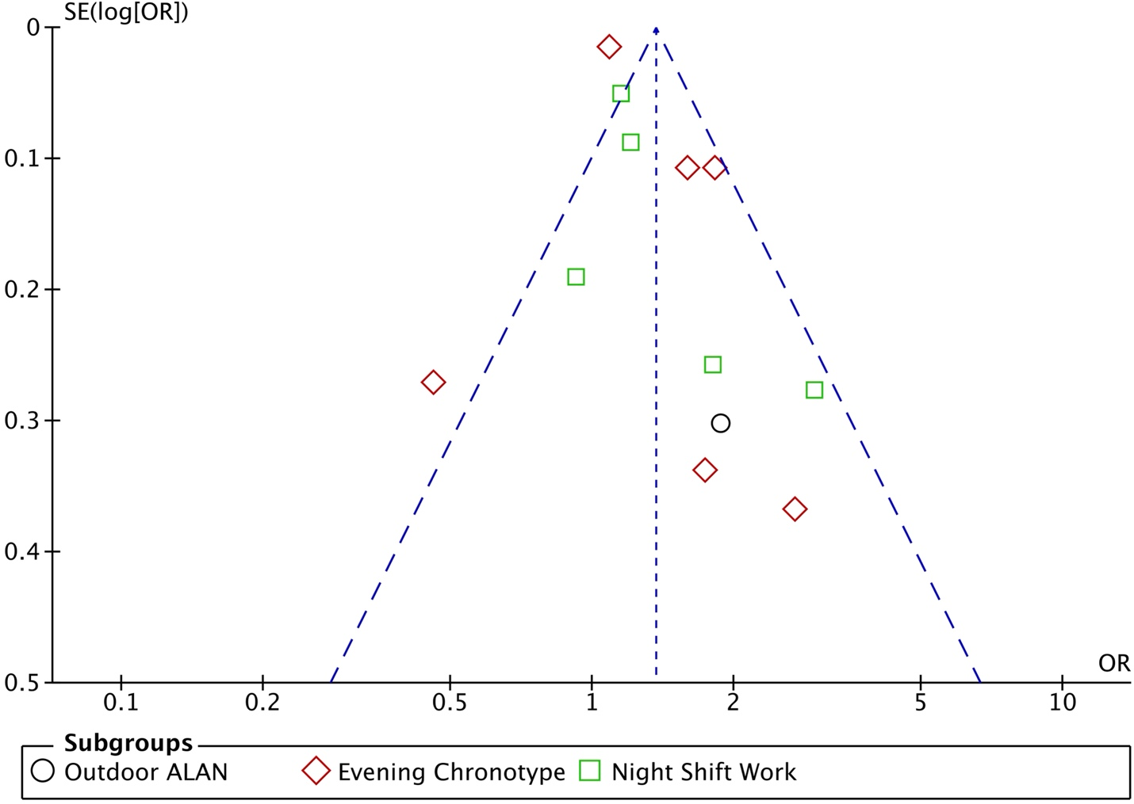

For chronotype, Egger’s test p-value: 0.31 and Begg’s test p-value: 0.85. For shift work, Egger’s test p-value: 0.27 and Begg’s test p-value: 0.14. Bias could not be computed for outdoor ALAN (n=1).

Fig. S2 Funnel plot of the outcome-specific meta-analysis for the association between light at night exposure and the odds of allergic diseases.

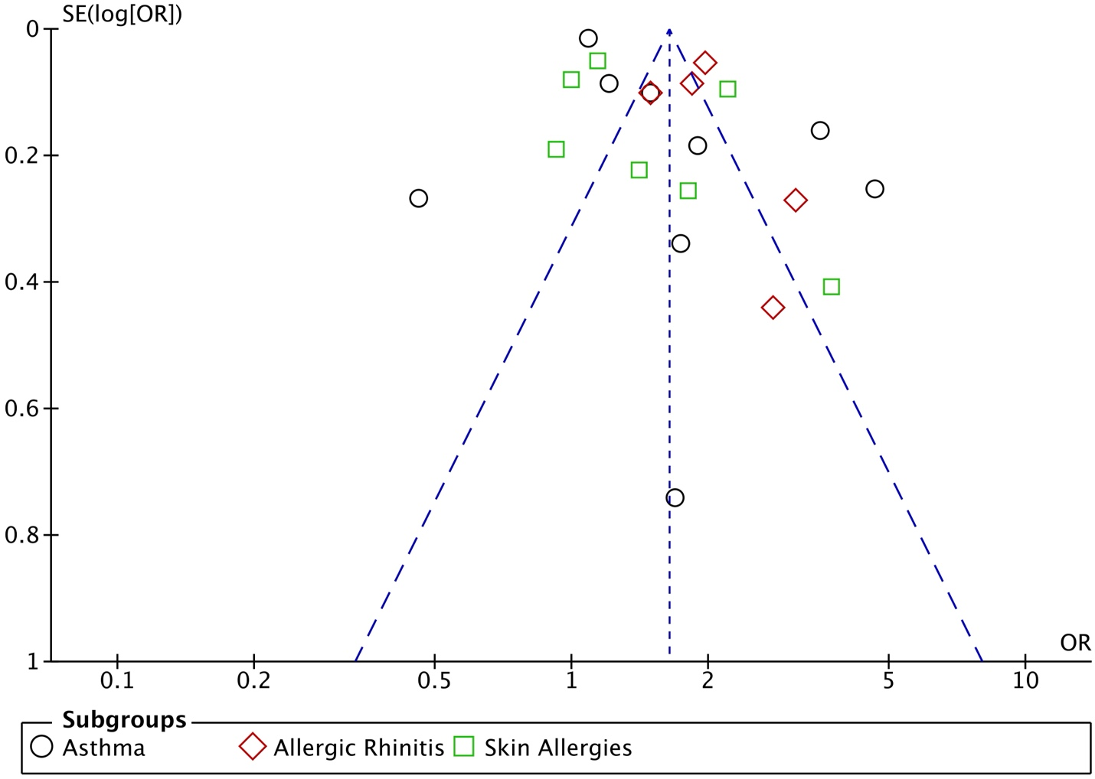

For asthma, Egger’s test p-value: 0.09 and Begg’s test p-value: 1.00. For allergic rhinitis, Egger’s test p-value: 0.17 and Begg’s test p-value: 0.14. For skin allergies, Egger’s test p-value: 0.26 and Begg’s test p-value: 0.19.

Fig. S3 Risk of Bias In Non-randomized Studies – of Exposures (ROBINS-E) quality assessment of included studies considering the influence of light at night exposure on allergic diseases.

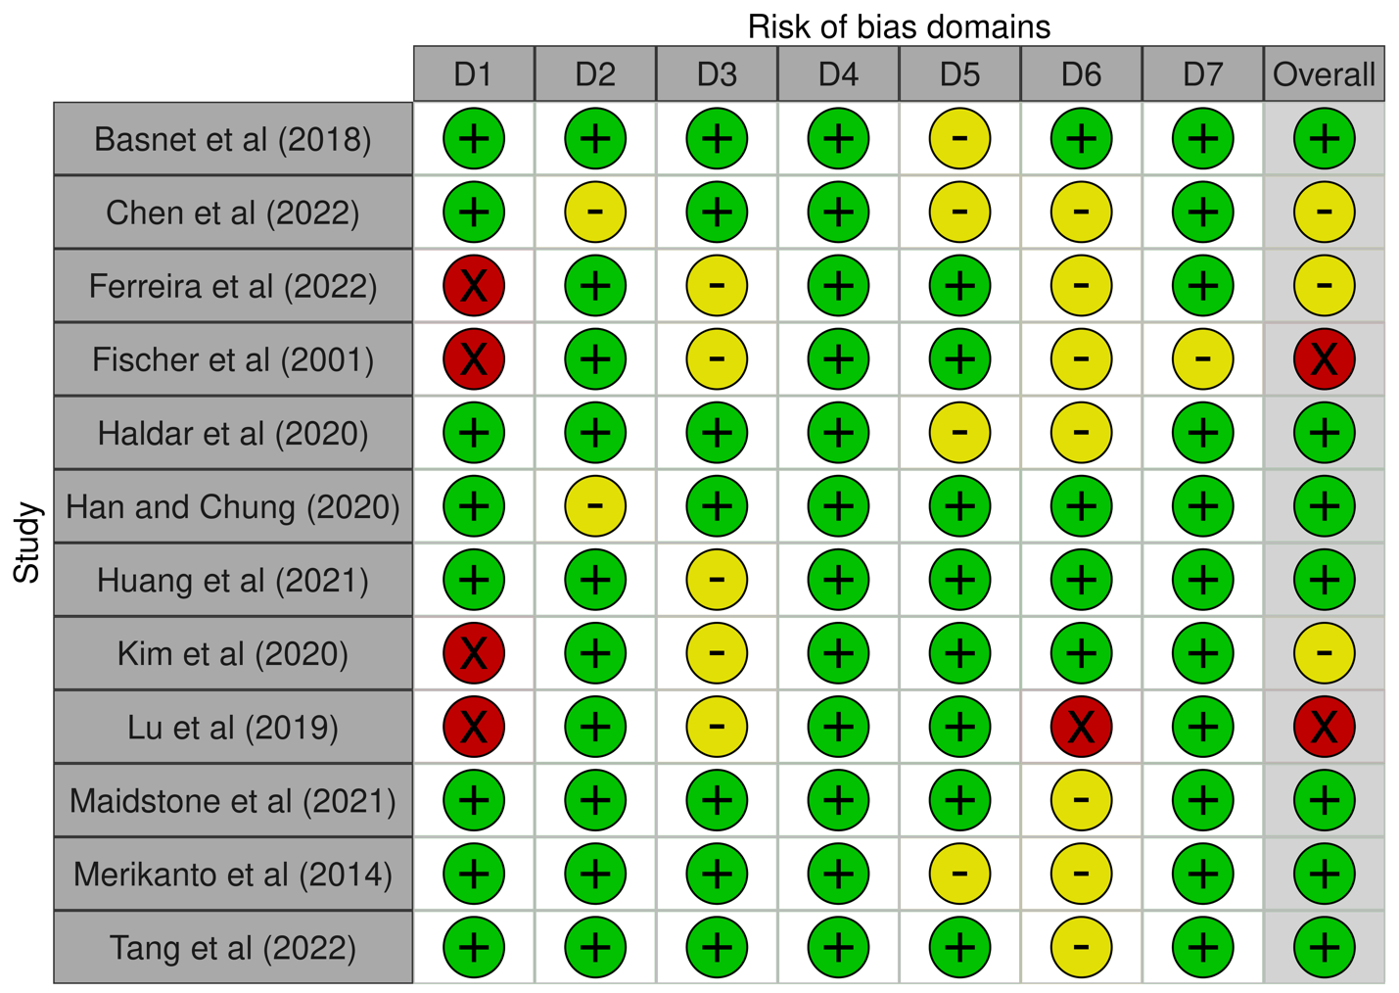

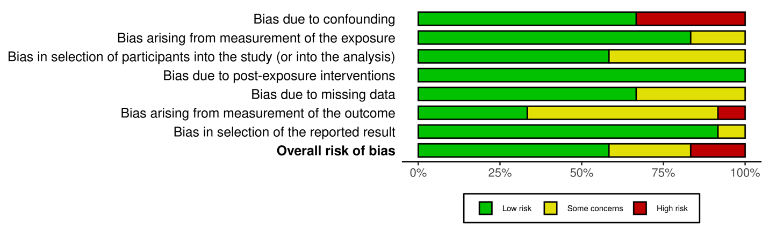

(1-12)

Table S4 Grading of Recommendations, Assessment, Development, and Evaluation (GRADE) criteria evidence table of meta-analyses considering the influence of light at night exposure on the odds of allergic diseases.

Certainty assessment |  |  |  |  |  |  | № of patients |  | Effect |  | Certainty | Importance
№ of studies | Study design | Risk of bias | Inconsistency | Indirectness | Imprecision | Other considerations | Asthma and Allergic Diseases | placebo | Relative  (95% CI) | Absolute  (95% CI) | Certainty | Importance
Outdoor ALAN
1 | N/A | N/A | N/A | N/A | N/A | N/A | N/A | N/A | OR 1.88  (1.04 to 3.39) | 2 fewer per 1,000  (from 3 fewer to 1 fewer) | N/A | N/A
Evening Chronotype
6 | non-randomised studies | not serious | serious | not serious | not serious | none | N/A | N/A | OR 1.35  (0.98 to 1.87) | 1 fewer per 1,000  (from 2 fewer to 1 fewer) | ⨁◯◯◯  Very low | N/A
Night Shift Work
5 | non-randomised studies | not serious | not serious | not serious | not serious | none | N/A | N/A | OR 1.33  (1.06 to 1.67) | 1 fewer per 1,000  (from 2 fewer to 1 fewer) | ⨁⨁◯◯  Low | N/A
Asthma
9 | non-randomised studies | not serious | serious | not serious | not serious | none | N/A | N/A | OR 1.62  (1.19 to 2.20) | 2 fewer per 1,000  (from 2 fewer to 1 fewer) | ⨁◯◯◯  Very low | N/A
Allergic Rhinitis
5 | non-randomised studies | not serious | not serious | not serious | not serious | strong association | N/A | N/A | OR 1.89  (1.60 to 2.24) | 2 fewer per 1,000  (from 2 fewer to 2 fewer) | ⨁⨁⨁◯  Moderate | N/A
Skin Allergies
7 | non-randomised studies | not serious | serious | not serious | not serious | none | N/A | N/A | OR 1.44  (1.09 to 1.91) | 1 fewer per 1,000  (from 2 fewer to 1 fewer) | ⨁◯◯◯  Very low | N/A

