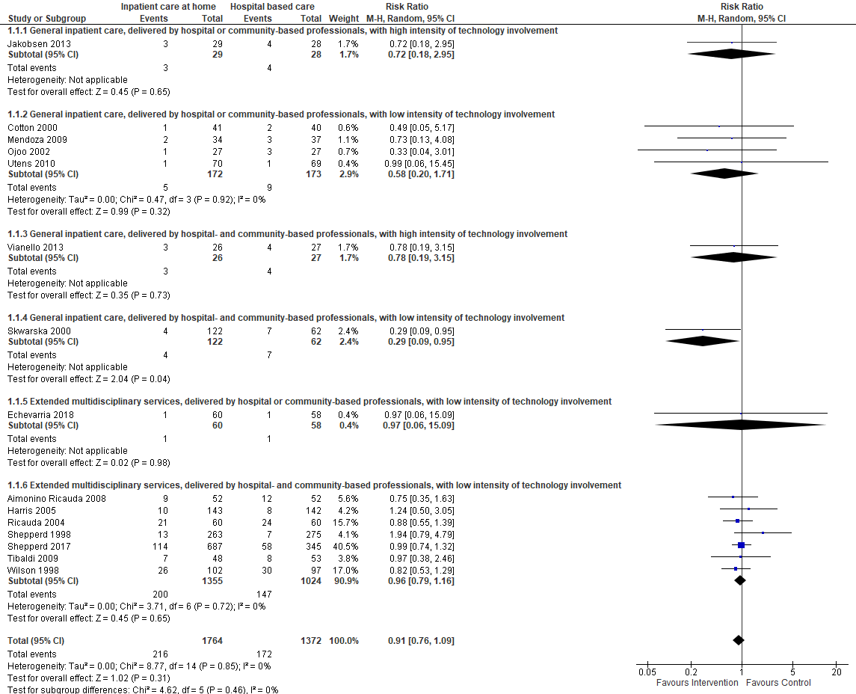
Fig. S1. Meta-analyses of RCT data by care models for mortality
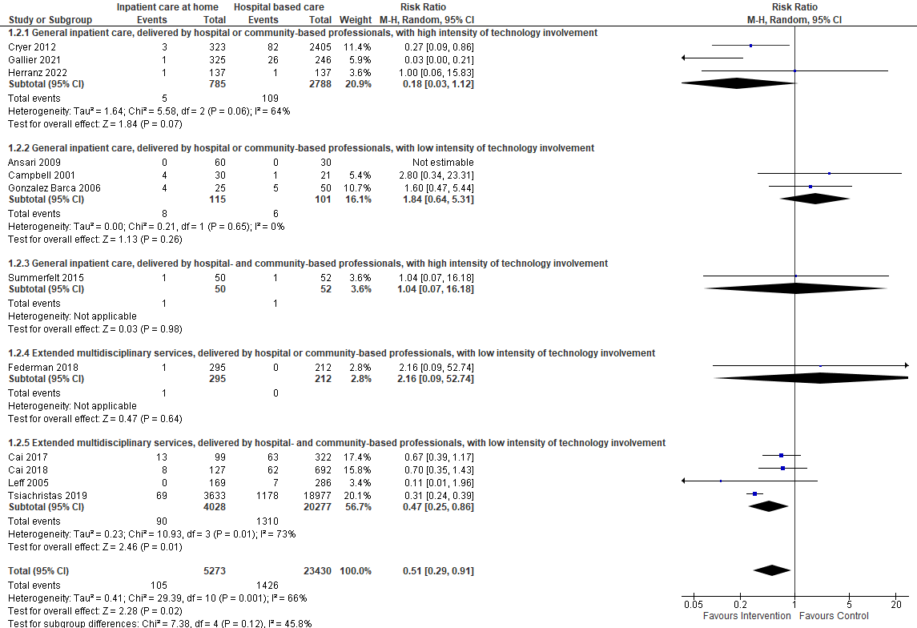
Fig. S2. Meta-analyses of non-randomised data by care models for mortality
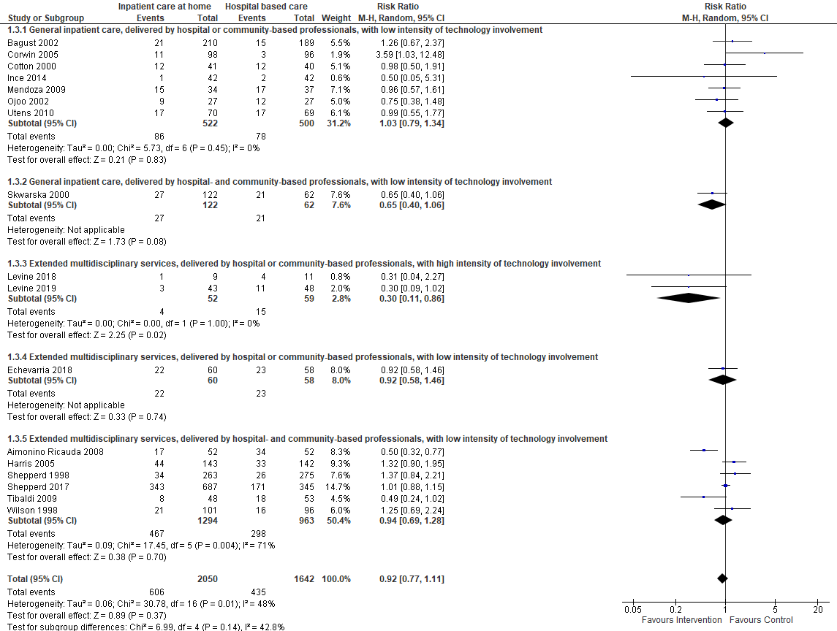
Fig. S3. Meta-analyses of RCT data by care models for hospital readmission

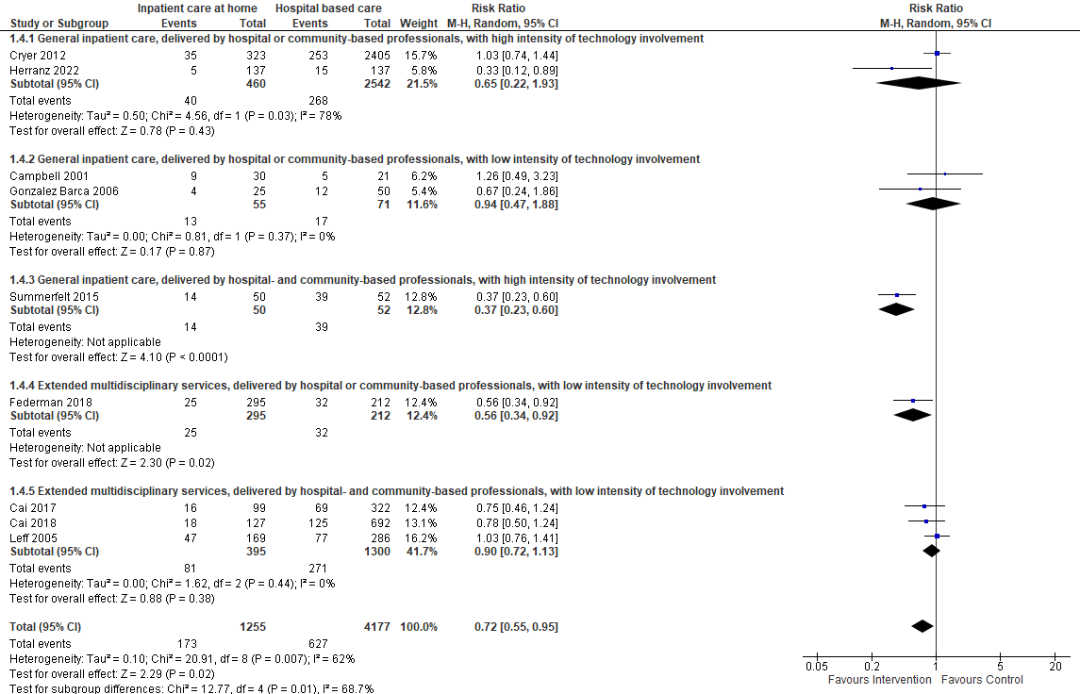
Fig. S4. Meta-analyses of non-randomised data by care models for hospital readmission

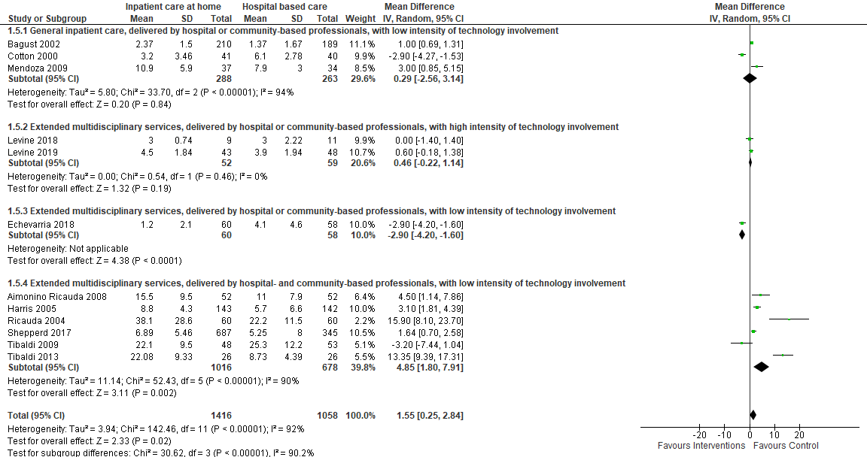

Fig. S5. Meta-analyses of RCT data by care models for the length of care stay in days
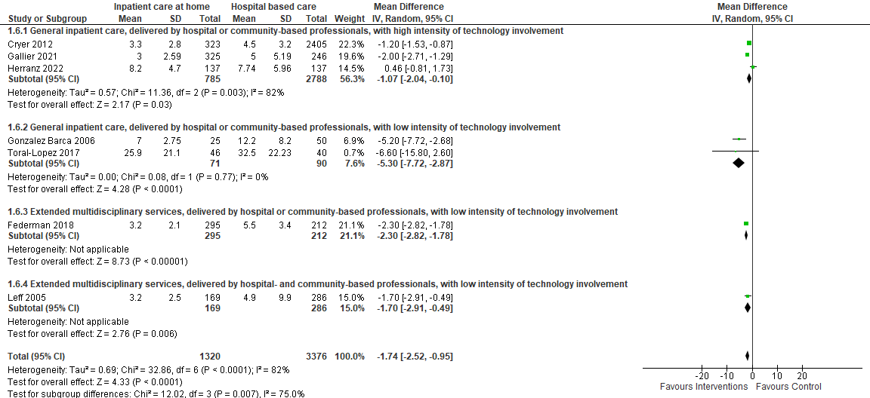
Fig. S6. Meta-analyses of non-randomised data by care models for the length of care stay in days

