Additional file 2. Details of model performance and identification of important features

Table S1. Metrics for all four models in the three cohorts.
Comparison of the prediction performance of Light GBM, support vector machine, logistic regression and random forest in the discovery cohort, internal validation cohort and prospective validation cohort. Besides, parameters are adjusted in discovery cohort 1.
Algorithm | Discovery cohort | Adjusted in discovery cohort | Internal validation cohort | Prospective validation cohort
Light GBM | 0.829 | 0.839 | 0.791 | 0.987
Support vector machine | 0.735 | 0.767 | 0.656 | 0.699
Logistic regression | 0.694 | 0.771 | 0.688 | 0.697
Random forest | 0.654 | 0.723 | 0.721 | 0.922

Table S2. Comparison of the prediction performance of all inputted and selected features in different cohorts.
Features | AUC
272 features | 0.829
Identified 20 features | 0.815
Abbreviations: AUC, area under the curve.

Fig. S1. The inter-correlation of selected taxa-related features in the discovery cohort.
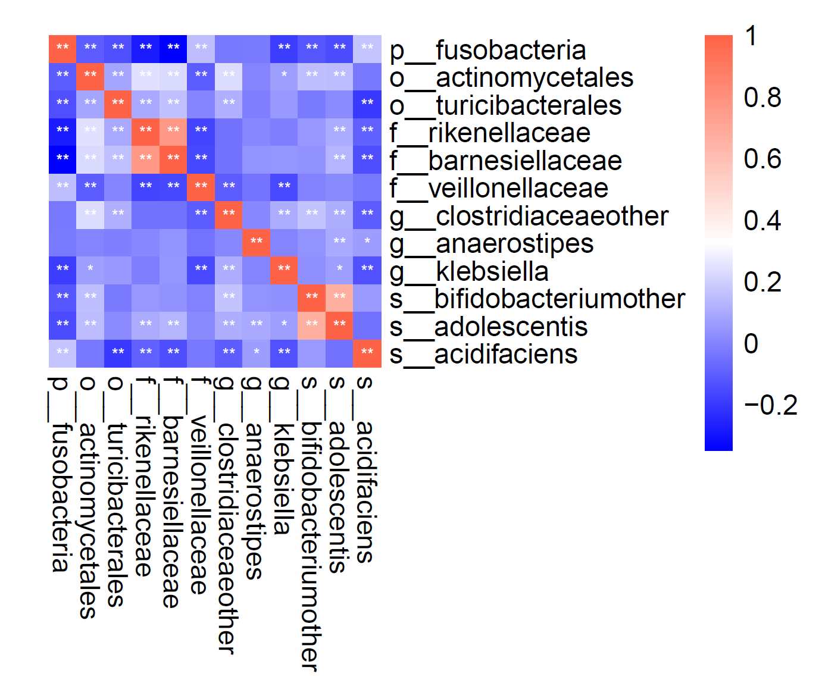

Fig. S2. The marginal effect of individual selected features on non-alcoholic fatty liver disease.
Note: The SHAP dependence plot shows how lightGBM prediction output is affected by a selected gut microbiome feature for each sample. The feature variable is represented by the X-axis, and the SHAP value for the feature variable is represented by the Y-axis. If the SHAP value is larger than zero, the feature may increase the risk of non-alcoholic fatty liver disease for the given sample; if not, the disease risk may decrease.

