Additional file 5. Details of identification of significantly different metabolites and the association between SDM with gut microbiota features.

Fig. S1. The Principal Component Analysis (PCA) score plot of the first two principal components for metabolite levels among groups by MRS in the discovery cohort.
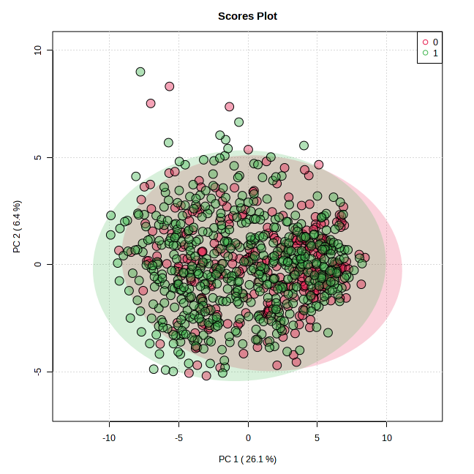
Note: The samples in the score plots were classified by MRS, with red (legend 0) denoting the lower MRS group and green (legend 1) denoting higher MRS group.

Fig. S2. Univariate analysis results of differential metabolites in different groups by MRS in the discovery cohort. 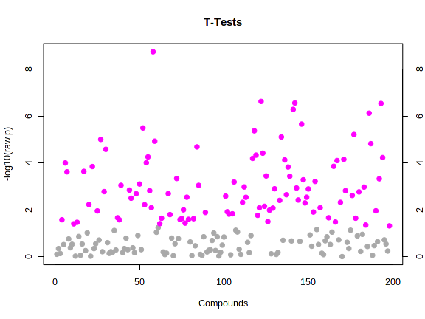
Note: Symbol in violet denotes a statistically significant Benjamini-Hochberg adjusted false discovery rate (FDR) of the Student’s t-test (FDR<0.05) whereas symbol in grey indicates no significant FDR.

Fig. S3. Important metabolites selected by volcano plot in different groups by MRS in the discovery cohort.
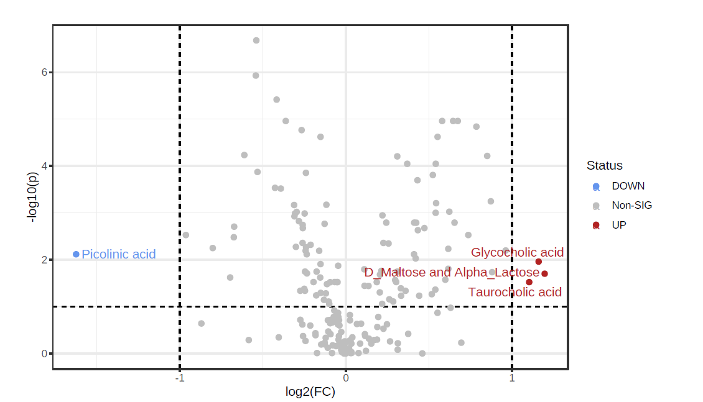
Note: Red indicates the upregulated metabolites expression level of the NAFLD patient group, green indicates the downregulated metabolites expression level of the NAFLD patient group, and black indicated insignificant differential expression; both FC and P-value are log transformed; the further its position away from the (0, 0), the more significant the feature is.

Fig. S4. The Principal Component Analysis (PCA) score plot of the first two principal components for metabolite levels among groups by whether with NAFLD or not in the discovery cohort.
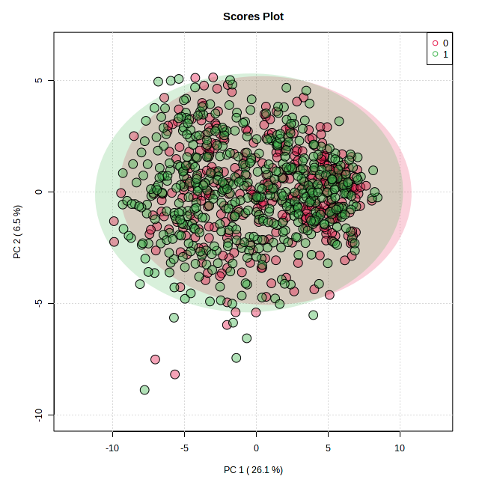
Note: The samples in the score plots were classified by MRS, with red (legend 0) denoting the lower MRS group and green (legend 1) denoting higher MRS group.

Fig. S5. Univariate analysis results of differential metabolites in different groups by whether with NAFLD or not in the discovery cohort. 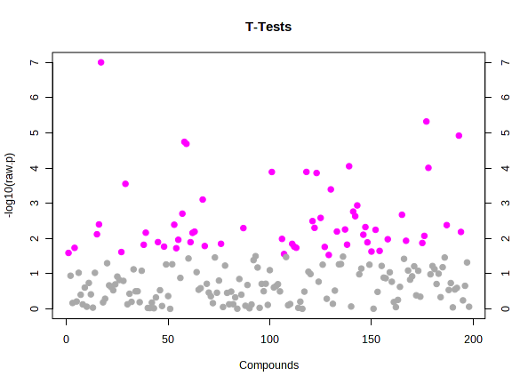
Note: Symbol in violet denotes a statistically significant Benjamini-Hochberg adjusted false discovery rate (FDR) of the Student’s t-test (FDR<0.05) whereas symbol in grey indicates no significant FDR.

Fig. S6. Important metabolites selected by volcano plot in different groups by whether with NAFLD or not in the discovery cohort.
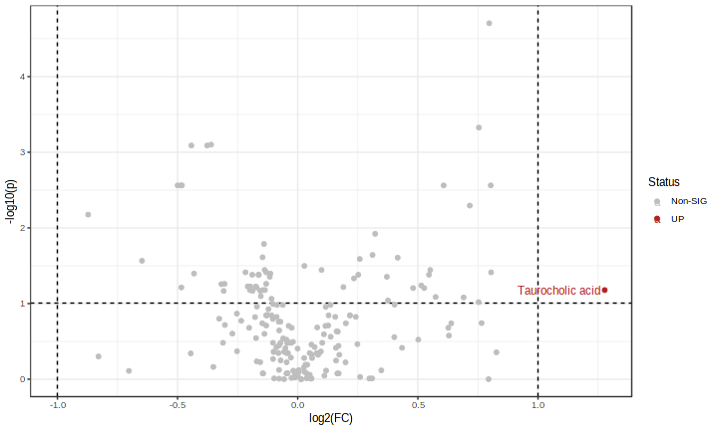
Note: Red indicates the upregulated metabolites expression level of the NAFLD patient group, green indicates the downregulated metabolites expression level of the NAFLD patients group, and black indicated insignificant differential expression; both FC and P-value are log transformed; the further its position away from the (0, 0), the more significant the feature is.

Table S1. Four significant different metabolites (SDMs) in faecal samples among discovery cohort (higher MRS group vs. lower MRS group).
 | Volcano |  |  |  |  | T-test
 | FC | log2(FC) | FDR | -Log10(p) |  | t | P | -Log10(p) | FDR
Glycocholic acid | 2.235 | 1.160 | 0.003 | 2.543 |  | 3.483 | 0.001 | 3.283 | 0.003
D_Maltose and Alpha_Lactose | 2.292 | 1.197 | 0.004 | 2.363 |  | 3.332 | 0.001 | 3.047 | 0.004
Taurocholic acid | 2.149 | 1.104 | 0.028 | 1.560 |  | 2.571 | 0.010 | 1.987 | 0.028
Picolinic acid | 0.324 | -1.625 | 0.056 | 1.248 |  | -2.222 | 0.027 | 1.576 | 0.056
Note: The FC describes the ratio of expression in metabolites between NAFLD patients and control group.
Abbreviations: FC, fold change, FDR, false discovery rate.

Table S2. One significant different metabolites (SDMs) in faecal samples among discovery cohort (NAFLD group vs. control group).
 | Volcano |  |  |  |  | T-test
 | FC | log2(FC) | FDR | -Log10(p) |  | t | P | -Log10(p) | FDR
Taurocholic acid | 2.424 | 1.278 | 0.066 | 1.178 |  | 2.382 | 0.017 | 1.759 | 0.066
Note: The FC describes the ratio of expression in metabolites between NAFLD patients and control group.
Abbreviations: FC, fold change, FDR, false discovery rate.

Table S3. Correlations between selected microbiomes and Taurocholic acid.
Metabolites | Microbiomes | Correlation coefficients | P-value
Taurocholic acid | p__fusobacteria | 0.198 | <0.001
Taurocholic acid | o__actinomycetales | -0.142 | <0.001
Taurocholic acid | o__turicibacterales | -0.070 | 0.041
Taurocholic acid | f__barnesiellaceae | -0.357 | <0.001
Taurocholic acid | f__rikenellaceae | -0.345 | <0.001
Taurocholic acid | f__veillonellaceae | 0.064 | 0.061
Taurocholic acid | g__anaerostipes | 0.010 | 0.778
Taurocholic acid | g__clostridiaceaeother | 0.099 | 0.004
Taurocholic acid | g__klebsiella | -0.038 | 0.274
Taurocholic acid | s__acidifaciens | 0.004 | 0.911
Taurocholic acid | s__adolescentis | -0.085 | 0.014
Taurocholic acid | s__bifidobacteriumother | -0.036 | 0.292
Note: The Spearman correlation coefficients between 12 microbiomes selected through lightGBM and the host faecal metabolites were calculated in the discovery cohort.

