 | SSRI | MAOI | TCA | TRAZ
SSRI | 134 | 0 | 8 | 12
MAOI | 0 | 4 | 0 | 0
TCA | 8 | 0 | 46 | 3
TRAZ | 12 | 0 | 3 | 72
Supplementary table S1. Antidepressant mono- and polytherapy in MrOS. The number of participants taking four types of antidepressant drugs (selective serotonin reuptake inhibitors [SSRI], monoamine oxidase inhibitors [MAOI], tricyclic antidepressants [TCA] and trazodone [TRAZ]) is reported in the diagonal. Off-diagonal cells contain the number of participants taking both drugs.

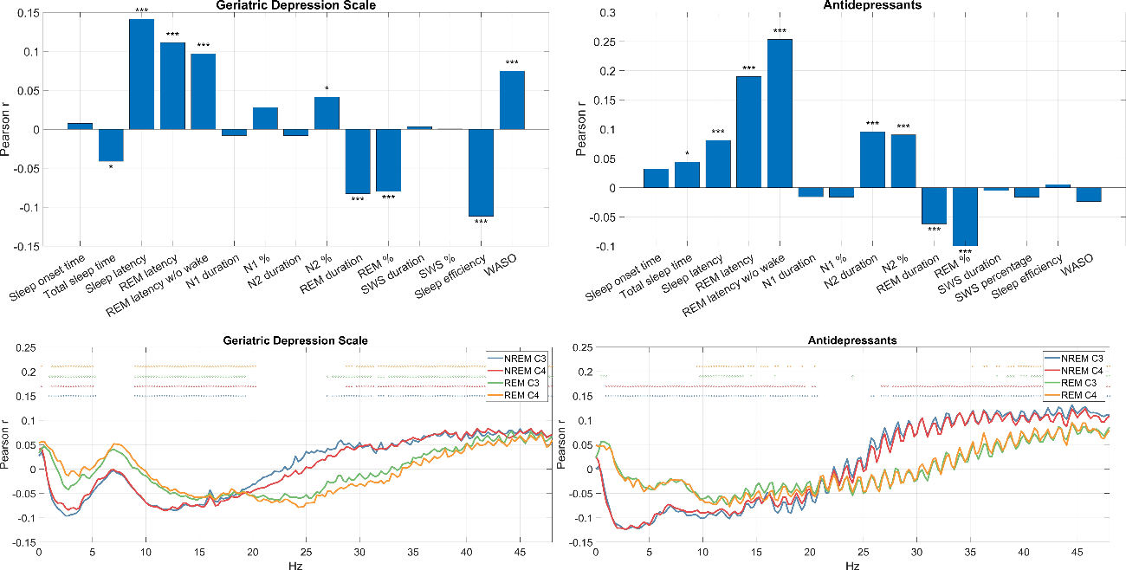
Supplementary figure S1. Correlations between sleep macrostructure (top panels) or EEG PSD (bottom panels) and Geriatric Depression Scale scores in antidepressant naïve participants (left panels) or antidepressant use (right panels).
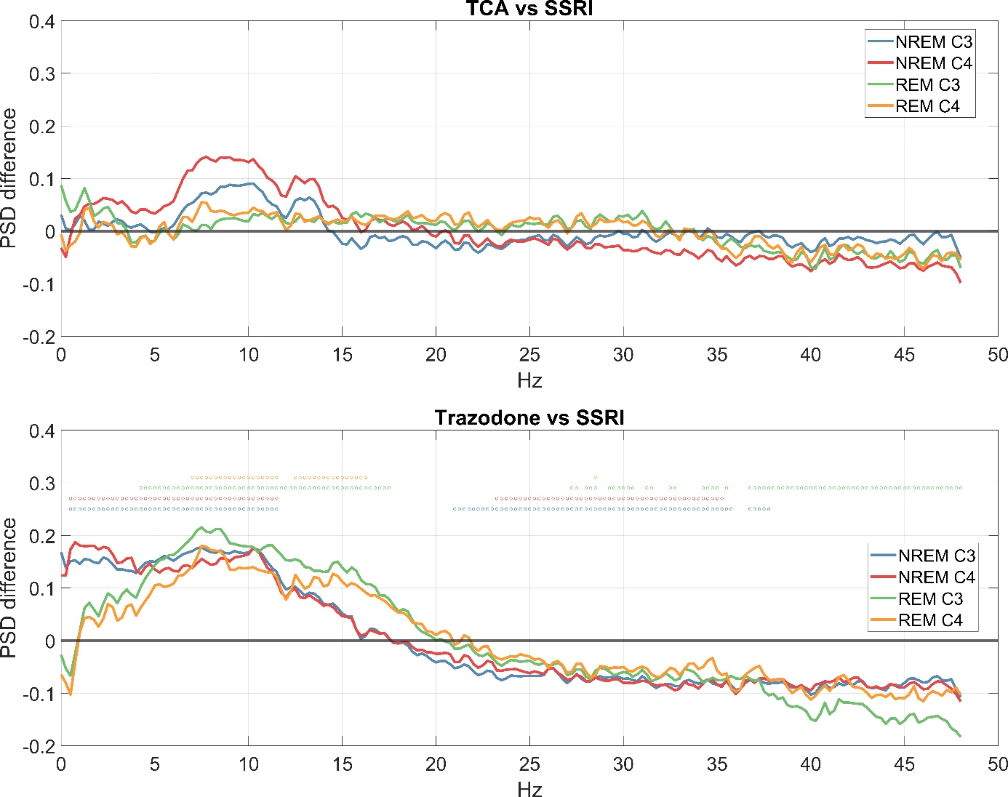
Supplementary figure S2. Comparing sleep EEG PSD in participant receiving different types of antidepressive treatment. Axis Y shows the expected PSD difference between SSRI users and TCA users (top) and trazodone users (bottom). Effects significant after correction for multiple comparisons are marked with a dot in the appropriate color above the lines. Note increased slow and decreased fast frequency activity in non-SSRI users. Analyses were restricted for participants undergoing antidepressive monotherapy. Participants reporting MAOI treatment were excluded due to low sample size (N=4).

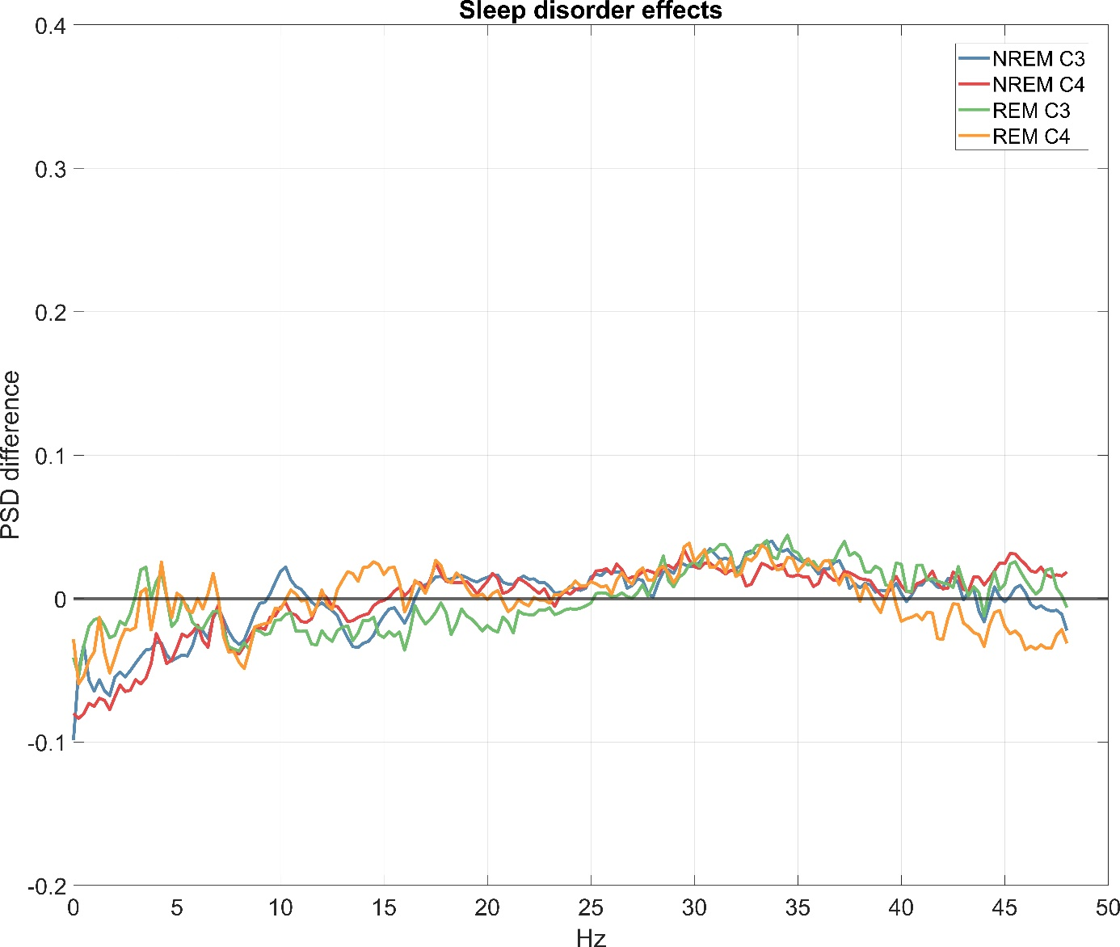
Supplementary figure S3. Comparing PSD in participants using benzodiazepine medication with (N=34) or without (N=100) sleep disorders. The chart shows log10 PSD differences between the two subgroups (axis Y) as a function of frequency (axis X) on both available channels in REM and NREM. No differences are significant even at the nominal p<0.05 level without correction for multiple comparisons.

