Additional file 13: 2-sample MR sensitivity analyses other domains

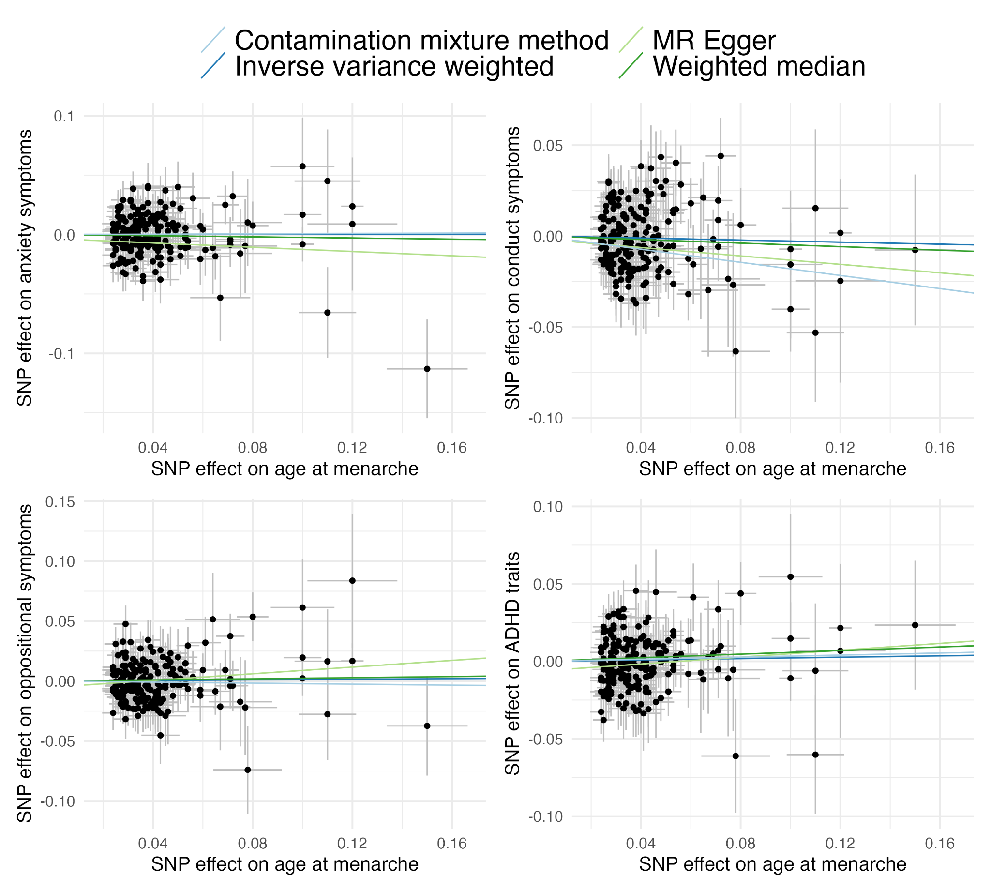
Figure S11. 2-sample MR sensitivity analyses of age at menarche and other domains.
MR sensitivity analyses showing results that are broadly consistent with the 1-sample MR, with little support for causal relationships between age at menarche and other symptom domains, apart from conduct disorder symptoms. MR, Mendelian randomisation; SNP, single nucleotide polymorphism.

