Figure S1. Calculation of the Healthy Lifestyle Index (HLI) score.
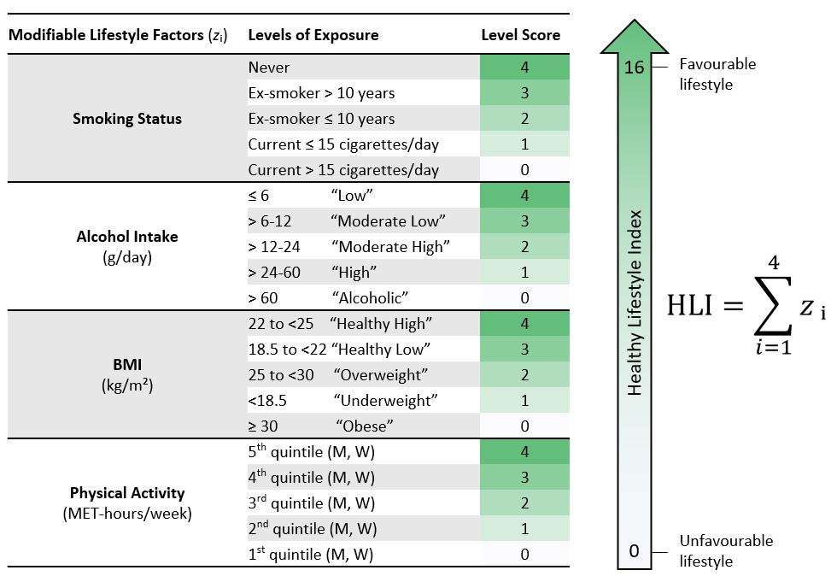
Figure S2. Country- and sex-specific mean HLI change between follow-up and baseline, mean age at baseline, mean HLI at baseline, mean HLI at follow-up and mean time difference between follow-up and baseline.
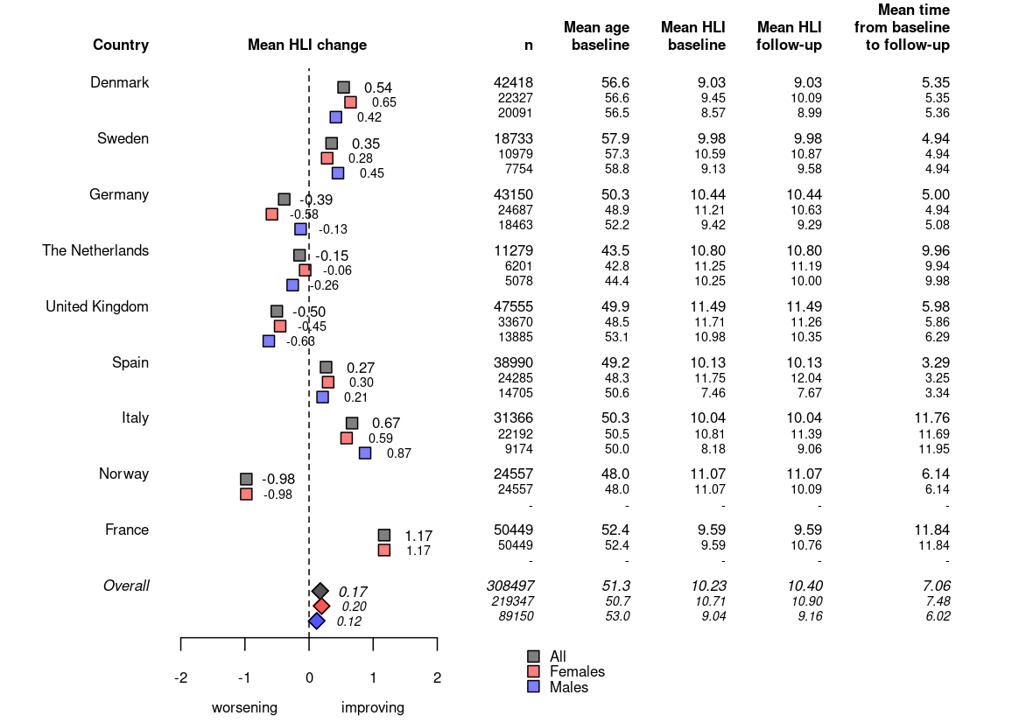

Figure S3. Sankey diagram for HLI categories (low, 0-8; medium, 9-11; high, 12-16 units) showing HLI changes between baseline and follow-up assessments, and for each HLI component.
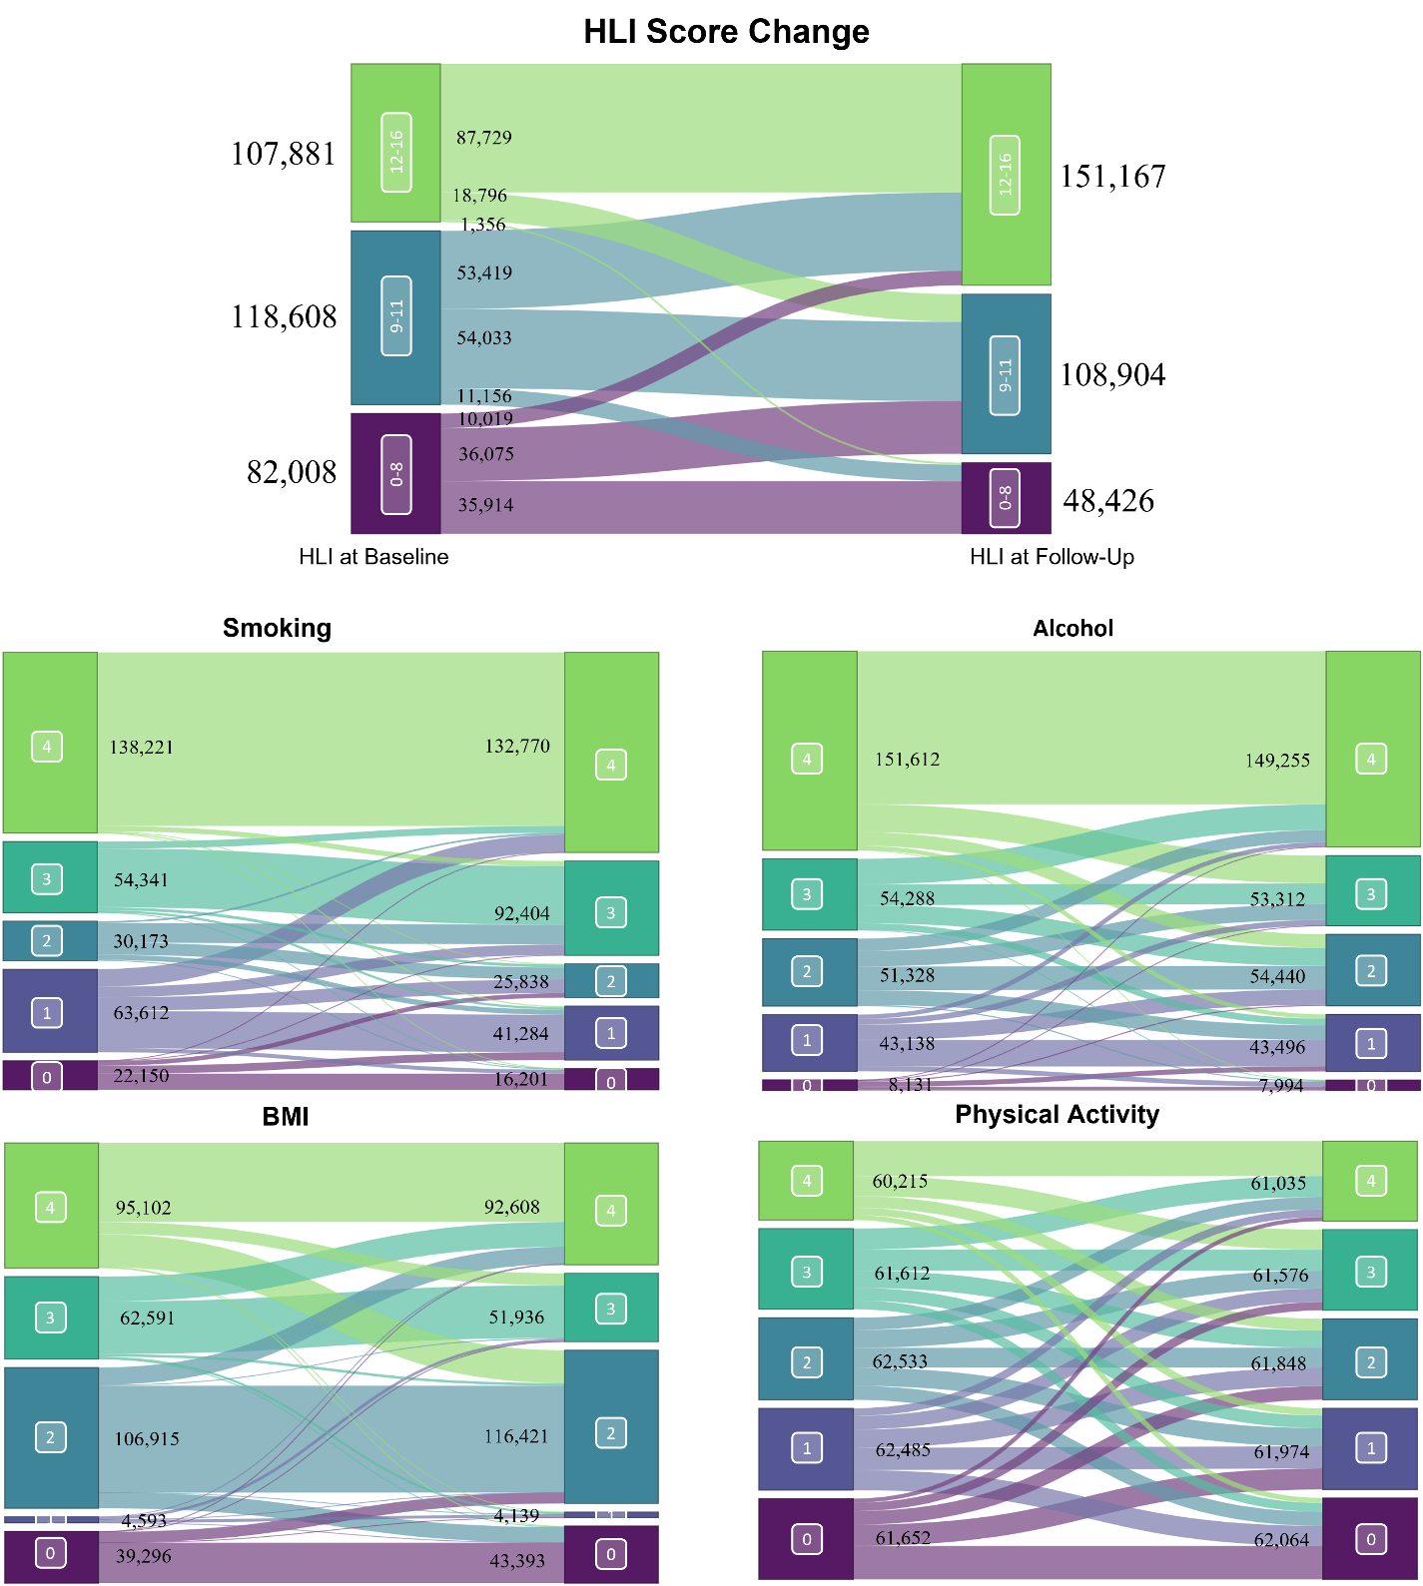

Figure S4. Country-specific HLI mean score difference between follow-up and baseline overall and for each HLI component. Positive changes indicate lifestyle improvements over time.
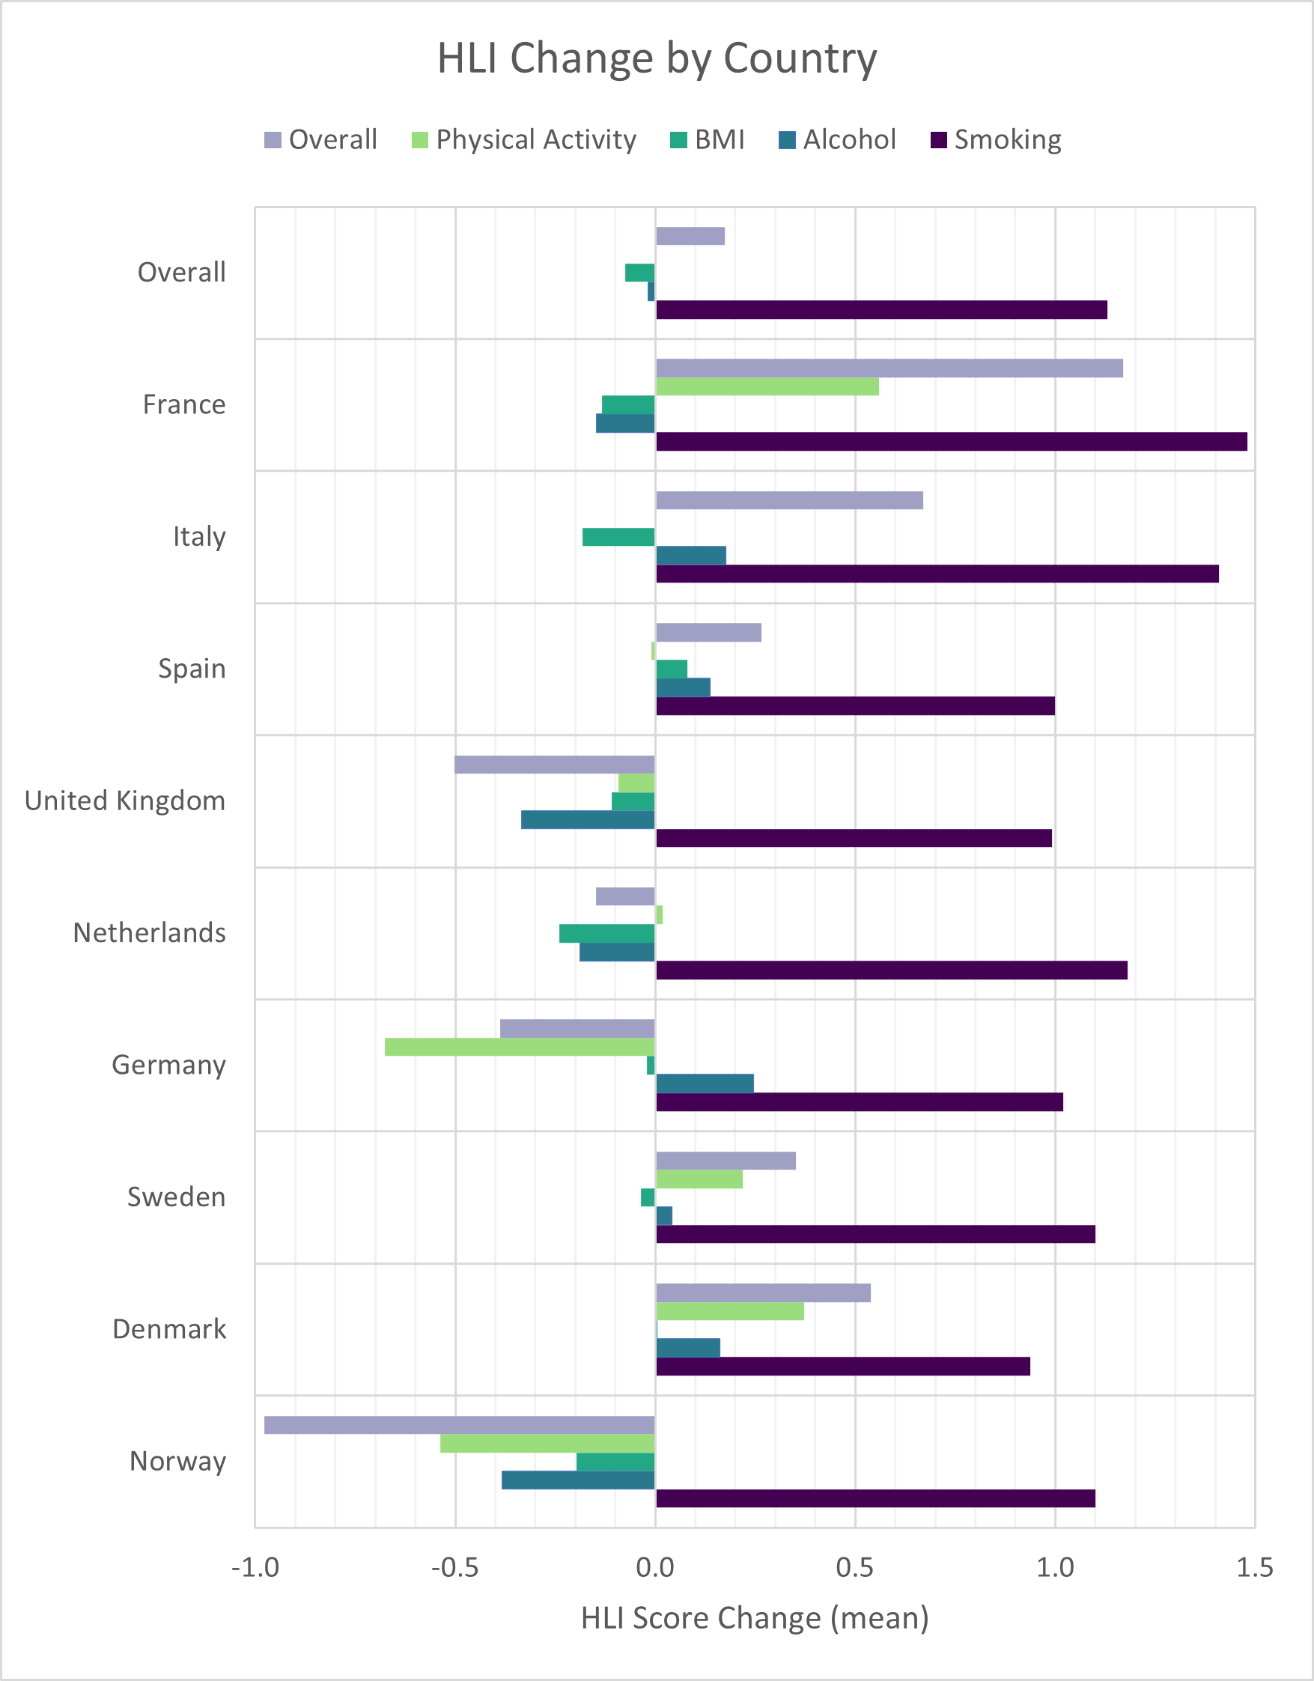

Figure S5. Forest plot of all-cause and cancer mortality hazard ratios (and 95% confidence intervals) for HLI change, excluding observations up to the first 2 and 5 years after follow-up lifestyle questionnaire (washout) (multiple imputation data).
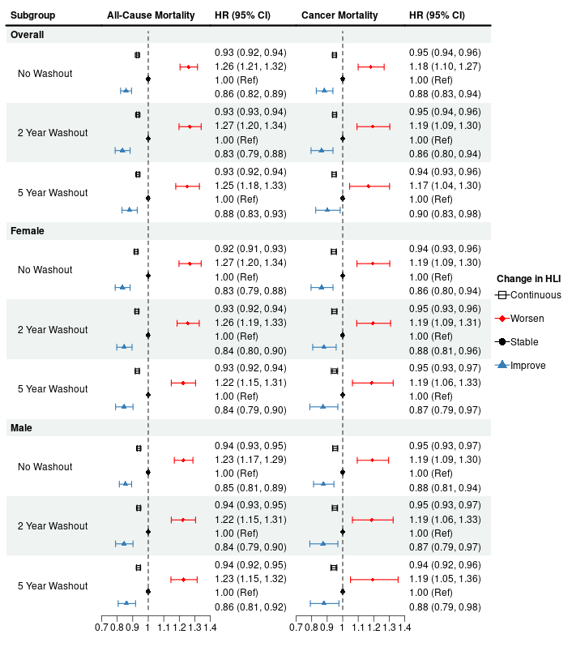
Table S1. All-cause and cancer mortality hazard ratios (and 95% confidence intervals) for HLI change by country (multiple imputation data).
 |  |  | All-Cause Mortality |  |  |  |  | Cancer Mortality
 | Person-Years | N | All Deaths | HR (95% CI) |  |  |  | Cancer Deaths | HR (95% CI)
 |  |  |  | Continuous | Categorical |  |  |  | Continuous | Categorical
 |  |  |  |  | Worsen | Stable | Improve |  |  | Worsen | Stable | Improve
France | 990,581 | 50,449 | 1,483 | 0.92 (0.90, 0.94) | 1.23 (1.01, 1.51) | 1 (ref) | 0.73 (0.64, 0.82) | 455 | 0.91 (0.87, 0.96) | 1.33 (0.91, 1.93) | 1 (ref) | 0.71 (0.57, 0.88)
Italy | 495,704 | 31,366 | 505 | 0.93 (0.89, 0.98) | 1.15 (0.81, 1.63) | 1 (ref) | 0.81 (0.65, 1.01) | 249 | 0.94 (0.88, 1.01) | 1.16 (0.72, 1.86) | 1 (ref) | 0.84 (0.62, 1.15)
Spain | 724,102 | 38,990 | 3,051 | 0.95 (0.93, 0.97) | 1.34 (1.17, 1.53) | 1 (ref) | 0.86 (0.80, 0.94) | 1,387 | 0.95 (0.92, 0.97) | 1.36 (1.12, 1.67) | 1 (ref) | 0.90 (0.80, 1.01)
United Kingdom | 818,226 | 47,555 | 4,614 | 0.95 (0.94, 0.97) | 1.26 (1.16, 1.36) | 1 (ref) | 0.95 (0.88, 1.02) | 1,306 | 0.98 (0.95, 1.01) | 1.15 (0.99, 1.34) | 1 (ref) | 0.98 (0.85, 1.12)
Netherlands | 196,283 | 11,279 | 341 | 0.94 (0.89, 1.00) | 1.61 (1.15, 2.25) | 1 (ref) | 1.14 (0.85, 1.50) | 153 | 0.95 (0.87, 1.03) | 1.63 (0.98, 2.72) | 1 (ref) | 1.12 (0.74, 1.69)
Germany | 596,544 | 43,150 | 1,981 | 0.92 (0.90, 0.94) | 1.31 (1.15, 1.49) | 1 (ref) | 0.84 (0.76, 0.94) | 848 | 0.94 (0.91, 0.98) | 1.14 (0.93, 1.40) | 1 (ref) | 0.85 (0.73, 1.00)
Sweden | 347,472 | 18,733 | 4,149 | 0.93 (0.91, 0.95) | 1.27 (1.14, 1.42) | 1 (ref) | 0.86 (0.78, 0.94) | 1,474 | 0.96 (0.93, 0.98) | 1.21 (1.02, 1.45) | 1 (ref) | 0.91 (0.79, 1.04)
Denmark | 708,602 | 42,418 | 5,128 | 0.93 (0.91, 0.94) | 1.19 (1.07, 1.32) | 1 (ref) | 0.80 (0.74, 0.87) | 2,277 | 0.94 (0.92, 0.97) | 1.13 (0.96, 1.33) | 1 (ref) | 0.84 (0.75, 0.95)
Norway | 344,205 | 24,557 | 444 | 0.90 (0.85, 0.95) | 1.43 (1.09, 1.87) | 1 (ref) | 0.91 (0.63, 1.31) | 258 | 0.97 (0.90, 1.05) | 1.07 (0.75, 1.53) | 1 (ref) | 0.93 (0.60, 1.45)

Table S2. All-cause and cancer mortality hazard ratios (and 95% confidence intervals) for HLI change by HLI component (0-4) (multiple imputation data).
 | All-Cause Mortality |  |  |  | Cancer Mortality
 | HR (95% CI) |  |  |  | HR (95% CI)
 | Continuous | Categorical |  |  | Continuous | Categorical
 |  | Worsen | Stable | Improve |  | Worsen | Stable | Improve
Smoking | 0.93 (0.90, 0.95) | 1.22 (1.01, 1.46) | 1 (ref) | 0.82 (0.78, 0.86) | 0.94 (0.90, 0.97) | 1.04 (0.76, 1.44) | 1 (ref) | 0.80 (0.74, 0.86)
Alcohol | 1.05 (1.04, 1.07) | 0.99 (0.93, 1.05) | 1 (ref) | 1.20 (1.13, 1.29) | 1.01 (0.98, 1.04) | 1.09 (0.99, 1.21) | 1 (ref) | 1.11 (1.00, 1.23)
BMI | 0.98 (0.97, 0.99) | 1.11 (1.06, 1.16) | 1 (ref) | 1.08 (1.03, 1.13) | 0.98 (0.95, 1.00) | 1.10 (1.00, 1.18) | 1 (ref) | 1.01 (0.94, 1.09)
Physical Activity | 0.91 (0.89, 0.92) | 1.30 (1.24, 1.35) | 1 (ref) | 0.86 (0.82, 0.90) | 0.98 (0.96, 0.99) | 1.08 (1.00, 1.17) | 1 (ref) | 0.97 (0.90, 1.04)

