Figure S1. Study schema to illustrate the linkage between analyses
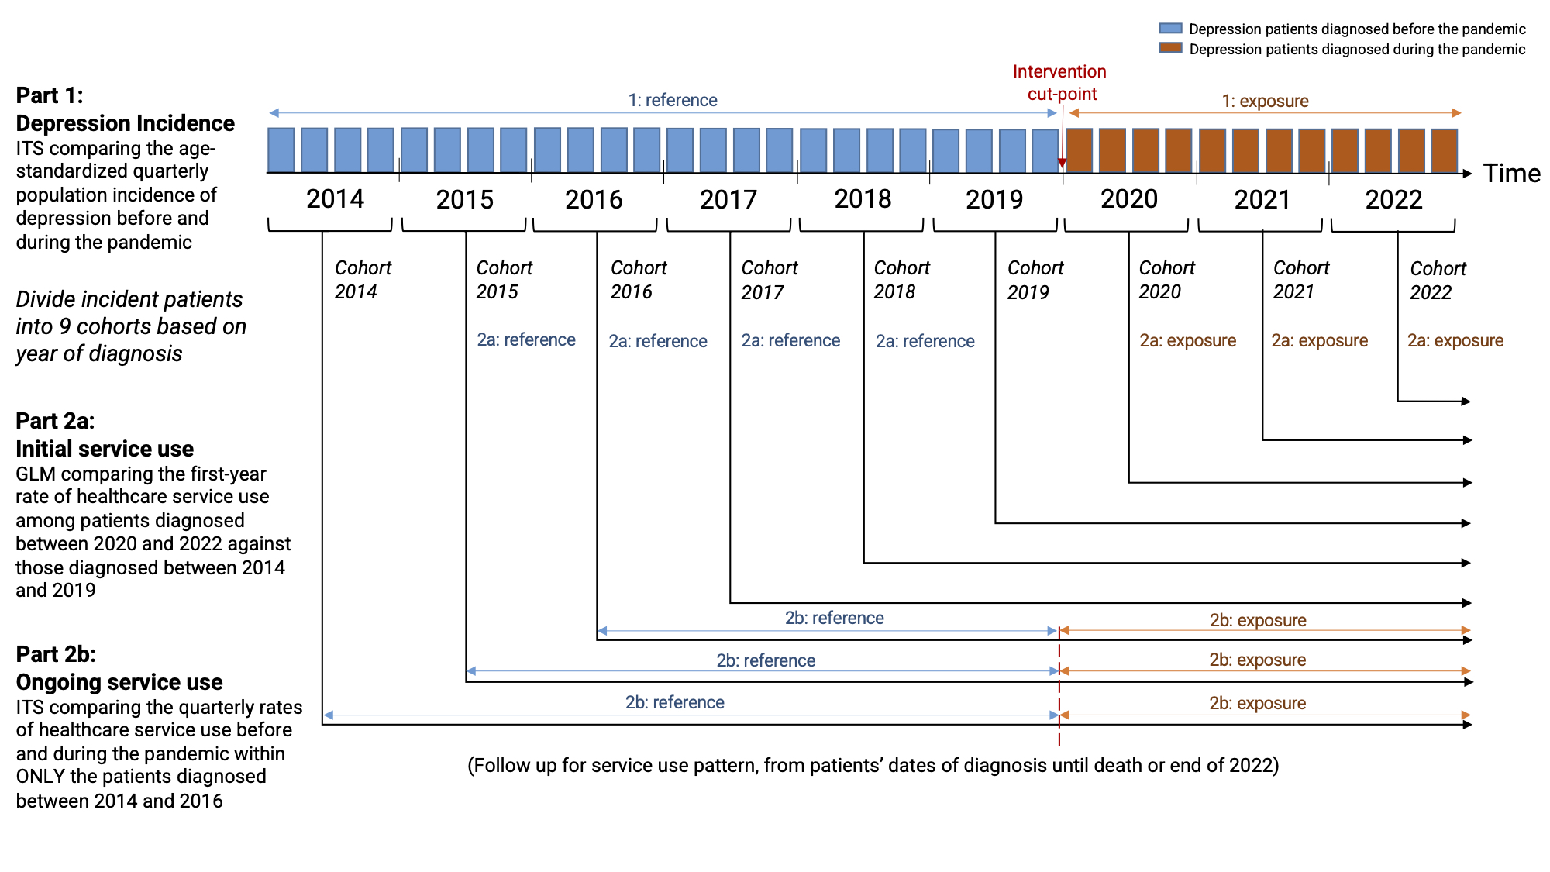
Abbreviation: GLM – Generalized linear modelling, ITS – Interrupted time-series.

