A randomized controlled trial of an app-based intervention on physical activity and glycemic control in people with type 2 diabetes

Gyuri Kim MD, PhD^{1,†}, Seohyun Kim^{2,†}, You-Bin Lee MD, PhD¹, Sang-Man Jin MD, PhD¹, Kyu Yeon Hur MD, PhD¹, Jae Hyeon Kim MD, PhD^{1,2,*}

¹Division of Endocrinology and Metabolism, Department of Medicine, Samsung Medical Center, Sungkyunkwan University School of Medicine, Seoul 06351, Republic of Korea
²Department of Clinical Research Design and Evaluation, Samsung Advanced Institute for
Health Sciences and Technology, Sungkyunkwan University, Seoul 06355, Republic of Korea
†These two authors contributed equally to this work.

Figure S1. Flow chart
Figure S2. Changes in HbA1c at each follow up
Figure S3. Changes in HbA1c at each follow up (subjects with baseline HbA1c <7.5%, N=152)
Figure S4. Changes in HbA1c at each follow up (subjects with baseline HbA1c ≥7.5%, N=30)

Table S1. Results of linear mixed effect model
Table S2. Changes in fasting plasma glucose levels from baseline to week 12 and week 24
Table S3. Changes in body weight from baseline to week 12 and week 24
Table S4. Total MET-min/week at baseline, week 12, and week 24
Table S5. Changes in lipid levels from baseline to week 12 and week 24
Figure S1. Flow chart
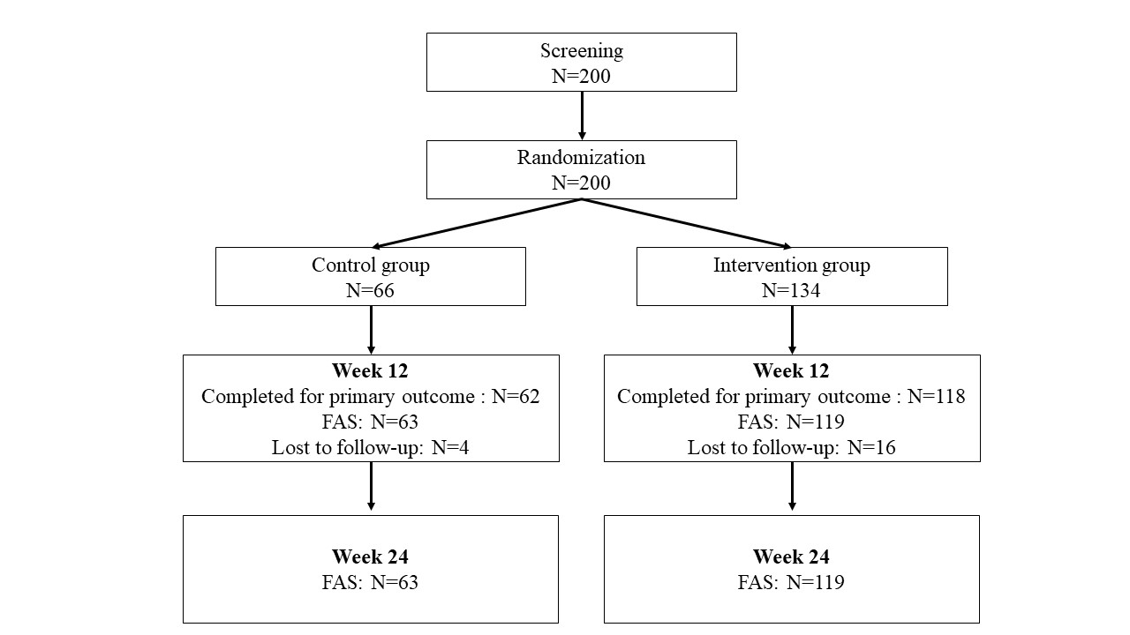
Figure S2. Changes in HbA1c at each follow up
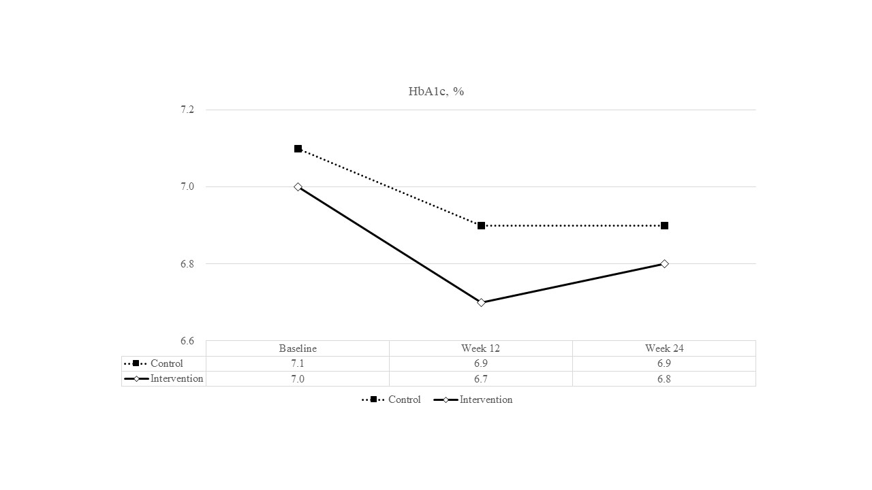

Figure S3. Changes in HbA1c at each follow up (subjects with baseline HbA1c <7.5%, N=152)
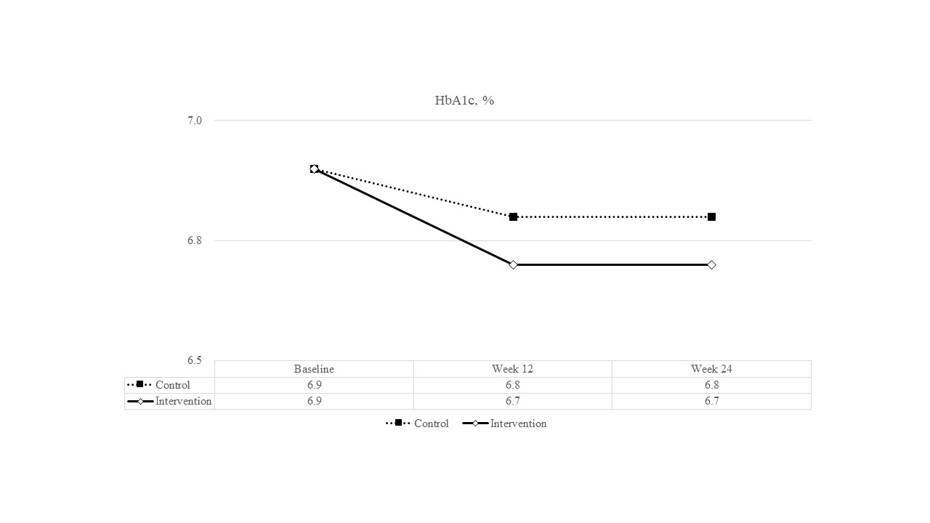

Figure S4. Changes in HbA1c at each follow up (subjects with baseline HbA1c ≥7.5%, N=30)
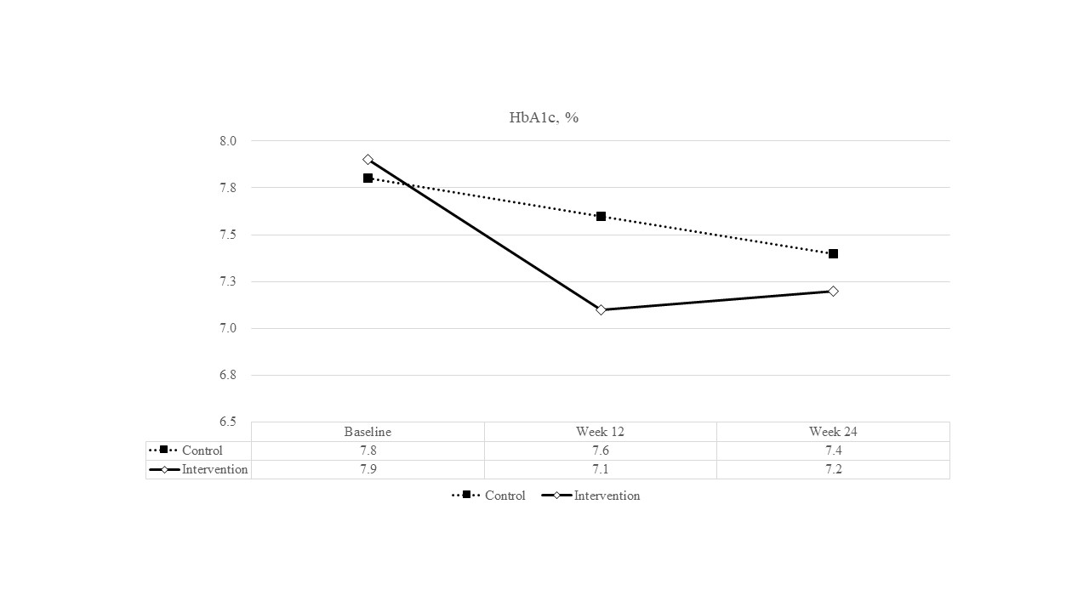

Table S1. Results of linear mixed effect model
 | Control  (β, 95% CI) | Intervention  (β, 95% CI) | P value
No. of patients | 63 | 119
Average difference of step counts in every 12 weeks | 0 (Reference) | 76 (642, -490) | 0.791
Average difference of HbA1c (%) in every 12 weeks | 0 (Reference) | -0.05 (0.05, -0.14) | 0.329
* Abbreviations: CI, confidence interval

Table S2. Changes in fasting plasma glucose levels from baseline to week 12 and week 24
 | Control |  | Intervention |  | P-value
 | N | FPG (mg/dL) | N | FPG (mg/dL)
Baseline (Mean ± SD) | 63 | 135.2 ± 21.1 | 119 | 138.2 ± 24.9 | $${0.421}^{b}$$
At week 12 (Mean ± SD) | 62 | 134.1 ± 22.7 | 117 | 128.3 ± 21.1 | $${0.090}^{b}$$
Changes from baseline to week 12 (Mean ± SD) | -0.84 ± 22.92 |  | -9.22 ± 21.25 |  | $${0.016}^{b}$$
P-value for mean difference from baseline to week 12 | $${0.774}^{a}$$ |  | <${0.001}^{a}$
At week 24 (Mean ± SD) | 62 | 136.4 ± 22.5 | 117 | 133.6 ± 25.7 | $${0.475}^{b}$$
Changes from baseline to week 24 (Mean ± SD) | 1.44 ± 19.29 |  | -3.91 ± 25.41 |  | $${0.148}^{b}$$
P-value for mean difference from baseline to week 24 | $${0.560}^{a}$$ |  | $${0.147}^{a}$$
Abbreviations: FPG, fasting plasma glucose; SD, standard deviation
$^{a}$P-values were derived using paired t-tests.
$^{b}$P-values were derived from a two-sample t-test.

Table S3. Changes in body weight from baseline to week 12 and week 24

 | Control |  | Intervention |  | P-value
 | N | Weight (kg) | N | Weight (kg)
Baseline (Mean ± SD) | 63 | 73.5 ± 8.6 | 119 | 73.7 ± 9.8 | $${0.898}^{b}$$
At week 12 (Mean ± SD) | 62 | 72.4 ± 8.7 | 118 | 72.8 ± 9.5 | $${0.821}^{b}$$
Changes from baseline to week 12 (Mean ± SD) | -0.65 ± 3.62 |  | -1.07 ± 2.06 |  | $${0.846}^{b}$$
P-value for mean difference from baseline to week 12 | $${0.161}^{a}$$ |  | <${0.001}^{a}$
At week 24 (Mean ± SD) | 58 | 71.6 ± 8.9 | 109 | 72.4 ± 9.8 | $${0.324}^{b}$$
Changes from baseline to week 24 (Mean ± SD) | -1.05 ± 3.62 |  | -1.46 ± 2.22 |  | $${0.370}^{b}$$
P-value for mean difference from baseline to week 24 | $${0.030}^{a}$$ |  | <${0.001}^{a}$
Abbreviations: SD, standard deviation
$^{a}$P-values were derived using paired t-tests.
$^{b}$P-values were derived from a two-sample t-test.

Table S4. Total MET-min/week at baseline, week 12, and week 24

 | Control |  | Intervention |  | P-value
 | N | Weight (kg) | N | Weight (kg)
Total MET-min/week at baseline | 61 | 2123.4 ± 2539.6 | 117 | 1792.1 ± 2648.3 | $${0.423}^{a}$$
Total MET-min/week at week 12 | 61 | 1824.6 ± 1867.9 | 115 | 1906.9 ± 2273.8 | $${0.809}^{a}$$
Total MET-min/week at week 24 | 39 | 1874.6 ± 2157.4 | 76 | 1578.5 ± 2775.2 | $${0.562}^{a}$$
* Abbreviations: MET, metabolic equivalent of task; SD, standard deviation
$^{a}$P-values were derived using paired t-tests.

Table S5. Changes in lipid levels from baseline to week 12 and week 24
 | Control |  | Intervention |  |  | P-value
 | N | Mean ± SD (mg/dL) |  | N | Mean ± SD (mg/dL)
Total cholesterol
Baseline | 63 | 142.8 ± 27.2 |  | 116 | 147.6 ± 29.4 |  | $${0.281}^{a}$$
At week 12 | 57 | 142.1 ± 29.2 |  | 105 | 144.8 ± 25.4 |  | $${0.542}^{a}$$
At week 24 | 28 | 144.8 ± 28.3 |  | 59 | 143.2 ± 27.0 |  | $${0.796}^{a}$$
LDL cholesterol
Baseline | 63 | 81.8 ± 25.6 |  | 117 | 86.7 ± 28.7 |  | $${0.256}^{a}$$
At week 12 | 57 | 81.3 ± 26.0 |  | 105 | 85.5 ± 26.2 |  | $${0.329}^{a}$$
At week 24 | 27 | 84.1 ± 24.3 |  | 55 | 85.0 ± 26.0 |  | $${0.878}^{a}$$
HDL cholesterol
Baseline | 63 | 55.1 ± 14.1 |  | 117 | 50.6 ± 13.7 |  | $${0.036}^{a}$$
At week 12 | 57 | 55.2 ± 13.0 |  | 105 | 53.3 ± 12.8 |  | $${0.355}^{a}$$
At week 24 | 27 | 55.6 ± 13.4 |  | 55 | 52.5 ± 13.3 |  | $${0.334}^{a}$$
Triglycerides
Baseline | 63 | 131.1 ± 63.7 |  | 117 | 154.8 ± 140.7 |  | $${0.123}^{a}$$
At week 12 | 57 | 121.8 ± 57.8 |  | 105 | 130.7 ± 84.1 |  | $${0.425}^{a}$$
At week 24 | 28 | 122.0 ± 46.0 |  | 55 | 127.3 ± 71.0 |  | $${0.682}^{a}$$
Abbreviations HDL, high-density lipoprotein; LDL, low-density lipoprotein; SD, standard deviation
$^{a}$P-values were derived from a two-sample t-test.

