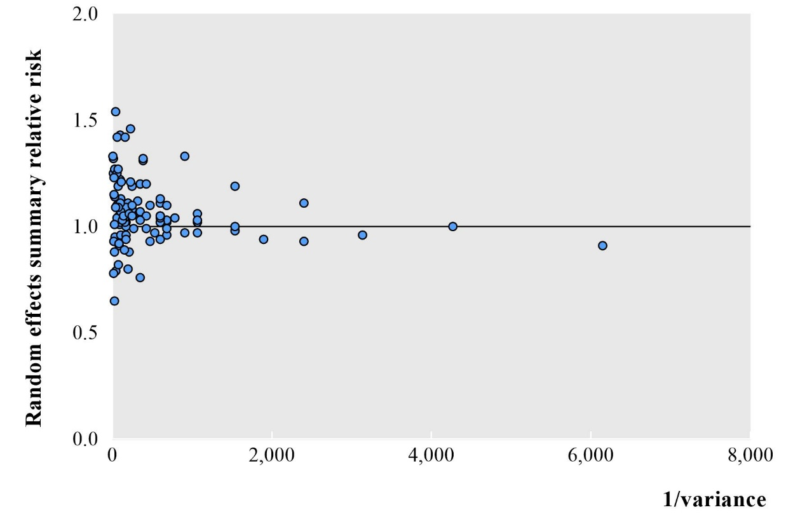
Fig. S1-Summary effects sizes with inverse of the variance of association between blood group and cancer outcomes

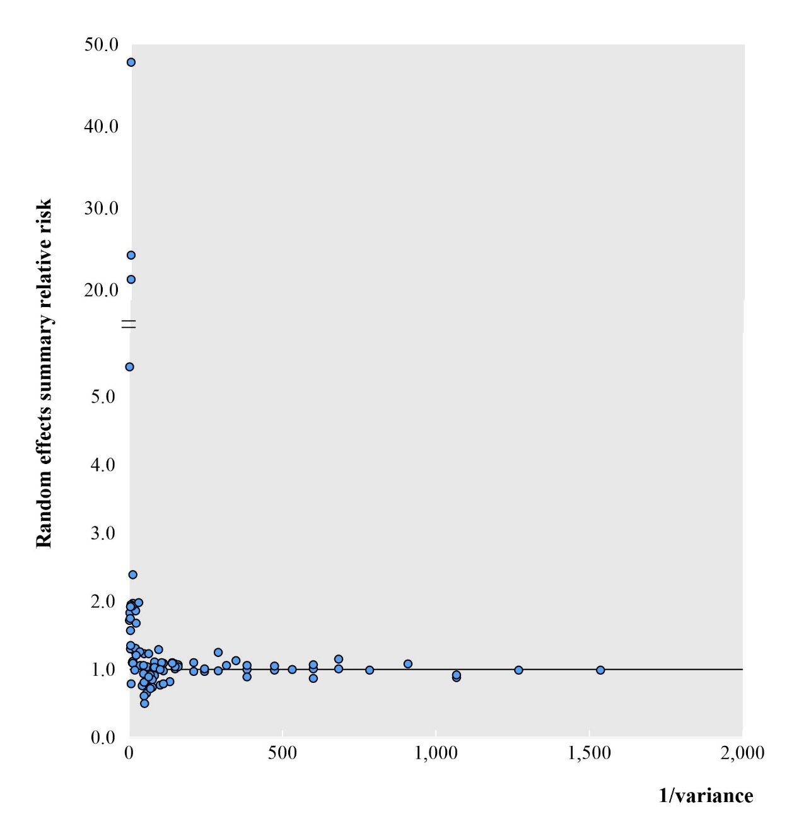
Fig. S2-Summary effects sizes with inverse of the variance of association between blood group and infectious disease outcomes

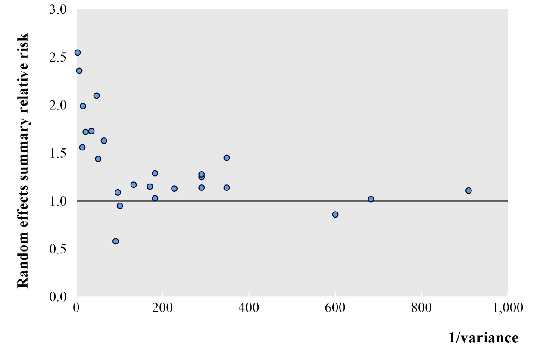
Fig. S3-Summary effects sizes with inverse of the variance of association between blood group and cardiovascular and cerebrovascular outcomes

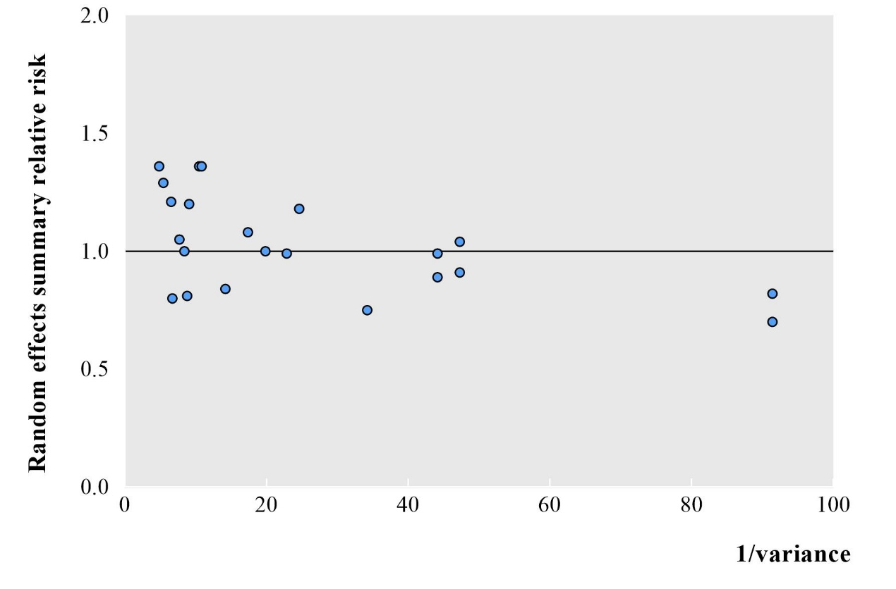
Fig. S4-Summary effects sizes with inverse of the variance of association between blood group and oral related outcomes

Fig. S5-Summary effects sizes with inverse of the variance of association between blood group and pregnancy related outcomes

Fig. S6-Summary effects sizes with inverse of the variance of association between blood group and metabolic disease outcomes

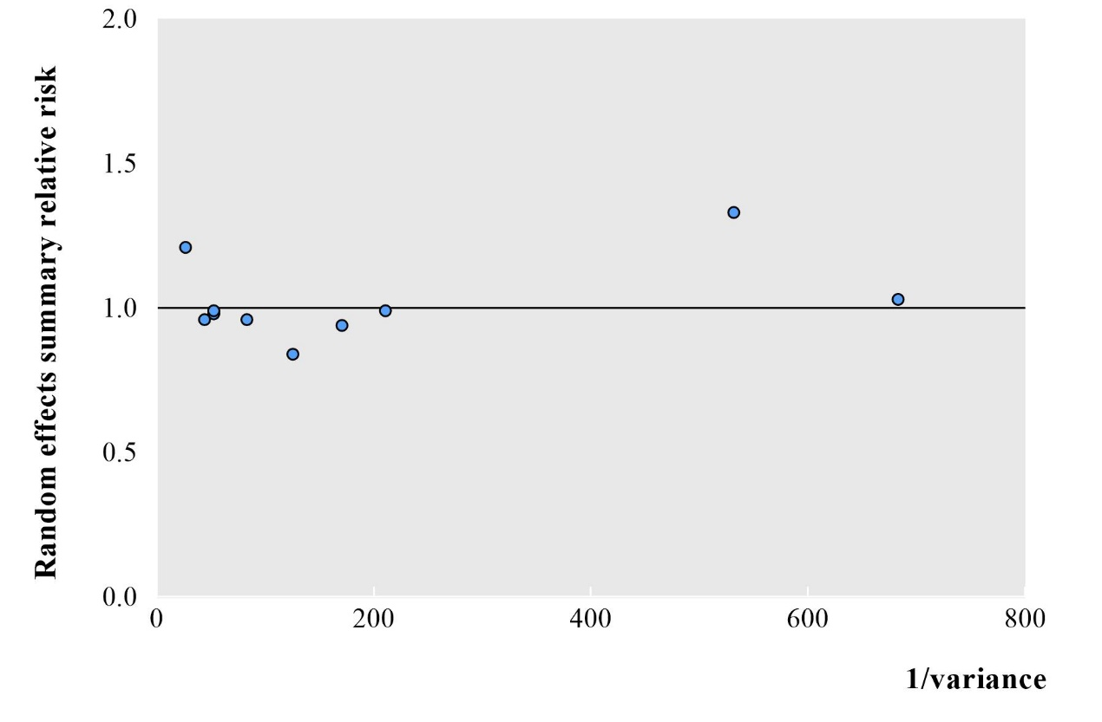
Fig. S7-Summary effects sizes with inverse of the variance of association between blood group and other outcomes

