Additional File 1

Image S1: Screenshot of the cardiac arrest scenario, created with 360-degree filming of an acted-out scenario.

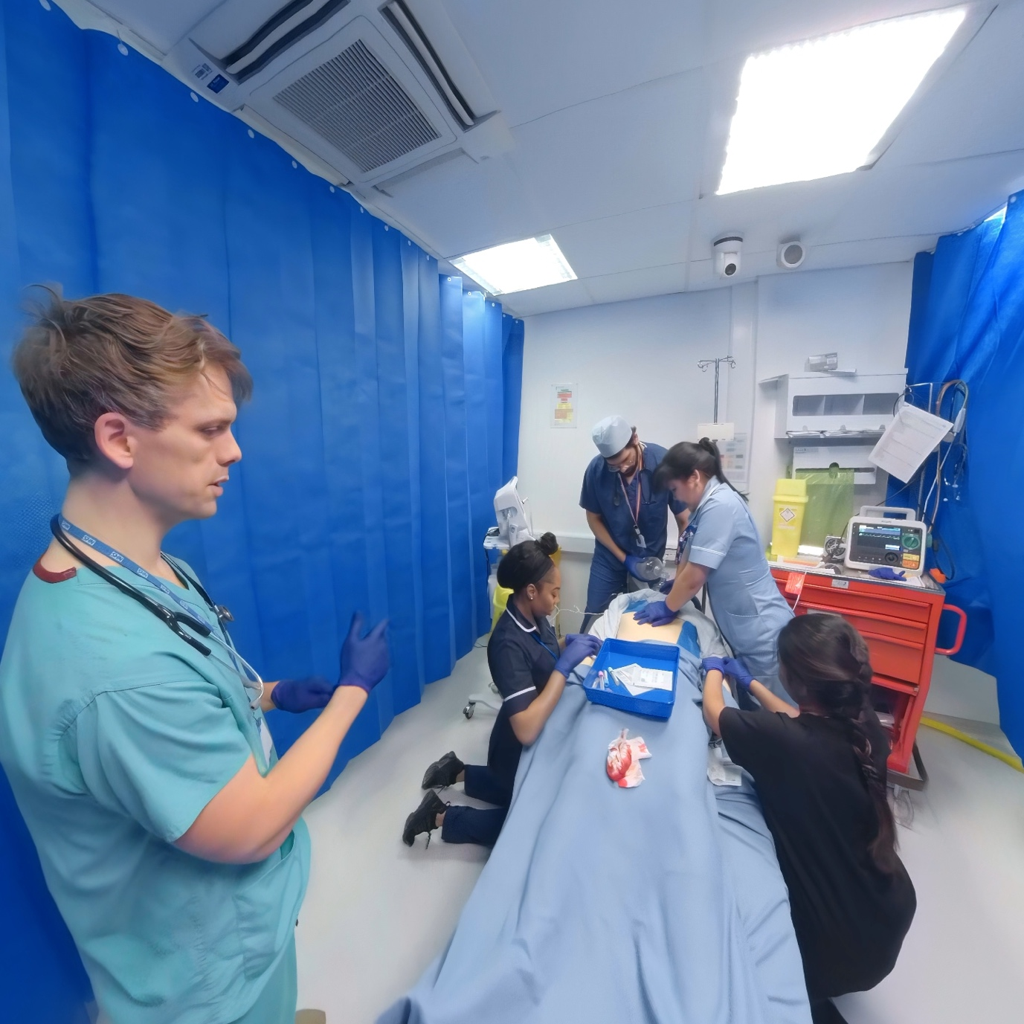

Image S2: Screenshot of the life-threatening asthma scenario, created with 360-degree filming of an acted-out scenario.

