Fig. S1. Flowchart for Screening and Enrollment of Study Participants
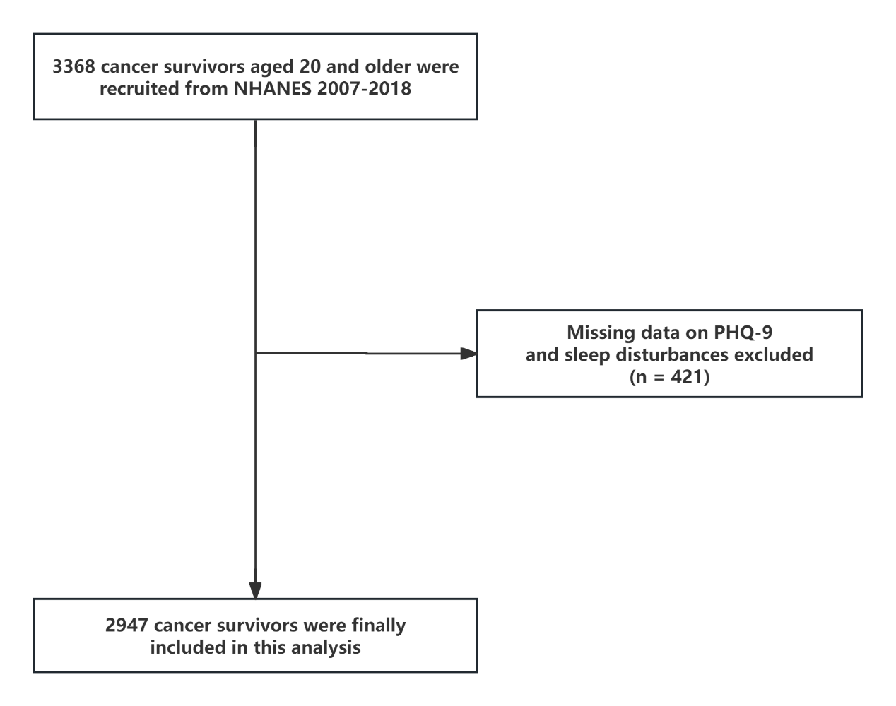
Abbreviations: NHANES, National Health and Nutrition Examination Survey; PHQ-9, Patient Health Questionnaire-9.

