SUPPLEMENTARY MATERIAL
Supplementary Table 1: Search terms used to assess biomarker success rate
 | Embase |  |  | Medline
1 | exp breast tumor/ | 660,988 | 1 | exp breast neoplasms/ | 348,200
2 | exp breast cancer/ | 580,489 | 2 | Breast neoplasm*.mp. | 349,683
3 | exp breast carcinoma/ | 101,519 | 3 | Breast tumo?r*.mp. | 28,186
4 | Breast neoplasm*.mp. | 19,792 | 4 | Breast carcinoma*.mp. | 33,612
5 | Breast tumo?r*.mp. | 121,793 | 5 | Breast cancer*.mp. | 353,039
6 | Breast carcinoma*.mp. | 96,958 | 6 | Mammary neoplasm*.mp. | 23,632
7 | Breast cancer*.mp. | 650,099 | 7 | Mammary tumo?r*.mp. | 16,900
8 | Mammary neoplasm*.mp. | 1,398 | 8 | Mammary cancer*.mp. | 3,739
9 | Mammary tumo?r*.mp. | 19,775 | 9 | Breast carcinogenesis.mp. | 1,801
10 | Mammary cancer*.mp | 5,568 | 10 | exp BMs, tumor/ | 312,489
11 | Breast carcinogenesis.mp. or exp breast carcinogenesis | 13,468 | 11 | BM*.mp. or exp BMs | 1,144,719
12 | exp tumor marker/ | 392,990 | 12 | Cancer BM*.mp. | 7,202
13 | exp biological marker/ or BM*.mp. | 525,268 | 13 | exp neoplasm recurrence, Local/ or cancer recurrence.mp. | 152,605
14 | Cancer BM*.mp. | 6,751 | 14 | exp recurrence/ or recurrence.mp | 594,634
15 | Cancer recurrence.mp. or exp cancer recurrence/] | 191,798 | 15 | relapse.mp. | 151,262
16 | Recurrence.mp. or exp recurrent disease/ | 729,386 | 16 | cancer relapse.mp. | 1,314
17 | relapse/ or relapse.mp. | 341,457 | 17 | 1 or 2 or 3 or 4 or 5 or 6 or 7 or 8 or 9 | 483,369
18 | cancer relapse.mp. or exp cancer relapse/ | 289,297 | 18 | 10 or 11 or 12 | 1,144,719
19 | carci* relapse.mp. or exp carci* relapse/ | 90 | 19 | 13 or 14 or 15 or 16 | 689,660
20 | 1 or 2 or 3 or 4 or 5 or 6 or 7 or 8 or 9 or 10 or 11 | 745,698 | 20 | 17 and 18 and 19 | 8,830
21 | 15 or 16 or 17 or 18 | 909,698
22 | 12 or 13 or 14 | 824,986
23 | 20 and 21 and 22 | 10,365

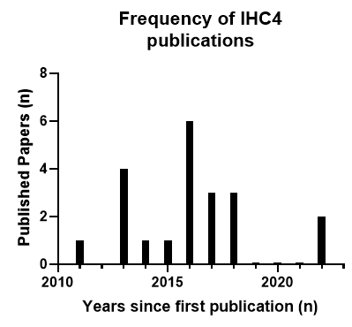

Supplementary Fig. 1: Biomarker Survival Analysis: Bar charts indicating the number of published papers over the years for IHC4

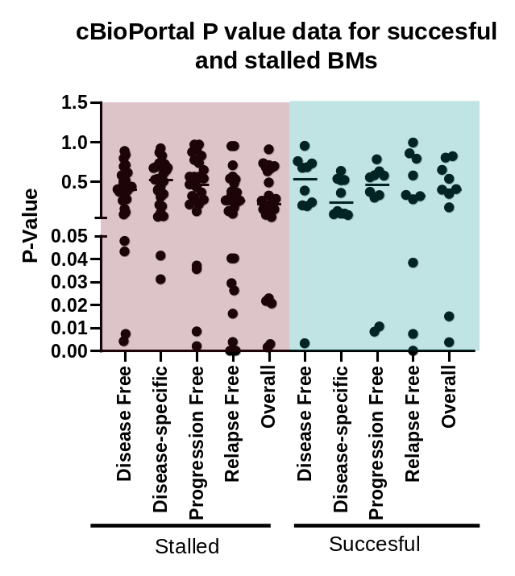

Supplementary Table 2: Stalled BMs with greater than 20 publications.
Biomarker Name | Total Published Literature
IHC4 | 21
CD44 | 21
Cyclin E | 21
PTEN | 21
E-cadherin | 23
ALDH1 | 24
TOP2A | 29
VEGF | 33
BCL2 | 39
AR | 47
EGFR | 49
IHC4: Immunohistochemistry 4, PTEN: Phosphatase and Tensin Homolog, ALDH1: Aldehyde Dehydrogenase 1, TOP2A: DNA Topoisomerase II Alpha , VEFG: Vascular Endothelial Growth Factor, BCL2: B-cell lymphoma 2, AR: Androgen receptor, EGFR: Epidermal Growth Factor Receptor

Supplementary Fig. 2: Evaluating differences between stalled and successful biomarker prognostic outcomes using cBioPortal: Survival outcomes of all successful and stalled biomarkers with more than 12 publications were assessed. P-values comparing the survival outcome between the mutant and wildtype version of the biomarker from 16 breast cancer studies (6805 breast samples/6391 patients) were extracted.

.

Supplementary Table 3: cBioPortal Studies included in the analysis
This combined study contains samples from 16 studies
Breast Cancer (MSK, Cancer Cell 2018)
Breast Cancer (MSK, Nature Cancer 2020)
Breast Fibroepithelial Tumors (Duke-NUS, Nat Genet 2015)
Breast Cancer (METABRIC, Nature 2012 & Nat Commun 2016)
Breast Cancer (MSKCC, NPJ Breast Cancer 2019)
Breast Cancer (SMC 2018)
Breast Invasive Carcinoma (British Columbia, Nature 2012)
Breast Invasive Carcinoma (Broad, Nature 2012)
Breast Cancer Xenografts (British Columbia, Nature 2015)
Breast Invasive Carcinoma (Sanger, Nature 2012)
Juvenile Papillomatosis and Breast Cancer (MSK, 2020)
Metastatic Breast Cancer (INSERM, PLoS Med 2016)
The Metastatic Breast Cancer Project (Provisional, February 2020)
Breast Invasive Carcinoma (TCGA, PanCancer Atlas)
Metaplastic Breast Cancer (MSK, 2021)
Adenoid Cystic Carcinoma of the Breast (MSKCC, J Pathol. 2015)

Supplementary Table 4: Binary logistic Regression Results assessing the relationship between biomarker success and prognostic outcomes
Variables in the equation | Sig. | Exp(B) | Lower | Upper
Disease free-Survival | 0.173 | 0.033 | 0.000 | 4.452
Disease Specific-Survival | 0.094 | 31.990 | 0.557 | 1837.829
Overall Survival | 0.851 | 0.664 | 0.009 | 47.068
Progression Free Survival | 0.400 | 3.288 | 0.205 | 52.718
Relapse Free Survival | 0.482 | 0.468

