ADDITIONAL FILE 1 (Fig. 1-10)

Figure S1: CD63 expression in age-matched controls (AMC), mild cognitive impairment (MCI), and Alzheimer’s disease (AD) and their densitometric analysis.

Figure S2: CD81 expression in age-matched controls (AMC), mild cognitive impairment (MCI), and Alzheimer’s disease (AD) and their densitometric analysis.

Figure S3: TSG101 expression in age-matched controls (AMC), mild cognitive impairment (MCI), and Alzheimer’s disease (AD) and their densitometric analysis.

Figure S4: L1CAM expression in age-matched controls (AMC), mild cognitive impairment (MCI), and Alzheimer’s disease (AD) and their densitometric analysis.

Figure S5: Synaptophysin (SYP) expression in age-matched controls (AMC), mild cognitive impairment (MCI), and Alzheimer’s disease (AD) and their densitometric analysis.

Figure S6: Glial Fibrillary Acidic Protein (GFAP) expression in age-matched controls (AMC), mild cognitive impairment (MCI), and Alzheimer’s disease (AD) and their densitometric analysis.

Figure S7: β-Actin expression in age-matched controls (AMC), mild cognitive impairment (MCI), and Alzheimer’s disease (AD) and their densitometric analysis.

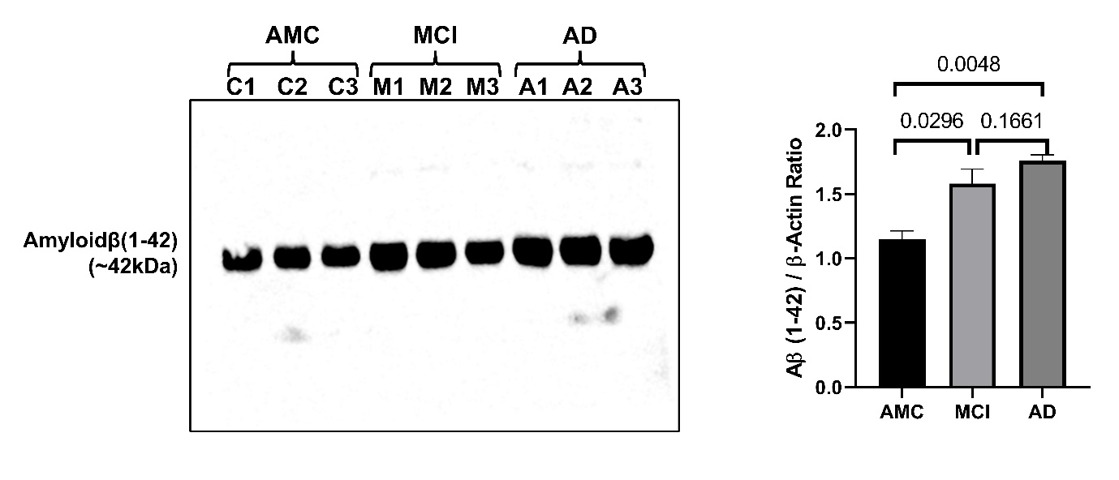

Figure S8: Amyloidβ-42 Oligomer expression in age-matched controls (AMC), mild cognitive impairment (MCI), and Alzheimer’s disease (AD) and their densitometric analysis.

Figure S9: IL1β (A) and TNFα (B) expression in age-matched controls (AMC), mild cognitive impairment (MCI), and Alzheimer’s disease (AD) and their densitometric analysis.

Figure S10: p-Tau expression in age-matched controls (AMC), mild cognitive impairment (MCI), and Alzheimer’s disease (AD) and their densitometric analysis

