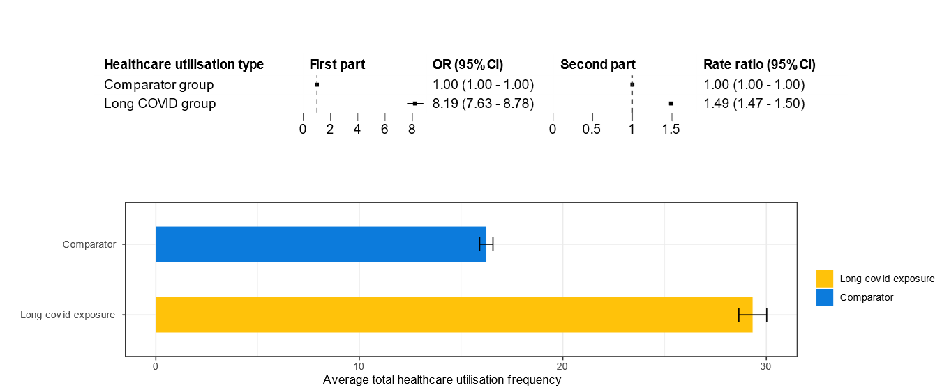
Fig. S7. Sensitivity analyses among people who had been registered to a GP and visited a GP one year before the study follow-up

