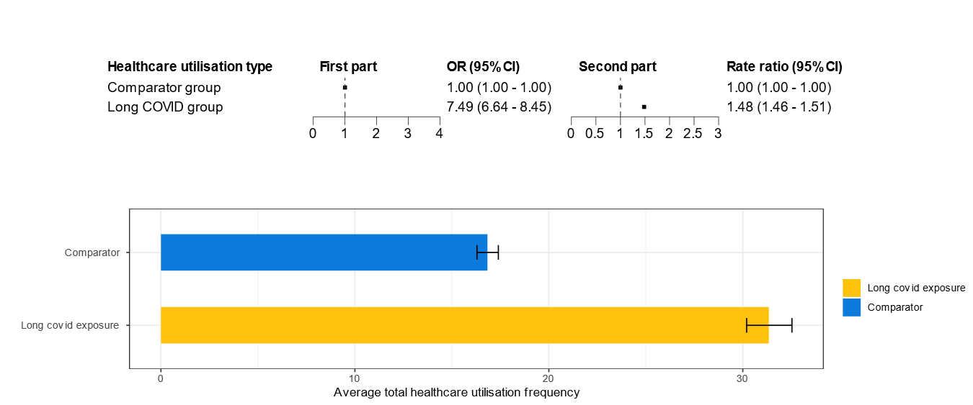
Fig. S8. Analyses among people who had tested positive for COVID before the index date

