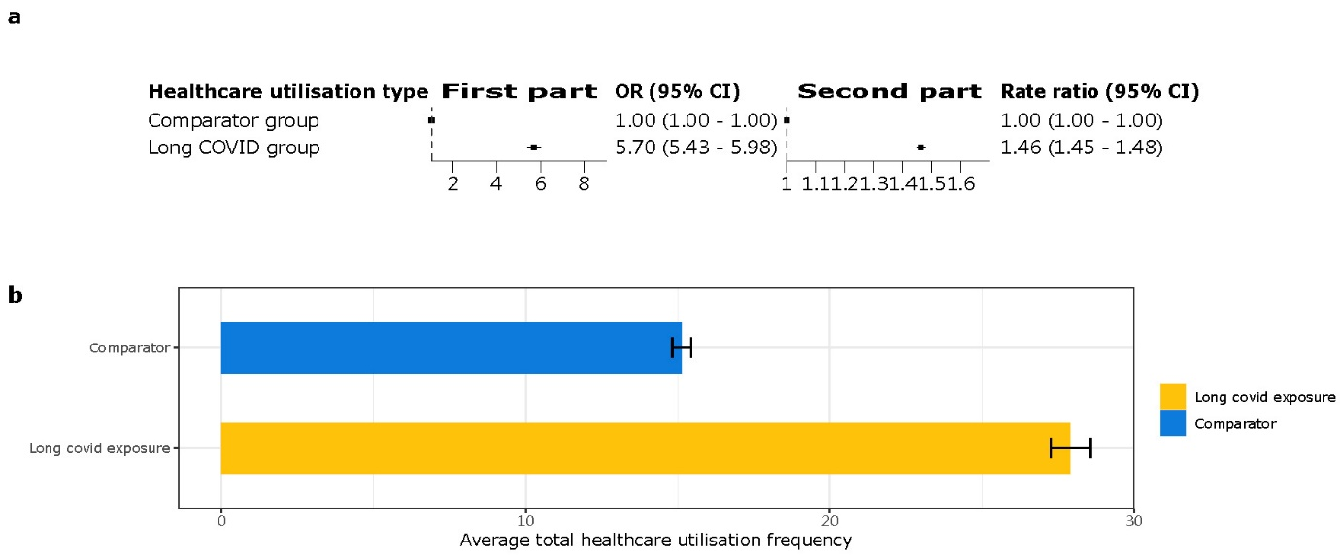
Fig. S9. Sensitivity analyses excluding the first GP appointment record

