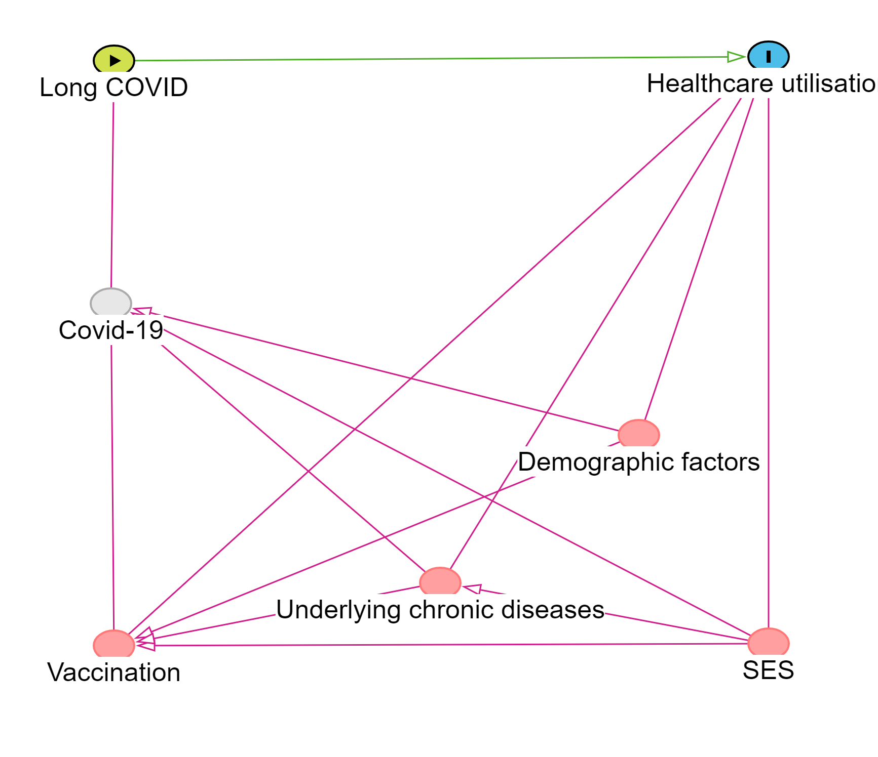
Fig. S1. DAGs for covariate selection.

