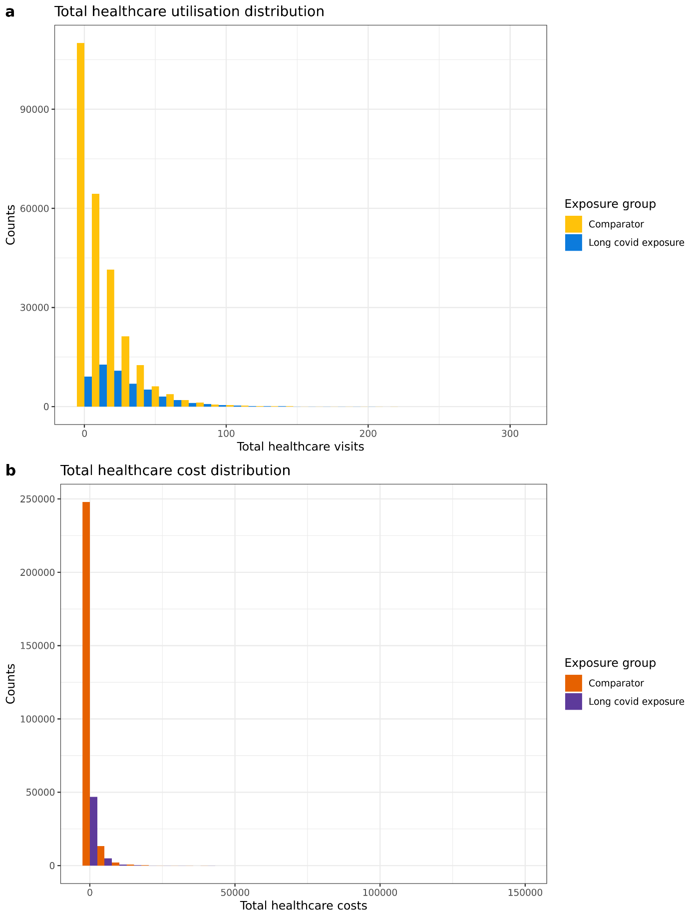

Fig. S2. Distribution of healthcare utilisation and costs by exposure group. a. the distribution of healthcare visits; b. the distribution of healthcare costs.

