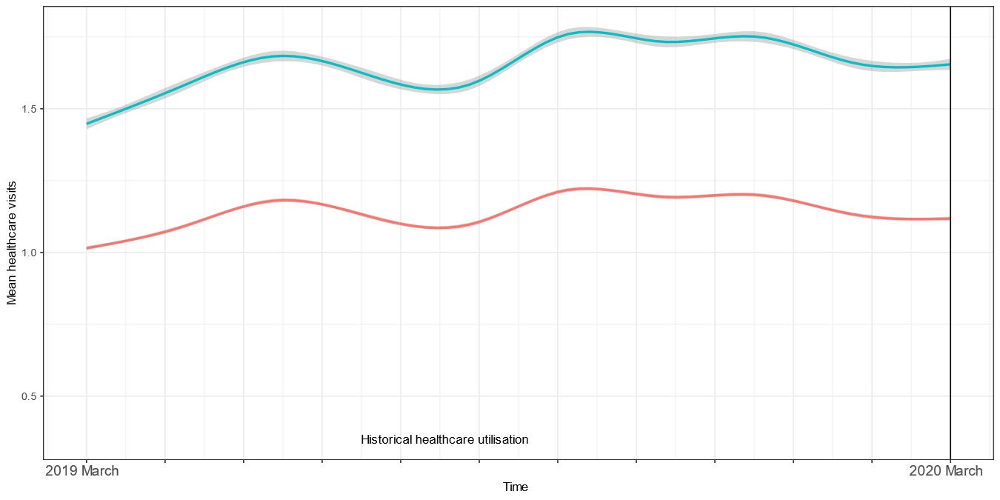

Fig. S4. Historical average healthcare visits. The trend in healthcare utilisation for the long COVID and comparator groups was parallel before the pandemic, meeting the common trend assumption.

