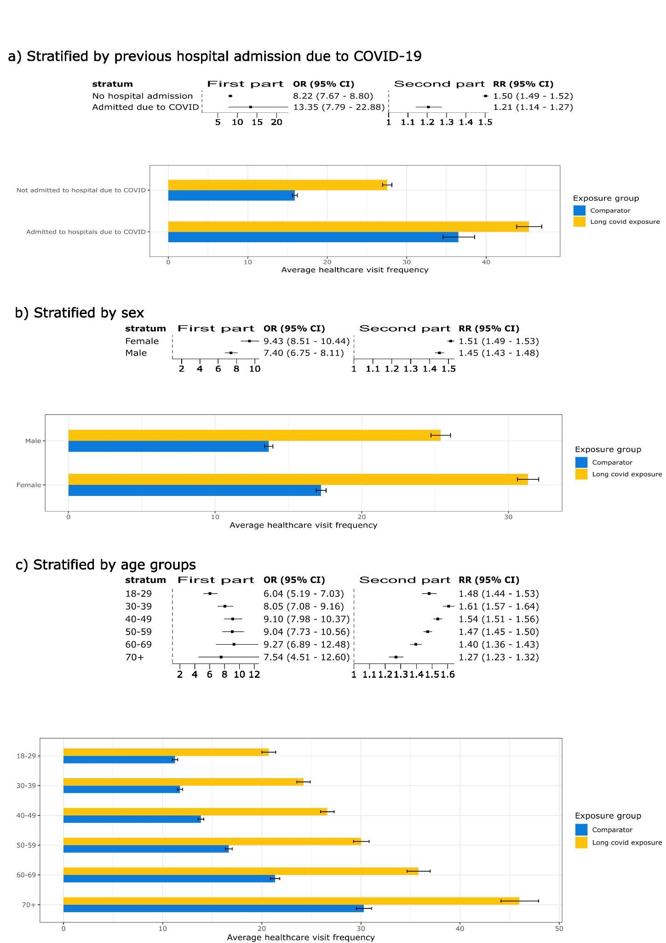 Fig. S6. Stratified analysis by variables

