Additional file 6: Fig. S4
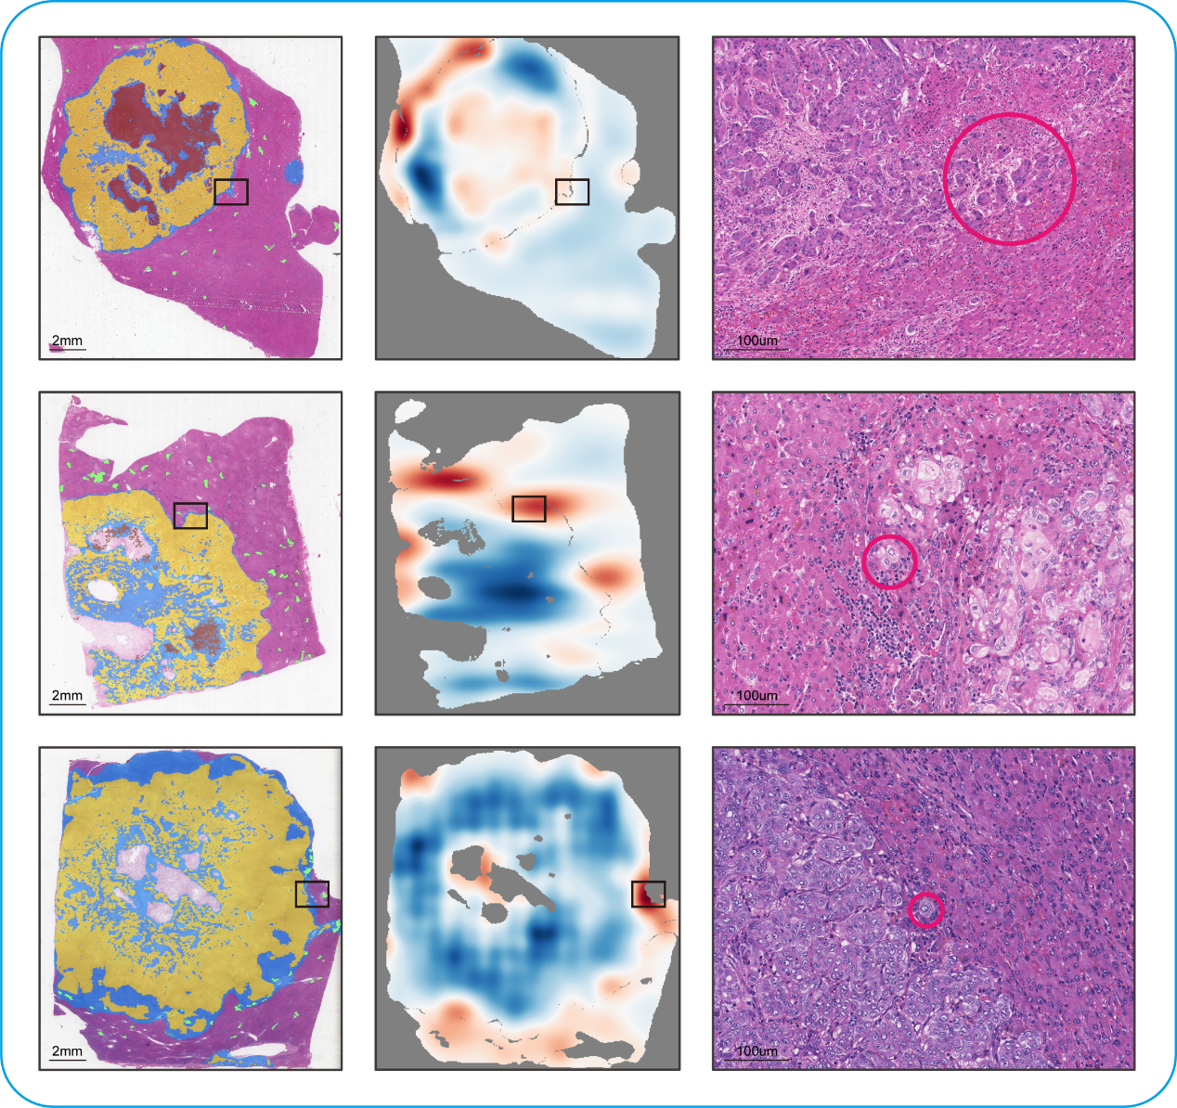
Figure S4. The presence of tumor budding at the protrusions and depressions along the invasive margin of intrahepatic cholangiocarcinoma. Tumor budding was indicated by red circle.

