Additional file 7: Fig. S5
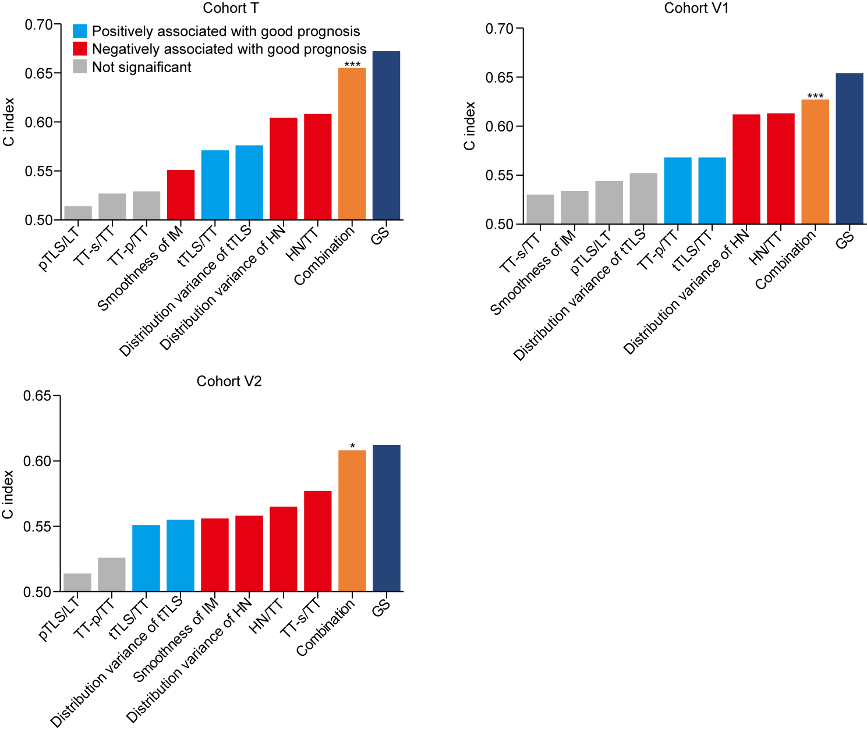
Figure S5. Comparison of C-indices for predefined architectural parameters, the combination of these parameters and GS. *, P <0.05; ***, P <0.001. TT, tumor tissue; LT, peri-tumor liver tissue; TLS, tertiary lymphoid structure; HN, hemorrhage and necrosis; IM: invasive margin; pTLS: peri-tumor TLS; tTLS: intra-tumor TLS; TT-s: tumor stroma; TT-p: tumor parenchyma; GS: GSM score; GSM, global segmentation map.

