Additional file 8: Fig. S6
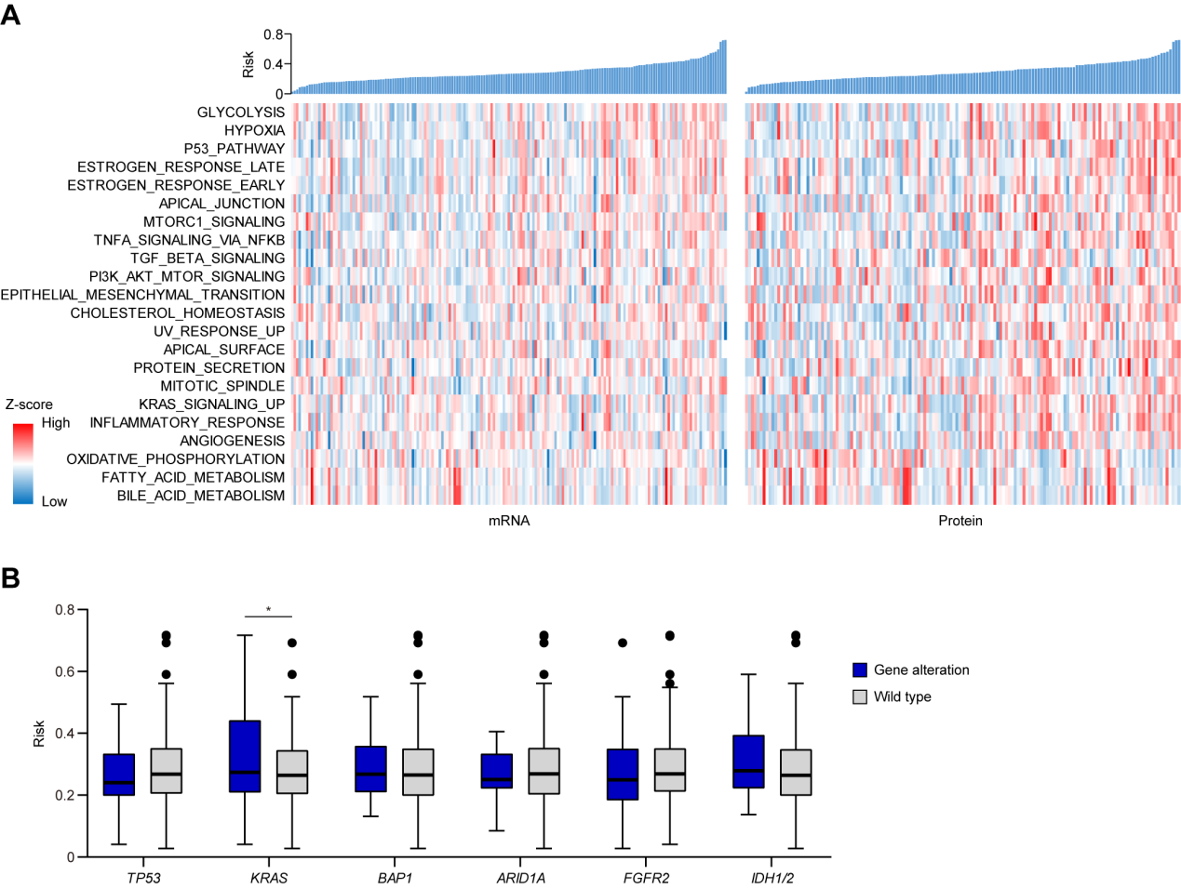
Figure S6. (A) Heatmaps shows the relevance of TiRS to hallmark gene sets of cancer. (B) Relevance of TiRS to recurrent genomic alterations. Boxes represent 25%-75% percentiles; range bars represent the 5% and 95% percentiles. *: P <0.05

