Supplementary

eAppendix 1. Full Search Strategy 2
eAppendix 2. PRISMA flow diagram of the screened studies 7
eAppendix 3. List of the included studies 8
eAppendix 4. Study Characteristics 13
eAppendix 5. Bias Assessment of Eligible Studies 19
eAppendix 6. Pairwise Meta-analysis of forest plots 21
eAppendix 7. Network Meta-analysis of forest plots and p-scores 25
eAppendix 8. Comparison of network meta-analysis, iSMD (95%CI) 27
eAppendix 9. Results of minimally contextualised framework 32
eAppendix 10. Assessment of transitivity: distribution of effect modifiers 38
eAppendix 11. Inconsistency test for direct and indirect evidence 40
eAppendix 12. Grading the evidence of the network meta-analysis using CINeMA 45
12.1 CINeMA quality assessment of the comparisons in the network 45
12.2 Results of the comparison-adjusted funnel plot 48
12.3 Risk of Bias Chart showing the contribution of low, moderate or high RoB comparisons to each network estimates. 52
12.4 Results of the CINeMA quality assessment 59
eAppendix 13. Sensitivity analyses 74
eAppendix 14. Subgroup analysis 74

eAppendix 1. Full Search Strategy
We did not find a description consistent with subjective cognitive decline in the Mesh thesaurus, so we used free-word search.
1.1 Cochrane Library
Databases on the Cochrane Library CDSR, CENTRAL, DARE, HTA and NHS-EED have been searched using the following strategy note specific list of subjective memory decline:
#1 (subjective memory complaint*):ti,ab,kw
#2 (subjective memory loss):ti,ab,kw
#3 (subjective memory impairment*):ti,ab,kw
#4 (subjective memory decline*):ti,ab,kw
#5 (cognitive complaint*):ti,ab,kw
#6(memory complaint*):ti,ab,kw
#7 (subjective cognitive complaint*):ti,ab,kw
#8 (subjective cognitive loss):ti,ab,kw
#9 (subjective cognitive impairment*):ti,ab,kw
#10 (subjective cognitive decline*):ti,ab,kw
#11 #1 OR #2 OR #3 OR #4 OR #5 OR #6 OR #7 OR #8 OR #9 OR #10
#12 (randomized controlled trial):ti,ab,kw
#13 (controlled clinical trial):ti,ab,kw
#14 (random*):ti,ab,kw
#15 (alloc*):ti,ab,kw
#16 (assign*):ti,ab,kw
#17 (placebo):ti,ab,kw
#18 #12 OR #13 OR #14 OR #15 OR #16 OR #17
#19 #11 AND #18
1.2 PubMed
PubMed have been searched using the following terms:
#1 subjective memory complaint*[Title/Abstract]
#2 subjective memory loss[Title/Abstract]
#3 subjective memory impairment*[Title/Abstract]
#4 subjective memory decline*[Title/Abstract]
#5 cognitive complaint*[Title/Abstract]
#6 memory complaint*[Title/Abstract]
#7 subjective cognitive complaint*[Title/Abstract]
#8 subjective cognitive loss[Title/Abstract]
#9 subjective cognitive impairment*[Title/Abstract]
#10 subjective cognitive decline*[Title/Abstract]
#11 #1 OR #2 OR #3 OR #4 OR #5 OR #6 OR #7 OR #8 OR #9 OR #10
#12 randomized controlled trial[Title/Abstract]
#13 controlled clinical trial[Title/Abstract]
#14 random*[Title/Abstract]
#15 alloc*[Title/Abstract]
#16 assign*[Title/Abstract]
#17 placebo[Title/Abstract]
#18#12 OR #13 OR #14 OR #15 OR #16 OR #17
#19 #11 AND #18
1.3 EBSCOhost Research Databases
PsycINFO, PsycARTICLES and CINAHL databases were searched through EBSCOhost Research Databases.
1.3.1 CINAHL
CINAHL have been searched using the following terms:
S1AB subjective memory complaint* OR AB subjective memory loss OR AB subjective memory impairment* OR AB subjective memory decline* OR AB cognitive complaint* OR AB memory complaint* OR AB subjective cognitive complaint* OR AB subjective cognitive loss OR
AB subjective cognitive impairment* OR AB subjective cognitive decline* Expanders - Apply equivalent subjects
Search modes - Find all my search terms Interface - EBSCOhost Research Databases
Search Screen - Advanced Search
Database - CINAHL Plus with Full Text
S2AB randomized controlled trial OR AB controlled clinical trial OR AB random* OR AB alloc* OR AB assign* OR AB placebo Expanders- Apply equivalent subjects
Search modes - Find all my search terms Interface- EBSCOhost Research Databases
Search Screen - Advanced Search
Database - CINAHL Plus with Full Text
S3(AB randomized controlled trial OR AB controlled clinical trial OR AB random* OR AB alloc* OR AB assign* OR AB placebo) AND (S1 AND S2) Expanders - Apply equivalent subjects
Search modes - Find all my search terms Interface - EBSCOhost Research Databases
Search Screen - Advanced Search
Database - CINAHL Plus with Full Text
1.3.2 PsycINFO
We searched PsycINFO using the following terms:
S1 AB subjective memory complaint* OR AB subjective memory loss OR AB subjective memory impairment* OR AB subjective memory decline* OR AB cognitive complaint* OR AB memory complaint* OR AB subjective cognitive complaint* OR AB subjective cognitive loss OR AB subjective cognitive impairment* OR AB subjective cognitive decline*
S2 AB randomized controlled trial OR AB controlled clinical trial OR AB random* OR AB alloc* OR AB assign* OR AB placebo
S3 S1 AND S2
1.3.3 PsycARTICLES
We searched PsycINFO using the following terms:
S1 AB subjective memory complaint* OR AB subjective memory loss OR AB subjective memory impairment* OR AB subjective memory decline* OR AB cognitive complaint* OR AB memory complaint* OR AB subjective cognitive complaint* OR AB subjective cognitive loss OR
AB subjective cognitive impairment* OR AB subjective cognitive decline*

S2 AB randomized controlled trial OR AB controlled clinical trial OR AB random* OR AB alloc* OR AB assign* OR AB placebo
S3 S1 AND S2
1.4 Web of Science
#1 (TI=(subjective memory complaint)) OR AB=(subjective memory complaint)
#2 (TI=(subjective memory loss)) OR AB=(subjective memory loss)
#3 (TI=(subjective memory impairment)) OR AB=(subjective memory impairment)
#4 (TI=(subjective memory decline)) OR AB=(subjective memory decline)
#5 (TI=(cognitive complaint)) OR AB=(cognitive complaint)
#6 (TI=(memory complaint)) OR AB=(memory complaint)
#7 (TI=(subjective cognitive complaint)) OR AB=(subjective cognitive complaint)
#8 (TI=(subjective cognitive loss)) OR AB=(subjective cognitive loss)
#9 (TI=(subjective cognitive impairment)) OR AB=(subjective cognitive impairment)
#10 (TI=(subjective cognitive decline)) OR AB=(subjective cognitive decline)
#11 #1 OR #2 OR #3 OR #4 OR #5 OR #6 OR #7 OR #8 OR #9 OR #10
#12 (TI=(randomized controlled trial)) OR AB=(randomized controlled trial)
#13 (TI=(controlled clinical trial)) OR AB=(controlled clinical trial)
#14 (TI=(random*)) OR AB=(random*)
#15 (TI=(alloc*)) OR AB=(alloc*)
#16 (TI=(assign)) OR AB=(assign)
#17 (TI=(placebo)) OR AB=(placebo)
#18 #12 OR #13 OR #14 OR #15 OR #16 OR #17
#19 #11 AND #18
1.5 Embase
We searched Embase using the following terms:
#1 'subjective memory complaint*':ab,ti
#2 'subjective memory loss':ab,ti
#3 'subjective memory impairment*':ab,ti
#4 'subjective memory decline*':ab,ti
#5 'cognitive complaint*':ab,ti
#6 'memory complaint*':ab,ti
#7 'subjective cognitive complaint*':ab,ti
#8 'subjective cognitive loss':ab,ti
#9 'subjective cognitive impairment*':ab,ti
#10 'subjective cognitive decline*':ab,ti
#11 #1 OR #2 OR #3 OR #4 OR #5 OR #6 OR #7 OR #8 OR #9 OR #10
#12 'randomized controlled trial':ab,ti
#13 'controlled clinical trial':ab,ti
#14 'random*':ab,ti
#15 'alloc*':ab,ti
#16 'assign*':ab,ti
#17 'placebo':ab,ti
#18 #12 OR #13 OR #14 OR #15 OR #16 OR #17
#19 #11 AND #18
1.6 Chinese Databases
1.6.1 China National Knowledge Infrastructure (CNKI)
We performed searches in China National Knowledge Infrastructure (CNKI) using the following Chinese terms:
#1 （篇关摘%主观记忆减退）OR(关键词%主观记忆减退）
#2 （篇关摘%主观记忆障碍）OR(关键词%主观记忆障碍）
#3 （篇关摘%主观记忆损害）OR(关键词%主观记忆损害）
#4 （篇关摘%主观记忆衰退）OR(关键词%主观记忆衰退）
#5 （篇关摘%主观记忆抱怨）OR(关键词%主观记忆抱怨）
#6 （篇关摘%主观记忆下降）OR(关键词%主观记忆下降）
#7 （篇关摘%记忆抱怨主诉）OR(关键词%记忆抱怨主诉）
#8 （篇关摘%主观认知减退）OR(关键词%主观认知减退）
#9 （篇关摘%主观认知障碍）OR(关键词%主观认知障碍）
#10 （篇关摘%主观认知损害）OR(关键词%主观认知损害）
#11 （篇关摘%主观认知衰退）OR(关键词%主观认知衰退）
#12 （篇关摘%主观认知抱怨）OR(关键词%主观认知抱怨）
#13 （篇关摘%主观认知下降）OR(关键词%主观认知下降）
#14 #1 OR #2 OR #3 OR #4 OR #5 OR #6 OR #7 OR #8 OR #9 OR #10 OR #11 OR #12 OR #13
#15 (篇关摘%随机对照试验）OR(关键词%随机对照试验）
#16 (篇关摘%随机对照研究）OR(关键词%随机对照研究）
#17 (篇关摘%临床对照试验）OR(关键词%临床对照试验）
#18 (篇关摘%临床对照研究）OR(关键词%临床对照研究）
#19 (篇关摘%随机）OR(关键词%随机）
#20 (篇关摘%分配）OR(关键词%分配）
#21 (篇关摘%安慰剂）OR(关键词%安慰剂）
#22 #15 OR #16 OR #17 OR #18 OR #19 OR #20 OR #21
#23 #14 * #22
中国知网 (cnki.net) （Hold down ctrl and click the accessible link）
1.6.2 WanFang Database
We performed searches in WanFang Database using the following Chinese terms:
#1 题名或关键词:(主观记忆减退) or 摘要:(主观记忆减退)
#2 题名或关键词:(主观记忆障碍) or 摘要:(主观记忆障碍)
#3 题名或关键词:(主观记忆损害) or 摘要:(主观记忆损害)
#4 题名或关键词:(主观记忆衰退) or 摘要:(主观记忆衰退)
#5 题名或关键词:(主观记忆抱怨) or 摘要:(主观记忆抱怨)
#6 题名或关键词:(主观记忆下降) or 摘要:(主观记忆下降)
#7 题名或关键词:(记忆抱怨主诉) or 摘要:(记忆抱怨主诉)
#8 题名或关键词:(主观认知减退) or 摘要:(主观认知减退)
#9 题名或关键词:(主观认知障碍) or 摘要:(主观认知障碍)
#10 题名或关键词:(主观认知损害) or 摘要:(主观认知损害)
#11 题名或关键词:(主观认知衰退) or 摘要:(主观认知衰退)
#12 题名或关键词:(主观认知抱怨) or 摘要:(主观认知抱怨)
#13 题名或关键词:(主观认知下降) or 摘要:(主观认知下降)
#14 #1 OR #13
#15 题名或关键词:(随机对照试验) or 摘要:(随机对照试验)
#16 题名或关键词:(随机对照研究) or 摘要:(随机对照研究)
#17 题名或关键词:(临床对照试验) or 摘要:(临床对照试验)
#18 题名或关键词:(临床对照研究) or 摘要:(临床对照研究)
#19 题名或关键词:(随机) or 摘要:(随机)
#20 题名或关键词:(分配) or 摘要:(分配)
#21 题名或关键词:(安慰剂) or 摘要:(安慰剂)
#22 #15 OR #16 OR #17 OR #18 OR #19 OR #20 OR #21
#23 #14 and #22
万方数据知识服务平台 (wanfangdata.com.cn) （Hold down ctrl and click the accessible link）

eAppendix 2. PRISMA flow diagram of the screened studies
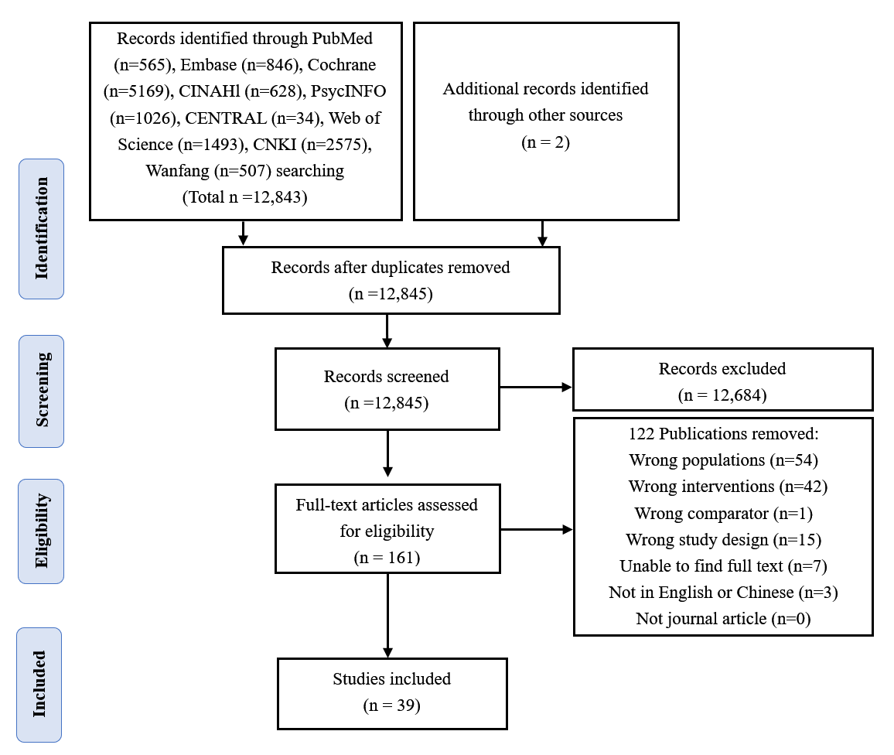

eAppendix 3. List of the included studies
- Bozoki A, Radovanovic M, Winn B, Heeter C, Anthony JC. Effects of a computer-based cognitive exercise program on age-related cognitive decline. Arch Gerontol Geriatr. 2013;57(1):1-7.
- Brooks H, Oughli HA, Kamel L, Subramanian S, Morgan G, Blumberger DM, et al. Enhancing Cognition in Older Persons with Depression or Anxiety with a Combination of Mindfulness-Based Stress Reduction (MBSR) and Transcranial Direct Current Stimulation (tDCS): Results of a Pilot Randomized Clinical Trial. Mindfulness (N Y). 2021;12(12):3047-59.
- Cabral DF, Santos VS, Pereira OTT, Silva MJ, Pascual-Leone A, Rundek T, et al. Feasibility and Preliminary Efficacy of a Multimodal Approach to Increase Physical Activity in Older Adults With Memory Complaints: The Education for Action Study. J Aging Phys Act. 2022;30(2):204-16.
- Cavalcante BR, de Souza MF, Falck RS, Liu-Ambrose T, Behm DG, Pitangui ACR, et al. Effects of Resistance Exercise with Instability on Cognitive Function (REI Study): A Proof-Of-Concept Randomized Controlled Trial in Older Adults with Cognitive Complaints. J Alzheimers Dis. 2020;77(1):227-39.
- Chan AS, Cheung WK, Yeung MK, Woo J, Kwok T, Shum DHK, et al. A Chinese Chan-based Mind-Body Intervention Improves Memory of Older Adults. Front Aging Neurosci. 2017;9:190.
- Cohen-Mansfield J, Cohen R, Buettner L, Eyal N, Jakobovits H, Rebok G, et al. Interventions for older persons reporting memory difficulties: a randomized controlled pilot study. Int J Geriatr Psychiatry. 2015;30(5):478-86.
- Cox KL, Clare L, Cyarto EV, Ellis KA, Etherton-Beer C, Southam J, et al. A Randomized Controlled Trial on the Effects of a 6-Month Home-Based Physical Activity Program with Individual Goal-Setting and Volunteer Mentors on Physical Activity, Adherence, and Physical Fitness in Inactive Older Adults at Risk of Cognitive Decline: The INDIGO Study. J Alzheimers Dis. 2021;84(1):207-26.
- Cuesta M, Verty LV, Abdessalem HB, Byrns A, Bruneau M-A, Frasson C, et al., editors. Virtual Reality and EEG-Based Intelligent Agent in Older Adults With Subjective Cognitive Decline: A Feasibility Study for Effects on Emotion and Cognition. Frontiers in Virtual Reality. 2022;2:807991.
- Dawson D, Richardson J, Troyer A, Binns M, Clark A, Polatajko H, et al. An occupation-based strategy training approach to managing age-related executive changes: a pilot randomized controlled trial. Clin Rehabil. 2014;28(2):118-27.
- Denny KG, Chan ML, Gravano J, Harvey D, Meyer OL, Huss O, et al. A randomized control trial of a behavioral intervention for older adults with subjective cognitive complaints that combines cognitive rehabilitation strategies and lifestyle modifications. Neuropsychol Dev Cogn B Aging Neuropsychol Cogn. 2023;30(1):78-93.
- Fabre C, Massé-Biron J, Chamari K, Varray A, Mucci P, Préfaut C. Evaluation of quality of life in elderly healthy subjects after aerobic and/or mental training. Arch Gerontol Geriatr. 1999;28(1):9-22.
- Fairchild JK, Scogin FR. Training to Enhance Adult Memory (TEAM): an investigation of the effectiveness of a memory training program with older adults. Aging Ment Health. 2010;14(3):364-73.
- Frankenmolen NL, Overdorp EJ, Fasotti L, Claassen J, Kessels RPC, Oosterman JM. Memory Strategy Training in Older Adults with Subjective Memory Complaints: A Randomized Controlled Trial. J Int Neuropsychol Soc. 2018;24(10):1110-20.
- Fujita K, Umegaki H, Makino T, Uemura K, Hayashi T, Inoue A, et al. Short- and long-term effects of different exercise programs on the gait performance of older adults with subjective cognitive decline: A randomized controlled trial. Exp Gerontol. 2021;156:111590.
- Hermes S, Lurz M, Böhm M, Krcmar H, editors. Evaluating the Usability and Usefulness of a Mobile Application for Training Visual Mnemonic Techniques in Participants with Subjective Cognitive Decline: An Exploratory Pilot Study. EUSPN/ICTH. 2019;160:439-444.
- Hong YJ, Lee JH, Choi EJ, Han N, Kim JE, Park SH, et al. Efficacies of Cognitive Interventions in the Elderly with Subjective Cognitive Decline: A Prospective, Three-Arm, Controlled Trial. J Clin Neurol. 2020;16(2):304-13.
- Hoogenhout EM, de Groot RH, van der Elst W, Jolles J. Effects of a comprehensive educational group intervention in older women with cognitive complaints: a randomized controlled trial. Aging Ment Health. 2012;16(2):135-44.
- Innes KE, Montgomery C, Selfe TK, Wen S, Khalsa DS, Flick M. Incorporating a Usual Care Comparator into a Study of Meditation and Music Listening for Older Adults with Subjective Cognitive Decline: A Randomized Feasibility Trial. J Alzheimers Dis Rep. 2021;5(1):187-206.
- Iuliano E, Fiorilli G, Aquino G, Di Costanzo A, Calcagno G, di Cagno A. Twelve-Week Exercise Influences Memory Complaint but not Memory Performance in Older Adults: A Randomized Controlled Study. J Aging Phys Act. 2017;25(4):612-20.
- Krause-Sorio B, Siddarth P, Kilpatrick L, Milillo MM, Aguilar-Faustino Y, Ercoli L, et al. Yoga Prevents Gray Matter Atrophy in Women at Risk for Alzheimer's Disease: A Randomized Controlled Trial. J Alzheimers Dis. 2022;87(2):569-81.
- Kwok T, Wong A, Chan G, Shiu YY, Lam KC, Young D, et al. Effectiveness of cognitive training for Chinese elderly in Hong Kong. Clin Interv Aging. 2013;8:213-9.
- Kwok TC, Bai X, Li JC, Ho FK, Lee TM. Effectiveness of cognitive training in Chinese older people with subjective cognitive complaints: a randomized placebo-controlled trial. Int J Geriatr Psychiatry. 2013;28(2):208-15.
- Postigo JML, Hernández-Viadel JV, Trives JJR. Efficacy of a Group Memory Training Method for Older Adults Based on Visualization and Association Techniques: A Randomized, Controlled Trial with a Placebo Group. Applied Cognitive Psychology. 2010;24:956-68.
- Liou H, Stonnington CM, Shah AA, Buckner-Petty SA, Locke DEC. Compensatory and Lifestyle-Based Brain Health Program for Subjective Cognitive Decline: Self-Implementation versus Coaching. Brain Sci. 2021;11(10).
- Marchant NL, Barnhofer T, Coueron R, Wirth M, Lutz A, Arenaza-Urquijo EM, et al. Effects of a Mindfulness-Based Intervention versus Health Self-Management on Subclinical Anxiety in Older Adults with Subjective Cognitive Decline: The SCD-Well Randomized Superiority Trial. Psychother Psychosom. 2021;90(5):341-50.
- McEwen SC, Siddarth P, Rahi B, Kim Y, Mui W, Wu P, et al. Simultaneous Aerobic Exercise and Memory Training Program in Older Adults with Subjective Memory Impairments. J Alzheimers Dis. 2018;62(2):795-806.
- Oh SJ, Seo S, Lee JH, Song MJ, Shin MS. Effects of smartphone-based memory training for older adults with subjective memory complaints: a randomized controlled trial. Aging Ment Health. 2018;22(4):526-34.
- Pereira-Morales AJ, Cruz-Salinas AF, Aponte J, Pereira-Manrique F. Efficacy of a computer-based cognitive training program in older people with subjective memory complaints: a randomized study. Int J Neurosci. 2018;128(1):1-9.
- Ramnath U, Rauch L, Lambert EV, Kolbe-Alexander T. Efficacy of interactive video gaming in older adults with memory complaints: A cluster-randomized exercise intervention. PLoS One. 2021;16(5):e0252016.
- Smart CM, Segalowitz SJ, Mulligan BP, Koudys J, Gawryluk JR. Mindfulness Training for Older Adults with Subjective Cognitive Decline: Results from a Pilot Randomized Controlled Trial. J Alzheimers Dis. 2016;52(2):757-74.
- Stroehlein JK, Vieluf S, Zimmer P, Schenk A, Oberste M, Goelz C, et al. Learning to play golf for elderly people with subjective memory complaints: feasibility of a single-blinded randomized pilot trial. BMC Neurol. 2021;21(1):200.
- Su H, Wang H, Meng L. The effects of Baduanjin exercise on the subjective memory complaint of older adults: A randomized controlled trial. Medicine (Baltimore). 2021;100(30):e25442.
- Sun Q. Effect and Mechanism of Baduanjin on Episodic Memory with SCD Patients-Based on the posterior Default Mode Network. PhD dissertation. Fujian University of Traditional Chinese Medicine; 2021. Accessed November 25, 2022. https://chn.oversea.cnki.net/KCMS/detail/detail.aspx?dbcode=CDFD&dbname=CDFDLAST2022&filename=1021610265.nh&uniplatform=OVERSEA&v=s2R_qofYChSLXhrxI-omcQC5_TLqscWMctDV2_w945FQYKNl9SuGWUhcENjwK4_R
- Thana-Udom K, Siddarth P, Miller KJ, Dunkin JJ, Small GW, Ercoli LM. The Effect of Memory Training on Memory Control Beliefs in Older Adults with Subjective Memory Complaints. Exp Aging Res. 2021;47(2):131-44.
- Valentijn SA, van Hooren SA, Bosma H, Touw DM, Jolles J, van Boxtel MP, et al. The effect of two types of memory training on subjective and objective memory performance in healthy individuals aged 55 years and older: a randomized controlled trial. Patient Educ Couns. 2005;57(1):106-14.
- Xu S. Clinical Evaluation of the Effect of Tai Chi Training on Cognitive Function of the Elderly with Subjective Cognitive Decline. Master dissertation. Fujian University of Traditional Chinese Medicine; 2022. Accessed November 25, 2022.
https://chn.oversea.cnki.net/KCMS/detail/detail.aspx?dbcode=CMFD&dbname=CMFDTEMP&filename=1022567488.nh&uniplatform=OVERSEA&v=BRU6EWBO6WAfl0eUMA389MXEvArfMVwry6mw_mvWbBskgDaHILUv2V2xL0D14mkZ
- Yin S, Zhu X, Li R, Huo L, Ren W, Niu Y, et al. Alleviated Anxiety Boosts Memory Training Gain in Older Adults with Subjective Memory Complaints: A Randomized Controlled Trial. Am J Geriatr Psychiatry. 2022;30(2):184-94.
- Youn JH, Ryu SH, Lee JY, Park S, Cho SJ, Kwon H, et al. Brain structural changes after multi-strategic metamemory training in older adults with subjective memory complaints: A randomized controlled trial. Brain Behav. 2019;9(5):e01278.
- Youn JH, Lee JY, Kim S, Ryu SH. Multistrategic memory training with the metamemory concept in healthy older adults. Psychiatry Investig. 2011;8(4):354-61.

eAppendix 4. Study Characteristics
4.1 Table 1. Study Characteristics of Included RCTs
Study | Year | Country | Recruitment | Treatment | Participations (n) | Age (mean ± SD) | Female (%) | Research setting | Treatment Duration
Bozoki A ^{[1]} | 2013 | USA | community | cognitive intervention | 32 | 67.20±6.37 | 50.0% | Not reported | 6 weeks
 |  |  |  | usual care | 28 | 70.80±6.81 | 67.9% | Not reported | 6 weeks
Brooks H ^{[2]} | 2021 | Canada | Not reported | cognitive intervention + occupational therapy | 14 | 68.30±5.90 | 64.3% | Hospital and home | 10 weeks
 |  |  |  | cognitive intervention | 12 | 69.00±5.00 | 25.0% | Hospital and home | 10 weeks
Cabral DF ^{[3]} | 2022 | Brazil | community | exercise + psychotherapy | 24 | 65.30±3.50 | 87.5% | Home | 4 weeks
 |  |  |  | wl | 22 | 66.90±6.10 | 90.9% | Home | 4 weeks
Cavalcante BR ^{[4]} | 2020 | Germany | community | exercise (Balance Group) | 22 | 71.00±6.00 | 77.0% | Gym | 12 weeks
 |  |  |  | exercise (Resistance Group) | 23 | 71.00±4.00 | 78.0% | Gym | 12 weeks
 |  |  |  | usual care | 22 | 71.00±6.00 | 77.0% | Gym | 12 weeks
Chan AS ^{[5]} | 2017 | China | community | cognitive intervention + psychotherapy | 42 | 68.34±4.42 | 35.7% | Not reported | 10 weeks
 |  |  |  | cognitive intervention | 26 | 69.50±6.89 | 80.7% | Not reported | 10 weeks
Cohen-Mansfield J ^{[6]} | 2015 | Israel | community | cognitive intervention | 15 | 72.80±3.78 | 60% | Institute of Medicine | 10 weeks
 |  |  |  | psychotherapy | 15 | 74.44±5.78 | 86.7% | Institute of Medicine | 10 weeks
 |  |  |  | occupational therapy | 14 | 73.21±5.97 | 71.4% | Institute of Medicine | 10 weeks
Cox KL ^{[7]} | 2021 | Australia | memory clinic and community | psychotherapy + exercise | 26 | 71.90±5.90 | 53.8% | Home | 24 weeks
 |  |  |  | usual care | 26 | 68.50±6.50 | 73.1% | Home | 24 weeks
Cuesta M ^{[8]} | 2022 | Canada | community | cognitive intervention | 19 | 69.70±5.50 | 57.9% | Not reported | 12 weeks
 |  |  |  | wl | 19 | 72.40±6.50 | 84.2% | Not reported | 12 weeks
Dawson D ^{[9]} | 2014 | Canada | community | occupational therapy | 10 | 74.10±8.77 | 90.0% | Institute of Medicine | 8 weeks
 |  |  |  | cognitive intervention + psychotherapy | 9 | 73.67±5.43 | 77.8% | Institute of Medicine | 8 weeks
Denny KG ^{[10]} | 2021 | USA | memory clinic and community | cognitive intervention + psychotherapy + exercise | 28 | 76.60±5.80 | 66.7% | Home | 10 weeks
 |  |  |  | wl | 29 | 73.20±6.80 | 93.1% | Home | 10 weeks
Fabre C ^{[11]} | 1999 | France | community | exercise (Aerobic Group) | 8 | 65.40±6.20 | NA | Not reported | 8 weeks
 |  |  |  | cognitive intervention | 8 | 67.50±3.40 | NA | Not reported | 8 weeks
 |  |  |  | cognitive intervention + exercise | 8 | 64.90±3.90 | NA | Not reported | 8 weeks
 |  |  |  | wl | 8 | 65.70±4.20 | NA | Not reported | 8 weeks
Fairchild JK ^{[12]} | 2010 | USA | community | cognitive intervention | 28 | 73.45±9.89 | 82.1% | Not reported | 6 weeks
 |  |  |  | usual care | 25 | 71.24±8.25 | 80.0% | Not reported | 6 weeks
Frankenmolen NL ^{[13]} | 2018 | Netherlands | community | cognitive intervention | 31 | 66.20±7.30 | 65.5% | Not reported | 7 weeks
 |  |  |  | active placebo | 29 | 68.00±7.80 | 65.5% | Not reported | 7 weeks
Fujita K ^{[14]} | 2021 | Japan | community | exercise (Aerobic Group) | 95 | 72.20 ±4.60 | 50.5% | Not reported | 26 weeks
 |  |  |  | exercise (Resistance Group) | 93 | 72.30±4.80 | 49.5% | Not reported | 26 weeks
 |  |  |  | exercise (Aerobic Group) + exercise (Resistance Group) | 98 | 72.60±4.50 | 41.8% | Not reported | 26 weeks
 |  |  |  | usual care | 102 | 72.10±4.60 | 51.0% | Not reported | 26 weeks
Hermes S ^{[15]} | 2019 | Germany | memory clinic | cognitive intervention | 8 | NA | 75.0% | Not reported | 10days
 |  |  |  | wl | 6 | NA | 50.0% | Not reported | 10days
Hong YJ ^{[16]} | 2020 | South Korea | memory clinic and hospital | cognitive intervention + psychotherapy + exercise | 23 | 66.22±5.73 | 73.9% | Memory clinic | 12 weeks
 |  |  |  | Psychotherapy + exercise | 15 | 65.40±4.82 | 93.3% | Memory clinic | 12 weeks
 |  |  |  | wl | 18 | 65.83±4.89 | 66.7% | Memory clinic | 12 weeks
Hoogenhout EM ^{[17]} | 2012 | Netherlands | Not reported | cognitive intervention + psychotherapy | 30 | 66.00±4.23 | 100% | Institute of Medicine | 7 weeks
 |  |  |  | wl | 30 | 66.10±4.48 | 100% | Institute of Medicine | 7 weeks
Innes KE ^{[18]} | 2021 | USA | community | cognitive intervention + psychotherapy | 20 | 66.85±2.14 | 55.0% | Home | 12 weeks
 |  |  |  | usual care | 20 | 61.45±1.38 | 90.0% | Home | 12 weeks
Iuliano E ^{[19]} | 2017 | Italy | Not reported | exercise (Resistance Group) | 20 | 65.80±6.32 | 55.0% | Gym | 12 weeks
 |  |  |  | exercise (Aerobic Group) | 20 | 68.44±6.40 | 60.0% | Gym | 12 weeks
 |  |  |  | exercise (Balance Group) | 20 | 66.67±5.83 | 65.0% | Gym | 12 weeks
 |  |  |  | wl | 20 | 66.47±6.32 | 60.0% | Gym | 12 weeks
Krause-Sorio B ^{[20]} | 2022 | USA | community | exercise (Balance Group) | 11 | NA | 100% | Not reported | 12 weeks
 |  |  |  | occupational therapy | 11 | NA | 100% | Not reported | 12 weeks
Kwok T ^{[21]} | 2013 | China | community | cognitive intervention | 86 | 77.41±6.75 | 87.2% | Not reported | 8 weeks
 |  |  |  | usual care | 90 | 73.50±7.35 | 83.3% | Not reported | 8 weeks
Kwok TC ^{[22]} | 2012 | China | community | cognitive intervention | 111 | 75.41±5.82 | 87.4% | Not reported | 12 weeks
 |  |  |  | usual care | 112 | 75.39±5.83 | 83.0% | Not reported | 12 weeks
Latorre-Postigo JM ^{[23]} | 2010 | Spain | community | cognitive intervention | 15 | 67.80±2.85 | 73.3% | Not reported | 5 weeks
 |  |  |  | usual care | 15 | 65.73±3.36 | 53.3% | Not reported | 5 weeks
 |  |  |  | wl | 15 | 67.40±2.99 | 66.7% | Not reported | 5 weeks
Liou H ^{[24]} | 2021 | USA | clinic | cognitive intervention + exercise | 7 | NA | 71.4% | Not reported | 10 weeks
 |  |  |  | usual care | 10 | NA | 60.0% | Not reported | 10 weeks
Marchant NL ^{[25]} | 2021 | UK | memory clinic | psychotherapy | 73 | 72.10±7.60 | 64.4% | Memory clinic | 8 weeks
 |  |  |  | usual care | 74 | 73.30±6.20 | 64.9% | Memory clinic | 8 weeks
McEwen SC ^{[26]} | 2018 | USA | Not reported | cognitive intervention + exercise | 29 | 67.00±5.10 | 65.5% | Institute of Medicine or Patient Room | 4 weeks
 |  |  |  | cognitive intervention | 26 | 65.40±3.00 | 73.1% | Institute of Medicine or Patient Room | 4 weeks
Oh SJ ^{[27]} | 2018 | South Korea | Not reported | cognitive intervention | 18 | 59.28±5.11 | 50.0% | Home | 8 weeks
 |  |  |  | active placebo | 19 | 58.79±5.00 | 52.6% | Home | 8 weeks
 |  |  |  | wl | 16 | 59.94±5.17 | 56.3% | Home | 8 weeks
Pereira-Morales AJ ^{[28]} | 2018 | Colombia | community | cognitive intervention + psychotherapy | 17 | 64.50±4.80 | 88.2% | Home | 8 weeks
 |  |  |  | cognitive intervention | 12 | 69.30±4.80 | 91.7% | Home | 8 weeks
 |  |  |  | usual care | 11 | 65.60±7.20 | 90.9% | Home | 8 weeks
Ramnath U ^{[29]} | 2021 | South Africa | community | cognitive intervention + exercise | 23 | 70.80±4.52 | NA | Nursing home or assisted living | 12 weeks
 |  |  |  | usual care | 22 | 74.14±5.80 | NA | Nursing home or assisted living | 12 weeks
Smart CM ^{[30]} | 2016 | Canada | Not reported | psychotherapy | 15 | 69.60±3.58 | 73.3% | Not reported | 8 weeks
 |  |  |  | usual care | 23 | 70.00±3.45 | 39.1% | Not reported | 8 weeks
Stroehlein JK ^{[31]} | 2021 | Germany | Not reported | exercise (Balance Group) | 23 | 67.87±4.70 | 56.5% | Institute of Medicine | 22 weeks
 |  |  |  | wl | 19 | 67.89±3.90 | 52.6% | Institute of Medicine | 22 weeks
Su H ^{[32]} | 2021 | China | community | exercise (Balance Group) | 32 | 64.40±6.57 | 54.3% | Not reported | 12 weeks
 |  |  |  | active placebo | 33 | 65.37±6.31 | 48.6% | Not reported | 12 weeks
Sun Q ^{[33]} | 2021 | China | community | exercise (Balance Group) | 34 | 65.94±4.35 | 47.1% | Not reported | 24 weeks
 |  |  |  | exercise (Aerobic Group) | 32 | 66.28±5.56 | 40.6% | Not reported | 24 weeks
 |  |  |  | usual care | 28 | 67.11±5.09 | 57.1% | Not reported | 24 weeks
Thana-Udom K ^{[34]} | 2021 | USA | community | cognitive intervention | 23 | 67.26 ±6.87 | 26.1% | Not reported | 7 weeks
 |  |  |  | psychotherapy | 23 | 67.78 ±6.57 | 17.3% | Not reported | 7 weeks
 |  |  |  | wl | 17 | 70.29± 6.74 | 47.1% | Not reported | 7 weeks
Valentijn SA ^{[35]} | 2005 | Netherlands | community | cognitive intervention + psychotherapy | 53 | 69.32±7.77 | 70.0% | Not reported | 8 weeks
 |  |  |  | cognitive intervention | 43 | 68.07±6.58 | 63.0% | Not reported | 8 weeks
 |  |  |  | wl | 43 | 68.30±8.03 | 63.0% | Not reported | 8 weeks
Xu S ^{[36]} | 2022 | China | community | usual care | 26 | NA | 69.2% | Not reported | 24 weeks
 |  |  |  | exercise (Balance Group) | 26 | NA | 61.5% | Not reported | 24 weeks
 |  |  |  | exercise (Aerobic Group) | 26 | NA | 65.4% | Not reported | 24 weeks
Yin S ^{[37]} | 2021 | China | community | cognitive intervention | 38 | 71.34±6.63 | 68.4% | Not reported | 7 weeks
 |  |  |  | cognitive intervention +psychotherapy | 42 | 72.90±5.29 | 59.5% | Not reported | 7 weeks
 |  |  |  | usual care | 44 | 71.93±6.46 | 59.1% | Not reported | 7 weeks
Youn JH ^{[38]} | 2019 | South Korea | memory clinic and community | cognitive intervention + psychotherapy | 112 | 69.93±5.10 | 57.1% | Not reported | 10 weeks
 |  |  |  | wl | 89 | 69.11±4.60 | 67.4% | Not reported | 10 weeks
Youn JH ^{[39]} | 2011 | South Korea | memory clinic and community | cognitive intervention | 16 | 68.75±4.60 | 62.5% | Not reported | 10 weeks
 |  |  |  | wl | 16 | 69.00±3.45 | 56.3% | Not reported | 10 weeks

Note: Reference numbers here correspond to eAppendix 3 (List of the included studies).
4.2 Table 2. The distribution of effect modifiers across studies
Characteristic | Studies, n(%) | Characteristic | Studies, n(%)
Recruitment sourse |  | Women enrolled in study
Memory clinic and community | 4 (10.3) | 0%-49% | 4 (10.3)
Memory clinic and hospital | 1 (2.6) | 50%-100% | 33 (84.6)
Memory clinic | 2 (5.1) | Not reported | 2 (5.1)
Clinic | 1 (2.6) | Intervention duration (weeks)
Community | 24 (61.5) | ＜10w | 18 (46.2)
Not reported | 7 (17.9) | 10w-19w | 16 (41.0)
Number of participants |  | ≥20w | 5 (12.8)
≤50 | 16 (41.0)
51-99 | 16 (41.0)
100-149 | 3 (7.7)
≥150 | 4 (10.3)
Mean age of participants (years)
＜60 | 1 (2.6)
60-64.99 | 2 (5.1)
65-69.99 | 19 (48.7)
≥70 | 13 (33.3)
Not reported | 4 (10.3)

eAppendix 5. Bias Assessment of Eligible Studies
Study | Random sequence  Generation | Allocation concealment | Blinding of participants and personnel | Blinding of outcome assessment | Incomplete outcome data | Selective reporting | Other bias | Overall risk of bias
Bozoki A | Unclear | Unclear | High | Unclear | Unclear | Low | Low | High
Brooks H | Low | Low | Low | Low | Low | Unclear | Low | Low
Cabral DF | Low | Low | High | High | Low | Low | Low | High
Cavalcante BR | Low | Low | Unclear | High | Low | Low | Low | High
Chan AS | Unclear | Unclear | Unclear | Low | Low | Unclear | Low | Unclear
Cohen-Mansfield J | Unclear | Unclear | Unclear | Low | Low | Unclear | Low | Unclear
Cox KL | Low | Low | High | Low | Low | Low | Low | High
Cuesta M | Unclear | Unclear | Unclear | Unclear | Low | Unclear | Low | Unclear
Dawson D | Low | Low | Low | Low | Low | Low | Low | Low
Denny KG | Low | Low | Unclear | Unclear | Low | Low | Low | Low
Fabre C | Unclear | Unclear | Unclear | Unclear | Unclear | Unclear | Low | Unclear
Fairchild JK | Unclear | Unclear | Unclear | Unclear | Low | Unclear | Low | Unclear
Frankenmolen NL | Low | Low | Low | Low | Low | Unclear | Low | Low
Fujita K | Low | Low | Unclear | Unclear | Low | Low | Low | Low
Hermes S | Unclear | Unclear | Unclear | Unclear | Low | Low | Low | Unclear
Hong YJ | Low | Low | Unclear | Low | Low | Low | Low | Low
Hoogenhout EM | Low | Low | Unclear | Low | Low | Low | Low | Low
Innes KE | Low | Low | Low | Low | Low | Unclear | Low | Low
Iuliano E | Low | Low | Unclear | Low | Low | Unclear | Low | Low
Krause-Sorio B | Low | Low | Unclear | Unclear | Low | Unclear | Low | Low
Kwok T | Unclear | Unclear | Unclear | Low | Unclear | Unclear | Low | Unclear
Kwok TC | Unclear | Unclear | High | Low | Low | Unclear | Low | High
Latorre-Postigo JM | Low | Low | Low | Low | Low | Unclear | Low | Low
Liou H | Low | Unclear | Unclear | Unclear | Unclear | Unclear | Low | Unclear
Marchant NL | Low | Low | Low | Low | Low | Low | Low | Low
McEwen SC | Unclear | Unclear | High | Unclear | Low | Unclear | Low | High
Oh SJ | Unclear | Unclear | Unclear | Unclear | Low | Unclear | Low | Unclear
Pereira-Morales AJ | Unclear | Unclear | Unclear | Unclear | Unclear | Unclear | Low | Unclear
Qianqian Sun | Low | Low | Low | Low | Low | Low | Low | Low
Ramnath U | Unclear | Unclear | High | Unclear | Low | Low | Low | High
Shurui Xu | Low | Low | Low | Low | Low | Low | Low | Low
Smart CM | Unclear | Unclear | Low | Low | Low | Unclear | Low | Low
Stroehlein JK | Low | Low | Unclear | Unclear | Low | Low | Low | Low
Su H | Low | Low | Unclear | Unclear | Low | Unclear | Low | Low
Thana-Udom K | Unclear | Unclear | Unclear | Unclear | Low | Low | Low | Unclear
Valentijn SA | Low | Low | Low | Low | Low | Unclear | Low | Low
Yin S | Low | Low | Low | Low | Low | Low | Low | Low
Youn JH 2019 | Low | Low | Unclear | Unclear | Low | Unclear | Low | Low
Youn JH 2011 | Unclear | Unclear | Unclear | Unclear | Low | Unclear | Low | Unclear

eAppendix 6. Pairwise Meta-analysis of forest plots
6.1 Pairwise meta-analyses for subjective memory complaints
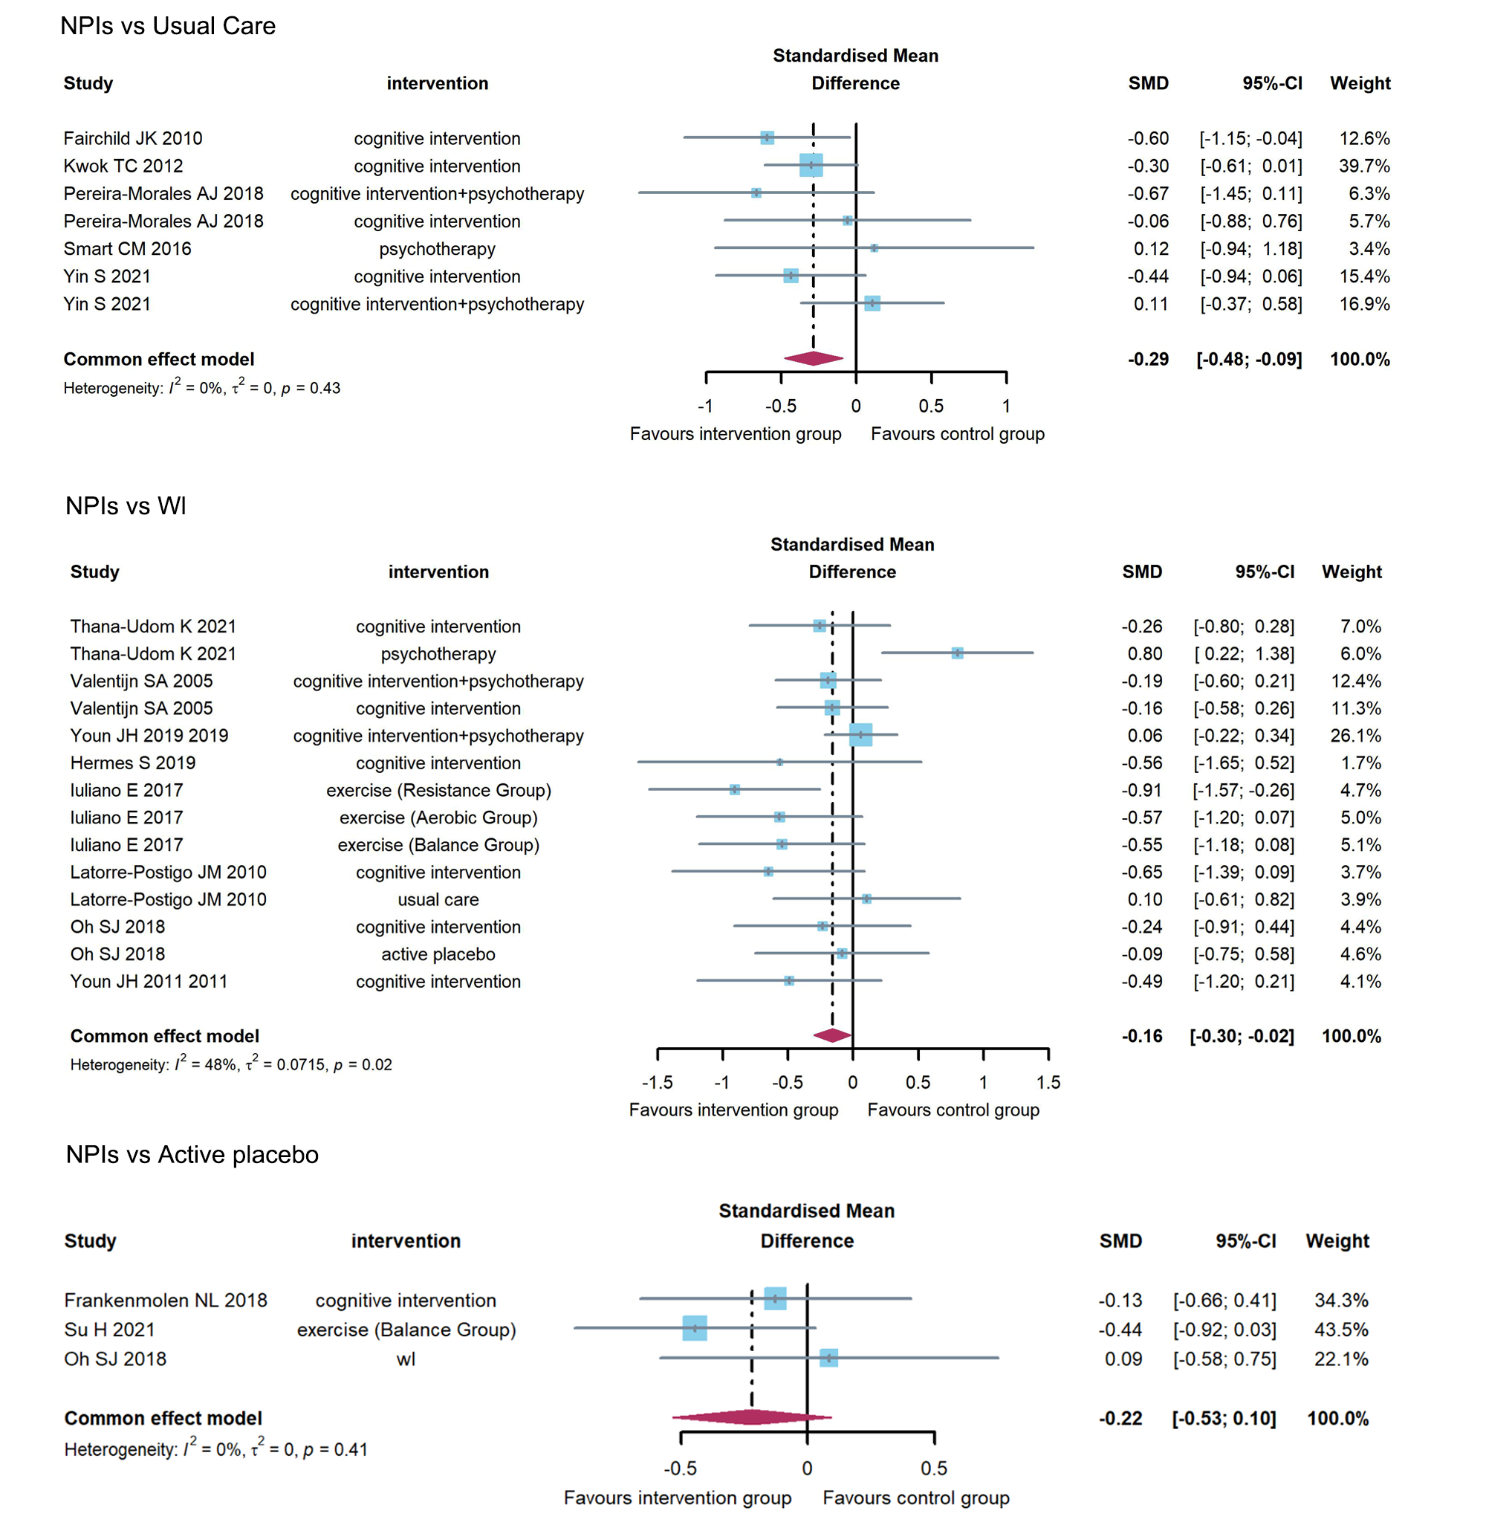

6.2 Pairwise meta-analyses for global cognitive function
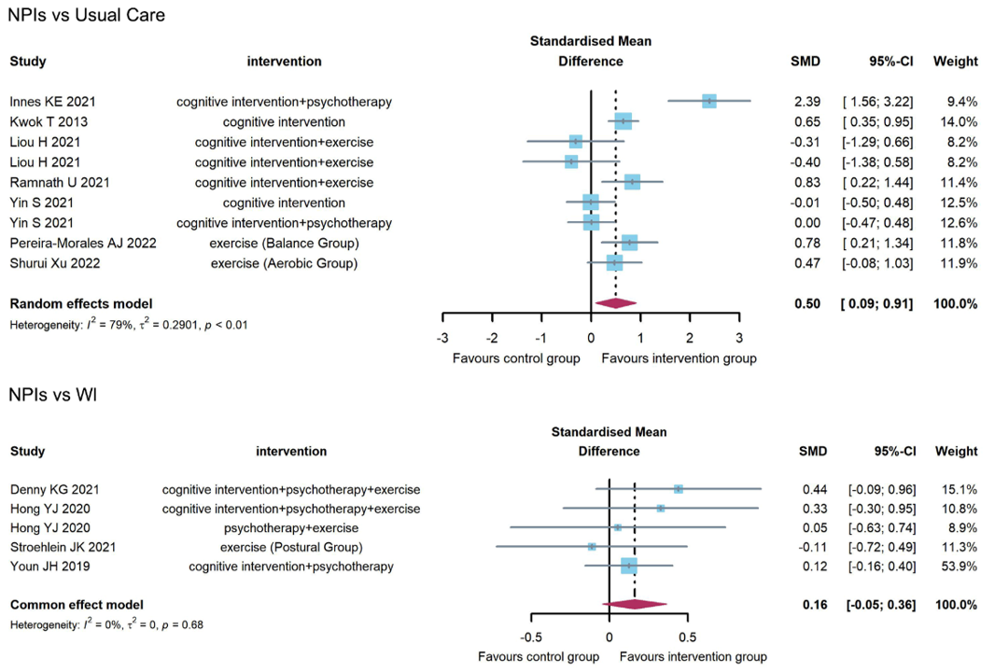
6.3 Pairwise meta-analyses for language function
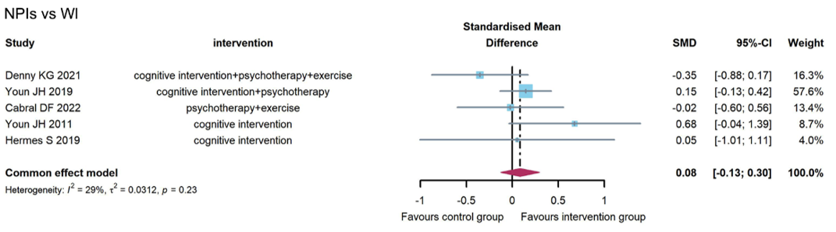
6.4 Pairwise meta-analyses for executive function
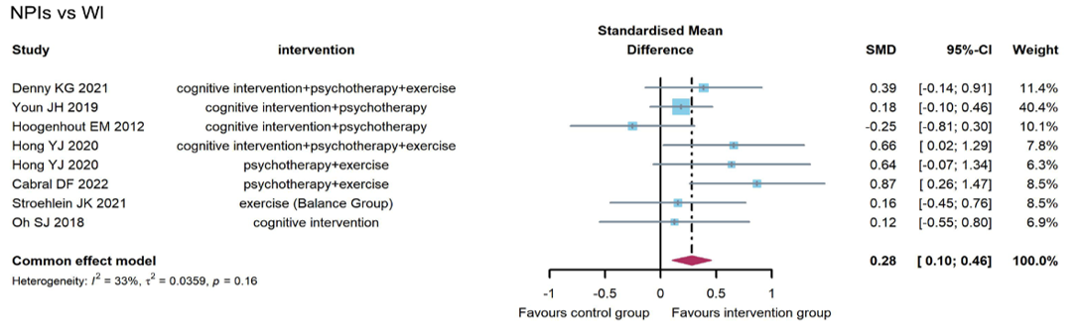
6.5 Pairwise meta-analyses for visuospatial ability
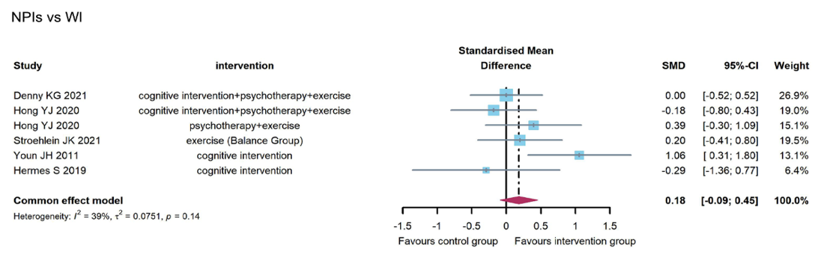
6.6 Pairwise meta-analyses for attention
6.7 Pairwise meta-analyses for activities of daily living
6.8 Pairwise meta-analyses for anxiety
6.9 Pairwise meta-analyses for depression
6.10 Pairwise meta-analyses for physical health

eAppendix 7. Network Meta-analysis of forest plots and p-scores
7.1 Subjective memory complaints; wl (SMD=0; p-score=0.310)
7.2 Global cognitive function; wl (SMD=0; p-score=0.563)
7.3 Language function; wl (SMD=0; p-score=0.200)
7.4 Executive function; wl (SMD=0; p-score=0.380)
7.5 Visuospatial ability; wl (SMD=0; p-score=0.229)
7.6 Attention; wl (SMD=0; p-score=0.425)
7.7 Anxiety; wl (SMD=0; p-score=0.698)
7.8 Depression; wl (SMD=0; p-score=0.747)

eAppendix 8. Comparison of network meta-analysis, iSMD (95%CI)
8.1 Subjective memory complaints
Active placebo | 0.15 (-0.27 to 0.57) | NA | NA | 0.45 (-0.04 to 0.94) | NA | NA | NA | -0.09 (-0.77 to 0.59)
0.12 (-0.23 to 0.47) | Cognitive intervention | -0.27 (-0.53 to -0.01) | NA | 0.74 (-0.13 to 1.61) | NA | -0.85 (-1.32 to -0.39) | -0.39 (-0.62 to -0.16) | -0.32 (-0.58 to -0.06)
-0.19 (-0.59 to 0.20) | -0.31 (-0.53 to -0.10) | Cognitive intervention  +Psychotherapy | NA | NA | NA | 0.22 (-0.65 to 1.10) | -0.11 (-0.53 to 0.31) | -0.03 (-0.28 to 0.22)
0.50 (-0.14 to 1.14) | 0.38 (-0.23 to 0.99) | 0.69 (0.07 to 1.31) | Exercise (Aerobic Group) | -0.02 (-0.66 to 0.61) | 0.09 (-0.54 to 0.73) | NA | NA | -0.64 (-1.28 to 0.00)
0.51 (0.12 to 0.91) | 0.39 (-0.02 to 0.81) | 0.71 (0.27 to 1.15) | 0.01 (-0.57 to 0.60) | Exercise (Balance Group) | 0.12 (-0.52 to 0.75) | NA | NA | -0.62 (-1.26 to 0.02)
0.59 (-0.05 to 1.24) | 0.47 (-0.14 to 1.09) | 0.79 (0.17 to 1.41) | 0.10 (-0.54 to 0.73) | 0.08 (-0.51 to 0.67) | Exercise (Resistance Group) | NA | NA | -0.74 (-1.38 to -0.09)
-0.65 (-1.17 to -0.13) | -0.77 (-1.16 to -0.37) | -0.45 (-0.87 to -0.04) | -1.15 (-1.86 to -0.44) | -1.16 (-1.72 to -0.60) | -1.24 (-1.95 to -0.53) | Psychotherapy | 0.13 (-0.94 to 1.19) | 0.76 (0.18 to 1.35)
-0.28 (-0.69 to 0.13) | -0.40 (-0.62 to -0.18) | -0.08 (-0.35 to 0.19) | -0.78 (-1.42 to -0.14) | -0.79 (-1.25 to -0.33) | -0.87 (-1.51 to -0.23) | 0.37 (-0.06 to 0.80) | Usual care | 0.00 (-0.73 to 0.73)
-0.18 (-0.56 to 0.19) | -0.30 (-0.51 to -0.09) | 0.01 (-0.20 to 0.23) | -0.68 (-1.27 to -0.09) | -0.70 (-1.11 to -0.28) | -0.78 (-1.37 to -0.18) | 0.47 (0.06 to 0.88) | 0.10 (-0.18 to 0.38) | Wl
8.2 General cognitive function
Cognitive intervention | -0.35 (-1.58 to 0.88) | -0.22 (-1.59 to 1.15) | 0.11 (-0.81 to 1.03) | NA | NA | NA | 0.02 (-1.34 to 1.39) | NA | 0.34 (-0.49 to 1.17) | NA
0.01 (-0.86 to 0.87) | Cognitive intervention  + Exercise | NA | NA | NA | NA | NA | NA | NA | 0.35 (-0.61 to 1.31) | NA
-0.22 (-1.59 to 1.15) | -0.23 (-1.85 to 1.39) | Cognitive intervention  + Occupational therapy | NA | NA | NA | NA | NA | NA | NA | NA
-0.33 (-1.11 to 0.45) | -0.34 (-1.35 to 0.68) | -0.11 (-1.68 to 1.47) | Cognitive intervention  + Psychotherapy | NA | NA | NA | -0.25 (-1.66 to 1.16) | NA | 1.06 (0.15 to 1.97) | 0.12 (-1.02 to 1.27)
-0.66 (-2.12 to 0.81) | -0.66 (-2.25 to 0.92) | -0.43 (-2.44 to 1.57) | -0.33 (-1.65 to 0.99) | Cognitive intervention  + Psychotherapy  + Exercise | NA | NA | NA | 0.26 (-1.02 to 1.55) | NA | 0.38 (-0.50 to 1.27)
0.14 (-1.21 to 1.48) | 0.13 (-1.29 to 1.55) | 0.36 (-1.56 to 2.28) | 0.46 (-0.87 to 1.79) | 0.79 (-0.88 to 2.46) | Exercise (Aerobic Group) | -0.41 (-1.65 to 0.82) | NA | NA | 0.48 (-0.76 to 1.72) | NA
-0.24 (-1.42 to 0.94) | -0.25 (-1.53 to 1.04) | -0.02 (-1.83 to 1.79) | 0.09 (-1.03 to 1.20) | 0.42 (-0.95 to 1.79) | -0.37 (-1.56 to 0.81) | Exercise (Balance Group) | NA | NA | 0.89 (-0.35 to 2.14) | -0.12 (-1.38 to 1.15)
-0.26 (-1.51 to 0.99) | -0.27 (-1.74 to 1.20) | -0.04 (-1.89 to 1.81) | 0.07 (-1.20 to 1.33) | 0.39 (-1.40 to 2.19) | -0.40 (-2.15 to 1.35) | -0.02 (-1.63 to 1.59) | Psychotherapy | NA | NA | NA
-0.36 (-2.05 to 1.33) | -0.37 (-2.16 to 1.42) | -0.14 (-2.32 to 2.03) | -0.03 (-1.60 to 1.53) | 0.29 (-0.91 to 1.50) | -0.50 (-2.37 to 1.37) | -0.12 (-1.73 to 1.48) | -0.10 (-2.08 to 1.88) | Psychotherapy  + Exercise | NA | 0.06 (-1.25 to 1.36)
0.58 (-0.11 to 1.26) | 0.57 (-0.23 to 1.37) | 0.80 (-0.73 to 2.33) | 0.90 (0.16 to 1.65) | 1.23 (-0.17 to 2.64) | 0.44 (-0.75 to 1.63) | 0.81 (-0.22 to 1.85) | 0.84 (-0.50 to 2.17) | 0.94 (-0.70 to 2.57) | Usual care | NA
-0.27 (-1.44 to 0.90) | -0.28 (-1.59 to 1.03) | -0.05 (-1.85 to 1.75) | 0.06 (-0.93 to 1.04) | 0.38 (-0.50 to 1.27) | -0.41 (-1.83 to 1.01) | -0.03 (-1.08 to 1.01) | -0.01 (-1.58 to 1.56) | 0.09 (-1.13 to 1.31) | -0.85 (-1.94 to 0.25) | Wl
8.3 Language function
Cognitive intervention | 0.31 (-0.33 to 0.96) | NA | NA | 0.11 (-0.19 to 0.41) | 0.48 (-0.15 to 1.12)
0.32 (-0.17 to 0.81) | Cognitive intervention + Psychotherapy | NA | NA | NA | 0.15 (-0.26 to 0.55)
0.12 (-0.66 to 0.89) | -0.21 (-0.92 to 0.50) | Cognitive intervention  + Psychotherapy + Exercise | NA | NA | 0.36 (-0.24 to 0.96)
0.50 (-0.32 to 1.31) | 0.17 (-0.58 to 0.92) | 0.38 (-0.51 to 1.27) | Exercise + Psychotherapy | NA | -0.02 (-0.67 to 0.63)
0.11 (-0.19 to 0.41) | -0.21 (-0.78 to 0.36) | -0.00 (-0.83 to 0.83) | -0.38 (-1.25 to 0.48) | Usual care | NA
0.47 (-0.01 to 0.96) | 0.15 (-0.22 to 0.52) | 0.36 (-0.24 to 0.96) | -0.02 (-0.67 to 0.63) | 0.36 (-0.21 to 0.93) | Wl
8.4 Execution function
Active placebo | NA | NA | NA | NA | -0.71 (-1.19 to -0.22) | NA | NA | NA | NA
-0.70 (-1.58 to 0.18) | Cognitive intervention | 0.05 (-0.48 to 0.58) | 0.14 (-0.34 to 0.62) | NA | NA | 0.07 (-0.73 to 0.87) | NA | 0.41 (-0.42 to 1.23) | 0.13 (-0.55 to 0.80)
-0.65 (-1.68 to 0.38) | 0.05 (-0.48 to 0.58) | Cognitive intervention + Exercise | NA | NA | NA | NA | NA | NA | NA
-0.64 (-1.45 to 0.17) | 0.06 (-0.33 to 0.45) | 0.01 (-0.65 to 0.67) | Cognitive intervention + Psychotherapy | NA | NA | -0.06 (-0.92 to 0.81) | NA | 0.57 (0.08 to 1.07) | 0.10 (-0.15 to 0.34)
-1.10 (-1.97 to -0.23) | -0.40 (-0.97 to 0.17) | -0.45 (-1.23 to 0.32) | -0.46 (-0.92 to -0.01) | Cognitive intervention + Psychotherapy  + Exercise | NA | NA | 0.04 (-0.61 to 0.69) | NA | 0.51 (0.11 to 0.92)
-0.71 (-1.19 to -0.22) | -0.00 (-0.74 to 0.73) | -0.06 (-0.97 to 0.85) | -0.07 (-0.72 to 0.59) | 0.40 (-0.33 to 1.12) | Exercise (Balance Group) | NA | NA | NA | 0.16 (-0.45 to 0.77)
-0.66 (-1.75 to 0.43) | 0.04 (-0.69 to 0.77) | -0.01 (-0.92 to 0.89) | -0.02 (-0.77 to 0.72) | 0.44 (-0.42 to 1.30) | 0.04 (-0.94 to 1.02) | Psychotherapy | NA | NA | NA
-1.27 (-2.16 to -0.38) | -0.57 (-1.17 to 0.04) | -0.62 (-1.43 to 0.18) | -0.63 (-1.13 to -0.13) | -0.17 (-0.67 to 0.34) | -0.56 (-1.31 to 0.19) | -0.61 (-1.49 to 0.28) | Psychotherapy  + Exercise | NA | 0.78 (0.32 to 1.24)
-0.06 (-1.00 to 0.88) | 0.64 (0.07 to 1.21) | 0.58 (-0.19 to 1.36) | 0.58 (0.10 to 1.06) | 1.04 (0.38 to 1.70) | 0.64 (-0.16 to 1.45) | 0.60 (-0.27 to 1.47) | 1.21 (0.52 to 1.89) | Usual care | NA
-0.55 (-1.32 to 0.23) | 0.15 (-0.26 to 0.57) | 0.10 (-0.57 to 0.77) | 0.09 (-0.15 to 0.33) | 0.55 (0.17 to 0.94) | 0.16 (-0.45 to 0.77) | 0.11 (-0.65 to 0.88) | 0.72 (0.28 to 1.16) | -0.48 (-1.01 to 0.04) | Wl
8.5 Visuospatial ability
Cognitive intervention | -0.26 (-1.28 to 0.77) | NA | NA | 0.04 (-0.93 to 1.01) | NA | 0.15 (-0.29 to 0.59) | 0.56 (-0.17 to 1.29)
-0.26 (-1.28 to 0.77) | Cognitive intervention  + Psychotherapy | NA | NA | 0.30 (-0.73 to 1.33) | NA | NA | NA
0.64 (-0.27 to 1.56) | 0.90 (-0.47 to 2.28) | Cognitive intervention  + Psychotherapy + Exercise | NA | NA | -0.58 (-1.44 to 0.27) | NA | -0.08 (-0.64 to 0.48)
0.36 (-0.73 to 1.46) | 0.62 (-0.88 to 2.12) | -0.28 (-1.27 to 0.71) | Exercise (Balance Group) | NA | NA | NA | 0.20 (-0.62 to 1.02)
0.04 (-0.93 to 1.01) | 0.30 (-0.73 to 1.33) | -0.60 (-1.94 to 0.73) | -0.32 (-1.79 to 1.14) | Psychotherapy | NA | NA | NA
0.11 (-0.99 to 1.20) | 0.36 (-1.14 to 1.87) | -0.54 (-1.35 to 0.27) | -0.26 (-1.41 to 0.90) | 0.06 (-1.40 to 1.53) | Psychotherapy + Exercise | NA | 0.40 (-0.48 to 1.28)
0.15 (-0.29 to 0.59) | 0.41 (-0.71 to 1.52) | -0.49 (-1.51 to 0.52) | -0.21 (-1.40 to 0.97) | 0.11 (-0.96 to 1.17) | 0.04 (-1.14 to 1.23) | Usual care | NA
0.56 (-0.17 to 1.29) | 0.82 (-0.44 to 2.08) | -0.08 (-0.64 to 0.48) | 0.20 (-0.62 to 1.02) | 0.52 (-0.69 to 1.73) | 0.46 (-0.36 to 1.28) | 0.41 (-0.44 to 1.27) | Wl
8.6 Attention
Active placebo | 0.01 (-0.69 to 0.71) | NA | NA | NA | NA | NA | NA | NA | NA | NA | -0.02 (-0.74 to 0.70)
-0.05(-0.68 to 0.57) | Cognitive intervention | -0.28 (-0.87 to 0.31) | -0.25 (-0.82 to 0.31) | NA | NA | NA | NA | NA | NA | 0.15 (-0.08 to 0.38) | 0.24 (-0.18 to 0.65)
-0.32(-1.13 to 0.49) | -0.27(-0.79 to 0.25) | Cognitive intervention  + Exercise | NA | NA | NA | NA | NA | NA | NA | 0.43 (-0.59 to 1.44) | NA
-0.10(-0.77 to 0.56) | -0.05(-0.38 to 0.28) | 0.22(-0.38 to 0.82) | Cognitive intervention  + Psychotherapy | NA | -0.47 (-1.38 to 0.44) | NA | NA | -0.61 (-1.53 to 0.30) | NA | 0.37 (-0.06 to 0.80) | 0.04 (-0.35 to 0.42)
0.08(-0.84 to 1.00) | 0.13(-0.62 to 0.88) | 0.40(-0.51 to 1.31) | 0.18(-0.56 to 0.93) | Cognitive intervention  + Psychotherapy  + Exercise | NA | NA | NA | NA | -0.06 (-0.76 to 0.65) | NA | -0.03 (-0.70 to 0.64)
-0.37(-1.44 to 0.70) | -0.32(-1.21 to 0.57) | -0.05(-1.07 to 0.98) | -0.27(-1.12 to 0.59) | -0.45(-1.57 to 0.68) | Cognitive training | NA | NA | -0.14 (-0.99 to 0.70) | NA | NA | NA
0.41(-0.48 to 1.31) | 0.47(-0.18 to 1.11) | 0.74(-0.07 to 1.55) | 0.52(-0.18 to 1.21) | 0.33(-0.64 to 1.31) | 0.78(-0.29 to 1.85) | Exercise (Aerobic Group) | -0.01 (-0.62 to 0.59) | NA | NA | -0.28 (-0.89 to 0.32) | NA
0.40(-0.50 to 1.29) | 0.45(-0.19 to 1.10) | 0.72(-0.09 to 1.53) | 0.50(-0.19 to 1.19) | 0.32(-0.66 to 1.30) | 0.77(-0.31 to 1.84) | -0.01(-0.62 to 0.59) | Exercise (Balance Group) | NA | NA | -0.27 (-0.88 to 0.34) | NA
-0.36(-1.31 to 0.59) | -0.30(-1.05 to 0.44) | -0.03(-0.93 to 0.86) | -0.25(-0.97 to 0.46) | -0.44(-1.45 to 0.58) | 0.01(-0.80 to 0.82) | -0.77(-1.72 to 0.18) | -0.76(-1.70 to 0.19) | Psychotherapy | NA | -0.02 (-1.11 to 1.07) | NA
0.02(-0.95 to 0.99) | 0.07(-0.73 to 0.88) | 0.34(-0.61 to 1.30) | 0.12(-0.68 to 0.93) | -0.06(-0.76 to 0.65) | 0.39(-0.77 to 1.55) | -0.39(-1.41 to 0.63) | -0.38(-1.40 to 0.64) | 0.38(-0.68 to 1.44) | Psychotherapy  + Exercise | NA | 0.03 (-0.71 to 0.76)
0.13(-0.53 to 0.78) | 0.18(-0.04 to 0.40) | 0.45(-0.09 to 0.99) | 0.23(-0.10 to 0.57) | 0.05(-0.71 to 0.82) | 0.50(-0.39 to 1.38) | -0.28(-0.89 to 0.32) | -0.27(-0.88 to 0.34) | 0.49(-0.24 to 1.22) | 0.11(-0.71 to 0.93) | Usual care | NA
0.05(-0.58 to 0.68) | 0.10(-0.23 to 0.44) | 0.37(-0.24 to 0.98) | 0.15(-0.17 to 0.47) | -0.03(-0.70 to 0.64) | 0.42(-0.48 to 1.32) | -0.36(-1.07 to 0.35) | -0.35(-1.06 to 0.36) | 0.41(-0.36 to 1.17) | 0.03(-0.71 to 0.76) | -0.08(-0.45 to 0.29) | Wl
8.7 Anxiety
Active placebo | 0.24 (-0.70 to 1.18) | NA | NA | NA | NA | NA | NA | NA | 0.09 (-0.86 to 1.05)
0.20 (-0.66 to 1.07) | Cognitive intervention | 0.33 (-0.73 to 1.39) | 0.34 (-0.16 to 0.85) | NA | 0.67 (-0.43 to 1.77) | NA | NA | 0.20 (-0.47 to 0.86) | -0.18 (-0.79 to 0.44)
0.53 (-0.83 to 1.90) | 0.33 (-0.73 to 1.39) | Cognitive intervention  + Occupational therapy | NA | NA | NA | NA | NA | NA | NA
0.54 (-0.41 to 1.49) | 0.34 (-0.16 to 0.83) | 0.01 (-1.16 to 1.17) | Cognitive intervention  + Psychotherapy | NA | NA | NA | NA | -0.38 (-1.03 to 0.27) | -0.21 (-1.00 to 0.58)
0.61 (-0.46 to 1.69) | 0.41 (-0.45 to 1.27) | 0.08 (-1.28 to 1.44) | 0.07 (-0.83 to 0.98) | Cognitive intervention  + Psychotherapy  + Exercise | NA | NA | -0.62 (-1.57 to 0.32) | NA | -0.48 (-1.11 to 0.15)
0.87 (-0.52 to 2.27) | 0.67 (-0.43 to 1.77) | 0.34 (-1.18 to 1.86) | 0.33 (-0.87 to 1.53) | 0.26 (-1.13 to 1.65) | Exercise (Balance Group) | NA | NA | NA | NA
0.36 (-0.93 to 1.65) | 0.15 (-0.82 to 1.13) | -0.17 (-1.62 to 1.27) | -0.18 (-1.15 to 0.79) | -0.26 (-1.53 to 1.01) | -0.52 (-1.98 to 0.95) | Psychotherapy | NA | -0.08 (-0.83 to 0.68) | NA
0.19 (-1.06 to 1.44) | -0.01 (-1.08 to 1.06) | -0.34 (-1.84 to 1.17) | -0.34 (-1.45 to 0.77) | -0.42 (-1.31 to 0.47) | -0.68 (-2.21 to 0.86) | -0.16 (-1.58 to 1.26) | Psychotherapy  + Exercise | NA | -0.29 (-1.26 to 0.68)
0.28 (-0.76 to 1.33) | 0.08 (-0.54 to 0.70) | -0.25 (-1.48 to 0.98) | -0.26 (-0.87 to 0.36) | -0.33 (-1.35 to 0.69) | -0.59 (-1.85 to 0.67) | -0.08 (-0.83 to 0.68) | 0.09 (-1.12 to 1.29) | Usual care | NA
0.13 (-0.74 to 1.00) | -0.07 (-0.66 to 0.51) | -0.40 (-1.61 to 0.81) | -0.41 (-1.06 to 0.24) | -0.48 (-1.11 to 0.15) | -0.74 (-1.98 to 0.50) | -0.23 (-1.33 to 0.88) | -0.06 (-0.96 to 0.83) | -0.15 (-0.95 to 0.65) | Wl
8.8 Depression
Active placebo | 0.16 (-0.69 to 1.01) | NA | NA | NA | NA | NA | NA | NA | 0.06 (-0.80 to 0.92)
0.21 (-0.58 to 1.01) | Cognitive intervention | 0.14 (-0.83 to 1.11) | 0.21 (-0.53 to 0.95) | NA | 0.44 (-0.57 to 1.45) | NA | NA | 0.57 (-0.17 to 1.31) | -0.21 (-0.83 to 0.41)
0.35 (-0.90 to 1.61) | 0.14 (-0.83 to 1.11) | Cognitive intervention  + Occupational therapy | NA | NA | NA | NA | NA | NA | NA
0.42 (-0.66 to 1.51) | 0.21 (-0.53 to 0.95) | 0.07 (-1.16 to 1.29) | Cognitive intervention  + Psychotherapy | NA | NA | NA | NA | 0.37 (-0.36 to 1.09) | NA
0.18 (-0.80 to 1.15) | -0.04 (-0.87 to 0.80) | -0.18 (-1.46 to 1.10) | -0.25 (-1.36 to 0.87) | Cognitive intervention  + Psychotherapy  + Exercise | NA | NA | -0.40 (-1.26 to 0.45) |  | -0.17 (-0.73 to 0.39)
0.66 (-0.63 to 1.94) | 0.44 (-0.57 to 1.45) | 0.30 (-1.10 to 1.70) | 0.23 (-1.02 to 1.48) | 0.48 (-0.83 to 1.79) | Exercise (Balance Group) | NA | NA | NA | NA
0.98 (-0.28 to 2.23) | 0.76 (-0.21 to 1.74) | 0.62 (-0.76 to 2.00) | 0.56 (-0.41 to 1.52) | 0.80 (-0.48 to 2.08) | 0.32 (-1.08 to 1.72) | Psychotherapy | NA | -0.19 (-0.82 to 0.45) | NA
-0.03 (-1.18 to 1.11) | -0.25 (-1.27 to 0.78) | -0.39 (-1.80 to 1.02) | -0.45 (-1.72 to 0.81) | -0.21 (-1.01 to 0.59) | -0.69 (-2.12 to 0.75) | -1.01 (-2.42 to 0.41) | Psychotherapy  + Exercise | NA | -0.18 (-1.06 to 0.69)
0.79 (-0.30 to 1.87) | 0.57 (-0.17 to 1.31) | 0.43 (-0.79 to 1.66) | 0.37 (-0.36 to 1.09) | 0.61 (-0.50 to 1.73) | 0.13 (-1.12 to 1.38) | -0.19 (-0.82 to 0.45) | 0.82 (-0.44 to 2.08) | Usual care | NA
0.00 (-0.80 to 0.80) | -0.21 (-0.83 to 0.41) | -0.35 (-1.50 to 0.80) | -0.42 (-1.38 to 0.55) | -0.17 (-0.73 to 0.39) | -0.65 (-1.83 to 0.53) | -0.97 (-2.13 to 0.18) | 0.04 (-0.78 to 0.85) | -0.79 (-1.75 to 0.18) | Wl

eAppendix 9. Results of minimally contextualised framework
The minimally contextualised framework is the GRADE Working Group's guide for concluding a network meta-analysis [1]. The guidance uses a minimally contextualised approach that avoids value judgments regarding the magnitude of intervention effects. When grouping categories, it simultaneously considers the estimates of effect, the certainty of the evidence, and the rankings. As the first step, choosing reference intervention and decision threshold directly impact the minimally contextualised framework results. In this study, we used the waitlist intervention as the reference intervention and the 95% interval not intersecting the zero value as the decision threshold. The results are shown as follows:

9.1. Subjective memory complaints
Certainty of the evidence, and classification of intervention | Intervention* | Intervention VS Waitlist  (incremental standardized mean differences (95% credible interval) | Surface under the cumulative ranking curve
Low certainty (low to very low certainty evidence)
Category 1: might be inferior to the most effective or superior than the least effective | Exercise (Resistance Group) (L) | -0.78 (-1.37 to -0.18) | 0.888
 | Exercise (Balance Group) (L) | -0.70 (-1.11 to -0.28) | 0.859
 | Exercise (Aerobic Group) (L) | -0.68 (-1.27 to -0.09) | 0.832
 | Cognitive intervention (VL) | -0.30 (-0.51 to -0.09) | 0.618
Category 0: might be among the least effective | Active placebo (VL) | -0.18 (-0.56 to 0.19) | 0.490
 | Waitlist | - | 0.310
 | Cognitive intervention + psychotherapy (L) | 0.01 (-0.20 to 0.23) | 0.295
 | Usual care (L) | 0.10 (-0.18 to 0.38) | 0.197
Category -1: might be less effective | Psychotherapy (L) | 0.47 (0.06 to 0.88) | 0.011
*Letters in brackets represent the certainty of evidence for each intervention when compared with the reference: L=low; VL=very low.

9.2. Global cognitive function
Certainty of the evidence, and classification of intervention | Intervention* | Intervention VS Waitlist  (mean difference (95% credible interval) | Surface under the cumulative ranking curve
Low certainty (low to very low certainty evidence)
Category 0: might be among the least effective | Cognitive intervention + Psychotherapy + Exercise (L) | 0.38 (-0.50 to 1.27) | 0.761
 | Psychotherapy + Exercise (L) | 0.09 (-1.13 to 1.31) | 0.593
 | Cognitive intervention + Psychotherapy (L) | 0.06 (-0.93 to 1.04) | 0.628
 | Waitlist | - | 0.563
 | Psychotherapy (L) | -0.01 (-1.58 to 1.56) | 0.563
 | Exercise (Balance Group) (L) | -0.03 (-1.08 to 1.01) | 0.560
 | Cognitive intervention + Occupational therapy (L) | -0.05 (-1.85 to 1.75) | 0.541
 | Cognitive intervention (L) | -0.27 (-1.44 to 0.90) | 0.416
 | Cognitive intervention + Exercise (VL) | -0.28 (-1.59 to 1.03) | 0.424
 | Exercise (Aerobic Group) (L) | -0.41 (-1.83 to 1.01) | 0.358
 | Usual care (L) | -0.85 (-1.94 to 0.25) | 0.094
*Letters in brackets represent the certainty of evidence for each intervention when compared with the reference: L=low; VL=very low.

9.3. Language function
Certainty of the evidence, and classification of intervention | Intervention* | Intervention VS Waitlist  (mean difference (95% credible interval) | Surface under the cumulative ranking curve
Low certainty (low to very low certainty evidence)
Category 0: might be among the least effective | Cognitive intervention (L) | 0.47 (-0.01 to 0.96) | 0.829
 | Cognitive intervention + Psychotherapy + Exercise (L) | 0.36 (-0.24 to 0.96) | 0.656
 | Usual care (L) | 0.36 (-0.21 to 0.93) | 0.638
 | Cognitive intervention + Psychotherapy (L) | 0.15 (-0.22 to 0.52) | 0.416
 | Waitlist | - | 0.200
 | Exercise + Psychotherapy (VL) | -0.02 (-0.67 to 0.63) | 0.262
*Letters in brackets represent the certainty of evidence for each intervention when compared with the reference: L=low; VL=very low.

9.4. Executive function
Certainty of the evidence, and classification of intervention | Intervention* | Intervention VS Waitlist  (mean difference (95% credible interval) | Surface under the cumulative ranking curve
Low certainty (low to very low certainty evidence)
Category 1: might be inferior to the most effective or superior than the least effective | Psychotherapy + Exercise (VL) | 0.72 (0.28 to 1.16) | 0.942
 | Cognitive intervention + Psychotherapy + Exercise (L) | 0.55 (0.17 to 0.94) | 0.857
Category 0: might be among the least effective | Exercise (Balance Group) (VL) | 0.16 (-0.45 to 0.77) | 0.557
 | Cognitive intervention (VL) | 0.15 (-0.26 to 0.57) | 0.561
 | Psychotherapy (VL) | 0.11 (-0.65 to 0.88) | 0.513
 | Cognitive intervention + Exercise (VL) | 0.10 (-0.57 to 0.77) | 0.499
 | Cognitive intervention + Psychotherapy (L) | 0.09 (-0.15 to 0.33) | 0.500
 | Waitlist | - | 0.380
 | Usual care (VL) | -0.48 (-1.01 to 0.04) | 0.092
 | Active placebo (VL) | -0.55 (-1.32 to 0.23) | 0.099
*Letters in brackets represent the certainty of evidence for each intervention when compared with the reference: L=low; VL=very low.

9.5. Visuospatial ability
Certainty of the evidence, and classification of intervention | Intervention* | Intervention VS Waitlist  (mean difference (95% credible interval) | Surface under the cumulative ranking curve
Low certainty (low to very low certainty evidence)
Category 0: might be among the least effective | Cognitive intervention + Psychotherapy (VL) | 0.82 (-0.44 to 2.08) | 0.778
 | Cognitive intervention (VL) | 0.56 (-0.17 to 1.29) | 0.680
 | Psychotherapy (VL) | 0.52 (-0.69 to 1.73) | 0.591
 | Psychotherapy + Exercise (L) | 0.46 (-0.36 to 1.28) | 0.596
 | Usual care (VL) | 0.41 (-0.44 to 1.27) | 0.526
 | Exercise (Balance Group) (L) | 0.20 (-0.62 to 1.02) | 0.413
 | Waitlist | - | 0.229
 | Cognitive intervention + Psychotherapy + Exercise (L) | -0.08 (-0.64 to 0.48) | 0.188
*Letters in brackets represent the certainty of evidence for each intervention when compared with the reference: L=low; VL=very low.

9.6. Attention
Certainty of the evidence, and classification of intervention | Intervention* | Intervention VS Waitlist  (mean difference (95% credible interval) | Surface under the cumulative ranking curve
High certainty (moderate to high certainty evidence)
 | Cognitive intervention + Psychotherapy (M) | 0.15(-0.17 to 0.47) | 0.626
Low certainty (low to very low certainty evidence)
Category 0: might be among the least effective | Cognitive training (L) | 0.42(-0.48 to 1.32) | 0.570
 | Psychotherapy (VL) | 0.41(-0.36 to 1.17) | 0.776
 | Cognitive intervention + Exercise (L) | 0.37(-0.24 to 0.98) | 0.787
 | Cognitive intervention | 0.10(-0.23 to 0.44) | 0.570
 | Active placebo (VL) | 0.05(-0.58 to 0.68) | 0.494
 | Psychotherapy + Exercise (L) | 0.03(-0.71 to 0.76) | 0.479
 | Waitlist | - | 0.425
 | Cognitive intervention + Psychotherapy + Exercise (L) | -0.03(-0.70 to 0.64) | 0.425
 | Usual care (VL) | -0.08(-0.45 to 0.29) | 0.326
 | Exercise (Balance Group) (VL) | -0.35(-1.06 to 0.36) | 0.173
 | Exercise (Aerobic Group) (VL) | -0.36(-1.07 to 0.35) | 0.164
*Letters in brackets represent the certainty of evidence for each intervention when compared with the reference: M=moderate; L=low; VL=very low.

9.7. Anxiety
Certainty of the evidence, and classification of intervention | Intervention* | Intervention VS Waitlist  (mean difference (95% credible interval) | Surface under the cumulative ranking curve
Low certainty (low to very low certainty evidence)
Category 0: might be among the least effective | Active placebo (VL) | 0.13 (-0.74 to 1.00) | 0.747
 | Waitlist | - | 0.698
 | Psychotherapy + Exercise (L) | -0.06 (-0.96 to 0.83) | 0.611
 | Cognitive intervention (L) | -0.07 (-0.66 to 0.51) | 0.643
 | Usual care (L) | -0.15 (-0.95 to 0.65) | 0.565
 | Psychotherapy (L) | -0.23 (-1.33 to 0.88) | 0.500
 | Cognitive intervention + Occupational therapy (L) | -0.40 (-1.61 to 0.81) | 0.395
 | Cognitive intervention + Psychotherapy (L) | -0.41 (-1.06 to 0.24) | 0.326
 | Cognitive intervention + Psychotherapy + Exercise (L) | -0.48 (-1.11 to 0.15) | 0.299
 | Exercise (Balance Group) (L) | -0.74 (-1.98 to 0.50) | 0.216
*Letters in brackets represent the certainty of evidence for each intervention when compared with the reference: L=low; VL=very low.

9.8. Depression
Certainty of the evidence, and classification of intervention | Intervention* | Intervention VS Waitlist  (mean difference (95% credible interval) | Surface under the cumulative ranking curve
Low certainty (low to very low certainty evidence)
Category 0: might be among the least effective | Psychotherapy + Exercise (L) | 0.04 (-0.78 to 0.85) | 0.727
 | Waitlist | - | 0.747
 | Active placebo (VL) | 0.00 (-0.80 to 0.80) | 0.723
 | Cognitive intervention + Psychotherapy + Exercise (L) | -0.17 (-0.73 to 0.39) | 0.585
 | Cognitive intervention (VL) | -0.21 (-0.83 to 0.41) | 0.592
 | Cognitive intervention + Occupational therapy (VL) | -0.35 (-1.50 to 0.80) | 0.491
 | Cognitive intervention + Psychotherapy (L) | -0.42 (-1.38 to 0.55) | 0.455
 | Exercise (Balance Group) (VL) | -0.65 (-1.83 to 0.53) | 0.317
 | Usual care (L) | -0.79 (-1.75 to 0.18) | 0.220
 | Psychotherapy (L) | -0.97 (-2.13 to 0.18) | 0.144
*Letters in brackets represent the certainty of evidence for each intervention when compared with the reference: L=low; VL=very low.

Reference:
1. Brignardello-Petersen R, Florez ID, Izcovich A, Santesso N, Hazlewood G, Alhazanni W, et al. GRADE approach to drawing conclusions from a network meta-analysis using a minimally contextualised framework. Bmj. 2020;371:m3900.

eAppendix 10. Assessment of transitivity: distribution of effect modifiers
Transitivity is a crucial assumption for the robustness of indirect comparisons that consist of direct comparisons. Thus, we compared the distributions of the characteristics across arms grouped by the corresponding interventions. We considered the following factors: age, gender, and treatment duration. The transmissibility analysis results suggested that the intervention duration was higher in the exercise (Aerobic Group) + exercise (Resistance Group) group than in the other intervention subgroups, which may influence the effect size of indirect evidence to be biased. The other moderators, including age and gender, appeared to be evenly distributed across the subgroups.
10.1 Age
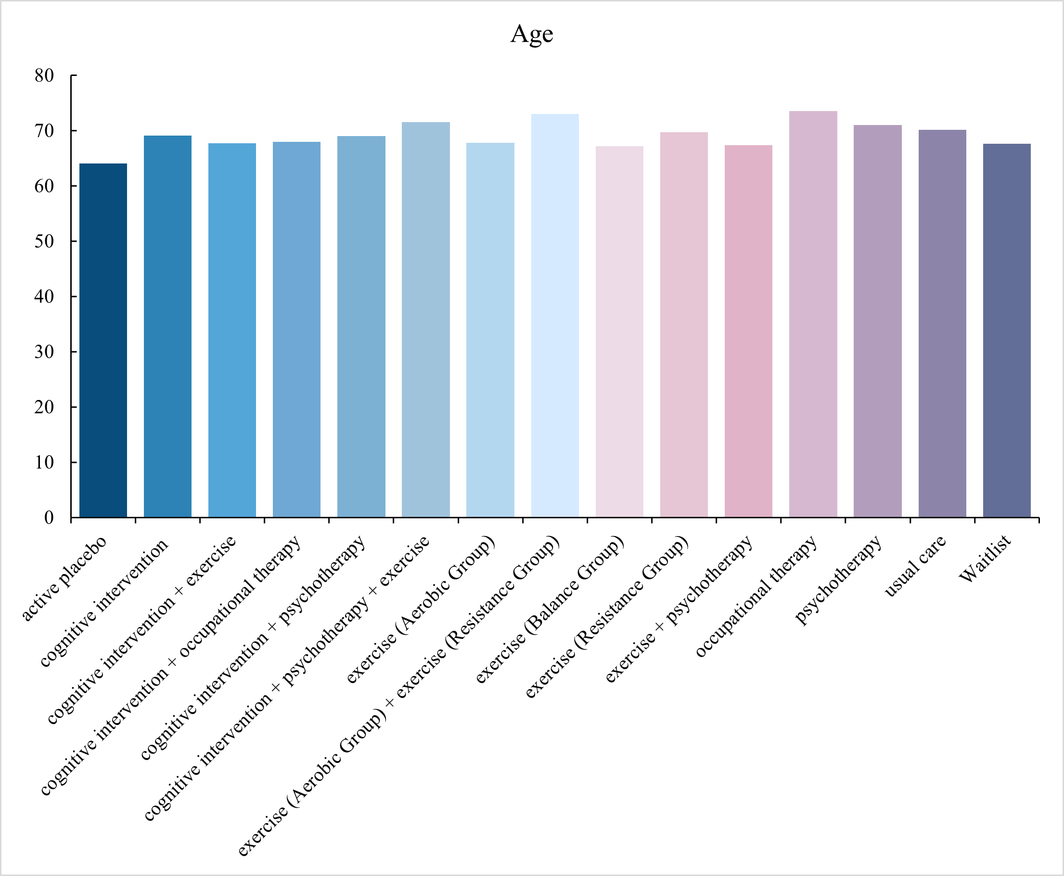
10.2 Gender
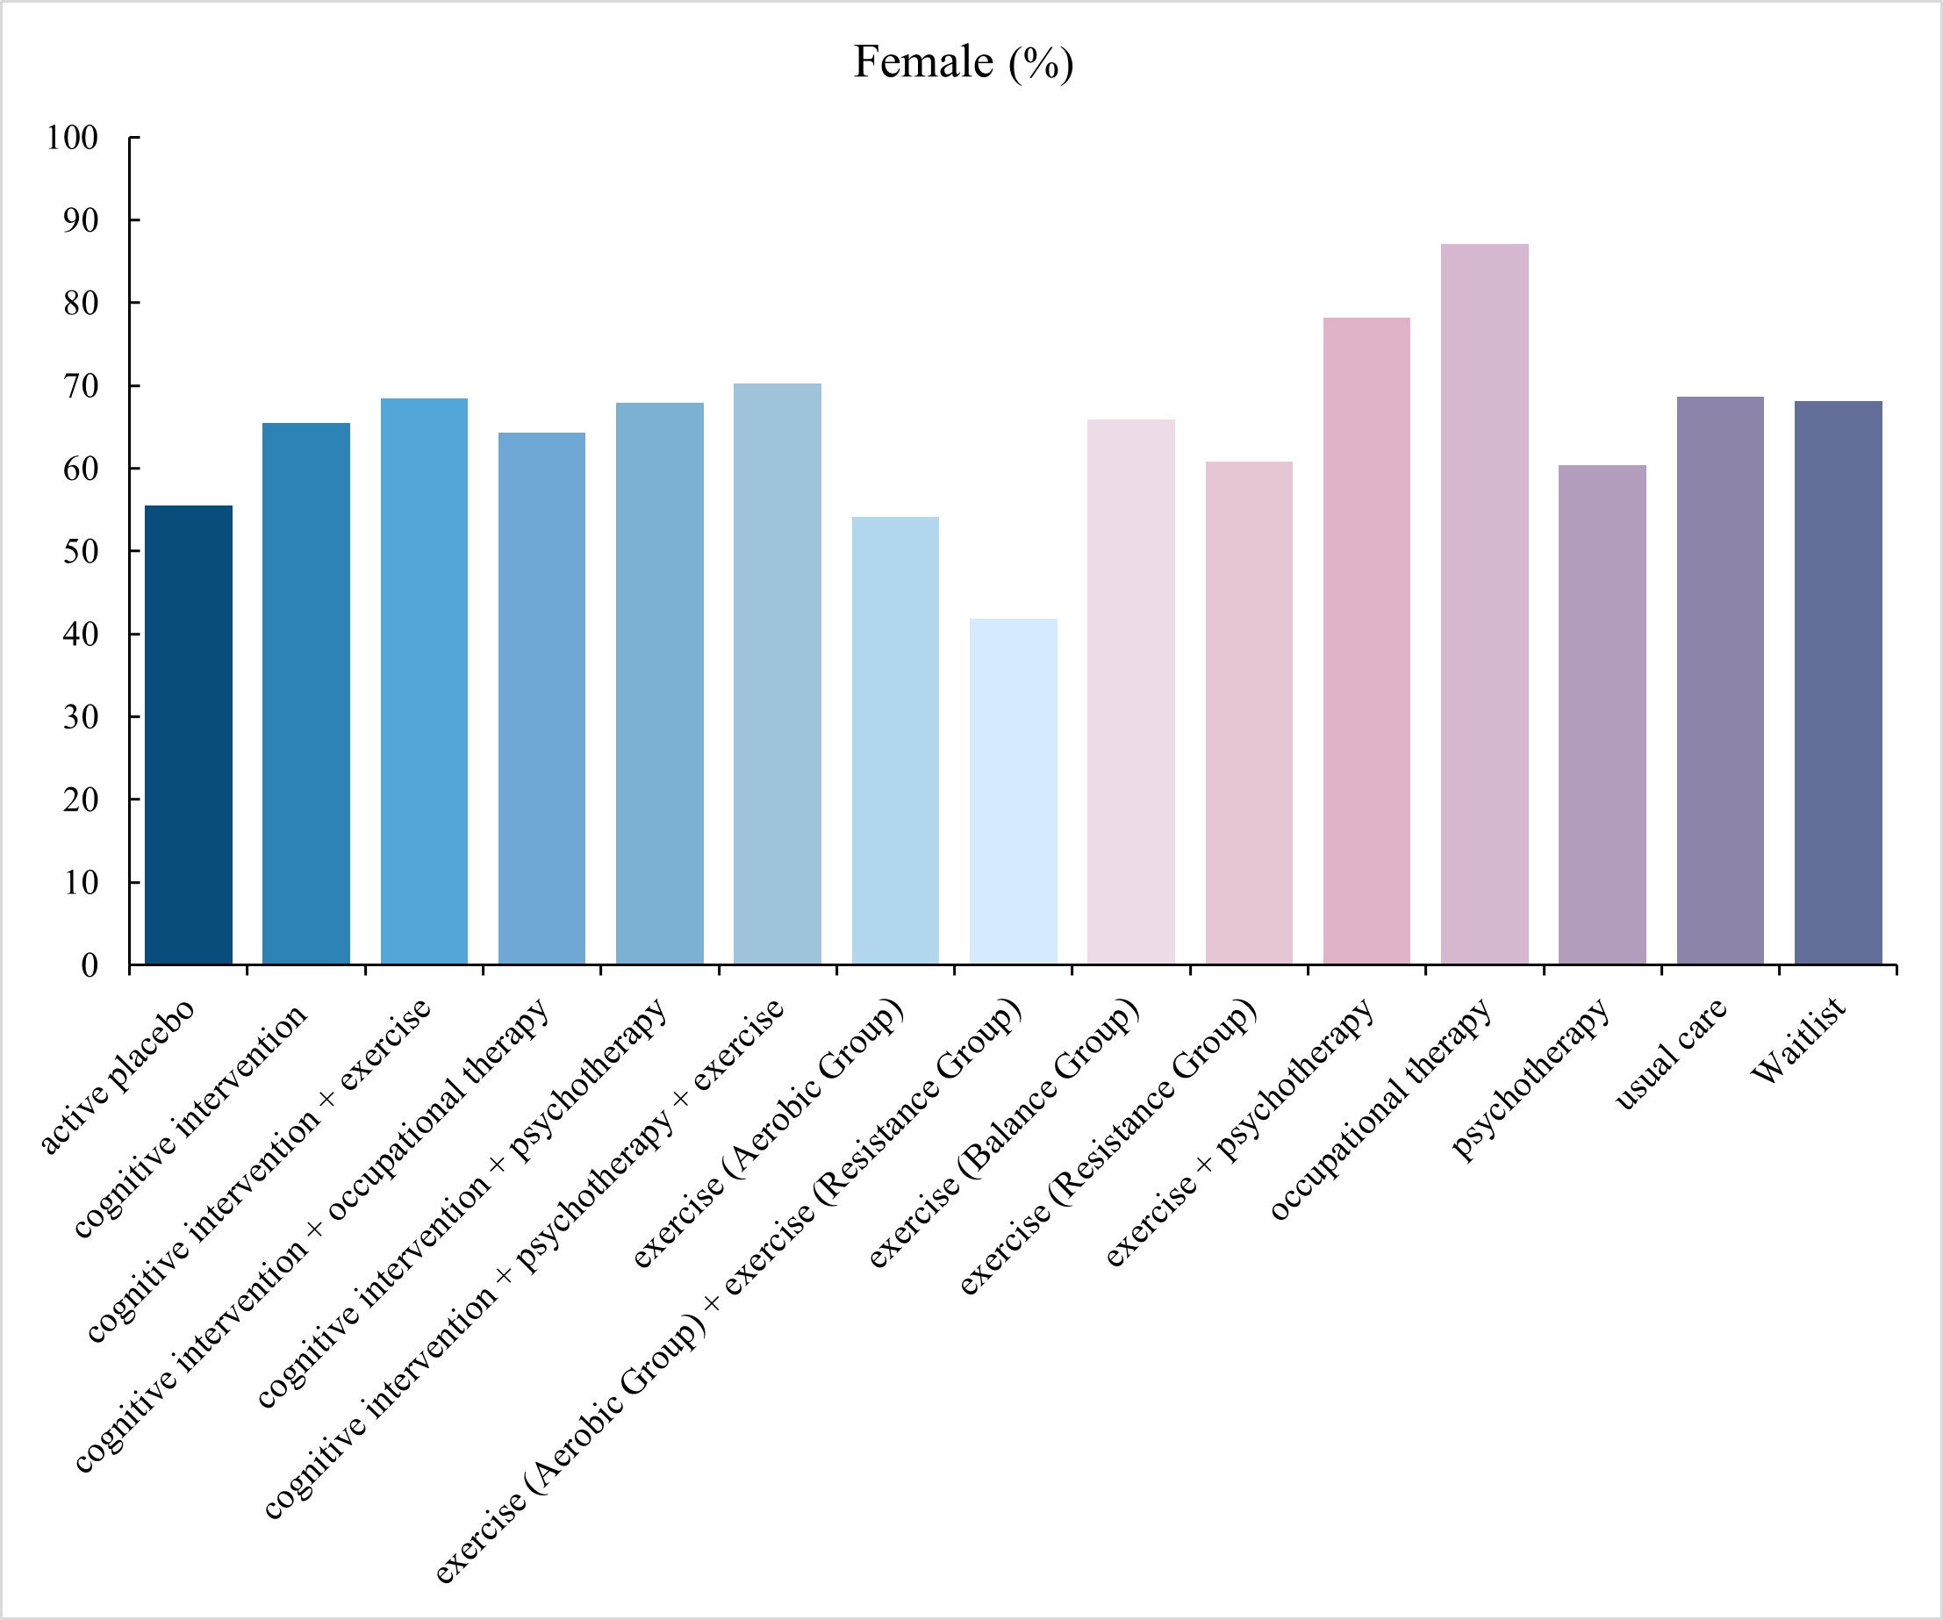
10.3 Treatment duration
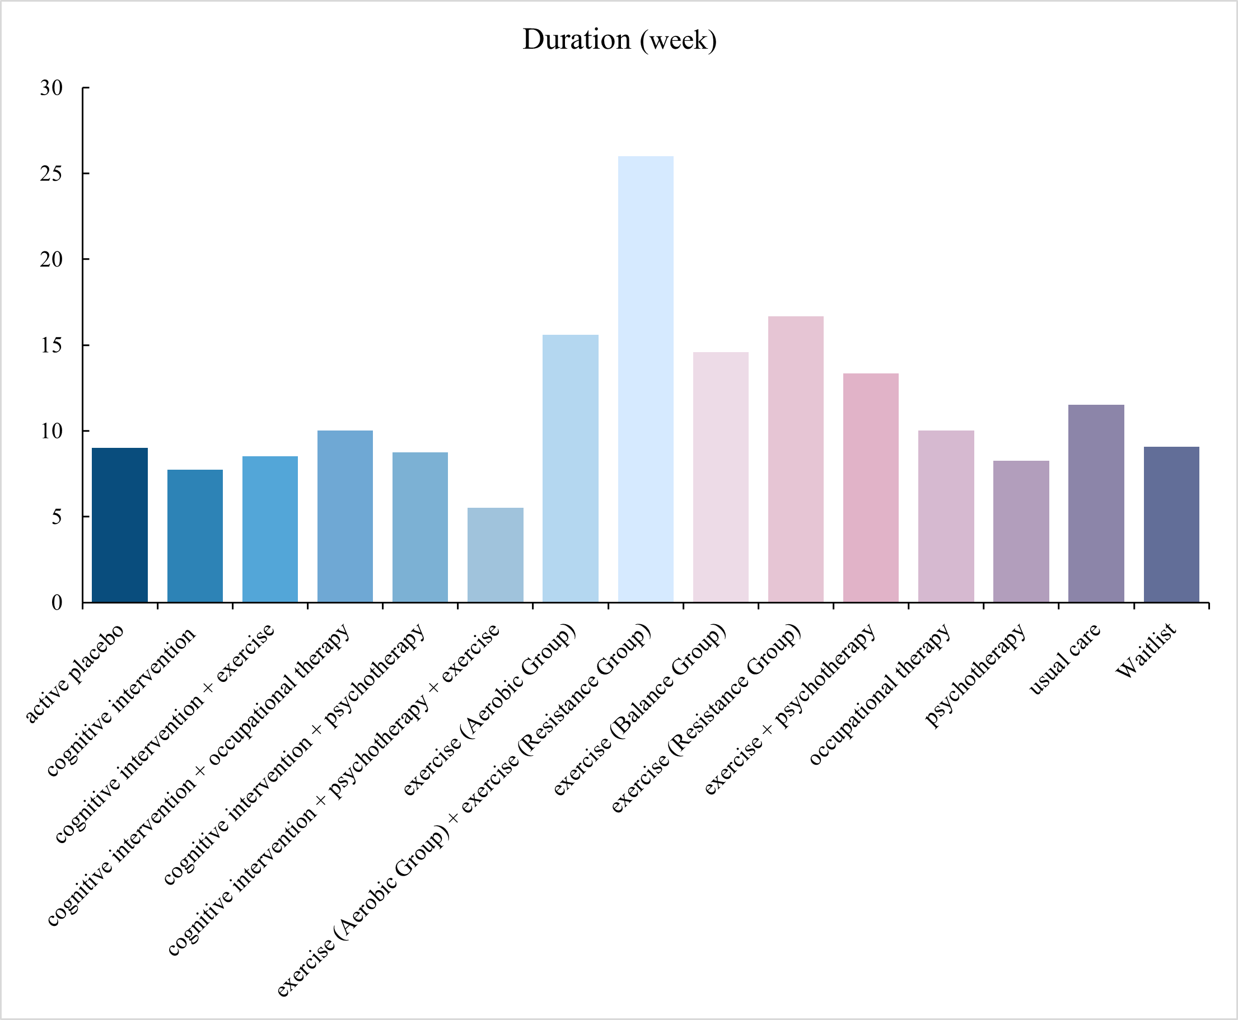

eAppendix 11. Inconsistency test for direct and indirect evidence

eAppendix 12. Grading the evidence of the network meta-analysis using CINeMA

12.1 CINeMA quality assessment of the comparisons in the network
We evaluated the certainty of evidence for all the outcomes by using the Confidence in Network Meta-Analysis Software CINeMA, which covers 6 domains: (i) within-study bias, (ii) reporting bias, (iii) indirectness, (iv) imprecision, (v) heterogeneity, and (vi) incoherence and was considered to be a transparent, rigorous, and comprehensive system. We assessed each network estimate according to the following criteria [1-2].
1.within-study bias:
We assigned to each trial an overall risk of bias judgement according to the following criteria: a study with a judgement of high risk of bias in one or more domain has been considered as a ‘high risk’ study, a judgement of low risk of bias in most domains lead to a ‘low risk’ study at least four out of seven, and a study with judgements of unclear risk of bias in most domains has been considered as a ‘moderate risk’ study at least four out of seven. We rated each pairwise comparison based on the average bias judgment across direct estimate contribution from individual studies to the contribution matrix. The table below shows how the global rating is coded base on the individual items of the risk of bias tool:
Global rating | Items with high risk | Items with unclear risk
low | 0 | ≤ 3
moderate | 0 | ＞3
moderate | 1 | any
High risk | ≥ 1 | any
2. Reporting bias:
We systematically searched electronic databases and contacted investigators and relevant experimenters by mail to obtain detailed literature information for incomplete reports and information on unpublished experiments. Also, we conducted various manual and non-database Internet searches to find additional papers that met the criteria. Therefore, although our study took a lot of time to complete the review, for which recently published literature was not included, our search was systematic and comprehensive for the dates included in the search. Furthermore, in pairwise comparisons with at least ten trials, the presence of small-study effects was examined graphically by generating comparison adjusted funnel plots. Egger’s test was carried out to evaluate the funnel plot symmetry. A p-value less than 0.05 was considered significant [3]. We did not find that there was a significant publication bias.
3. Indirectness:
In order to control for transmission studies in adults with subjective memory complaints, studies in cognitively impaired subjects (MCI, AD), psychiatric disorders, neurologic disorders, or substance abuse were excluded a priori. Because their degree of cognitive impairment and performance is known to be different from that of SCD adults. Therefore, no indirectness was assumed and no comparison was downgraded for this reason.
4. Imprecision:
We could not find any published value for clinically important relative effect estimate in the intervention study of SCD. Drawing from Cohen et al. effect sizes were categorized as small when below 0.2, moderate between 0.2 and 0.5, and large above 0.5 [4]. Through group discussions, for comparisons of two non-pharmacological interventions the clinically meaningful threshold was set at standardized mean differences of -0.5 and 0.5 for continuous outcomes and at odds ratio of 0.8 and 1.25 for dichotomous outcomes. If the confidence interval crossed one threshold the comparison was downgraded one level. Crossing both thresholds resulted in a downgrading of two levels.
5. Heterogeneity:
We made use of prediction intervals to prepopulate judgments on heterogeneity and its implications on the quality of the network treatment effects. We judged the agreement of conclusions based on confidence and prediction intervals in relation to the clinically important effect size. The recommendations automatically provided by CINeMA were followed [2].
6. Incoherence:
To evaluate the presence of inconsistency locally, we compared direct and indirect treatment estimates of each treatment comparisons as this can be used to inspect the consistency of a network meta-analysis [5]. For this purpose, we used the netsplit command in the R package netmeta 1.0-1, which enables the splitting of the network evidence into direct and indirect contributions [6]. For each treatment comparison, direct and indirect treatment estimates and the network are presented as forest plots. We did not downgrade comparisons that had only direct evidence with respect to incoherence.
Reference:
- Nikolakopoulou A, Higgins JPT, Papakonstantinou T, Chaimani A, Del Giovane C, Egger M, et al. CINeMA: An approach for assessing confidence in the results of a network meta-analysis. PLoS Med. 2020;17(4):e1003082.
- De Crescenzo F, D'Alò GL, Ostinelli EG, Ciabattini M, Di Franco V, Watanabe N, et al. Comparative effects of pharmacological interventions for the acute and long-term management of insomnia disorder in adults: a systematic review and network meta-analysis. Lancet. 2022;400(10347):170-84.
- Sterne JAC, Egger M, Moher D. Addressing Reporting Biases. In: Higgins JPT, editor. Cochrane handbook for systematic reviews of interventions. Chichester: Wiley-Blackwell; 2008. p. 297–333.
- Warsi A, LaValley MP, Wang PS, Avorn J, Solomon DH. Arthritis self-management education programs: a meta-analysis of the effect on pain and disability. Arthritis Rheum. 2003;48(8):2207-13.
- Dias S, Welton NJ, Caldwell DM, Ades AE. Checking consistency in mixed treatment comparison meta-analysis. Stat Med. 2010;29(7-8):932-44.
- Roheger M, Hennersdorf XS, Riemann S, Flöel A, Meinzer M. A systematic review and network meta-analysis of interventions for subjective cognitive decline. Alzheimers Dement (N Y). 2021;7(1):e12180.

12.2 Results of the comparison-adjusted funnel plot
12.2.1 Subjective memory complaints
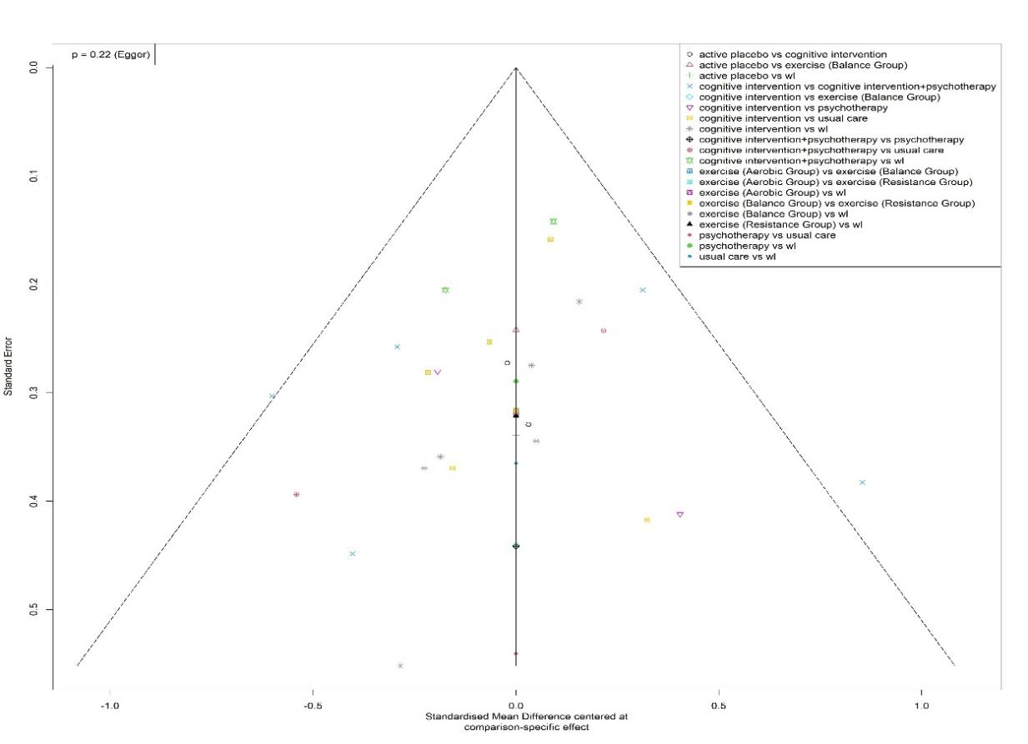
12.2.2 General Cognitive Functioning
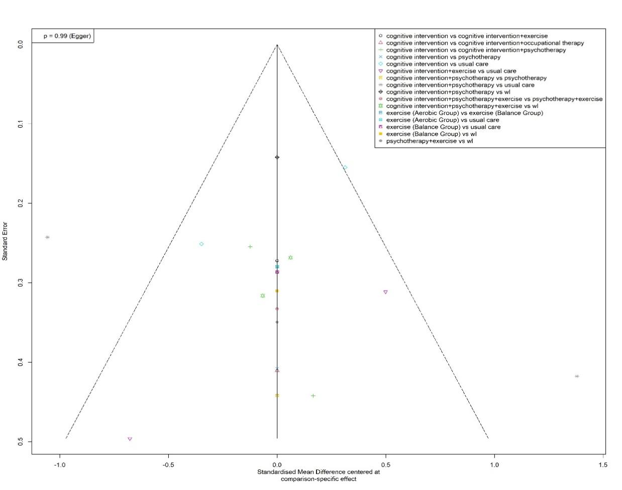

12.2.3 Language function: less than ten studies, not suitable for publication bias test
12.2.4 Executive function
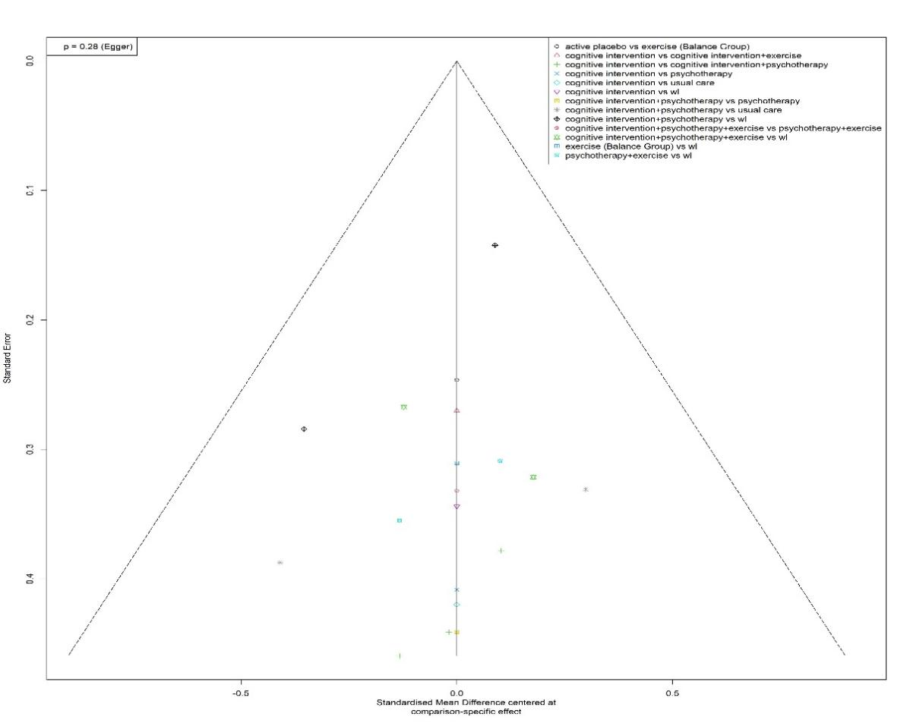
12.2.5 Visuospatial ability
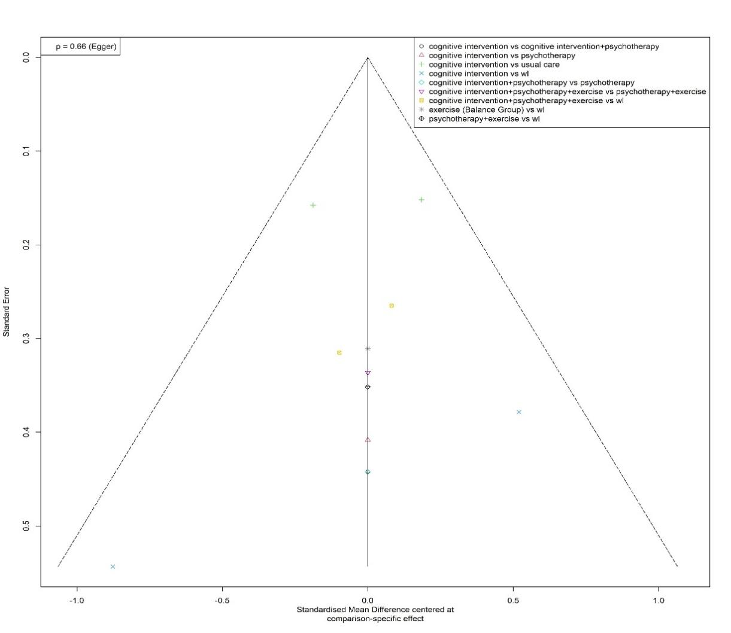
12.2.6 Attention
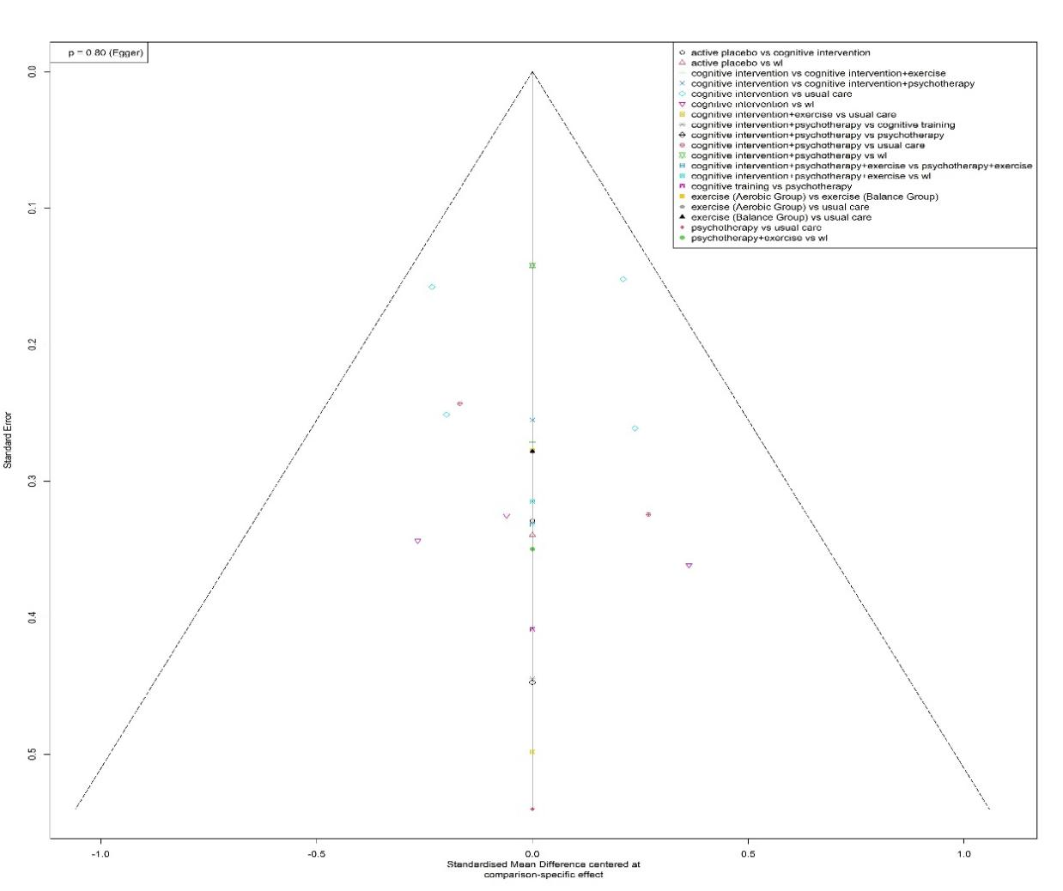
12.2.7 Anxiety
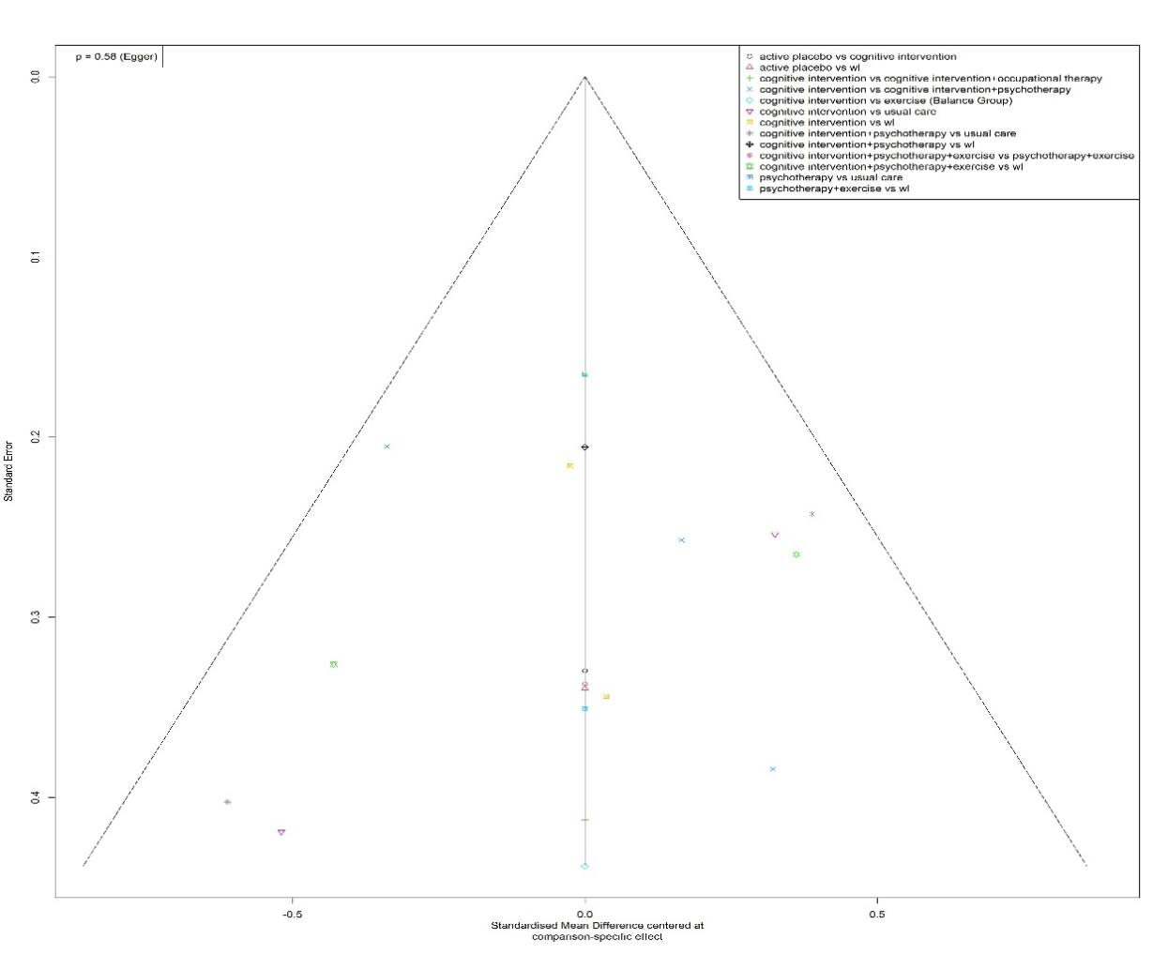
12.2.8 Depression
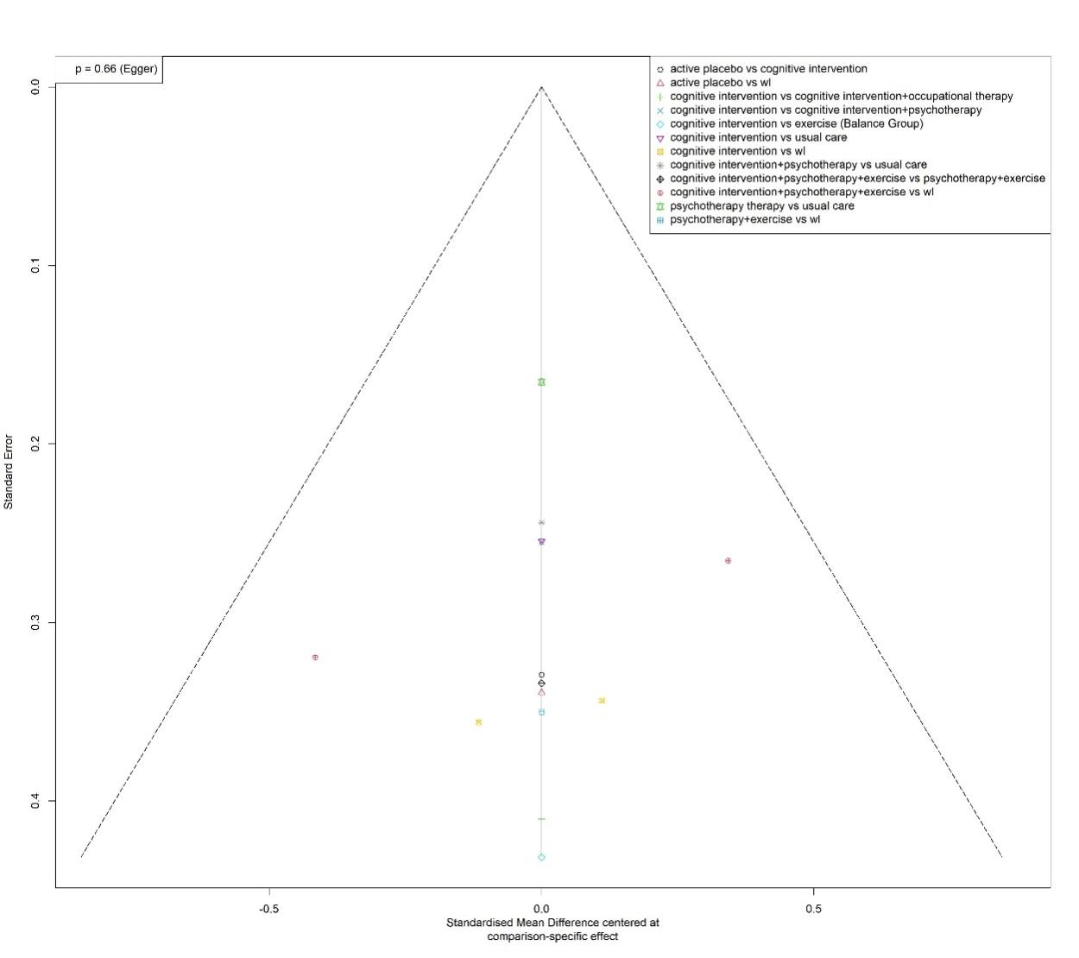

12.3 Risk of Bias Chart showing the contribution of low, moderate or high RoB comparisons to each network estimates.
12.3.1 Subjective memory complaints
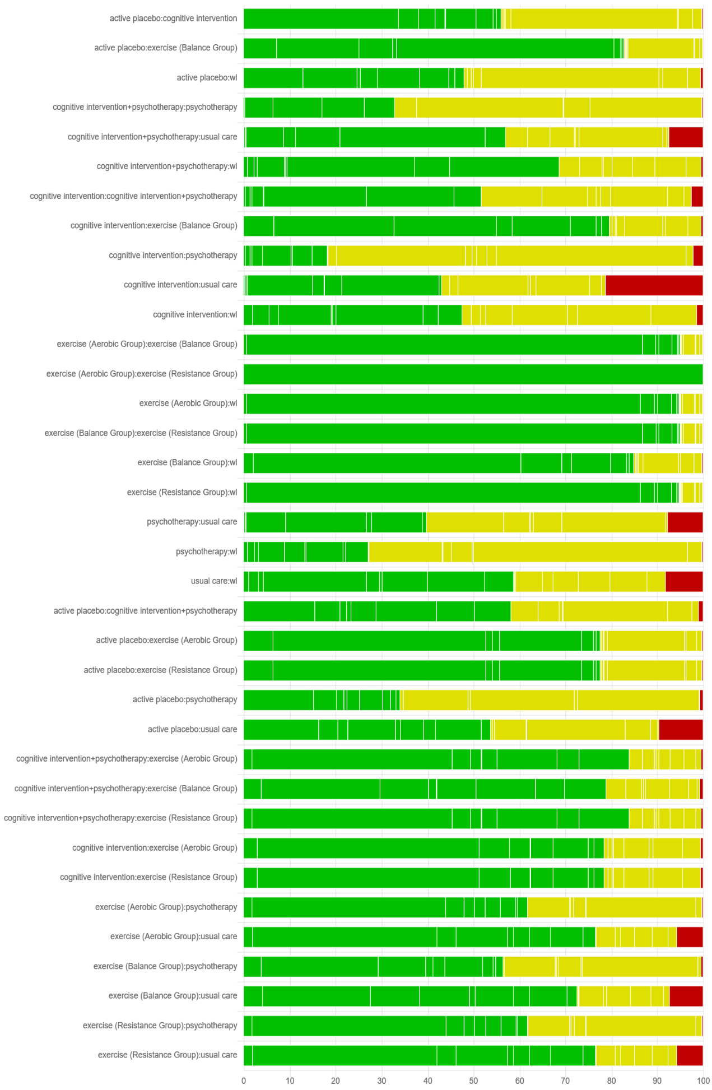
12.3.2 Global cognitive function
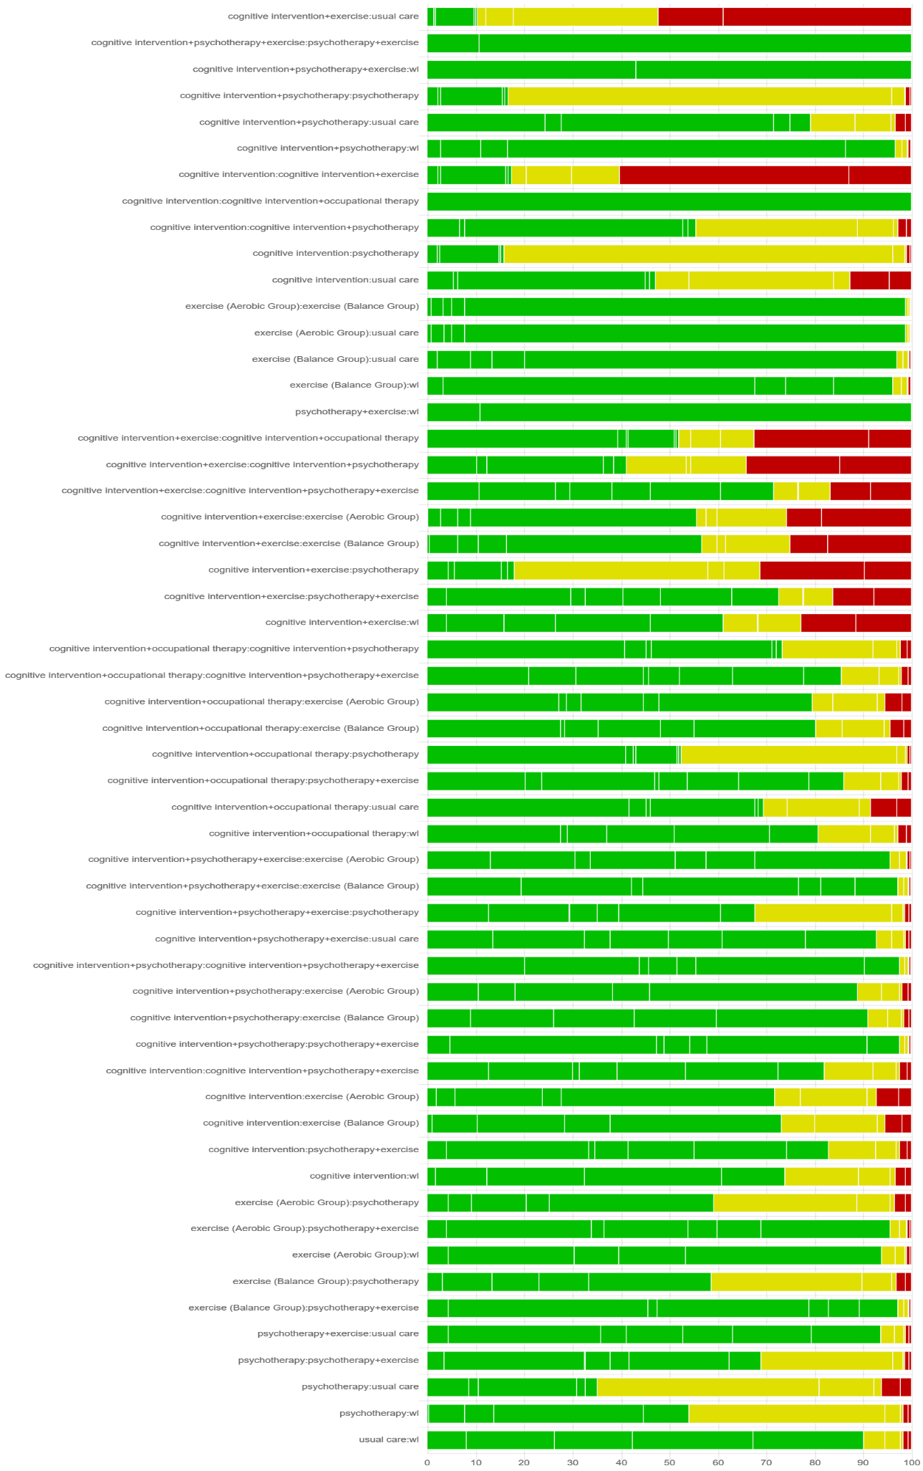
12.3.3 Language function
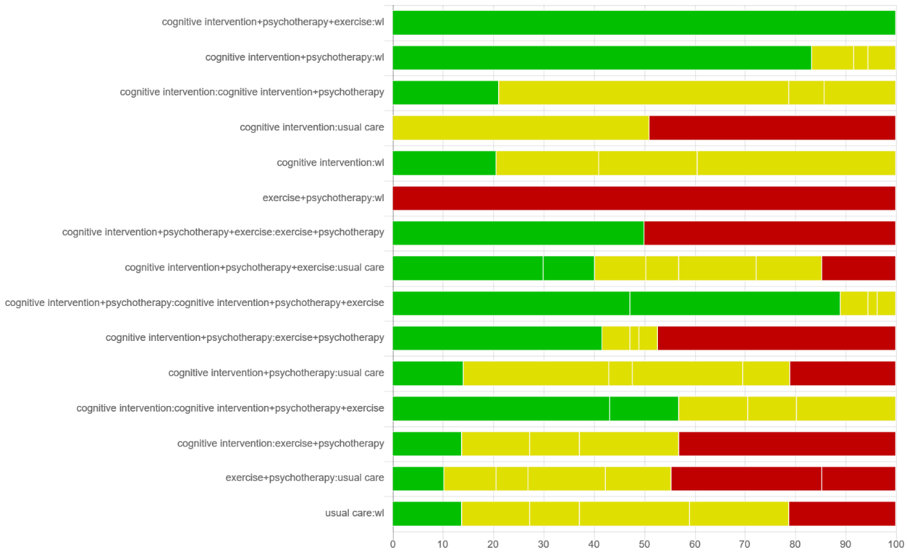
12.3.4 Visuospatial ability
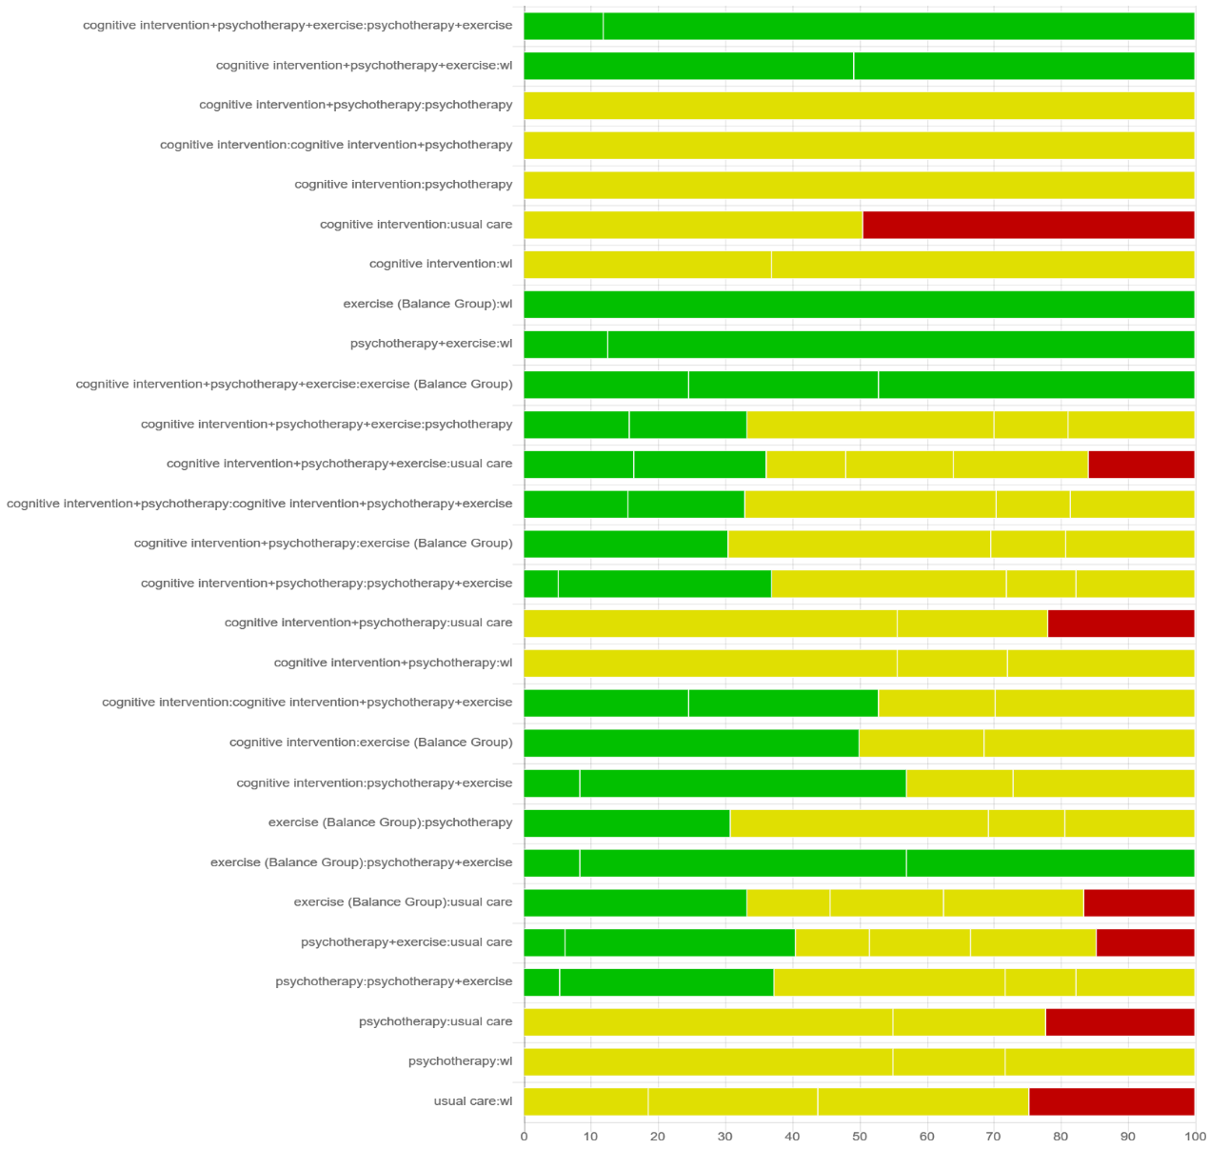
12.3.5 Executive function
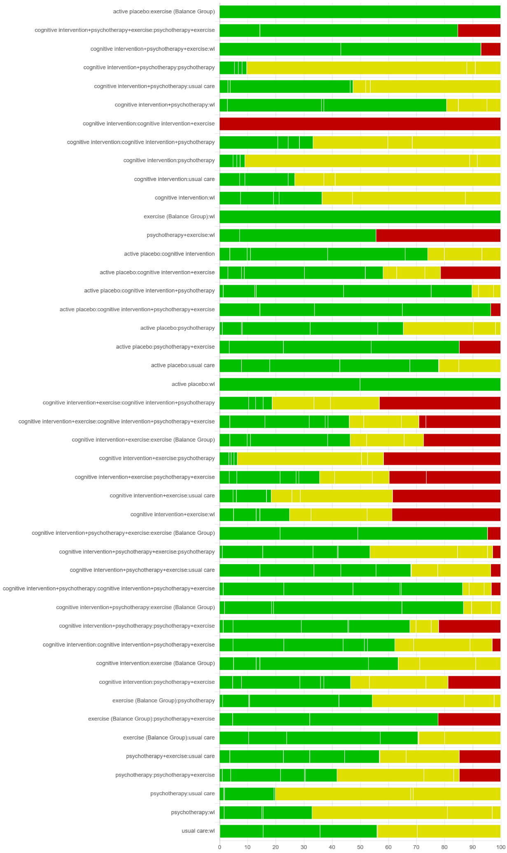
12.3.6 Attention
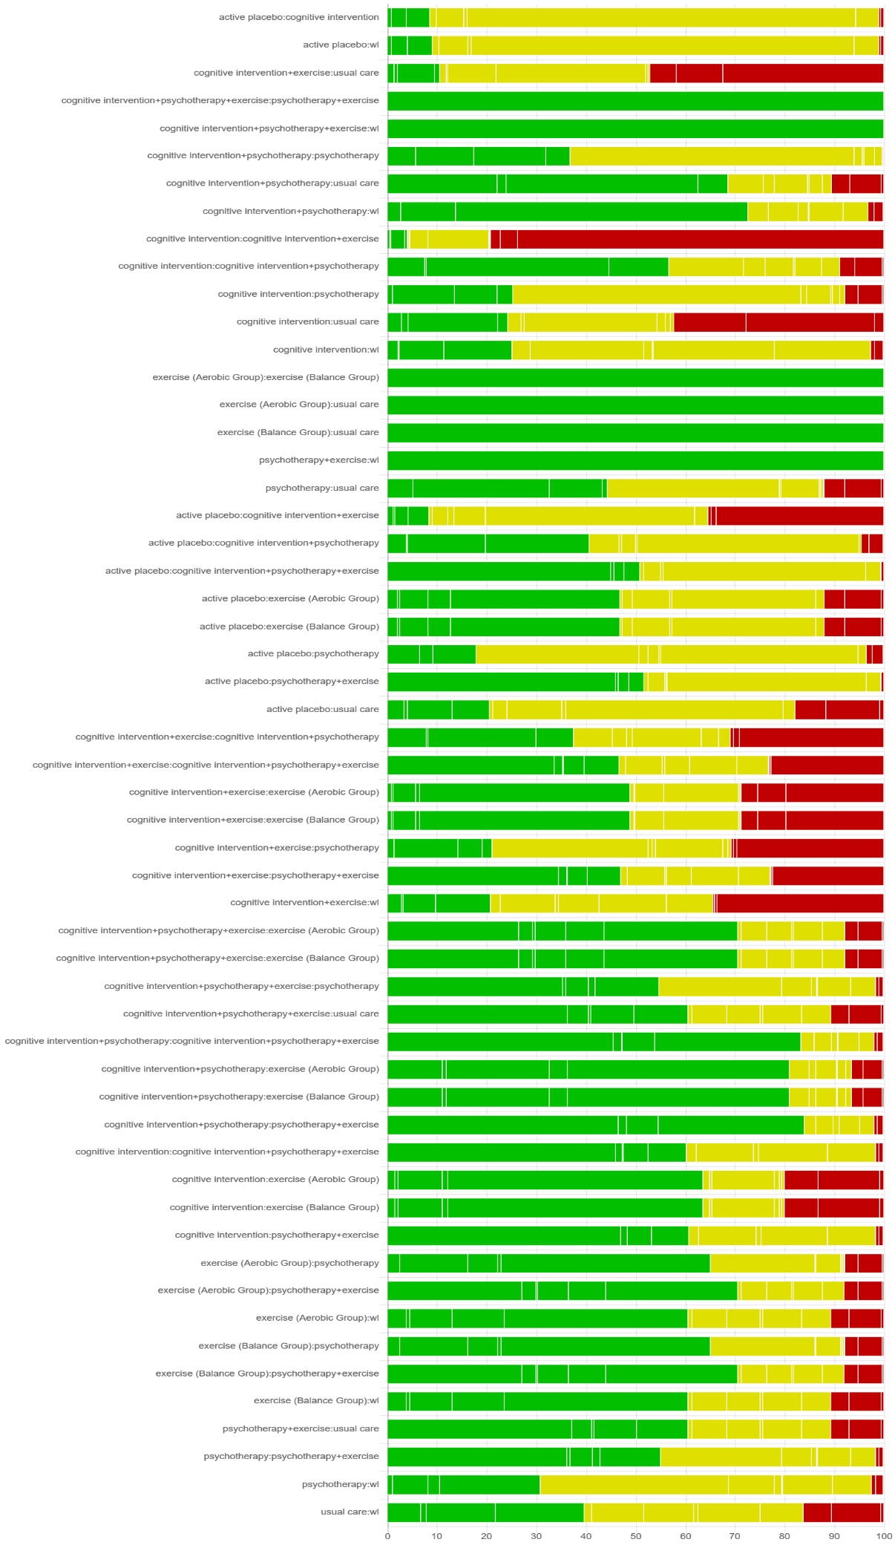
12.3.7 Anxiety
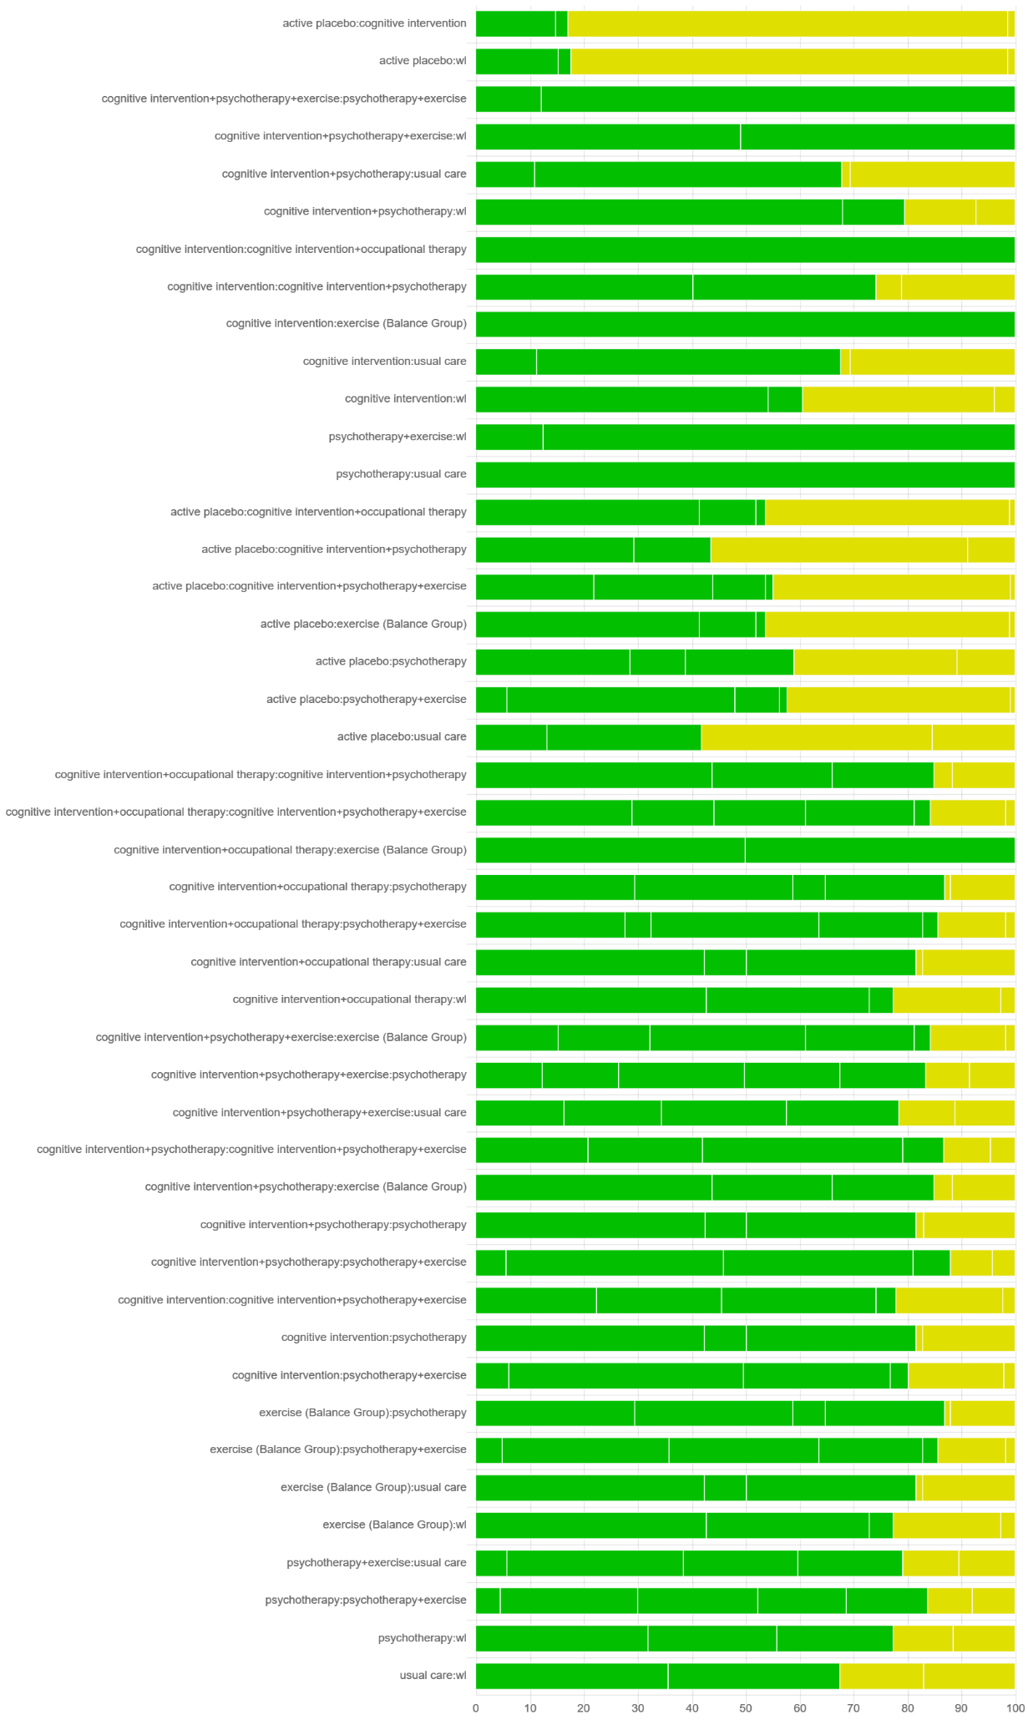
12.3.8 Depression
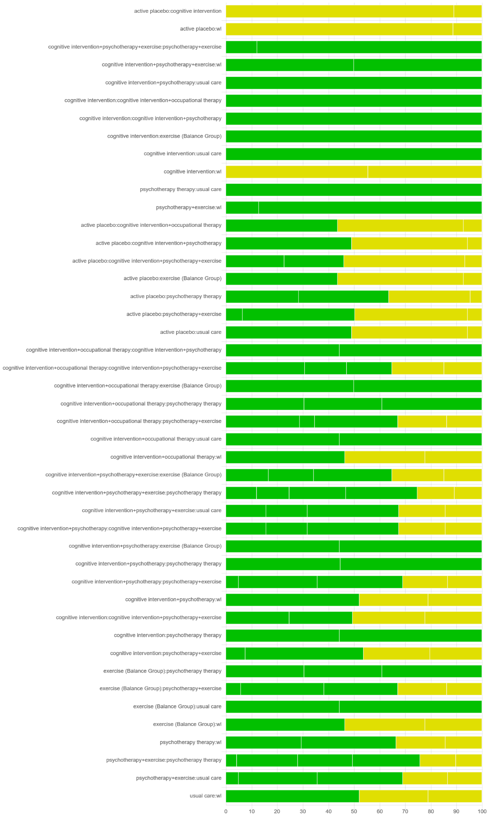

12.4 Results of the CINeMA quality assessment
12.4.1 Subjective memory complaints
Comparison | N. of studies | Within-study bias | Reporting bias | Indirectness | Imprecision | Heterogeneity | Incoherence | Confidence  rating
active placebo:cognitive intervention | 2 | No concerns | Low risk | No concerns | Some concerns | Some concerns | No concerns | Low
active placebo:exercise (Balance Group) | 1 | No concerns | Low risk | No concerns | Some concerns | Some concerns | No concerns | Low
active placebo:wl | 1 | Some concerns | Low risk | No concerns | Major concerns | No concerns | No concerns | Very Low
cognitive intervention:cognitive intervention+psychotherapy | 5 | Some concerns | Some concerns | No concerns | No concerns | Major concerns | No concerns | Very Low
cognitive intervention:exercise (Balance Group) | 1 | No concerns | Low risk | No concerns | Major concerns | No concerns | Major concerns | Very Low
cognitive intervention:psychotherapy | 2 | Some concerns | Low risk | No concerns | Some concerns | Some concerns | No concerns | Very Low
cognitive intervention:usual care | 5 | Some concerns | Low risk | No concerns | No concerns | Major concerns | No concerns | Very Low
cognitive intervention:wl | 6 | Some concerns | Low risk | No concerns | No concerns | Major concerns | No concerns | Very Low
cognitive intervention+psychotherapy:psychotherapy | 1 | Some concerns | Low risk | No concerns | Some concerns | Some concerns | No concerns | Very Low
cognitive intervention+psychotherapy:usual care | 2 | Some concerns | Low risk | No concerns | No concerns | Major concerns | No concerns | Very Low
cognitive intervention+psychotherapy:wl | 2 | No concerns | Low risk | No concerns | Some concerns | Some concerns | No concerns | Low
exercise (Aerobic Group):exercise (Balance Group) | 1 | No concerns | Low risk | No concerns | Major concerns | No concerns | No concerns | Low
exercise (Aerobic Group):exercise (Resistance Group) | 1 | No concerns | Low risk | No concerns | Major concerns | No concerns | No concerns | Low
exercise (Aerobic Group):wl | 1 | No concerns | Low risk | No concerns | Some concerns | Some concerns | No concerns | Low
exercise (Balance Group):exercise (Resistance Group) | 1 | No concerns | Low risk | No concerns | Major concerns | No concerns | No concerns | Low
exercise (Balance Group):wl | 1 | No concerns | Low risk | No concerns | Some concerns | Some concerns | No concerns | Low
exercise (Resistance Group):wl | 1 | No concerns | Low risk | No concerns | Some concerns | Some concerns | No concerns | Low
psychotherapy:usual care | 1 | Some concerns | Low risk | No concerns | Some concerns | Some concerns | No concerns | Very Low
psychotherapy:wl | 1 | Some concerns | Low risk | No concerns | Some concerns | No concerns | No concerns | Low
usual care:wl | 1 | No concerns | Low risk | No concerns | Some concerns | Some concerns | No concerns | Low
active placebo:cognitive intervention+psychotherapy | 0 | No concerns | Low risk | No concerns | Some concerns | Some concerns | No concerns | Low
active placebo:exercise (Aerobic Group) | 0 | No concerns | Low risk | No concerns | Some concerns | Some concerns | No concerns | Low
active placebo:exercise (Resistance Group) | 0 | No concerns | Low risk | No concerns | Some concerns | Some concerns | No concerns | Low
active placebo:psychotherapy | 0 | Some concerns | Low risk | No concerns | Some concerns | Some concerns | No concerns | Very Low
active placebo:usual care | 0 | Some concerns | Low risk | No concerns | Some concerns | Some concerns | No concerns | Very Low
cognitive intervention:exercise (Aerobic Group) | 0 | No concerns | Low risk | No concerns | Major concerns | No concerns | No concerns | Low
cognitive intervention:exercise (Resistance Group) | 0 | No concerns | Low risk | No concerns | Major concerns | No concerns | No concerns | Low
cognitive intervention+psychotherapy:exercise (Aerobic Group) | 0 | No concerns | Low risk | No concerns | Major concerns | No concerns | No concerns | Low
cognitive intervention+psychotherapy:exercise (Balance Group) | 0 | No concerns | Low risk | No concerns | Major concerns | No concerns | No concerns | Low
cognitive intervention+psychotherapy:exercise (Resistance Group) | 0 | No concerns | Low risk | No concerns | Major concerns | No concerns | No concerns | Low
exercise (Aerobic Group):psychotherapy | 0 | No concerns | Low risk | No concerns | Major concerns | No concerns | No concerns | Low
exercise (Aerobic Group):usual care | 0 | No concerns | Low risk | No concerns | Major concerns | No concerns | No concerns | Low
exercise (Balance Group):psychotherapy | 0 | No concerns | Low risk | No concerns | Major concerns | No concerns | No concerns | Low
exercise (Balance Group):usual care | 0 | No concerns | Low risk | No concerns | Major concerns | No concerns | No concerns | Low
exercise (Resistance Group):psychotherapy | 0 | No concerns | Low risk | No concerns | Major concerns | No concerns | No concerns | Low
exercise (Resistance Group):usual care | 0 | No concerns | Low risk | No concerns | Major concerns | No concerns | No concerns | Low
12.4.2 General cognitive functioning
Comparison | N. of studies | Within-study bias | Reporting bias | Indirectness | Imprecision | Heterogeneity | Incoherence | Confidence  rating
cognitive intervention:cognitive intervention+exercise | 1 | Some concerns | Low risk | No concerns | Major concerns | No concerns | No concerns | Very Low
cognitive intervention:cognitive intervention+occupational therapy | 1 | No concerns | Low risk | No concerns | Major concerns | No concerns | No concerns | Low
cognitive intervention:cognitive intervention+psychotherapy | 2 | No concerns | Low risk | No concerns | Major concerns | No concerns | No concerns | Low
cognitive intervention:psychotherapy | 1 | Some concerns | Low risk | No concerns | Major concerns | No concerns | No concerns | Very Low
cognitive intervention:usual care | 2 | Some concerns | Low risk | No concerns | Some concerns | Some concerns | No concerns | Very Low
cognitive intervention+exercise:usual care | 2 | Some concerns | Low risk | No concerns | Some concerns | Some concerns | No concerns | Very Low
cognitive intervention+psychotherapy:psychotherapy | 1 | Some concerns | Low risk | No concerns | Major concerns | No concerns | No concerns | Very Low
cognitive intervention+psychotherapy:usual care | 2 | No concerns | Low risk | No concerns | Some concerns | Some concerns | No concerns | Low
cognitive intervention+psychotherapy:wl | 1 | No concerns | Low risk | No concerns | Major concerns | No concerns | No concerns | Low
cognitive intervention+psychotherapy+exercise:psychotherapy+exercise | 1 | No concerns | Low risk | No concerns | Major concerns | No concerns | No concerns | Low
cognitive intervention+psychotherapy+exercise:wl | 2 | No concerns | Low risk | No concerns | Major concerns | No concerns | No concerns | Low
exercise (Aerobic Group):exercise (Balance Group) | 1 | No concerns | Low risk | No concerns | Major concerns | No concerns | No concerns | Low
exercise (Aerobic Group):usual care | 1 | No concerns | Low risk | No concerns | Major concerns | No concerns | No concerns | Low
exercise (Balance Group):usual care | 1 | No concerns | Low risk | No concerns | Major concerns | No concerns | No concerns | Low
exercise (Balance Group):wl | 1 | No concerns | Low risk | No concerns | Major concerns | No concerns | No concerns | Low
psychotherapy+exercise:wl | 1 | No concerns | Some concerns | No concerns | Major concerns | No concerns | No concerns | Low
cognitive intervention:cognitive intervention+psychotherapy+exercise | 0 | No concerns | Low risk | No concerns | Major concerns | No concerns | No concerns | Low
cognitive intervention:exercise (Aerobic Group) | 0 | No concerns | Low risk | No concerns | Major concerns | No concerns | No concerns | Low
cognitive intervention:exercise (Balance Group) | 0 | No concerns | Low risk | No concerns | Some concerns | Some concerns | No concerns | Low
cognitive intervention:psychotherapy+exercise | 0 | No concerns | Low risk | No concerns | Major concerns | No concerns | No concerns | Low
cognitive intervention:wl | 0 | No concerns | Low risk | No concerns | Major concerns | No concerns | No concerns | Low
cognitive intervention+exercise:cognitive intervention+occupational therapy | 0 | Some concerns | Low risk | No concerns | Major concerns | No concerns | No concerns | Very Low
cognitive intervention+exercise:cognitive intervention+psychotherapy | 0 | Some concerns | Low risk | No concerns | Major concerns | No concerns | No concerns | Very Low
cognitive intervention+exercise:cognitive intervention+psychotherapy+exercise | 0 | No concerns | Low risk | No concerns | Major concerns | No concerns | No concerns | Low
cognitive intervention+exercise:exercise (Aerobic Group) | 0 | Some concerns | Low risk | No concerns | Major concerns | No concerns | No concerns | Very Low
cognitive intervention+exercise:exercise (Balance Group) | 0 | Some concerns | Low risk | No concerns | Major concerns | No concerns | No concerns | Very Low
cognitive intervention+exercise:psychotherapy | 0 | Some concerns | Low risk | No concerns | Major concerns | No concerns | No concerns | Very Low
cognitive intervention+exercise:psychotherapy+exercise | 0 | No concerns | Low risk | No concerns | Major concerns | No concerns | No concerns | Low
cognitive intervention+exercise:wl | 0 | Some concerns | Low risk | No concerns | Major concerns | No concerns | No concerns | Very Low
cognitive intervention+occupational therapy:cognitive intervention+psychotherapy | 0 | No concerns | Low risk | No concerns | Major concerns | No concerns | No concerns | Low
cognitive intervention+occupational therapy:cognitive intervention+psychotherapy+exercise | 0 | No concerns | Low risk | No concerns | Major concerns | No concerns | No concerns | Low
cognitive intervention+occupational therapy:exercise (Aerobic Group) | 0 | No concerns | Low risk | No concerns | Major concerns | No concerns | No concerns | Low
cognitive intervention+occupational therapy:exercise (Balance Group) | 0 | No concerns | Low risk | No concerns | Major concerns | No concerns | No concerns | Low
cognitive intervention+occupational therapy:psychotherapy | 0 | No concerns | Low risk | No concerns | Major concerns | No concerns | No concerns | Low
cognitive intervention+occupational therapy:psychotherapy+exercise | 0 | No concerns | Low risk | No concerns | Major concerns | No concerns | No concerns | Low
cognitive intervention+occupational therapy:usual care | 0 | No concerns | Low risk | No concerns | Major concerns | No concerns | No concerns | Low
cognitive intervention+occupational therapy:wl | 0 | No concerns | Low risk | No concerns | Major concerns | No concerns | No concerns | Low
cognitive intervention+psychotherapy:cognitive intervention+psychotherapy+exercise | 0 | No concerns | Low risk | No concerns | Some concerns | Some concerns | No concerns | Low
cognitive intervention+psychotherapy:exercise (Aerobic Group) | 0 | No concerns | Low risk | No concerns | Major concerns | No concerns | No concerns | Low
cognitive intervention+psychotherapy:exercise (Balance Group) | 0 | No concerns | Low risk | No concerns | Some concerns | Some concerns | No concerns | Low
cognitive intervention+psychotherapy:psychotherapy+exercise | 0 | No concerns | Low risk | No concerns | Major concerns | No concerns | No concerns | Low
cognitive intervention+psychotherapy+exercise:exercise (Aerobic Group) | 0 | No concerns | Low risk | No concerns | Major concerns | No concerns | No concerns | Low
cognitive intervention+psychotherapy+exercise:exercise (Balance Group) | 0 | No concerns | Low risk | No concerns | Major concerns | No concerns | No concerns | Low
cognitive intervention+psychotherapy+exercise:psychotherapy | 0 | No concerns | Low risk | No concerns | Major concerns | No concerns | No concerns | Low
cognitive intervention+psychotherapy+exercise:usual care | 0 | No concerns | Low risk | No concerns | Major concerns | No concerns | No concerns | Low
exercise (Aerobic Group):psychotherapy | 0 | No concerns | Low risk | No concerns | Major concerns | No concerns | No concerns | Low
exercise (Aerobic Group):psychotherapy+exercise | 0 | No concerns | Low risk | No concerns | Major concerns | No concerns | No concerns | Low
exercise (Aerobic Group):wl | 0 | No concerns | Low risk | No concerns | Major concerns | No concerns | No concerns | Low
exercise (Balance Group):psychotherapy | 0 | No concerns | Low risk | No concerns | Major concerns | No concerns | No concerns | Low
exercise (Balance Group):psychotherapy+exercise | 0 | No concerns | Low risk | No concerns | Major concerns | No concerns | No concerns | Low
psychotherapy:psychotherapy+exercise | 0 | No concerns | Low risk | No concerns | Major concerns | No concerns | No concerns | Low
psychotherapy:usual care | 0 | Some concerns | Low risk | No concerns | Major concerns | No concerns | No concerns | Very Low
psychotherapy:wl | 0 | No concerns | Low risk | No concerns | Major concerns | No concerns | No concerns | Low
psychotherapy+exercise:usual care | 0 | No concerns | Low risk | No concerns | Major concerns | No concerns | No concerns | Low
usual care:wl | 0 | No concerns | Low risk | No concerns | Major concerns | No concerns | No concerns | Low
12.4.3 Language function
Comparison | N. of studies | Within-study bias | Reporting bias | Indirectness | Imprecision | Heterogeneity | Incoherence | Confidence  rating
cognitive intervention:cognitive intervention+psychotherapy | 2 | No concerns | Low risk | No concerns | Major concerns | No concerns | No concerns | Low
cognitive intervention:usual care | 2 | Some concerns | Low risk | No concerns | Some concerns | Some concerns | No concerns | Very Low
cognitive intervention+psychotherapy:usual care | 2 | No concerns | Low risk | No concerns | Some concerns | Some concerns | No concerns | Low
cognitive intervention+psychotherapy:wl | 1 | No concerns | Low risk | No concerns | Major concerns | No concerns | No concerns | Low
cognitive intervention+psychotherapy+exercise:psychotherapy+exercise | 1 | No concerns | Low risk | No concerns | Major concerns | No concerns | No concerns | Low
cognitive intervention+psychotherapy+exercise:wl | 2 | No concerns | Low risk | No concerns | Major concerns | No concerns | No concerns | Low
psychotherapy+exercise:wl | 1 | No concerns | Some concerns | No concerns | Major concerns | No concerns | No concerns | Very Low
cognitive intervention:cognitive intervention+psychotherapy+exercise | 0 | No concerns | Low risk | No concerns | Major concerns | No concerns | No concerns | Low
cognitive intervention:psychotherapy+exercise | 0 | No concerns | Low risk | No concerns | Major concerns | No concerns | No concerns | Low
cognitive intervention:wl | 0 | No concerns | Low risk | No concerns | Major concerns | No concerns | No concerns | Low
cognitive intervention+psychotherapy:cognitive intervention+psychotherapy+exercise | 0 | No concerns | Low risk | No concerns | Some concerns | Some concerns | No concerns | Low
cognitive intervention+psychotherapy:psychotherapy+exercise | 0 | No concerns | Low risk | No concerns | Major concerns | No concerns | No concerns | Low
cognitive intervention+psychotherapy+exercise:usual care | 0 | No concerns | Low risk | No concerns | Major concerns | No concerns | No concerns | Low
psychotherapy+exercise:usual care | 0 | No concerns | Low risk | No concerns | Major concerns | No concerns | No concerns | Low
usual care:wl | 0 | No concerns | Low risk | No concerns | Major concerns | No concerns | No concerns | Low
12.4.4 Executive function
Comparison | N. of studies | Within-study bias | Reporting bias | Indirectness | Imprecision | Heterogeneity | Incoherence | Confidence  rating
active placebo:exercise (Balance Group) | 1 | No concerns | Low risk | No concerns | Some concerns | Some concerns | Some concerns | Very Low
cognitive intervention:cognitive intervention+exercise | 1 | Major concerns | Low risk | No concerns | Major concerns | No concerns | Some concerns | Very Low
cognitive intervention:cognitive intervention+psychotherapy | 3 | Some concerns | Low risk | No concerns | Some concerns | Some concerns | No concerns | Very Low
cognitive intervention:psychotherapy | 1 | Some concerns | Low risk | No concerns | Major concerns | No concerns | No concerns | Very Low
cognitive intervention:usual care | 1 | Some concerns | Low risk | No concerns | Major concerns | No concerns | No concerns | Very Low
cognitive intervention:wl | 1 | Some concerns | Low risk | No concerns | Major concerns | No concerns | No concerns | Very Low
cognitive intervention+psychotherapy:psychotherapy | 1 | Some concerns | Low risk | No concerns | Major concerns | No concerns | No concerns | Very Low
cognitive intervention+psychotherapy:usual care | 2 | Some concerns | Low risk | No concerns | Some concerns | Some concerns | No concerns | Very Low
cognitive intervention+psychotherapy:wl | 2 | No concerns | Low risk | No concerns | Major concerns | No concerns | No concerns | Low
cognitive intervention+psychotherapy+exercise:psychotherapy+exercise | 1 | No concerns | Low risk | No concerns | Major concerns | No concerns | No concerns | Low
cognitive intervention+psychotherapy+exercise:wl | 2 | No concerns | Low risk | No concerns | Major concerns | No concerns | No concerns | Low
exercise (Balance Group):wl | 1 | No concerns | Low risk | No concerns | Major concerns | No concerns | Some concerns | Very Low
psychotherapy+exercise:wl | 2 | Some concerns | Low risk | No concerns | Some concerns | Some concerns | No concerns | Very Low
active placebo:cognitive intervention | 0 | No concerns | Low risk | No concerns | Major concerns | No concerns | Some concerns | Very Low
active placebo:cognitive intervention+exercise | 0 | Some concerns | Low risk | No concerns | Major concerns | No concerns | Some concerns | Very Low
active placebo:cognitive intervention+psychotherapy | 0 | No concerns | Low risk | No concerns | Major concerns | No concerns | Some concerns | Very Low
active placebo:cognitive intervention+psychotherapy+exercise | 0 | No concerns | Low risk | No concerns | Major concerns | No concerns | Some concerns | Very Low
active placebo:psychotherapy | 0 | No concerns | Low risk | No concerns | Major concerns | No concerns | Some concerns | Very Low
active placebo:psychotherapy+exercise | 0 | No concerns | Low risk | No concerns | Major concerns | No concerns | Some concerns | Very Low
active placebo:usual care | 0 | No concerns | Low risk | No concerns | Major concerns | No concerns | Some concerns | Very Low
active placebo:wl | 0 | No concerns | Low risk | No concerns | Major concerns | No concerns | Some concerns | Very Low
cognitive intervention:cognitive intervention+psychotherapy+exercise | 0 | No concerns | Low risk | No concerns | Major concerns | No concerns | Some concerns | Very Low
cognitive intervention:exercise (Balance Group) | 0 | No concerns | Low risk | No concerns | Major concerns | No concerns | Some concerns | Very Low
cognitive intervention:psychotherapy+exercise | 0 | Some concerns | Low risk | No concerns | Major concerns | No concerns | Some concerns | Very Low
cognitive intervention+exercise:cognitive intervention+psychotherapy | 0 | Some concerns | Low risk | No concerns | Major concerns | No concerns | Some concerns | Very Low
cognitive intervention+exercise:cognitive intervention+psychotherapy+exercise | 0 | Some concerns | Low risk | No concerns | Major concerns | No concerns | Some concerns | Very Low
cognitive intervention+exercise:exercise (Balance Group) | 0 | Some concerns | Low risk | No concerns | Major concerns | No concerns | Some concerns | Very Low
cognitive intervention+exercise:psychotherapy | 0 | Some concerns | Low risk | No concerns | Major concerns | No concerns | Some concerns | Very Low
cognitive intervention+exercise:psychotherapy+exercise | 0 | Some concerns | Low risk | No concerns | Major concerns | No concerns | Some concerns | Very Low
cognitive intervention+exercise:usual care | 0 | Some concerns | Low risk | No concerns | Major concerns | No concerns | Some concerns | Very Low
cognitive intervention+exercise:wl | 0 | Some concerns | Low risk | No concerns | Major concerns | No concerns | Some concerns | Very Low
cognitive intervention+psychotherapy:cognitive intervention+psychotherapy+exercise | 0 | No concerns | Low risk | No concerns | Major concerns | No concerns | Some concerns | Very Low
cognitive intervention+psychotherapy:exercise (Balance Group) | 0 | No concerns | Low risk | No concerns | Major concerns | No concerns | Some concerns | Very Low
cognitive intervention+psychotherapy:psychotherapy+exercise | 0 | Some concerns | Low risk | No concerns | Major concerns | No concerns | Some concerns | Very Low
cognitive intervention+psychotherapy+exercise:exercise (Balance Group) | 0 | No concerns | Low risk | No concerns | Major concerns | No concerns | Some concerns | Very Low
cognitive intervention+psychotherapy+exercise:psychotherapy | 0 | No concerns | Low risk | No concerns | Major concerns | No concerns | Some concerns | Very Low
cognitive intervention+psychotherapy+exercise:usual care | 0 | No concerns | Low risk | No concerns | Major concerns | No concerns | Some concerns | Very Low
exercise (Balance Group):psychotherapy | 0 | No concerns | Low risk | No concerns | Major concerns | No concerns | Some concerns | Very Low
exercise (Balance Group):psychotherapy+exercise | 0 | No concerns | Low risk | No concerns | Major concerns | No concerns | Some concerns | Very Low
exercise (Balance Group):usual care | 0 | No concerns | Low risk | No concerns | Major concerns | No concerns | Some concerns | Very Low
psychotherapy:psychotherapy+exercise | 0 | Some concerns | Low risk | No concerns | Major concerns | No concerns | Some concerns | Very Low
psychotherapy:usual care | 0 | Some concerns | Low risk | No concerns | Major concerns | No concerns | Some concerns | Very Low
psychotherapy:wl | 0 | Some concerns | Low risk | No concerns | Major concerns | No concerns | Some concerns | Very Low
psychotherapy+exercise:usual care | 0 | Some concerns | Low risk | No concerns | Major concerns | No concerns | Some concerns | Very Low
usual care:wl | 0 | No concerns | Low risk | No concerns | Major concerns | No concerns | Some concerns | Very Low
12.4.5 Visuospatial ability
Comparison | N. of studies | Within-study bias | Reporting bias | Indirectness | Imprecision | Heterogeneity | Incoherence | Confidence  rating
cognitive intervention:cognitive intervention+psychotherapy | 1 | Some concerns | Low risk | No concerns | Major concerns | No concerns | No concerns | Very Low
cognitive intervention:psychotherapy | 1 | Some concerns | Low risk | No concerns | Major concerns | No concerns | No concerns | Very Low
cognitive intervention:usual care | 2 | Some concerns | Low risk | No concerns | Some concerns | Some concerns | No concerns | Very Low
cognitive intervention:wl | 2 | Some concerns | Low risk | No concerns | Some concerns | Some concerns | No concerns | Very Low
cognitive intervention+psychotherapy:psychotherapy | 1 | Some concerns | Low risk | No concerns | Major concerns | No concerns | No concerns | Very Low
cognitive intervention+psychotherapy+exercise:psychotherapy+exercise | 1 | No concerns | Low risk | No concerns | Some concerns | Some concerns | No concerns | Low
cognitive intervention+psychotherapy+exercise:wl | 2 | No concerns | Low risk | No concerns | Some concerns | Some concerns | No concerns | Low
exercise (Balance Group):wl | 1 | No concerns | Low risk | No concerns | Major concerns | No concerns | No concerns | Low
psychotherapy+exercise:wl | 1 | No concerns | Low risk | No concerns | Some concerns | Some concerns | No concerns | Low
cognitive intervention:cognitive intervention+psychotherapy+exercise | 0 | No concerns | Low risk | No concerns | Some concerns | Some concerns | No concerns | Low
cognitive intervention:exercise (Balance Group) | 0 | Some concerns | Low risk | No concerns | Some concerns | Some concerns | No concerns | Very Low
cognitive intervention:psychotherapy+exercise | 0 | No concerns | Low risk | No concerns | Some concerns | Some concerns | No concerns | Low
cognitive intervention+psychotherapy:cognitive intervention+psychotherapy+exercise | 0 | Some concerns | Low risk | No concerns | Major concerns | No concerns | No concerns | Very Low
cognitive intervention+psychotherapy:exercise (Balance Group) | 0 | Some concerns | Low risk | No concerns | Some concerns | Some concerns | No concerns | Very Low
cognitive intervention+psychotherapy:psychotherapy+exercise | 0 | Some concerns | Low risk | No concerns | Some concerns | Some concerns | No concerns | Very Low
cognitive intervention+psychotherapy:usual care | 0 | Some concerns | Low risk | No concerns | Major concerns | No concerns | No concerns | Very Low
cognitive intervention+psychotherapy:wl | 0 | Some concerns | Low risk | No concerns | Some concerns | Some concerns | No concerns | Very Low
cognitive intervention+psychotherapy+exercise:exercise (Balance Group) | 0 | No concerns | Low risk | No concerns | Major concerns | No concerns | No concerns | Low
cognitive intervention+psychotherapy+exercise:psychotherapy | 0 | Some concerns | Low risk | No concerns | Major concerns | No concerns | No concerns | Very Low
cognitive intervention+psychotherapy+exercise:usual care | 0 | Some concerns | Low risk | No concerns | Major concerns | No concerns | No concerns | Very Low
exercise (Balance Group):psychotherapy | 0 | Some concerns | Low risk | No concerns | Major concerns | No concerns | No concerns | Very Low
exercise (Balance Group):psychotherapy+exercise | 0 | No concerns | Low risk | No concerns | Major concerns | No concerns | No concerns | Low
exercise (Balance Group):usual care | 0 | Some concerns | Low risk | No concerns | Major concerns | No concerns | No concerns | Very Low
psychotherapy:psychotherapy+exercise | 0 | Some concerns | Low risk | No concerns | Some concerns | Some concerns | No concerns | Very Low
psychotherapy:usual care | 0 | Some concerns | Low risk | No concerns | Major concerns | No concerns | No concerns | Very Low
psychotherapy:wl | 0 | Some concerns | Low risk | No concerns | Major concerns | No concerns | No concerns | Very Low
psychotherapy+exercise:usual care | 0 | Some concerns | Low risk | No concerns | Some concerns | Some concerns | No concerns | Very Low
usual care:wl | 0 | Some concerns | Low risk | No concerns | Some concerns | Some concerns | No concerns | Very Low
12.4.6 Attention
Comparison | N. of studies | Within-study bias | Reporting bias | Indirectness | Imprecision | Heterogeneity | Incoherence | Confidence  rating
active placebo:cognitive intervention | 1 | Some concerns | Low risk | No concerns | Major concerns | No concerns | No concerns | Very Low
active placebo:wl | 1 | Some concerns | Low risk | No concerns | Major concerns | No concerns | No concerns | Very Low
cognitive intervention:cognitive intervention+exercise | 1 | Major concerns | Low risk | No concerns | Some concerns | No concerns | No concerns | Very Low
cognitive intervention:cognitive intervention+psychotherapy | 2 | Some concerns | Low risk | No concerns | No concerns | Major concerns | No concerns | Very Low
cognitive intervention:psychotherapy | 1 | Some concerns | Low risk | No concerns | Some concerns | Some concerns | No concerns | Very Low
cognitive intervention:usual care | 4 | Some concerns | Low risk | No concerns | No concerns | Some concerns | No concerns | Low
cognitive intervention:wl | 3 | Some concerns | Low risk | No concerns | No concerns | Some concerns | No concerns | Low
cognitive intervention+exercise:usual care | 1 | Some concerns | Low risk | No concerns | Some concerns | No concerns | No concerns | Low
cognitive intervention+psychotherapy:psychotherapy | 1 | Some concerns | Low risk | No concerns | Major concerns | No concerns | No concerns | Very Low
cognitive intervention+psychotherapy:usual care | 2 | No concerns | Low risk | No concerns | No concerns | Some concerns | No concerns | Moderate
cognitive intervention+psychotherapy:wl | 1 | No concerns | Low risk | No concerns | Some concerns | No concerns | No concerns | Moderate
cognitive intervention+psychotherapy+exercise:psychotherapy+exercise | 1 | No concerns | Low risk | No concerns | Major concerns | No concerns | No concerns | Low
cognitive intervention+psychotherapy+exercise:wl | 1 | No concerns | Low risk | No concerns | Major concerns | No concerns | No concerns | Low
exercise (Aerobic Group):exercise (Balance Group) | 1 | No concerns | Low risk | No concerns | Major concerns | No concerns | No concerns | Low
exercise (Aerobic Group):usual care | 1 | No concerns | Low risk | No concerns | Some concerns | Some concerns | No concerns | Low
exercise (Balance Group):usual care | 1 | No concerns | Low risk | No concerns | Some concerns | Some concerns | No concerns | Low
psychotherapy:usual care | 1 | Some concerns | Low risk | No concerns | Some concerns | Some concerns | No concerns | Very Low
psychotherapy+exercise:wl | 1 | No concerns | Low risk | No concerns | Major concerns | No concerns | No concerns | Low
active placebo:cognitive intervention+exercise | 0 | Some concerns | Low risk | No concerns | Major concerns | No concerns | No concerns | Very Low
active placebo:cognitive intervention+psychotherapy | 0 | Some concerns | Low risk | No concerns | Major concerns | No concerns | No concerns | Very Low
active placebo:cognitive intervention+psychotherapy+exercise | 0 | No concerns | Low risk | No concerns | Major concerns | No concerns | No concerns | Low
active placebo:exercise (Aerobic Group) | 0 | Some concerns | Low risk | No concerns | Major concerns | No concerns | No concerns | Very Low
active placebo:exercise (Balance Group) | 0 | Some concerns | Low risk | No concerns | Major concerns | No concerns | No concerns | Very Low
active placebo:psychotherapy | 0 | Some concerns | Low risk | No concerns | Major concerns | No concerns | No concerns | Very Low
active placebo:psychotherapy+exercise | 0 | No concerns | Low risk | No concerns | Major concerns | No concerns | No concerns | Low
active placebo:usual care | 0 | Some concerns | Low risk | No concerns | Major concerns | No concerns | No concerns | Very Low
cognitive intervention:cognitive intervention+psychotherapy+exercise | 0 | No concerns | Low risk | No concerns | Major concerns | No concerns | No concerns | Low
cognitive intervention:exercise (Aerobic Group) | 0 | Some concerns | Low risk | No concerns | Some concerns | Some concerns | No concerns | Very Low
cognitive intervention:exercise (Balance Group) | 0 | Some concerns | Low risk | No concerns | Major concerns | No concerns | No concerns | Very Low
cognitive intervention:psychotherapy+exercise | 0 | No concerns | Low risk | No concerns | Major concerns | No concerns | No concerns | Low
cognitive intervention+exercise:cognitive intervention+psychotherapy | 0 | Some concerns | Low risk | No concerns | Some concerns | Some concerns | No concerns | Very Low
cognitive intervention+exercise:cognitive intervention+psychotherapy+exercise | 0 | Some concerns | Low risk | No concerns | Major concerns | No concerns | No concerns | Very Low
cognitive intervention+exercise:exercise (Aerobic Group) | 0 | Some concerns | Low risk | No concerns | Major concerns | No concerns | No concerns | Very Low
cognitive intervention+exercise:exercise (Balance Group) | 0 | Some concerns | Low risk | No concerns | Major concerns | No concerns | No concerns | Very Low
cognitive intervention+exercise:psychotherapy | 0 | Some concerns | Low risk | No concerns | Major concerns | No concerns | No concerns | Very Low
cognitive intervention+exercise:psychotherapy+exercise | 0 | Some concerns | Low risk | No concerns | Major concerns | No concerns | No concerns | Very Low
cognitive intervention+exercise:wl | 0 | Some concerns | Low risk | No concerns | Some concerns | No concerns | No concerns | Low
cognitive intervention+psychotherapy:cognitive intervention+psychotherapy+exercise | 0 | No concerns | Low risk | No concerns | Major concerns | No concerns | No concerns | Low
cognitive intervention+psychotherapy:exercise (Aerobic Group) | 0 | No concerns | Low risk | No concerns | Major concerns | No concerns | No concerns | Low
cognitive intervention+psychotherapy:exercise (Balance Group) | 0 | No concerns | Low risk | No concerns | Major concerns | No concerns | No concerns | Low
cognitive intervention+psychotherapy:psychotherapy+exercise | 0 | No concerns | Low risk | No concerns | Major concerns | No concerns | No concerns | Low
cognitive intervention+psychotherapy+exercise:exercise (Aerobic Group) | 0 | No concerns | Low risk | No concerns | Major concerns | No concerns | No concerns | Low
cognitive intervention+psychotherapy+exercise:exercise (Balance Group) | 0 | No concerns | Low risk | No concerns | Major concerns | No concerns | No concerns | Low
cognitive intervention+psychotherapy+exercise:psychotherapy | 0 | No concerns | Low risk | No concerns | Major concerns | No concerns | No concerns | Low
cognitive intervention+psychotherapy+exercise:usual care | 0 | Some concerns | Low risk | No concerns | Major concerns | No concerns | No concerns | Very Low
exercise (Aerobic Group):psychotherapy | 0 | No concerns | Low risk | No concerns | Major concerns | No concerns | No concerns | Low
exercise (Aerobic Group):psychotherapy+exercise | 0 | No concerns | Low risk | No concerns | Major concerns | No concerns | No concerns | Low
exercise (Aerobic Group):wl | 0 | Some concerns | Low risk | No concerns | Some concerns | Some concerns | No concerns | Very Low
exercise (Balance Group):psychotherapy | 0 | No concerns | Low risk | No concerns | Major concerns | No concerns | No concerns | Low
exercise (Balance Group):psychotherapy+exercise | 0 | No concerns | Low risk | No concerns | Major concerns | No concerns | No concerns | Low
exercise (Balance Group):wl | 0 | Some concerns | Low risk | No concerns | Some concerns | Some concerns | No concerns | Very Low
psychotherapy:psychotherapy+exercise | 0 | No concerns | Low risk | No concerns | Major concerns | No concerns | No concerns | Low
psychotherapy:wl | 0 | Some concerns | Low risk | No concerns | Some concerns | Some concerns | No concerns | Very Low
psychotherapy+exercise:usual care | 0 | Some concerns | Low risk | No concerns | Major concerns | No concerns | No concerns | Very Low
usual care:wl | 0 | Some concerns | Low risk | No concerns | No concerns | Major concerns | No concerns | Very Low
12.4.7 Anxiety
Comparison | N. of studies | Within-study bias | Reporting bias | Indirectness | Imprecision | Heterogeneity | Incoherence | Confidence  rating
active placebo:cognitive intervention | 1 | Some concerns | Low risk | No concerns | Major concerns | No concerns | No concerns | Very Low
active placebo:wl | 1 | Some concerns | Low risk | No concerns | Major concerns | No concerns | No concerns | Very Low
cognitive intervention:cognitive intervention+occupational therapy | 1 | No concerns | Low risk | No concerns | Major concerns | No concerns | No concerns | Low
cognitive intervention:cognitive intervention+psychotherapy | 3 | No concerns | Low risk | No concerns | Some concerns | Some concerns | No concerns | Low
cognitive intervention:exercise (Balance Group) | 1 | No concerns | Low risk | No concerns | Some concerns | Some concerns | No concerns | Low
cognitive intervention:usual care | 2 | No concerns | Low risk | No concerns | Major concerns | No concerns | No concerns | Low
cognitive intervention:wl | 2 | No concerns | Low risk | No concerns | Some concerns | Some concerns | No concerns | Low
cognitive intervention+psychotherapy:usual care | 2 | No concerns | Low risk | No concerns | Some concerns | Some concerns | No concerns | Low
cognitive intervention+psychotherapy:wl | 1 | No concerns | Low risk | No concerns | Some concerns | Some concerns | No concerns | Low
cognitive intervention+psychotherapy+exercise:psychotherapy+exercise | 1 | No concerns | Low risk | No concerns | Some concerns | Some concerns | No concerns | Low
cognitive intervention+psychotherapy+exercise:wl | 2 | No concerns | Low risk | No concerns | Some concerns | Some concerns | No concerns | Low
psychotherapy:usual care | 1 | No concerns | Low risk | No concerns | Major concerns | No concerns | No concerns | Low
psychotherapy+exercise:wl | 1 | No concerns | Low risk | No concerns | Major concerns | No concerns | No concerns | Low
active placebo:cognitive intervention+occupational therapy | 0 | No concerns | Low risk | No concerns | Major concerns | No concerns | No concerns | Low
active placebo:cognitive intervention+psychotherapy | 0 | Some concerns | Low risk | No concerns | Some concerns | Some concerns | No concerns | Very Low
active placebo:cognitive intervention+psychotherapy+exercise | 0 | No concerns | Low risk | No concerns | Some concerns | Some concerns | No concerns | Low
active placebo:exercise (Balance Group) | 0 | No concerns | Low risk | No concerns | Major concerns | No concerns | No concerns | Low
active placebo:psychotherapy | 0 | No concerns | Low risk | No concerns | Major concerns | No concerns | No concerns | Low
active placebo:psychotherapy+exercise | 0 | No concerns | Low risk | No concerns | Major concerns | No concerns | No concerns | Low
active placebo:usual care | 0 | Some concerns | Low risk | No concerns | Major concerns | No concerns | No concerns | Very Low
cognitive intervention:cognitive intervention+psychotherapy+exercise | 0 | No concerns | Low risk | No concerns | Some concerns | Some concerns | No concerns | Low
cognitive intervention:psychotherapy | 0 | No concerns | Low risk | No concerns | Major concerns | No concerns | No concerns | Low
cognitive intervention:psychotherapy+exercise | 0 | No concerns | Low risk | No concerns | Major concerns | No concerns | No concerns | Low
cognitive intervention+occupational therapy:cognitive intervention+psychotherapy | 0 | No concerns | Low risk | No concerns | Major concerns | No concerns | No concerns | Low
cognitive intervention+occupational therapy:cognitive intervention+psychotherapy+exercise | 0 | No concerns | Low risk | No concerns | Major concerns | No concerns | No concerns | Low
cognitive intervention+occupational therapy:exercise (Balance Group) | 0 | No concerns | Low risk | No concerns | Major concerns | No concerns | No concerns | Low
cognitive intervention+occupational therapy:psychotherapy | 0 | No concerns | Low risk | No concerns | Major concerns | No concerns | No concerns | Low
cognitive intervention+occupational therapy:psychotherapy+exercise | 0 | No concerns | Low risk | No concerns | Major concerns | No concerns | No concerns | Low
cognitive intervention+occupational therapy:usual care | 0 | No concerns | Low risk | No concerns | Major concerns | No concerns | No concerns | Low
cognitive intervention+occupational therapy:wl | 0 | No concerns | Low risk | No concerns | Major concerns | No concerns | No concerns | Low
cognitive intervention+psychotherapy:cognitive intervention+psychotherapy+exercise | 0 | No concerns | Low risk | No concerns | Major concerns | No concerns | No concerns | Low
cognitive intervention+psychotherapy:exercise (Balance Group) | 0 | No concerns | Low risk | No concerns | Major concerns | No concerns | No concerns | Low
cognitive intervention+psychotherapy:psychotherapy | 0 | No concerns | Low risk | No concerns | Major concerns | No concerns | No concerns | Low
cognitive intervention+psychotherapy:psychotherapy+exercise | 0 | No concerns | Low risk | No concerns | Major concerns | No concerns | No concerns | Low
cognitive intervention+psychotherapy+exercise:exercise (Balance Group) | 0 | No concerns | Low risk | No concerns | Major concerns | No concerns | No concerns | Low
cognitive intervention+psychotherapy+exercise:psychotherapy | 0 | No concerns | Low risk | No concerns | Major concerns | No concerns | No concerns | Low
cognitive intervention+psychotherapy+exercise:usual care | 0 | No concerns | Low risk | No concerns | Major concerns | No concerns | No concerns | Low
exercise (Balance Group):psychotherapy | 0 | No concerns | Low risk | No concerns | Major concerns | No concerns | No concerns | Low
exercise (Balance Group):psychotherapy+exercise | 0 | No concerns | Low risk | No concerns | Major concerns | No concerns | No concerns | Low
exercise (Balance Group):usual care | 0 | No concerns | Low risk | No concerns | Major concerns | No concerns | No concerns | Low
exercise (Balance Group):wl | 0 | No concerns | Low risk | No concerns | Some concerns | Some concerns | No concerns | Low
psychotherapy:psychotherapy+exercise | 0 | No concerns | Low risk | No concerns | Major concerns | No concerns | No concerns | Low
psychotherapy:wl | 0 | No concerns | Low risk | No concerns | Major concerns | No concerns | No concerns | Low
psychotherapy+exercise:usual care | 0 | No concerns | Low risk | No concerns | Major concerns | No concerns | No concerns | Low
usual care:wl | 0 | No concerns | Low risk | No concerns | Major concerns | No concerns | No concerns | Low
12.4.8 Depression
Comparison | N. of studies | Within-study bias | Reporting bias | Indirectness | Imprecision | Heterogeneity | Incoherence | Confidence  rating
active placebo:cognitive intervention | 1 | Some concerns | Low risk | No concerns | Major concerns | No concerns | No concerns | Very Low
active placebo:wl | 1 | Some concerns | Low risk | No concerns | Major concerns | No concerns | No concerns | Very Low
cognitive intervention:cognitive intervention+occupational therapy | 1 | No concerns | Low risk | No concerns | Major concerns | No concerns | No concerns | Low
cognitive intervention:cognitive intervention+psychotherapy | 1 | No concerns | Low risk | No concerns | Major concerns | No concerns | No concerns | Low
cognitive intervention:exercise (Balance Group) | 1 | No concerns | Low risk | No concerns | Major concerns | No concerns | No concerns | Low
cognitive intervention:usual care | 1 | No concerns | Low risk | No concerns | Some concerns | Some concerns | No concerns | Low
cognitive intervention:wl | 2 | Some concerns | Low risk | No concerns | Some concerns | Some concerns | No concerns | Very Low
cognitive intervention+psychotherapy:usual care | 1 | No concerns | Low risk | No concerns | Some concerns | Some concerns | No concerns | Low
cognitive intervention+psychotherapy+exercise:psychotherapy+exercise | 1 | No concerns | Low risk | No concerns | Major concerns | No concerns | No concerns | Low
cognitive intervention+psychotherapy+exercise:wl | 2 | No concerns | Low risk | No concerns | Some concerns | Some concerns | No concerns | Low
psychotherapy therapy:usual care | 1 | No concerns | Low risk | No concerns | Some concerns | Some concerns | No concerns | Low
psychotherapy+exercise:wl | 1 | No concerns | Low risk | No concerns | Major concerns | No concerns | No concerns | Low
active placebo:cognitive intervention+occupational therapy | 0 | Some concerns | Low risk | No concerns | Major concerns | No concerns | No concerns | Very Low
active placebo:cognitive intervention+psychotherapy | 0 | Some concerns | Low risk | No concerns | Major concerns | No concerns | No concerns | Very Low
active placebo:cognitive intervention+psychotherapy+exercise | 0 | Some concerns | Low risk | No concerns | Major concerns | No concerns | No concerns | Very Low
active placebo:exercise (Balance Group) | 0 | Some concerns | Low risk | No concerns | Major concerns | No concerns | No concerns | Very Low
active placebo:psychotherapy therapy | 0 | No concerns | Low risk | No concerns | Some concerns | Some concerns | No concerns | Low
active placebo:psychotherapy+exercise | 0 | No concerns | Low risk | No concerns | Major concerns | No concerns | No concerns | Low
active placebo:usual care | 0 | Some concerns | Low risk | No concerns | Some concerns | Some concerns | No concerns | Very Low
cognitive intervention:cognitive intervention+psychotherapy+exercise | 0 | Some concerns | Low risk | No concerns | Major concerns | No concerns | No concerns | Very Low
cognitive intervention:psychotherapy therapy | 0 | No concerns | Low risk | No concerns | Some concerns | Some concerns | No concerns | Low
cognitive intervention:psychotherapy+exercise | 0 | No concerns | Low risk | No concerns | Major concerns | No concerns | No concerns | Low
cognitive intervention+occupational therapy:cognitive intervention+psychotherapy | 0 | No concerns | Low risk | No concerns | Major concerns | No concerns | No concerns | Low
cognitive intervention+occupational therapy:cognitive intervention+psychotherapy+exercise | 0 | No concerns | Low risk | No concerns | Major concerns | No concerns | No concerns | Low
cognitive intervention+occupational therapy:exercise (Balance Group) | 0 | No concerns | Low risk | No concerns | Major concerns | No concerns | No concerns | Low
cognitive intervention+occupational therapy:psychotherapy therapy | 0 | No concerns | Low risk | No concerns | Major concerns | No concerns | No concerns | Low
cognitive intervention+occupational therapy:psychotherapy+exercise | 0 | No concerns | Low risk | No concerns | Major concerns | No concerns | No concerns | Low
cognitive intervention+occupational therapy:usual care | 0 | No concerns | Low risk | No concerns | Major concerns | No concerns | No concerns | Low
cognitive intervention+occupational therapy:wl | 0 | Some concerns | Low risk | No concerns | Major concerns | No concerns | No concerns | Very Low
cognitive intervention+psychotherapy:cognitive intervention+psychotherapy+exercise | 0 | No concerns | Low risk | No concerns | Major concerns | No concerns | No concerns | Low
cognitive intervention+psychotherapy:exercise (Balance Group) | 0 | No concerns | Low risk | No concerns | Major concerns | No concerns | No concerns | Low
cognitive intervention+psychotherapy:psychotherapy therapy | 0 | No concerns | Low risk | No concerns | Some concerns | Some concerns | No concerns | Low
cognitive intervention+psychotherapy:psychotherapy+exercise | 0 | No concerns | Low risk | No concerns | Major concerns | No concerns | No concerns | Low
cognitive intervention+psychotherapy:wl | 0 | No concerns | Low risk | No concerns | Major concerns | No concerns | No concerns | Low
cognitive intervention+psychotherapy+exercise:exercise (Balance Group) | 0 | No concerns | Low risk | No concerns | Major concerns | No concerns | No concerns | Low
cognitive intervention+psychotherapy+exercise:psychotherapy therapy | 0 | No concerns | Low risk | No concerns | Some concerns | Some concerns | No concerns | Low
cognitive intervention+psychotherapy+exercise:usual care | 0 | No concerns | Low risk | No concerns | Some concerns | Some concerns | No concerns | Low
exercise (Balance Group):psychotherapy therapy | 0 | No concerns | Low risk | No concerns | Major concerns | No concerns | No concerns | Low
exercise (Balance Group):psychotherapy+exercise | 0 | No concerns | Low risk | No concerns | Major concerns | No concerns | No concerns | Low
exercise (Balance Group):usual care | 0 | No concerns | Low risk | No concerns | Major concerns | No concerns | No concerns | Low
exercise (Balance Group):wl | 0 | Some concerns | Low risk | No concerns | Major concerns | No concerns | No concerns | Very Low
psychotherapy+exercise:psychotherapy therapy | 0 | No concerns | Low risk | No concerns | Some concerns | Some concerns | No concerns | Low
psychotherapy therapy:wl | 0 | No concerns | Low risk | No concerns | Some concerns | Some concerns | No concerns | Low
psychotherapy+exercise:usual care | 0 | No concerns | Low risk | No concerns | Some concerns | Some concerns | No concerns | Low
usual care:wl | 0 | No concerns | Low risk | No concerns | Some concerns | Some concerns | No concerns | Low

eAppendix 13. Sensitivity analyses
13.1 Results of leave-one-out
13.1.1 Subjective memory complaints—cognitive intervention vs usual care
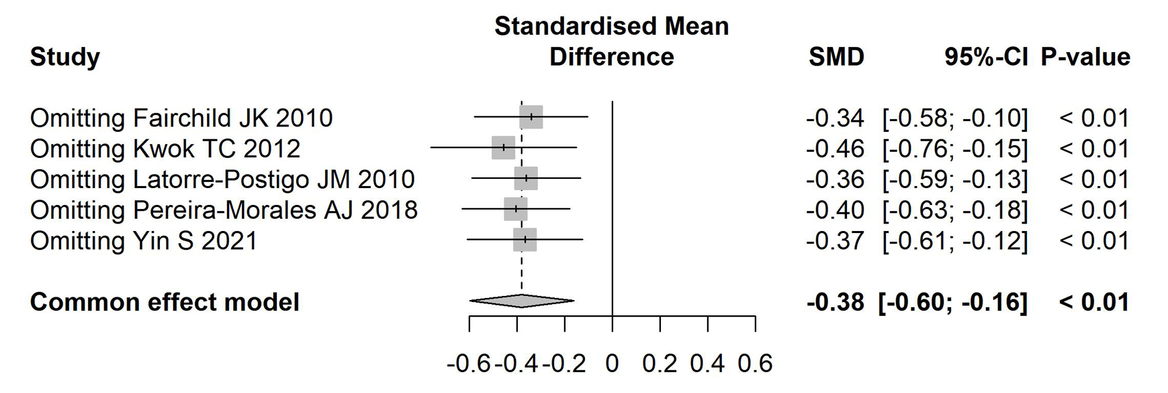
13.1.2 Subjective memory complaints—cognitive intervention vs waitlist
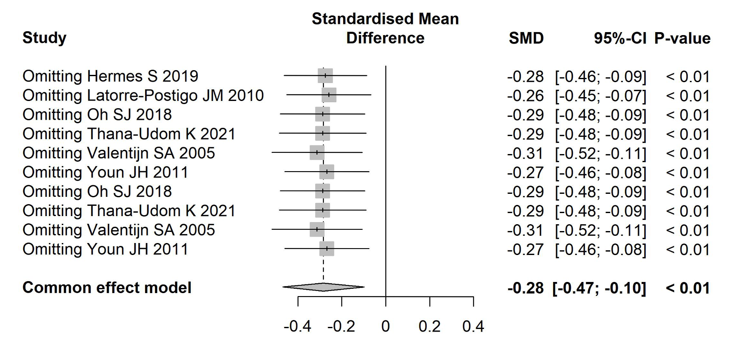
13.2 Results of exclusion of high-risk of bias studies
In the primary outcome (subjective memory complaints), only the Kwok TC et al. (2012) study was rated as high risk. Therefore, sensitivity analyses were performed on models that included cognitive intervention vs usual care, and Kwok TC (2012) was excluded. This result is consistent with our previous sensitivity analysis using the leave-one-out method.

eAppendix 14. Subgroup analyses
14.1 Subjective memory complaints—NPIs vs usual care

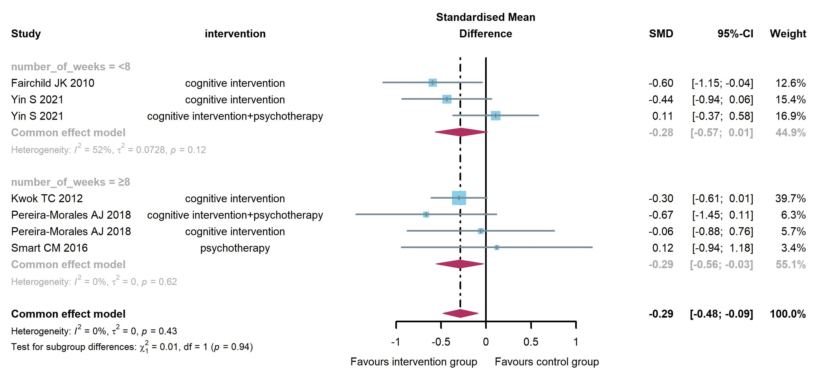
14.1 Subjective memory complaints—NPIs vs waitlist
