ADDITIONAL FILE

Maternal and neonatal plasma steroid concentrations
Neither dexamethasone nor betamethasone were detected (limit of detection 1 ng/ml, Signal/Noise ration >10) in maternal plasma samples at baseline or at any time point for the Saline Control Group Animals. At delivery, the median maternal plasma betamethasone concentration in the Beta-Acetate Group was 1.28 ng/ml (range 0.74 ng/ml - 2.97 ng/ml) whilst maternal plasma dexamethasone was not detectable in the Dex High or Dex Low Group animals at delivery. Neither dexamethasone nor betamethasone was detectable in neonatal plasma collected at delivery and 48h after interventions commenced.

Neonatal delivery Data
No statistically significant differences between the groups were observed for the following variables: gestational age at delivery (dGA), birthweight, neonatal sex, delivery cord blood pH / PaCO2, lung weight adjusted for body weight, or birthweight post-ventilation (Additional Table 1).

Neonatal respiratory physiological data at 10, 20 and 30 minutes of ventilation
Preterm arterial umbilical cord gas PaCO₂ values for each intervention group at 10,20,30 minutes of ventilation are shown in Figure 1C. Compared to Saline Control group, Beta-Acetate Group animals had significantly improved cord at 10 minutes mean difference -26.13 mmHg (95% CI -52.15 to – 0.12, p = 0.049), 20 minutes mean difference -38.65 mmHg (95% CI -70.68 to -6.62, p = 0.015) and 30 minutes, mean difference -45.04 mmHg (95% CI -86.73 to -3.34, p = 0.032). Dex Low Group animals had significantly improved cord PaCO₂ at 10 minutes mean difference -30.80 mmHg (95% CI -54.16 to -7.43, p = 0.007) and 20 minutes mean difference -32.63 mmHg (95% CI -61.41 to -3.85, p = 0.023).

Preterm neonatal dynamic lung compliance data for each intervention group at 10, 20 and 30 minutes of ventilation are shown in Additional Figure 1A. Beta-Acetate Group animals demonstrated significantly improved dynamic lung compliance compared to animals in the Saline Control Group at 10 minutes of ventilation mean difference 0.18 (95% CI 0.003 to 0.36, p= 0.045) and 20 minutes of ventilation mean difference 0.21 (95% CI 0.005 to 0.41, p= 0.044) Additional Figure 1A. There was no significant improvement in dynamic lung compliance between Dex Low Group, Dex High Group, and Saline Control Group at 10 and 20 minutes of ventilation Additional Figure 1A. No steroid treatment group had significant improvement in dynamic compliance at 30 minutes of ventilation compared to Saline Control Group.

Preterm neonatal Ventilation Efficiency Index (VEI) data at 10, 20 and 30 minutes of ventilation are shown in Additional Figure 1B. Beta-Acetate Group animals had significantly improved VEI compared to Saline Control Group at 10 minutes mean difference 0.03(95% CI 0.01 to 0.05, p= 0.004) and 20 minutes of ventilation mean difference 0.03 (95% CI 0.002 to 0.05, p= 0.029) Additional Figure 1B. Dex Low Group animals had significantly improved VEI only at 10 minutes of ventilation mean difference 0.02 (95% CI 0.001 to 0.039, p= 0.036). There was no significant improvement in VEI at 30 minutes of ventilation in any group. No statistically significant differences were found between Dex High Group animals and Saline Control Group animals at any time timepoint.

Preterm neonatal lung tidal volumes normalised to birth weight (Vt/Bw) were significantly increased in the Beta-Acetate Group animals compared to Saline Control Group animals at 10 minutes, mean difference 2.02ml/Kg (95% CI 0.44 to 3.60, p= 0.009), and 20 minutes of ventilation, mean difference 1.81ml/Kg (95% CI 0.14 to 3.49 , p= 0.031) and in Dex Low Group animals compared to Saline Control Group animals at 10 minutes ventilation, mean difference 1.85ml/Kg (95% CI 0.49 to 3.22, p= 0.006), and 20 minutes of ventilation, mean difference 1.61ml/Kg (95% CI 0.17 to 3.06, p= 0.026) as illustrated in Additional Figure 1C. There were no significant differences in Vt/Bw at 30 minutes of ventilation in any treatment group compared to Saline Control Group animals; however, Beta-Acetate (p= 0.055) and Dex Low (p= 0.06) approached significance. Vt/Bw in Dex High Group animals compared to Saline Control Group animals was not significant at any time point. Again, no statistically significant differences were found between Dex High Group animals and Saline Control Group animals at any time timepoint.

Neonatal ventilation data lung maturation analysis
Static inflation-deflation measurements of the preterm neonatal lung at necropsy (0 – 40 cm H₂O after 30 minutes of ventilation) showed functionally larger hysteresis loops for Beta-Acetate Group Animals and Dex Low Group animals compared to Saline Control Group animals and Dex High Group animals, with the two last groups behaving almost equally, Additional Figure 2A. Lung volumes at 40cm H₂O normalised to lung weight in the Beta-Acetate Group compared to Saline Control Group approached statistical significance (p=0.074), Additional Figure 2B.

Fetal Hippocampal transcriptome changes after antenatal steroid exposure
Individual steroid-exposed groups demonstrated primarily negative patterns of KEGG pathway enrichment (Dex High Group 76.9%; Dex Low Group 79.7%; and Beta-Acetate Group 82.1% negatively enriched respectively).

Maternal and fetal plasma endocrine assessments
Maternal Cortisol and ACTH
Serial maternal cortisol and ACTH plasma levels are shown in Additional Figure 5A. Saline Control Group Animals had significantly elevated maternal levels of cortisol at baseline vs. 48 hours (mean difference 76.0nmol/L, 95% CI 21.6 to 124.3, p=0.004) but not at any other time point. There was no significant difference in maternal plasma cortisol or ACTH between steroid treatment groups (Beta-Acetate, Dex High, Dex Low) and Saline Control Group at baseline. All steroid treated groups (Beta-Acetate, Dex High, Dex Low) had significant maternal plasma cortisol suppression at 6, 12, 24 and 36 hours (p= <0.001 *all treatment groups). At 48 hours post first injection only Dex Low Group animals showed significant maternal cortisol suppression (p= 0.006).

Maternal plasma ACTH was significantly suppressed in all steroid treatment groups (Beta-Acetate, Dex High, Dex Low) compared to Saline Control Group at 6 hours and 24 hours (Additional Figure 5A). There was no significant suppression of ACTH observed at 12hours or at 48hours in any steroid treatment group vs Saline Control. At 36 hours Beta-Acetate Group (p = 0.019) and Dex Low group (p = 0.002) had significant ACTH suppression compared to Saline Control Group.

Fetal Cortisol and ACTH
Fetal cord plasma cortisol and ACTH values for each group are shown in Additional Figure 5B. Fetal cord plasma cortisol levels at delivery were significantly suppressed in Beta-Acetate Group mean difference -9.9nmol/L (95% CI -17.66 to -2.14, p=0.009) and Dex Low Group mean difference -11.60nmol/L (95% CI -18.57 to -4.62, p=<0.001) but not Dex High Group (p= 0.46) vs Saline Control Group. Fetal cord plasma ACTH levels were significantly suppressed in all treatment groups compared to Saline Control Group; Beta-Acetate Group mean difference -328.48pg/ml (95%CI -576.13 to -80.83, p= 0.007), Dex Low Group mean difference -330.80pg/ml (95%CI -553.27 to -108.33, p= 0.002), Dex High Group mean difference -257.04pg/ml (95%CI -479.51 to -34.57, p= 0.02).

Maternal and fetal immune modulation
Maternal
Maternal WBC, plasma neutrophil and lymphocyte counts are shown in Additional Figure 6A. Maternal WBC and plasma neutrophils were significantly elevated in all steroid treatment groups vs. Saline Control Group at 6, 12, 24 and 36 hours. The Dex Low Group vs Saline Control Group at 48hrs had significant neutrophil elevation (p= 0.035).

Maternal plasma lymphocyte counts were significantly reduced in all steroid treatment groups vs. Saline Control Group at 6 hours, 12 hours, 24 hours and 36hours (p<0.05) (Additional Figure 6A). At 48 hours only Beta-Acetate Group (p=0.009) and Dex Low Group (p=0.022) vs. Saline Control Group had significant reduced lymphocyte count.

Fetal
Fetal plasma neutrophil and lymphocyte counts at delivery are shown in Additional Figure 6B. Fetal plasma neutrophil counts were significantly elevated in all steroid treatment groups vs. Saline Control Group; Beta-Acetate Group mean difference +25.74% (95%CI 14.1 to 37.6, p=<0.001), Dex Low Group mean difference 18.20% (95% CI 7.76 to 28.64, p=<0.001) and Dex High Group mean difference 12.36% (95% CI 1.92 to 22.80, p=0.017). Fetal plasma lymphocyte counts were significantly lower in all steroid treatment groups vs. Saline Control Group; Beta-Acetate Group mean difference -25.51% (95%CI -37.73 to -13.30, p=<0.001), Dex Low Group mean difference -17.55% (95% CI -28.53 to -6.58, p=0.001) and Dex High Group mean difference -12.14% (95% CI -23.11 to -1.16, p= 0.027). There was no significant difference in fetal WBC between steroid treatment groups and Saline Control Group (Beta-Acetate Group p= 0.999, Dex Low Group p= 0.933, Dex High Group p= 0.453). Inter-steroid treatment group analysis revealed a significant difference between Beta-Acetate Group and Dex High group in elevation of fetal plasma neutrophil count mean difference 13.38% (95%CI 0.63 to 26.12, p=0.039) and fetal plasma lymphocyte count mean difference 13.38% (95%CI – 26.54 to – 0.22, p=0.045).

Fetal Liver Function
The effects of ACS on neonatal liver functioning are poorly understood. In this study we have shown that all steroid treated groups exhibited significant elevated neonatal plasma GGT, which may be an indication of potential hepatobiliary dysfunction ¹ (Additional Figure 6C). Specifically, fetal GGT levels were significantly elevated in all steroid treatment group animals vs. Saline Control group animals; Beta-Acetate group mean difference 15.22U/L (95%CI 4.89 to 25.55, p=0.002), Dex Low group mean difference 16.09 U/L (95% CI 6.81 to 25.37, p=<0.001) and Dex High group mean difference 14.34U/L (95% CI 5.06 to 23.62, p= 0.001). There was no difference in GGT levels between steroid-treated groups (Additional Figure 6C). However, there was no significant difference in neonatal ALT or AST (other markers of hepatic damage) between steroid treatment group animals and Saline Control Group animals. Neonatal GLDH approached significance between groups on Oneway ANOVA (p= 0.06) with post hoc analysis showing neonatal GLDH was significantly elevated in Dex High Group compared to Saline Control Group mean difference 28.17U/L (95%CI 1.89 to 54.45, p=0.033) but not in the Low Dose Dex group (p=0.112) or Beta-Acetate Group (p=0.121) (Additional Figure 6C). Neonatal serum bile acids were significantly reduced in all steroid exposed groups compared to Saline Control Group animals; Dex High Group mean difference -5.63 (95%CI -10.17 to -1.08, p=0.012), Dex Low Group mean difference -5.82 (95%CI -10.27 to -1.36, p=0.008), Beta Acetate Group mean difference -7.12 (95%CI -12.06 to -2.19, p=0.003). There was no significant difference in maternal plasma GGT, ALT or AST at any time point for any steroid treatment group animals vs. Saline Control Group animals. Our findings are in keeping with those by Zhang et al. who demonstrated evidence of liver dysplasia, inhibition of hepatocyte proliferation and dose dependent reduction in liver weight after antenatal dexamethasone exposure in a rat model of pregnancy².

Additional References
1. Cabrera-Abreu, J.C., and Green, A. (2002). γ-Glutamyltransferase: value of its measurement in paediatrics. Annals of clinical biochemistry 39, 22-25.
2. Zhang, D., Liu, K., Hu, W., Lu, X., Li, L., Zhang, Q., Huang, H., and Wang, H. (2021). Prenatal dexamethasone exposure caused fetal rats liver dysplasia by inhibiting autophagy-mediated cell proliferation. Toxicology 449, 152664. https://doi.org/10.1016/j.tox.2020.152664.

Additional Table 1. Summary of delivery data (Mean ± Standard Deviation).

 | Saline Control | Dex High | Dex Low | Beta Acetate | test | p value
Group Size | 11 | 12 | 12 | 8 | - | -
Gestational age (d) | 123.1 ± 0.8 | 123 ± 0.9 | 123 ± 0.9 | 123 ± 0.0 | Kruskal - Wallis | 0.99
Birthweight (kg) | 2.93 ± 0.30 | 2.73 ± 0.30 | 2.67 ± 0.18 | 2.74 ± 0.17 | 1 way ANOVA | 0.09
Sex (M or F) | 5 / 6 | 5 / 7 | 8 / 4 | 4 / 4 | Chi-square | 0.80
Cord pH | 7.33 ± 0.07 | 7.31 ± 0.04 | 7.31 ± 0.05 | 7.27 ± 0.07 | 1 way ANOVA | 0.11
Cord blood pC02 (mmHg) | 53.8 ± 8.8 | 50.8 ± 4.5 | 51.0 ± 6.6 | 56.1 ± 7.7 | 1 way ANOVA | 0.26
Lung Weight per birthweight (g/kg) | 37.8 ± 4.4 | 35.7 ± 2.2 | 38.0 ± 5.3 | 35.5 ± 3.7 | 1 way ANOVA | 0.27
Birthweight post ventilation (kg) | 2.73 ± 0.27 | 2.59 ± 0.28 | 2.48 ± 0.16 | 2.53 ± 0.19 | 1 way ANOVA | 0.13

 | Mean | SD
T_{max} (hour) | 6.54 | 1.89
C_{max} (hour) | 23.60 | 5.58
AUC₀₋₄₈ (ng hour/ml) | 482.72 | 119.32
CL/F (ml/hour) | 16780.21 | 3554.45
t_{1/2} (hours) | 15.63 | 0.34

Additional Table 2. Pharmacokinetic data for Betamethasone Acetate following single 0.125mg/ kg dose (Geometric mean + Standard Deviation). T_{max} time to peak plasma concentration, Cmax peak plasma concentration, AUC_{0-48,} 0 – 48-hour area under the concentration-time cure; CL/F, total apparent clearance; t_{1/2} terminal half-life.

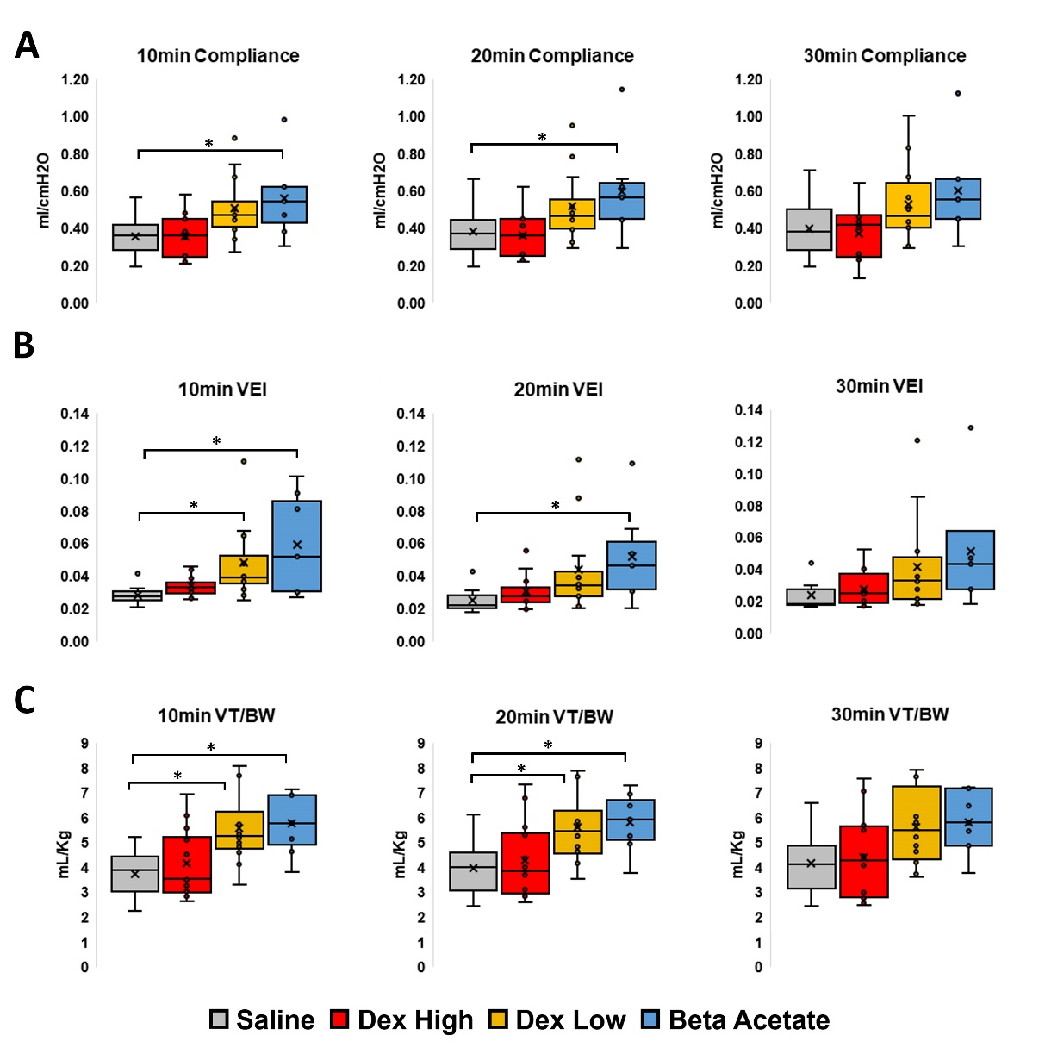

Additional Figure 1. Preterm neonatal respiratory physiological data at 10, 20 and 30 minutes of ventilation
- 1A: Dynamic lung compliance at 10, 20 and 30 minutes of ventilation (Saline control, Dex High, Dex Low, Beta – Acetate groups).
- 1B: Ventilation Efficiency Index (VEI) at 10, 20 and 30 minutes of ventilation (Saline control, Dex High, Dex Low, Beta – Acetate groups).
- 1C: Tidal Volume per birth weight (ml / Kg) at 10, 20 and 30 minutes of ventilation (Saline control, Dex High, Dex Low, Beta – Acetate groups).
- The Asterix indicates a significant difference among the groups. Error bars represent ± 1 Standard Deviation.

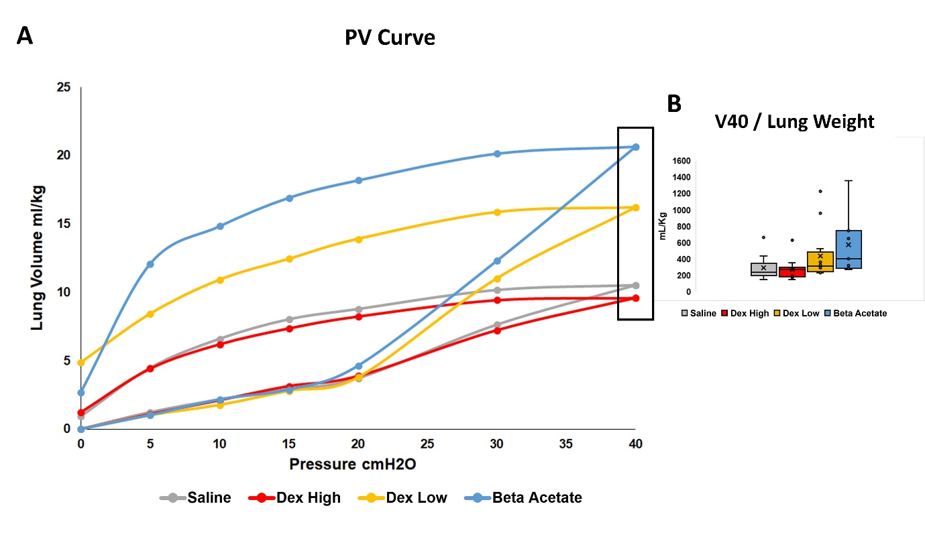
Additional Figure 2. Preterm neonatal ventilation data lung maturation analysis
- 2A: Pressure-volume relationship for air inflation and deflation of the lung at necropsy. The superior line from 0cm H₂O to 40cm H₂O of pressure in each loop is the inflation arm whilst the lower line from 40cm H₂O to 0cm H₂O of pressure is the deflation arm.
- 2B: Static lung gas volumes measure at a maximal pressure of 40cm H₂O.

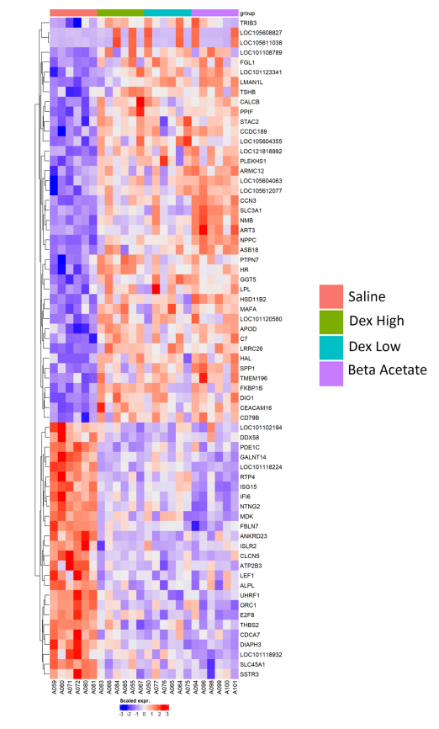

Additional Figure 3. Hippocampal bulk RNA sequencing data for differentially expressed genes common to all steroid treated groups
Heat map demonstrating Hippocampal RNA bulk sequencing data for the 41 significantly upregulated and 26 significantly downregulated DEGs (Fold change >1.5, False Discovery Rate FDR <5%) in common between all steroid treated groups (Dex High/ Dex Low/ Beta Acetate) compared to Saline Control Group.

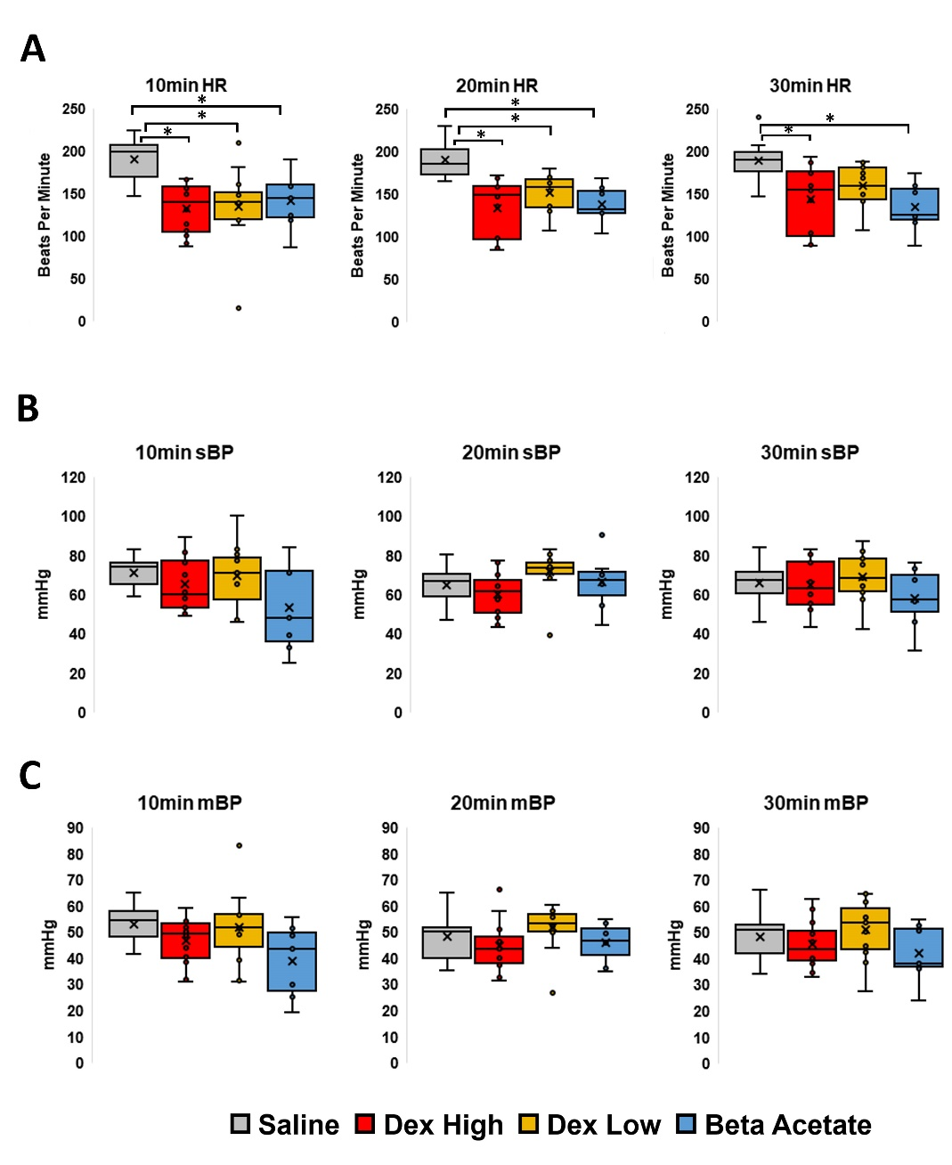

Additional Figure 4. Preterm neonatal cardiovascular data at 10, 20, 30 minutes of ventilation
- 4A: Neonatal heart rate (bpm) at 10, 20 and 30 minutes of ventilation (Saline control, Dex High, Dex Low, Beta – Acetate groups).
- 4B: Neonatal systolic blood pressure at 10, 20 and 30 minutes of ventilation (Saline control, Dex High, Dex Low, Beta – Acetate groups).
- 4C: Neonatal mean blood pressure at 10, 20 and 30 minutes of ventilation (Saline control, Dex High, Dex Low, Beta – Acetate groups).

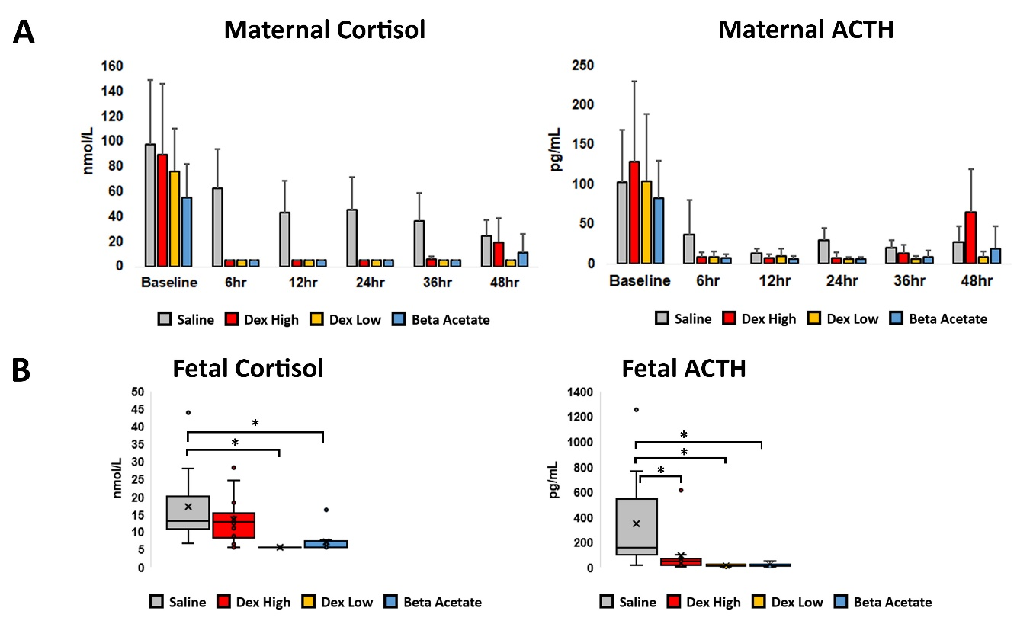
Additional Figure 5. Maternal and fetal plasma endocrine data
- 5A. Serial time course Maternal ACTH & Cortisol plasma concentrations.
- 5B. Fetal ACTH & Cortisol cord plasma concentration at delivery.
- The Asterix indicates a significant difference among the groups. Error bars represent ± 1 Standard Deviation.

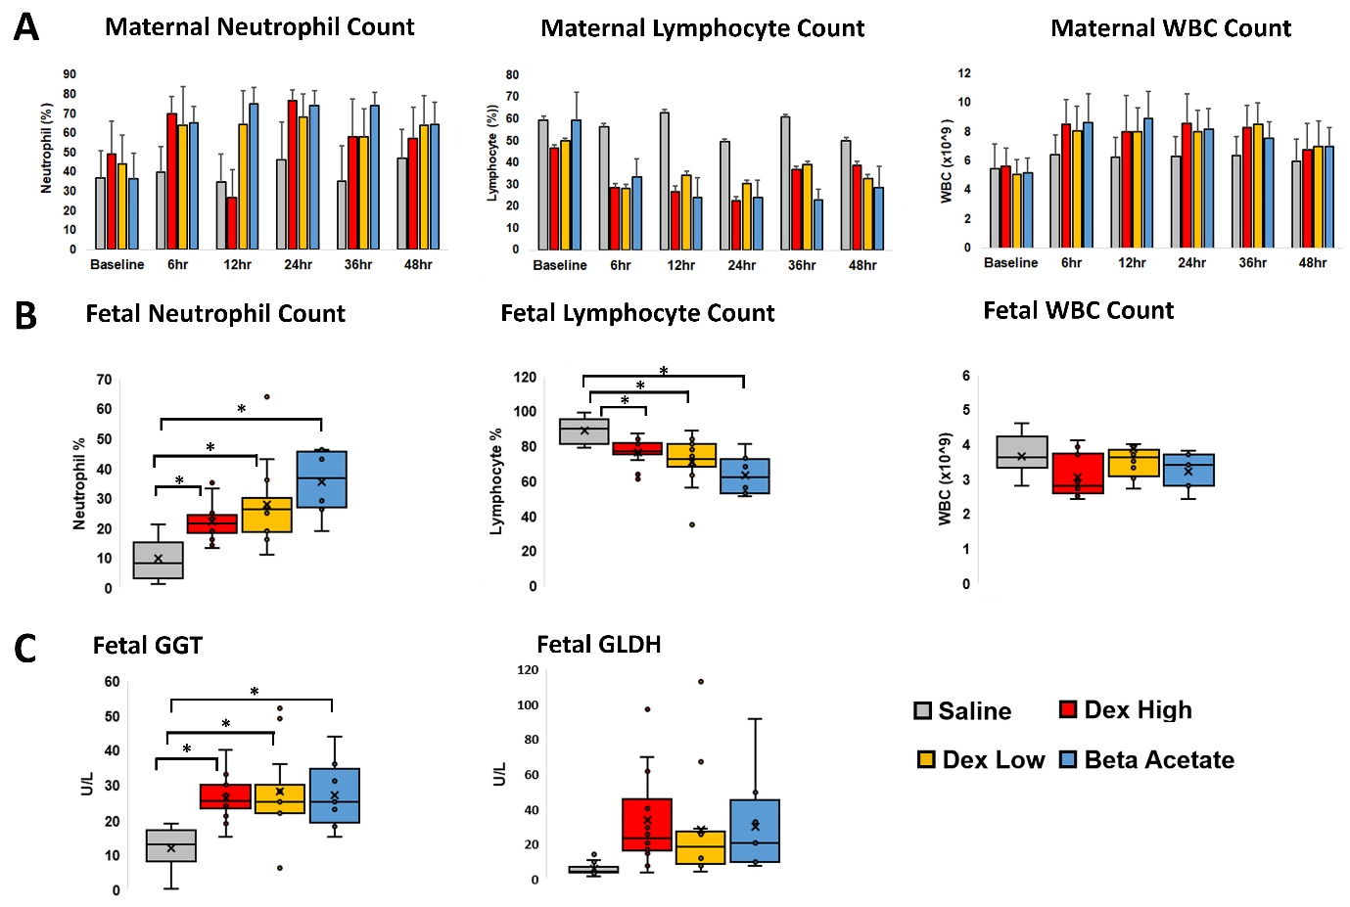
Additional Figure 6. Plasma Immune and liver function data
- 6A: Serial time course maternal haematological data (WBC/ Neutrophil count / Lymphocyte count).
- 6B: Preterm fetal cord plasma immune marker (WBC/ Neutrophil / Lymphocyte count) at delivery.
- 6C Preterm fetal cord plasma GGT and GLDH at delivery
- The Asterix indicates a significant difference among the groups. Error bars represent ± 1 Standard Deviation.

