Newborn DNA methylation age differentiates long-term weight trajectories:
The Boston Birth Cohort
Anat Yaskolka Meir¹ RD Ph.D., Guoying Wang ² MD Ph.D., Xiumei Hong² MD Ph.D., Frank B. Hu, MD PhD^{1,3,4} Xiaobin Wang^{2,5*} MD ScD, Liming Liang^{1*} Ph.D.
¹ Department of Epidemiology, Harvard T.H. Chan School of Public Health, Boston, MA, USA.
² Center on Early Life Origins of Disease, Department of Population, Family and Reproductive Health, Johns Hopkins University Bloomberg School of Public Health, Baltimore, MD, USA.
³ Department of Nutrition, Harvard T.H. Chan School of Public Health, Boston, MA, USA.
⁴ Channing Division of Network Medicine, Department of Medicine, Brigham and Women’s Hospital and Harvard Medical School, Boston, MA, USA.
⁵ Department of Pediatrics, Johns Hopkins University School of Medicine, Baltimore, MD, USA.

Additional file 1.
Methods S1: BMIPCT imputation
To complete missing data (for the primary analysis), we fitted a LOWESS (locally weighted scatterplot smoothing) curve [33], as we demonstrated before [32]. Briefly, we adopted a locally weighted scatterplot smoothing curve within a time-limit aware scheme (LOWESS-TLS). Each missing BMIPCT data was predicted using a regression curve (LOWESS) of the available observations within the reasonable time frame around the missing time point. The missing rate for the 831 children included in the current analysis for all age periods was 60.3% before imputation and 22.4% after imputation (total missing rates calculated for the first 12 months, quarterly measurements in year 2, and yearly measurements starting year 3 to 18). For the first age period (birth to 1 year), determining the sample size for the current analysis, the missing rate across 12 months ranged from 4-7%.

Methods S2: Array, sample size, population, and methods for the employed clocks
“All three clocks estimate gestational age based on cord blood DNA methylation. The Knight and Bohlin clocks estimate gestational age in weeks, whereas the Haftorn (referred to as “GAmAge” in this study) estimates in days.
The Knight clock [40] includes 148 CpGs. It is based on 27K or 450K methylation arrays. The sample size for training was 207 newborns, and the set included 1,135 newborns (data collected from 15 independent cohorts). Training and test sets were based on mostly White population. The prediction model was generated using elastic net regression with 10-fold cross-validation.
The Bohlin clock [41] includes 96 CpGs and was based on the 450K methylation array. The sample size for training was 1,068 newborns, and the test set included 685 newborns. Both training and test sets were based on the Norwegian population. The prediction model was generated using lasso regression with leave-one-out cross-validation.
The Haftorn clock [38] (“GAmAge”) includes 176 CpGs and was based on the EPIC 850K methylation array. The sample size for training was 755 newborns, and the test sets included 200 and 148 newborns. Both training and test sets were based on the Finnish and Norwegian populations. The prediction model was generated using lasso regression with leave 10-fold cross-validation.

Table S4: BMIPCT across OWO groups at the end of each age period
 | Early OWO | Late OWO | NW to very late OWO | NW
Birth to 1y, n | 229 | 216 | 187 | 199
Month 12, median (IQR) | 76.1 (27.4) | 87.6 (21.8) | 37.2 (33.5) | 28.2 (30.0)
Birth to 2y, n | 234 | 222 | 168 | 207
Month 22-24, median (IQR) | 69.9 (41.4) | 88.8 (21.0) | 53.9 (44.7) | 20.1 (33.4)
Birth to 3y, n | 244 | 214 | 167 | 206
Month 36, median (IQR) | 71.0 (35.0) | 89.2 (19.3) | 53.6 (39.4) | 15.3 (26.8)
Birth to 6y, n | 245 | 234 | 157 | 195
Month 72, median (IQR) | 83.9 (32.2) | 95.0 (12.8) | 71.8 (41.1) | 31.4 (38.6)
Birth to 10y, n | 253 | 244 | 158 | 176
Month 120, median (IQR) | 86.3 (29.9) | 97.0 (6.9) | 80.6 (36.6) | 35.9 (39.2)
Birth to 14y, n | 263 | 254 | 148 | 166
Month 168, median (IQR) | 85.7 (20.7) | 96.5 (9.5) | 75.7 (29.6) | 27.4 (36.6)
Birth to 18y, n | 274 | 258 | 140 | 159
Month 216, median (IQR) | 87.6 (38.7) | 93.9 (12.9) | 79.6 (55.3) | 23.7 (17.3)

Table S5: Differential level of GAmAge across OWO groups in different age periods
Age period | ANOVA P-value | P-value for Bonferroni correction
Age period | ANOVA P-value | Early OWO vs. late OWO | Early OWO vs. NW to very late OWO | Early OWO vs. NW | Late OWO vs. NW to very late OWO | Late OWO vs. NW | Very late OWO vs. NW
Birth to 1y | 5.93e-16 | 0.004 | 1.4e-14 | 1 | 1.7e-05 | 0.049 | 9.4e-12
Birth to 2y | 0.0279 | 0.28 | 6.6e-11 | 1 | 4.6e-06 | 1 | 1.7e-08
Birth to 3y | 0.019 | 0.088 | 4.8e-09 | 1 | 8.3e-04 | 1 | 6.6e-06
Birth to 6y | 8.6e-03 | 0.159 | 2.2e-06 | 0.539 | 0.012 | 1 | 4.8e-03
Birth to 10y | 6.2e-03 | 0.135 | 1.8e-04 | 0.290 | 0.185 | 1 | 0.208
Birth to 14y | 0.022 | 0.085 | 0.001 | 0.674 | 0.584 | 1 | 0.252
Birth to 18y | 0.048 | 0.010 | 0.071 | 0.452 | 1 | 1 | 1

Table 6: The association between GAmAge, GEAA, and OWO groups across different age periods. The model includes mutual adjustment for GAmAge and GEAA and the following covariates: maternal weight gain during pregnancy, maternal smoking, delivery method, and child sex. Results presented for the GAmAge and gestational age (both in days) predictors. N=831. GAmAge, gestational methylation age; GEAA, gestational age
 |  | GAmAge |  |  | GEAA
Birth to 1y | Effect | z-score | p-value | OR [95%CI] | z-score | p-value | OR [95% CI]
Ref: NW | Early OWO | -0.23 | 0.82 | 1.00 [0.97,1.02] | 0.15 | 0.88 | 1.00 [0.98,1.03]
 | Late OWO | -2.69 | 0.007 | 0.97 [0.94,0.99] | 0.15 | 0.88 | 1.00 [0.99,1.01]
 | NW to very late OWO | -2.42 | 0.02 | 0.97 [0.94,0.99] | -1.76 | 0.08 | 0.98 [0.95.1.00]
Ref: NW to very late OWO | Early OWO | 2.25 | 0.02 | 1.03 [1.00,1.06] | 1.95 | 0.05 | 1.03 [0.99,1.05]
 | Late OWO | -0.20 | 0.84 | 0.99 [0.97,1.02] | 2.08 | 0.04 | 1.03 [1.00,1.05]
Ref: Late OWO | Early OWO | 2.53 | 0.01 | 1.03 [1.00,1.06] | 0.003 | 0.99 | 1.00 [0.98,1.03]
Birth to 2y | Effect | z-score | p-value | OR [95% CI] | z-score | p-value | OR [95% CI]
Ref: NW | Early OWO | -0.19 | 0.85 | 1.00 [0.97,1.02] | 0.46 | 0.64 | 1.01 [0.98,1.03]
 | Late OWO | -1.53 | 0.12 | 0.98 [0.96,1.00] | 0.57 | 0.57 | 1.01 [0.98,1.03]
 | NW to very late OWO | -1.18 | 0.24 | 0.99 [0.96,1.01] | -1.58 | 0.12 | 0.98 [0.96,1.00]
Ref: NW to very late OWO | Early OWO | 1.01 | 0.31 | 1.01 [0.99,1.04] | 2.05 | 0.04 | 1.03 [1.00,1.05]
 | Late OWO | -0.32 | 0.75 | 0.99 [0.97,1.02] | 2.18 | 0.03 | 1.03 [1.00,1.05]
Ref: Late OWO | Early OWO | 1.38 | 0.17 | 1.02 [0.99,1.04] | -0.11 | 0.91 | 0.99 [0.97,1.02]
Birth to 3y | Effect | z-score | p-value | OR [95% CI] | z-score | p-value | OR [95% CI]
Ref: NW | Early OWO | -0.88 | 0.38 | 0.99 [0.97,1.01] | 1.32 | 0.19 | 1.02 [0.99,1.04]
 | Late OWO | -2.10 | 0.03 | 0.97 [0.95,0.99] | 0.99 | 0.32 | 1.01 [0.99,1.04]
 | NW to very late OWO | -2.06 | 0.04 | 0.97 [0.95,0.99] | -0.46 | 0.65 | 0.99 [0.97,1.02]
Ref: NW to very late OWO | Early OWO | 1.20 | 0.23 | 1.01 [0.99,1.04] | 1.73 | 0.08 | 1.02 [0.99,1.03]
 | Late OWO | -0.0001 | 0.99 | 1.00 [0.98,1.02] | 1.44 | 0.15 | 1.02 [0.99,1.04]
Ref: Late OWO | Early OWO | 1.25 | 0.21 | 1.01 [0.99,1.04] | 0.33 | 0.74 | 1.00 [0.98,1.03]
Birth to 6y | Effect | z-score | p-value | OR [95% CI] | z-score | p-value | OR [95% CI]
Ref: NW | Early OWO | -1.16 | 0.24 | 0.99 [0.96,1.01] | 1.66 | 0.10 | 1.02 [0.99,1.05]
 | Late OWO | -3.09 | 0.002 | 0.96 [0.94,0.98] | 2.24 | 0.02 | 1.03 [1.00,1.05]
 | NW to very late OWO | -2.18 | 0.03 | 0.97 [0.95,0.99] | 0.37 | 0.71 | 1.00 [0.98,1.03]
Ref: NW to very late OWO | Early OWO | 1.07 | 0.28 | 1.01 [0.99,1.04] | 1.21 | 0.22 | 1.02 [0.99,1.04]
 | Late OWO | -0.80 | 0.42 | 0.99 [0.97,1.01] | 1.79 | 0.07 | 1.02 [0.99,1.05]
Ref: Late OWO | Early OWO | 1.98 | 0.047 | 1.02 [1.00,1.05] | -0.61 | 0.54 | 0.99 [0.97,1.02]
Birth to 10y | Effect | z-score | p-value | OR [95% CI] | z-score | p-value | OR [95% CI]
Ref: NW | Early OWO | -1.51 | 0.13 | 0.98 [0.96,1.00] | 2.08 | 0.04 | 1.03 [1.00,1.05]
 | Late OWO | -3.35 | 0.0008 | 0.96 [0.94,0.98] | 2.35 | 0.02 | 1.03 [1.00,1.06]
 | NW to very late OWO | -1.17 | 0.24 | 0.98 [0.96,1.01] | -0.05 | 0.96 | 0.99 [0.97,1.02]
Ref: NW to very late OWO | Early OWO | -0.31 | 0.76 | 0.99 [0.97,1.02] | 2.13 | 0.03 | 1.03 [1.00,1.05]
 | Late OWO | -2.17 | 0.03 | 0.97 [0.95,0.99] | 2.44 | 0.01 | 1.03 [1.00,1.06]
Ref: Late OWO | Early OWO | 1.94 | 0.052 | 1.02 [0.99,1.05] | -0.28 | 0.78 | 0.99 [0.97,1.02]
Birth to 14y | Effect | z-score | p-value | OR [95% CI] | z-score | p-value | OR [95% CI]
Ref: NW | Early OWO | -1.31 | 0.19 | 0.98 [0.96,1.01] | 1.79 | 0.07 | 1.02 [0.99,1.02]
 | Late OWO | -2.84 | 0.004 | 0.97 [0.04,0.99] | 1.77 | 0.08 | 1.02 [0.99,1.05]
 | NW to very late OWO | -0.86 | 0.39 | 0.99 [0.96,1.01] | -0.08 | 0.93 | 0.99 [0.97,1.03]
Ref: NW to very late OWO | Early OWO | -0.40 | 0.69 | 0.99 [0.97,1.02] | 1.85 | 0.06 | 1.02 [0.99,1.05]
 | Late OWO | -1.90 | 0.056 | 0.98 [0.95,1.00] | 1.86 | 0.06 | 1.02 [0.99,1.05]
Ref: Late OWO | Early OWO | 1.60 | 0.11 | 1.02 [0.99,1.04] | 0.07 | 0.94 | 1.00 [0.98,1.02]
Birth to 18y | Effect | z-score | p-value | OR [95% CI] | z-score | p-value | OR [95% CI]
Ref: NW | Early OWO | -0.74 | 0.46 | 0.99 [0.97,1.01] | 1.50 | 0.13 | 1.02 [0.99,1.05]
 | Late OWO | -2.18 | 0.03 | 0.97 [0.95,0.99] | 1.05 | 0.30 | 1.01 [0.99,1.04]
 | NW to very late OWO | 0.50 | 0.62 | 1.01 [0.98,1.03] | -0.60 | 0.55 | 0.99 [0.96,1.02]
Ref: NW to very late OWO | Early OWO | -1.28 | 0.20 | 0.98 [0.96,1.01] | 2.13 | 0.03 | 1.03 [1.00,1.05]
 | Late OWO | -2.73 | 0.006 | 0.97 [0.94,0.99] | 1.71 | 0.09 | 1.02 [0.99,1.05]
Ref: Late OWO | Early OWO | 1.54 | 0.12 | 1.02 [0.99,1.04] | 0.57 | 0.57 | 1.01 [0.98,1.03]

Table S7: The association between age acceleration and OWO groups across different age periods. Model adjusted for GEAA, maternal smoking, delivery method, and child sex. N=831. GAmAge, gestational methylation age; GEAA, gestational age.
 | GAmAge acceleration
Birth to 1y | Effect | z-score | p-value | OR [95%CI]
Ref: NW | Early OWO | 0.37 | 0.71 | 1.00 [0.97,1.04]
 | Late OWO | -1.77 | 0.08 | 0.97 [0.94,1.00]
 | NW to very late OWO | -1.32 | 0.19 | 0.98 [0.94,1.01]
Ref: NW to very late OWO | Early OWO | 1.69 | 0.09 | 1.03 [0.99,1.07]
 | Late OWO | -0.38 | 0.70 | 0.99 [0.96,1.03]
Ref: Late OWO | Early OWO | 2.18 | 0.03 | 1.04 [1.00,1.07]
Birth to 2y | Effect | z-score | p-value | OR [95% CI]
Ref: NW | Early OWO | -0.001 | 0.99 | 0.99 [0.97,1.03]
 | Late OWO | -0.84 | 0.40 | 0.98 [0.95,1.02]
 | NW to very late OWO | -0.87 | 0.38 | 0.98 [0.95,1.02]
Ref: NW to very late OWO | Early OWO | 0.88 | 0.38 | 1.02 [0.98,1.05]
 | Late OWO | 0.09 | 0.93 | 1.00 [0.97,1.04]
Ref: Late OWO | Early OWO | 0.86 | 0.39 | 1.01 [0.98,1.05]
Birth to 3y | Effect | z-score | p-value | OR [95% CI]
Ref: NW | Early OWO | -0.33 | 0.74 | 0.99 [0.96,1.03]
 | Late OWO | -1.17 | 0.23 | 0.98 [0.95,1.01]
 | NW to very late OWO | -1.28 | 0.20 | 0.98 [0.94,1.01]
Ref: NW to very late OWO | Early OWO | 0.99 | 0.32 | 1.02 [0.98,1.05]
 | Late OWO | 0.18 | 0.86 | 1.00 [0.97,1.04]
Ref: Late OWO | Early OWO | 0.88 | 0.38 | 1.01 [0.98,1.05]
Birth to 6y | Effect | z-score | p-value | OR [95% CI]
Ref: NW | Early OWO | -0.49 | 0.62 | 0.99 [0.96,1.03]
 | Late OWO | -1.58 | 0.11 | 0.97 [0.94,1.01]
 | NW to very late OWO | -1.27 | 0.20 | 0.98 [0.94,1.01]
Ref: NW to very late OWO | Early OWO | 0.83 | 0.40 | 1.02 [0.98,1.05]
 | Late OWO | -0.20 | 0.84 | 0.99 [0.96,1.03]
Ref: Late OWO | Early OWO | 1.14 | 0.25 | 1.02 [0.99,1.05]
Birth to 10y | Effect | z-score | p-value | OR [95% CI]
Ref: NW | Early OWO | -0.58 | 0.56 | 0.99 [0.96,1.02]
 | Late OWO | -1.48 | 0.14 | 0.97 [0.94,1.01]
 | NW to very late OWO | -0.38 | 0.71 | 0.99 [0.96,1.03]
Ref: NW to very late OWO | Early OWO | -1.06 | 0.87 | 0.99 [0.96,1.03]
 | Late OWO | -0.17 | 0.29 | 0.98 [0.95,1.02]
Ref: Late OWO | Early OWO | 0.97 | 0.33 | 1.02 [0.98,1.05]
Birth to 14y | Effect | z-score | p-value | OR [95% CI]
Ref: NW | Early OWO | -0.47 | 0.64 | 0.99 [0.96,1.03]
 | Late OWO | -1.32 | 0.19 | 0.98 [0.94,1.01]
 | NW to very late OWO | -0.50 | 0.62 | 0.99 [0.95,1.03]
Ref: NW to very late OWO | Early OWO | 0.08 | 0.93 | 1.00 [0.97,1.04]
 | Late OWO | -0.76 | 0.45 | 0.99 [0.95,1.02]
Ref: Late OWO | Early OWO | 0.96 | 0.34 | 1.02 [0.98,1.05]
Birth to 18y | Effect | z-score | p-value | OR [95% CI]
Ref: NW | Early OWO | -0.13 | 0.90 | 0.99 [0.96,1.03]
 | Late OWO | -0.87 | 0.38 | 0.98 [0.95,1.02]
 | NW to very late OWO | 0.35 | 0.72 | 1.01[0.97,1.05]
Ref: NW to very late OWO | Early OWO | -0.52 | 0.60 | 0.99 [0.96,1.03]
 | Late OWO | -1.25 | 0.21 | 0.98 [0.94,1.01]
Ref: Late OWO | Early OWO | 0.85 | 0.40 | 1.01 [0.98,1.04]

Table S8: The association between Knight clock, GEAA, and OWO groups across different age periods. The model includes mutual adjustment for Knight and GEAA and the following covariates: maternal smoking, delivery method, and child sex. Results presented for the Knight clock and gestational age (both in weeks) predictors. N=831. GEAA, gestational age.
 |  | Knight clock |  |  | GEAA
Birth to 1y | Effect | z-score | p-value | OR [95%CI] | z-score | p-value | OR [95% CI]
Ref: NW | Early OWO | 0.29 | 0.77 | 1.02 [0.89,1.17] | 0.52 | 0.59 | 1.04 [0.91, 1.18]
 | Late OWO | -0.40 | 0.69 | 0.97 [0.84,1.12] | -1.17 | 0.24 | 0.92 [0.81,1.05]
 | NW to very late OWO | -0.47 | 0.64 | 0.96 [0.83,1.12] | -3.29 | 0.0009 | 0.79 [0.69,0.91]
Ref: NW to very late OWO | Early OWO | 0.64 | 0.44 | 1.05 [0.92,1.22] | 3.88 | 0.0001 | 1.31 [1.14,1.50]
 | Late OWO | 0.44 | 0.92 | 1.01 [0.87,1.16] | 2.37 | 0.017 | 1.16 [1.03,1.32]
Ref: Late OWO | Early OWO | 0.73 | 0.47 | 1.05 [0.92,1.20] | 1.76 | 0.078 | 1.12 [0.99,1.28]
Birth to 2y | Effect | z-score | p-value | OR [95% CI] | z-score | p-value | OR [95% CI]
Ref: NW | Early OWO | 0.06 | 0.95 | 1.00 [0.88,1.15] | 0.87 | 0.38 | 1.06 [0.93,1.21]
 | Late OWO | -0.13 | 0.89 | 0.99 [0.86,1.14] | -0.34 | 0.73 | 0.98 [0.86,1.11]
 | NW to very late OWO | -0.73 | 0.46 | 0.94 [0.81,1.10] | -2.42 | 0.015 | 0.85 [0.74,0.97]
Ref: NW to very late OWO | Early OWO | 0.80 | 0.42 | 1.06 [0.92,1.23] | 3.28 | 0.001 | 1.25 [1.09,1.43]
 | Late OWO | 0.63 | 0.53 | 1.05 [0.90,1.21] | 2.19 | 0.028 | 1.15 [1.01,1.31]
Ref: Late OWO | Early OWO | 0.21 | 0.84 | 1.01 [0.89,1.16] | 1.25 | 0.21 | 1.08 [0.96,1.23]
Birth to 3y | Effect | z-score | p-value | OR [95% CI] | z-score | p-value | OR [95% CI]
Ref: NW | Early OWO | -0.49 | 0.62 | 0.97 [0.85,1.10] | 1.83 | 0.07 | 1.13 [0.99,1.28]
 | Late OWO | -0.91 | 0.36 | 0.94 [0.82,1.07] | 0.39 | 0.69 | 1.03 [0.90,1.16]
 | NW to very late OWO | -1.21 | 0.23 | 0.91 [0.78,1.06] | -1.33 | 0.18 | 0.91 [0.80,1.04]
Ref: NW to very late OWO | Early OWO | 0.79 | 0.43 | 1.23 [0.92,1.22] | 3.09 | 0.002 | 1.23 [1.08,1.41]
 | Late OWO | 0.37 | 0.71 | 1.12 [0.89, 1.19] | 1.76 | 0.08 | 1.12 [0.99,1.27]
Ref: Late OWO | Early OWO | 0.46 | 0.65 | 1.03 [0.90,1.18] | 1.48 | 0.14 | 1.10 [0.97,1.24]
Birth to 6y | Effect | z-score | p-value | OR [95% CI] | z-score | p-value | OR [95% CI]
Ref: NW | Early OWO | -0.36 | 0.72 | 0.98 [0.85,1.12] | 1.96 | 0.05 | 1.14 [0.99,1.29]
 | Late OWO | -0.42 | 0.68 | 0.97 [0.85,1.11] | 0.79 | 0.43 | 1.05 [0.93,1.19]
 | NW to very late OWO | -0.39 | 0.69 | 0.97 [0.83,1.13] | -1.17 | 0.24 | 0.92 [0.81,1.06]
Ref: NW to very late OWO | Early OWO | 0.08 | 0.94 | 1.01 [0.87,1.16] | -0.71 | 0.002 | 1.23 [1.08,1.40]
 | Late OWO | 0.01 | 0.99 | 1.00 [0.87,1,16] | 0.76 | 0.047 | 1.14 [1.00,1.29]
Ref: Late OWO | Early OWO | 0.07 | 0.94 | 1.00 [0.88,1.14] | 1.25 | 0.21 | 1.08 [0.96,1.22]
Birth to 10y | Effect | z-score | p-value | OR [95% CI] | z-score | p-value | OR [95% CI]
Ref: NW | Early OWO | -0.16 | 0.87 | 0.98 [0.76,1.26] | 1.67 | 0.09 | 1.15 [0.98,1.35]
 | Late OWO | -1.31 | 0.19 | 0.85 [0.66,1.08] | 1.60 | 0.11 | 1.14 [0.97,1.33]
 | NW to very late OWO | -0.15 | 0.88 | 0.98 [0.75,1.29] | -0.72 | 0.47 | 0.94 [0.79,1.11]
Ref: NW to very late OWO | Early OWO | 0.0002 | 0.99 | 1.00 [0.77,1.29] | 2.41 | 0.01 | 1.22 [1.04,1.44]
 | Late OWO | -1.17 | 0.24 | 0.87 [0.68,1.10] | 2.42 | 0.01 | 1.21 [1.04,1.42]
Ref: Late OWO | Early OWO | 1.26 | 0.21 | 1.15 [0.92,1.44] | 0.13 | 0.89 | 1.01 [0.87, 1.17]
Birth to 14y | Effect | z-score | p-value | OR [95% CI] | z-score | p-value | OR [95% CI]
Ref: NW | Early OWO | -0.43 | 0.67 | 0.97 [0.84,1,12] | 1.93 | 0.053 | 1.14 [0.99,1.29]
 | Late OWO | -0.93 | 0.35 | 0.93 [0.81,1.08] | 0.83 | 0.41 | 1.05 [0.93,1.20]
 | NW to very late OWO | -1.00 | 0.31 | 0.92 [0.78,1.08] | -0.16 | 0.87 | 0.99 [0.86,1.14]
Ref: NW to very late OWO | Early OWO | 0.69 | 0.49 | 1.05 [0.91,1.22] | 2.09 | 0.037 | 1.15 [1.01,1.31]
 | Late OWO | 0.20 | 0.84 | 1.01 [0.88,1.17] | 1.01 | 0.32 | 1.07 [0.94,1.21]
Ref: Late OWO | Early OWO | 0.58 | 0.56 | 1.04 [0.92,1.17] | 1.27 | 0.20 | 1.08 [0.96,1.21]
Birth to 18y | Effect | z-score | p-value | OR [95% CI] | z-score | p-value | OR [95% CI]
Ref: NW | Early OWO | -0.71 | 0.47 | 0.95 [0.82,1.09] | 2.09 | 0.04 | 1.15 [1.01,1.31]
 | Late OWO | -1.12 | 0.26 | 0.92 [0.80,1.06] | 0.62 | 0.53 | 1.04 [0.92,1.18]
 | NW to very late OWO | -0.94 | 0.34 | 0.92 [0.78,1.09] | 0.23 | 0.82 | 1.02 [0.88,1.17]
Ref: NW to very late OWO | Early OWO | 0.36 | 0.71 | 1.03 [0.89,1.19] | 1.83 | 0.07 | 1.13 [0.99,1.29]
 | Late OWO | -0.05 | 0.96 | 0.99 [0.86,1.15] | 0.37 | 0.71 | 1.02 [0.90,1.16]
Ref: Late OWO | Early OWO | 0.49 | 0.62 | 1.03 [0.91,1.16] | 1.73 | 0.08 | 1.10 [0.99,1.24]

Table S9: The association between Bohlin clock, GEAA, and OWO groups across different age periods. The model includes mutual adjustment for Knight and GEAA and the following covariates: maternal smoking, delivery method, and child sex. Results presented for the Bohlin clock and gestational age (both in weeks) predictors. N=831. GEAA, gestational age
 |  | Bohlin clock |  |  | GEAA
Birth to 1y | Effect | z-score | p-value | OR [95%CI] | z-score | p-value | OR [95% CI]
Ref: NW | Early OWO | 0.41 | 0.69 | 0.91 [0.81,1.37] | 0.27 | 0.78 | 1.02 [0.87,1.21]
 | Late OWO | -0.73 | 0.46 | 0.86 [0.70,1.17] | -0.58 | 0.59 | 0.95 [0.81,1.12]
 | NW to very late OWO | -1.15 | 0.85 | 1.06 [0.66,1.11] | -1.98 | 0.048 | 0.84 [0.71,0.99]
Ref: NW to very late OWO | Early OWO | 1.58 | 0.11 | 1.23 [0.95,1.60] | 2.28 | 0.022 | 1.21 [1.03,1.43]
 | Late OWO | 0.51 | 0.61 | 1.06 [0.84,1.34] | 1.58 | 0.11 | 1.13 [0.97,1.31]
Ref: Late OWO | Early OWO | 1.18 | 0.24 | 1.16 [0.91,1.49] | 0.88 | 0.38 | 1.07 [0.92,1.26]
Birth to 2y | Effect | z-score | p-value | OR [95% CI] | z-score | p-value | OR [95% CI]
Ref: NW | Early OWO | -0.034 | 0.97 | 0.99 [0.78,1.28] | -0.18 | 0.44 | 1.06 [0.91,1.25]
 | Late OWO | -0.22 | 0.83 | 0.97 [0.76,1.25] | -1.52 | 0.86 | 0.99 [0.84,1.16]
 | NW to very late OWO | -1.08 | 0.28 | 0.87 [0.67,1.12] | 0.77 | 0.13 | 0.88 [0.75,1.04]
Ref: NW to very late OWO | Early OWO | 1.05 | 0.29 | 1.14 [0.89,1.47] | 2.28 | 0.022 | 1.20 [1.03,1.42]
 | Late OWO | 0.91 | 0.36 | 1.12 [0.88,1.42] | 1.41 | 0.16 | 1.12 [0.96,1.31]
Ref: Late OWO | Early OWO | 0.19 | 0.85 | 1.02 [0.80,1.30] | 0.97 | 0.33 | 1.08 [0.92,1.26]
Birth to 3y | Effect | z-score | p-value | OR [95% CI] | z-score | p-value | OR [95% CI]
Ref: NW | Early OWO | -0.33 | 0.74 | 0.96 [0.76,1.22] | 1.48 | 0.14 | 1.12 [0.96,1.32]
 | Late OWO | -0.49 | 0.62 | 0.94 [0.74,1.20] | 0.18 | 0.86 | 1.01 [0.87,1.18]
 | NW to very late OWO | -0.64 | 0.52 | 0.92 [0.72,1.18] | 01.33 | 0.18 | 0.90 [0.76,1.05]
Ref: NW to very late OWO | Early OWO | 0.32 | 0.86 | 1.04 [0.82,1.32] | 2.80 | 0.005 | 1.26 [1.08,1.47]
 | Late OWO | 0.18 | 0.75 | 1.02 [0.81,1.29] | 1.58 | 0.11 | 1.13 [0.97,1.31]
Ref: Late OWO | Early OWO | 0.16 | 0.87 | 1.02 [0.81,1.28] | 1.35 | 0.18 | 1.10 [0.95,1.29]
Birth to 6y | Effect | z-score | p-value | OR [95% CI] | z-score | p-value | OR [95% CI]
Ref: NW | Early OWO | -0.19 | 0.85 | 0.98 [0.76,1.25] | 1.53 | 0.12 | 1.13 [0.97,1.33]
 | Late OWO | -0.99 | 0.32 | 0.88 [0.70,1.12] | 1.23 | 0.22 | 1.10 [0.94,1.29]
 | NW to very late OWO | -0.80 | 0.43 | 0.90 [0.81,1.13] | -0.50 | 0.61 | 0.96 [0.81,1.13]
Ref: NW to very late OWO | Early OWO | 0.64 | 0.52 | 1.08 [0.85,1.39] | 2.04 | 0.04 | 1.18 [1.00,1.39]
 | Late OWO | -0.15 | 0.88 | 0.98 [0.78, 1.23] | 1.81 | 0.07 | 1.15 [0.99,1.34]
Ref: Late OWO | Early OWO | 0.84 | 0.40 | 1.10 [0.87,1.38] | 0.36 | 0.71 | 1.03 [0.88,1.19]
Birth to 10y | Effect | z-score | p-value | OR [95% CI] | z-score | p-value | OR [95% CI]
Ref: NW | Early OWO | -0.89 | 0.37 | 0.94 [0.82,1.08] | 2.57 | 0.01 | 1.19 [1.04,1.35]
 | Late OWO | -0.98 | 0.33 | 0.93 [0.81,1.07] | 1.34 | 0.18 | 1.09 [0.96,1.24]
 | NW to very late OWO | -1.47 | 0.14 | 0.89 [0.76,1.04] | 0.13 | 0.89 | 1.01 [0.88,1.16]
Ref: NW to very late OWO | Early OWO | 0.73 | 0.47 | 1.05 [0.91,1.21] | 2.41 | 0.02 | 1.17 [0.95,1.22]
 | Late OWO | 0.64 | 0.52 | 1.05 [0.91,1.20] | 1.20 | 0.23 | 1.08 [0.95,1.22]
Ref: Late OWO | Early OWO | 0.10 | 0.92 | 1.00 [0.89,1.14] | 1.39 | 0.16 | 1.09 [0.97,1.22]
Birth to 14y | Effect | z-score | p-value | OR [95% CI] | z-score | p-value | OR [95% CI]
Ref: NW | Early OWO | -0.22 | 0.82 | 0.97 [0.75,1.26] | 1.47 | 0.14 | 1.13 [0.96,1.34]
 | Late OWO | -1.56 | 0.12 | 0.82 [0.63,1.05] | 1.45 | 0.15 | 1.13 [0.96,1.32]
 | NW to very late OWO | -0.60 | 0.55 | 0.92 [0.69,1.22] | -0.24 | 0.81 | 0.98 [0.82,1.17]
Ref: NW to very late OWO | Early OWO | 0.43 | 0.66 | 1.06 [0.82,1.37] | 1.74 | 0.08 | 1.16 [0.98,1.36]
 | Late OWO | -0.95 | 0.34 | 0.89 [0.70,1.13] | 1.79 | 0.07 | 1.15 [0.99,1.34]
Ref: Late OWO | Early OWO | 1.52 | 0.13 | 1.19 [0.95,1.48] | 0.07 | 0.94 | 1.00 [0.87,1.16]
Birth to 18y | Effect | z-score | p-value | OR [95% CI] | z-score | p-value | OR [95% CI]
Ref: NW | Early OWO | -0.27 | 0.79 | 0.96 [0.74,1.26] | 1.47 | 0.14 | 1.13 [0.96,1.34]
 | Late OWO | -1.51 | 0.13 | 0.82 [0.63,1.06] | 1.13 | 0.26 | 1.10 [0.93,1.29]
 | NW to very late OWO | -0.46 | 0.65 | 0.93 [0.69,1.25] | -0.02 | 0.99 | 0.99 [0.83,1.20]
Ref: NW to very late OWO | Early OWO | 0.25 | 0.81 | 1.03 [0.79,1.34] | 1.49 | 0.14 | 1.13 [0.96,1.34]
 | Late OWO | -1.03 | 0.30 | 0.88 [0.68,1.12] | 1.18 | 0.24 | 1.10 [0.94,1.29]
Ref: Late OWO | Early OWO | 1.46 | 0.14 | 1.18 [0.95,1.47] | 0.43 | 0.67 | 1.03 [0.90,1.19]

Table S10: Mediation analysis
Age period | Ref vs. OWO group | p-value: the effect of GAmAge on the mediator (A) | Average mediation effect [95%CI] (B) | p-value
Birth to 1y | NW vs. Early OWO | 0.03 | 5.6e-04 [-6.1e-06,0.00] | 0.07
 | NW vs. late OWO | 0.44 | Na | Na
 | NW vs. NW to very late OWO | 0.007 | -6.3 [-3.5e-03,0.00] | 0.01
Birth to 2y | NW vs. Early OWO | 0.01 | 3.1e-03 [1.2e-08.0.00] | 0.03
 | NW vs. late OWO | 0.14 | Na | Na
 | NW vs. NW to very late OWO | 0.03 | -3.8e-04 [-1.4e-03,0.00] | 0.87
Birth to 3y | NW vs. Early OWO | 0.02 | 1.7e-03 [4.5e-09,0.00] | 0.04
 | NW vs. late OWO | 0.07 | Na | Na
 | NW vs. NW to very late OWO | 0.052 | Na | Na
Birth to 6y | NW vs. Early OWO | 0.03 | 7.5e-04 [3.3e-03, 0.00] | 0.048
 | NW vs. late OWO | 0.06 | Na | Na
 | NW vs. NW to very late OWO | 0.03 | 1.7e-06 [-1.2e-03, 0.00] | 0.71
Birth to 10y | NW vs. Early OWO | 0.03 | 1.5e-04 [-3.0e-10,0.00] | 0.056
 | NW vs. late OWO | 0.02 | 9.1e-06 [-1.1e-08,0.00] | 0.07
 | NW vs. NW to very late OWO | 0.02 | 4.8e-04 [-2.4e-05, 0.00] | 0.11
Birth to 14y | NW vs. Early OWO | 0.01 | 2.8e-04 [1.8e-11, 0.01] | 0.04
 | NW vs. late OWO | 0.23 | Na | Na
 | NW vs. NW to very late OWO | 0.02 | 1.1e-04 [-2.8e-04, 0.00] | 0.52
Birth to 18y | NW vs. Early OWO | 0.02 | 9.0e-04 [8.1e-10,0.01] | 0.04
 | NW vs. late OWO | 0.07 | Na | Na
 | NW vs. NW to very late OWO | 0.02 | -7.2e-05 [-1.1e-03,0.00] | 0.84
- Linear regression model: birth weight ~ GAmAge + gestational age + child’s sex + delivery method + maternal smoking. (B) Mediation analysis using the following regression models: linear model (A) and a logistic regression model to assess the effect of the mediator birth weight on the two OWO groups: Ref vs. OWO group ~ GAmAge + birth weight + gestational age + child’s sex + delivery method + maternal smoking. With GAmAge as the exposure and birth weight as the mediator.

Figure S1(a-b): OWO trajectories. a. Birth to 1y; b. Birth to 6y. 1. Early OWO: children with early onset OWO who demonstrated a consistently high BMIPCT from birth to the end of each age period; 2. Late OWO: late onset OWO children that were NW at birth but experienced a rapid weight increase in the first months of life to become OWO by year one; 3. NW to very late OWO: children distinguished from the late OWO by maintaining NW at early ages but becoming OWO by year six; 4. NW children consistently kept NW from birth to the end of each age period.
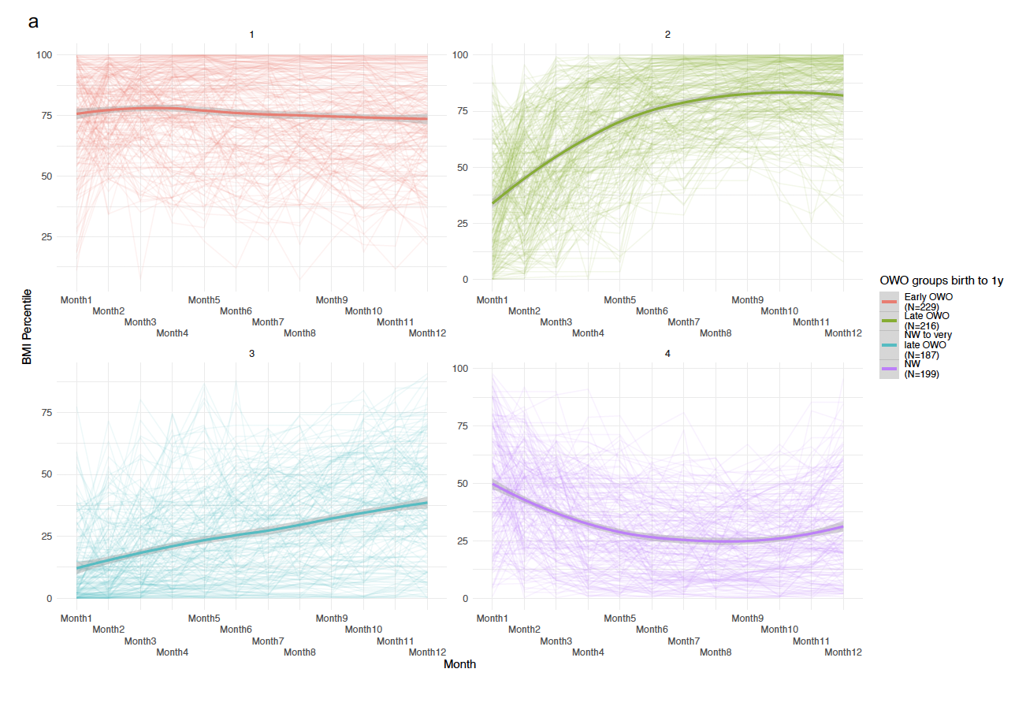
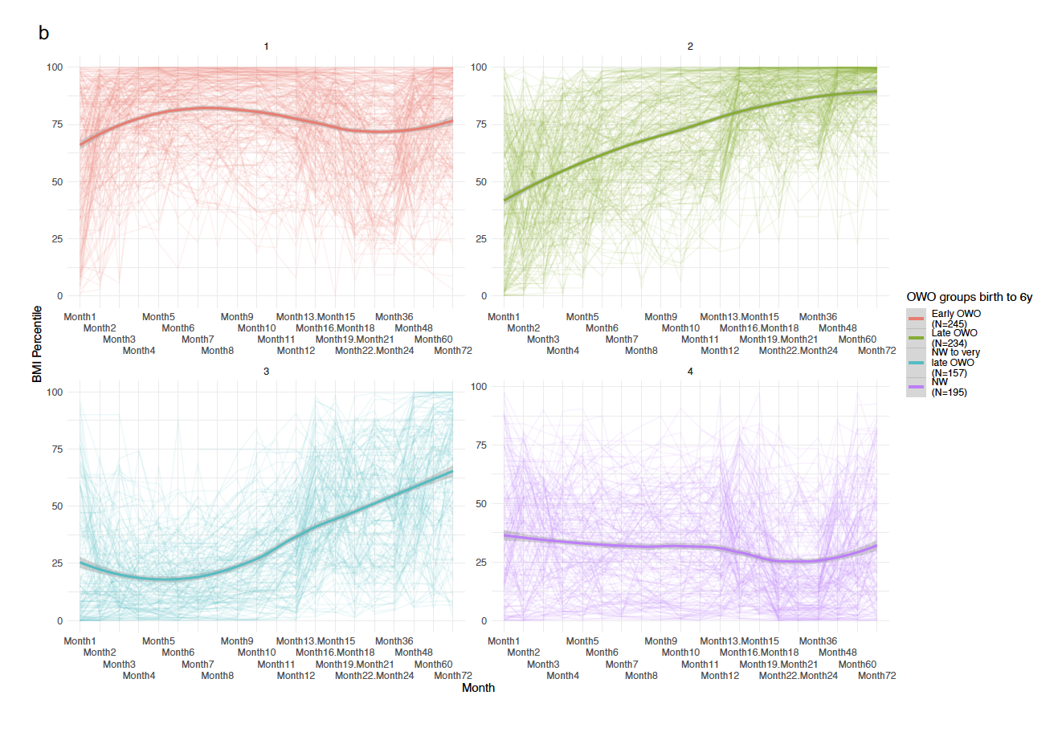

Figure S2: Overplaying CpGs between three gestational methylation age clocks. Missing CpGs in our data out of the CpGs in each clock: Knight: 6/148; Bohlin:8/96; Haftorn (GAmAge): 0/176 missing.

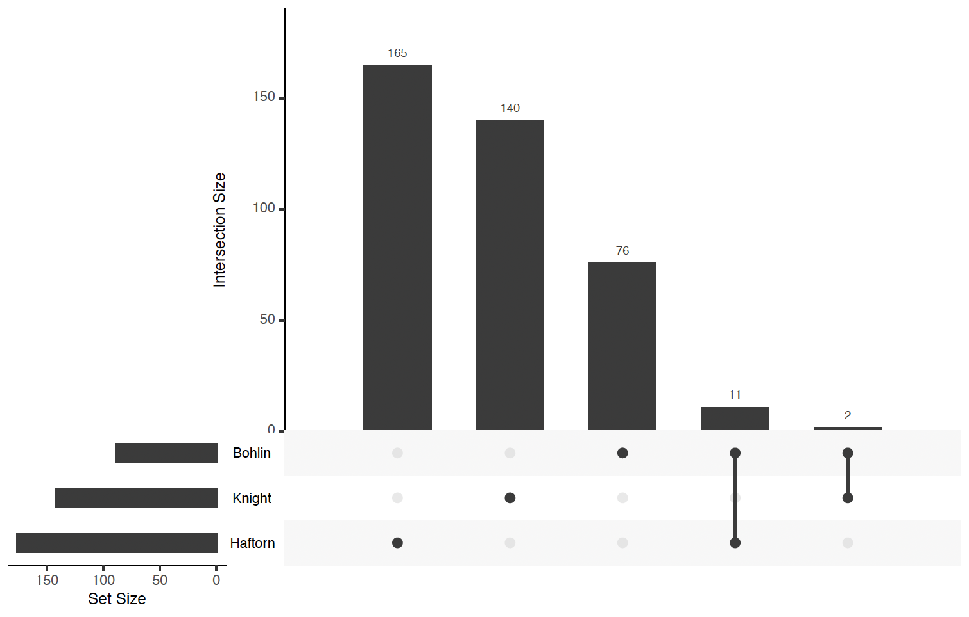

Figure S3: GAmAge and GEAA correlations across OWO groups in different age periods. a. Birth to 2 y. Correlation for early OWO vs. late OWO vs. NW to very late OWO vs. NW: 0.766 vs. 0.868 vs. 0.937 vs. 0.857, respectively (p<2.2e-16 for all). b. Birth to 3 y. Correlation for early OWO vs. late OWO vs. NW to very late OWO vs. NW: 0.749 vs. 0.877 vs. 0.938 vs. 0.868, respectively (p<2.2e-16 for all). c. Birth to 6 y. Correlation for early OWO vs. late OWO vs. NW to very late OWO vs. NW: 0.764 vs. 0.880 vs. 0.931 vs. 0.888, respectively (p<2.2e-16 for all). d. Birth to 10 y. Correlation for early OWO vs. late OWO vs. NW to very late OWO vs. NW: 0.790 vs. 0.870 vs. 0.935 vs. 0.894, respectively (p<2.2e-16 for all). e. Birth to 14 y. Correlation for early OWO vs. late OWO vs. NW to very late OWO vs. NW: 0.795 vs. 0.886 vs. 0.919 vs. 0.907, respectively (p<2.2e-16 for all). f. Birth to 18 y. Correlation for early OWO vs. late OWO vs. NW to very late OWO vs. NW: 0.818 vs. 0.899 vs. 0.902 vs. 0.902, respectively (p<2.2e-16 for all).
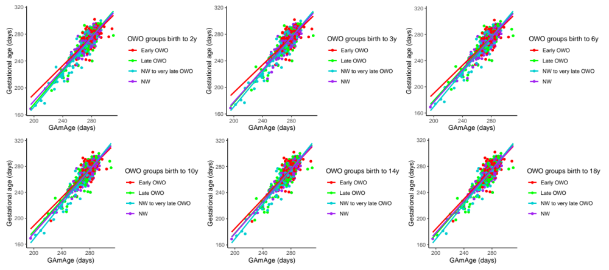

Figure S4: GAmAge clocks and GEAA correlations across OWO groups in the age period of birth to 1y. Upper figure: Knight GAmAge. Correlation for early OWO vs. late OWO vs. NW to very late OWO vs. NW: 0.494 vs. 0.760 vs. 0.869 vs. 0.761; Buttom figure: Bohlin GAmAge. Correlation for early OWO vs. late OWO vs. NW to very late OWO vs. NW: 0.705 vs. 0.879 vs. 871 vs. 0.852.
