Additional File 1

Table of Contents
Figure S1: Age vs log(odds) of three or more comorbidities for acute admissions across England from 2006 to 2021 2
Figure S2: Age vs log(odds) of three or more comorbidities for elective admissions across England from 2006 to 2021 2
Figure S3: Age vs log(odds) of two or more frailty syndromes for acute admissions across England from 2006 to 2021 3
Figure S4: Age vs log(odds) of two or more frailty syndromes for elective admissions across England from 2006 to 2021 3
Table S1: List of conditions used to measure multimorbidity and their point prevalence at the beginning and end of the study 4
Table S2: Percentages for the proportion of admission trends with 0 to 3+ conditions by age and admission type for 2006/7 and 2020/2021 4
Table S3: List of syndromes used to measure frailty and their point prevalence at the beginning and end of the study 5
Table S4: Percentages for the proportion of admission trends with 0 to 2+ frailty syndromes by age and admission type for 2006/7 and 2020/2021 5
Figure S5: Proportion of all inpatient HES admissions with dementia, depression or diabetes aged 18-44 years from 2009 to 2015. 6
Figure S6: Proportion of all inpatient HES admissions with dementia, depression, or diabetes aged 45-64 years from 2009 to 2015. 6
Figure S7: Proportion of all inpatient HES admissions with dementia, depression, or diabetes aged 65+ from 2009 to 2015. 6
Figure S8: Proportion of all elective inpatient HES admissions with dementia, depression, or diabetes for the 65+ from 2009 to 2015. 7
Figure S9: Proportion of all emergency inpatient HES admissions with dementia, depression, or diabetes for the 65+ from 2009 to 2015. 7

Figure S1: Age vs log(odds) of three or more comorbidities for acute admissions across England from 2006 to 2021
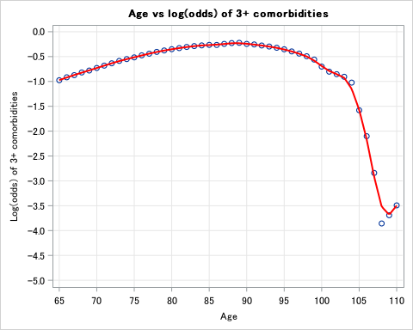

Spline selection: Spline knot applied at ages 90 and 103.

Figure S2: Age vs log(odds) of three or more comorbidities for elective admissions across England from 2006 to 2021
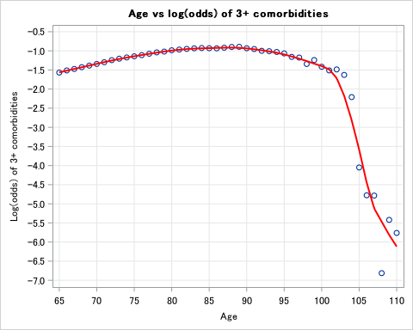

Spline selection: Spline knot applied at ages 90 and 103.

Frailty

Figure S3: Age vs log(odds) of two or more frailty syndromes for acute admissions across England from 2006 to 2021
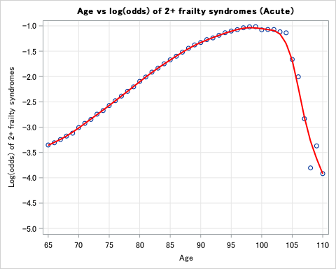

Spline selection: Spline knot applied at age 100.

Figure S4: Age vs log(odds) of two or more frailty syndromes for elective admissions across England from 2006 to 2021
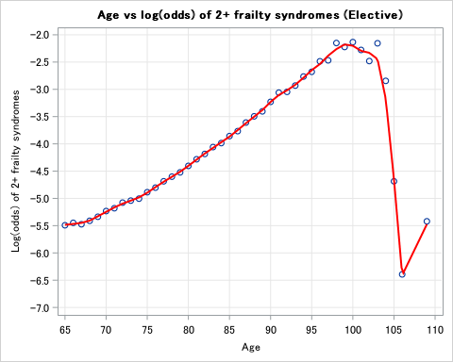

Spline selection: Spline knot applied at age 100.

Table S1: List of conditions used to measure multimorbidity and their point prevalence at the beginning and end of the study
Condition | 2006/2007 (%) | 2020/2021 (%)
CHF | 3.0 | 7.5
Arrhythmias | 7.3 | 15.4
Valvular disease | 1.4 | 4.7
Disease of pulmonary circulation | 0.5 | 1.6
Peripheral vascular diseases | 1.8 | 3.6
Hypertension (Combined HT with and without complications) | 16.4 | 30.4
Paralytic syndromes | 0.7 | 1.2
Other neurological diseases | 3.5 | 5.8
Chronic pulmonary diseases | 9.6 | 18.8
Diabetes (Combined diabetes with and without complications) | 8.1 | 15.2
Thyroid disorders | 2.5 | 6.0
Renal disease | 3.1 | 9.8
Liver disease | 1.1 | 3.7
Peptic ulcer | 0.2 | 0.3
HIV*
Cancer (Combined Lymphoma, Metastasis and Solid tumour) | 7.8 | 9.5
Connective tissue disorders | 1.5 | 3.5
Coagulopathy | 0.3 | 1.1
Obesity | 0.7 | 9.2
Weight loss | 0.4 | 1.0
Fluid disorders | 1.7 | 7.6
Anaemia (Combined Blood loss anaemia and Deficiency anaemia) | 1.0 | 3.0
Alcohol-related diseases | 3.2 | 5.0
Substance abuse | 0.6 | 1.7
Psychoses | 0.7 | 1.2
Depression | 1.9 | 10.1
Dementia³ (Charlson) | 1.9 | 5.0
* Note HIV was not included as it was omitted in our data extract due to sensitivity.

Table S2: Percentages for the proportion of admission trends with 0 to 3+ conditions by age and admission type for 2006/7 and 2020/2021
Acute |  | 18-44 |  |  |  |  |  | 45-64 |  |  |  |  |  | 65+
Number of comorbidities |  | 2006/2007 |  |  | 2020/2021 |  |  | 2006/2007 |  |  | 2020/2021 |  |  | 2006/2007 | 2020/2021
0 |  | 68.8 |  |  | 49.98 |  |  | 41.12 |  |  | 23.95 |  |  | 25.00 | 7.81
1 |  | 22.57 |  |  | 27.12 |  |  | 32.95 |  |  | 25.91 |  |  | 31.35 | 15.91
2 |  | 6.47 |  |  | 13.43 |  |  | 16.55 |  |  | 21.00 |  |  | 23.83 | 21.26
3+ |  | 2.15 |  |  | 9.47 |  |  | 9.39 |  |  | 29.13 |  |  | 19.83 | 55.02
Elective |  | 18-44 |  |  |  |  |  | 45-64 |  |  |  |  |  | 65+
Number of comorbidities |  | 2006/2007 |  |  | 2020/2021 |  |  | 2006/2017 |  |  | 2020/2021 |  |  | 2006/2017 | 2020/2021
0 |  | 89.79 |  |  | 63.66 |  |  | 48.96 |  |  | 24.77 |  |  | 34.58 | 14.11
1 |  | 8.41 |  |  | 26.71 |  |  | 32.93 |  |  | 31.46 |  |  | 34.90 | 24.18
2 |  | 1.38 |  |  | 7.47 |  |  | 12.19 |  |  | 21.61 |  |  | 18.69 | 24.22
3+ |  | 0.42 |  |  | 2.16 |  |  | 5.92 |  |  | 22.16 |  |  | 11.84 | 37.49

Table S3: List of syndromes used to measure frailty and their point prevalence at the beginning and end of the study
Frailty syndrome | 2006/07 Prevalence | 2020/2021 Prevalence
Dementia | 2.9 | 6.8
Delirium | 0.1 | 2.4
Mobility Problems | 0.7 | 3.8
Falls and Fractures | 6.5 | 8.2
Pressure Ulcers | 0.3 | 1.7
Incontinence | 0.4 | 1.6
Dependence and Care | 0.4 | 0.3
Anxiety and Depression | 2.2 | 14.3
Senility | 0.9 | 2.8

Table S4: Percentages for the proportion of admission trends with 0 to 2+ frailty syndromes by age and admission type for 2006/7 and 2020/2021
Acute | 18-44 |  | 45-64 |  | 65+
Number of frailty syndromes | 2006/07 | 2020/21 | 2006/07 | 2020/21 | 2006/07 | 2020/21
0 | 89.45 | 74.86 | 87.12 | 70.93 | 72.62 | 53.4
1 | 10.27 | 23.43 | 12.14 | 24.75 | 21.14 | 28.19
2+ | 0.28 | 1.72 | 0.73 | 4.32 | 6.25 | 18.41
Elective | 18-44 |  | 45-64 |  | 65+
Number of frailty syndromes | 2006/07 | 2020/21 | 2006/07 | 2020/21 | 2006/07 | 2020/21
0 | 98.33 | 85.78 | 96.78 | 82.90 | 94.67 | 85.84
1 | 1.64 | 14.03 | 3.07 | 16.14 | 4.56 | 12.38
2+ | 0.03 | 0.19 | 0.15 | 0.96 | 0.77 | 1.78

Sensitivity analysis - HES Coding Review for all admissions

Figure S5: Proportion of all inpatient HES admissions with dementia, depression or diabetes aged 18-44 years from 2009 to 2015.
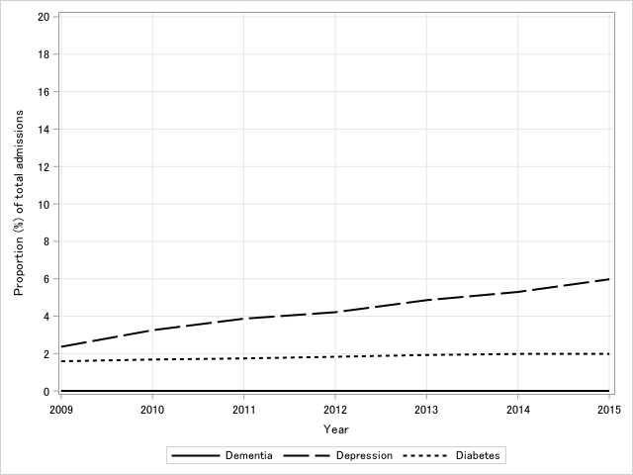

Figure S6: Proportion of all inpatient HES admissions with dementia, depression, or diabetes aged 45-64 years from 2009 to 2015.
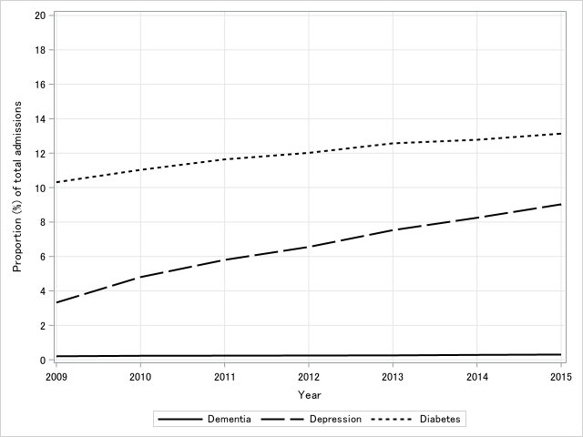

Figure S7: Proportion of all inpatient HES admissions with dementia, depression, or diabetes aged 65+ from 2009 to 2015.

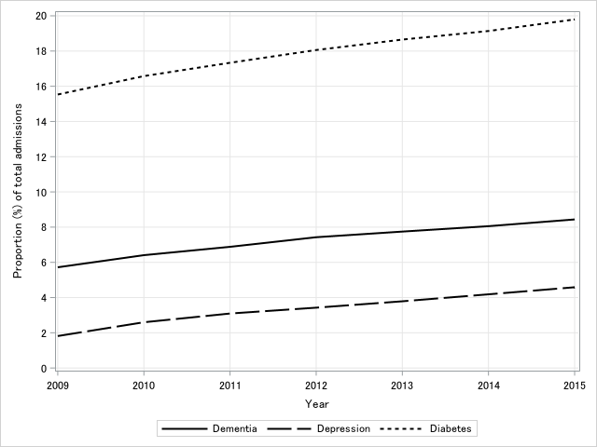

Figure S8: Proportion of all elective inpatient HES admissions with dementia, depression, or diabetes for the 65+ from 2009 to 2015.

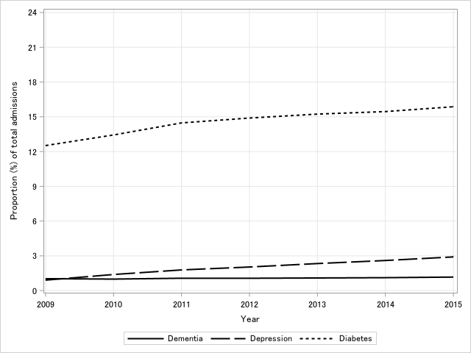

Figure S9: Proportion of all emergency inpatient HES admissions with dementia, depression, or diabetes for the 65+ from 2009 to 2015.

