Additional file
Table of contents
Fig. S1. Pharmacokinetic profiles of fuzuloparib, when combined with mFOLFIRINOX. 2
Fig. S2. Kaplan–Meier estimates of progression-free survival (A) and overall survival (B) in 30 and 60 mg BID cohorts. 3
Table S1. Dose-limiting toxicities 4
Table S2. Exposure of the individual components during combination of fuzuloparib and modified FOLFIRINOX 5
Table S3. Exposure of fuzuloparib during maintenance 7
Table S4. Safety summary 8
Table S5. Treatment-related serious adverse events 9
Table S6. CA19-9 response rate 10

Fig. S1. Pharmacokinetic profiles of fuzuloparib, when combined with mFOLFIRINOX.
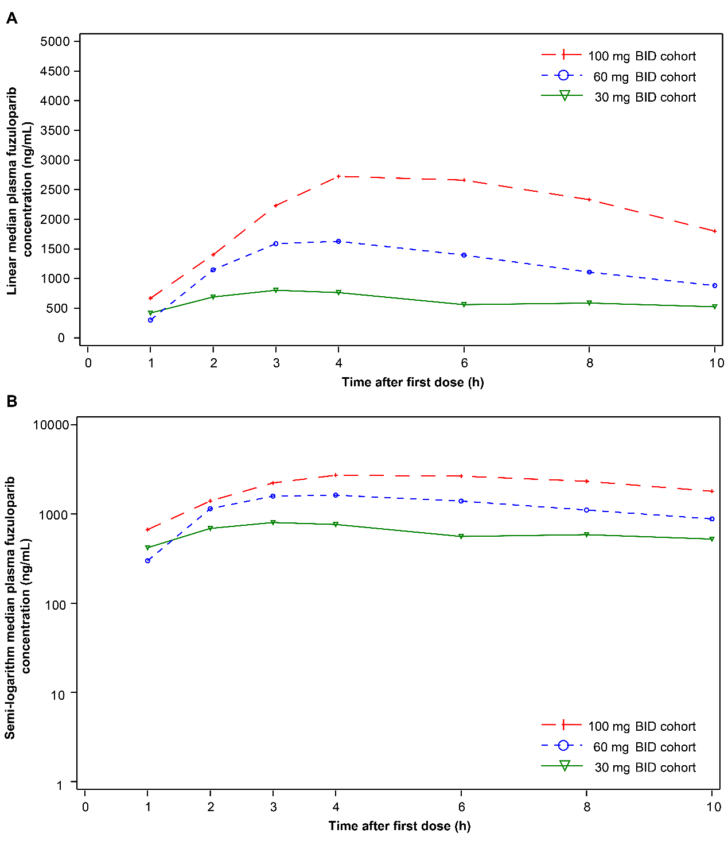
(A) Linear median plasma fuzuloparib concentration-time profiles following a single dose;
(B) Semi-logarithm median plasma fuzuloparib concentration-time profiles following a single dose.

Fig. S2. Kaplan–Meier estimates of progression-free survival (A) and overall survival (B) in 30 and 60 mg BID cohorts.
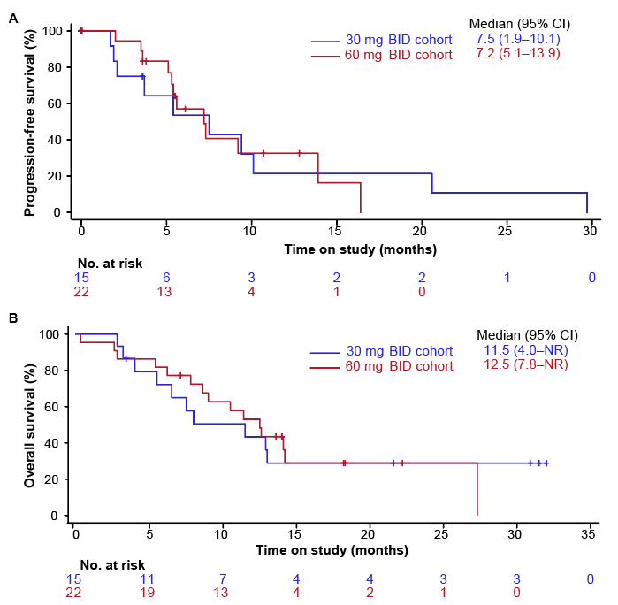
BID, twice daily; NR, not reached.

Table S1. Dose-limiting toxicities
 | 30 mg (n=3) | 60 mg (n=6) | 100 mg (n=1)
Dose-limiting toxicities, n (%) | 0 | 1 (16.7%) | 1 (100.0%)
Grade 4 decreased platelet count | 0 | 1 (16.7%) | 0
Grade 4 decreased neutrophil count lasting for ≥5 d | 0 | 1 (16.7%) | 1 (100.0%)
Among the 12 patients who were enrolled in the dose-escalation phase, 2 patients (1 in the 30 mg cohort and 1 in the 100 mg cohort) were unevaluable for dose-limiting toxicities assessment due to inadequate drug exposure.

Table S2. Exposure of the individual components during combination of fuzuloparib and modified FOLFIRINOX
 | 30 mg BID (n=15) | 60 mg BID (n=22) | 100 mg BID (n=2) | Overall (N=39)
Treatment cycles | 7 (1–12) | 7.5 (1–12) | 7.5 (3–12) | 7 (1–12)
Fuzuloparib
Treatment duration, weeks | 13.7 (1.1–28.9) | 16.9 (1.3–26.9) | 16.55 (5.7–27.4) | 16.7 (1.1–28.9)
Cumulative dose, mg | 4650 (450–11070) | 10635 (1080–20400) | 16400 (5000–27800) | 7410 (450–27800)
Dose intensity, mg/day | 50.5 (31.9–58.8) | 108.35 (40.0–120.0) | 134.9 (125.0–144.8) | 73.5 (31.9–144.8)
Relative dose intensity, % | 84.2 (53.2–98.0) | 90.3 (33.3–100.0) | 67.45 (62.5–72.4) | 84.6 (33.3–100.0)
Oxaliplatin
Treatment duration, weeks | 14.7 (2.0–28.9) | 16.9 (2.0–26.7) | 17.2 (6.7–27.7) | 16.4 (2.0–28.9)
Cumulative dose, mg/m² | 499.6 (83.9–857.2) | 545.1 (76.8–961.2) | 626.65 (257.6–995.7) | 541.7 (76.8–995.7)
Dose intensity, mg/m²/cycle | 79.3 (51.4–86.8) | 77.1 (53.3–86.7) | 84.45 (83.0–85.9) | 77.7 (51.4–86.8)
Relative dose intensity, % | 93.3 (60.5–102.1) | 90.7 (62.7–101.9) | 99.3 (97.6–101.0) | 91.4 (60.5–102.1)
Leucovorin
Treatment duration, weeks | 14.7 (2.0–28.9) | 16.9 (2.0–26.7) | 17.2 (6.7–27.7) | 16.4 (2.0–28.9)
Cumulative dose, mg/m² | 2278.8 (396.5–4142.7) | 2660.2 (362.5–4792.7) | 2927.75 (1205.1–4650.4) | 2500 (362.5–4792.7)
Dose intensity, mg/m²/cycle | 380.7 (242.4–416.5) | 363.35 (250.4–407.8) | 394.6 (387.5–401.7) | 380.7 (242.4–416.5)
Relative dose intensity, % | 95.2 (60.6–104.1) | 90.8 (62.6–101.9) | 98.65 (96.9–100.4) | 95.2 (60.6–104.1)
Irinotecan
Treatment duration, weeks | 14.7 (2.0–28.9) | 16.85 (2.0–26.7) | 17.2 (6.7–27.7) | 16.3 (2.0–28.9)
Cumulative dose, mg/m² | 881.8 (139.8–1508.7) | 977.7 (135.0–1805.4) | 947.95 (453.2–1442.7) | 965.4 (135.0–1805.4)
Dose intensity, mg/m²/cycle | 137.6 (90.4–152.7) | 136.25 (93.7–152.9) | 135.65 (120.2–151.1) | 137.1 (90.4–152.9)
Relative dose intensity, % | 91.8 (60.3–101.8) | 90.85 (62.5–101.9) | 90.4 (80.1–100.7) | 91.4 (60.3–101.9)
Fluorouracil
Treatment duration, weeks | 14.7 (2.0–28.9) | 16.85 (2.0–26.7) | 17.2 (6.7–27.7) | 16.3 (2.0–28.9)
Cumulative dose, mg/m² | 13493.8 (2393.4–24853.7) | 15605.4 (2155.3–27741.6) | 17827.1 (7144.4–28509.8) | 15000.1 (2155.3–28509.8)
Dose intensity, mg/m²/cycle | 2271.9 (1442.6–2481.4) | 2176.35 (1526.9–2429.6) | 2378.65 (2375.8–2381.5) | 2211.9 (1442.6–2481.4)
Relative dose intensity, % | 94.7 (60.1–103.4) | 90.7 (63.6–101.2) | 99.1 (99.0–99.2) | 92.2 (60.1–103.4)
Data are median (range). BID, twice daily.
Relative dose intensity was defined as the proportion of the administered cumulative dose relative to the planned cumulative dose. Planned cumulative dose of fuzuloparib was defined as planned daily dose×7×actual weeks of fuzuloparib during combination period; planned cumulative dose of chemotherapeutic agents was defined as planned cumulative dose per cycle multiplied by actual treatment cycles.

Table S3. Exposure of fuzuloparib during maintenance
 | 30 mg BID (n=7) | 60 mg BID (n=13) | 100 mg BID (n=1) | Overall (N=21)
Treatment cycles | 8.1 (1.1–53.9) | 4.3 (0.6–27.4) | 14.1 | 5.9 (0.6–53.9)
Treatment duration, weeks | 16.3 (2.1–107.9) | 8.6 (1.3–54.7) | 28.1 | 11.9 (1.3–107.9)
Cumulative dose, mg | 33000 (4230–134100) | 17460 (2610–114600) | 55650 | 22200 (2610–134100)
Dose intensity, mg/day | 296.2 (171.7–300.0) | 287.5 (201.8–299.2) | 282.5 | 288.0 (171.7–300.0)
Relative dose intensity, % | 98.7 (57.2–100.0) | 95.8 (67.3–99.7) | 94.2 | 96.0 (57.2–100.0)
Data are median (range). BID, twice daily.
Relative dose intensity was defined as the proportion of the administered cumulative dose relative to the planned cumulative dose. Planned cumulative dose of fuzuloparib was defined as planned daily dose×7×actual weeks of maintenance fuzuloparib.

Table S4. Safety summary
 | 30 mg BID (n=15) | 60 mg BID (n=22) | Overall (N=39)
TRAEs of any grade | 15 (100.0) | 22 (100.0) | 39 (100.0)
TRAEs of grade 3 or worse | 12 (80.0) | 20 (90.9) | 34 (87.2)
Serious TRAEs | 9 (60.0) | 14 (63.6) | 24 (61.5)
TRAEs leading to treatment interruption | 14 (93.3) | 17 (77.3) | 33 (84.6)
Fuzuloparib related | 14 (93.3) | 16 (72.7) | 32 (82.1)
mFOLFIRINOX related | 12 (80.0) | 14 (63.6) | 27 (69.2)
TRAEs leading to dose reduction | 7 (46.7) | 13 (59.1) | 22 (56.4)
Fuzuloparib related | 1 (6.7) | 8 (36.4) | 10 (25.6)
mFOLFIRINOX related | 6 (40.0) | 12 (54.5) | 19 (48.7)
TRAEs leading to treatment discontinuation | 2 (13.3) | 3 (13.6) | 5 (12.8)
Fuzuloparib related | 0 | 1 (4.5) | 1 (2.6)
mFOLFIRINOX related | 2 (13.3) | 3 (13.6) | 5 (12.8)
Treatment-related deaths | 0 | 1 (4.5) | 1 (2.6)
Data are n (%). BID, twice daily; TRAE, treatment-related adverse events.

Table S5. Treatment-related serious adverse events
 | 30 mg BID (n=15) | 60 mg BID (n=22) | Overall (N=39)
Investigations | 7 (46.7) | 10 (45.5) | 18 (46.2)
Neutrophil count decreased | 4 (26.7) | 7 (31.8) | 12 (30.8)
Platelet count decreased | 3 (20.0) | 5 (22.7) | 8 (20.5)
White blood cell count decreased | 1 (6.7) | 4 (18.2) | 5 (12.8)
Blood and lymphatic system disorders | 3 (20.0) | 6 (27.3) | 10 (25.6)
Febrile neutropenia | 2 (13.3) | 3 (13.6) | 6 (15.4)
Anemia | 1 (6.7) | 3 (13.6) | 4 (10.3)
Gastrointestinal disorders | 1 (6.7) | 2 (9.1) | 3 (7.7)
Constipation | 0 | 1 (4.5) | 1 (2.6)
Stomatitis | 0 | 1 (4.5) | 1 (2.6)
Vomiting | 1 (6.7) | 0 | 1 (2.6)
Metabolism and nutrition disorders | 0 | 2 (9.1) | 2 (5.1)
Hyponatremia | 0 | 1 (4.5) | 1 (2.6)
Decreased appetite | 0 | 1 (4.5) | 1 (2.6)
General disorders and administration site conditions | 0 | 2 (9.1) | 2 (5.1)
Asthenia | 0 | 2 (9.1) | 2 (5.1)
Infections and infestations | 0 | 1 (4.5) | 1 (2.6)
Septic shock | 0 | 1 (4.5) | 1 (2.6)
Data are n (%). BID, twice daily.

Table S6. CA19-9 response rate
 | 30 mg BID (n=10) | 60 mg BID (n=14) | 100 mg BID (n=2) | Overall (N=26)
CA19-9 response, n (%;  95% CI) | 4 (40.0;  12.2–73.8) | 10 (71.4;  41.9–91.6) | 1 (50.0;  1.3–98.7) | 15 (57.7;  36.9–76.7)
CA19-9, carbohydrate antigen 19-9; BID, twice daily.

