Additional file 14: Figure S14 Association between BMI and mortality in COVID-19 and non-COVID-19 respiratory patients, by admission date.
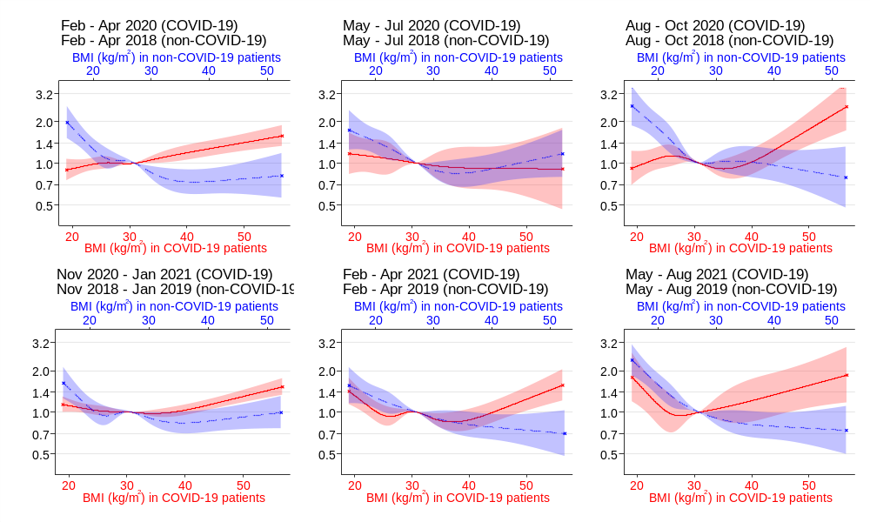Results from parametric survival analyses with Gompertz baseline hazard functions. BMI was modelled as a cubic spline with five knots and converted back from condition-specific standard deviations to kg/m² for display. The solid line is for COVID-19 patients and the long-dashed line is for non-COVID-19 respiratory patients. Survival time was censored at 30 days with patients discharged earlier assumed to survive to 30 days. Adjusted for sex, age (cubic spline), ethnic group, deprivation admission region.
Abbreviations: BMI; body mass index, HR; hazard ratio, CI; confidence interval. Crosses indicate the truncation of plots at the 1st and 99th percentiles of condition-specific BMI z-scores. Horizontal dashed lines indicate the truncation of extreme confidence limits.

