Additional file 6: Figure S6 Adiposity, dependency and comorbidity profiles of ICU patients with COVID-19 (1 March 2020 to 31 July 2021) and non-COVID-19 respiratory conditions (1 Feb 2018 to 31 Aug 2019), by admission date.
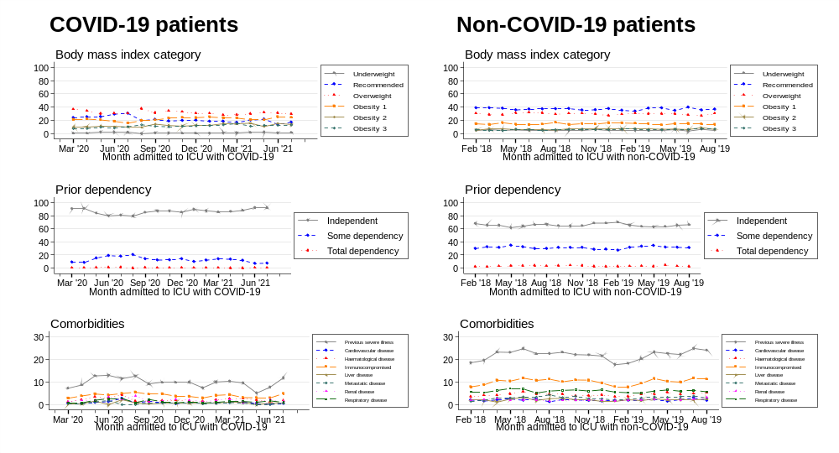
Note: Feb 2020 and Aug 2021 are excluded from COVID-19 profiles due to low case counts (N=5 and N=18 respectively)

