Fig. S1 Subgroup analyses of overall survival by (A) EGFR mutation type, (B) brain metastases, and (C) brain radiotherapy (efficacy set)
(A)
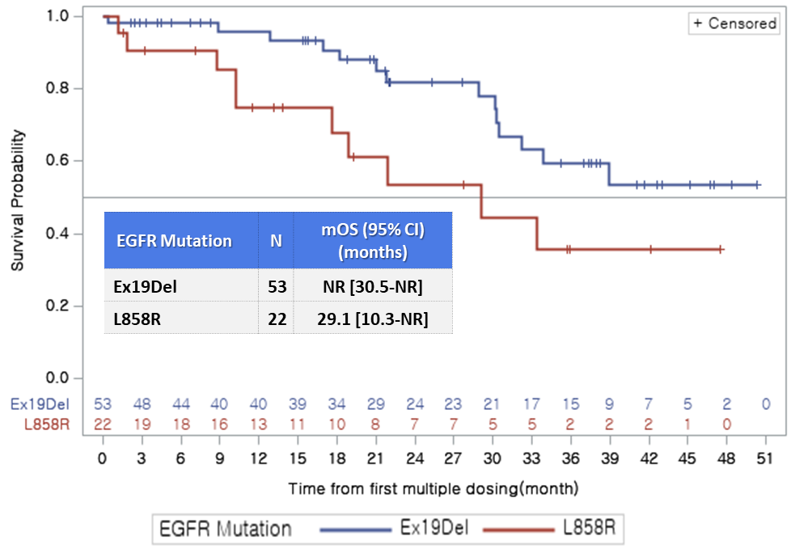
(B)
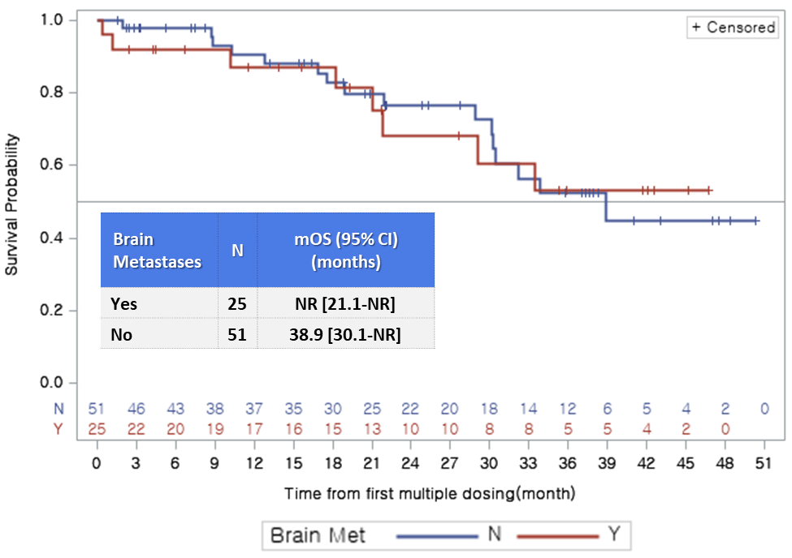
(C)
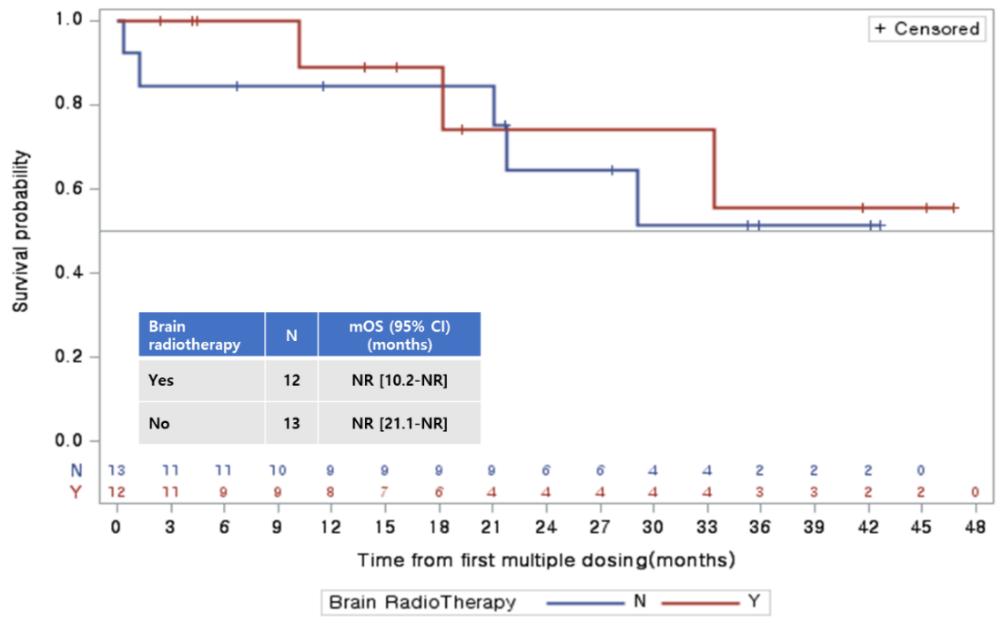
Data cut-off: April 8, 2022. CI confidence interval, EGFR epidermal growth factor receptor, met metastases, mOS median overall survival, NR not reached

Fig. S2. Cumulative incidence rate of CNS progression in lazertinib-treated patients in the LASER201 trial
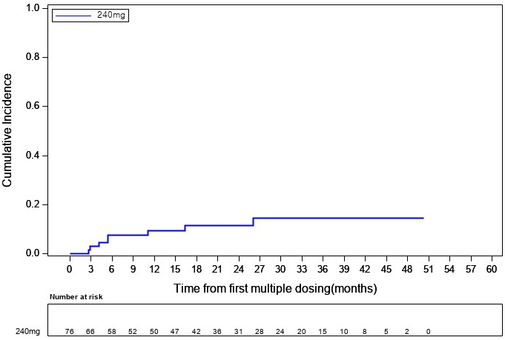Data cut-off: April 8, 2022

Fig. S3 Time to (A) first or (B) second subsequent therapy or death in patients with EGFR T790M-positive non-small cell lung cancer (efficacy set). Data cut-off April 8, 2022 (overall survival)
(A)
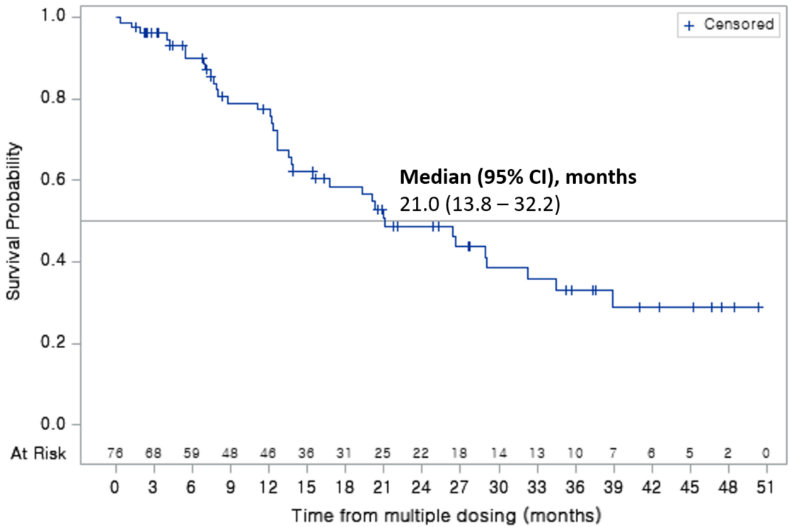
(B)
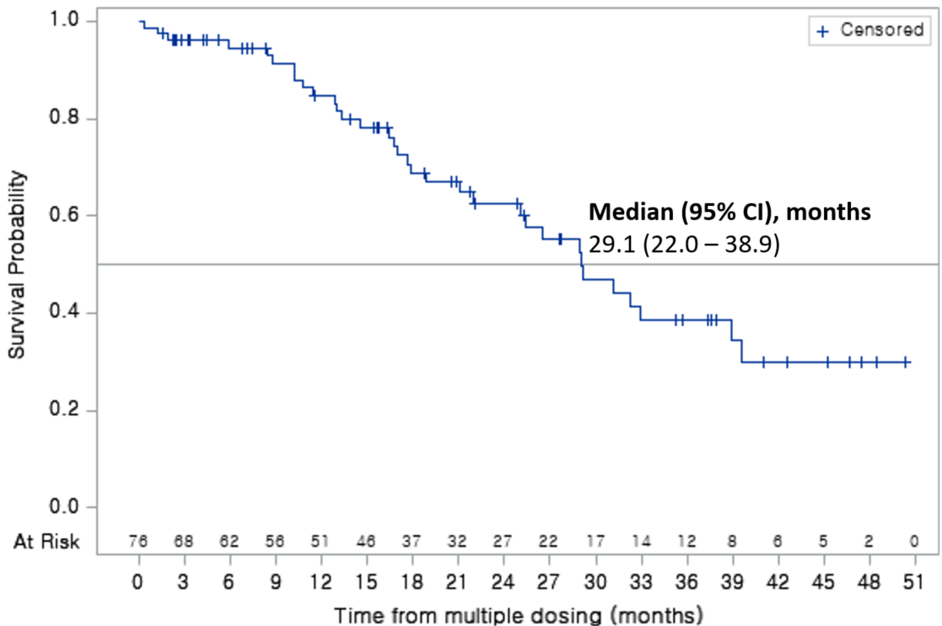
CI confidence interval, EGFR epidermal growth factor receptor

Fig. S4 Patient disposition for ctDNA analysis. Patients were categorized based on their clearance status as determined by ddPCR
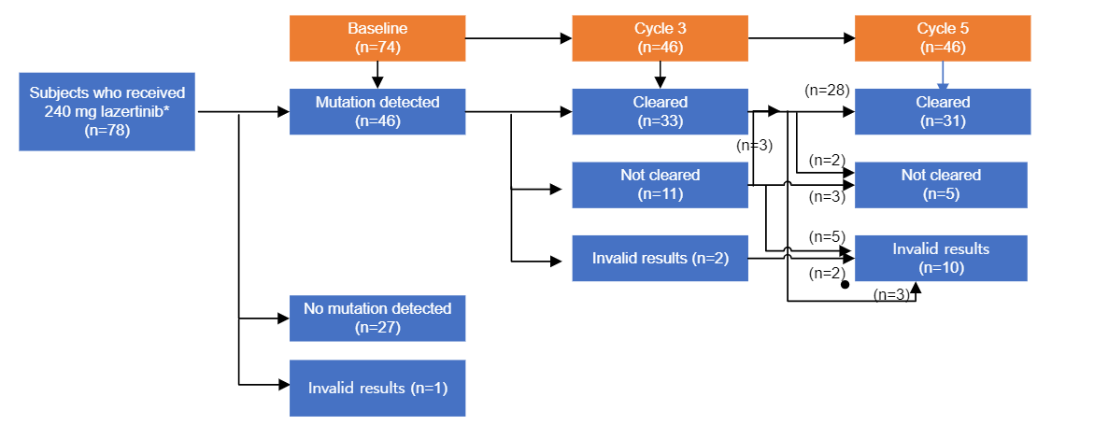
*Four patients were excluded as a sample for ctDNA analysis was not available. Invalid results are those cases where droplets were not formed or analyzed due to either insufficient ctDNA quantity or inadequate sample quality.
ddPCR droplet digital polymerase chain reaction.

Fig. S5 Analysis of plasma EGFR mutations at baseline, cycle 3 (week 6), and cycle 5 (week 12) in patients with a valid (detectable or non-detectable) ctDNA sample at baseline and cycle 3 (n = 44) and/or cycle 5 (n = 36). Kaplan–Meier estimates showing OS and independent central review-assessed PFS according to the presence of ctDNA at (A) baseline, (B) cycle 3, and (C) cycle 5
(A)
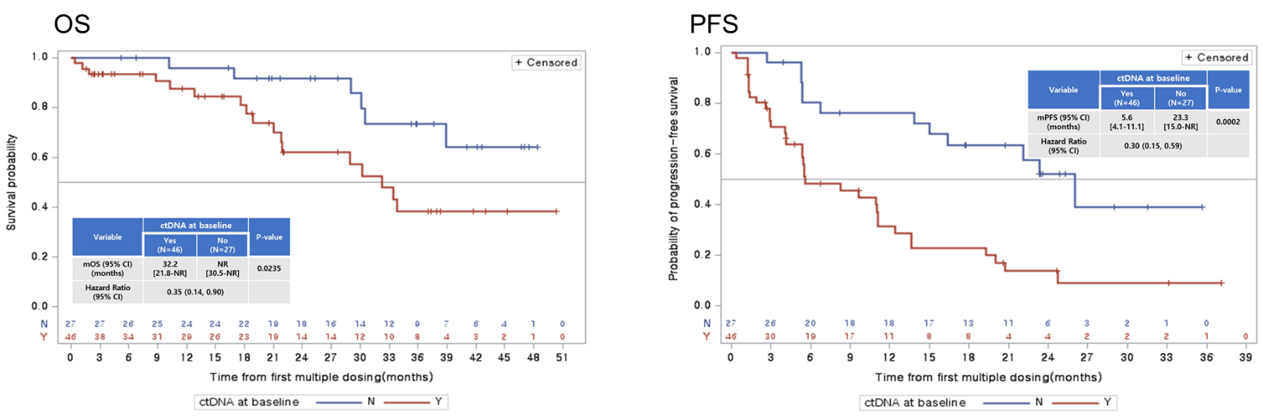
(B)
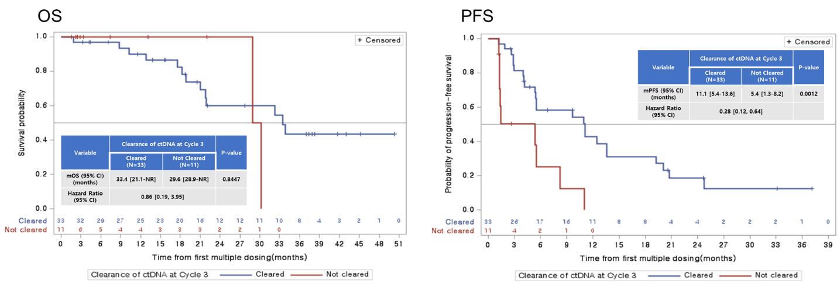
(C)
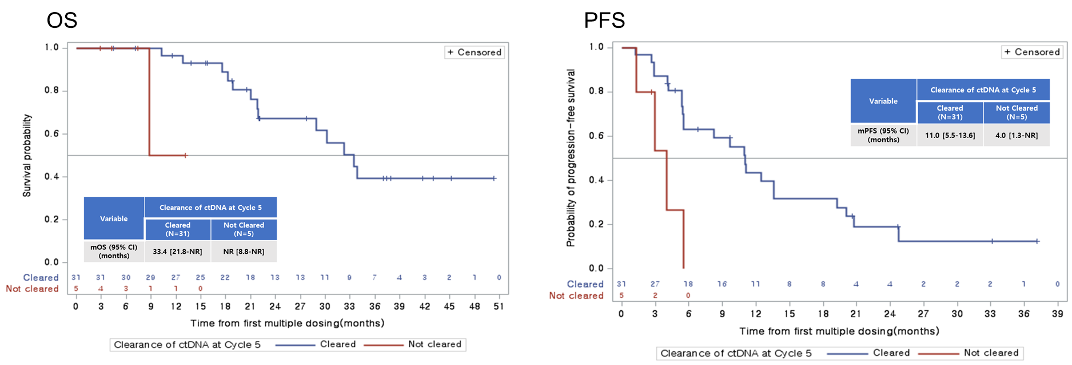
Data cut-off: January 8, 2021 (PFS) and April 8, 2022 (OS). C cycle, ctDNA circulating tumor DNA, OS overall survival, PFS progression-free survival

Fig. S6 Resistance mechanism with ctDNA clearance
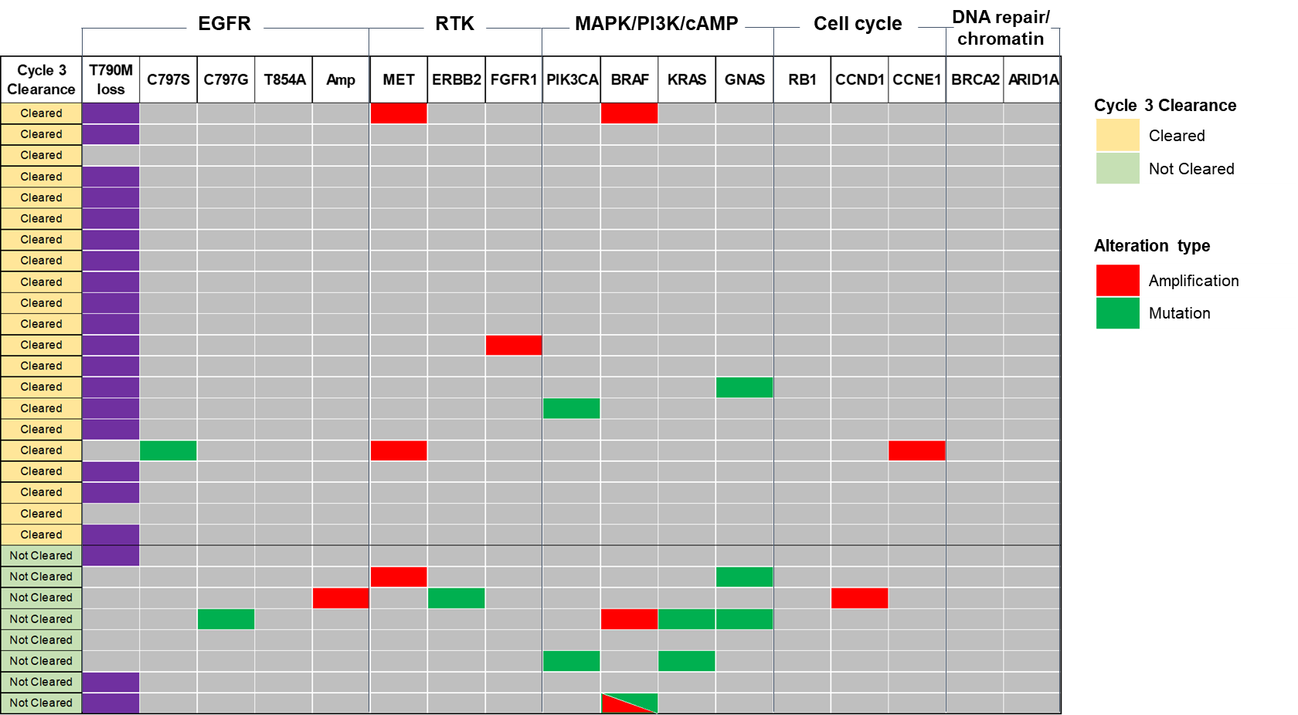
The determination of whether EGFR mutations were cleared or not was made using ddPCR testing. Subsequently, the genetic profiles of individuals with either cleared or uncleared mutations were assessed through cell-free DNA sequencing (Gurdant360), as previously reported.[14] This supplementary analysis incorporated ctDNA clearance analysis by ddPCR and genetic profiling by Gurdant360 to investigate the genetic profile of the Cleared or Not Cleared groups.
ctDNA circulating tumor DNA; ddPCR droplet digital polymerase chain reaction

Fig. S7 Summary of baseline genetic alterations at screening by ctDNA clearance at cycle 3 or not
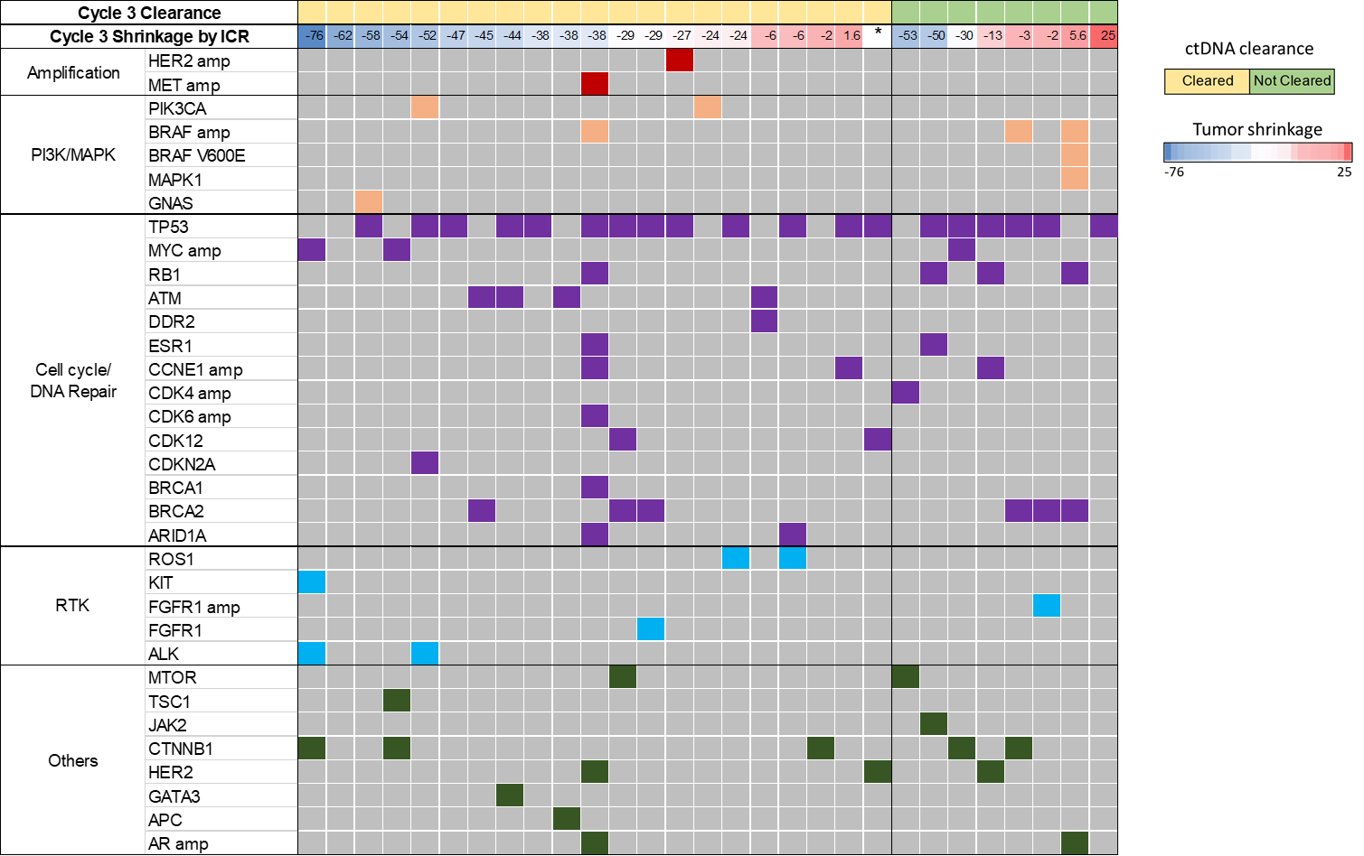
* One patient in the cleared group did not record in electronic data capture system for tumor shrinkage data. Alteration types included missense mutation, nonsense mutation, insertion/deletion, and splicing, and in case of amplification, ‘amp’ was indicated after the gene name
Patients were categorized based on their clearance status as determined by ddPCR. The baseline genetic alteration status from the Guardant 360 results was incorporated according to ctDNA "Cleared" or "Not Cleared" at cycle 3, and tumor shrinkage. In the right panel, the color gradient of the ‘Tumor Shrinkage’ bars represents the degree of tumor shrinkage in cycle 3, with blue indicating greater shrinkage and red indicating less shrinkage or tumor growth. Additionally, in the second line of the figure, labeled ‘Cycle 3 Shrinkage by ICR’, tumor shrinkage values for each patient are displayed, accompanied by color coding to facilitate identification of trends.

