Supplementary Information

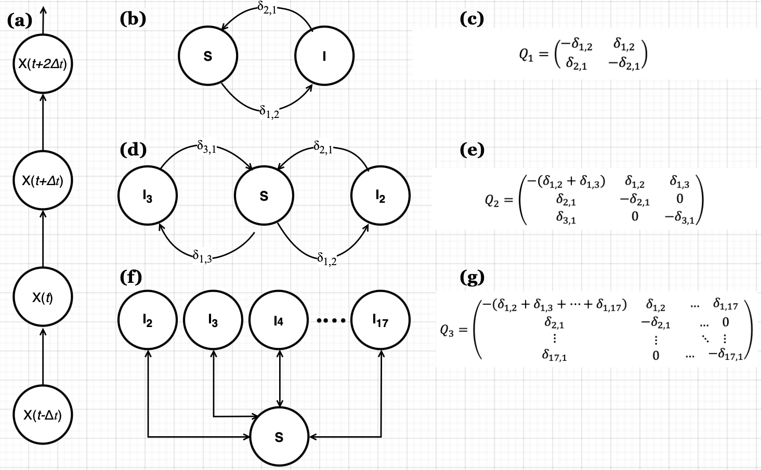

Supplementary Figure 1. Susceptible-infected-susceptible (SIS) Markov model of pneumococcal carriage dynamics among Malawian adults living with and without human immunodeficiency virus (HIV) between 2021 and 2023. (a) Individual sequence of observed carriage states under a continuous-time changes ($Δt$) time-homogeneous intensities, where $X(t$) represents observed carriage state at time $t$ under a Markov property. (b) SIS model that captures the dynamics ($δ_{ij}$) of whole pneumococcal nasopharynx carriage where ($I$) is carrier and ($S$) non-carrier states. (c) Transition intensity matrix ($Q_{1}$,) for carriage transitions between states to compute whole carriage rates ($δ_{ij}$). (d) SIS model that captures the dynamics ($δ_{ij}$) of pneumococcal nasopharynx carriage of pneumococcal conjugate vaccine (PCV13) serotypes ($I_{2}$), non-PCV13-serotypes ($I_{3}$) and non-carriers ($S$). (e) Transition intensity matrix ($Q_{2}$) for carriage transitions between states to compute vaccine serotype-group carriage rates ($δ_{ij}$). (f) SIS model that captures serotype-specific dynamics ($δ_{ij}$) of pneumococcal nasopharynx carriage of 16 serotypes including a few grouped PCV13 serotypes and non-PCV13 serotype ${(I}_{2}, I_{3}, I_{4}, …I_{17})$. (g) Transition intensity matrix ($Q_{3}$) for carriage transitions between states to compute serotype-specific carriage rates ($δ_{ij}$).
Supplementary Table 1. Daily acquisition probability of vaccine-serotype (VT) and non-vaccine-serotype (NVT) pneumococcal carriage among adults living with and without HIV estimated from a Markov model.
 | VT, HIV- | VT, ART<3m | VT, ART>1y | NVT, HIV- | NVT, ART<3m | NVT, ART>1y
Variable | Daily acquisition probability  (95%CI) | Daily acquisition probability  (95%CI) | Daily acquisition probability  (95%CI) | Daily acquisition probability  (95%CI) | Daily acquisition probability  (95%CI) | Daily acquisition probability  (95%CI)
Overall | 0.0022 (0.0011-0.0046) | 0.0014 (0.0006-0.0031) | 0.0022 (0.0010-0.0048) | 0.0142 (0.0101-0.0200) | 0.0192 (0.0135-0.0290) | 0.0205 (0.0143-0.0290)
Sex
Male | 0.0022 (0.0011-0.0046) | 0.0014 (0.0006-0.0031) | 0.0022 (0.0010-0.0048) | 0.0142 (0.0101-0.0200) | 0.0192 (0.0135-0.0290) | 0.0205 (0.0143-0.0290)
Female | 0.0042 (0.0021-0.0084) | 0.0027 (0.0012-0.0058) | 0.0044 (0.0020-0.0094) | 0.0216 (0.0158-0.0307) | 0.0294 (0.0202-0.0438) | 0.0312 (0.0222-0.0438)
Age group (years)
18-33 | 0.0022 (0.0011-0.0046) | 0.0014 (0.0006-0.0031) | 0.0022 (0.0010-0.0048) | 0.0142 (0.0101-0.0200) | 0.0192 (0.0135-0.0290) | 0.0205 (0.0143-0.0290)
34-44 | 0.0024 (0.0012-0.0047) | 0.0015 (0.0006-0.0033) | 0.0025 (0.0012-0.0049) | 0.0112 (0.0079-0.0158) | 0.0153 (0.0107-0.0220) | 0.0162 (0.0118-0.0222)
Number of children in the house
1 child | 0.0022 (0.0011-0.0046) | 0.0014 (0.0006-0.0031) | 0.0022 (0.0010-0.0048) | 0.0142 (0.0101-0.0200) | 0.0192 (0.0135-0.0290) | 0.0205 (0.0143-0.0290)
2+ children | 0.0038 (0.0017-0.0089) | 0.0024 (0.0010-0.0060) | 0.0040 (0.0017-0.0092) | 0.0156 (0.0105-0.0235) | 0.0212 (0.0143-0.0320) | 0.0225 (0.0154-0.0333)
SES
High | 0.0022 (0.0011-0.0046) | 0.0014 (0.0006-0.0031) | 0.0022 (0.0010-0.0048) | 0.0142 (0.0101-0.0200) | 0.0192 (0.0135-0.0290) | 0.0205 (0.0143-0.0290)
Low | 0.0044 (0.0020-0.0092) | 0.0028 (0.0014-0.0055) | 0.0046 (0.0024-0.0086) | 0.0194 (0.0138-0.0279) | 0.0264 (0.0193-0.0358) | 0.0280 (0.0206-0.0372)
95%CI: Confidence intervals at significance level of 0.05
Cut off for age groups is based on the median age of 33 years-old
VT: serotypes targeted by 13-valency pneumococcal conjugate vaccine (PCV13)
NVT: serotypes not targeted by PCV13
ART: Antiretroviral therapy
HIV-: Adults living without human immunodeficiency virus
HIV+: Adults living with human immunodeficiency virus
SES: social economic status is based on possession index, calculated as a sum of positive responses for household ownership of each of one of fifteen different functioning items: watch, radio, bank account, iron (charcoal), sewing machine (electric), mobile phone, CD player, fan (electric), bednet, mattress, bed, bicycle, motorcycle, car, and television.

Supplementary Table 2. Pneumococcal carriage duration (days) of vaccine-serotype (VT) and non-vaccine-serotype (NVT) among adults living with and without HIV estimated from a Markov model.
 | VT, HIV- | VT, ART<3m | VT, ART>1y | NVT, HIV- | NVT, ART<3m | NVT, ART>1y
Variable | Carriage duration  (95%CI) | Carriage duration  (95%CI) | Carriage duration  (95%CI) | Carriage duration  (95%CI) | Carriage duration  (95%CI) | Carriage duration  (95%CI)
Overall | 9.38 (5.49-15.96) | 17.85 (9.27-35.67) | 11.94 (6.44-22.02) | 9.99 (7.34-13.59) | 13.23(9.70-18.10) | 15.35 (11.71-20.41)
Sex
Male | 9.38 (5.49-15.96) | 17.85 (9.27-35.67) | 11.94 (6.44-22.02) | 9.99 (7.34-13.59) | 13.23 (9.70-18.10) | 15.35 (11.71-20.41)
Female | 10.04 (6.04-445.76) | 19.11 (9.58-37.31) | 12.79 (7.17-470.11) | 10.60 (8.04-14.02) | 14.04 (10.88-18.34) | 16.29 (12.49-21.55)
Age (years)
18-33 | 9.38 (5.49-15.96) | 17.85 (9.27-35.67) | 11.94 (6.44-22.02) | 9.99 (7.34-13.59) | 13.23 (9.70-18.10) | 15.35 (11.71-20.41)
34-44 | 7.20 (3.37-16.09) | 13.70 (7.22-25.37) | 9.17 (4.91-16.93) | 10.02 (7.22-13.77) | 13.27 (9.49-18.47) | 15.39 (11.69-20.61)
95%CI: Confidence intervals at significance level of 0.05.
ART: Antiretroviral therapy.
NA: Not applicable for adults without human immunodeficiency deficiency virus.
HIV-: Human immunodeficiency deficiency virus negative infection status.
ALWHIVT: Human immunodeficiency deficiency virus positive infection status on antiretroviral therapy.

Supplementary Table 3. Daily pneumococcal serotype carriage acquisition probability and duration (days) of carriage of each serotype among ALWHIV and adult without HIV estimated from a Markov model.
Serotype or serotype group | Proportion of total samples  n (%) | Acquisition probability  (95%CI) | Carriage duration  (95%CI)
15A/B/C/F | 55 (5.7) | 0.0018 (0.0012-0.0027) | 15.82 (9.59-25.70)
7A/B/C | 55 (5.7) | 0.0013 (0.0008-0.0021) | 17.83 (11.38-28.92)
3 | 52 (5.4) | 0.0014 (0.0009-0.0023) | 13.32 (8.55-20.46)
11A/B/C/D/F | 51 (5.3) | 0.0018 (0.0012-0.0028) | 12.18 (7.83-19.04)
23A/B | 48 (5.0) | 0.0017 (0.0010-0.0026) | 9.02 (6.11-13.55)
17A/F | 36 (3.7) | 0.0016 (0.0006-0.0018) | 15.30 (8.74-26.83)
19F | 30 (3.1) | 0.0016 (0.0010-0.0026) | 8.57 (5.27-14.74)
10A/B/C/F | 27 (2.8) | 0.0014 (0.0007-0.0023) | 7.80 (4.66-13.16)
20 | 25 (2.6) | 0.0011 (0.0006-0.0019) | 9.71 (5.40-18.52)
6C | 20 (2.1) | 0.0009 (0.0005-0.0016) | 10.74 (4.87-21.57)
19A | 16 (1.7) | 0.0004 (0.0002-0.0009) | 17.38 (7.30-43.06)
9A/L/N | 16 (1.7) | 0.0005 (0.0002-0.0013) | 9.23 (4.54-18.00)
6A | 14 (1.5) | 0.0004 (0.0002-0.0010) | 12.94 (5.28-30.51)
Other VT | 45 (4.7) | 0.0016 (0.0010-0.0025) | 10.90 (6.96-17.34)
Known NVT | 64 (6.5) | 0.0023 (0.0016-0.0034) | 10.09 (8.61-11.74)
Unknown NVT | 410 (42.5) | 0.0165 (0.0141-0.0193) | 10.88 (7.39-16.40)
95%CI: Confidence intervals at significance level of 0.05
Other VT: 13-valent Pneumococcal conjugate vaccine (PCV13) serotypes include 1, 4, 9V, 14, 18C, and 23F
known NVT: non-PCV13 serotypes include 22A/F, 33A/B/C/D/F, 18A/B/C/F, 12A/B/F, 19B/C, 8, and 6D

