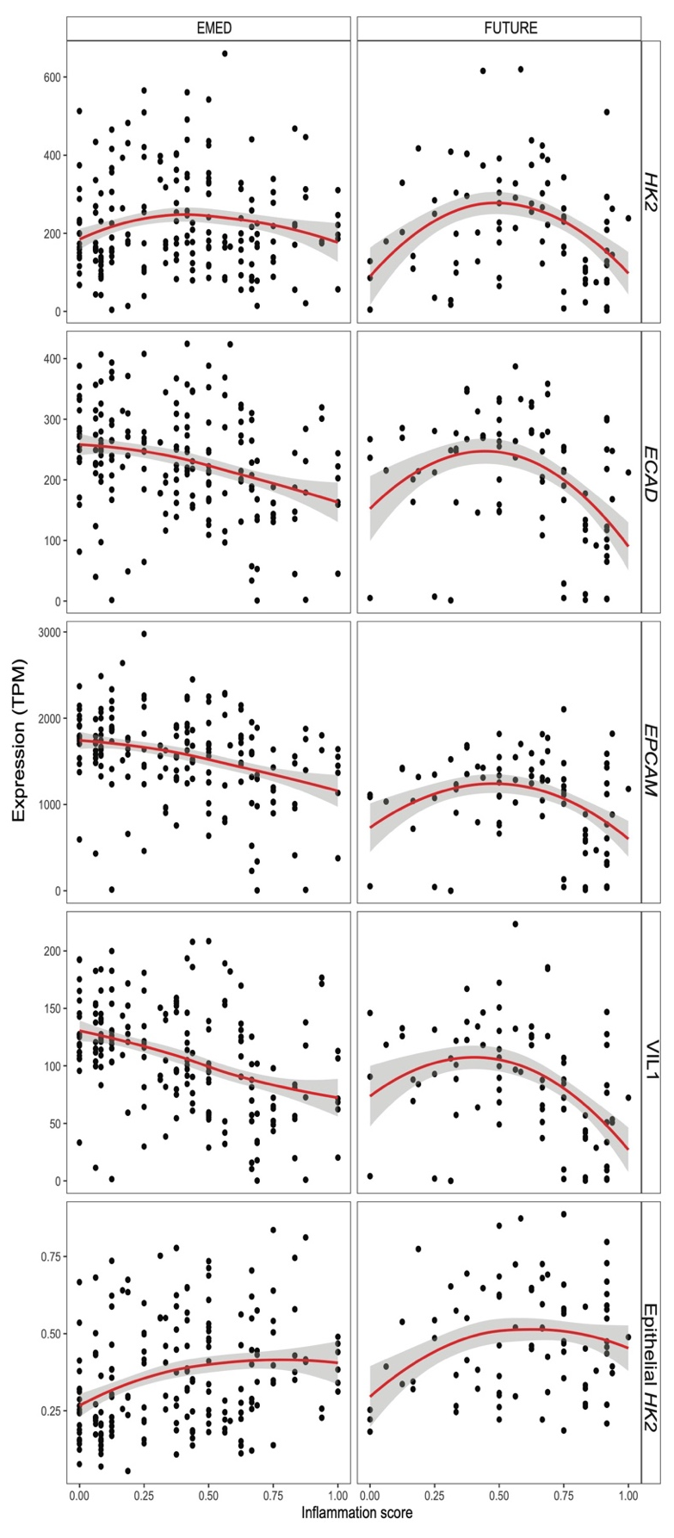
Additional file 5: Figure S2: Epithelial HK2 expression correlates with disease severity in both clinical cohorts. Expression data (TPM, transcript per million) of HK2 and the epithelial marker genes ECAD, VIL1 and EPCAM in the intestinal mucosa of patients with various degrees of gut inflammation split per clinical cohort FUTURE and EMED. The red lines represent the mean expression trendline with the grey area indicating its 95% confidence interval.

