Additional file 1
Title: In utero, childhood, and adolescence tobacco smoke exposure, physical activity and chronic kidney disease incidence in adulthood: evidence from a large prospective cohort study.
Bingxin Shang^{1,2}, Yuxin Yao^{1,2}, Haoyu Yin^{1,2}, Yujia Xie^{1,2}, Shiyu Yang^{1,2}, Xiaojie You^{1,2}, Haoxiang Liu^{1,2}, Miao Wang^{3*}, Jixuan Ma^{1,2*}

Methods S1. Additional information of Covariates
Table S1. Sensitivity analyses for the associations of in utero tobacco smoke exposure and age of smoke initiation with incident CKD
Table S2. Sensitivity analyses for the joint effects of in utero tobacco smoke exposure and age of smoking initiation on incident CKD
Table S3. Associations of physical activity with incident CKD among participants included for analysis of in utero tobacco smoke exposure
Table S4. Associations of physical activity with incident CKD among participants included for analysis of age of smoking initiation
Table S5. Sensitivity analyses for the joint effects of in utero tobacco smoke exposure and physical activity on incident CKD
Table S6. Sensitivity analyses for the joint effects of age of smoking initiation and physical activity on incident CKD
Fig. S1. Flowchart of the study

Methods S1. Additional information of Covariates
Weight and height were measured, and BMI was calculated by dividing weight by height squared (kg/m²). Drinking status was categorized into never, previous, and current. A healthy diet score was calculated based on five dietary factors: total vegetable intake ≥4 tablespoons/day; total fruit intake ≥3 pieces/day; total fish intake ≥ twice/week; processed meat intake ≤ once/week; and unprocessed red meat intake ≤ twice/ week. One point was given for each satisfied item, with a range of the total diet score from 0 to 5 and a higher score indicating a healthier diet. Prevalent hypertension was defined as self-reported hypertension, using of antihypertensive drug, measured systolic blood pressure ≥140 mmHg, or a diastolic blood pressure ≥90 mmHg, and diagnosis indicative of hypertension in primary care and hospital inpatient data. Prevalent diabetes was defined as self-reported diabetes, using insulin, Glycated hemoglobin (HbA1c) ≥48 mmol/mol, and diagnosis indicative of diabetes in primary care and hospital inpatient data. Prevalent hyperlipidemia was defined as a self-reported hyperlipidemia, using of cholesterol-lowering drug, and diagnosis indicative of hyperlipidemia in primary care and hospital inpatient data.

Table S1. Sensitivity analyses for the associations of in utero tobacco smoke exposure and age of smoke initiation with incident CKD
 | In utero tobacco smoke exposure |  |  | Age of smoking initiation |  |  |  | P trend
 | No | Yes |  | Never-smokers | Adulthood | Adolescence | Childhood | P trend
Participants without missing data
No. participants | 175,512 | 73,852 |  | 156,756 | 37,091 | 38,447 | 14,247
No. case, n (%) | 6,456 (3.68) | 2,832 (3.83) |  | 5,013 (3.20) | 1,726 (4.65) | 1,987 (5.17) | 698 (4.90)
Person-years | 2,279,395 | 956,754 |  | 2,052,609 | 473,574 | 489,962 | 180,335
HR (95% CI)
Model 1 | 1.00 (ref.) | 1.16 (1.11, 1.21) |  | 1.00 (ref.) | 1.23 (1.17, 1.30) | 1.46 (1.38, 1.54) | 1.69 (1.56, 1.83) | <0.001
Model 2 | 1.00 (ref.) | 1.07 (1.02, 1.12) |  | 1.00 (ref.) | 1.18 (1.11, 1.24) | 1.28 (1.22, 1.35) | 1.35 (1.24, 1.47) | <0.001
Model 3 | 1.00 (ref.) | 1.06 (1.01, 1.11) |  | 1.00 (ref.) | 1.24 (1.17, 1.31) | 1.30 (1.24, 1.38) | 1.34 (1.23, 1.45) | <0.001
Excluding cases within 2 years
No. participants | 248,331 | 103,333 |  | 223,261 | 51,946 | 54,968 | 20,472
No. case, n (%) | 8,848 (3.56) | 3,835 (3.71) |  | 6,930 (3.10) | 2,288 (4.40) | 2,753 (5.01) | 990 (4.84)
Person-years | 3,231,039 | 1,341,307 |  | 2,928,359 | 665,028 | 701,682 | 259,378
HR (95% CI)
Model 1 | 1.00 (ref.) | 1.17 (1.13, 1.22) |  | 1.00 (ref.) | 1.22 (1.16, 1.28) | 1.48 (1.41, 1.55) | 1.76 (1.65, 1.89) | <0.001
Model 2 | 1.00 (ref.) | 1.08 (1.04, 1.12) |  | 1.00 (ref.) | 1.17 (1.11, 1.22) | 1.30 (1.24, 1.36) | 1.40 (1.31, 1.50) | <0.001
Model 3 | 1.00 (ref.) | 1.08 (1.04, 1.12) |  | 1.00 (ref.) | 1.23 (1.17, 1.29) | 1.32 (1.26, 1.38) | 1.39 (1.30, 1.49) | <0.001
Abbreviations: CKD, chronic kidney disease; HR, hazard ratio; CI, confidence interval.
Mode1 1 was adjusted for age, sex, and ethnic.
Mode1 2 was additionally adjusted for body mass index, Townsend deprivation index, education level, physical activity, drinking status, and healthy diet score based on model 1.
Mode1 3 was additionally adjusted for antihypertensive drug use, Insulin use, cholesterol-lowering drug use, urinary albumin to creatinine ratio, estimated glomerular filtration rate, prevalent hypertension, diabetes, and hyperlipidemia based on model 2.

Table S2. Sensitivity analyses for the joint effects of in utero tobacco smoke exposure and age of smoking initiation on incident CKD
Subgroups | No. total | No. cases (%) | HR (95% CI)
Participants without missing data
Without in utero tobacco smoke exposure
Never-smokers | 99,110 | 3,100 (3.13) | 1.00 (ref.)
Smoking initiation in adulthood | 22,704 | 1,074 (4.73) | 1.28 (1.20, 1.38)
Smoking initiation in adolescence | 20,910 | 1,036 (4.95) | 1.26 (1.17, 1.35)
Smoking initiation in childhood | 6,713 | 347 (5.17) | 1.41 (1.26, 1.58)
With in utero tobacco smoke exposure
Never-smokers | 40,020 | 1,300 (3.25) | 1.06 (0.99, 1.13)
Smoking initiation in adulthood | 8,851 | 385 (4.35) | 1.25 (1.12, 1.39)
Smoking initiation in adolescence | 11,591 | 618 (5.33) | 1.44 (1.32, 1.58)
Smoking initiation in childhood | 5,452 | 244 (4.48) | 1.30(1.14, 1.48)
Excluding cases within 2 years
Without in utero tobacco smoke exposure
Never-smokers | 140,972 | 4,253 (3.02) | 1.00 (ref.)
Smoking initiation in adulthood | 31,573 | 1,393 (4.41) | 1.26 (1.18, 1.34)
Smoking initiation in adolescence | 29,572 | 1,474 (4.98) | 1.33 (1.25, 1.41)
Smoking initiation in childhood | 9,474 | 485 (5.12) | 1.47 (1.33, 1.61)
With in utero tobacco smoke exposure
Never-smokers | 55,869 | 1,785 (3.19) | 1.10 (1.04, 1.16)
Smoking initiation in adulthood | 12,184 | 517 (4.24) | 1.29 (1.17, 1.41)
Smoking initiation in adolescence | 16,354 | 808 (4.94) | 1.43 (1.32, 1.54)
Smoking initiation in childhood | 7,810 | 346 (4.43) | 1.37 (1.23, 1.54)
Abbreviations: CKD, chronic kidney disease; HR, hazard ratio; CI, confidence interval.
Models were adjusted for age, sex, ethnic, body mass index, Townsend deprivation index, education level, physical activity, drinking status, healthy diet score, antihypertensive drug use, Insulin use, cholesterol-lowering drug use, urinary albumin to creatinine ratio, estimated glomerular filtration rate, prevalent hypertension, diabetes, and hyperlipidemia.

Table S3. Associations of physical activity with incident CKD among participants included for analysis of in utero tobacco smoke exposure
 | No. participants | No. case (%) | Person-years | HR (95% CI)
Physical activity
Not recommended MVPA | 131,215 | 5,237 (3.99) | 1,699,480 | 1.00 (ref.)
Recommended MVPA | 158,294 | 5,570 (3.52) | 2,057,730 | 0.91 (0.88, 0.95)
P trend |  |  |  | <0.001
Abbreviations: CKD, chronic kidney disease; MVPA, moderate-to-vigorous physical activity; HR, hazard ratio; CI, confidence interval.
Models were adjusted for age, sex, ethnic, body mass index, Townsend deprivation index, education level, drinking status, healthy diet score, antihypertensive drug use, Insulin use, cholesterol-lowering drug use, urinary albumin to creatinine ratio, estimated glomerular filtration rate, prevalent hypertension, diabetes, and hyperlipidemia.

Table S4. Associations of physical activity with incident CKD among participants included for analysis of age of smoking initiation
 | No. participants | No. case (%) | Person-years | HR (95% CI)
Physical activity
Not recommended MVPA | 131,074 | 5,351 (4.08) | 1,695,193 | 1.00 (ref.)
Recommended MVPA | 154,872 | 5,592 (3.61) | 2,012,061 | 0.92 (0.88, 0.95)
P trend |  |  |  | <0.001
Abbreviations: CKD, chronic kidney disease; MVPA, moderate-to-vigorous physical activity; HR, hazard ratio; CI, confidence interval.
Models were adjusted for age, sex, ethnic, body mass index, Townsend deprivation index, education level, drinking status, healthy diet score, antihypertensive drug use, Insulin use, cholesterol-lowering drug use, urinary albumin to creatinine ratio, estimated glomerular filtration rate, prevalent hypertension, diabetes, and hyperlipidemia.

Table S5. Sensitivity analyses for the joint effects of in utero tobacco smoke exposure and physical activity on incident CKD
Subgroups | No. total | No. cases (%) | HR (95% CI)
Participants without missing data
Recommended MVPA
Without in utero tobacco smoke exposure | 95,807 | 3,302 (3.45) | 1.00 (ref.)
With in utero tobacco smoke exposure | 40,458 | 1,458 (3.60) | 1.08 (1.02, 1.15)
Not recommended MVPA
Without in utero tobacco smoke exposure | 79,705 | 3,154 (3.96) | 1.13 (1.08, 1.19)
With in utero tobacco smoke exposure | 33,394 | 1,374 (4.11) | 1.17 (1.10, 1.25)
Excluding cases within 2 years
Recommended MVPA
Without in utero tobacco smoke exposure | 111,133 | 3,547 (3.19) | 1.00 (ref.)
With in utero tobacco smoke exposure | 46,671 | 1,533 (3.28) | 1.07 (1.01, 1.14)
Not recommended MVPA
Without in utero tobacco smoke exposure | 92,240 | 3,315 (3.59) | 1.11 (1.05, 1.16)
With in utero tobacco smoke exposure | 38,514 | 1,461 (3.79) | 1.17 (1.10, 1.24)
Abbreviations: CKD, chronic kidney disease; MVPA, moderate-to-vigorous physical activity; HR, hazard ratio; CI, confidence interval.
Models were adjusted for age, sex, ethnic, body mass index, Townsend deprivation index, education level, drinking status, healthy diet score, antihypertensive drug use, Insulin use, cholesterol-lowering drug use, urinary albumin to creatinine ratio, estimated glomerular filtration rate, prevalent hypertension, diabetes, and hyperlipidemia.

Table S6. Sensitivity analyses for the joint effects of age of smoking initiation and physical activity on incident CKD
Subgroups | No. total | No. cases (%) | HR (95% CI)
Participants without missing data
Recommended MVPA
Never-smokers | 85,270 | 2,615 (3.07) | 1.00 (ref.)
Smoking initiation in adulthood | 19,708 | 871 (4.42) | 1.27 (1.17, 1.37)
Smoking initiation in adolescence | 20,777 | 978 (4.71) | 1.28 (1.19, 1.38)
Smoking initiation in childhood | 7,624 | 327 (4.29) | 1.29 (1.15, 1.45)
Not recommended MVPA
Never-smokers | 71,486 | 2,398 (3.35) | 1.10 (1.04, 1.16)
Smoking initiation in adulthood | 17,383 | 855 (4.92) | 1.35 (1.25, 1.46)
Smoking initiation in adolescence | 17,670 | 1,009 (5.71) | 1.47 (1.36, 1.58)
Smoking initiation in childhood | 6,623 | 371 (5.60) | 1.52 (1.36, 1.70)
Excluding cases within 2 years
Recommended MVPA
Never-smokers | 98,958 | 2,770 (2.80) | 1.00 (ref.)
Smoking initiation in adulthood | 22,792 | 942 (4.13) | 1.29 (1.20, 1.39)
Smoking initiation in adolescence | 23,926 | 1,056 (4.41) | 1.30 (1.21, 1.40)
Smoking initiation in childhood | 8,717 | 345 (3.96) | 1.30 (1.16, 1.46)
Not recommended MVPA
Never-smokers | 82,695 | 2,513 (3.04) | 1.08 (1.03, 1.15)
Smoking initiation in adulthood | 19,997 | 877 (4.39) | 1.31 (1.21, 1.42)
Smoking initiation in adolescence | 20,268 | 1,085 (5.35) | 1.49 (1.39, 1.60)
Smoking initiation in childhood | 7,644 | 406 (5.31) | 1.58 (1.42, 1.76)
Abbreviations: CKD, chronic kidney disease; MVPA, moderate-to-vigorous physical activity; HR, hazard ratio; CI, confidence interval.
Models were adjusted for age, sex, ethnic, body mass index, Townsend deprivation index, education level, drinking status, healthy diet score, antihypertensive drug use, Insulin use, cholesterol-lowering drug use, urinary albumin to creatinine ratio, estimated glomerular filtration rate, prevalent hypertension, diabetes, and hyperlipidemia.

Fig. S1. Flowchart of the study
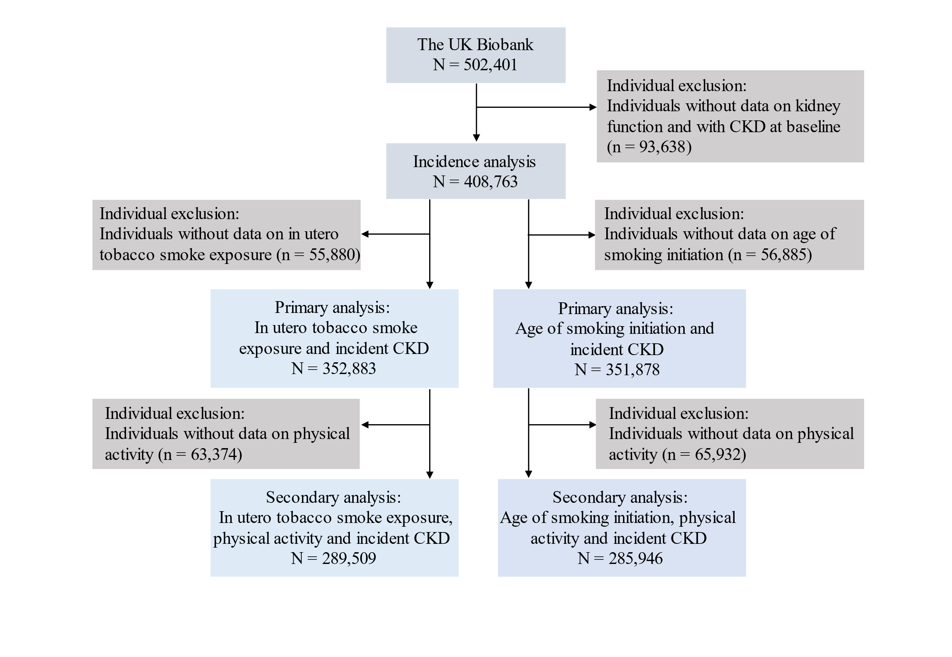
Abbreviations: CKD, chronic kidney disease.

