Investigating the causal effects of childhood and adulthood adiposity on later life mental health outcome: a Mendelian randomization study

Sweta Pathak¹ *, Tom G Richardson², Eleanor Sanderson², Bjørn Olav Åsvold^{1,3,4}, Laxmi Bhatta^{1 #}, Ben M. Brumpton^{1,4,5 #}*

¹ HUNT Center for Molecular and Clinical Epidemiology, Department of Public Health and Nursing, Norwegian University of Science and Technology, Trondheim, Norway
² MRC Integrative Epidemiology Unit, Population Health Sciences, Bristol Medical School, University of Bristol, United Kingdom
³ Department of Endocrinology, Clinic of Medicine, St. Olavs Hospital, Trondheim University Hospital, Trondheim 7030, Norway.
⁴ HUNT Research Centre, Department of Public Health and Nursing, NTNU Norwegian University of Science and Technology, Levanger, Norway.
⁵ Clinic of Medicine, St. Olavs Hospital, Trondheim University Hospital, Trondheim, Norway.

# Equal contributions
* Corresponding authors:
Sweta Pathak sweta.pathak@ntnu.no, Ben Brumpton ben.brumpton@ntnu.no
Department of Public Health and Nursing, Faculty of Medicine and Health Sciences, NTNU Norwegian University of Science and Technology, P.O. Box 8905, MTFS, NO-7491, Trondheim, Norway

Table S1. GAD-2 Phenotype.
GAD-2
Over the last 2 weeks, how often have you been bothered by the following problems ?  (Use “√” to indicate your answer) | Not at all | Several days | More than half the days | Nearly every day
Feeling nervous, anxious, or on edge | 0 | 1 | 2 | 3
Not being able to stop or control worrying | 0 | 1 | 2 | 3

Table S2. F statistics in univariable and conditional F statistics in multivariable MR.
Exposure | Outcome | Univariable MR | Multivariable MR
Childhood adiposity | Anxiety | 65.35 | 13.34
Childhood adiposity | Depression | 66.03 | 13.47
Adulthood adiposity | Anxiety | 52.14 | 15.74
Adulthood adiposity | Depression | 52.43 | 15.60
Abbreviations: MR, Mendelian randomization

Table S3. Univariable and multivariable Inverse Variance Weighted (IVW) estimates of childhood and adulthood adiposity on anxiety and depression.
Exposures | Outcomes | Univariable MR |  |  |  | Multivariable MR
Exposures | Outcomes | SNPs | Beta/OR* | 95% CI | P-value | SNPs | Beta/OR* | 95% CI | P-value
Childhood adiposity | Anxiety | 277 | -0.05 | -0.13 to 0.02 | 0.171 | 652 | -0.19 | -0.29 to -0.08 | 3.86×10⁻⁰⁴
Childhood adiposity | Depression | 260 | 1.06 | 0.94 to 1.20 | 0.345 | 638 | 0.83 | 0.71 to 0.97 | 0.019
Adulthood adiposity | Anxiety | 510 | 0.15 | 0.08 to 0.21 | 1.11×10⁻⁰⁵ | 652 | 0.24 | 0.15 to 0.33 | 1.09×10⁻⁰⁷
Adulthood adiposity | Depression | 496 | 1.32 | 1.20 to 1.46 | 3.31×10⁻⁰⁸ | 638 | 1.45 | 1.27 to 1.68 | 1.33×10⁻⁰⁷
Table illustrating the total (univariable MR) and direct (multivariable MR) causal estimates of childhood and adulthood adiposity on later life anxiety and depression.
*The causal estimates are presented as beta for anxiety and odds ratio for depression with 95% CI and P-value. Number of SNPs (genetic variant) involve in analysis to investigate causal effect of exposure on outcome also presented.
Abbreviations: MR, Mendelian randomization; CI, confidence interval; SNP, Single nucleotide polymorphism; OR, Odds ratio

Table S4. Univariable and multivariable MR Egger intercepts of childhood and adulthood adiposity on anxiety and depression.
Exposures | Outcomes | Univariable MR |  |  | Multivariable MR
Exposures | Outcomes | SNPs | intercept | P-value | SNPs | intercept | P-value
Childhood adiposity | Anxiety | 277 | -0.0002 | 0.784 | 652 | 0.000 | 0.583
Childhood adiposity | Depression | 260 | -0.002 | 0.367 | 638 | -0.001 | 0.432
Adulthood adiposity | Anxiety | 510 | 0.002 | 0.142 | 652 | 0.001 | 0.583
Adulthood adiposity | Depression | 496 | 0.002 | 0.185 | 638 | -0.001 | 0.432
Abbreviations: MR, Mendelian randomization; SNP, Single nucleotide polymorphism

Table S5. Univariable and multivariable MR Egger estimates of childhood and adulthood adiposity on anxiety and depression.
Exposures | Outcomes | Univariable MR |  |  |  | Multivariable MR
Exposures | Outcomes | SNPs | Beta/OR | 95% CI | P-value | SNPs | Beta/OR | 95% CI | P-value
Childhood adiposity | Anxiety | 277 | -0.03 | -0.19 to 0.13 | 0.702 | 652 | -0.17 | -0.29 to -0.06 | 0.004
Childhood adiposity | Depression | 260 | 1.18 | 0.91 to 1.55 | 0.216 | 638 | 0.85 | 0.71 to 1.02 | 0.085
Adulthood adiposity | Anxiety | 510 | 0.02 | -0.17 to 0.20 | 0.854 | 652 | 0.26 | 0.16 to 0.35 | 3.40×10⁻⁰⁷
Adulthood adiposity | Depression | 496 | 1.11 | 0.83 to 1.47 | 0.489 | 638 | 1.49 | 1.28 to 1.74 | 2.93×10⁻⁰⁷
Abbreviations: MR, Mendelian randomization; CI, confidence interval; SNP, Single nucleotide polymorphism; OR, Odds ratio

Table S6. Univariable weighted median and weighted mode estimates of childhood and adulthood adiposity on anxiety and depression.
Exposures | Outcomes | Univariable weight median |  |  |  | Univariable weighted mode
Exposures | Outcomes | SNPs | Beta/OR | 95% CI | P-value | SNPs | Beta/OR | 95% CI | P-value
Childhood adiposity | Anxiety | 277 | 0.006 | -0.10 to 0.11 | 0.904 | 277 | 0.04 | -0.11 to 0.21 | 0.589
Childhood adiposity | Depression | 260 | 1.20 | 1.02 to 1.42 | 0.032 | 260 | 1.28 | 1.05 to 1.57 | 0.014
Adulthood adiposity | Anxiety | 510 | 0.12 | 0.02 to 0.22 | 0.020 | 510 | 0.16 | -0.02 to 0.34 | 0.11
Adulthood adiposity | Depression | 496 | 1.43 | 1.25 to 1.64 | 5.34×10⁻⁰⁷ | 496 | 1.58 | 1.17 to 2.13 | 0.003
Abbreviations: CI, confidence interval; SNP, Single nucleotide polymorphism; OR, Odds ratio

Table S7. MR-Robust Adjusted Profile Score (MR-RAPS) estimates for from childhood and adulthood adiposity to anxiety and depression.
Exposure | Outcome | SNPs | Beta/OR | P-value
Childhood adiposity | Anxiety | 277 | -0.04 | 0.343
Childhood adiposity | Depression | 260 | 1.09 | 0.159
Adulthood adiposity | Anxiety | 510 | 0.17 | <0.005
Adulthood adiposity | Depression | 496 | 1.37 | <0.005
Abbreviations: MR, Mendelian randomization; SNP, Single nucleotide polymorphism; OR, Odds ratio

Table S8. MR with Automated Instrument Determination (MRAID) estimates for from childhood and adulthood adiposity to anxiety and depression.
Exposure | Outcome | Beta/OR | P-value
Childhood adiposity | Anxiety | -0.001 | 0.971
Childhood adiposity | Depression | 0.84 | 1.213
Adulthood adiposity | Anxiety | 1.36 | <0.005
Adulthood adiposity | Depression | 3.29 | <0.005
Note: LD matrixes were derived using 1000 genome reference panel for European population. Same LD matrix were used for exposure and outcome. The instruments used for exposure were clumped on r2<0.001.
Abbreviations: OR, Odds ratio

Supplement Figure S1. Leave-one-out anysis plot for Inverse Variance Weighted (IVW) estimates of childhood and adulthood adiposity on anxiety and depression.

- Childhood Adiposity on Anxiety B) Adulthood Adiposity on Anxiety

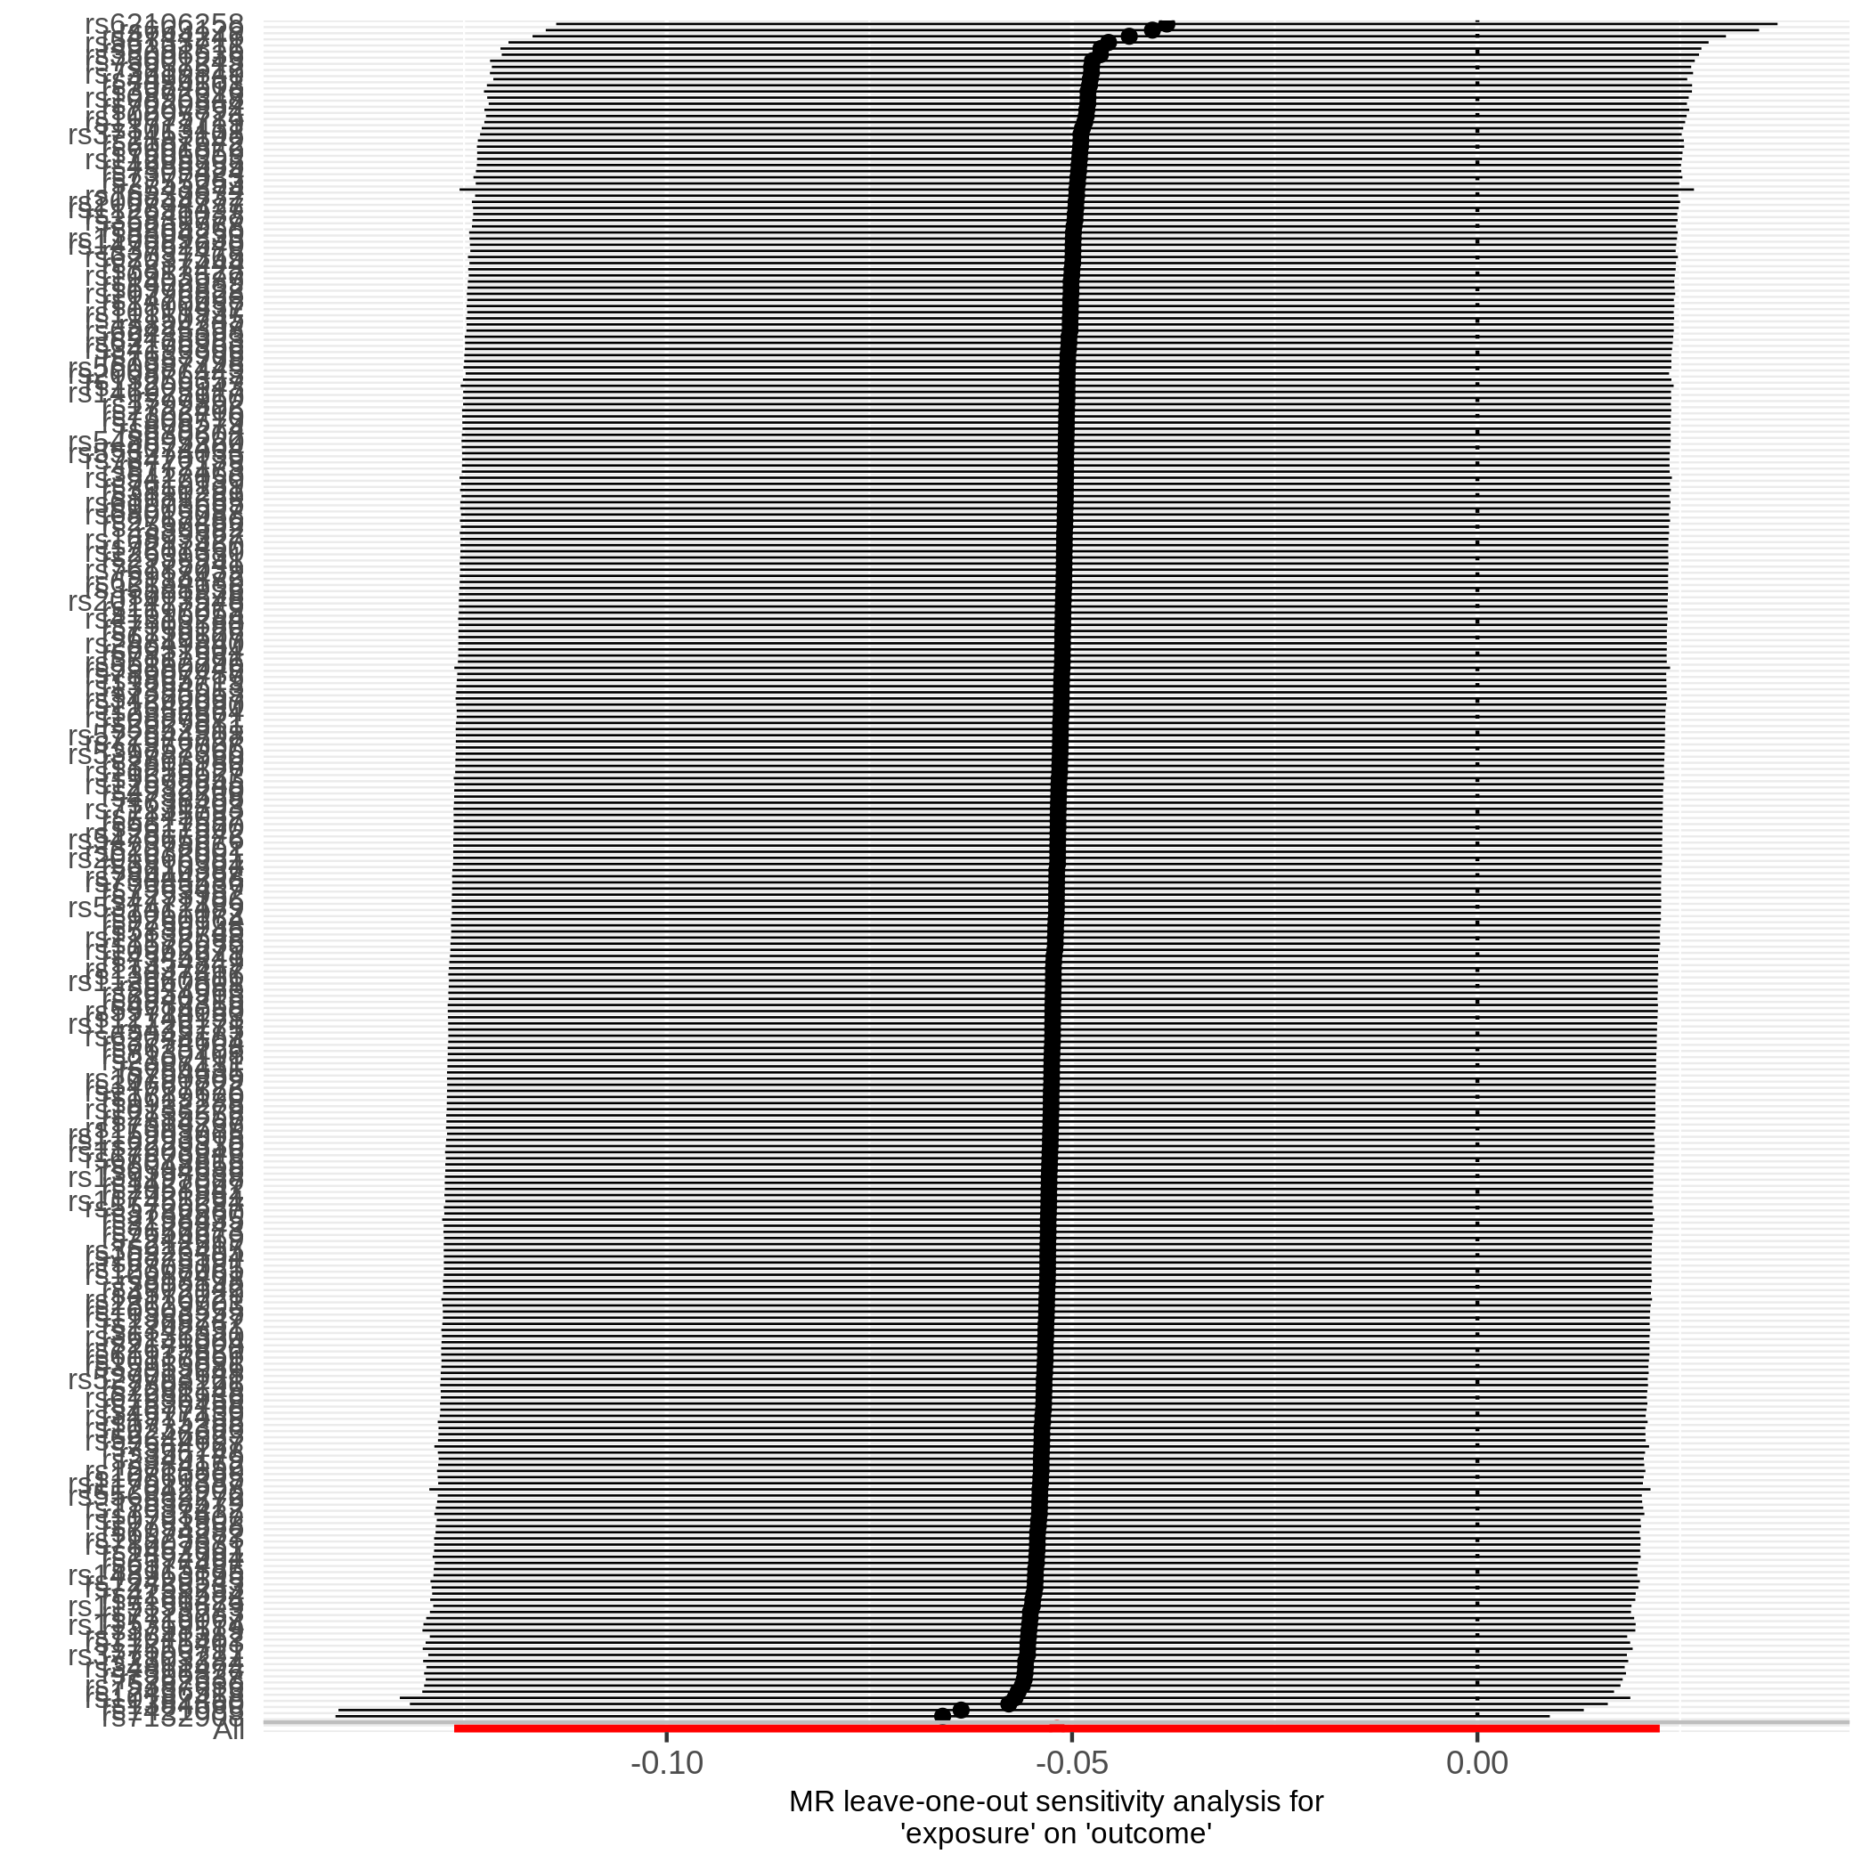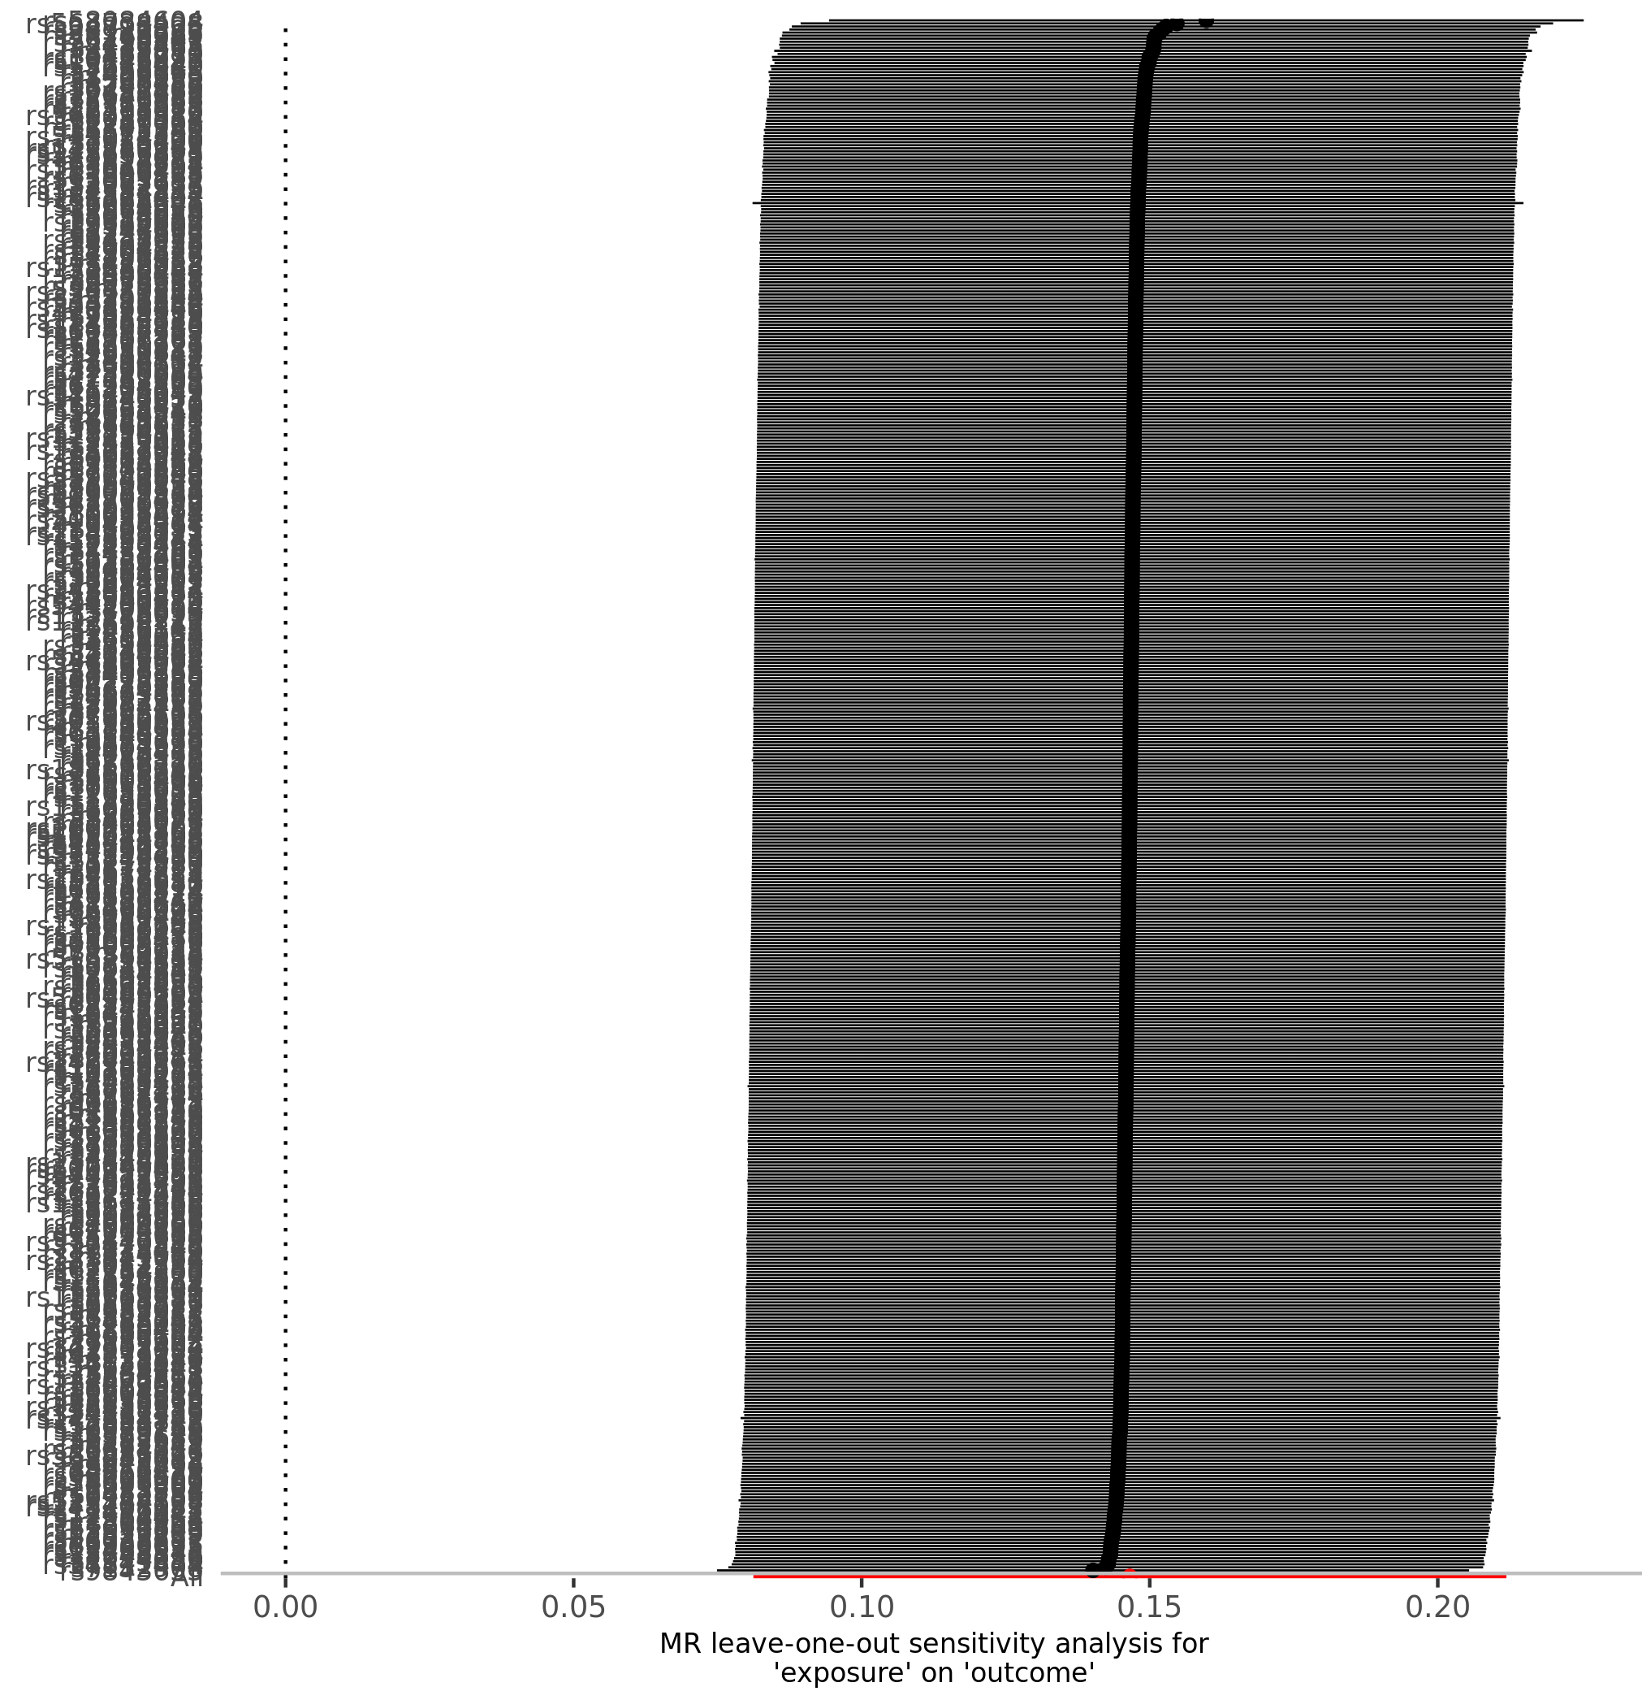

- Childhood Adiposity on Depression D) Adulthood Adiposity on Depression
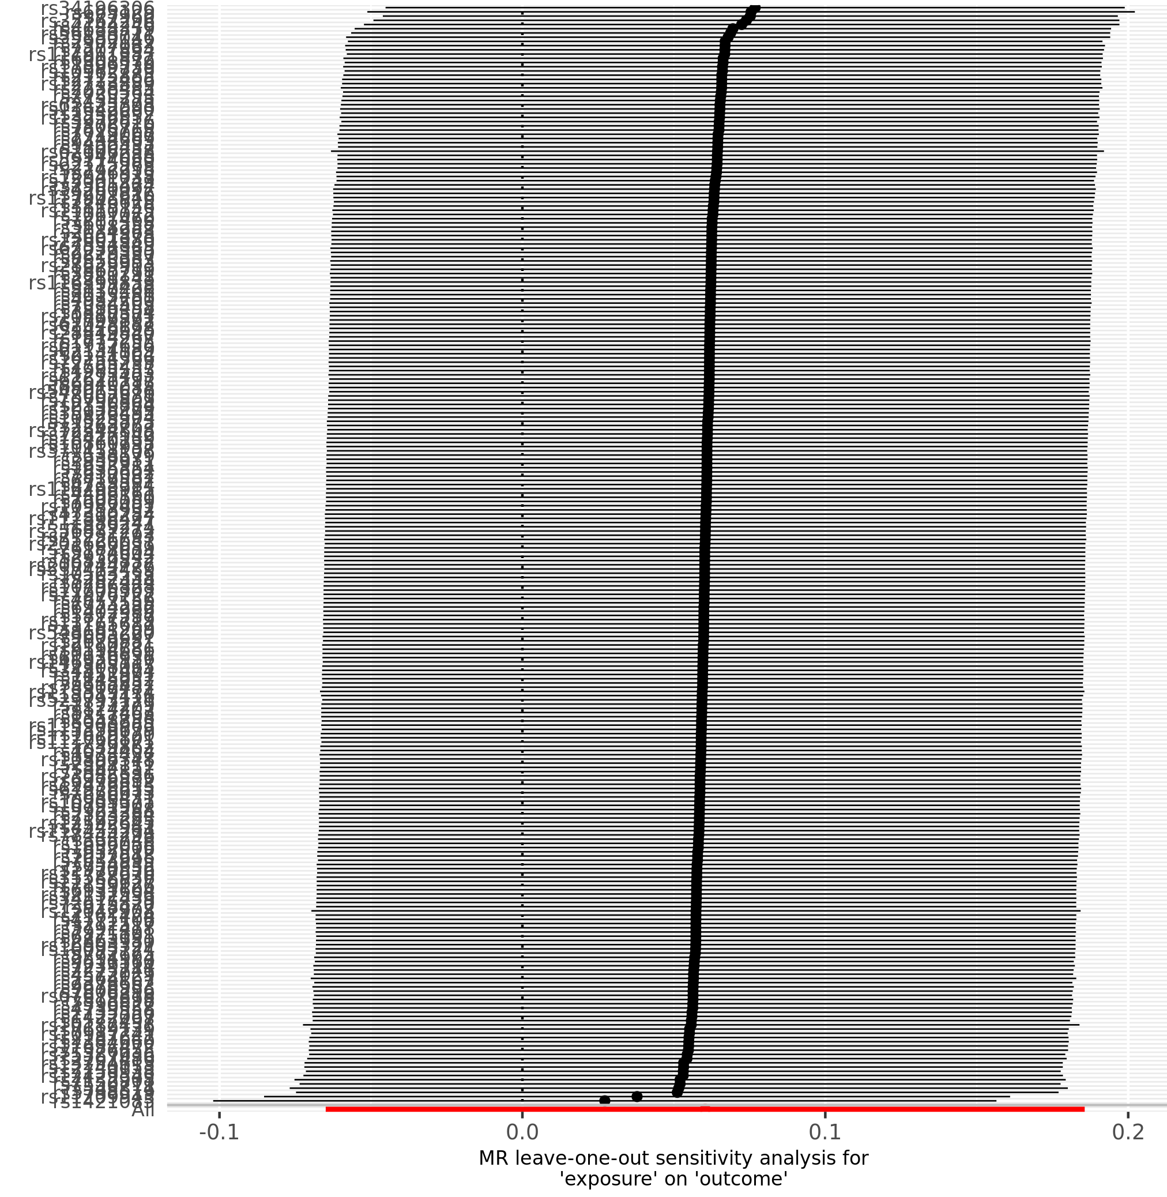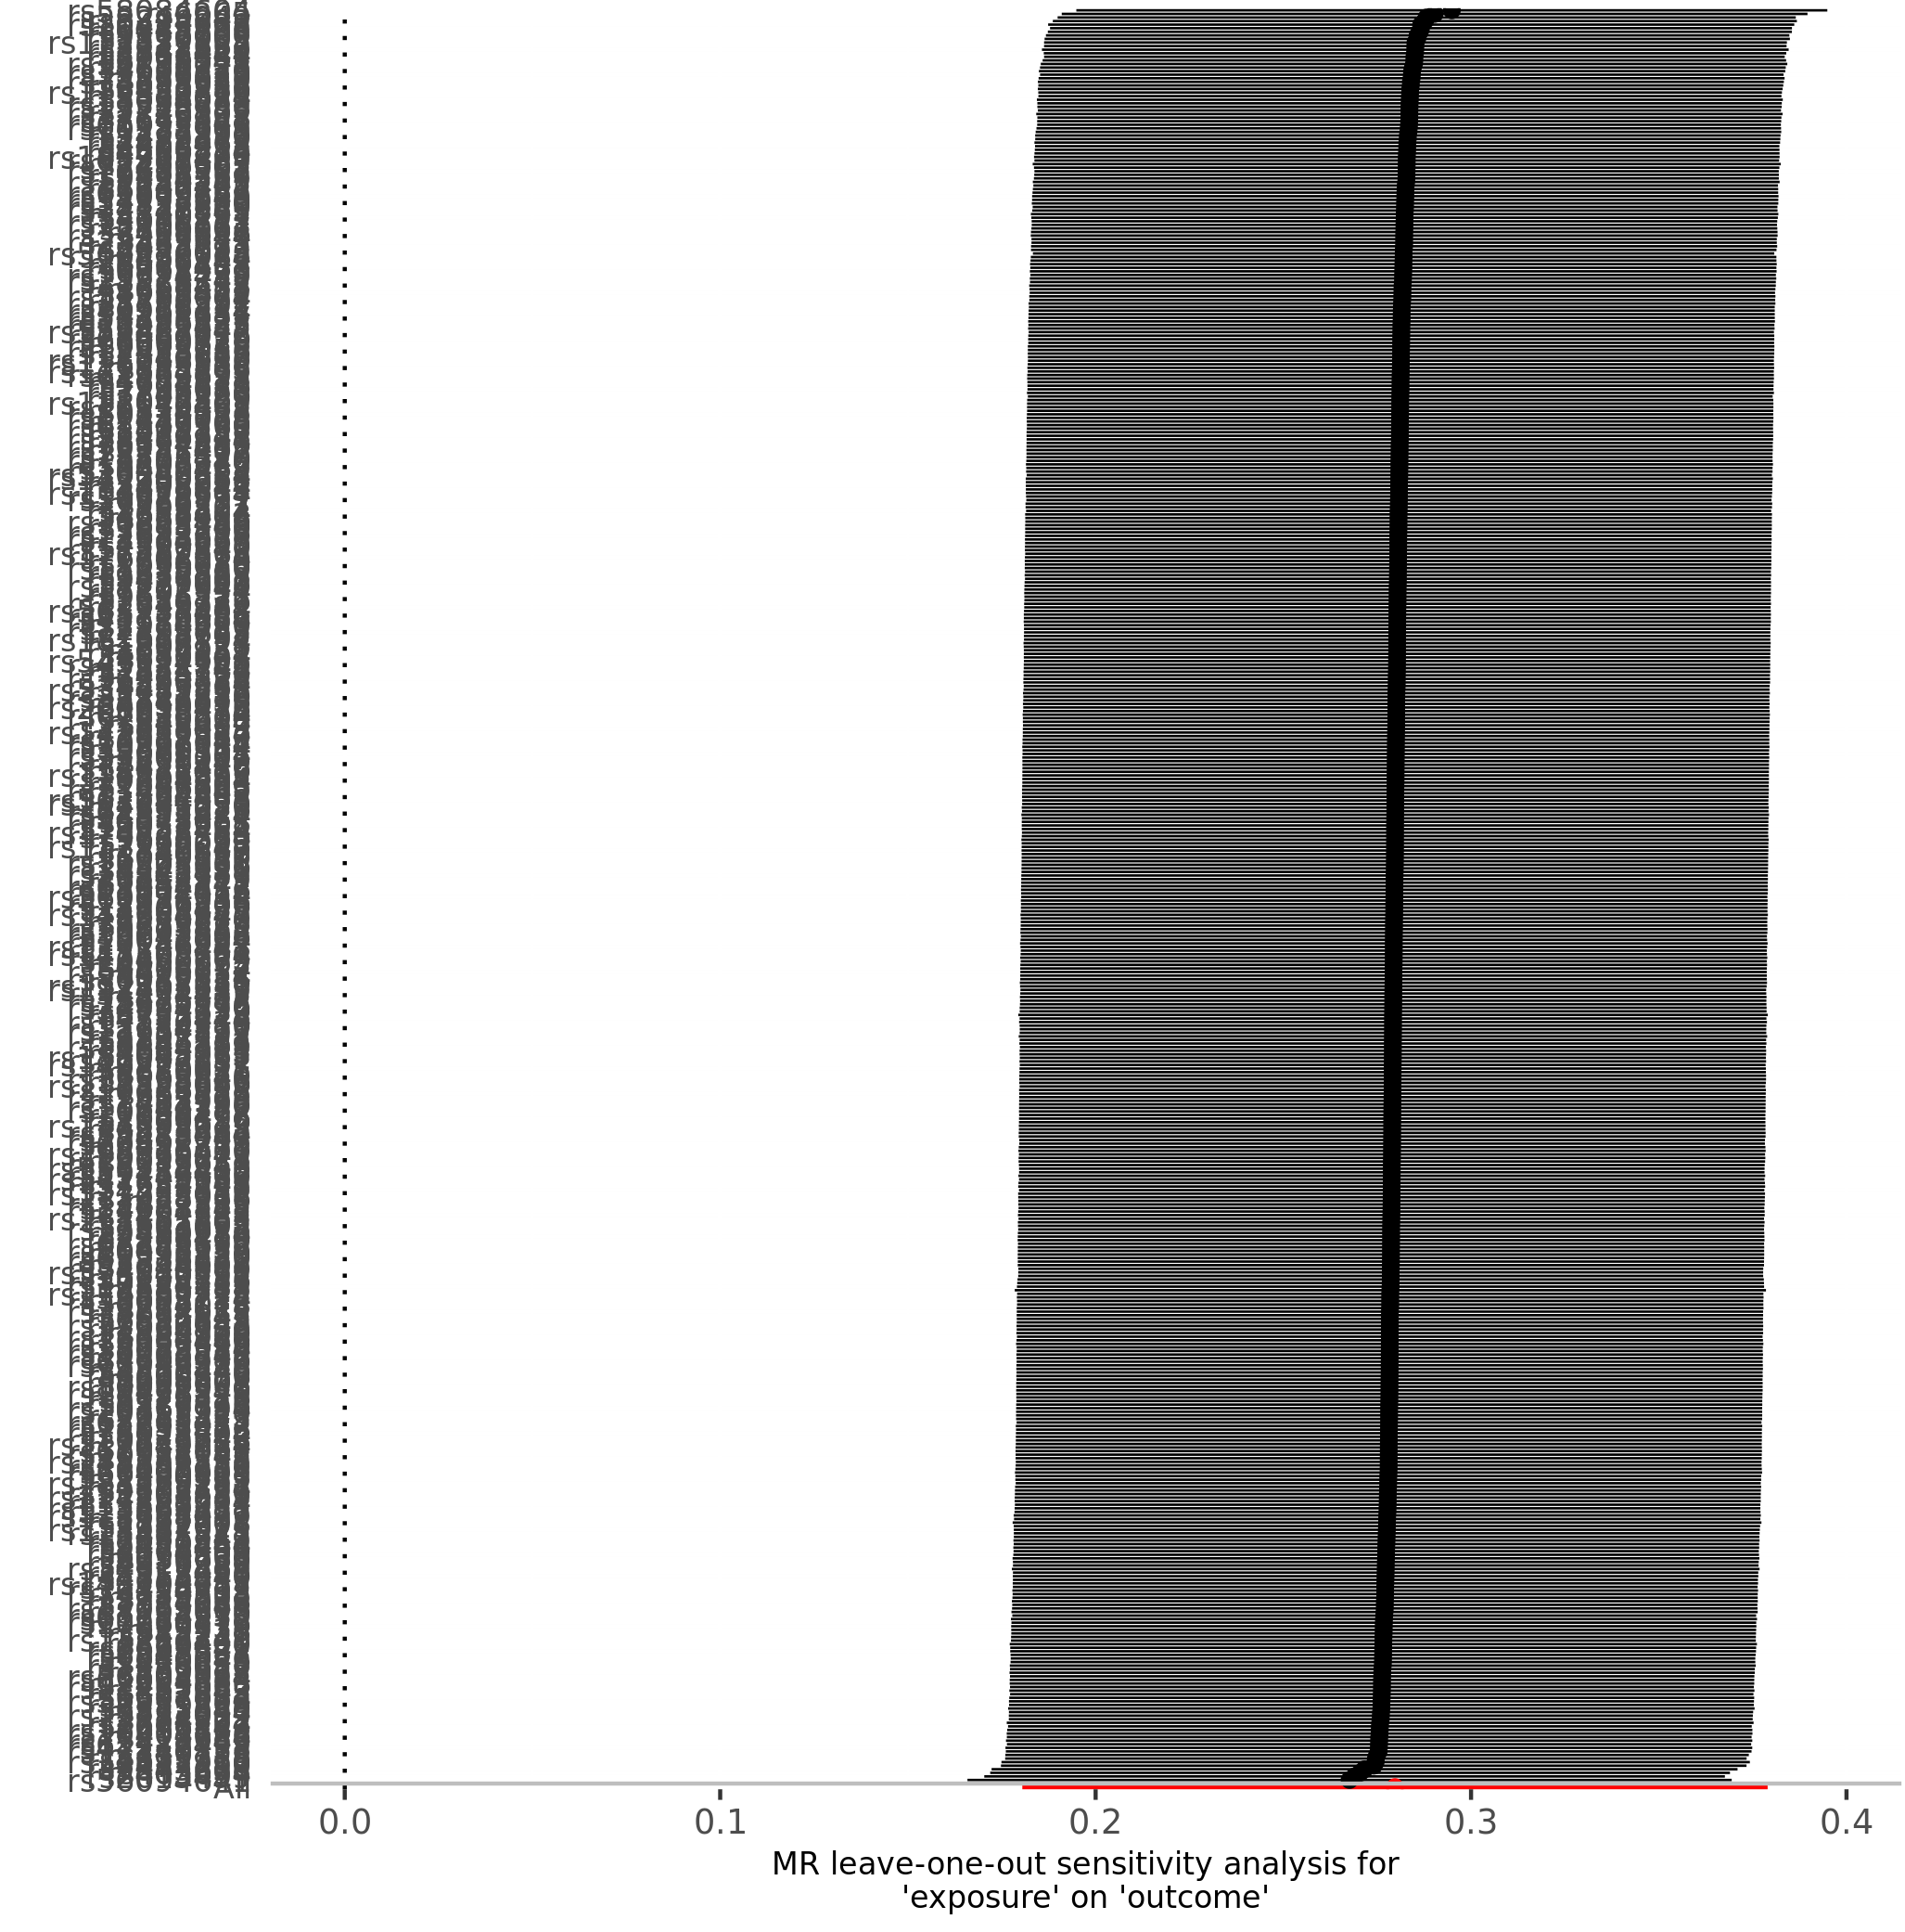

Table S9. Directionality test from childhood and adulthood adiposity to anxiety and depression.
Exposure | Outcome | snp_r2.exposure | snp_r2.outcome | correct_causal_direction | steiger_pval
Childhood adiposity | Anxiety | 0.040 | 0.002 | True | <0.005
Childhood adiposity | Depression | 0.038 | 0.009 | True | <0.005
Adulthood adiposity | Anxiety | 0.059 | 0.005 | True | <0.005
Adulthood adiposity | Depression | 0.058 | 0.018 | True | <0.005

Table S10. Heterogeneity test of univariable and multivariable MR.
Exposure | Outcome | Univariable MR | Multivariable MR
Exposure | Outcome | Q (P-value) | Q (P-value)
Childhood adiposity | Anxiety | 443 (7.34×10⁻¹⁰) | 1076 (1.46×10⁻²³)
Childhood adiposity | Depression | 527 (1.76×10⁻²⁰) | 1134 (1.40×10⁻³⁰)
Adulthood adiposity | Anxiety | 885 (1.05×10⁻²²) | 1076 (1.46×10⁻²³)
Adulthood adiposity | Depression | 874 (2.18×10⁻²³) | 1134 (1.40×10⁻³⁰)
Abbreviations: MR, Mendelian randomization

Table S11. Univariable and multivariable Inverse Variance Weighted (IVW) estimates of childhood and adulthood adiposity on anxiety. A validation study using anxiety summary statistics from FinnGen Biobank (KRA_PSY_ANXIETY, FREEZE 11 release).

Exposures | Outcomes | Univariable MR |  |  |  | Multivariable MR
Exposures | Outcomes | SNPs | OR | 95% CI | P-value | SNPs | OR | 95% CI | P-value
Childhood adiposity | Anxiety | 248 | 0.88 | 0.78 to 0.99 | 0.030 | 621 | 0.76 | 0.66 to 0.89 | 0.0004
Adulthood adiposity | Anxiety | 464 | 1.01 | 0.92 to 1.11 | 0.804 | 621 | 1.19 | 1.04 to 1.35 | 0.010
Table illustrating the total (univariable MR) and direct (multivariable MR) causal estimates of childhood and adulthood adiposity on later life anxiety. The anxiety summary statictics were derived from FinnGen Biobank (N_{case} = 50,486, N_{control} = 330,560). The ICD codes used to categorise anxiety were: ICD8 (3000, 3001, 3002, 30030, 3005, 3006, 3007, 3008, 3009, 305, 30680, 30799); ICD9 (3000, 3001, 3002, 3003, 3006, 3007, 3008, 3009, 3078A, 309); ICD10 (F40, F41, F42, F43, F44, F45, F46, F47, F48)
Abbreviations: MR, Mendelian randomization; CI, confidence interval; SNP, Single nucleotide polymorphism; OR, Odds ratio

