Impact of HIV exposure without infection on hospital course and 30-day mortality among young children in sub-Saharan Africa: a multi-site cohort study

ADDITIONAL FILE 1
TABLE OF CONTENTS
Contents
Supplementary Methods 1
Ethics approval 2
Data management 2
Missing data 3
Inverse sample weights 3
Resource Utilization data 4
Supplementary Tables 5
Table S1: Age stopped breastfeeding among HEU vs HUU children not breastfeeding at hospital admission 5
Table S2: Associations between inpatient mortality, HIV exposure, and key biologic variables 6
Table S3: Associations between 30-day mortality, HIV exposure, and key biologic variables 7
Table S4: Associations between wasting, HIV exposure, and key biologic variables 8
Table S5: Associations between stunting, HIV exposure, and key biologic variables 9
Table S6: Associations between prolonged hospital stay, HIV exposure, and key biologic variables 10
Table S7: Summary of total number of days on Oxygen, NGT use, and experience of any danger sign 11
Table S8: Number of days on Oxygen 12
Table S9: Number of days with NGT 13
Table S10: Antibiotics switch from first-line to second/third-line antibiotic among HEU vs HUU children. 14
Table S11: Associations between illness severity, HIV exposure, and key biologic variables 15
Table S12: Number of days with danger signs 16
Table S13: Experience of specific danger signs 17
Supplemental Figures 18

Supplementary Methods

Ethics approval
The study was approved by Oxford Tropical Research Ethics Committee, the Scientific & Ethical Review Unit (SERU), Kenya Medical Research Institute in Kenya, Makerere University School of Biomedical Sciences Research Ethics Committee in Uganda, and COMREC, Kamuzu University of Health Sciences in Malawi.

Data management
Details of data collection, data entry, and data cleaning are given in the CHAIN mortality paper (11)

Statistical Approach
All available data from hospitalized HEU and HUU children at the Ugandan, Kenyan, and Malawi CHAIN sites were included, and children documented to be living-with-HIV were excluded. A priori power calculations were not performed. The main exposure variable considered was perinatal HIV exposure, with analysis focusing on HEU and HUU children. The study outcomes were inpatient mortality, 30-day mortality, nutritional status at admission, illness severity at admission, hospital length of stay, presence of danger signs, and utilization of inpatient resources (supplemental oxygen, feeding tubes, and second-line antibiotics). All the analyses are weighted to reflect the stratification by nutritional status using inverse weights (1, 0.40, 0.39 for the not wasted, moderately wasted, and severely wasted and/or kwashiorkor) as explained elsewhere (11). Children’s characteristics at the time of admission to hospital stratified by HIV exposure category (HEU and HUU) are reported.

For all outcomes, directed acyclic graphs (DAGs) were developed to portray relationships between biologic, social, and demographic variables hypothesized to interact with each outcome and to delineate confounders, mediators, effect modifiers, and their relationships between the exposure variable and each outcome (Fig. S1-6). Variables selected for consideration included: age group (< 6 months, 6-11 months, and 12-24 months), biologic sex, breastfeeding status at enrollment, prematurity, nutritional wasting, limited household assets, high food insecurity, mother as primary caregiver, prolonged travel time to hospital, and recruitment site. Age < 6 months as tested as a potential effect modifier for each individual outcome (using a multiplicative interaction term between age and HIV exposure), and stratification performed if a significant interaction (p ≤0.05) was identified. Subsequent analytic models were developed for each outcome to support adjustment for confounding variables (26) as detailed below.

For inpatient mortality, days to death between the HIV exposure groups were compared using Wilcoxon Rank Sum test. To assess the effect of HIV exposure on inpatient mortality, a logistic regression model adjusting for sex, age group, limited household assets, high food insecurity, prolonged travel time to hospital, and recruitment site was used. Potential mediators, including duration of breastfeeding, prematurity, wasting, and mother as primary caregiver were not included in the final adjusted model so that the total impact of HIV-exposure on mortality could be observed (26) (Fig. S1 and Table S2). For 30-day mortality, multilevel parametric survival regression model with a Weibull probability distribution (as previously reported) (11) was performed. Adjustments were performed as described for inpatient mortality, with the exception that site adjustment was performed using a random-effects approach to be consistent with our prior work (11). Potential mediators, including breastfeeding status, prematurity, illness severity, and wasting status, were not included in the final adjusted models so that the total impact of HIV-exposure on each outcome could be observed (Fig. S1 and Table S3). We hypothesized that wasting status and/or age < 6 months could modify each outcome and formally tested for effect modification. Age < 6 months did not have a significant interaction with inpatient (p=0.9) or 30-day (p=0.87) mortality. Wasting status (yes/no) also did not have a significant interaction with inpatient (p=0.46) or 30-day (p=0.24) mortality. Despite not observing a significant interaction between wasting status and the mortality outcomes, an exploratory analysis that included adjustment for wasting status as a confounding variable for both inpatient and 30-day mortality was also performed, as reported in the Results section.

To assess the relationship between HIV exposure and nutritional status (binary wasted vs not wasted, and stunted vs not stunted) at hospital admission, logistic regression models adjusting for sex, age group, limited household assets, high food insecurity, prolonged travel time to hospital, and recruitment site were used. Potential mediators, including breastfeeding status, prematurity, and mother as primary caregiver, were not included in the final adjusted model so that the total impact of HIV exposure on nutritional status could be observed (Fig. S2 and Tables S4 and S5).

To assess the relationship between HIV exposure and illness severity (binary low and high), stratification based on age group (< 6 months versus > 6 months) was performed as age < 6 months was found to have a significant interaction with the outcome (p=0.013). Age-stratified logistic regression models adjusted for sex, limited household assets, high food insecurity, prolonged travel time to hospital, and recruitment site were used. Potential mediators, breastfeeding status, prematurity, mother as primary caregiver, and wasting were not included in the final adjusted model so that the total impact of HIV exposure on illness severity could be observed (Fig. S3 and Table S11).

To assess the relationship between HIV exposure and prolonged hospitalization, duration of hospitalization was categorized into binary variable using the median length of hospital stay (5 days) as the cut-off: short and prolonged duration of hospital stay. Length of hospital stay analysis was restricted to survivors and also excluded those who left against medical advice or absconded. We hypothesized that wasting status and/or age < 6 months could modify the length of hospitalization and formally tested for effect modification, with neither variable demonstrating a significant interaction p=0.1 and p=0.13, respectively). A logistic regression model adjusting for sex, age group, limited household assets, high food insecurity, prolonged travel time to hospital, and recruitment site were used. Potential mediators, including prematurity, illness severity, wasting status, and mother as primary caregiver, were not included in the final adjusted model so that the total impact of HIV exposure on prolonged hospital length of stay could be observed (Fig. S5 and Tables S6).

To assess the effect of HIV exposure on occurrence of daily danger signs and resource utilization (oxygen use, nasogastric tube use, and antibiotic switch), days with any danger sign or the use of a specific resource were counted. A zero-inflated negative binomial regression model was applied because the days with a danger sign or using any of the resources had leading zeros and was over-dispersed. The zero-inflated negative binomial regression was conducted for days with any danger sign and each resource separately. The reported measure of effect was incident rate ratio and corresponding 95% confidence intervals (95% CI). Potential mediators, including prematurity, illness severity, wasting status, and mother as primary caregiver, were not included in the final adjusted models so that the total impact of HIV exposure on each outcome could be observed (Fig. S4 and Tables S7 – S9, S12 and S13)

All statistical analyses were conducted using STATA College Station TX version 15.0 and the level of significance was assessed using two-tailed α <0.05 or 95% CIs.

Missing data
Multiple imputation methods were used to cater for missing data. For continuous variables, the predicted measurements were estimated after a linear regression of the observed measurements with age, site, and sex, stratified by the 3 enrolment strata. Missing values were replaced with the mean predicted values in each group. For categorical (binary variables), the predicted probability was estimated after a logistic regression of each variable with age, site, and sex, stratified by the 3 enrolment strata; missing values were replaced by zero category (attribute not present) if the mean predicted values <0.5 and one category (attribute present) if the mean predicted values ≥0.5 in each group. Household variables with missing data were imputed using the iterative principal component analysis (PCA) method before running PCA on complete observations (11).

Inverse sample weights
Because of the non-proportional stratified sampling in the original CHAIN study, we created sampling weights (3 weights for the 3 strata) proportional to the inverse of the sampling fraction of the respective group from a typical hospital admission in Africa and South Asia. Hospital pediatric admission surveillance data (for children 2 to 23 months old) during the period of the CHAIN study from four site hospitals were used to estimate the mean proportions across the three nutrition strata. Using the estimated proportions and the actual proportion of children recruited in the CHAIN study, we calculated the inverse probability of children being recruited in each nutrition stratum and standardized the inverse probability by dividing with the NW group probability. This resulted in 3 weights: 1.0, 0.40, and 0.39, for the not wasted, moderately wasted, and severely wasted or kwashiorkor groups respectively (11).

Resource Utilization data:

Data collection
Data on participants’ daily clinical events, clinical observations, and medications were captured on the daily record CRF. These included the experience of WHO danger signs in the last 24 hours (obstructed breathing, cyanosis, respiratory distress, shock, severe anemia, convulsions, severe dehydration, profuse watery diarrhea, vomiting everything, and impaired consciousness). Further, data on oxygen use, nasogastric use, antibiotic use (crystalline/benzylpenicillin, gentamicin, ceftriaxone, ampicillin, amikacin, ciprofloxacin, co-amoxiclav, chloramphenicol, cefotaxime, ceftazidime, flucloxacillin/cloxacillin, meropenem/imipenem, levofloxacin) were collected.

Analysis of Use of Hospital Resources & Presence of Danger Signs
Oxygen use
We determined which participants had at least one day of oxygen use and computed the total number of days on oxygen by HIV exposure group. We conducted zero-inflated negative binomial regression to detect differences in the use of oxygen between the two HIV exposure groups (HEU and HUU) and reported the incident rate ratio and the corresponding p-value. Sex, age, limited household assets, high food insecurity, recruitment site, and prolonged travel time were included in the count model. Sex, age, site, illness severity and nutritional status at admission were put in the inflation model.

Nasogastric tube use
We determined which participants had at least one day of nasogastric tube use and computed the total number of days during which a nasogastric tube was used by HIV exposure group. We used zero-inflated negative binomial regression to detect differences in the use of the nasogastric tube between the two HIV exposure groups (HEU and HUU) and reported the incident rate ratio and the corresponding p-value. Sex, age, limited household assets, high food insecurity, recruitment site, and prolonged travel time were included in the count model. Sex, age, site, illness severity, and nutritional status at admission were put in the inflation model.

Occurrence of danger signs
We determined which participants had at least one day of experiencing danger signs and the total number of days with at least a danger sign by HIV exposure groups (HEU and HUU). We used zero-inflated negative binomial regression to detect differences in the number of days with danger signs between the two HIV exposure groups (HEU and HUU). Sex, age, limited household assets, high food insecurity, recruitment site, and prolonged travel time were included in the count model. We reported the incident rate ratio, 95% confidence interval, and corresponding p-value.

Switching of antibiotics
We defined switching of antibiotics as changing from the first-line medication (intravenous ampicillin/benzylpenicillin and gentamicin) to a second-line or third-line intravenous antibiotic (cephalosporin, fluoroquinolone, carbapenem, and amphenicols). We compared the occurrence of antibiotic switch between the HIV exposure groups (HEU and HUU) using the chi-square test and reported the p-value.

Supplementary Tables

Table S1: Age stopped breastfeeding among HEU vs HUU children not breastfeeding at hospital admission
Factor | HUU | HEU | Total | P-value*
Age
0 - 3 months | 78 (20.91) | 32 (28.32) | 110 (22.63) | 0.011
4 -6 months | 47 (12.60) | 18 (15.93) | 65 (13.37)
7 - 12 months | 113 (30.30) | 34 (30.09) | 147 (30.25)
> 12 months | 110 (29.49) | 18 (15.93) | 128 (26.34)
Unknown | 25 (6.70) | 11 (9.73) | 36 (7.41)
Total | 373 | 113 | 486
*chi-square test

Table S2: Associations between inpatient mortality, HIV exposure, and key biologic variables

Factors | Crude OR  (95% CI) | P-value | Adjusted OR (95% CI) | P-value
HIV exposure
HUU | Ref | - | Ref | -
HEU | 1.74 (1.04-2.90) | 0.034 | 1.96 (1.14-3.37) | 0.014
Sex
Male | Ref | - | Ref | -
Female | 1.11 (0.72-1.72) | 0.641 | 1.14 (0.70-1.86) | 0.595
Hospital travel time
< 1 hour | Ref | - | Ref | -
1 – 2 hours | 0.97 (0.58-1.64) | 0.918 | 0.91 (0.54-1.54) | 0.735
>2 hours | 1.30 (0.65-2.63) | 0.459 | 1.34 (0.61-2.95) | 0.463
Age group
12 and above | Ref | - | Ref | -
6 to 11 | 1.81 (1.13-2.92) | 0.014 | 1.75 (1.02-2.99) | 0.041
<6 months | 1.32 (0.69-2.55) | 0.401 | 1.30 (0.63-2.69) | 0.484
Food insecurity
Low | Ref | - | Ref | -
Moderate | 0.59 (0.35-0.98) | 0.041 | 0.73 (0.41-1.30) | 0.278
High | 1.19 (0.71-2.02) | 0.509 | 1.37 (0.73-2.56) | 0.332
Household assets
Poorest | Ref | - | Ref | -
Second | 0.57 (0.29-1.12) | 0.105 | 0.81 (0.37-1.79) | 0.608
Middle | 1.02 (0.59-1.74) | 0.955 | 0.84 (0.37-1.88) | 0.670
Fourth | 0.30 (0.14-0.65) | 0.002 | 0.46 (0.18-1.15) | 0.097
Least poor | 0.28 (0.10-0.73) | 0.009 | 0.51 (0.15-1.70) | 0.273
Site
Kilifi | Ref | - | Ref | -
Mbagathi | 1.90 (0.75-4.78) | 0.173 | 1.89 (0.49-7.30) | 0.355
Migori | 3.98 (1.68-9.43) | 0.002 | 5.24 (1.96-14.05) | 0.001
Kampala | 1.23 (0.49-3.06) | 0.658 | 1.87 (0.54-6.51) | 0.324
Blantyre | 0.80 (0.30-2.18) | 0.669 | 1.14 (0.34-3.83) | 0.835
Abbreviations: OR-Odds ratios, CI-Confidence intervals.
Adjusted model included: sex, age, limited household assets, high food insecurity, recruitment site, and prolonged travel time (see Fig. S1).

Table S3: Associations between 30-day mortality, HIV exposure, and key biologic variables

Factors | Crude HR ( 95% CI) | P-value | Adjusted HR (95% CI) | P-value
HIV exposure
HUU | Ref | - | Ref | -
HEU | 2.06 (1.28-3.31) | 0.003 | 2.20 (1.10-4.42) | 0.027
Sex
Male | Ref | - | Ref | -
Female | 1.01 (0.67-1.55) | 0.949 | 1.04 (0.81-1.33) | 0.762
Hospital travel time
< 1 hour | Ref | - | Ref | -
1 – 2 hours | 1.01 (0.62-1.66) | 0.954 | 0.98 (0.75-3.24) | 0.907
>2 hours | 1.21 (0.61-2.37) | 0.585 | 1.15 (0.51-2.63) | 0.732
Age group
12 and above | Ref | - | Ref | -
6 to 11 | 1.48 (0.93-2.33) | 0.093 | 1.56 (0.75-3.24) | 0.233
<6 months | 1.35 (0.71-2.55) | 0.355 | 1.46 (0.59-3.58) | 0.41
Food insecurity
Low | Ref | - | Ref | -
Moderate | 0.78 (0.47-1.28) | 0.327 | 0.84 (0.67-1.06) | 0.139
High | 1.41 (0.85-2.35) | 0.184 | 1.36 (0.95-1.96) | 0.098
Household assets
Poorest | Ref | - | Ref | -
Second | 0.52 (0.26-1.02) | 0.058 | 0.57 (0.16-1.97) | 0.372
Middle | 1.04 (0.61-1.77) | 0.871 | 0.88 (0.33-2.33) | 0.797
Fourth | 0.46 (0.24-0.90) | 0.023 | 0.51 (0.17-1.58) | 0.245
Least poor | 0.36 (0.51-0.88) | 0.026 | 0.47 (0.09-2.29) | 0.347
Abbreviations: HR-Hazard ratios, CI-Confidence intervals.
Adjusted model included: sex, age, limited household assets, high food insecurity, recruitment site, and prolonged travel time (see Fig. S1).

Table S4: Associations between wasting, HIV exposure, and key biologic variables

Factors | Crude OR (95% CI) | P-value | Adjusted OR (95% CI) | P-value
HIV Exposure
HUU | Ref | - | Ref | -
HEU | 1.27 (0.94-1.71) | 0.119 | 1.41 (1.03-1.95) | 0.034
Sex
Male | Ref | - | Ref | -
Female | 1.29 (1.05-1.59) | 0.016 | 1.35 (1.08-1.68) | 0.009
Hospital travel time
< 1 hour | Ref | - | Ref | -
1-2 hours | 1.28 (1.02-1.61) | 0.03 | 1.20 (0.94-1.53) | 0.145
> 2 hours | 2.22 (1.57-3.16) | <0.001 | 1.86 (1.28-2.70) | 0.001
Age group
12 and above | Ref | - | Ref | -
6 – 11 months | 1.09 (0.86-1.37) | 0.472 | 1.05 (0.82-1.34) | 0.724
< 6 months | 0.93 (0.69-1.24) | 0.618 | 0.95 (0.70-1.30) | 0.76
Food insecurity
Low | Ref | - | Ref | -
Moderate | 1.26 (1.0-1.59) | 0.047 | 1.13 (0.89-1.45) | 0.318
High | 2.13 (1.57-2.89) | <0.001 | 2.08 (1.49-2.91) | <0.001
Household assets
Poorest | Ref | - | Ref | -
Second | 0.98 (0.71-1.34) | 0.885 | 0.96 (0.68-1.36) | 0.83
Middle | 1.29 (0.96-1.74) | 0.088 | 0.85 (0.58-1.25) | 0.405
Fourth | 1.02 (0.75-1.38) | 0.892 | 0.64 (0.42-0.96) | 0.032
Least poor | 1.24 (0.84-1.82) | 0.284 | 1.04 (0.64-1.68) | 0.882
Site
Kilifi | Ref | - | Ref | -
Mbagathi | 2.71 (1.51-3.12) | <0.001 | 2.24 (1.43-3.49) | <0.001
Migori | 1.55 (1.08-2.23) | 0.017 | 1.46 (1.0-2.14) | 0.05
Kampala | 2.65 (1.9-3.68) | <0.001 | 3.06 (2.08-4.49) | <0.001
Blantyre | 0.75 (0.53-1.07) | 0.113 | 0.70 (0.48-1.02) | 0.063
Abbreviations: OR-Odds ratios, CI-Confidence intervals.
Adjusted model included: sex, age, limited household assets, high food insecurity, recruitment site, and prolonged travel time (see Fig. S2).

Table S5: Associations between stunting, HIV exposure, and key biologic variables

Factors | Crude OR (95% CI) | P-value | Adjusted OR (95% CI) | P-value
HIV Exposure
HUU | Ref | - | Ref | -
HEU | 1.75 (1.27-2.41) | 0.001 | 1.91 (1.34-2.70) | <0.001
Sex
Male | Ref | - | Ref | -
Female | 0.72 (0.57-0.90) | 0.003 | 0.68 (0.54-0.87) | 0.002
Hospital travel time
< 1 hour | Ref | - | Ref | -
1-2 hours | 1.31 (1.02-1.67) | 0.031 | 1.33 (1.02-1.73) | 0.031
> 2 hours | 1.43 (1.0-2.03) | 0.045 | 1.23 (0.83-1.80) | 0.299
Age
>=12 months | Ref | - | Ref | -
6-11 months | 0.59 (0.46-0.76) | <0.001 | 0.56 (0.43-0.73) | <0.001
< 6 months | 0.53 (0.38-0.73) | <0.001 | 0.53 (0.37-0.75) | <0.001
Food insecurity
Low | Ref | - | Ref | -
Moderate | 1.14 (0.89-1.47) | 0.285 | 0.95 (0.72-1.25) | 0.732
High | 2.07 (1.51-2.83) | <0.001 | 1.80 (1.27-2.53) | 0.001
Household assets
Poorest | Ref | - | Ref | -
Second | 0.93 (0.66-1.31) | 0.688 | 0.82 (0.55-1.20) | 0.303
Middle | 1.12 (0.82-1.54) | 0.482 | 0.77 (0.52-1.15) | 0.2
Fourth | 0.88 (0.63-1.22) | 0.429 | 0.65 (0.42-1.02) | 0.058
Least poor | 0.79 (0.52-1.20) | 0.279 | 0.69 (0.41-1.17) | 0.166
Site
Kilifi | Ref | - | Ref | -
Mbagathi | 1.51 (1.02-2.24) | 0.04 | 1.77 (1.08-2.87) | 0.022
Migori | 1.43 (0.96-2.14) | 0.078 | 1.26 (0.82-1.93) | 0.285
Kampala | 2.65 (1.85-3.80) | <0.001 | 3.26 (2.13-4.98) | <0.001
Blantyre | 1.50 (1.02-2.21) | 0.038 | 1.39 (0.92-2.12) | 0.122
Abbreviations: OR-Odds ratios, CI-Confidence intervals.
Adjusted model included: sex, age, limited household assets, high food insecurity, recruitment site, and prolonged travel time (see Fig. S2).

Table S6: Associations between prolonged hospital stay, HIV exposure, and key biologic variables

Factors | Crude OR (95% CI) | P-value | Adjusted OR (95% CI) | P-value
HIV Exposure
HUU | Ref | - | Ref | -
HEU | 1.33 (0.94-1.89) | 0.101 | 1.58 (1.08-2.29) | 0.017
Sex
Male | Ref | - | Ref | -
Female | 0.94 (0.74-1.19) | 0.593 | 0.98 (0.75-1.26) | 0.851
Hospital travel time
< 1 hour | Ref | - | Ref | -
1 – 2 hours | 1.43 (1.10-1.85) | 0.007 | 1.22 (0.92-1.62) | 0.161
>2 hours | 3.78 (2.57-5.56) | <0.001 | 2.88 (1.94-4.29) | <0.001
Age
12 and above | Ref | - | Ref | -
6 to 11 | 0.86 (0.67-1.12) | 0.276 | 0.81 (0.61-1.08) | 0.159
<6 months | 0.87 (0.62-1.23) | 0.434 | 0.86 (0.59-1.27) | 0.46
Food insecurity
Low | Ref | - | Ref | -
Moderate | 1.24 (0.95-1.65) | 0.106 | 1.01 (0.75-1.34) | 0.971
High | 1.67 (1.20-2.33) | 0.002 | 1.69 (1.18-2.44) | 0.005
Household assets
Poorest | Ref | - | Ref | -
Second | 1.32 (0.91-1.91) | 0.144 | 1.23 (0.81-1.87) | 0.342
Middle | 1.72 (1.21-2.42) | 0.002 | 0.96 (0.61-1.51) | 0.852
Fourth | 1.82 (1.28-2.59) | 0.001 | 0.79 (0.47-1.34) | 0.381
Least poor | 1.72 (1.10-2.67) | 0.015 | 0.89 (0.49-1.63) | 0.711
Site
Kilifi | Ref | - | Ref | -
Mbagathi | 5.51 (3.59-8.4) | <0.001 | 6.23 (3.59-10.8) | <0.001
Migori | 1.40 (0.91-2.18) | 0.130 | 1.41 (0.87-2.26) | 0.162
Kampala | 2.50 (1.71-3.65) | <0.001 | 2.86 (1.78-4.60) | <0.001
Blantyre | 0.63 (0.40-0.98) | p=0.04 | 0.58 (0.36-0.93) | 0.025
Abbreviations: OR-odds ratios.
Adjusted model included: sex, age, limited household assets, high food insecurity, recruitment site, and prolonged travel time (see Fig. S4).

Table S7: Summary of total number of days on Oxygen, NGT use, and experience of any danger sign

Resource used/experience of any danger sign | No | Yes | Total days | Adjusted IRR (95% CI) | P value*
Oxygen use
HUU | 987 (83.7) | 192 (16.3) | 710 | 0.90 (0.52-1.55) | 0.71
HEU | 163 (84.5) | 30 (15.5) | 100
Nasogastric tube use
HUU | 1053 (89.3) | 126 (10.6) | 471 | 0.79 (0.40-1.69) | 0.541
HEU | 175 (90.7) | 18 (9.3) | 64
Any danger sign
HUU | 941 (79.8) | 238 (20.2) | 695 | 0.73 (0.51-1.06) | 0.103
HEU | 156 (80.8) | 37 (19.2) | 73
Abbreviations: IRR-Incident rate ratios, CI-Confidence intervals.
*Used zero-inflated negative binomial regression: sex, age, limited household assets, high food insecurity, recruitment site, and prolonged travel time (see Fig. S5) included in the adjusted count model; sex, age, size, nutritional status, and illness severity were put in the inflation model.

Table S8: Number of days on Oxygen

Factor | Un adjusted IRR(95% CI) | p-value | Adjusted IRR(95% CI) | p-value*
HIV Exposure
HUU | Ref | - | Ref | -
HEU | 0.83 (0.40-1.70) | 0.604 | 0.90 (0.52-1.55) | 0.71
Sex
Male | Ref | - | Ref | -
Female | 1.19 (0.72-1.96) | 0.494 | 1.05 (0.49-2.26) | 0.12
Hospital travel time
< 1 hour | Ref | - | Ref | -
1 – 2 hours | 1.34 (0.78-2.30) | 0.286 | 0.81 (0.57-1.16) | 0.246
>2 hours | 1.13 (0.59-2.14) | 0.720 | 0.81 (0.51-1.30) | 0.39
Age
>=12 months | Ref | - | Ref | -
6 to 11 | 2.51 (1.45-4.34) | 0.001 | 2.38 (1.39-4.08) | 0.002
<6months | 2.78 (1.51-5.09) | 0.001 | 2.65 (1.50-4.66 | 0.001
Food insecurity
Low | Ref | - | Ref | -
Moderate | 1.20 (0.69-2.09) | 0.514 | 1.26 (0.85-1.88) | 0.246
High | 1.18 (0.60-2.33) | 0.627 | 1.33 (0.76-2.33) | 0.316
Household assets
Poorest | Ref | - | Ref | -
Second | 0.69 (0.31-1.54) | 0.365 | 0.79 (0.37-1.67) | 0.532
Middle | 0.71 (0.35-1.42) | 0.328 | 0.66 (0.36-1.19) | 0.169
Fourth | 2.17 (1.09-4.31) | 0.027 | 0.99 (0.42-2.31) | 0.981
Least poor | 1.56 (0.70-3.46) | 0.273 | 0.75 (0.28-2.02) | 0.571
Site
Kilifi | Ref | - | Ref | -
Mbagathi | 1.77 (0.61-5.14) | 0.292 | 1.75 (0.39-7.85) | 0.467
Migori | 0.69 (0.22-2.22) | 0.539 | 0.43 (0.05-4.14) | 0.728
Kampala | 0.63 (0.20-1.95) | 0.423 | 0.84 (0.11-6.72) | 0.87
Blantyre | 1.08 (0.34-3.45) | 0.902 | 0.67 (0.09-4.79) | 0.689
Abbreviations: IRR-Incident rate ratios, CI-Confidence intervals.
*Used zero-inflated negative binomial regression: sex, age, limited household assets, high food insecurity, recruitment site, and prolonged travel time (see Fig. S5) included in the adjusted count model; sex, age, size, nutritional status, and illness severity were included in the inflation model. Age < 6 months was tested as an effect modifier and not found to have a significant interaction (p=0.22)

Table S9: Number of days with NGT

Factor | Un adjusted IRR(95% CI) | p-value | Adjusted IRR(95% CI) | p-value
HIV Exposure
HUU | Ref | - | Ref | -
HEU | 0.93 (0.44-1.98) | 0.844 | 0.79 (0.40-1.69) | 0.541
Sex
Male | Ref | - | Ref | -
Female | 1.22 (0.74-2.0) | 0.440 | 0.99 (0.53-1.86) | 0.983
Hospital travel time
>=12 months | Ref | - | Ref | -
6 to 11 | 0.97 (0.56-1.67) | 0.90 | 0.52 (0.32-0.82) | 0.006
<6months | 1.39 (0.73-2.66) | 0.320 | 0.90 (0.46-1.76) | 0.753
Age
>=12 months | Ref | - | Ref | -
6 to 11 | 1.38 (0.81-2.37) | 0.238 | 0.79 (0.43-1.44) | 0.439
<6months | 1.37 (0.64-2.91) | 0.418 | 0.42 (0.21-0.88) | 0.02
Food insecurity
Low | Ref | - | Ref | -
Moderate | 1.24 (0.72-2.14) | 0.439 | 0.83 (0.50-1.38) | 0.48
High | 1.50 (0.76-2.98) | 0.240 | 1.38 (0.70-2.70) | 0.352
Household assets
Poorest | Ref | - | Ref | -
Second | 0.72 (0.32-1.60) | 0.416 | 0.69 (0.27-1.80) | 0.449
Middle | 0.35 (0.17-0.73) | 0.005 | 0.44 (0.18-1.10) | 0.08
Fourth | 0.64 (0.31-1.33) | 0.231 | 0.48 (0.19-1.25) | 0.132
Least poor | 0.31 (0.12-0.81) | 0.017 | 0.22 (0.07-0.76) | 0.016
Site
Kilifi | Ref |  | Ref
Mbagathi | 0.46 (0.18-1.16) | 0.099 | 1.85 (0.24-14.1) | 0.554
Migori | 0.46 (0.13-1.63) | 0.231 | 2.27 (0.25-20.6) | 0.466
Kampala | 0.59 (0.25-1.44) | 0.250 | 1.45 (0.28-7.53) | 0.656
Blantyre | 0.36 (0.13-1.03) | 0.056 | 0.56 (0.11-2.90) | 0.492
Abbreviations: IRR-Incident rate ratios, CI-Confidence intervals.
*Used zero-inflated negative binomial regression: sex, age, limited household assets, high food insecurity, recruitment site, and prolonged travel time (see Fig. S5) included in the adjusted count model; sex, age, size, nutritional status, and illness severity were included in the inflation model. Age < 6 months was tested as an effect modifier and not found to have a significant interaction (p=0.42)

Table S10: Antibiotics switch from first-line to second/third-line antibiotic among HEU vs HUU children.

 | Switched antibiotics
Exposure | No | Yes | Total | p-value*
HUU | 844 (71.6) | 335 (28.4) | 1179 (100) | 0.188
HEU | 147 (76.2) | 46 (23.8) | 193 (100)
Total | 991 (72.2) | 381 (27.8) | 1372 (100)
*Used chi-square test, OR= 0.78 (0.55-1.12, p = 0.189)

Table S11: Associations between illness severity, HIV exposure, and key biologic variables

Factors | Crude OR(95% CI) | Adjusted OR (95% CI)  ≥6 months | Adjusted OR (95% CI)  <6 months
HIV Exposure
HUU | Ref | Ref | Ref
HEU | 1.02 (0.74-1.18)ª | 1.40 (0.96-2.04)^{b} | 0.47 (0.20-1.09)^{c}
Sex
Male | Ref | Ref | Ref
Female | 0.97 (0.77-1.23) | 1.03 (0.79-1.34) | 0.73 (0.40-1.34)
Hospital travel time
<1 hour | Ref | Ref | Ref
1-2 hours | 0.81 (0.63-1.05) | 0.73 (0.54-0.98)* | 0.96 (0.52-1.80)
>=2 hours | 0.93 (0.64-1.34) | 0.90 (0.59-1.38)
Food insecurity
Low | Ref | Ref | Ref
Moderate | 0.86 (0.66-1.11) | 0.99 (0.74-1.34) | 0.53 (0.26-1.05)
High | 0.92 (0.67-1.27) | 0.97 (0.65-1.44) | 0.62 (0.29-1.32)
Household assets
Poorest | Ref | Ref | Ref
Second | 0.56 (0.39-0.8)** | 0.63 (0.40-0.99)* | 0.38 (0.16-0.92)*
Middle | 0.81 (0.58-1.12) | 1.14 (0.73-1.76) | 0.31 (0.12-0.83)*
Fourth | 0.90 (0.65-1.26) | 1.17 (0.73-1.88) | 0.78 (0.30-2.04)
Least poor | 0.71 (0.47-1.09) | 0.98 (0.56-1.73) | 0.42 (0.12-1.42)
Site
Kilifi | Ref | Ref | Ref
Mbagathi | 0.83 (0.56-1.22) | 0.62 (0.37-1.04) | 1.71 (0.62-4.77)
Migori | 0.99 (0.67-1.48) | 0.96 (0.60-1.52) | 1.03 (0.43-2.43)
Kampala | 0.60 (0.42-0.86)** | 0.51 (0.33-0.8)** | 1.01 (0.35-2.90)
Blantyre | 0.63 (0.43-0.93)* | 0.58 (0.37-0.9)* | 1.29 (0.48-3.45)

* p<0.05; ** p<0.01; *** p<0.001
Abbreviations: OR-Odds ratios, CI-Confidence intervals
Age < 6 months was tested as an effect modifier and found to have a significant interaction (p=0.013) with HIV-exposure status. A stratified analysis was subsequent performed with adjustment for sex, prolonged travel time to hospital, high food insecurity, limited household assets and recruitment site, among children ≥6 months and <6 months (Fig. S6).

Table S12: Number of days with danger signs

Factor | Un adjusted IRR (95% CI) | p-value | Adjusted IRR (95% CI) | p-value*
HIV Exposure
HUU | Ref |  | Ref
HEU | 0.47 (0.26-0.85) | 0.012 | 0.73 (0.51-1.06) | 0.103
Sex
Male | Ref |  | Ref
Female | 1.12 (0.73-1.71) | 0.601 | 1.11 (0.74-1.64) | 0.619
Hospital travel time
<1 hour | Ref | - | Ref | -
1-2 hours | 1.04 (0.65-1.65) | 0.874 | 0.91 (0.63-1.30) | 0.596
>=2 hours | 1.24 (0.71-2.17) | 0.446 | 1.29 (0.85-1.95) | 0.23
Age
>=12 months | Ref | - | Ref | -
6 to 11 | 1.57 (1.0-2.47) | 0.05 | 1.62 (1.05-2.49) | 0.028
<6months | 0.76 (0.43-1.36) | 0.359 | 1.35 (0.75-2.43) | 0.312
Food insecurity
Low | Ref | - | Ref | -
Moderate | 0.95 (0.59-1.52) | 0.831 | 1.01 (0.71-1.43) | 0.958
High | 0.85 (0.48-1.53) | 0.595 | 1.01 (0.67-1.52) | 0.977
Household assets
Poorest | Ref | - | Ref | -
Second | 1.18 (0.56-2.47) | 0.661 | 0.82 (0.42-1.63) | 0.581
Middle | 0.62 (0.34-1.14) | 0.126 | 0.78 (0.43-1.45) | 0.437
Fourth | 0.82 (0.46-1.48) | 0.511 | 0.82 (0.44-1.55) | 0.542
Least poor | 0.59 (0.29-1.21) | 0.153 | 0.71 (0.32-1.59) | 0.407
Site
Kilifi | Ref |  | Ref
Mbagathi | 0.49 (0.31-0.80) | 0.005 | 0.55 (0.26-1.16) | 0.117
Migori | 0.33 (0.13-0.80) | 0.014 | 0.36 (0.13-1.02) | 0.054
Kampala | 0.77 (0.45-1.31) | 0.333 | 0.87 (0.47-1.63) | 0.671
Blantyre | 0.22 (0.10-0.47) | <0.001 | 0.22 (0.08-0.56) | 0.002
Abbreviations: IRR-Incident rate ratios, CI-Confidence intervals.
*Used zero-inflated negative binomial regression: sex, age, limited household assets, high food insecurity, recruitment site, and prolonged travel time (see Fig. S5) included in the adjusted count model; sex, age, size, nutritional status, and illness severity were put in the inflation model.

Table S13: Experience of specific danger signs

 | Experience of specific danger signs
HIV Exposure | No | Yes | Total | p-value*
Obstructed breathing
HUU | 1168 (99.1) | 11 (0.9) | 1179 | 0.178
HEU | 193 (100) | 0 (0) | 193
Respiratory distress
HUU | 1057 (89.7) | 122 (10.3) | 1179 | 0.182
HEU | 179 (92.8) | 14 (7.2) | 193
Cyanosis
HUU | 1169 (99.2) | 10 (0.8) | 1179 | 0.634
HEU | 192 (99.5) | 1 (0.5) | 193
Convulsions
HUU | 1146 (97.2) | 33 (2.8) | 1179 | 0.526
HEU | 186 (96.4) | 7 (3.6) | 193
Severe anemia
HUU | 1159 (98.3) | 20 (1.7) | 1179 | 0.887
HEU | 190 (98.5) | 3 (1.5) | 193
Severe dehydration
HUU | 1150 (97.5) | 29 (2.5) | 1179 | 0.745
HEU | 189 (97.9) | 4 (2.1) | 193
Shock
HUU | 1172 (99.4) | 7 (0.6) | 1179 | 0.146
HEU | 190 (98.5) | 3 (1.5) | 193
Profuse watery diarrhea
HUU | 1111 (94.2) | 68 (5.8) | 1179 | 0.970
HEU | 182 (94.3) | 11 (5.7) | 193
Impaired consciousness
HUU | 1154 (97.9) | 25 (2.1) | 1179 | 0.679
HEU | 188 (97.4) | 5 (2.6) | 193
Vomits everything
HUU | 1156 (98.1) | 23 (1.9) | 1179 | 0.560
HEU | 188 (97.4) | 5 (2.6) | 193

*Used chi-square and Fisher’s exact test

Supplemental Figures

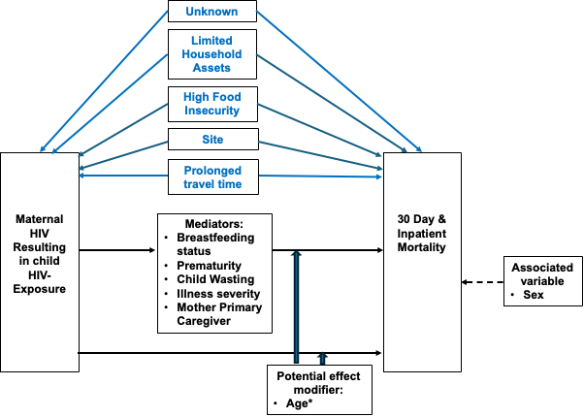

Supplemental Figure 1. Directed acyclic graph illustrating hypothesized relationships between various clinical and sociodemographic variables, HIV-exposure, and 30 day and inpatient mortality. Blue arrows indicate potential confounding variables; black arrows indicate potential mediators; dotted arrow indicates variables associated with the outcome; block arrows indicate potential effect modifiers. *Age < 6 months was tested as an effect modifier and not found to have a significant interaction (p=0.9 and p = 0.87 for inpatient and 30-day mortality, respectively). Age was subsequently adjusted for based on categories of < 6 months, 6-12 months, and greater than 12 months. The interaction between wasting status and mortality was also not found to be significant (p = 0.46 and p=0.24 for inpatient and 30-day mortality respectively). An exploratory analysis was performed with wasting status included in the final model (see Results section “HIV exposure and mortality).
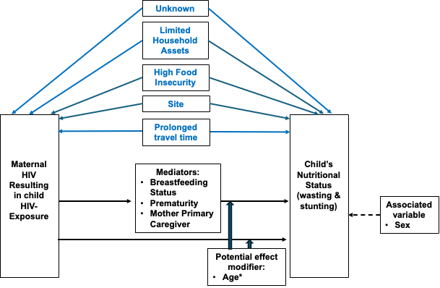
Supplemental Figure 2. Directed acyclic graph illustrating hypothesized relationships between various clinical and sociodemographic variables, HIV-exposure, and child’s nutritional status. Blue arrows indicate potential confounding variables; black arrows indicate potential mediators; block arrows indicate potential effect modifiers. The dotted arrow indicates variables associated with the outcome. Age < 6 months was tested as an effect modifier and was not found to have a significant interaction (p=0.8 and p=0.4 for wasting and stunting, respectively). *Age was subsequently adjusted for based on categories of < 6 months, 6-12 months, and greater than 12 months.
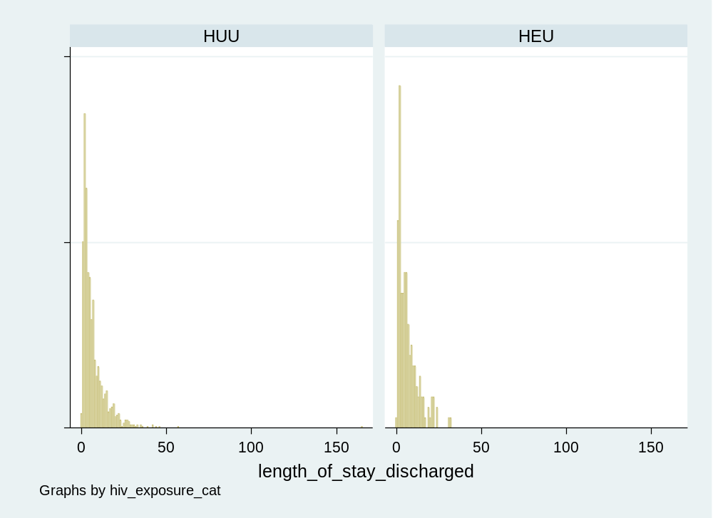
Supplemental figure 3: Histogram of duration of hospitalization by HIV exposure category
Length of hospital stay analysis was restricted to survivors and also excluded those who left against medical advice or absconded. The median length of hospital stay among all study participants was 5 days.

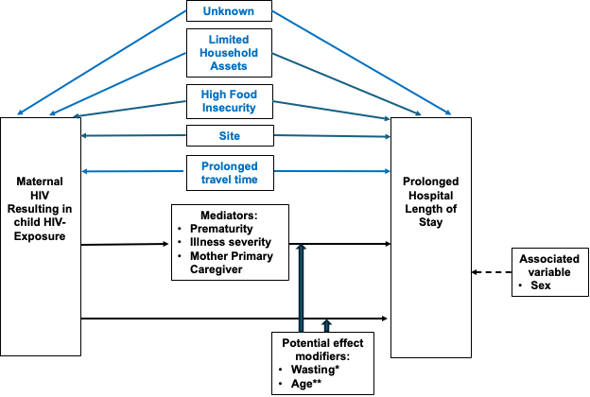
Supplemental Figure 4. Directed acyclic graph illustrating hypothesized relationships between various clinical and sociodemographic variables, HIV-exposure, and hospital length of stay. Blue arrows indicate potential confounding variables; black arrows indicate potential mediators; block arrows indicate potential effect modifiers. The dotted arrow indicates variables associated with the outcome. *Wasting status was tested as an effect modifier and not found to have a significant interaction (p=0.1). **Age < 6 months was tested as an effect modifier and not found to have a significant interaction (p= 0.13). Age was subsequently adjusted for based on categories of < 6 months, 6-12 months, and greater than 12 months.

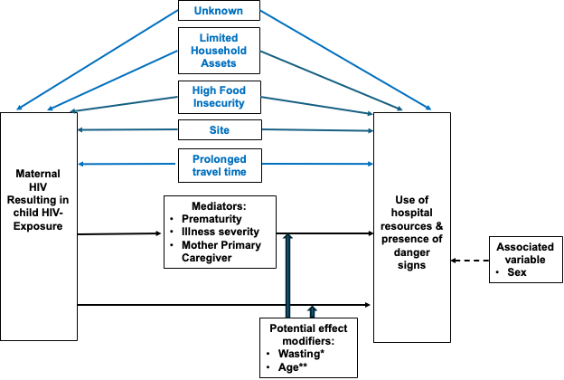
Supplemental Figure 5. Directed acyclic graph illustrating hypothesized relationships between various clinical and sociodemographic variables, HIV-exposure, and use of hospital resources, and presence of danger signs. Blue arrows indicate potential confounding variables; black arrows indicate potential mediators; block arrows indicate potential effect modifiers. The dotted arrow indicates variables associated with the outcome. *Wasting status was tested as an effect modifier and not found to have a significant interaction with presence of danger signs (p=0.86). **Age < 6 months was tested as an effect modifier and not found to have a significant interaction with presence of danger signs (p=0.55). Age was subsequently adjusted for based on categories of < 6 months, 6-12 months, and greater than 12 months.

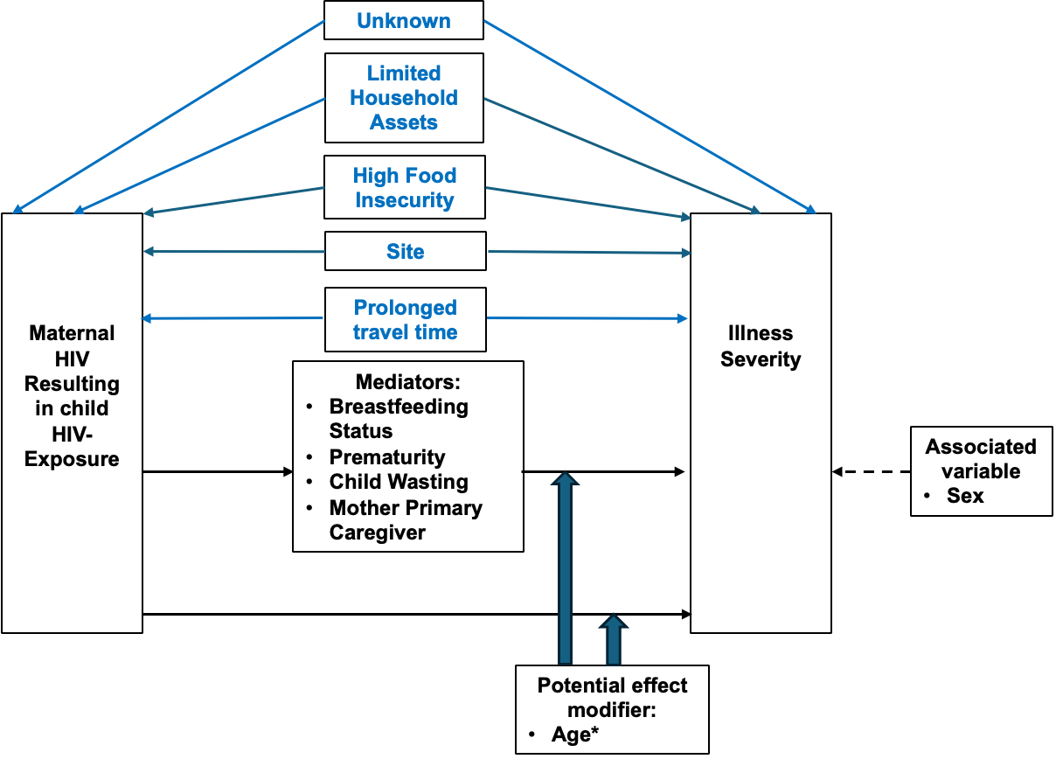
Supplemental Figure 6. Directed acyclic graph illustrating hypothesized relationships between various clinical and sociodemographic variables, HIV-exposure, and illness severity at enrollment. Blue arrows indicate potential confounding variables; black arrows indicate potential mediators; and block arrow indicates potential effect modifiers; block arrows indicate potential effect modifiers. The dotted arrow indicates a variable associated with the outcome. *Age < 6 months was tested as an effect modifier and found to have a significant interaction (p=0.013); a stratified analysis was subsequently performed.

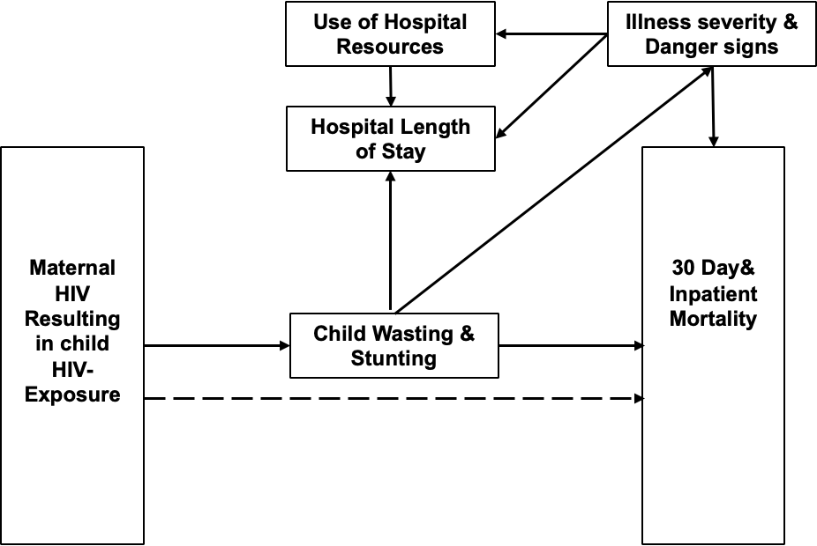
Supplemental Figure 7. Directed acyclic graph illustrating hypothesized relationships between HIV-exposure and study outcomes. Solid lines represent relationships explored in this analysis. The dotted line represents untested variables that may influence the relationship between HIV-exposure and mortality.

