Supplementary material

Physiological measures variability and risks of heart disease and stroke: Evidence from three cohort studies
Wei Liu MD, PhD ^{1,2,3}, Lieyang Fan MD, PhD ^{1,4}, Da Shi PhD ⁵, Linling Yu MD, PhD ^{1,4}, Jiahao Song MD, PhD ^{1,4}, Ruyi Liang MD, PhD ^{1, 4}, Xuefeng Lai MD, PhD ^{1, 4}, Hao Wang MD, PhD ⁶, Yongfang Zhang MD, PhD ^{1, 4}, Shuhui Wan MD ^{1, 4}, Yueru Yang MD ^{1, 4}, Bin Wang MD, PhD ^{1, 4,*}

Author Affiliations
¹ Department of Occupational and Environmental Health, School of Public Health, Tongji Medical College, Huazhong University of Science and Technology, Wuhan, Hubei 430030, China
² Medical Big Data and Bioinformatics Research Centre, First Affiliated Hospital of Gannan Medical University, Ganzhou, Jiangxi 341000, China
³ School of Public Health and Health Management, Gannan Medical University, Ganzhou, Jiangxi 341000, China
⁴ Key Laboratory of Environment and Health, Ministry of Education & Ministry of Environmental Protection, and State Key Laboratory of Environmental Health (Incubating), School of Public Health, Tongji Medical College, Huazhong University of Science and Technology, Wuhan, Hubei 430030, China
⁵ Agricultural, Food and Nutritional Science, Faculty of Agricultural, Life and Environmental Sciences, University of Alberta, Edmonton, Alberta T6G 2P5, Canada
⁶ Department of Epidemiology and Biostatistics, School of Public Health, Tongji
Medical College, Huazhong University of Science and Technology, Wuhan, Hubei 430030, China

*Corresponding authors:
Bin Wang MD, PhD
Department of Occupational and Environmental Health, School of Public Health, Tongji Medical College, Huazhong University of Science and Technology, Wuhan, Hubei 430030, China.
E-mail: gentwong@163.com

Supplementary methods
Study population
The China Health and Retirement Longitudinal Study (CHARLS) recruited participants aged 45 years or older in 2011 and revisited them in 2013, 2015, and 2018. Face-to-face interviews and physical examinations were administered to all participants at each visit [1].
In the Health and Retirement Study (HRS), participants aged 50 or older were recruited and were revisited biennially for collections of sociodemographic, lifestyle, and clinical information. Half of a randomly selected sample received physical examinations in 2006, 2010, and 2014 and the other half in 2008, 2012, and 2016 [2].
The UK biobank is a prospective, nationwide cohort study which had sent invitation letters to 9 million general adults aged 40 or older around the UK. From 2006 to 2010, there were 502401 (5% response rate) adults had attended one of 22 assessment centers across the UK, where they completed a touchscreen questionnaire and a nurse-led interview, provided biological samples, and had physical measurements taken, as described in detail elsewhere [3]. A subset of participants (n=20343) completed visit during 2012-2013 and 2014-2019 (biological samples were not provided at this visit) [3].
Physiological measures
Body weight, height, pulse rate, and blood pressure in the HRS, the CHARLS, and the UK Biobank were measured following similar protocols. Body weight was measured using an electronic weighing scale without shoes and with light clothing, and height was measured by having the respondent stand against a wall without shoes. BMI was calculated as weight in kilograms divided by height in meters squared. Pulse rate and blood pressure were each assessed three times, 45 to 60 seconds apart, in a seated position, by trained interviewers using an automated sphygmomanometer. The average values of the last two valid measurements were used at each visit.
Mediation analyses
Mediation was analyzed by fitting the following two models: equation (1) and (2) to estimate effects.
M = θ₁ + β_{exposure}X_{exposure} + β_{c}X_{c} + λ₁ (1)
Y = θ₂ + μ_{exposure}X_{exposure} + μM + μ_{c}X_{c} + λ₂ (2)
Here, Y signifies outcome, X_{exposure} signifies exposure (the composite score), M signifies mediator, X_{c} signifies covariate/confounder, θ₁ and θ₂ signify intercepts, λ₁ and λ₂ signify residuals, direct effect is μ_{exposure}, mediation effect is calculated as β_{exposure}×μ, and mediation proportion is calculated as β_{exposure}×μ /(β_{exposure}×μ + μ_{exposure})×100%.
Reference:
1. China Health and Retirement Longitudinal Study (CHARLS). China Health and Retirement Longitudinal Study. Available from: http://charls.pku.edu.cn/en/. Accessed 2023 Aug 13.
2. Health and Retirement Study (HRS). The Health and Retirement Study. Available from: https://hrs.isr.umich.edu/about?_ga=2.82991632.761114232.1668737860-1578651410.1635161200. Accessed 2023 Aug 13.
3. UK Biobank. UK Biobank Biomarker Project. Available from: https://biobank.ndph.ox.ac.uk/showcase/showcase/docs/serum_biochemistry.pdf. Accessed 2023 Aug 13.
Table S1. Associations of variability in physiological measures with incident risks of heart disease and stroke
Outcome | Variability in physiological measures | Models | CHARLS  HR (95% CI) | HRS  HR (95% CI) | UK Biobank  HR (95% CI)
Heart disease | BPV | Unadjusted model | 1.01 (0.85, 1.10) | 1.21 (1.11, 1.32) | 1.12 (1.04, 1.19)
 |  | Full-adjusted model | 1.06 (0.91, 1.14) | 1.09 (1.04, 1.15) | 1.12 (1.04, 1.19)
 | PRV | Unadjusted model | 1.12 (1.05, 1.32) | 1.31 (1.21, 1.43) | 1.25 (1.18, 1.34)
 |  | Full-adjusted model | 1.05 (0.99, 1.26) | 1.17 (1.12, 1.23) | 1.25 (1.18, 1.34)
 | BWV | Unadjusted model | 1.15 (0.99, 1.29) | 1.20 (1.10, 1.31) | 1.06 (0.98, 1.14)
 |  | Full-adjusted model | 1.06 (0.89, 1.11) | 1.06 (1.01, 1.12) | 1.06 (0.98, 1.14)
Stroke | BPV | Unadjusted model | 1.20 (1.07, 1.36) | 1.24 (1.05, 1.47) | 1.34 (1.15, 1.60)
 |  | Full-adjusted model | 1.12 (1.01, 1.24) | 1.16 (1.06, 1.27) | 1.22 (1.03, 1.44)
 | PRV | Unadjusted model | 1.11 (0.90, 1.30) | 1.24 (1.05, 1.47) | 1.33 (1.14, 1.55)
 |  | Full-adjusted model | 1.05 (0.86, 1.07) | 1.08 (0.98, 1.19) | 1.19 (1.01, 1.39)
 | BWV | Unadjusted model | 1.12 (0.97, 1.28) | 1.36 (1.16, 1.61) | 1.18 (0.99, 1.44)
 |  | Full-adjusted model | 1.05 (0.91, 1.10) | 1.09 (1.01, 1.17) | 1.06 (0.88, 1.27)
Abbreviation: CHARLS, China Health and Retirement Longitudinal Study; HRS, Health and Retirement Study; BPV, blood pressure variability; PRV, pulse rate variability; BWV, body weight variability; HR, hazard ratio; CI, confidence interval.
Unadjusted model was a crude model.
Full-adjusted models were adjusted for age, sex, education, smoking status, drinking status, physical activity, histories of diabetes, dyslipidemia, stroke, and heart disease, systolic blood pressure, body mass index, and pulse rate.
Participants with a history of heart disease were excluded a priori if the outcome was heart disease, and participants with a history of stroke were excluded a priori if the outcome was stroke.
Significant effects are in bold.

Table S2. Stratified analyses for the association of the composite score of variability in physiological measures with incident risk of heart disease
Group |  | CHARLS |  | HRS |  | UK Biobank
 |  | HR (95% CI) | P for interaction | HR (95% CI) | P for interaction | HR (95% CI) | P for interaction
Sex | Male | 1.06 (0.89, 1.26) | 0.810 | 1.18 (1.12, 1.25) | 0.168 | 1.28 (1.19, 1.37) | 0.720
 | Female | 1.07 (0.91, 1.27) | 0.810 | 1.19 (1.12, 1.25) | 0.168 | 1.27 (1.10, 1.49) | 0.720
Age | <65 years | 1.06 (0.89, 1.26) | 0.240 | 1.22 (1.06, 1.41) | 0.141 | 1.22 (1.04, 1.44) | 0.884
 | ≥65 years | 1.08 (0.91, 1.28) | 0.240 | 1.17 (1.10, 1.25) | 0.141 | 1.26 (1.14, 1.39) | 0.884
Body mass index | <25 kg/m² | 1.08 (0.92, 1.27) | 0.921 | 1.21 (1.06, 1.38) | 0.362 | 1.30 (1.11, 1.53) | 0.678
 | ≥25 kg/m² | 1.04 (0.90, 1.21) | 0.921 | 1.18 (1.11, 1.26) | 0.362 | 1.22 (1.11, 1.35) | 0.678
Physical activity | Active | 1.07 (0.93, 1.22) | 0.051 | 1.20 (1.12, 1.27) | 0.497 | 1.25 (1.12, 1.41) | 0.890
 | Inactive | 1.05 (0.89, 1.24) | 0.051 | 1.14 (1.02, 1.28) | 0.497 | 1.23 (1.08, 1.39) | 0.890
Smoking status | Smoker | 1.04 (0.90, 1.20) | 0.825 | 1.19 (1.01, 1.41) | 0.981 | 1.22 (1.06, 1.39) | 0.746
 | Nonsmoker | 1.08 (0.92, 1.27) | 0.825 | 1.18 (1.12, 1.26) | 0.981 | 1.27 (1.14, 1.42) | 0.746
Drinking status | Drinker | 1.07 (0.99, 1.27) | 0.599 | 1.19 (1.10, 1.28) | 0.789 | 1.21 (1.02, 1.43) | 0.586
 | Nondrinker | 1.07 (0.90, 1.28) | 0.599 | 1.18 (1.04, 1.28) | 0.789 | 1.26 (1.14, 1.39) | 0.586
Abbreviation: CHARLS, China Health and Retirement Longitudinal Study; HRS, Health and Retirement Study; HR, hazard ratio; CI, confidence interval.
Models were adjusted for age, sex, education, smoking status, drinking status, physical activity, histories of diabetes, dyslipidemia, and stroke, systolic blood pressure, body mass index, and pulse rate.
Participants with a history of heart disease were excluded.
Significant effects are in bold.

Table S3. Stratified analyses for the association of the composite score of variability in physiological measures with incident risk of stroke
Group |  | CHARLS |  | HRS |  | UK Biobank
 |  | HR (95% CI) | P for interaction | HR (95% CI) | P for interaction | HR (95% CI) | P for interaction
Sex | Male | 1.18 (0.93, 1.50) | 0.875 | 1.22 (1.04, 1.44) | 0.454 | 1.41 (1.08, 1.83) | 0.354
 | Female | 1.16 (0.92, 1.46) | 0.875 | 1.12 (0.96, 1.31) | 0.454 | 1.13 (0.79, 1.61) | 0.354
Age | <65 years | 1.16 (0.93, 1.46) | 0.876 | 1.23 (0.92, 1.65) | 0.328 | 1.15 (0.76, 1.74) | 0.412
 | ≥65 years | 1.18 (0.95, 1.49) | 0.876 | 1.18 (1.05, 1.34) | 0.328 | 1.35 (1.06, 1.73) | 0.412
Body mass index | <25 kg/m² | 1.18 (0.94, 1.48) | 0.777 | 1.36 (1.06, 1.72) | 0.331 | 1.36 (0.93, 1.99) | 0.888
 | ≥25 kg/m² | 1.17 (0.94, 1.46) | 0.777 | 1.17 (1.02, 1.32) | 0.331 | 1.25 (0.97, 1.61) | 0.888
Physical activity | Active | 1.05 (0.86, 1.29) | <0.001 | 1.20 (1.06, 1.36) | 0.818 | 1.24 (0.94, 1.63) | 0.670
 | Inactive | 1.30 (1.03, 1.64) | <0.001 | 1.18 (0.93, 1.50) | 0.818 | 1.36 (0.98, 1.89) | 0.670
Smoking status | Smoker | 1.17 (0.94, 1.46) | 0.364 | 1.04 (0.78, 1.40) | 0.238 | 1.33 (0.93, 1.92) | 0.252
 | Nonsmoker | 1.19 (0.95, 1.50) | 0.364 | 1.21 (1.08, 1.37) | 0.238 | 1.26 (0.98, 1.64) | 0.252
Drinking status | Drinker | 1.12 (0.91, 1.37) | 0.493 | 1.18 (1.01, 1.39) | 0.824 | 1.33 (0.86, 2.06) | 0.598
 | Nondrinker | 1.23 (0.98, 1.56) | 0.493 | 1.19 (1.03, 1.39) | 0.824 | 1.28 (1.01, 1.62) | 0.598
Abbreviation: CHARLS, China Health and Retirement Longitudinal Study; HRS, Health and Retirement Study; HR, hazard ratio; CI, confidence interval.
Models were adjusted for age, sex, education, smoking status, drinking status, physical activity, histories of diabetes, dyslipidemia, and heart disease, systolic blood pressure, body mass index, and pulse rate.
Participants with a history of stroke were excluded.
Significant effects are in bold.

Table S4. Sensitivity analyses for the associations of the composite score of variability in physiological measures with incident risks of heart disease and stroke
Outcome | Group | CHARLS  HR (95% CI) | HRS  HR (95% CI) | UK Biobank  HR (95% CI) | Pooled  HR (95% CI)
Heart disease | Additionally adjusting for residence or race | 1.05 (0.91, 1.27) | 1.15 (1.06 1.24) | 1.24 (1.14, 1.35) | 1.18 (1.09, 1.31)
 | Excluding participants with diabetes | 1.06 (0.90, 1.26) | 1.23 (1.15, 1.33) | 1.23 (1.12, 1.34) | 1.21 (1.11, 1.31)
 | Excluding participants with hypertension | 1.05 (0.86, 1.29) | 1.24 (1.10, 1.39) | 1.22 (1.11, 1.35) | 1.20 (1.07, 1.34)
 | Excluding participants with dyslipidemia | 1.06 (0.90, 1.27) | 1.11 (1.03, 1.21) | 1.27 (1.14, 1.41) | 1.14 (1.04, 1.26)
 | Using SD | 1.05 (0.93, 1.20) | 1.13 (1.04, 1.19) | 1.25 (1.12, 1.36) | 1.15 (1.03, 1.26)
 | Using VIM | 1.07 (0.95, 1.21) | 1.16 (1.09, 1.22) | 1.29 (1.19, 1.41) | 1.17 (1.07, 1.28)
 | Using competing risk model with setting death as a competing event | 1.09 (0.94.1.26) | 1.19 (1.08, 1.32) | 1.28 (1.15, 1.46) | 1.23 (1.07, 1.28)
Stroke | Additionally adjusting for residence or race | 1.34 (1.04, 1.66) | 1.17 (1.06, 1.33) | 1.24 (1.05, 1.62) | 1.21 (1.05, 1.39)
 | Excluding participants with diabetes | 1.32 (1.05, 1.67) | 1.19 (1.06, 1.34) | 1.27 (1.02, 1.58) | 1.22 (1.05, 1.41)
 | Excluding participants with hypertension | 1.32 (1.04, 1.67) | 1.15 (0.98, 1.32) | 1.62 (1.09, 2.44) | 1.24 (1.01, 1.48)
 | Excluding participants with dyslipidemia | 1.25 (0.99, 1.59) | 1.14 (1.02, 1.35) | 1.24 (1.01, 1.57) | 1.19 (1.01, 1.37)
 | Using SD | 1.36 (1.06, 1.70) | 1.16 (1.05, 1.31) | 1.29 (1.05, 1.63) | 1.20 (1.04, 1.37)
 | Using VIM | 1.41 (1.11, 1.78) | 1.19 (1.07, 1.34) | 1.26 (1.02, 1.56) | 1.23 (1.06, 1.40)
 | Using competing risk model with setting death as a competing event | 1.38 (1.05, 1.84) | 1.18 (1.03, 1.36) | 1.31 (1.02, 1.60) | 1.23 (1.09, 1.38)
Abbreviation: CHARLS, China Health and Retirement Longitudinal Study; HRS, Health and Retirement Study; BPV, blood pressure variability; PRV, pulse rate variability; BWV, body weight variability; SD, standard deviation; VIM; variation independent of the mean; HR, hazard ratio; CI, confidence interval.
Models were adjusted for age, sex, education, smoking status, drinking status, physical activity, histories of diabetes, dyslipidemia, stroke, and heart disease, systolic blood pressure, body mass index, and pulse rate.
Participants with a history of heart disease were excluded a priori if the outcome was heart disease, and participants with a history of stroke were excluded a priori if the outcome was stroke.
VIM was calculated as the SD divided by the mean to the power x and multiplied by the population mean to the power x. The power x is obtained by fitting a curve through a plot of SD against mean using the model SD=$a×{mean}^{x}$, where x was derived by nonlinear regression analysis.
Significant effects are in bold.

Table S5. Associations of the composite score of variability (1-point increment) with mediating biomarkers
Biomarkers | CHARLS  β (95 % CI) | HRS  β (95 % CI) | UK Biobank  β (95 % CI)
Grip strength, kg | -0.94 (-1.34, -0.55) | -1.67 (-1.94, -1.41) | -1.36 (-1.64, -1.09)
CRP, mg/L | 0.28 (0.09, 0.45) | 0.49 (0.26, 0.71) | -
HbAlc, % | 0.05 (0.02, 0.08) | 0.03 (0.01, 0.05) | -
TC, mg/dL | -0.82 (-1.84, 0.19) | -1.46 (-5.06, 2.14) | -
TG, mg/dL | -1.72 (-4.22, 0.78) | - | -
HDL, mg/dL | 0.26 (-0.07, 0.60) | 0.13 (-1.07, 1.33) | -
LDL, mg/dL | -0.56 (-1.38, 0.25) | - | -
Cystatin C, mg/L | 0.04 (0.01, 0.06) | 0.01 (0.001, 0.02) | -
Abbreviation: CHARLS, China Health and Retirement Longitudinal Study; HRS, Health and Retirement Study; HbAlc, glycosylated hemoglobin Alc; CRP, C-reactive protein; TC, total cholesterol; TG, triglycerides; HDL, high density lipoprotein; LDL, low density lipoprotein; CI, confidence interval.
Models were adjusted for age, sex, education, smoking status, drinking status, physical activity, histories of diabetes (not adjusted for when outcome was HbAlc), dyslipidemia (not adjusted for when outcome was lipid profile), stroke, and heart disease, systolic blood pressure, body mass index, pulse rate, and levels of biomarker at recruitment (2011 for the CHARLS; 2006/2008 for the HRS; 2006-2010 for the UK Biobank).
Significant effects are in bold.

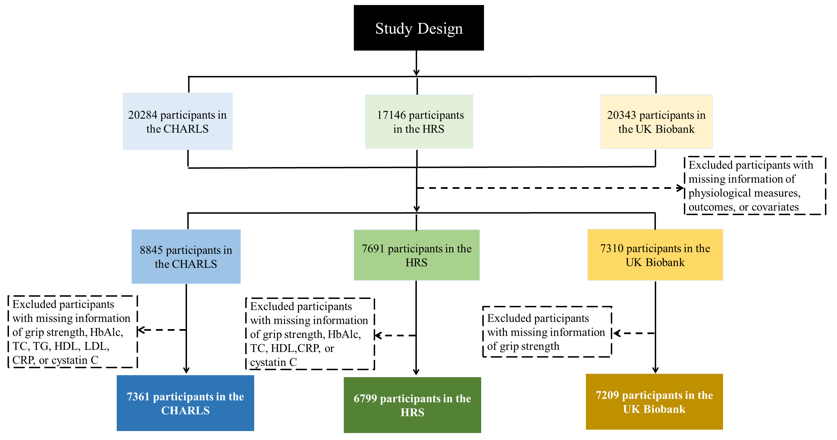
Fig. S1. Participant inclusion and exclusion flowchart
Abbreviation: BPV, blood pressure variability; PRV, pulse rate variability; BWV, body weight variability; HbAlc, glycosylated hemoglobin Alc; CRP, C-reactive protein; TC, total cholesterol; TG, triglycerides; HDL, high density lipoprotein; LDL, low density lipoprotein.

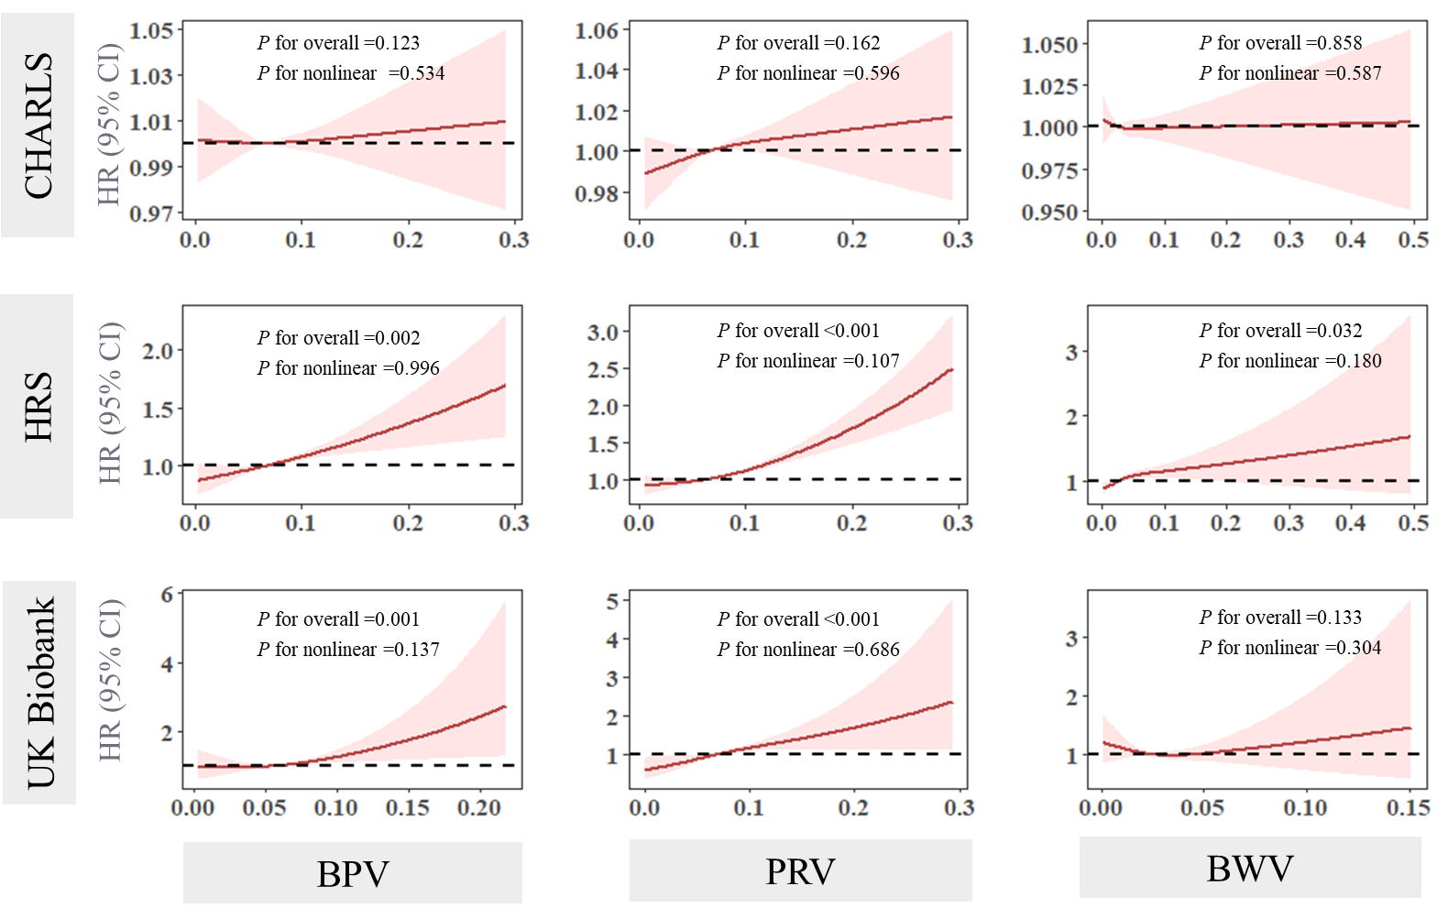
Fig. S2. Restricted cubic spline plots of the association of variability in physiological measures with incident risk of heart disease
The solid red line and the shadow of pink represent the estimated HR and its 95% CI, respectively.
Abbreviation: CHARLS, China Health and Retirement Longitudinal Study; HRS, Health and Retirement Study; BPV, blood pressure variability; PRV, pulse rate variability; BWV, body weight variability; HR, hazard ratio; CI, confidence interval.
Models were adjusted for age, sex, education, smoking status, drinking status, physical activity, histories of diabetes, dyslipidemia, and stroke, systolic blood pressure, body mass index, and pulse rate.
Participants with a history of heart disease were excluded.

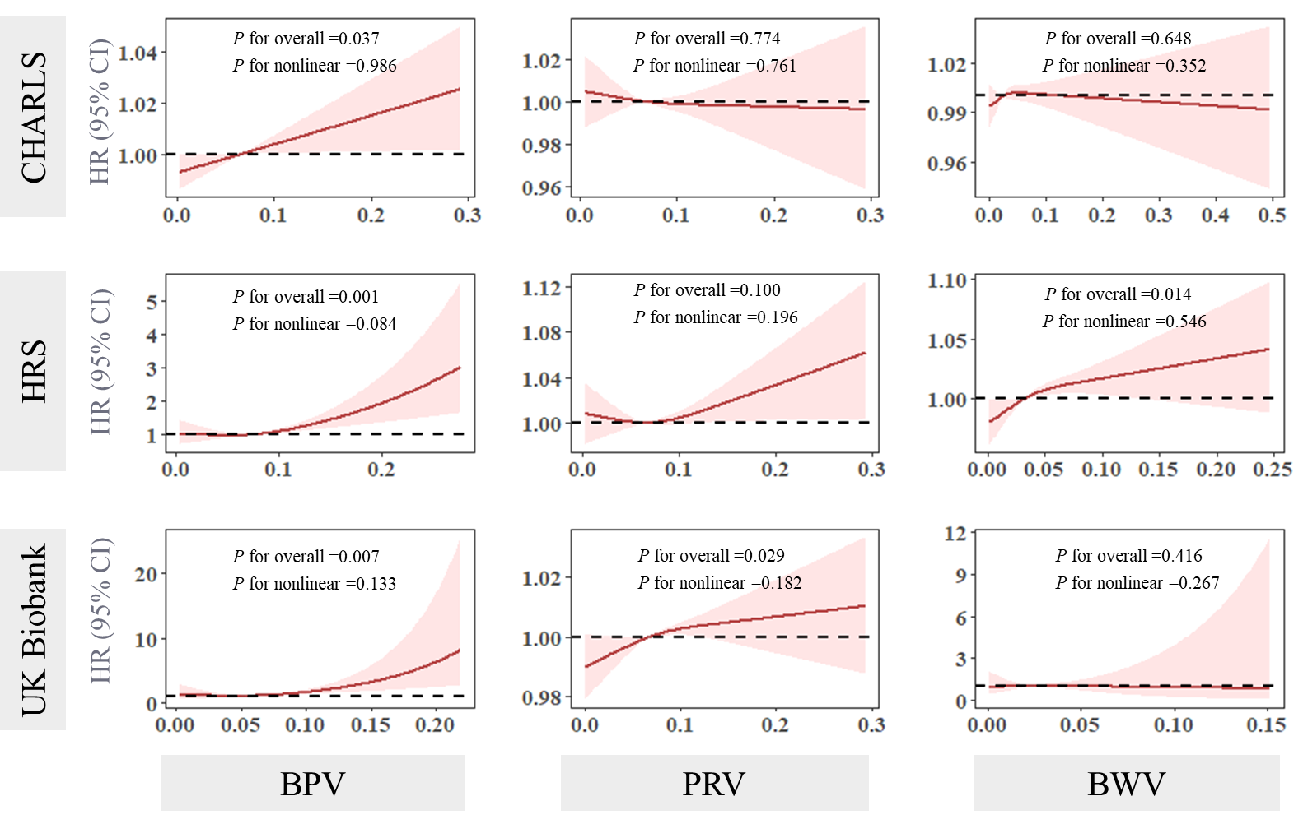
Fig. S3. Restricted cubic spline plots of the association of variability in physiological measures with incident risk of stroke
The solid red line and the shadow of pink represent the estimated HR and its 95% CI, respectively.
Abbreviation: CHARLS, China Health and Retirement Longitudinal Study; HRS, Health and Retirement Study; BPV, blood pressure variability; PRV, pulse rate variability; BWV, body weight variability; HR, hazard ratio; CI, confidence interval.
Models were adjusted for age, sex, education, smoking status, drinking status, physical activity, histories of diabetes, dyslipidemia, and heart disease, systolic blood pressure, body mass index, and pulse rate.
Participants with a history of stroke were excluded.

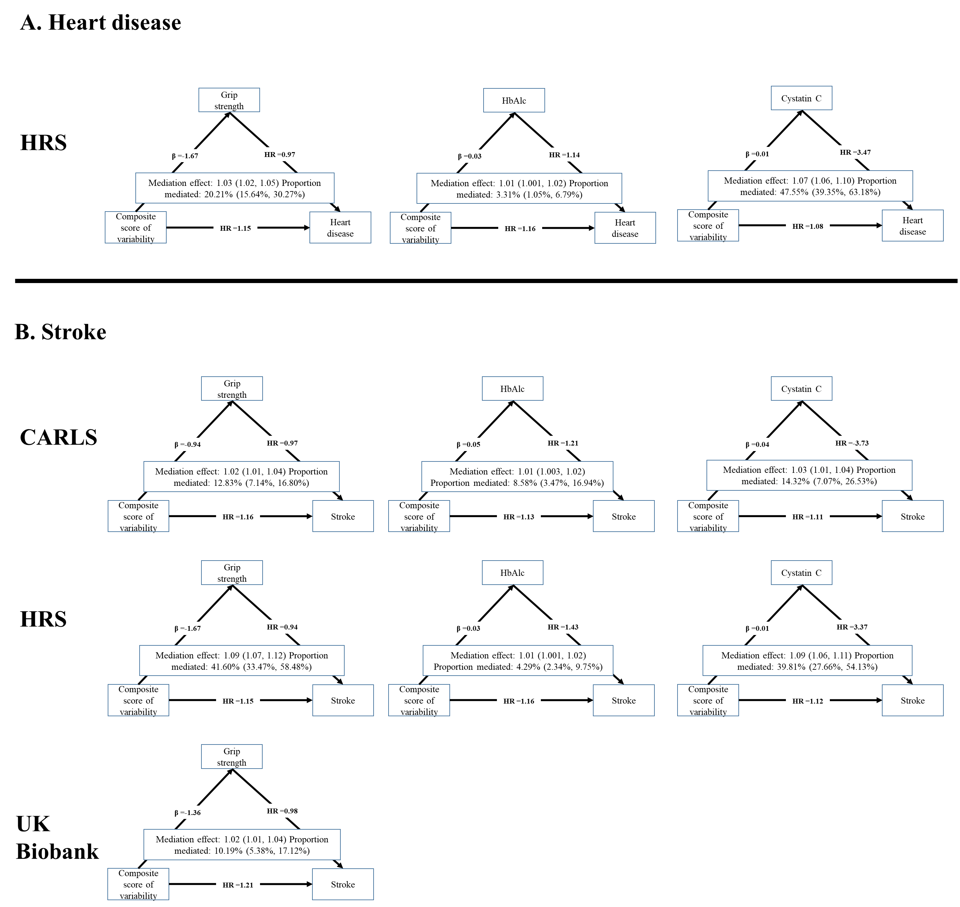
Fig. S4. Directed acyclic graphs of the significant mediation roles found in mediation analyses
Abbreviation: CHARLS, China Health and Retirement Longitudinal Study; HRS, Health and Retirement Study; HbAlc, glycosylated hemoglobin Alc; HR, hazard ratio.
Models were adjusted for age, sex, education, smoking status, drinking status, physical activity, histories of diabetes, dyslipidemia, heart disease, and stroke, systolic blood pressure, body mass index, pulse rate, and mediating biomarkers.
Participants with a history of heart disease were excluded a priori if the outcome was heart disease, and participants with a history of stroke were excluded a priori if the outcome was stroke.

