Additional File 1

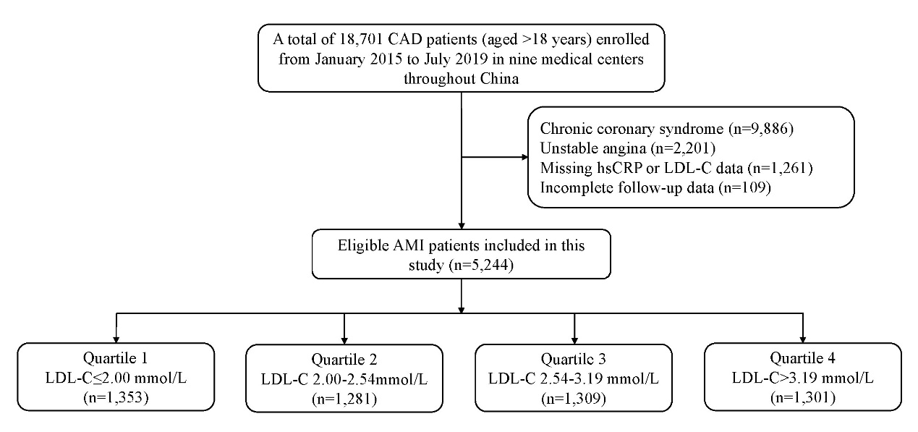
Additional File 1: Fig. S1. Study flow chart. AMI, acute myocardial infarction; CAD, coronary artery disease; hsCRP, high-sensitive C-reactive protein; LDL-C, low-density lipoprotein cholesterol.
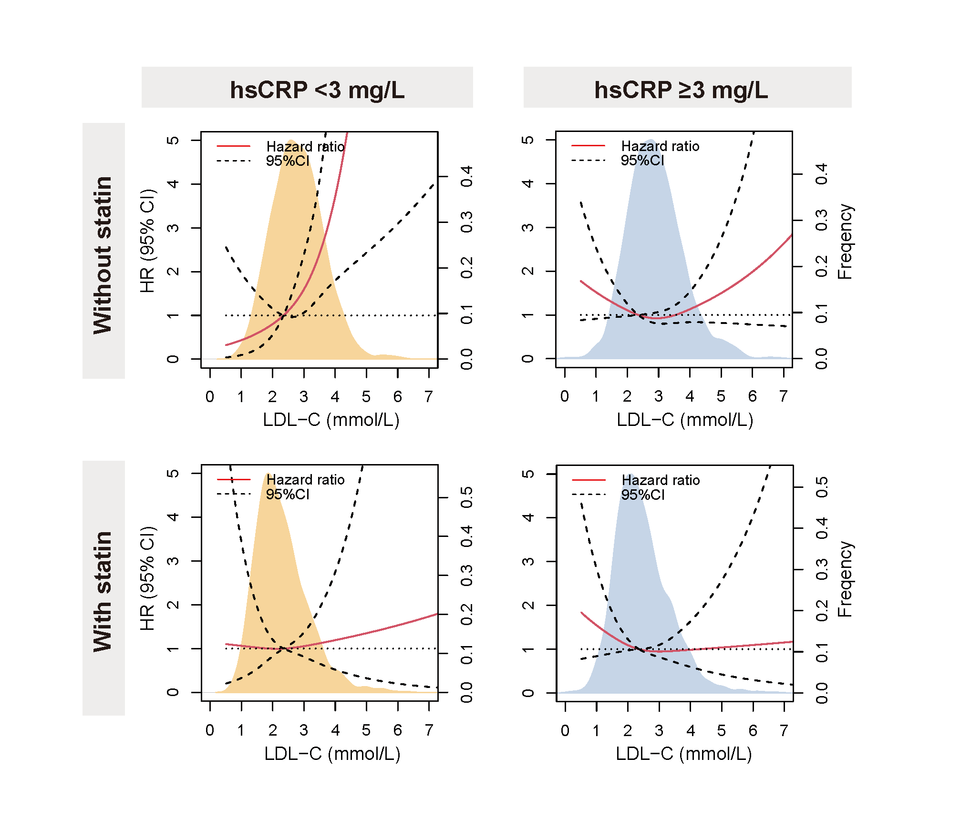
Additional File 1: Fig. S2. Adjusted all-cause mortality risks associated with low-density lipoprotein cholesterol (LDL-C) on a continuous scale stratified by hsCRP levels and statin treatment before admission. Hazard ratio (red solid line) and 95% confidence intervals (black dotted lines) were calculated using restricted cubic splines with three knots, adjusted for variables based on backward regression selection. The distribution of LDL-C is shown as shaded areas, with the median LDL-C value in the group as the reference. CI, confidence interval; HR, hazard ratio.

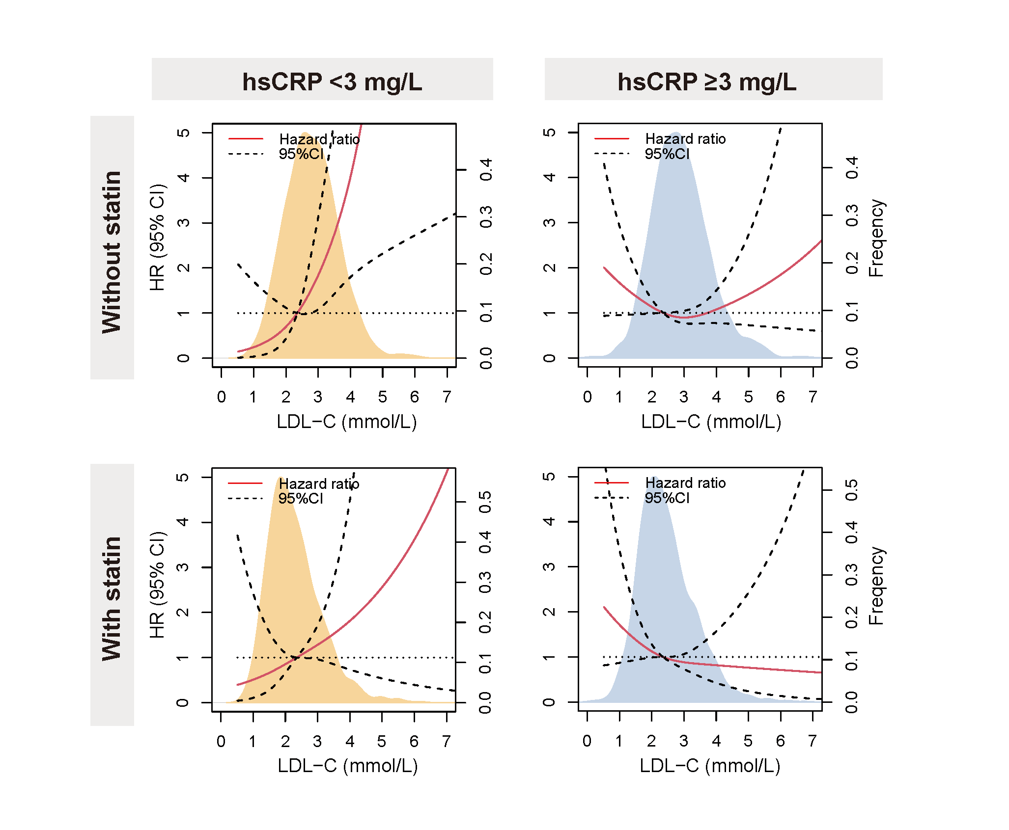
Additional File 1: Fig. S3. Adjusted cardiac mortality risks associated with low-density lipoprotein cholesterol (LDL-C) on a continuous scale stratified by hsCRP levels and statin treatment before admission. Hazard ratio (red solid line) and 95% confidence intervals (black dotted lines) were calculated using restricted cubic splines with three knots, adjusted for variables based on backward regression selection. The distribution of LDL-C is shown as shaded areas, with the median LDL-C value in the group as the reference. CI, confidence interval; HR, hazard ratio.

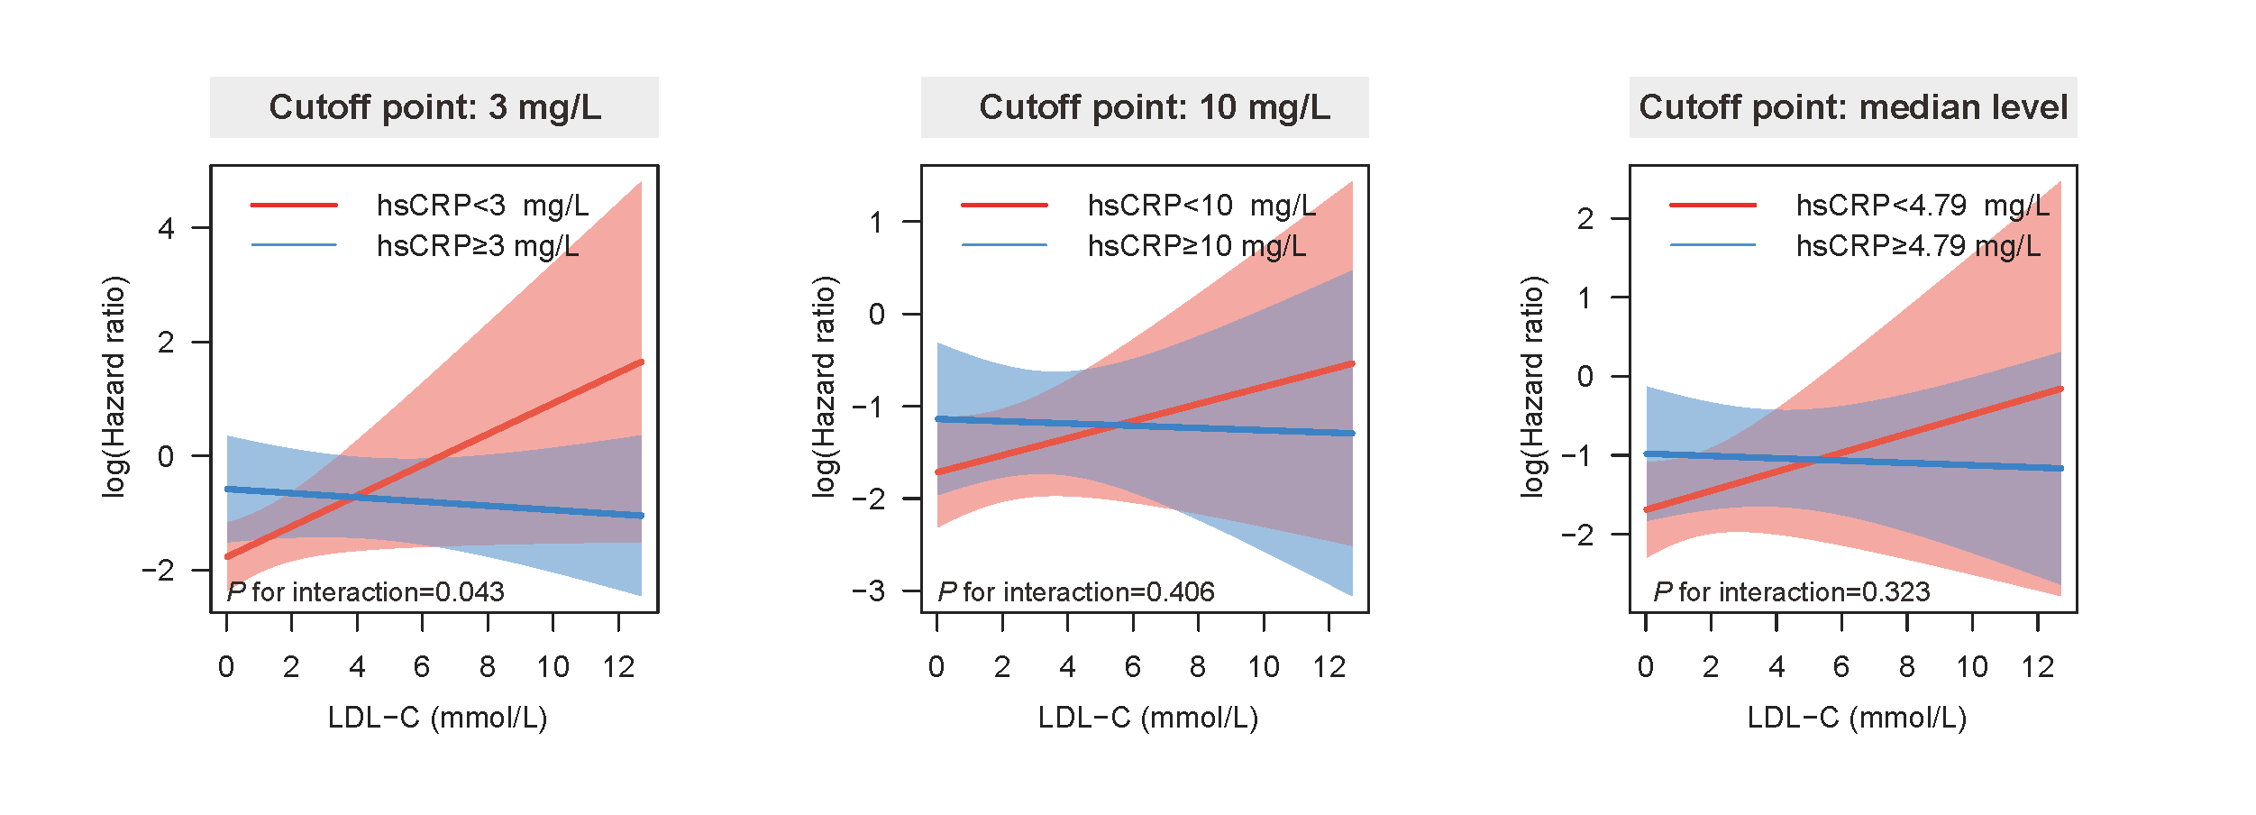
Additional File 1: Fig. S4. Interaction between low-density lipoprotein cholesterol (LDL-C) levels and high-sensitive C-reactive protein (hsCRP) levels for all-cause mortality at different hsCRP cutoff points (3mg/L, 10mg/L and median level).

