Additional file 1
Impaired Pulmonary Function Increases the Risk of Gout: Evidence from a Large Cohort Study in the UK Biobank Zijian Kang^{1#}, Jianzheng Zhang^{2#}, Chen Zhu^{3#}, Ying Zhu⁴, Hanlei Jiang¹, Qiang Tong^{1,5*} and Sheng-Ming Dai^{1*}

- Department of Rheumatology and Immunology, Shanghai Sixth People's Hospital Affiliated to Shanghai Jiao Tong University School of Medicine, Shanghai, China
- Senior Department of Orthopedics, The Forth Medical Center of Chinese PLA General Hospital, Beijing, China
- College of Economics and Management, China Agricultural University, Beijing, China
- Department of Respiratory and Critical Care Medicine, The Eighth Medical Center of Chinese PLA General Hospital, China
- Division of Rheumatology and Clinical Immunology, Department of Medicine, Queen Mary Hospital, Hong Kong, China

#These authors contributed equally to this work.
*Corresponding author:
Dr. Sheng-Ming Dai, Department of Rheumatology and Immunology, Shanghai Sixth People's Hospital Affiliated to Shanghai Jiao Tong University School of Medicine, Shanghai, China (shengmingdai@163.com)
Dr. Qiang Tong, Department of Rheumatology and Immunology, Shanghai Sixth People's Hospital Affiliated to Shanghai Jiao Tong University School of Medicine, Shanghai, China (jasontong1985@163.com)

Appendices index
Table S1. Extraction of data variables from the UK Biobank 4
Table S2. Selection of biomarkers as potential mediators between pulmonary function and incident gout 5
Table S3. Cross-sectional association between pulmonary function and gout 6
Table S4. Baseline characteristics of the study population after PSM 7
Table S5. Risk of gout exposed to impaired pulmonary function compared to normal pulmonary function 8
Table S6. Sensitivity analyses for the association between impaired pulmonary function and gout risk, excluding cases diagnosed within the first two years of follow-up 9
Table S7. Effects of genetically predicted lung function indicators on the risk of gout in the MR analysis 10
Table S8. Incidence of gout according to baseline pulmonary indicators 11
Table S9. Selection of biomarkers as potential mediators between pulmonary function and incident gout 12
Fig. S1. The forest plot illustrating the outcomes of a multivariable Cox regression analysis 13
Fig. S2. Kaplan-Meier analysis for risk of gout in males (A), females (B), age≤55 individuals (C) and age≤55 (D) individuals with impaired pulmonary function compared to normal pulmonary function 14
Fig. S3. Sensitivity analysis using E-value estimation for unmeasured confounding 15
Fig. S4. Scatter plots of genetic associations between lung function indicators and gout. The effects of SNPs on gout are plotted in relation to their effects on FVC (A), FEV1(B) and FEV1 predicted percentage (C). The slope of each line reflects the causal association, with each method yielding a distinct line. 16
Fig. S5. Distribution of inflammatory-related and renal function biomarkers pre- and post-imputation 17
Fig. S6. Distribution of liver function biomarkers pre- and post-imputation 18
Fig. S7. Distribution of lipids and glucose pre- and post-imputation 19
Fig. S8. Distribution of hormone and mineral metabolism biomarker pre- and post-imputation 20

Table S1. Extraction of data variables from the UK Biobank
Field ID | Description | Category
22189 | Townsend deprivation index at recruitment | Baseline characteristics
21022 | Age at recruitment | Baseline characteristics
33 | Date of birth | Baseline characteristics
31 | Sex | Baseline characteristics
21000 | Ethnic background | Ethnicity
21001 | Body size measures | Body size measures
50 | Standing height | Body size measures
4080 | Systolic blood pressure, automated reading | Blood pressure
4079 | Diastolic blood pressure, automated reading | Blood pressure
21003 | Age when attended assessment centre | Reception
53 | Date of attending assessment centre | Reception
22040 | Summed MET minutes per week for all activity | MET Scores
131858 | Date M10 first reported (gout) | Musculoskeletal system and connective tissue disorders
40000 | Date of death | Death register
191 | Date lost to follow-up | Ongoing characteristics
20116 | Smoking status | Smoking
20161 | Pack years of smoking | Smoking
20117 | Alcohol drinker status | Alcohol
20403 | Amount of alcohol drunk on a typical drinking day | Alcohol
1558 | Alcohol intake frequency | Alcohol
100580 | Alcohol consumed | Alcohol
3062 | Forced vital capacity (FVC) | Spirometry
20257 | Forced vital capacity (FVC) Z-score | Spirometry
3063 | Forced expiratory volume in 1-second (FEV1) | Spirometry
20153 | Forced expiratory volume in 1-second (FEV1), predicted | Spirometry
20154 | Forced expiratory volume in 1-second (FEV1), predicted percentage | Spirometry
20256 | Forced expiratory volume in 1-second (FEV1) Z-score | Spirometry
20258 | FEV1/ FVC ratio Z-score | Spirometry
3064 | Peak expiratory flow (PEF) | Spirometry
6150 | Vascular/heart problems diagnosed by doctor | Medical conditions
3060 | Time of blow measurement | Spirometry
6153 | Medication for cholesterol, blood pressure, diabetes, or take exogenous hormones | Medication
6177 | Medication for cholesterol, blood pressure or diabetes | Medication
30750 | Glycated haemoglobin (HbA1c) | Blood biochemistry
2443 | Diabetes diagnosed by doctor | Medical conditions
6152 | Blood clot, DVT, bronchitis, emphysema, asthma, rhinitis, eczema, allergy diagnosed by doctor | Medical conditions

Table S2. Selection of biomarkers as potential mediators between pulmonary function and incident gout

Biomarkers | Unit | Original |  | Imputation
Biomarkers | Unit | Mean | SD | Mean | SD
Inflammatory-related biomarkers
Leukocyte count | 10^9 cells/L | 2.02 | 1.24 | 2.04 | 1.43
Neutrophil count | 10^9 cells/L | 4.36 | 1.47 | 4.36 | 1.52
Monocyte count | 10^9 cells/L | 0.49 | 0.24 | 0.5 | 0.24
Lymphocyte count | 10^9 cells/L | 2.02 | 1.24 | 2.04 | 1.43
C reactive protein | mg/L | 2.91 | 4.55 | 2.92 | 4.57
Platelet count | 10^9 cells/L | 251.56 | 60.93 | 251.67 | 61.06
Rheumatoid factor | IU/ml | 24.86 | 20.06 | 24.5 | 19.66
Renal function-related biomarkers
Cystatin C | mg/L | 0.93 | 0.19 | 0.93 | 0.19
Urate | μmol/L | 32.074 | 80.25 | 320.64 | 80.10
Urea | mmol/L | 5.44 | 1.43 | 5.44 | 1.43
Creatinine | mmol/l | 73.64 | 19.45 | 73.6 | 19.29
Liver function-related biomarkers
Alanine aminotransferase | U/L | 24.72 | 14.84 | 24.69 | 14.88
Alkaline phosphatase | U/L | 85.55 | 26.76 | 85.53 | 26.81
Aspartate aminotransferase | U/L | 26.77 | 11.47 | 26.75 | 11.55
Gamma-glutamyl transferase | U/L | 40.49 | 44.79 | 40.44 | 44.82
Total bilirubin | μmol/L | 9.07 | 4.40 | 9.05 | 4.38
Direct bilirubin | μmol/L | 1.84 | 0.87 | 1.74 | 0.84
Total protein | g/L | 72.66 | 4.02 | 72.66 | 4.21
Albumin | g/L | 45.09 | 2.66 | 45.09 | 2.66
Lipids and glucose
Apolipoprotein A | g/L | 1.50 | 0.27 | 1.51 | 0.27
Apolipoprotein B | g/L | 1.03 | 0.24 | 1.03 | 0.25
Cholesterol | mmol/L | 5.60 | 1.18 | 5.60 | 1.18
HDL cholesterol | mmol/L | 1.39 | 0.37 | 1.39 | 0.37
LDL direct | mmol/L | 3.51 | 0.89 | 3.51 | 0.89
Lipoprotein A | ng/mL | 45.37 | 49.33 | 45.39 | 49.30
Triglycerides | mmol/L | 1.86 | 1.08 | 1.86 | 1.08
Glucose | mmol/L | 5.24 | 1.50 | 5.24 | 1.49
Glycated haemoglobin (HbA1c) | % | 37.34 | 8.03 | 37.34 | 8.03
Hormone
Oestradiol | pmol/L | 420.31 | 409.42 | 324.43 | 275.69
SHBG | nmol/L | 48.27 | 25.99 | 48.34 | 26.04
Testosterone | nmol/L | 7.38 | 6.01 | 7.07 | 6.01
IGF-1 | ng/mL | 20.99 | 5.75 | 21 | 5.75
Mineral metabolism
Phosphate | mmol/L | 1.15 | 0.16 | 1.15 | 0.16
Calcium | mmol/L | 2.38 | 0.10 | 2.38 | 0.10
Vitamin D | ng/mL | 46.66 | 21.04 | 46.43 | 21.01

Table S3. Cross-sectional association between pulmonary function and gout

Group | Cases, No (%) | OR (95% CI)
Group | Cases, No (%) | Model 0 | Model 1 | Model 2 | Model 3
Normal  (n=328,954) | 11,351(3.45) | Ref | Ref | Ref | Ref
PRISm  (n=55,365) | 3,494(6.31) | 1.85(1.75-1.95) *** | 1.34(1.27-1.42) *** | 1.36(1.29-1.44) *** | 1.24(1.17-1.31) ***
COPD  (n=35,683) | 2,232(6.26) | 1.82(1.71-1.94) *** | 1.22(1.15-1.30) * | 1.23(1.15-1.32) *** | 1.14(1.07-1.22) ***
Model 0: Crude model; Model 1: adjusted for age, sex, Townsend score, and body mass index. Model 2: adjusted for model 1 plus smoking status, alcohol consumption, physical activity, fish consumption, and meat consumption. Model 3: adjusted for model 2 plus hypertension, diabetes, CKD, CVD, and asthma.
Abbreviations: OR: Odds ratio; CI: Confidence intervals; PRISm: Preserved ratio impaired spirometry; Ref: reference; CVD: Cardiovascular disease; CKD: Chronic kidney disease. CVD, Cardiovascular disease. *P < 0.05. **P < 0.01. ***P < 0.001.

Table S4. Baseline characteristics of the study population after PSM

 | Normal  (N=86809) | Impaired  (N=86809) | P-value | SMD
Age | 59 (51-63) | 59 (51-64) | <0.001 | 0.014
Sex (%) |  |  | 0.008
Female | 40300 (46.4%) | 39754 (45.8%) |  | -0.013
Male | 46509 (53.6%) | 47055 (54.2%) |  | 0.013
BMI (%) |  |  | <0.001
Normal | 21983 (25.3%) | 22991 (26.5%) |  | 0.026
Underweight | 409 (0.5%) | 566 (0.7%) |  | 0.022
Overweight | 64305 (74.1%) | 63098 (72.7%) |  | -0.03
Townsend score (%) |  |  | 0.085
1 (least deprived) | 18214 (21.0%) | 18112 (20.9%) |  | -0.002
2 | 19140 (22.0%) | 18982 (21.9%) |  | -0.004
3 | 21287 (24.5%) | 21360 (24.6%) |  | 0.002
4 (most deprived) | 28094 (32.4%) | 28246 (32.5%) |  | 0.003
Smoking (%) |  |  | <0.001
Never | 42001 (48.4%) | 41744 (48.1%) |  | -0.005
Previous | 30767 (35.4%) | 30451 (35.1%) |  | -0.007
Current | 13457 (15.5%) | 13916 (16.0%) |  | 0.014
Drink (%) |  |  | 0.003
Never | 10580 (12.2%) | 10265 (11.8%) |  | -0.011
Occasions | 21567 (24.8%) | 21432 (24.7%) |  | -0.004
Frequent | 54361 (62.6%) | 54741 (63.1%) |  | 0.009
Activity (%) |  |  | <0.001
Normal | 11905 (13.7%) | 11955 (13.8%) |  | 0.002
Low | 33273 (38.3%) | 33317 (38.4%) |  | 0.001
High | 18899 (21.8%) | 18785 (21.6%) |  | -0.003
Fish |  |  | 0.279
Low | 42594 (49.1%) | 42822 (49.3%) |  | 0.005
High | 44048 (50.7%) | 43799 (50.5%) |  | -0.005
Meat |  |  | 0.015
Low | 18893 (21.8%) | 18849 (21.7%) |  | -0.001
Medium | 33651 (38.8%) | 33497 (38.6%) |  | -0.003
High | 33828 (39.0%) | 33928 (39.1%) |  | 0.002
Comorbidities
Hypertension | 30766 (35.4%) | 30790 (35.5%) | 0.002 | <0.001
Diabetes | 6333 (7.3%) | 6863 (7.9%) | <0.001 | -0.007
CVD | 5913 (6.8%) | 6139 (7.1%) | <0.001 | 0.009
CKD | 2017 (2.3%) | 2303 (2.7%) | <0.001 | 0.020
Asthma | 16191 (18.7%) | 15938 (18.4%) | 0.119 | -0.007
FVC Pred (%) | 98.67 (91.13-107.49) | 78.11 (71.14-84.56) | <0.001 | —
FEV1 Pred (%) | 96.53 (89.00-105.18) | 71.80 (64.20-76.51) | <0.001 | —
FEV1/FVC | 0.78 (0.75-0.81) | 0.72 (0.66-0.77) | <0.001 | —
Abbreviations: PSM: Propensity score matching; SMD: Standardized mean difference; BMI: Body mass index; FEV1: Forced expiratory volume in 1 second; FVC: Forced vital capacity; PRISm: Preserved ratio impaired spirometry; CVD: Cardiovascular disease; CKD: Chronic kidney disease.

Table S5. Risk of gout exposed to impaired pulmonary function compared to normal pulmonary function
 | Sample | Normal |  | Impaired | HR (95% CI)
Model 1 | 87866 | 1982 |  | 2778 | 1.45 (1.37–1.54)***
Model 2 | 87628 | 2018 |  | 2770 | 1.41 (1.33–1.50)***
Model 3 | 86809 | 2093 |  | 2712 | 1.32 (1.24–1.40)***

Model 1: Propensity matching by age, sex, Townsend score, and BMI.
Model 2: Propensity matching by age, sex, Townsend score, BMI, smoking status, alcohol consumption, physical activity, fish consumption, and meat consumption
Model 3: Propensity matching by age, sex, Townsend score, BMI, smoking status, alcohol consumption, physical activity, fish consumption, meat consumption, hypertension, diabetes, CKD, CVD, and asthma. **P < 0.01. ***P < 0.001. Abbreviations: HR: Hazard ratio; CI: Confidence interval; BMI: Body mass index; CVD: Cardiovascular disease; CKD: Chronic kidney disease.

Table S6. Sensitivity analyses for the association between impaired pulmonary function and gout risk, excluding cases diagnosed within the first two years of follow-up
 | Sample | Normal |  | Impaired | HR (95% CI)
Model 1 | 87542 | 1713 |  | 2452 | 1.49 (1.40–1.59)***
Model 2 | 87282 | 1747 |  | 2447 | 1.44 (1.36–1.54)***
Model 3 | 86500 | 1811 |  | 2401 | 1.38 (1.29–1.47)***

Model 1: Propensity matching by age, sex, Townsend score, and BMI.
Model 2: Propensity matching by age, sex, Townsend score, BMI, smoking status, alcohol consumption, physical activity, fish consumption, and meat consumption
Model 3: Propensity matching by age, sex, Townsend score, BMI, smoking status, alcohol consumption, physical activity, fish consumption, meat consumption, hypertension, diabetes, CKD, CVD, and asthma. **P < 0.01. ***P < 0.001. Abbreviations: HR: Hazard ratio; CI: Confidence interval; BMI: Body mass index; CVD: Cardiovascular disease; CKD: Chronic kidney disease.

Exposure | Outcome | No. of SNPs | Method | β | OR (95% CI)) | P value
FVC | Gout | 327 | RE-IVW | -0.23 | 0.80(0.66, 0.96) | 0.016
FEV1 | Gout | 52 | RE-IVW | -3.22 | 0.72 (0.55, 0.95) | 0.021
FEV1 pred (%) | Gout | 150 | RE-IVW | -0.56 | 0.70 (0.53, 0.93) | 0.013

Table S7. Effects of genetically predicted lung function indicators on the risk of gout in the MR analysis
Abbreviations: MR: Mendelian Randomization; FVC: Forced vital capacity; FEV1: Forced expiratory volume in 1 Second; SNP: single nucleotide polymorphism; OR: odds ratio; CI: Confidence Interval; IVW: inverse-variance weighted.

Table S8. Incidence of gout according to baseline pulmonary indicators
Pulmonary function | Cases, No. (Incidence Rate, per 1000 Person-Years) | HR (95% CI)
Pulmonary function | Cases, No. (Incidence Rate, per 1000 Person-Years) | Model 1 | Model 2 |  | Model 3
FVC (% predicted)
Q1 (n=43405) | 1495 (2.58) | Ref | Ref |  | Ref
Q2 (n=43408) | 1217 (2.03) | 0.83(0.75-0.93)*** | 0.74(0.67-0.83)*** |  | 0.86(0.77-0.97)*
Q3 (n=43400) | 1216 (2.02) | 0.71(0.64-0.79)*** | 0.64(0.58-0.71)*** |  | 0.74(0.67-0.83)***
Q4 (n=43405) | 877 (1.43) | 0.52(0.47-0.59)*** | 0.54(0.49-0.60)*** |  | 0.59(0.53-0.66)***
FEV1 (% predicted)
Q1 (n=43405) | 1567 (2.69) | Ref | Ref |  | Ref
Q2 (n=43404) | 1308 (2.20) | 0.79(0.70-0.90)*** | 0.83(0.74-0.94)** |  | 0.87(0.77-0.98)*
Q3 (n=43404) | 1114 (1.85) | 0.71(0.65-0.79)*** | 0.71(0.65-0.78)*** |  | 0.80(0.72-0.88)***
Q4 (n=43405) | 816 (1.33) | 0.51(0.46-0.57)*** | 0.57(0.51-0.64)*** |  | 0.61(0.55-0.68)***
Model 1: adjusted for age, sex, Townsend score, and BMI.
Model 2: adjusted for model 1 plus smoking status, alcohol consumption, physical activity, fish consumption, and meat consumption.
Model 3: adjusted for model 2 plus hypertension, diabetes, CVD, CKD, and asthma.
*P < 0.05. **P < 0.01. ***P < 0.001. Abbreviations: HR: Hazard ratio; BMI: Body mass index; Ref: Reference. CVD: Cardiovascular disease; CKD: Chronic kidney disease.

Variable | β1 | β1 lower | β1 upper | FDR | HR | HR lower | HR upper | FDR
Inflammatory-related biomarkers
C-reactive protein | 0.162 | 0.153 | 0.172 | <0.001 | 1.123 | 1.102 | 1.146 | <0.001
Monocyte count | 0.021 | 0.018 | 0.023 | <0.001 | 1.203 | 1.142 | 1.266 | <0.001
Neutrophil count | 0.129 | 0.116 | 0.143 | <0.001 | 1.093 | 1.074 | 1.113 | <0.001
Renal Function
Cystatin C | 0.135 | 0.126 | 0.144 | <0.001 | 1.187 | 1.176 | 1.198 | <0.001
Urate | 0.097 | 0.089 | 0.105 | <0.001 | 3.016 | 2.943 | 3.091 | <0.001
Liver Function
ALT | 0.018 | 0.009 | 0.027 | <0.001 | 1.066 | 1.042 | 1.091 | <0.001
ALP | 0.094 | 0.085 | 0.104 | <0.001 | 1.045 | 1.018 | 1.073 | <0.001
AST | 0.032 | 0.023 | 0.042 | <0.001 | 1.064 | 1.053 | 1.076 | <0.001
GGT | 0.069 | 0.06 | 0.078 | <0.001 | 1.126 | 1.110 | 1.144 | <0.001
Total bilirubin | -0.057 | -0.065 | -0.047 | <0.001 | 1.029 | 1.002 | 1.058 | <0.001
Direct bilirubin | -0.022 | -0.031 | -0.013 | <0.001 | 1.050 | 1.024 | 1.076 | <0.001
Total protein | 0.053 | 0.043 | 0.062 | <0.001 | 1.100 | 1.069 | 1.132 | <0.001
Lipids
APOA | -0.040 | -0.048 | -0.031 | <0.001 | 0.963 | 0.931 | 0.996 | <0.001
Cholesterol | -0.063 | -0.072 | -0.054 | <0.001 | 0.965 | 0.937 | 0.995 | <0.001
HDL cholesterol | -0.049 | -0.057 | -0.041 | <0.001 | 0.864 | 0.832 | 0.896 | <0.001
LDL direct | -0.063 | -0.072 | -0.054 | <0.001 | 0.945 | 0.917 | 0.975 | <0.001
Triglycerides | 0.035 | 0.026 | 0.044 | <0.001 | 1.207 | 1.180 | 1.234 | <0.001
Hormone
IGF-1 | -0.128 | -0.137 | -0.119 | <0.001 | 0.914 | 0.887 | 0.942 | <0.001
SHBG | -0.046 | -0.054 | -0.038 | <0.001 | 0.711 | 0.679 | 0.745 | <0.001
Testosterone | -0.037 | -0.042 | -0.031 | <0.001 | 0.867 | 0.827 | 0.909 | <0.001
Mineral metabolism
Vitamin D | -0.129 | -0.138 | -0.119 | <0.001 | 0.949 | 0.921 | 0.978 | <0.001
Calcium | -0.067 | -0.076 | -0.057 | <0.001 | 1.083 | 1.052 | 1.114 | <0.001

Table S9. Selection of biomarkers as potential mediators between pulmonary function and incident gout

Abbreviations: HR: Hazard ratio; ALT: Alanine aminotransferase; ALP: Alkaline phosphatase; AST: Aspartate aminotransferase; GGT: Gamma-glutamyl transferase; APOA: Apolipoprotein A; HDL: High-density lipoprotein; LDL: Low-density lipoprotein; IGF-1: Insulin-like growth factor 1; SHBG: Sex hormone-binding globulin; FDR: False discovery rate.

Fig. S1. The forest plot illustrating the outcomes of a multivariable Cox regression analysis

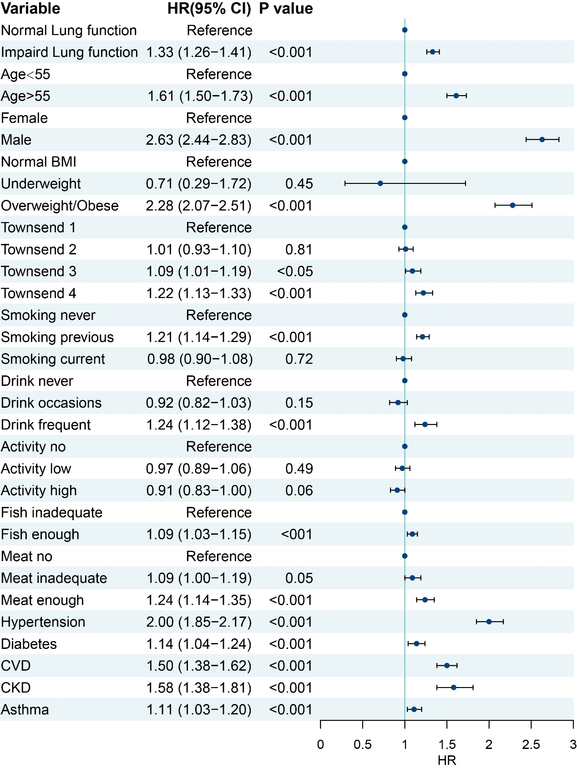
Abbreviations: HR: Hazard ratio; CI: Confidence interval; BMI: Body mass index; CVD: Cardiovascular disease; CKD: Chronic kidney disease.

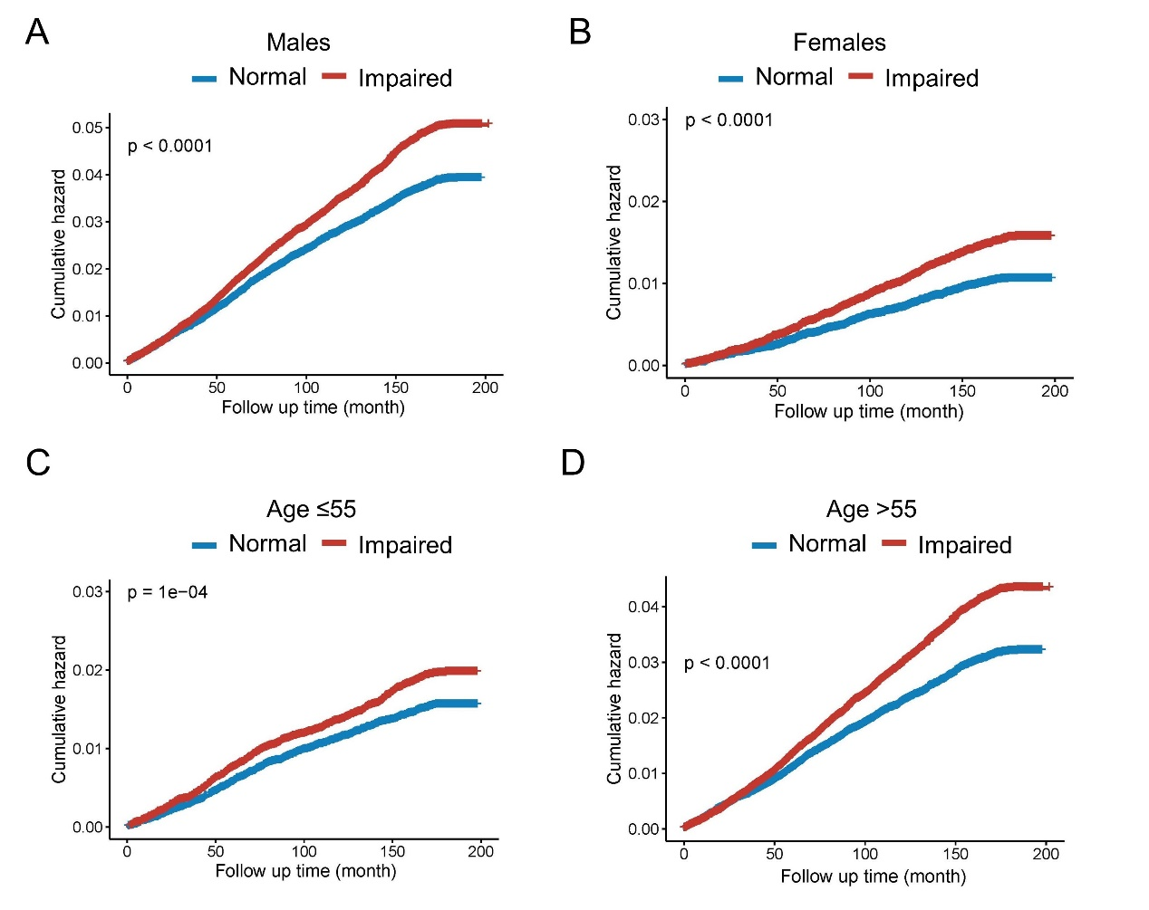
Fig. S2. Kaplan-Meier analysis for risk of gout in males (A), females (B), age≤55 individuals (C) and age≤55 (D) individuals with impaired pulmonary function compared to normal pulmonary function

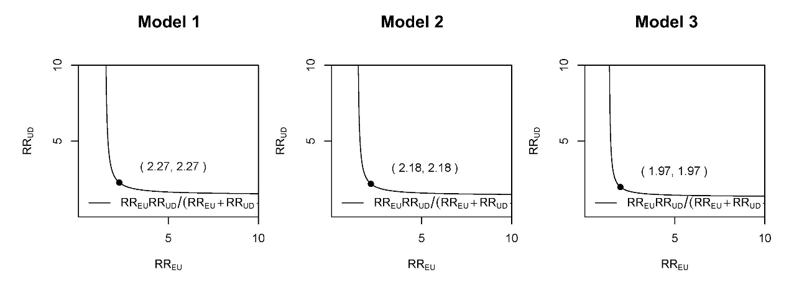
Fig. S3. Sensitivity analysis using E-value estimation for unmeasured confounding
Model 1: adjusted for age, sex, Townsend score, and BMI.
Model 2: adjusted for model 1 plus smoking status, alcohol consumption, physical activity, fish consumption, and meat consumption.
Model 3: adjusted for model 2 plus hypertension, diabetes, CVD, CKD, and asthma.
Abbreviations: BMI: Body mass index; CVD: Cardiovascular disease; CKD: Chronic kidney disease.

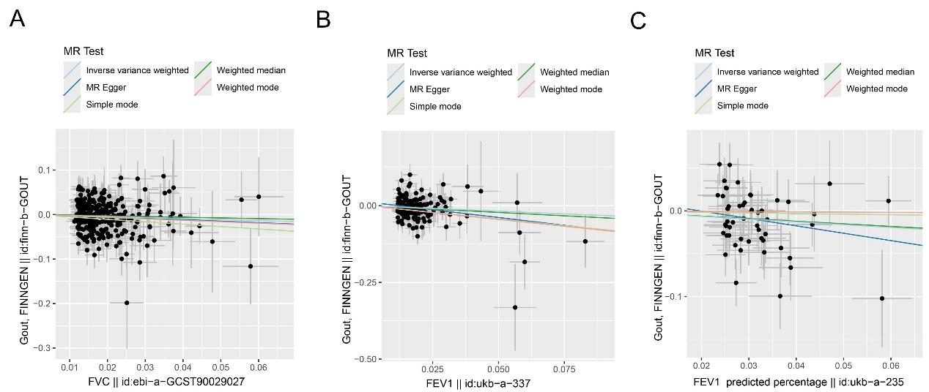
Fig. S4. Scatter plots of genetic associations between lung function indicators and gout. The effects of SNPs on gout are plotted in relation to their effects on FVC (A), FEV1(B) and FEV1 predicted percentage (C). The slope of each line reflects the causal association, with each method yielding a distinct line.
MR: Mendelian Randomization; FVC: Forced vital capacity; FEV1: Forced expiratory volume in 1 Second; SNP: single nucleotide polymorphism.

Fig. S5. Distribution of inflammatory-related and renal function biomarkers pre- and post-imputation

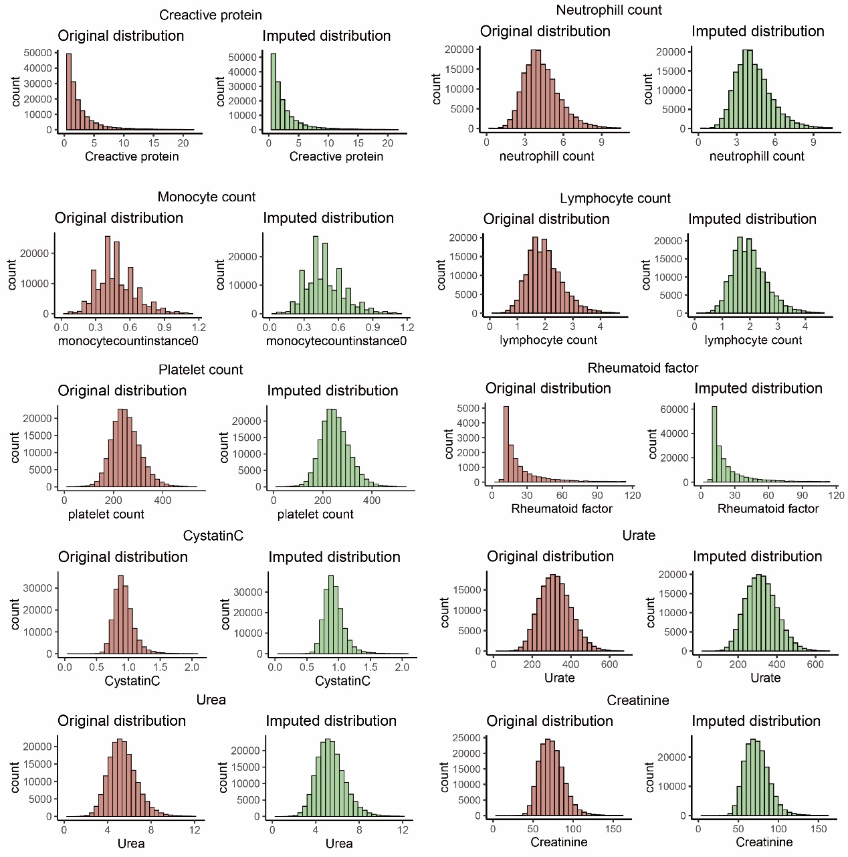

Fig. S6. Distribution of liver function biomarkers pre- and post-imputation
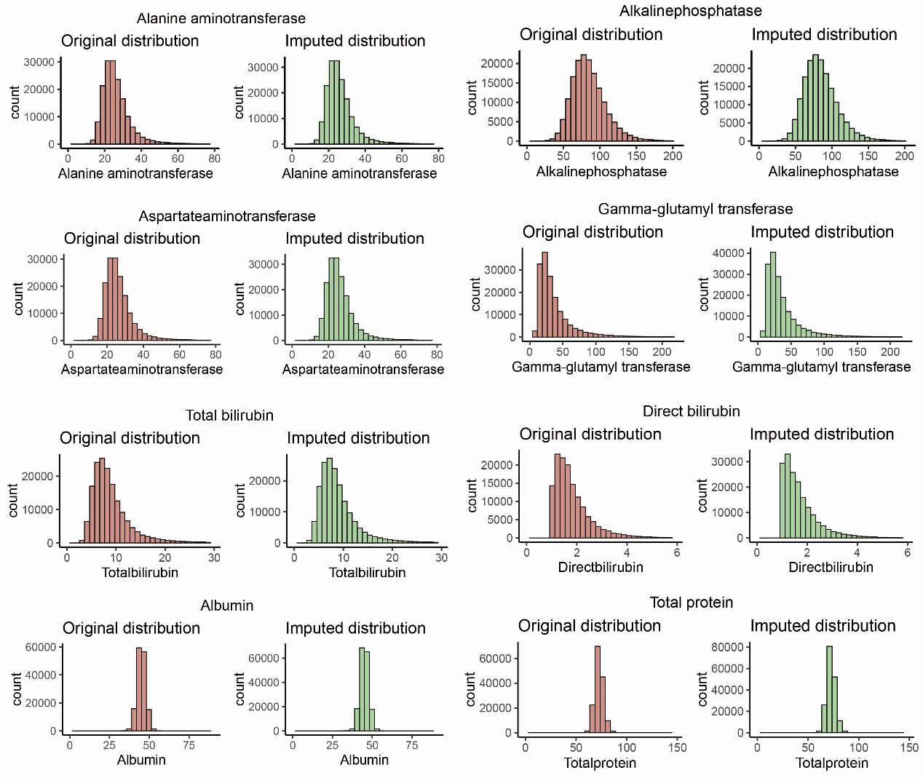

Fig. S7. Distribution of lipids and glucose pre- and post-imputation

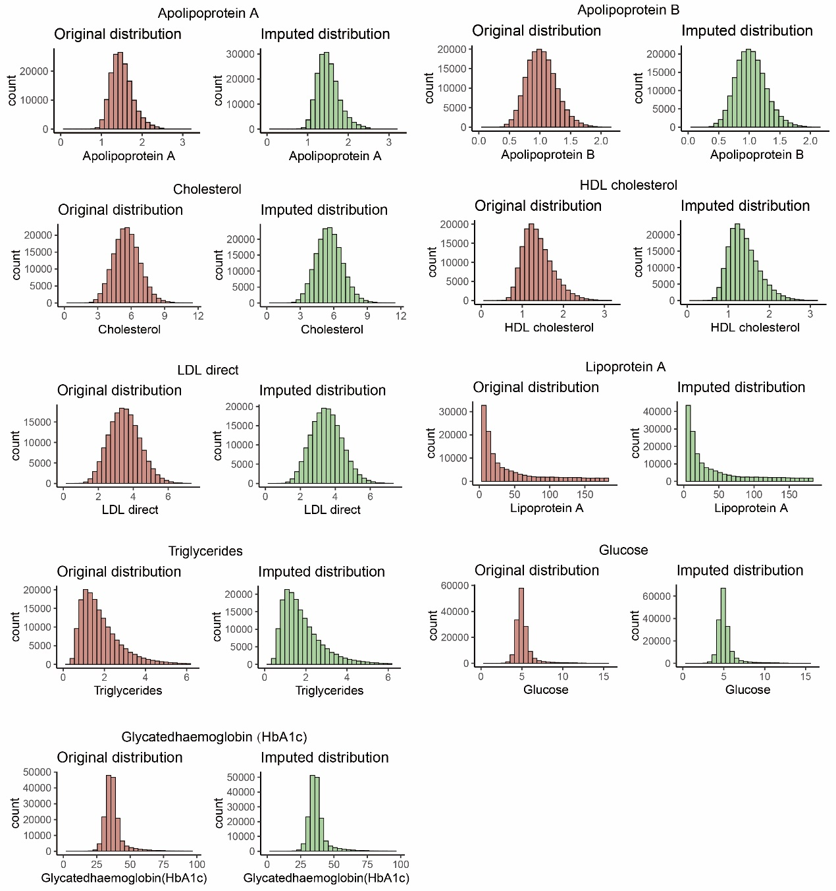
Abbreviations: HDL: High-density lipoprotein; LDL: Low-density lipoprotein.

Fig. S8. Distribution of hormone and mineral metabolism biomarker pre- and post-imputation
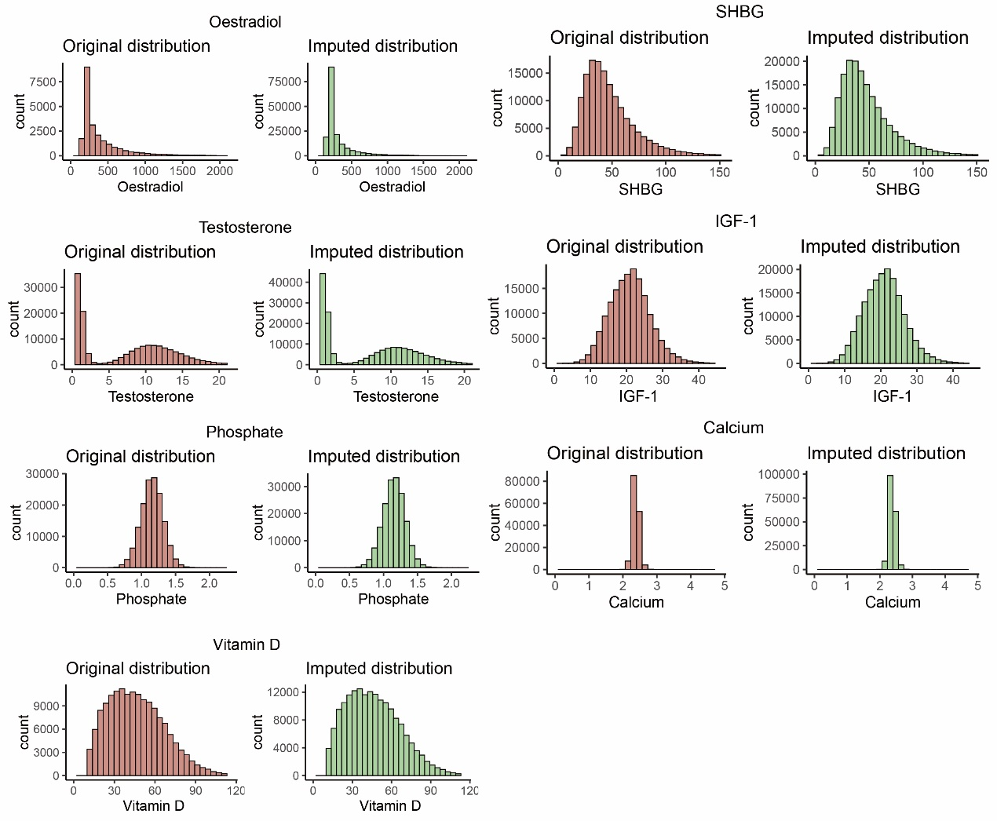

Abbreviations: IGF-1: Insulin-like growth factor 1; SHBG: Sex hormone-binding globulin; FDR: False discovery rate.

