Supplementary figures and tables

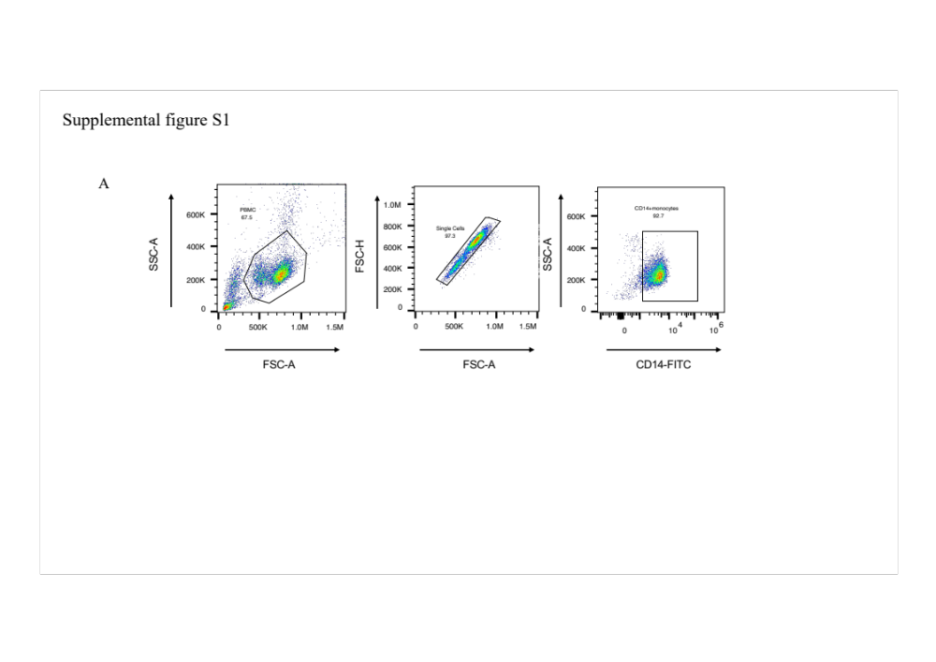
Fig. S1 Purification rate of CD14+ PBMCs.
Gating strategy and purification of CD14+ PBMCs by flow cytometry.

Fig. S2 Cytotoxicity and effects of MTHFD2i on different stages of osteoclastogenesis.
A, B Effects of MTHFD2i on cell viability of CD14+ monocytes and BMMs at different time points (n=4). C Representative images of TRAP staining of BMMs-derived osteoclasts after MTHFD2i intervention in different stages of osteoclastogenesis. Scale bars, 100 μm. Data are expressed as mean ± SD (ns=no significance, by Student’s t-test).

Fig. S3 Expression of MTHFD2 in adenovirus or lentivirus transfected BMMs.
A mRNA and protein levels of MTHFD2 in BMMs transfected with short hairpin RNA expression adenovirus for MTHFD2 knockdown (n=3-4). B Efficiency of MTHFD2 overexpression in BMMs by lentivirus transfection, detected by quantitative polymerase chain reaction and Western blot (n=3-4). Data are shown as mean ± SD (*p<0.05, by Student’s t-test).

Fig. S4 Gene expression profile of RNA-sequencing and Gene Ontology (GO) analysis.
A Principal Component Analysis (PCA) plot of RNA-sequencing (n=4). B Overall gene expression profile of RNA-sequencing (n=4). C 30 most significantly enriched functions in downregulated biological process of GO analysis.

Fig. S5 Mitochondrial respiration, mitochondria morphology and mitochondrial markers expression after MTHFD2 OE or MTHFD2i treatment.
A Mitochondrial function parameters analyzed by extracellular flux assay in OE-MTHFD2 OCPs (n=3). B ATP levels of OE-MTHFD2 OCPs (n=4). C, D Representative images of TEM in OCPs at day 3 and quantitative analysis on mitochondrial perimeter (n=4). Scale bars, 500 nm. E Expression of mitochondrial markers of OCPs stimulated with RANKL for 48h with or without MTHFD2i (n=3). F TRAP staining of PGC1β reintroduction rescue experiment in which PGC1β overexpressed osteoclasts stimulated with DMSO or MTHFD2i (n=3). Scale bars, 100 μm. Data are shown as mean ± SD. (ns=not significant, * = P < 0.05; ** = P < 0.01; *** = P < 0.001, **** = P < 0.0001, by Student’s t-test.)

Fig. S6 mRNA level of autophagy and mitophagy markers in OCPs.
Expression of key molecules associated with autophagy and mitophagy of OCPs stimulated with RANKL for 48h with or without MTHFD2i (n=4). Data are shown as mean ± SD. Analyzed by Student’s t-test.

Fig. S7 MitoSOX staining and NAD/NADH ratio of OCPs treated with DMSO or MTHFD2i.
A, B Mitochondrial reactive oxygen species level of OCPs stimulated with RANKL for 72h with or without MTHFD2i were assessed by laser confocal microscope (A) or flow cytometry (B) (n=3). C Ratio of NAD+/NADH in OCPs stimulated with RANKL for 72h with or without MTHFD2i (n=4). D Addition of β-nicotinamide mononucleotide to rescue osteoclast formation defects caused by MTHFD2i (n=3). Scale bars, 100 μm. Data are shown as mean ± SD (*p<0.05; **p<0.01, by Student’s t-test).

Fig. S8 Expression of CKMT1 after MTHFD2 OE.
CKMT1 protein level of OCPs treated with MTHFD2 overexpression compared to the NC groups (n=3). Data are shown as mean ± SD.

Fig. S9 CIA model establishment and osteoclast-specific markers in MTHFD2 knockdown CIA mice.
A Effectiveness of MTHFD2 silencing confirmed by Western blot (n=3). B Photos of paws from WT or CIA mice. C Weight of CIA mice (n=6). D Bone mineral density (BMD) results of tibia in WT and CIA mice (n=5-6). E Expression of osteoclast marker genes in knee joint cells from MTHFD2-knockdown mice (n=3). Data are shown as mean ± SD (**p<0.01; ***p<0.001, by Student’s t-test).

Table S1: Primers sequences used for Real-Time PCR
Primers for murine Real-Time PCR
Gene name | Forward sequence | Reverse sequence
Mthfd2 | GCGAATGTGCTTGGACCAGTAC | TTTGACCTGCCAGCCACTACCA
Tnfrsf11a | TTGTGGCAGGGGACTTTAAC | ATTGTCATCCTGCCCTCAAC
Nfatc1 | GGTGCCTTTTGCGAGCAGTATC | CGTATGGACCAGAATGTGACGG
Ctsk | ATATGTGGCCAGGATGAAAGTT | TCGTTCCCCACAGGAATCTCT
Acp5 | GGCCGGCCACTACCCCATCT | CACCGTAGCCACAAGCAGGACTCT
Mmp9 | GCTGACTACGATAAGGACGGCA | TAGTGGTGCAGGCAGAGTAGGA
Atp6v0d2 | CAGAGCTGTACTTCAATGTGGAC | AGGTCTCACACTGCACTAGGT
Itgb3 | GTGAGTGCGATGACTTCTCCTG | CAGGTGTCAGTGCGTGTAGTAC
Ckmt1 | TGGCTGGAGATGAGGAGACCTA | CTGGCATCAAGGTCAGTGGTGT
Ckb | ACTTTGGACGACGCCATTCAG | GGTCGGTCTTGTGCTCATCA
Beclin1 | CAGCCTCTGAAACTGGACACGA | CTCTCCTGAGTTAGCCTCTTCC
Lc3b | GTCAGATCGTCTGGCTCGG | TGCAAGCGCCGTCTGATTAT
Atg5 | CTTGCATCAAGTTCAGCTCTTCC | AAGTGAGCCTCAACCGCATCCT
Atg7 | CCTGTGAGCTTGGATCAAAGGC | GAGCAAGGAGACCAGAACAGTG
Pink | CGACAACATCCTTGTGGAGTGG | CATTGCCACCACGCTCTACACT
Parkin | GTGTTTGTCAGGTTCAACTCCA | GAAAATCACACGCAACTGGTC
Drp1 | GCGAACCTTAGAATCTGTGGACC | CAGGCACAAATAAAGCAGGACGG
Fis1 | GCTGGTTCTGTGTCCAAGAGCA | GACATAGTCCCGCTGTTCCTCT
Dnm1l | GCGAACCTTAGAATCTGTGGACC | CAGGCACAAATAAAGCAGGACGG
Mfn1 | CCAGGTACAGATGTCACCACAG | TTGGAGAGCCGCTCATTCACCT
Opa1 | TCTCAGCCTTGCTGTGTCAGAC | TTCCGTCTCTAGGTTAAAGCGCG
Scna | CACTGGCTTTGTCAAGAAGGACC | CATAAGCCTCACTGCCAGGATC
Sqstm1 | GCTCTTCGGAAGTCAGCAAACC | GCAGTTTCCCGACTCCATCTGT
beta actin | TGTCCACCTTCCAGCAGATGT | AGCTCAGTAACAGTCCGCCTAGA
Primers for human Real-Time PCR
Gene name | Forward sequence | Reverse sequence
Mthfd2 | CTCCTTGTTCAGTTGCCTCTTCC | CTGATCCAAACACATTCGTCCTAC
Tnfrsf11a | GCTCAACAAGGACACAGTGTGC | CGCATCGGATTTCTCTGTCCCA
Nfatc1 | CACCAAAGTCCTGGAGATCCCA | TTCTTCCTCCCGATGTCCGTCT
Ctsk | GAGGCTTCTCTTGGTGTCCATAC | TTACTGCGGGAATGAGACAGGG
Acp5 | CATGACCACCTTGGCAATGTCTC | CTGTGGGATCTTGAAGTGCAGG
Mmp9 | GCCACTACTGTGCCTTTGAGTC | CCCTCAGAGAATCGCCAGTACT
Atp6v0d2 | CAGAGCTGTACTTCAATGTGGAC | AGGTCTCACACTGCACTAGGT
Itgb3 | CATGGATTCCAGCAATGTCCTCC | TTGAGGCAGGTGGCATTGAAGG
beta actin | CATGGATTCCAGCAATGTCCTCC | TTGAGGCAGGTGGCATTGAAGG

