Additional file 2
Single-round performance of colorectal cancer screening programs: A network meta-analysis of randomized clinical trials
Authors
Teruhiko Terasawa, Toshihiro Tadano, Koichiro Abe, Seiju Sasaki, Satoyo Hosono, Takafumi Katayama, Keika Hoshi, Tomio Nakayama, Chisato Hamashima

Supplementary Methods 4
Literature searches 4
Eligibility criteria and study selection 17
Data collection process and data items 18
Geometry of the network 19
Risk of bias within individual studies 19
Correction of events and effective sample sizes for cluster-randomized clinical trials 19
Model fitting and prior distributions 19
Supplementary Tables 21
Table S1. Exclusion criteria and histological definitions of neoplastic outcomes. 21
Table S2. Screening test and adherence characteristics. 25
Table S3. Test characteristics of flexible sigmoidoscopy, computed tomography colonography, and total colonoscopy 28
Table S4. Network table for screening participation. 36
Table S5. Ranking analysis of screening participation. 36
Table S6. Network table for advanced neoplasia detection in the intention-to-screen analysis. 36
Table S7. Ranking analysis of advanced neoplasia detection in the intention-to-screen analysis. 37
Table S8. Network table for advanced neoplasia detection in the per-protocol analysis. 37
Table S9. Ranking analysis of advanced neoplasia detection in the per-protocol analysis. 38
Table S10. Network table for colorectal cancer detection in the intention-to-screen analysis. 38
Table S11. Ranking analysis of colorectal cancer detection in the intention-to-screen analysis. 39
Table S12. Network table for colorectal cancer detection in the per-protocol analysis. 39
Table S13. Ranking analysis of colorectal cancer detection in the per-protocol analysis. 39
Table S14. Meta-analysis of subgroup interactions for screening participation.ª 41
Table S15. Meta-analysis of subgroup interactions for advanced neoplasia detection in the intention-to-screen analysis.ª 43
Table S16. Meta-analysis of subgroup interactions for colorectal cancer detection in the intention-to-screen analysis.ª 44
Table S17. Meta-analysis of subgroup interactions for advanced neoplasia detection in the per-protocol analysis.ª 46
Table S18. Meta-analysis of subgroup interactions for colorectal cancer detection in the per-protocol analysis.ª 48
Table S19. Subgroup and sensitivity analysis results. 50
Table S20. Network meta-analysis of participation that subcategorized the FOB-based method programs by kit delivery methods. 52
Table S21. Randomized clinical trials that allowed crossover to different modalities. 53
Table S22. Previous systematic reviews of RCTs that evaluated direct evidence on program-level outcomes.* 54
Supplementary Figures 56
Figure S1. Geometry of the network of included randomized clinical trials. 56
Figure S2. The risk of bias assessment of studies that evaluated screening participation in all screening invitees. 57
Figure S3. The risk of bias assessment of studies that evaluated the intention-to-screen effect of the detection of advanced neoplasia, colorectal cancer, or both in all screening invitees. 58
Figure S4. The risk of bias assessment of studies that evaluated the per-protocol effect of the detection of advanced neoplasia, colorectal cancer, or both in screening participants only. 59
Figure S5. Forest plot of individual study results included in the network meta-analysis of screening participation. 60
Figure S6. SUCRA plot and Litmus Rank-O-Gram of network meta-analysis of screening participation. 61
Figure S7. Forest plot of individual study results included in the network meta-analysis of advanced neoplasia detection for evaluating the intention-to-screen effect. 62
Figure S8. SUCRA plot and Litmus Rank-O-Gram of network meta-analysis of advanced neoplasia detection for evaluating the intention-to-screen effect. 63
Figure S9. Forest plot of individual study results included in the network meta-analysis of advanced neoplasia detection for evaluating the per-protocol effect. 64
Figure S10. Network meta-analysis of advanced neoplasia detection for evaluating the per-protocol effect. 65
Figure S11. SUCRA plot and Litmus Rank-O-Gram of network meta-analysis of advanced neoplasia detection for evaluating the per-protocol effect. 66
Figure S12. Forest plot of individual study results included in the network meta-analysis of colorectal cancer detection for evaluating the intention-to-screen analysis. 67
Figure S13. SUCRA plot and Litmus Rank-O-Gram of network meta-analysis of colorectal cancer detection for evaluating the intention-to-screen effect. 68
Figure S14. Forest plot of individual study results included in the network meta-analysis of colorectal cancer detection for evaluating the per-protocol effect. 69
Figure S15. Network meta-analysis of colorectal cancer detection for evaluating the per-protocol effect. 70
Figure S16. SUCRA plot and Litmus Rank-O-Gram of network meta-analysis of colorectal cancer detection for evaluating the per-protocol effect. 71
Figure S17. Meta-analysis of screening positivity. 72
Figure S18. Meta-analysis of PPV. 73
Figure S19. The risk of bias assessment of randomized clinical trials that allowed crossover. 74
List of Excluded Study Reports (n = 33) 75
RCT reports reporting on screening participation or completion only (n = 8) 75
Relevant but duplicate RCT reports (n = 5) 75
RCT reports reporting on the cumulative number of target regions after multiround screening (n = 5) 75
RCTs comparing screening with a guaiac fecal occult blood test (gFOBT) alone with screening with a strategy using combined gFOBT and sigmoidoscopy (n = 3) 75
RCT reports reporting on the reduction of colorectal cancer incidence or mortality (n = 3) 76
RCT reports from which the data based on both intension-to-screen and per-protocol effects could not be extracted (n = 3) 76
RCT reports reporting on irrelevant outcomes (n = 2) 76
Conference abstracts (n = 2) 76
RCT not using total colonoscopy as the confirmatory test for the target legions (n = 1) 76
RCT reports reporting on irrelevant comparisons (n = 1) 76

Supplementary Methods

Literature searches

Ovid MEDLINE and Cochrane Central Register of Controlled Trials

Original search
1 exp Colorectal Neoplasms/
2 exp Rectal Neoplasms/
3 exp Colonic Neoplasms/
4 exp sigmoid neoplasms/
5 (colorectal* or colon* or bowel* or rectal or rectum or sigmoid or intestinal or intestine).mp.
6 (cancer* or neoplasm* or neoplasia or tumor* or tumour* or carcinoma* or adenocarcinom* or adeno?carcinom* or
adenom* or adenomat* or lesion* or polyps or polyp).mp.
7 5 and 6
8 CRC.mp.
9 1 or 2 or 3 or 4 or 7 or 8
10 Occult Blood/
11 occult blood.ti,ab.
12 ((fecal or faecal or stool or feces) and occult).ti,ab.
13 (fobt or ifobt or gfobt or i-fobt or g-fobt or fit).ti,ab.
14 guaiac.ti,ab.
15 ((fecal or faecal or stool or feces) adj5 test*).ti,ab.
16 ((fecal or faecal or stool or feces) and immuno*).ti,ab.
17 (colonoscopy or colonoscopies).mp.
18 colorectal endoscop*.ti,ab.
19 Colonoscopy/
20 TCS.mp.
21 FS.mp.
22 sigmoidoscopy/ or sigmoidoscopy.mp. or sigmoidoscopies.mp.
23 exp "Colonography, Computed Tomographic"/
24 (colonography and computed and tomographic).mp.
25 computed tomographic colonography.mp.
26 (ct and colonography).mp.
27 CTC.mp.
28 10 or 11 or 12 or 13 or 14 or 15 or 16 or 17 or 18 or 19 or 20 or 21 or 22 or 23 or 24 or 25 or 26 or 27
29 10 or 11 or 12 or 13 or 14 or 15 or 16 or 17 or 18 or 19 or 20 or 21 or 22
30 exp Mass Screening/
31 exp "Early Detection of Cancer"/
32 exp Population Surveillance/
33 (screen* or detect* or test*).ti,ab.
34 (early adj3 prevent*).ti,ab.
35 (surveillance or survey*).ti,ab.
36 30 or 31 or 32 or 33 or 34 or 35
37 9 and 28 and 36
38 9 and 29 and 36
39 randomized controlled trial.pt.
40 controlled clinical trial.pt.
41 randomized.ti,ab.
42 randomised.ti,ab.
43 blind*.ab.
44 mask*.ab.
45 clinical trial.sh.
46 randomly.ab.
47 trial*.ti,ab.
48 allocate*.ab.
49 allocation*.ab.
50 RCT*.ti,ab.
51 39 or 40 or 41 or 42 or 43 or 44 or 45 or 46 or 47 or 48 or 49 or 50
52 37 and 51
53 38 and 51
54 limit 52 to animals [Limit not valid in CCTR; records were retained]
55 limit 52 to humans [Limit not valid in CCTR; records were retained]
56 54 not 55
57 52 not 56

Update search
1 exp Colorectal Neoplasms/
2 exp Rectal Neoplasms/
3 exp Colonic Neoplasms/
4 exp sigmoid neoplasms/
5 (colorectal* or colon* or bowel* or rectal or rectum or sigmoid or intestinal or intestine).mp.
6 (cancer* or neoplasm* or neoplasia or tumor* or tumour* or carcinoma* or adenocarcinom* or adeno?carcinom* or adenom* or adenomat* or lesion* or polyps or polyp).mp.
7 5 and 6
8 CRC.mp.
9 1 or 2 or 3 or 4 or 7 or 8
10 Occult Blood/
11 occult blood.ti,ab.
12 ((fecal or faecal or stool or feces) and occult).ti,ab.
13 (fobt or ifobt or gfobt or i-fobt or g-fobt or fit).ti,ab.
14 guaiac.ti,ab.
15 ((fecal or faecal or stool or feces) adj5 test*).ti,ab.
16 ((fecal or faecal or stool or feces) and immuno*).ti,ab.
17 (colonoscopy or colonoscopies).mp.
18 colorectal endoscop*.ti,ab.
19 Colonoscopy/
20 TCS.mp.
21 FS.mp.
22 sigmoidoscopy/ or sigmoidoscopy.mp. or sigmoidoscopies.mp.
23 exp "Colonography, Computed Tomographic"/
24 (colonography and computed and tomographic).mp.
25 computed tomographic colonography.mp.
26 (ct and colonography).mp.
27 CTC.mp.
28 10 or 11 or 12 or 13 or 14 or 15 or 16 or 17 or 18 or 19 or 20 or 21 or 22 or 23 or 24 or 25 or 26 or 27
29 exp Mass Screening/ (154426)
30 exp "Early Detection of Cancer"/
31 exp Population Surveillance/
32 (screen* or detect* or test*).ti,ab.
33 (early adj3 prevent*).ti,ab.
34 (surveillance or survey*).ti,ab.
35 29 or 30 or 31 or 32 or 33 or 34
36 randomized controlled trial.pt.
37 controlled clinical trial.pt.
38 randomized.ti,ab.
39 randomised.ti,ab.
40 blind*.ab.
41 mask*.ab.
42 clinical trial.sh.
43 randomly.ab.
44 trial*.ti,ab.
45 allocate*.ab.
46 allocation*.ab.
47 RCT*.ti,ab.
48 36 or 37 or 38 or 39 or 40 or 41 or 42 or 43 or 44 or 45 or 46 or 47
49 9 and 28 and 35 and 48
50 limit 49 to animals [Limit not valid in CCTR; records were retained]
51 limit 49 to humans [Limit not valid in CCTR; records were retained]
52 50 not 51
53 49 not 52
54 limit 53 to english language
55 limit 54 to yr="2023 -Current"
56 remove duplicates from 55

EMBASE

Original search
#1 'colorectal cancer'/exp
#2 'colorectal tumor'/exp
#3 'colorectal carcinoma'/exp
#4 'colorectal adenoma'/exp
#5 'colon carcinoma'/exp
#6 'colon cancer'/exp
#7 'colon adenoma'/exp
#8 'colon adenocarcinoma'/exp
#9 'colon tumor'/exp
#10 'rectum cancer'/exp
#11 'rectum tumor'/exp
#12 'rectum carcinoma'/exp
#13 'rectum adenoma'/exp
#14 colorectal* OR crc OR colon OR colonic OR bowel* OR intestine OR rectal OR rectum OR sigmoid OR anal OR anus
#15 cancer OR neoplasm* OR malign* OR tumor* OR tumour* OR carcinom* OR adenocarcinom* OR adeno?carcinom* OR adenom* OR lesion*
#16 #14 AND #15
#17 #1 OR #2 OR #3 OR #4 OR #5 OR #6 OR #7 OR #8 OR #9 OR #10 OR #11 OR #12 OR #13 OR #16
#18 'mass screening'/exp
#19 'early cancer diagnosis'/exp
#20 'health survey'/exp
#21 (early NEAR/3 prevent*):ti,ab
#22 (population* NEAR/2 surveillance):ti,ab
#23 screen*:ti,ab OR detect*:ti,ab OR test*:ti,ab
#24 #18 OR #19 OR #20 OR #21 OR #22 OR #23
#25 'occult blood'/exp OR 'occult blood' 20,195
#26 'feces analysis'/exp 62,012
#27 'immunochemistry'/exp 1,188,271
#28 (faecal:ab,ti OR fecal:ab,ti OR feces:ab,ti OR faeces:ab,ti OR stool:ab,ti) AND occult*:ab,ti 8,904
#29 fobt:ab,ti OR ifobt:ab,ti OR gfobt:ab,ti OR 'i fobt':ab,ti OR 'g fobt':ab,ti OR fob:ab,ti OR fit:ab,ti 213,876
#30 guaiac:ab,ti 1,443
#31 (faecal:ab,ti OR fecal:ab,ti OR feces:ab,ti OR faeces:ab,ti OR stool:ab,ti) AND immuno*:ab,ti 31,427
#32 immunochemical*:ab,ti AND (test*:ab,ti OR screen*:ab,ti OR diagn*:ab,ti OR detect*:ab,ti) 12,990
#33 immunologic*:ab,ti AND (test*:ab,ti OR screen*:ab,ti OR diagn*:ab,ti OR detect*:ab,ti) 113,247
#34 colonoscopy:ti,ab OR colonoscopies:ti,ab
#35 'colonoscopy'/exp
#36 tcs:ti,ab
#37 'sigmoidoscopy'/exp OR sigmoidoscopy:ti,ab
#38 sigmoidoscopies:ti,ab
#39 'colonography, computed tomographic'/exp
#40 colonography:ti,ab
#41 ctc:ti,ab
#42 #25 OR #26 OR #27 OR #28 OR #29 OR #30 OR #31 OR #32 OR #33 OR #34 OR #35 OR #36 OR #37 OR #38 OR #39 OR #40 OR #41
#43 'controlled clinical trial'/de OR 'randomized controlled trial'/de
#44 'double blind procedure'/exp OR 'double blind procedure'
#45 'single-blind procedure'/exp OR 'single-blind procedure'
#46 random*
#47 blind*
#48 assign*
#49 allocat*
#50 mask*
#51 randomized:ti,ab
#52 randomised:ti,ab
#53 trial:ti
#54 #43 OR #44 OR #45 OR #46 OR #47 OR #48 OR #49 OR #50 OR #51 OR #52 OR #53
#55 #17 AND #24 AND #42 AND #54
#56 #55 AND [humans]/lim
#57 #55 AND [animals]/lim
#58 #57 NOT #56
#59 #55 NOT #58
#60 #59 AND ('conference abstract'/it OR 'conference paper'/it OR 'conference review'/it)
#61 #59 NOT #60

Update search
#1 'colorectal cancer'/exp
#2 'colorectal tumor'/exp
#3 'colorectal carcinoma'/exp
#4 'colorectal adenoma'/exp
#5 'colon carcinoma'/exp
#6 'colon cancer'/exp
#7 'colon adenoma'/exp
#8 'colon adenocarcinoma'/exp
#9 'colon tumor'/exp
#10 'rectum cancer'/exp
#11 'rectum tumor'/exp
#12 'rectum carcinoma'/exp
#13 'rectum adenoma'/exp
#14 colorectal* OR crc OR colon OR colonic OR bowel* OR intestine OR rectal OR rectum OR sigmoid
#15 cancer OR neoplasm* OR malign* OR tumor* OR tumour* OR carcinom* OR adenocarcinom* OR adeno?carcinom* OR adenom* OR lesion*
#16 #14 AND #15
#17 crc:ti,ab
#18 #1 OR #2 OR #3 OR #4 OR #5 OR #6 OR #7 OR #8 OR #9 OR #10 OR #11 OR #12 OR #13 OR #16 OR #17
#19 'occult blood'/exp OR 'occult blood'
#20 'feces analysis'/exp
#21 'immunochemistry'/exp
#22 (faecal:ab,ti OR fecal:ab,ti OR feces:ab,ti OR faeces:ab,ti OR stool:ab,ti) AND occult*:ab,ti
#23 fobt:ab,ti OR ifobt:ab,ti OR gfobt:ab,ti OR 'i fobt':ab,ti OR 'g fobt':ab,ti OR fob:ab,ti OR fit:ab,ti
#24 guaiac:ab,ti
#25 (faecal:ab,ti OR fecal:ab,ti OR feces:ab,ti OR faeces:ab,ti OR stool:ab,ti) AND immuno*:ab,ti
#26 immunochemical*:ab,ti AND (test*:ab,ti OR screen*:ab,ti OR diagn*:ab,ti OR detect*:ab,ti)
#27 immunologic*:ab,ti AND (test*:ab,ti OR screen*:ab,ti OR diagn*:ab,ti OR detect*:ab,ti)
#28 colonoscopy:ti,ab OR colonoscopies:ti,ab
#29 'colonoscopy'/exp
#30 tcs:ti,ab OR fs:ti,ab
#31 'sigmoidoscopy'/exp OR sigmoidoscopy:ti,ab
#32 sigmoidoscopies:ti,ab
#33 'colonography, computed tomographic'/exp
#34 colonography:ti,ab
#35 ctc:ti,ab
#36 #19 OR #20 OR #21 OR #22 OR #23 OR #24 OR #25 OR #26 OR #27 OR #28 OR #29 OR #30 OR #31 OR #32 OR #33 OR #34 OR #35
#37 'mass screening'/exp
#38 'early cancer diagnosis'/exp
#39 'health survey'/exp
#40 (early NEAR/3 prevent*):ti,ab
#41 (population* NEAR/2 surveillance):ti,ab
#42 screen*:ti,ab OR detect*:ti,ab OR test*:ti,ab
#43 #37 OR #38 OR #39 OR #40 OR #41 OR #42
#44 'controlled clinical trial'/de OR 'randomized controlled trial'/de
#45 'double blind procedure'/exp OR 'double-blind procedure'/exp OR 'double blind*' OR 'double -blind*'
#46 'single blind procedure'/exp OR 'single-blind procedure'/exp OR 'single-blind*' OR 'single blind*'
#47 random*
#48 blind*
#49 assign*
#50 allocat*
#51 mask*
#52 randomized:ti,ab
#53 randomised:ti,ab
#54 trial*:ti
#55 #44 OR #45 OR #46 OR #47 OR #48 OR #49 OR #50 OR #51 OR #52 OR #53 OR #54
#56 #18 AND #36 AND #43 AND #55
#57 #56 AND [humans]/lim
#58 #56 AND [animals]/lim
#59 #58 NOT #57
#60 #56 NOT #59
#61 #60 AND ('conference abstract'/it OR 'conference paper'/it OR 'conference review'/it)
#62 #60 NOT #61
#63 #62 AND [embase]/lim
#64 #62 AND [medline]/lim
#65 #63 NOT #64
#66 #65 AND (2023:py OR 2024:py OR 2025:py)

Ichushi-Web (original and update search)

#1 大腸/TH or 大腸/AL
#2 結腸/TH or 結腸/AL
#3 直腸/TH or 直腸/AL
#4 盲腸/TH or 盲腸/AL
#5 肛門部/TH or 肛門/AL
#6 虫垂/TH or 虫垂/AL
#7 colorectal/AL
#8 colon/AL
#9 rectum/AL
#10 colonic/AL
#11 腸/TH or bowel/AL or intestine/AL or intestinal/AL
#12 rectal/AL or rectum/AL
#13 (S状結腸/TH or sigmoid/AL)
#14 #1 or #2 or #3 or #4 or #5 or #6 or #7 or #8 or #9 or #10 or #11 or #12 or #13
#15 neoplasms/AL
#16 malignant/AL
#17 tumor/AL
#18 tumour/AL
#19 (癌腫/TH or carcinoma/AL)
#20 (腺腫/TH or adenoma/AL)
#21 (肉腫/TH or sarcoma/AL)
#22 (腺癌/TH or adenocarcinoma/AL)
#23 新生物/AL
#24 (腫瘍侵入性/TH or 浸潤がん/AL)
#25 (腫瘍侵入性/TH or 浸潤癌/AL)
#26 (腫瘍侵入性/TH or 浸潤ガン/AL)
#27 (腫瘍/TH or 進行がん/AL)
#28 (腫瘍/TH or 進行癌/AL)
#29 (腫瘍/TH or 進行ガン/AL)
#30 (疾患/TH or lesion/AL)
#31 #15 or #16 or #17 or #18 or #19 or #20 or #21 or #22 or #23 or #24 or #25 or #26 or #27 or #28 or #29 or #30
#32 #14 and #31
#33 crc/AL
#34 (大腸腫瘍/TH or 大腸がん/AL)
#35 (大腸腫瘍/TH or 大腸癌/AL)
#36 (大腸腫瘍/TH or 大腸ガン/AL)
#37 大腸腫瘍/AL
#38 #32 or #33 or #34 or #35 or #36 or #37
#39 (集団検診/TH or 検診/AL)
#40 (診断サービス/TH or 健診/AL)
#41 診断サービス/AL
#42 スクリーニング/AL
#43 健康診査/AL
#44 集検/AL
#45 健康診断/AL
#46 "Mass Health Examination"/AL
#47 ふるい分け検査/AL
#48 検査/AL
#49 screen/AL or detect/AL or test/AL or surveillance/AL
#50 (人間ドック/TH or ドック/AL)
#51 (健康調査/TH or "health survey"/AL)
#52 (早期診断/TH or 早期診断/AL)
#53 早期発見/AL
#54 #39 or #40 or #41 or #42 or #43 or #44 or #45 or #46 or #47 or #48 or #49 or #50 or #51 or #52 or #53
#55 (糞便/TH or 便/AL)
#56 occult/AL
#57 (血液/TH or blood/AL)
#58 (潜血反応/TH or 潜血/AL)
#59 faecal/AL
#60 fecal/AL
#61 feces/AL
#62 faeces/AL
#63 FOB/AL
#64 FIT/AL
#65 (潜血反応/TH or 便潜血/AL)
#66 免疫法/AL
#67 化学法/AL
#68 chemical/AL
#69 immuno/AL
#70 (内視鏡/TH or 内視鏡/AL)
#71 カメラ/AL
#72 (大腸内視鏡法/TH or colonoscopy/AL)
#73 (大腸内視鏡/TH or colonoscope/AL)
#74 (S状結腸内視鏡/TH or S状結腸鏡/AL)
#75 (S状結腸内視鏡/TH or S状結腸鏡/AL or 結腸内視鏡/AL)
#76 (S状結腸内視鏡法/TH or シグモイドスコピー/AL)
#77 sigmoidoscopy/AL or FS/AL
#78 (X線CT/TH or CT/AL)
#79 Computed/AL and (断層撮影/TH or Tomography/AL)
#80 Computed/AL and Tomogram/AL
#81 computed/AL and tomographic/AL
#82 #78 or #79 or #80 or #81
#83 colonography/AL
#84 #82 and #83
#85 コロノグラフィー/AL
#86 3DCT/AL
#87 3D-CT/AL
#88 (CTコロノグラフィー/TH or CTC/AL)
#89 #55 or #56 or #57 or #58 or #59 or #60 or #61 or #62 or #63 or #64 or #65 or #66 or #67 or #68 or #69 or #70 or #71 or #72 or #73 or #74 or #75 or #76 or #77 or #84 or #85 or #86 or #87 or #88
#90 ランダム/AL
#91 (ランダム化比較試験/TH or RCT/AL)
#92 無作為/AL
#93 (ランダム化比較試験/TH or ランダム化比較試験/AL)
#94 (準ランダム化比較試験/TH or 準ランダム化比較試験/AL)
#95 比較研究/AL
#96 割付/AL
#97 割り付け/AL
#98 割りつけ/AL
#99 randomized/AL
#100 randomised/AL
#101 randomly/AL
#102 controlled/AL
#103 trial/AL
#104 試験/AL
#105 盲検/AL
#106 ブラインド/AL
#107 masking/AL
#108 マスク/AL or マスキング/AL
#109 #90 or #91 or #92 or #93 or #94 or #95 or #96 or #97 or #98 or #99 or #100 or #101 or #102 or #103 or #104 or #105 or #106 or #107 or #108
#110 #38 and #54 and #89 and #109
#111 (#38 and #54 and #89) and (RD = ランダム化比較試験,準ランダム化比較試験,比較研究)
#112 #110 or #111

Eligibility criteria and study selection
Paired reviewers from seven investigators (TTe, TTa, KA, SS, SH, TK, and CH) independently double-screened nonoverlapping sets of abstracts. Four reviewers in pairs (TTe, TTa, KA, and SS) independently determined the eligibility of potential full-text articles screened by at least one reviewer, with discrepancies adjudicated by discussion among all authors. Eligible randomized clinical trials (RCTs) compared screening programs using guaiac-based or immunochemical fecal occult blood testing (gFOBT or FIT, respectively), flexible sigmoidoscopy (FS), computed tomography colonography (CTC), or total colonoscopy (TCS) aimed at detecting advanced adenomas and invasive cancers in healthy standard-risk adults. We included RCTs with any designs irrespective of the unit of randomization (i.e., individual vs cluster), the number of compared screening program groups, or crossover to alternative screening programs.
We included RCTs that compared screening programs based on a single primary screening test (followed by TCS as the post-triage diagnostic test for positive results) or upfront primary screening with TCS. We excluded RCTs that evaluated screening programs based on sequential testing (e.g., gFOBT triage followed by FIT), screening programs based on parallel testing with two primary screening modalities (e.g., primary screening with combined gFOBT and FS) before diagnostic TCS, or risk-adapted screening programs based on the application of a risk prediction score and risk-based selection of screening tests (e.g., TCS for those with high risk and FIT for those with low risk). When these ineligible screening programs were additionally compared with eligible single-modality screening programs in an RCT, we included the RCT but excluded the ineligible screening programs.

Data collection process and data items
One reviewer from four investigators (TTe, TTa, KA, and SS) extracted descriptive data, which was confirmed by another reviewer. Collected descriptive data included study identification (first author and publication year), sample size, inclusion and/or exclusion criteria, study locations, study years, and unit of randomization as study characteristics; target age, mean or median age, and the percentage of males as participant characteristics; details on screening tests, number of participants assigned to a particular screening program with its uptake rates, completion rates, positivity rates, and adherence rates for total colonoscopy, and definitions of neoplastic outcomes as intervention characteristics; kit names and cutoff values for gFOBT and FIT, and device names, number and experience of examiners, navigation systems, bowel preparation methods, use of sedation or analgesia, positivity criteria for FS, CTC, and TCS as test characteristics.
Quantitative outcome data extracted included the number of eligible invitees, individuals who participated in the intended screening, those with a positive screening, those who completed diagnostic TCS, individuals with ≥1 detected advanced neoplasia (AN), and those with detected colorectal cancer (CRC).
We sent two emails at least two weeks apart to corresponding authors of RCTs that may have collected pertinent quantitative outcome data but did not report this in the publications. We considered all the requests rejected since no authors responded. Therefore, no potentially eligible RCTs were salvaged by contacting the corresponding authors.

Geometry of the network
The Stata “network map” command was utilized to construct standard network graphs of the comparative evidence considering screening interventions as nodes and their direct linking contrast as edges [26].

Risk of bias within individual studies
Paired independent reviewers from seven investigators (TTe, TTa, KA, SS, SH, TK, and CH) double-rated the risk of bias using the revised Risk of Bias tool following the proposed guidance [24]. Operationally, a study was rated as having a low risk of bias in the domain assessing the risk of bias due to missing outcome data only when the screen-positive samples had been histologically verified in all invitees or results were statistically corrected for the potential for bias caused by missing outcome data. Any discrepancies were resolved by discussion among all authors.

Correction of events and effective sample sizes for cluster-randomized clinical trials
For cluster-RCTs, the variance of an effect estimate was increased conventionally with the design effect C (i.e., so-called the C adjustment), using the average cluster size (M) and intraclass correlation coefficient (ICC) of the trial, which is defined as C = (M − 1) × ICC [33]. The C adjustment is a recommended approach to appropriately reduce the number of events and effective sample sizes when incorporating cluster-RCTs in a network meta-analysis [32]. In the main analysis, we used two ICCs, 0.008333 for fecal occult blood-based screening modalities (i.e., gFOBT and FIT) and 0.000654 for visualization screening modalities (i.e., FS, CTC, and TCS). These ICCs were reported from an Italian cluster-RCT comparing a gFOBT-based program with an FS-based program that explicitly reported the C values on screening participation rates, which were the only available values for the correction. We used the same C values on the detection rates of AN and CRC since empirical evidence was unavailable for C values on the outcomes of CRC screening other than participation [35-37]. In sensitivity analyses, we used a C value of 0.05 for any programs regardless of screening devices and outcomes.

Model fitting and prior distributions
A conventional, non-informative, normal prior distribution, specifically N(0, 1000), was specified for all outcome measures, including the log-transformed relative effect parameters, baseline effects, probit-transformed proportions, and log-transformed treatment-covariate interactions. We used a uniform prior with an upper limit of 𝑢, that is, U(0, 𝑢) for the between-study heterogeneity standard deviation (tau) for network meta-analysis, where the maximum value of the random effects for the relative effect of all possible treatment contrasts, estimated using maximum likelihood estimation, was selected as the 𝑢 [30]. For the tau for meta-analysis of proportions and meta-analysis of interactions, a weakly informative, half-normal prior HN(0, 0,5) was applied [39]. For all meta-analysis models, we based the results on four different chains and 25,000 iterations (a total of 100,000 iterations) after 5000 (a total of 20,000) burn-in iterations. We evaluated model convergence based on the Brooks–Gelman–Rubin statistic and deemed a model to be converged when the value stabilized to <1.01 [38].

Supplementary Tables

Table S1. Exclusion criteria and histological definitions of neoplastic outcomes.
Author and year | Exclusion criteria | Advanced adenoma | Colorectal cancer
Studies not allowing crossover or other screening tests
Verne 1998 [49] | Previous diagnosis of colorectal neoplasia, investigation of the colon and rectum <2 years, and physical or mental disease contraindicating screening | ≥1 adenoma was >1 cm, villous, or tubulovillous or features of severe dysplasia | ND
Federici 2005 [50] | ND | “high-grade adenoma” | “cancer”
Segnan 2005 [51] | Unable to give informed consent, diagnosis with a terminal illness or IBD, history of polyps or CRC or two first-degree relatives with CRC, or colorectal endoscopy or FOBT <2 years | Adenoma ≥10 mm, HGD (including intramucosal carcinoma or carcinoma in situ), or a villous component of >20% | Invasion of malignant cells beyond the muscularis mucosae
Federici 2006 [52] | ND | “high-grade adenoma” | “cancer”
Segnan 2007 [53] | Unable to give informed consent, diagnosis with a terminal illness or IBD, history of polyps or CRC or two first-degree relatives with CRC, or colorectal endoscopy or FOBT <2 years | Adenoma ≥10 mm, HGD (including intramucosal carcinoma or carcinoma in situ), or a villous component of >20% | Invasion of malignant cells beyond the muscularis mucosae
van Rossum 2008 [54] | Institutionalized and symptomatic people | Adenoma ≥10 mm, with HGD or with a villous component ≥20%. | ND
Lisi 2009 [55] | Unable to give informed consent, history of colorectal neoplasia or IBD or two or more first-degree relatives with CRC, screening colonoscopy, flexible sigmoidoscopy or barium enema <10 years or screening FOBT <2 years, symptoms/signs suggestive of CRC (rectal bleeding, anemia, marked change in bowel habits or lower abdominal pain that would normally require medical evaluation), with a major comorbidity | Adenoma ≥10 mm or with HGD or a significant villous component | ND
Hol 2010 [56] | History of IBD or CRC; colonoscopy, sigmoidoscopy, or barium contrast enema <3 years; or major health problems | Adenoma >10 mm, with villous histology (>25% villous) or with HGD | ND
Levi 2011 [57] | Colonoscopy or sigmoidoscopy <5 years or screening gFOBT <2 years, previous diagnosis with CRC or IBD, or visible rectal bleeding, hematuria, menstruation, or with symptoms related to the gastrointestinal tract | Adenomas ≥10 mm in diameter or having ≥20% villous histology or having any amount of HGD independent of size | ND
Stoop 2012 [59] | CRC symptoms (rectal blood loss and/or changed bowel habits) <3 months, complete colonoscopy and/or double contrast barium enema <5 years, history of CRC, colonic adenomas or IBD, severe or terminal disease with a life expectancy <5 years, pregnant women, or exposure to ionizing radiation for research purposes <12 months | Adenoma of ≥10 mm, or as an adenoma (irrespective of size) with ≥25% villous histology or with HGD, or both | ND
Sali 2016 [15] | History of CRC or advanced adenoma, IBD, and TCS <5 years or FIT <2 years | Adenoma >9 mm and/or with villous histological component higher than 20% and/or with severe dysplasia | ND
Regge 2017 [62] | Family (>1 first-degree relative) or personal history of CRC/polyps; history of IBD; colonoscopy <5 years or a gFOBT/FIT <2 years; or diagnosis with a terminal illness | Adenoma ≥10 mm, HGD, or villous component >20% | Invasion of malignant cells beyond the muscularis mucosae
Chen 2020 [63] | History of CRC, a receipt of cancer-related therapy, previous CRC screening within a given time period, symptoms of lower gastrointestinal tract disease warranting endoscopic evaluation, or significant comorbidity not suitable for screening | HGD, villous, or tubular-villous histologic features, ≥1 cm | ND
Randel 2021 [14] | ND | Adenoma ≥10 mm, villous components ≥25%, or HGD | ND
Forsberg 2022 [13] | History of CRC or anal cancer or participation in the ongoing NordICC trial | Adenoma ≥ 10 mm, villous component, or HGD | ND
Studies allowing crossover or other screening tests
Quintero 2012 [58] | History of CRC, adenoma, or IBD; family history of hereditary or familial CRC (≥ two first-degree relatives with CRC or one in whom the disease was diagnosed before the age of 60 years); a severe coexisting illness; and previous colectomy, fecal occult blood testing <2 years, or sigmoidoscopy or colonoscopy<5 years, or symptoms requiring additional workup | Adenomas ≥10 mm, with villous architecture, HGD, or intramucosal carcinoma | Malignant cells observed beyond the muscularis mucosae
Chubak 2013 [60] | Past CRC, ulcerative colitis, Crohn's disease, colostomy, hereditary polyposis, family history of CRC in a first-degree relative <60 years, or serious chronic diseases (e.g., heart failure, dementia), colonoscopy <9 years | ≥3 adenomas, adenoma ≥1 cm, an adenoma with villous features, an adenoma with HGD, or sessile adenomas removed piecemeal | ND
Gupta 2013 [61] | History of CRC, IBD, or colorectal polyps; no recent health system visit (defined as any visit <8 months; or fecal occult blood test <1 year, sigmoidoscopy or barium enema <5 years, or colonoscopy <8 years | Adenoma ≥1 cm, with villous or tubulovillous features, and/or with HGD | ND
CTC = computed tomography colonography; CRC = colorectal cancer; FIT = fecal immunochemical test; FS = flexible sigmoidoscopy; gFOBT = guaiac fecal occult blood test; HGD = high-grade dysplasia; IBD = inflammatory bowel disease; ND = no data; TCS = total colonoscopy

Table S2. Screening test and adherence characteristics.
Author and year | Screening test | FOBT kit (cutoff value, μg Hb/g feces) | Assigned participants, n | Screening uptake rates (%) | Screening completion rates (%) | Positivity rates (%) | TCS adherence rates (%)
Studies not allowing crossover
Verne 1998 [49] | FS | – | 1,249 | 582/1,249 (47) | 582/582 (100) | ND | ND
 | gFOBT (mailed) | Hemoccult | 1,245 | 393/1,245 (32) | 393/393 (100) | ND | ND
Federici 2005 [50] | FIT | OC-sensor (ND) | 3,716 | 1,341/3,716 (36) | 1,341/1,341 (100) | 84/1,341 (6) | 58/84 (69)
 | gFOBT | Hemo-Fec | 3,604 | 1,096/3,604 (30) | 1,096/1,096 (100) | 113/1,096 (10) | 76/113 (67)
Segnan 2005 [51] | FIT (mailed or pick-up) | Immudia-HemSp (ND) | 8,311 | 2,336/8,159 (29) | 2,336/2,336 (100) | 108/2,336 (5) | 95/108 (88)
 | FS | – | 14,740 | 4,025/14,517 (28) | 4,025/4,025 (100) | ND | ND
Federici 2006 [52] | FS | – | 1,538 | 108/1,372 (8) | 105/108 (97) | 14/108 (13) | 14/14 (100)
 | gFOBT | "gFOBT" | 1,449 | 249/1,347 (18) | 245/249 (98) | 14/249 (6) | 14/14 (100)
Segnan 2007 [53] | FIT | Immudia-HemSp (ND) | 6,075 | 1,965/6,075 (32) | 1,965/1,965 (100) | 92/1,965 (5) | 81/92 (88)
 | FS | – | 6,018 | 1,944/6,018 (32) | 1,922/1,944 (99) | 138/1,944 (7) | 124/138 (90)
 | TCS | – | 6,021 | 1,595/6,021 (26) | 1,383/1,595 (87) | – | –
van_Rossum 2008 [54] | FIT (mailed) | OC-sensor (20) | 10,322 | 6,157/10,322 (60) | 6,157/6,157 (100) | 339/6,157 (6) | 280/339 (83)
 | gFOBT (mailed) | Hemoccult | 10,301 | 4,836/10,301 (47) | 4,836/4,836 (100) | 117/4,836 (2) | 103/117 (88)
Lisi 2009 [55] | TCS | – | 4,859 | 414/4,133 (10) | 352/414 (85) | – | –
 | gFOBT | Hemoccult SENSA | 5,030 | 1,149/4,245 (27) | 1,149/1,149 (100) | 57/1,149 (5) | 33/57 (58)
Hol 2010 [56] | FIT (mailed) | OC-Sensor micro (20) | 5,007 | 2,979/4,843 (62) | 2,975/2,979 (100) | 143/2,979 (5) | 137/143 (96)
 | FS | – | 5,000 | 1,522/4,700 (32) | 1,386/1,522 (91) | 142/1,522 (9) | 141/142 (99)
 | gFOBT (mailed) | Hemoccult II | 5,004 | 2,375/4,798 (49) | 2,351/2,375 (99) | 65/2,375 (3) | 62/65 (95)
Levi 2011 [57] | FIT | OC-Sensor micro (14) | 4,657 | 1,536/4,657 (33) | 1,224/1,536 (80) | 153/1,536 (10) | 108/153 (71)
 | gFOBT | Hemoccult | 7,880 | 3,616/7,880 (46) | 2,266/3,616 (63) | 88/3,616 (2) | 63/88 (72)
Stoop 2012 [59] | CTC | – | 2,920 | 982/2,920 (34) | 971/982 (99) | 84/982 (9) | 84/84 (100)
 | TCS | – | 5,924 | 1,276/5,924 (22) | 1,248/1,276 (98) | – | –
Sali 2016 [15] | CTC | – | 5,242 | 1,286/4,825 (27) | 1,266/1,286 (98) | 129/1,286 (10) | 126/129 (98)
 | FIT | OC-SENSOR MICRO (20) | 9,739 | 4,677/9,288 (50) | 4,677/4,677 (100) | 257/4,677 (5) | 217/257 (84)
 | TCS | – | 1,106 | 153/1,036 (15) | 146/153 (95) | – | –
Regge 2017 [62] | CTC | – | 2,674 | ND | 2,595/2,674 (97) | 264/2,674 (10) | 260/264 (98)
 | FS | – | 2,738 | ND | 2,673/2,738 (98) | 271/2,738 (10) | 235/271 (87)
Chen 2020 [63] | FIT | Pupu Tube (4) | 7,858 | 7,386/7,854 (94) | 7,386/7,386 (100) | 1,084/7,386 (15) | 827/1,084 (76)
 | TCS | – | 3,937 | 1,665/3,916 (43) | 1,665/1,665 (100) | – | –
Randel 2021 [14] | FIT (mailed) | OC-sensor Diana (15) | 77,371 | 40,966/70,096 (58) | 40,966/40,966 (100) | 3,317/40,966 (8) | 3,107/3,317 (94)
 | FS |  | 77,372 | 36,065/69,195 (52) | 24,800/36,065 (69) | 3,378/36,065 (9) | 3,297/3,378 (98)
Forsberg 2022 [13] | FIT (mailed) | OC-sensor (10) | 60300 | 28,975/60,137 (48) | 28,975/28,975 (100) | 3,682/28,975 (13) | 3,339/3,682 (91)
 | TCS | – | 31140 | 10,679/30,400 (35) | 10,283/10,679 (96) | – | –
Studies allowing crossover
Quintero 2012 [58] | FIT | OC-sensor (15) | 28,696 | 9,353/26,599 (35) | 8,983/9,353 (96) | 675/9,353 (7) | 587/675 (87)
 | TCS | – | 28,708 | 5,649/26,703 (21) | 4,953/5,649 (88) | – | –
Chubak 2013 [60] | FIT (mailed) | OC-Auto (20) | 750 | 473/739 (64) | 473/473 (100) | 16/473 (3) | 12/16 (75)
 | gFOBT (mailed) | Hemoccult II | 763 | 403/754 (53) | 403/403 (100) | 14/403 (3) | 14/14 (100)
Gupta 2013 [61] | FIT (mailed) | OC-Auto FIT CHEK (ND) | 1,600 | 648/1,593 (41) | ND | ND | ND
 | TCS | – | 480 | 118/479 (25) | ND | – | –
CTC = computed tomography colonography; FIT = fecal immunochemical test; FS = flexible sigmoidoscopy; gFOBT = guaiac-based fecal occult blood test; Hb = hemoglobin; ND = no data; TCS = total colonoscopy

Table S3. Test characteristics of flexible sigmoidoscopy, computed tomography colonography, and total colonoscopy
Author and year | Test | Examiners (n) | Device | Navigation | Bowel preparation | Sedation or analgesia | Positivity criteria | Other interventions
Studies not allowing crossover or other screening tests
Flexible sigmoidoscopy
Verne 1998 [49] | FS | A general practitioner (1) | ND | ND | ND | ND | Adenoma or other lesions | (Apparently) hyperplastic polyps <5 mm were removed for histological examination
Segnan 2005 [51] | FS | Gastroenterologists in hospital endoscopy units (ND) | A 140-cm colonoscope | ND | A 133-mL 22% sodium phosphate enema 2 h before the test; no dietary restriction | As needed basis | Polyps ≥10 mm or larger, more than two adenomas, or polyps with a villous component >20% or high-grade dysplasia | Polyps <10 mm were removed for histologic evaluation
Federici 2006 [52] | FS | ND | ND | ND | ND | ND | ND | ND
Segnan 2007 [53] | FS | Gastroenterologists in hospital endoscopy units (ND) | ND | ND | A 133-mL 22% sodium phosphate enema 2 h before the test; no dietary restriction | ND | Polyps ≥10 mm or polyps with high-grade dysplasia or villous component >20%. | Polyps <10 mm were removed for histologic evaluation
Hol 2010 [56] | FS | Experienced endoscopists with >200 test experience (ND) | A regular forward-looking video-colonoscope (Olympus Europe, Hamburg, Germany) | ND | A 120-mL phosphate enema (Clyssie, B; Braun Medical, Oss, The Netherlands) | None | Polyps ≥10 mm; adenoma with serrated, villous histology (>25% villous) or high-grade dysplasia; >3 adenomas; >20 hyperplastic polyps; or invasive CRC | Polyps ≤9 mm were removed for histological evaluation
Regge 2017 [62] | FS | ND | ND | ND | A 133-mL 22% sodium phosphate enema 2 h before the test. | None | Polyps ≥10 mm, or with high-risk polyps (≥1 advanced adenoma <10 mm, or ≥2 small tubular adenomas with low-grade dysplasia); or polyps too large to be removed or with suspected CRCs (sent for surgery) | Polyps <10 mm were removed for histologic evaluation
Randel 2021 [14] | FS | ND | The Olympus Exera II/III systems (Olympus H180DL/I, CF-HQ190L/I, PCF-PH190L/I, PCFH190DL/I); automated pressure-controlled CO2 insufflation | A magnetic imaging system (ScopeGuide, Olympus Europa) | A 240-mL sorbitol enema (Klyx, Ferring Pharmaceuticals AS) | None | Polyp ≥10 mm, ≥3 adenomas, an adenoma with high-grade dysplasia, ≥25% villous architecture, or CRC. | Polyps <10 mm were usually removed
CT colonography
Stoop 2012 [59] | CTC | A physician or nurse from the radiology department (ND) | Two 64-slice CT scanners (Brilliance, Philips Healthcare, Best, Netherlands; SOMATOM Sensation, Siemens Medical Solutions, Erlangen, Germany) using a low-dose protocol; with collimation 64 × 0·625 mm, slice thickness 0·9 mm, reconstruction interval 0·7 mm, tube voltage 120 kV, and 25 reference mAs (for Brilliance) and collimation 128 × 0·6 mm, slice thickness 1·0 mm, reconstruction interval 0·7 mm, tube voltage 120 kV, and 16 ref mAs (for SOMATOM Sensation); automated pressure-controlled CO₂ insufflation | NA | 50 mL of iodinated contrast agent (Telebrix Gastro, Guerbet, Aulnaysous-Bois, France) given on the day before and another 50 mL 1·5 h before the test, and low-fiber diet for 1 d. | ND | ≥1 lesion ≥10 mm by one of three experienced readers with ≥800 test experience followed by a commercial CAD system of Philips healthcare (lesion 6–9 mm were submitted to surveillance or follow-up CTC) | ND
Sali 2016 [15] | CTC | A hospitalist (2) | 64- and 128-slice CT scanners (Somatom Sensation 64 and Definition AS 128, Siemens, Erlangen, Germany) using a low dose protocol (120 kVp, 50 effective mAs); automated pressure-controlled CO₂ insufflation | NA | - Reduced preparation: 13.8 g of macrogol 3350 (Movicol; Norgine, Milan, Italy) for 3 d  - Full preparation: 2 L of polyethylene glycol (Moviprep; Norgine) followed by 2 L of clean liquids before the test  - A low fiber diet for 3 days and oral 70 mL of iodinated contrast agent (GASTROGRAFIN, Bayer Schering Pharma AG, Berlin, Germany) 2–3 h before the test | ND | ≥1 polyp >6 mm (CAD-COLON, im3D S.p.A., Turin, Italy) confirmed by one of two experienced radiologists with >300 test experience | ND
Regge 2017 [62] | CTC | Qualified radiographers and nurses (ND) | ND | NA | A low-residue diet and stool softener (Movicol; Norgine, Milan, Italy) for 3 days and orally 70 mL of sodium diatrizoate and meglumine diatrizoate (Gastrografin, Bayer) 2 h before the test | ND | Lesions ≥6 mm (CAD-COLON version 1.20, im3D, Turin, Italy, verified by a qualified, expert radiologist) | ND
Total colonoscopy
Verne 1998 [49] | (RS) | A general practitioner (1) | ND | ND | ND | ND | ND | ND
Federici 2005 [50] | (RS) | ND | ND | ND | ND | ND | ND | ND
Segnan 2005 [51] | (RS) | ND | ND | ND | ND | ND | ND | ND
Federici 2006 [52] | (RS) | ND | ND | ND | ND | ND | ND | ND
Segnan 2007 [53] | TCS | Gastroenterologists in hospital endoscopy units (ND) | ND | ND | Mild dietary restriction and 2 L of sodium phosphate | ND | ND | ND
van Rossum 2008 [54] | (RS) | Experienced gastroenterologists (ND) | ND | ND | ND | Conscious sedation with midazolam and propofol anesthesia if needed | All observed neoplasias were removed, and other lesions were biopsied, if necessary. | ND
Lisi 2009 [55] | TCS | ND | ND | ND | 4 L of polyethylene glycol pm in the day before the test | Per local practice | ND | ND
Hol 2010 [56] | (RS) | ND | ND | ND | ND | ND | ND | ND
Levi 2011 [57] | (RS) | ND | ND | ND | ND | ND | ND | ND
Stoop 2012 [59] | TCS | An endoscopist with ≥1 1000 test experience (5) | ND | ND | 2 L of polyethylene glycol (Moviprep; Norgine, Amsterdam, Netherlands) together with 2 L of transparent fluid and low fiber diet for 2 d | Conscious sedation (midazolam) and analgesics (fentanyl) | ND | ND
Sali 2016 [15] | TCS | An endoscopist with ≥1 1000 test experience/yr (1) | ND | ND | 2 L of polyethylene glycol (Moviprep; Norgine) followed by 2 L of clean liquids before the test | Deep sedation with Propofol (DIPRIVAN, AstraZeneca, Milan, Italy) | ND | ND
Regge 2017 [62] | (RS) | ND | A 130-cm colonoscopy and air insufflation | ND | A low-residue diet for 3 days and oral 2 L of polyethylene glycol (Moviprep; Norgine) followed by 2 L of clean liquids before the test | No standard protocol | ND | ND
Chen 2020 [63] | TCS | ND | ND | ND | ND | ND | ND | ND
Randel 2021 [14] | (RS) | ND | The Olympus Exera II/III systems (Olympus H180DL/I, CF-HQ190L/I, PCF-PH190L/I, PCFH190DL/I); automated pressure-controlled CO₂ insufflation | A magnetic imaging system (ScopeGuide, Olympus Europa) | 1st dose pm in the day before and 2nd dose 4 h before the test (PicoPrep, Ferring Pharmaceuticals) | Provided on demand | ND | ND
Forsberg 2022 [13] | TCS | Certified endoscopists, gastroenterologists, surgeons, or nurses with >100 tests/yr and experience of a total of >1000 tests (146) | ND with CO₂ insufflation | ND | A high-volume split laxative | ND | ND | ND
Studies allowing crossover or other screening tests
Quintero 2012 [58] | TCS | An experienced endoscopist with ≥1 200 test experience/yr (ND) | ND | ND | Polyethylene glycol (Bohm® solution) or disodium hydrogen phosphate (Fosfosoda®) | “Under sedation” | ND | ND
Chubak 2013 [60] | (RS) | ND | ND | ND | ND | ND | ND | ND
Gupta 2013 [61] | TCS | ND | ND | ND | ND | ND | ND | ND
CTC = computed tomography colonography; FS = flexible sigmoidoscopy; ND = no data; RS = reference standard test; TCS = total colonoscopy

Table S4. Network table for screening participation.
Author year | gFOBT |  | FIT |  | FS |  | CTC |  | TCS
Author year | Event, n | Total, n | Event, n | Total, n | Event, n | Total, n | Event, n | Total, n | Event, n | Total, n
Verne 1998 [49] | 393 | 1245 | — | — | 582 | 1249 | — | — | — | —
Federici 2005 [50] | 756* | 2486* | 909* | 2519* | — | — | — | — | — | —
Segnan 2005 [51] | — | — | 2336 | 8159 | 4075 | 14517 | — | — | — | —
Federici 2006 [52] | 118* | 639* | — | — | 99* | 1260* | — | — | — | —
Segnan 2007 [53] | — | — | 1965 | 6075 | 1944 | 6018 | — | — | 1595 | 6021
van Rossum 2008 [54] | 4836 | 10301 | 6157 | 10322 | — | — | — | — | — | —
Lisi 2009 [55] | 549* | 2030* | — | — | — | — | — | — | 382* | 3814*
Hol 2010 [56] | 2375 | 4798 | 2979 | 4843 | 1522 | 4700 | — | — | — | —
Levi 2011 [57] | 303* | 660* | 110* | 334* | — | — | — | — | — | —
Stoop 2012 [59] | — | — | — | — | — | — | 982 | 2920 | 1276 | 5924
Sali 2016 [15] | — | — | 4677 | 9288 | — | — | 1286 | 4825 | 153 | 1036
Chen 2020 [63] | — | — | 7386 | 7854 | — | — | — | — | 1665 | 3916
Randel 2021 [14] | — | — | 40966 | 70096 | 36065 | 69195 | — | — | — | —
Forsberg 2022 [13] | — | — | 28975 | 60137 | — | — | — | — | 10679 | 30400
*The number of events and effective sample size were reduced by applying the design effect.
CTC = computed tomography colonoscopy; FIT = fecal immunochemical test; FS = flexible sigmoidoscopy; gFOBT = guaiac-based fecal occult blood test; TCS = total colonoscopy

Table S5. Ranking analysis of screening participation.
Program | Best, % | 2nd, % | 3rd, % | 4th, % | Worst, % | SUCRA
gFOBT | 48 | 35 | 14 | 3 | 0 | 82.3
FIT | 39 | 46 | 13 | 2 | 0 | 80.5
FS | 3 | 10 | 51 | 34 | 2 | 44.7
CTC | 10 | 8 | 22 | 52 | 9 | 39.6
TCS | 0 | 0 | 1 | 10 | 89 | 3.0
CTC = computed tomography colonoscopy; FIT = fecal immunochemical test; FS = flexible sigmoidoscopy; gFOBT = guaiac-based fecal occult blood test; SUCRA = surface under the cumulative ranking curve; TCS = total colonoscopy

Table S6. Network table for advanced neoplasia detection in the intention-to-screen analysis.
Author year | gFOBT |  | FIT |  | FS |  | CTC |  | TCS
Author year | Event, n | Total, n | Event, n | Total, n | Event, n | Total, n | Event, n | Total, n | Event, n | Total, n
Verne 1998 [49] | 2 | 1245 | — | — | 30 | 1249 | — | — | — | —
Federici 2005 [50] | 10* | 2486* | 12* | 2519* | — | — | — | — | — | —
Federici 2006 [52] | 1* | 639* | — | — | 3* | 1260* | — | — | — | —
Segnan 2007 [53] | — | — | 23 | 6075 | 100 | 6018 | — | — | 113 | 6021
van Rossum 2008 [54] | 57 | 10301 | 145 | 10322 | — | — | — | — | — | —
Lisi 2009 [55] | 3* | 2030* | — | — | — | — | — | — | 26* | 3814*
Hol 2010 [56] | 28 | 4798 | 73 | 4843 | 111 | 4700 | — | — | — | —
Levi 2011 [57] | 2* | 660* | 3* | 334* | — | — | — | — | — | —
Stoop 2012 [59] | — | — | — | — | — | — | 60 | 2920 | 111 | 5924
Sali 2016 [15] | — | — | 79 | 9288 | — | — | 67 | 4825 | 11 | 1036
Chen 2020 [63] | — | — | 89 | 7854 | — | — | — | — | 94 | 3916
Randel 2021 [14] | — | — | 1123 | 70096 | 1901 | 69195 | — | — | — | —
Forsberg 2022 [13] | — | — | 661 | 60137 | — | — | — | — | 686 | 30400
*The number of events and effective sample size were reduced by applying the design effect.
CTC = computed tomography colonoscopy; FIT = fecal immunochemical test; FS = flexible sigmoidoscopy; gFOBT = guaiac-based fecal occult blood test; TCS = total colonoscopy

Table S7. Ranking analysis of advanced neoplasia detection in the intention-to-screen analysis.
Program | Best, % | 2nd, % | 3rd, % | 4th, % | Worst, % | SUCRA
gFOBT | 0 | 0 | 0 | 0 | 100 | 0
FIT | 0 | 0 | 2 | 98 | 0 | 25.5
FS | 33 | 29 | 38 | 0 | 0 | 73.5
CTC | 36 | 26 | 36 | 1 | 0 | 74.3
TCS | 31 | 45 | 24 | 0 | 0 | 76.6
CTC = computed tomography colonoscopy; FIT = fecal immunochemical test; FS = flexible sigmoidoscopy; gFOBT = guaiac-based fecal occult blood test; SUCRA = surface under the cumulative ranking curve; TCS = total colonoscopy

Table S8. Network table for advanced neoplasia detection in the per-protocol analysis.
Author year | gFOBT |  | FIT |  | FS |  | CTC |  | TCS
Author year | Event, n | Total, n | Event, n | Total, n | Event, n | Total, n | Event, n | Total, n | Event, n | Total, n
Verne 1998 [49] | 2 | 393 | — | — | 30 | 582 | — | — | — | —
Federici 2005 [50] | 10* | 756* | 12* | 909* | — | — | — | — | — | —
Federici 2006 [52] | 1* | 118* | — | — | 3* | 99* | — | — | — | —
Segnan 2007 [53] | — | — | 23 | 1965 | 100 | 1944 | — | — | 113 | 1595
van Rossum 2008 [54] | 57 | 4836 | 145 | 6157 | — | — | — | — | — | —
Lisi 2009 [55] | 3* | 549* | — | — | — | — | — | — | 26* | 382*
Hol 2010 [56] | 28 | 2375 | 73 | 2979 | 111 | 1522 | — | — | — | —
Levi 2011 [57] | 2* | 303* | 3* | 110* | — | — | — | — | — | —
Stoop 2012 [59] | — | — | — | — | — | — | 60 | 982 | 111 | 1276
Sali 2016 [15] | — | — | 79 | 4677 | — | — | 67 | 1286 | 11 | 153
Ragge 2017 [62] | — | — | — | — | 127 | 2738 | 133 | 2674
Chen 2020 [63] | — | — | 89 | 7386 | — | — | — | — | 94 | 1665
Randel 2021 [14] | — | — | 1123 | 40966 | 1901 | 36065 | — | — | — | —
Forsberg 2022[13] | — | — | 661 | 28975 | — | — | — | — | 686 | 10679
*The number of events and effective sample size were reduced by applying the design effect.
CTC = computed tomography colonoscopy; FIT = fecal immunochemical test; FS = flexible sigmoidoscopy; gFOBT = guaiac-based fecal occult blood test; TCS = total colonoscopy

Table S9. Ranking analysis of advanced neoplasia detection in the per-protocol analysis.
Program | Best, % | 2nd, % | 3rd, % | 4th, % | Worst, % | SUCRA
gFOBT | 0 | 0 | 0 | 0 | 100 | 0
FIT | 0 | 0 | 0 | 100 | 0 | 25
FS | 2 | 37 | 60 | 0 | 0 | 60.4
CTC | 6 | 56 | 39 | 0 | 0 | 66.7
TCS | 92 | 7 | 1 | 0 | 0 | 97.9
CTC = computed tomography colonoscopy; FIT = fecal immunochemical test; FS = flexible sigmoidoscopy; gFOBT = guaiac-based fecal occult blood test; SUCRA = surface under the cumulative ranking curve; TCS = total colonoscopy

Table S10. Network table for colorectal cancer detection in the intention-to-screen analysis.
Author year | gFOBT |  | FIT |  | FS |  | CTC |  | TCS
Author year | Event, n | Total, n | Event, n | Total, n | Event, n | Total, n | Event, n | Total, n | Event, n | Total, n
Verne 1998 [49] | 0 | 1245 | — | — | 3 | 1249 | — | — | — | —
Segnan 2007 [53] | — | — | 2 | 6075 | 12 | 6018 | — | — | 13 | 6021
van Rossum 2008 [54] | 11 | 10301 | 24 | 10322 | — | — | — | — | — | —
Lisi 2009 [55] | 0* | 2030* | — | — | — | — | — | — | 2* | 3814*
Hol 2010 [56] | 6 | 4798 | 14 | 4843 | 8 | 4700 | — | — | — | —
Stoop 2012 [59] | — | — | — | — | — | — | 5 | 2920 | 7 | 5924
Sali 2016 [15] | — | — | 6 | 9288 | — | — | 7 | 4825 | 0 | 1036
Chen 2020 [63] | — | — | 7 | 7854 | — | — | — | — | 9 | 3916
Randel 2021 [14] | — | — | 173 | 70096 | 202 | 69195 | — | — | — | —
Forsberg 2022 [13] | — | — | 69 | 60137 | — | — | — | — | 49 | 30400
*The number of events and effective sample size were reduced by applying the design effect.
CTC = computed tomography colonoscopy; FIT = fecal immunochemical test; FS = flexible sigmoidoscopy; gFOBT = guaiac-based fecal occult blood test; TCS = total colonoscopy

Table S11. Ranking analysis of colorectal cancer detection in the intention-to-screen analysis.
Program | Best, % | 2nd, % | 3rd, % | 4th, % | Worst, % | SUCRA
gFOBT | 0 | 0 | 1 | 3 | 96 | 1.6
FIT | 0 | 3 | 21 | 73 | 2 | 31.2
FS | 6 | 18 | 57 | 17 | 1 | 53
CTC | 76 | 14 | 6 | 3 | 1 | 90.8
TCS | 17 | 64 | 15 | 3 | 0 | 73.4
CTC = computed tomography colonoscopy; FIT = fecal immunochemical test; FS = flexible sigmoidoscopy; gFOBT = guaiac-based fecal occult blood test; SUCRA = surface under the cumulative ranking curve; TCS = total colonoscopy

Table S12. Network table for colorectal cancer detection in the per-protocol analysis.
Author year | gFOBT |  | FIT |  | FS |  | CTC |  | TCS
Author year | Event, n | Total, n | Event, n | Total, n | Event, n | Total, n | Event, n | Total, n | Event, n | Total, n
Verne 1998 [49] | 0 | 394 | — | — | 3 | 583 | — | — | — | —
Segnan 2005 [51] | — | — | 8 | 2336 | 14 | 4025 |  |  | — | —
Segnan 2007 [53] | — | — | 2 | 1965 | 12 | 1944 | — | — | 13 | 1595
van Rossum 2008 [54] | 11 | 4836 | 24 | 6157 | — | — | — | — | — | —
Lisi 2009 [55] | 0* | 550* | — | — | — | — | — | — | 2* | 383*
Hol 2010 [56] | 6 | 2375 | 14 | 2979 | 8 | 1522 | — | — | — | —
Stoop 2012 [59] | — | — | — | — | — | — | 5 | 982 | 7 | 1276
Sali 2016 [15] | — | — | 6 | 4678 | — | — | 7 | 1287 | 0 | 154
Regge 2017 [62] |  |  | — | — | 9 | 2738 | 10 | 2674 | — | —
Chen 2020 [63] | — | — | 7 | 7386 | — | — | — | — | 9 | 1665
Randel 2021 [14] | — | — | 173 | 40966 | 202 | 36065 | — | — | — | —
Forsberg 2022 [13] | — | — | 69 | 28975 | — | — | — | — | 49 | 10679
*The number of events and effective sample size were reduced by applying the design effect.
CTC = computed tomography colonoscopy; FIT = fecal immunochemical test; FS = flexible sigmoidoscopy; gFOBT = guaiac-based fecal occult blood test; TCS = total colonoscopy

Table S13. Ranking analysis of colorectal cancer detection in the per-protocol analysis.
Program | Best, % | 2nd, % | 3rd, % | 4th, % | Worst, % | SUCRA
gFOBT | 0 | 0 | 0 | 4 | 96 | 1.2
FIT | 0 | 0 | 3 | 92 | 4 | 24.9
FS | 1 | 10 | 85 | 3 | 0 | 52.6
CTC | 51 | 40 | 8 | 1 | 0 | 85.4
TCS | 47 | 49 | 3 | 0 | 0 | 85.9
CTC = computed tomography colonoscopy; FIT = fecal immunochemical test; FS = flexible sigmoidoscopy; gFOBT = guaiac-based fecal occult blood test; SUCRA = surface under the cumulative ranking curve; TCS = total colonoscopy

Table S14. Meta-analysis of subgroup interactions for screening participation.ª
Study ID | All, RR | Men, RR | Women, RR | Between sex groups, RRR | P for interaction | <60 years, RR | >60 years, RR | Between age groups, RRR | P for interaction
gFOBT vs FIT
van Rossum 2008 [54] | 0.79  (0.77–0.81) | 0.76  (0.73–0.79) | 0.81  (0.78–0.84) | 0.94  (0.89–0.99)^{b} | 0.015 | 0.75  (0.72–0.78) | 0.82  (0.79–0.85) | 0.92  (0.87–0.96)^{b} | 0.001
FIT vs FS
Segnan 2005 [51] | 1.02  (0.98–1.06) | 0.88  (0.83–0.94) | 1.16  (1.09–1.23) | 0.76  (0.70–0.83)^{b} | <0.001 | 0.97  (0.91–1.04) | 1.06  (1.00–1.13) | 0.91  (0.84–1.00)^{b} | 0.043
Segnan 2007 [53] | 1.00  (0.95–1.05) | 0.89  (0.83–0.96) | 1.12  (1.04–1.20) | 0.79  (0.72–0.88)^{b} | <0.001 | 0.95  (0.89–1.02) | 1.08  (0.99–1.16) | 0.89  (0.80–0.98)^{b} | 0.024
Summary |  |  |  | 0.78  (0.62–0.97)^{c}  [0.54–1.13] | 0.017 |  |  | 0.90  (0.73–1.12)  [0.63–1.30] | 0.092
FIT vs CTC
Sali 2016 [15] | 1.89  (1.80–1.99) | 1.70  (1.58–1.83) | 2.07  (1.93–2.22) | 0.82  (0.74–0.91)^{b} | <0.001 | 1.84  (1.72–1.97) | 1.96  (1.81–2.12) | 0.94  (0.85–1.04) | 0.240
FIT vs TCS
Chen 2020 [63] | 2.21  (2.13–2.29) | 2.15  (2.03–2.27) | 2.26  (2.15–2.37) | 0.95  (0.88–1.02) | 0.169 | 2.08  (1.97–2.19) | 2.34  (2.22–2.46) | 0.89  (0.83–0.96)^{b} | 0.002
Sali 2016 [15] | 3.41  (2.94–3.95) | 3.16  (2.54–3.93) | 3.63  (2.97–4.44) | 0.87  (0.65–1.17) | 0.352 | 3.00  (2.51–3.60) | 4.20  (3.25–5.42) | 0.72  (0.52–0.98)^{b} | 0.036
Segnan 2007 [53] | 1.22  (1.15–1.29) | 1.10  (1.02–1.19) | 1.34  (1.24–1.45) | 0.82  (0.73–0.92)^{b} | <0.001 | 1.16  (1.08–1.25) | 1.31  (1.20–1.42) | 0.89  (0.80–1.00)^{b} | 0.044
Summary |  |  |  | 0.89  (0.73–1.07)  [0.61–1.26] | 0.070 |  |  | 0.87  (0.71–1.01)  [0.62–1.16] | 0.028
FS vs TCS
Segnan 2007 [53] | 1.22  (1.15–1.29) | 1.24  (1.15–1.34) | 1.20  (1.11–1.30) | 1.03  (0.92–1.15) | 0.589 | 1.22  (1.13–1.31) | 1.21  (1.11–1.32) | 1.00  (0.90–1.13) | 0.935
CTC vs TCS
Sali 2016 [15] | 1.80  (1.55–2.10) | 1.86  (1.48–2.33) | 1.76  (1.43–2.17) | 1.06  (0.78–1.44) | 0.729 | 1.63  (1.35–1.97) | 2.14  (1.65–2.79) | 0.76  (0.55–1.05) | 0.100
Stoop 2012 [59] | 1.56  (1.46–1.68) | 1.59  (1.44–1.75) | 1.54  (1.39–1.70) | 1.03  (0.90–1.19) | 0.644 | 1.57  (1.42–1.73) | 1.55  (1.40–1.71) | 1.01  (0.88–1.17) | 0.856
Summary |  |  |  | 1.04  (0.79–1.37)  [0.68–1.60] | 0.350 |  |  | 0.93  (0.65–1.25)  [0.52–1.52] | 0.279
- For subgroup results, relative risk (RR)<1 indicates that the second program is better (i.e., a higher participation rate) than the first, whereas RR>1 indicates that the first program is better than the second. For subgroup interactions, relative RR (RRR)<1 indicates that the effect in the second subgroup is greater than the effect in the first subgroup, while RRR>1 indicates that the effect in the first subgroup is greater than the effect in the second subgroup. The results were point estimates followed by 95% confidence or credible intervals in parentheses and 95% prediction intervals in brackets.
- Statistically significant at a study level (P value <0.05)
- Statistically significant at a meta-analysis level (Bayesian P value approximately <0.25)
CTC = computed tomography colonoscopy; FIT = fecal immunochemical test; FS = flexible sigmoidoscopy; gFOBT = guaiac-based fecal occult blood test; TCS = total colonoscopy

Table S15. Meta-analysis of subgroup interactions for advanced neoplasia detection in the intention-to-screen analysis.ª
Study ID | All, RR | Men, RR | Women, RR | Between sex groups, RRR | P for interaction | <60 years, RR | >60 years, RR | Between age groups, RRR | P for interaction
gFOBT vs FIT
van Rossum 2008 [54] | 0.39  (0.29–0.53) | 0.43  (0.30–0.62) | 0.34  (0.20–0.58) | 1.26  (0.66–2.42) | 0.485 | 0.46  (0.28–0.76) | 0.35  (0.24–0.52) | 1.31  (0.70–2.46) | 0.395
FIT vs FS
Segnan 2005 [51] | 0.34  (0.24–0.47) | 0.30  (0.19–0.46) | 0.40  (0.24–0.65) | 0.75  (0.39–1.45) | 0.398 | 0.15  (0.07–0.32) | 0.45  (0.31–0.65) | 0.33  (0.14–0.76)^{b} | 0.010
Segnan 2007 [53] | 0.23  (0.15–0.36) | 0.27  (0.16–0.47) | 0.17  (0.07–0.37) | 1.64  (0.62–4.32) | 0.320 | 0.20  (0.11–0.36) | 0.28  (0.14–0.57) | 0.69  (0.28–1.74) | 0.435
Summary |  |  |  | 0.98  (0.53–1.85)  [0.47–2.09] | 0.469 |  |  | 0.47  (0.24–0.92)^{c}  [0.21–1.03] | 0.014
FIT vs TCS
Chen 2020 [63] | 0.47  (0.35–0.63) | 0.54  (0.38–0.77) | 0.36  (0.22–0.59) | 1.51  (0.82–2.76) | 0.185 | 0.34  (0.21–0.54) | 0.58  (0.40–0.84) | 0.59  (0.32–1.07) | 0.082
Segnan 2007 [53] | 0.20  (0.13–0.32) | 0.19  (0.11–0.32) | 0.23  (0.10–0.53) | 0.82  (0.31–2.18) | 0.691 | 0.22  (0.12–0.41) | 0.18  (0.09–0.35) | 1.23  (0.50–3.03) | 0.649
Summary |  |  |  | 1.26  (0.69–2.26)  [0.61–2.53] | 0.220 |  |  | 0.75  (0.43–1.37)  [0.38–1.56] | 0.165
FS vs TCS
Segnan 2007 [53] | 0.89  (0.68–1.16) | 0.70  (0.50–0.98) | 1.40  (0.88–2.23) | 0.50  (0.28–0.89)^{b} | 0.018 | 1.13  (0.80–1.62) | 0.64  (0.42–0.97) | 1.78  (1.03–3.06)^{b} | 0.039
- For subgroup results, relative risk (RR)<1 indicates that the second program is better (i.e., a higher detection rate) than the first, whereas RR>1 indicates that the first program is better than the second. For subgroup interactions, relative RR (RRR) <1 indicates that the effect in the second subgroup is greater than the effect in the first subgroup, while RRR >1 indicates that the effect in the first subgroup is greater than the effect in the second subgroup. The results were point estimates followed by 95% confidence or credible intervals.
- Statistically significant at a study level (P value <0.05)
- Statistically significant at a meta-analysis level (Bayesian P value approximately <0.025)
CTC = computed tomography colonoscopy; FIT = fecal immunochemical test; FS = flexible sigmoidoscopy; gFOBT = guaiac-based fecal occult blood test; TCS = total colonoscopy

Table S16. Meta-analysis of subgroup interactions for colorectal cancer detection in the intention-to-screen analysis.ª
Study ID | All, RR | Men, RR | Women, RR | Between sex groups, RRR | P for interaction | <60 years, RR | >60 years, RR | Between age groups, RRR | P for interaction
gFOBT vs FIT
van_Rossum 2008 [54] | 0.46  (0.23–0.94) | 0.32  (0.12–0.87) | 0.74  (0.26–2.12) | 0.43  (0.10–1.86) | 0.261 | 0.51  (0.13–2.05) | 0.43  (0.19–1.00) | 1.18  (0.24–5.96) | 0.837
FIT vs FS
Segnan 2005 [51] | 1.02  (0.43–2.42) | 1.16  (0.41–3.26) | 0.73  (0.14–3.74) | 1.60  (0.23–11.10) | 0.635 | 1.37  (0.31–6.10) | 0.87  (0.30–2.55) | 1.57  (0.25–9.87) | 0.633
Segnan 2007 [53] | 0.17  (0.04–0.74) | – | 0.66  (0.11–3.97) | – | – | – | 0.41  (0.08–2.11) | – | –
FIT vs TCS
Chen 2020 [63] | 0.39  (0.15–1.04) | 0.49  (0.14–1.69) | 0.25  (0.05–1.38) | 1.93  (0.24–15.80) | 0.538 | 0.17  (0.02–1.62) | 0.49  (0.16–1.53) | 0.34  (0.03–4.29) | 0.406
Segnan 2007 [53] | 0.15  (0.03–0.68) | – | 0.40  (0.08–2.05) | – | – | – | 0.23  (0.05–1.06) | – | –
FS vs TCS
Segnan 2007 [53] | 0.92  (0.42–2.02) | 1.13  (0.44–2.92) | 0.60  (0.14–2.50) | 1.88  (0.34–10.49) | 0.470 | 1.74  (0.51–5.93) | 0.56  (0.19–1.67) | 3.09  (0.60–15.98) | 0.178
- For subgroup results, relative risk (RR) <1 indicates that the second program is better (i.e., a higher detection rate) than the first, whereas RR>1 indicates that the first program is better than the second. For subgroup interactions, relative RR (RRR) <1 indicates that the effect in the second subgroup is greater than the effect in the first subgroup, while RRR >1 indicates that the effect in the first subgroup is greater than the effect in the second subgroup. The results were point estimates followed by 95% confidence intervals.
CTC = computed tomography colonoscopy; FIT = fecal immunochemical test; FS = flexible sigmoidoscopy; gFOBT = guaiac-based fecal occult blood test; TCS = total colonoscopy

Table S17. Meta-analysis of subgroup interactions for advanced neoplasia detection in the per-protocol analysis.ª
Study ID | All, RR | Men, RR | Women, RR | Between sex groups, RRR | P for interaction | <60 years, RR | >60 years, RR | Between age groups, RRR | P for interaction
gFOBT vs FIT
van Rossum 2008 [54] | 0.50  (0.37–0.68) | 0.57  (0.39–0.82) | 0.42  (0.25–0.72) | 1.35  (0.70–2.58) | 0.369 | 0.62  (0.38–1.01) | 0.43  (0.29–0.63) | 1.43  (0.77–2.68) | 0.258
FIT vs FS
Segnan 2005 [51] | 0.33  (0.24–0.46) | 0.34  (0.22–0.52) | 0.34  (0.21–0.56) | 0.99  (0.52–1.90) | 0.979 | 0.15  (0.07–0.32) | 0.42  (0.30–0.61) | 0.36  (0.15–0.83)^{b} | 0.017
Segnan 2007 [53] | 0.23  (0.15–0.36) | 0.31  (0.18–0.53) | 0.15  (0.07–0.33) | 2.06  (0.78–5.40) | 0.143 | 0.21  (0.11–0.37) | 0.26  (0.13–0.53) | 0.78  (0.31–1.95) | 0.598
Summary |  |  |  | 1.28  (0.70–2.36)  [0.62–2.67] | 0.212 |  |  | 0.52  (0.26–1.03)  [0.24–1.14] | 0.031
FIT vs TCS
Chen 2020 [63] | 0.21  (0.16–0.28) | 0.25  (0.18–0.36) | 0.16  (0.10–0.26) | 1.59  (0.87–2.90) | 0.132 | 0.16  (0.10–0.26) | 0.25  (0.17–0.36) | 0.66  (0.37–1.20) | 0.173
Segnan 2007 [53] | 0.17  (0.11–0.26) | 0.17  (0.10–0.29) | 0.17  (0.08–0.39) | 1.00  (0.38–2.65) | 0.999 | 0.19  (0.11–0.35) | 0.14  (0.07–0.27) | 1.38  (0.57–3.38) | 0.477
Summary |  |  |  | 1.39  (0.76–2.46)  [0.68–2.74] | 0.135 |  |  | 0.86  (0.48–1.53)  [0.43–1.77] | 0.162
FS vs CTC
Regge 2017 [62] | 0.93  (0.74–1.18) | 0.89  (0.67–1.19) | 1.00  (0.66–1.52) | 0.89  (0.54–1.48) | 0.663 | – | – | – | –
FS vs TCS
Segnan 2007 [53] | 0.73  (0.56–0.94) | 0.57  (0.41–0.78) | 1.17  (0.74–1.84) | 0.49  (0.28–0.85)^{b} | 0.012 | 0.93  (0.66–1.32) | 0.53  (0.35–0.79) | 1.77  (1.04–3.01)^{b} | 0.036
- For subgroup results, relative risk (RR) <1 indicates that the second program is better (i.e., a higher detection rate) than the first, whereas RR >1 indicates that the first program is better than the second. For subgroup interactions, relative RR (RRR) <1 indicates that the effect in the second subgroup is greater than the effect in the first subgroup, while RRR >1 indicates that the effect in the first subgroup is greater than the effect in the second subgroup. The results were point estimates followed by 95% confidence or credible intervals.
- Statistically significant at a study level (P value <0.05)
CTC = computed tomography colonoscopy; FIT = fecal immunochemical test; FS = flexible sigmoidoscopy; gFOBT = guaiac-based fecal occult blood test; TCS = total colonoscopy

Table S18. Meta-analysis of subgroup interactions for colorectal cancer detection in the per-protocol analysis.ª
Study ID | All, RR | Men, RR | Women, RR | Between sex groups, RRR | P for interaction | <60 years, RR | >60 years, RR | Between age groups, RRR | P for interaction
gFOBT vs FIT
van Rossum 2008 [54] | 0.58  (0.29–1.19) | 0.42  (0.15–1.15) | 0.91  (0.32–2.62) | 0.46  (0.11–1.99) | 0.300 | 0.68  (0.17–2.73) | 0.53  (0.23–1.21) | 1.29  (0.26–6.51) | 0.754
FIT vs FS
Segnan 2005 [51] | 1.00  (0.42–2.37) | 1.32  (0.47–3.69) | 0.63  (0.12–3.22) | 2.10  (0.30–14.58) | 0.451 | 1.41  (0.32–6.28) | 0.82  (0.28–2.40) | 1.71  (0.27–10.77) | 0.567
Segnan 2007 [53] | 0.16  (0.04–0.74) | – | 0.59  (0.10–3.54) | – | – |  | 0.38  (0.07–1.95) | – | –
FIT vs TCS
Chen 2020 [63] | 0.18  (0.07–0.47) | 0.23  (0.07–0.78) | 0.11  (0.02–0.61) | 2.04  (0.25–16.62) | 0.506 | 0.08  (0.01–0.78) | 0.21  (0.07–0.65) | 0.39  (0.03–4.83) | 0.460
Segnan 2007 [53] | 0.13  (0.03–0.55) | – | 0.30  (0.06–1.52) | – | – | – | 0.18  (0.04–0.81) | – | –
FS vs CTC
Regge 2017 [62] | 0.88  (0.36–2.17) | 0.39  (0.08–1.99) | 1.37  (0.43–4.29) | 0.28  (0.04–2.09) | 0.216 | – | – | – | –
FS vs TCS
Segnan 2007 [53] | 0.76  (0.35–1.66) | 0.91  (0.35–2.35) | 0.50  (0.12–2.08) | 1.83  (0.33–10.14) | 0.491 | 1.42  (0.42–4.85) | 0.46  (0.16–1.37) | 3.08  (0.60–15.84) | 0.179
- For subgroup results, relative risk (RR) <1 indicates that the second program is better (i.e., a higher detection rate) than the first, whereas RR >1 indicates that the first program is better than the second. For subgroup interactions, relative RR (RRR) <1 indicates that the effect in the second subgroup is greater than the effect in the first subgroup, while RRR >1 indicates that the effect in the first subgroup is greater than the effect in the second subgroup. The results were point estimates followed by 95% confidence intervals.
CTC = computed tomography colonoscopy; FIT = fecal immunochemical test; FS = flexible sigmoidoscopy; gFOBT = guaiac-based fecal occult blood test; TCS = total colonoscopy

Table S19. Subgroup and sensitivity analysis results.
Reference test | Compared test | Main analysis, RR (95% CrI) | European RCTs, RR (95% CrI) | Excluding cluster design RCTs, RR (95% CrI) | Alternative C adjustment, RR (95% CrI)
Participation
gFOBT | FIT | 0.98 (0.69–1.40) | 1.04 (0.68–1.59) | 1.28 (0.77–2.13) | 1.01 (0.70–1.42)
FS | CTC | 0.91 (0.45–1.83) | 0.93 (0.43–2.02) | 0.93 (0.45–1.90) | 0.89 (0.45–1.79)
FS | TCS | 0.62 (0.39–1.01) | 0.64 (0.37–1.11) | 0.65 (0.38–1.09) | 0.62 (0.39–0.99)
FIT | FS | 0.79 (0.55–1.15) | 0.77 (0.51–1.17) | 0.81 (0.55–1.20) | 0.80 (0.55–1.15)
FIT | CTC | 0.72 (0.39–1.35) | 0.72 (0.36–1.45) | 0.75 (0.40–1.42) | 0.72 (0.39–1.33)
FIT | TCS | 0.49 (0.34–0.73) | 0.50 (0.31–0.79) | 0.53 (0.35–0.79) | 0.50 (0.34–0.72)
AN detection (ITS effect)
gFOBT | FIT | 2.48 (1.52–4.21) | 2.43 (1.36–4.49) | 2.75 (1.51–5.44) | 2.59 (1.47–4.71)
FS | CTC | 1.01 (0.43–2.23) | 1.00 (0.36–2.50) | 1.03 (0.42–2.40) | 1.03 (0.43–2.33)
FS | TCS | 1.03 (0.54–1.78) | 1.01 (0.46–1.98) | 1.04 (0.52–1.88) | 1.05 (0.53–1.89)
FIT | FS | 2.13 (1.38–3.77) | 2.22 (1.33–4.27) | 2.07 (1.30–3.68) | 2.10 (1.35–3.79)
FIT | CTC | 2.16 (1.11–4.51) | 2.21 (0.99–5.27) | 2.14 (1.06–4.57) | 2.16 (1.09–4.64)
FIT | TCS | 2.19 (1.43–3.48) | 2.24 (1.28–4.11) | 2.15 (1.35–3.49) | 2.19 (1.42–3.62)
CRC detection (ITS effect)
gFOBT | FIT | 2.25 (0.94–6.92) | 2.29 (0.88–8.32) | 2.21 (0.87–6.62) | 2.21 (0.89–6.71)
FS | CTC | 2.11 (0.52–8.76) | 2.04 (0.43–10.31) | 2.07 (0.52–8.82) | 2.12 (0.5–8.91)
FS | TCS | 1.35 (0.49–3.42) | 1.24 (0.36–3.75) | 1.34 (0.46–3.35) | 1.34 (0.46–3.33)
FIT | FS | 1.25 (0.64–3.15) | 1.25 (0.58–3.55) | 1.25 (0.64–3.20) | 1.25 (0.65–3.17)
FIT | CTC | 2.69 (0.85–10.34) | 2.59 (0.69–11.97) | 2.64 (0.84–10.45) | 2.68 (0.82–10.68)
FIT | TCS | 1.70 (0.85–3.87) | 1.56 (0.62–4.34) | 1.69 (0.83–3.76) | 1.69 (0.82–3.77)
AN detection (PP effect)
gFOBT | FIT | 2.14 (1.46–3.20) | 2.10 (1.40–3.16) | 2.20 (1.43–3.44) | 2.58 (1.48–4.64)
FS | CTC | 1.06 (0.69–1.61) | 1.05 (0.66–1.62) | 1.06 (0.69–1.58) | 1.03 (0.43–2.32)
FS | TCS | 1.44 (1.00–2.10) | 1.4 (0.94–2.11) | 1.42 (0.98–2.04) | 1.05 (0.54–1.87)
FIT | FS | 2.81 (2.15–3.92) | 2.79 (2.13–4.00) | 2.75 (2.12–3.78) | 2.1 (1.35–3.75)
FIT | CTC | 2.97 (2.00–4.64) | 2.92 (1.94–4.72) | 2.92 (1.99–4.45) | 2.16 (1.10–4.65)
FIT | TCS | 4.06 (3.05–5.79) | 3.91 (2.83–5.98) | 3.91 (2.93–5.47) | 2.19 (1.42–3.61)
CRC detection (PP effect)
gFOBT | FIT | 1.9 (0.91–4.25) | 1.88 (0.96–4.18) | 1.82 (0.86–4.21) | 1.85 (0.86–4.29)
FS | CTC | 1.72 (0.74–3.98) | 1.66 (0.75–3.64) | 1.72 (0.71–4.02) | 1.71 (0.73–3.95)
FS | TCS | 1.69 (0.89–3.36) | 1.51 (0.79–2.86) | 1.67 (0.84–3.33) | 1.66 (0.86–3.35)
FIT | FS | 1.49 (0.99–2.78) | 1.43 (1.00–2.57) | 1.50 (1.00–2.88) | 1.50 (1.00–2.83)
FIT | CTC | 2.60 (1.19–6.50) | 2.43 (1.17–5.76) | 2.62 (1.14–6.61) | 2.60 (1.17–6.50)
FIT | TCS | 2.54 (1.56–5.13) | 2.19 (1.32–4.34) | 2.53 (1.54–5.11) | 2.52 (1.56–5.10)
CrI = credible interval; CTC = computed tomography colonoscopy; FIT = fecal immunochemical test; FS = flexible sigmoidoscopy; gFOBT = guaiac-based fecal occult blood test; ITS = intention to screen; PP = per-protocol; RCT = randomized clinical trial; RR = risk ratio; TCS = total colonoscopy

Table S20. Network meta-analysis of participation that subcategorized the FOB-based method programs by kit delivery methods.
Reference\comparator | Conventional FIT | Conventional gFOBT | CTC | FS | Mailed FIT | Mailed gFOBT | TCS
Conventional FIT | Conventional FIT | 1.26 (0.82–1.95) | 0.72 (0.41–1.28) | 0.71 (0.46–1.09) | 0.87 (0.54–1.39) | 0.68 (0.37–1.23) | 0.49 (0.34–0.72)
Conventional gFOBT | 0.79 (0.51–1.21) | Conventional gFOBT | 0.57 (0.29–1.11) | 0.56 (0.34–0.93) | 0.69 (0.39–1.2) | 0.54 (0.28–1.03) | 0.39 (0.24–0.63)
CTC | 1.39 (0.78–2.47) | 1.76 (0.9–3.44) | CTC | 0.99 (0.51–1.9) | 1.2 (0.61–2.37) | 0.94 (0.44–2.03) | 0.69 (0.41–1.16)
FS | 1.41 (0.92–2.17) | 1.78 (1.08–2.95) | 1.01 (0.53–1.95) | FS | 1.22 (0.83–1.79) | 0.95 (0.6–1.53) | 0.7 (0.44–1.1)
Mailed FIT | 1.16 (0.72–1.86) | 1.46 (0.83–2.57) | 0.83 (0.42–1.63) | 0.82 (0.56–1.2) | Mailed FIT | 0.78 (0.49–1.25) | 0.57 (0.35–0.92)
Mailed gFOBT | 1.47 (0.82–2.68) | 1.86 (0.97–3.62) | 1.06 (0.49–2.28) | 1.05 (0.66–1.68) | 1.28 (0.8–2.05) | Mailed gFOBT | 0.73 (0.4–1.34)
TCS | 2.02 (1.38–2.95) | 2.56 (1.59–4.12) | 1.45 (0.86–2.45) | 1.44 (0.91–2.27) | 1.75 (1.08–2.84) | 1.37 (0.74–2.52) | TCS
CTC = computed tomography colonoscopy; FIT = fecal immunochemical test; FS = flexible sigmoidoscopy; gFOBT = guaiac-based fecal occult blood test; TCS = total colonoscopy

Table S21. Randomized clinical trials that allowed crossover to different modalities.
Trial ID (country) | Participation |  |  | AN detection |  |  | CRC detection
gFOBT vs FIT | gFOBT, n (%) | FIT, n (%) | RR (95% CI) | gFOBT, n (%) | FIT, n (%) | RR (95% CI) | gFOBT, n (%) | FIT, n (%) | RR (95% CI)
Chubak 2013 (USA) [60] | 456/754 (60.5) | 504/739 (68.2) | 1.12 (1.04–1.20) favoring FITª | 2/754 (0.27) | 2/739 (0.27) | 1.02 (0.14–7.22) favoring FIT | ND | ND | —
FIT vs TCS | FIT, n (%) | TCS, n (%) | RR (95% CI) | FIT, n (%) | TCS, n (%) | RR (95% CI) | FIT, n (%) | TCS, n (%) | RR (95% CI)
Quintero 2012 (Spain) [58] | 9470/26599 (35.6) | 7355/26703 (27.5) | 0.77 (0.75–0.79) favoring FIT^{b} | 264/26599 (0.99) | 544/26703 (2.04) | 2.05 (1.77–2.38) favoring TCS^{c} | 33/26599 (0.12) | 30/26703 (0.11) | 0.91 (0.55–1.48) favoring FIT^{d}
Gupta 2013 (USA) [61] | 648/1593 (40.7) | 118/479 (24.6) | 0.61 (0.51–0.72) favoring FIT | 16/1593 (1.00) | 7/479 (1.46) | 1.45 (0.60–3.52) favoring TCS | 6/1593 (0.38) | 2/479 (0.42) | 1.11 (0.22–5.47) favoring TCS
AN = advanced neoplasia; CI = confidence interval; CRC = colorectal cancer; FIT = fecal immunochemical test; gFOBT = guaiac-based fecal occult blood test; RR = risk ratio
- The RR was 1.20 (1.10–1.30) when only individuals who participated in the screening with originally assigned device were concerned.
- The RR was 0.60 (0.58–0.62) when only individuals who participated in the screening with originally assigned device were concerned.
- The RR was 2.01 (1.73–2.33) when only individuals who participated in the screening with originally assigned device were concerned.
- The RR was 1.24 (0.74–2.07) when only individuals who participated in the screening with originally assigned device were concerned.

Table S22. Previous systematic reviews of RCTs that evaluated direct evidence on program-level outcomes.*
AN detection |  | CRC detection |  | Participation
Compared programs  SR ID (RCTs, n) | Study results  (95% CI/CrI) | Compared programs  SR ID (RCTs, n) | Study results  (95% CI/CrI) | Compared programs  SR ID (RCTs, n) | Study results  (95% CI/CrI)
gFOBT vs FIT |  | gFOBT vs FIT |  | gFOBT vs FIT
Hassan 2012 (4) | RR = 2.28 (1.68–3.10) | Hassan 2012 (3) | RR = 1.96 (1.19–3.24) | Hassan 2012 (5) | RR = 1.16 (1.03–1.31)
This NMA (4) | RR = 2.48 (1.52–4.21) | This NMA (2) | RR = 2.25 (0.94–6.92) | This NMA (4) | RR = 0.98 (0.69–1.40)
gFOBT vs FS† |  | gFOBT vs FS† |  | gFOBT vs FS†
Hassan 2012 (4) | RR = 3.68 (2.23–6.08) | Hassan 2012 (3) | RR = 1.21 (0.64–2.31) | Hassan 2012 (4) | RR = 0.81 (0.57–1.15)
This NMA (3) | RR = 5.31 (3.13–10.53) | This NMA (2) | RR = 2.85 (1.15–11.02) | This NMA (3) | RR = 0.78 (0.52–1.16)
gFOBT vs TCS† |  | gFOBT vs TCS† |  | gFOBT vs TCS†
Hassan 2012 (1) | RR = 4.79 (1.99–11.56) | Hassan 2012 (1) | RR = 2.05 (0.19–22.65) | Hassan 2012 (1) | RR = 0.37 (0.33–0.41)
This NMA (1) | RR = 5.45 (3.00–10.55) | This NMA (1) | RR = 3.82 (1.37–15.55) | This NMA (1) | RR = 0.49 (0.31–0.77)
FIT vs FS |  | FIT vs FS |  | FIT vs FS
Hassan 2012 (2) | RR = 2.57 (0.92–7.17) | Hassan 2012 (2) | RR = 1.74 (0.17–17.70) | Hassan 2012 (2) | RR = 0.73 (0.39–1.36)
Mutneja 2021 (5) | OR = 1.61 (1.19–2.22) | Mutneja 2021 (5) | OR = 0.87 (0.50–1.54) | Mutneja 2021 (5) | OR = 0.47 (0.29–0.78)
This NMA (3) | RR = 2.13 (1.38–3.77) | This NMA (3) | RR = 1.25 (0.64–3.15) | This NMA (4) | RR = 0.79 (0.55–1.15)
FIT vs TCS |  | FIT vs TCS |  | FIT vs TCS
Hassan 2012 (3) | RR = 3.27 (1.45–7.37) | Hassan 2012 (2) | RR = 2.05 (0.26–16.29) | Hassan 2012 (3) | RR = 0.66 (0.48–0.93)
This NMA (4) | RR = 2.19 (1.43–3.48) | This NMA (4) | RR = 1.70 (0.85–3.87) | This NMA (4) | RR = 0.49 (0.34–0.73)
 |  |  |  | CTC vs TCS†
 |  |  |  | Zhu 2020 (5) | RR = 0.79 (0.61–1.02)
 |  |  |  | This NMA (2) | RR = 0.69 (0.39–1.22)
*The results of three previous SRs (Hassan 2012 [18], Zhu 2020 [20], and Mutneja 2021 [19]) were compared with the results of this NMA. Data on the joint comparisons between combined stool-based testing (gFOBT alone, FIT alone, or any stool-based tests), combined FS and stool-based tests, and any combined endoscopy methods (FS alone, TCS alone, or any endoscopic methods) reported in Hassan 2012 [18] were omitted.
†Comparisons of paired programs that were not focused in this network meta-analysis.
CI = confidence interval; CrI = credible interval; CTC = computed tomography colonography; FIT = fecal immunochemical test; FS = flexible sigmoidoscopy; gFOBT = guaiac fecal occult blood test; NMA = network meta-analysis; OR = odds ratio; RCT = randomized clinical trial; RR = relative risk; SR = systematic review; TCS = total colonoscopy

Supplementary Figures

Figure S1. Geometry of the network of included randomized clinical trials.
A network diagram showing all included randomized clinical trials (RCTs). Numbers indicate the total number of trial participants, followed by the number of RCTs that compared specific screening test programs in parentheses. The size of the nodes and thickness of the links represent the number of trial participants and of RCTs evaluated, respectively. All RCTs with and without crossover were included.
CTC = computed tomography colonography; FIT = fecal immunochemical test; FS = flexible sigmoidoscopy; gFOBT = guaiac-based fecal occult blood test; TCS = total colonoscop
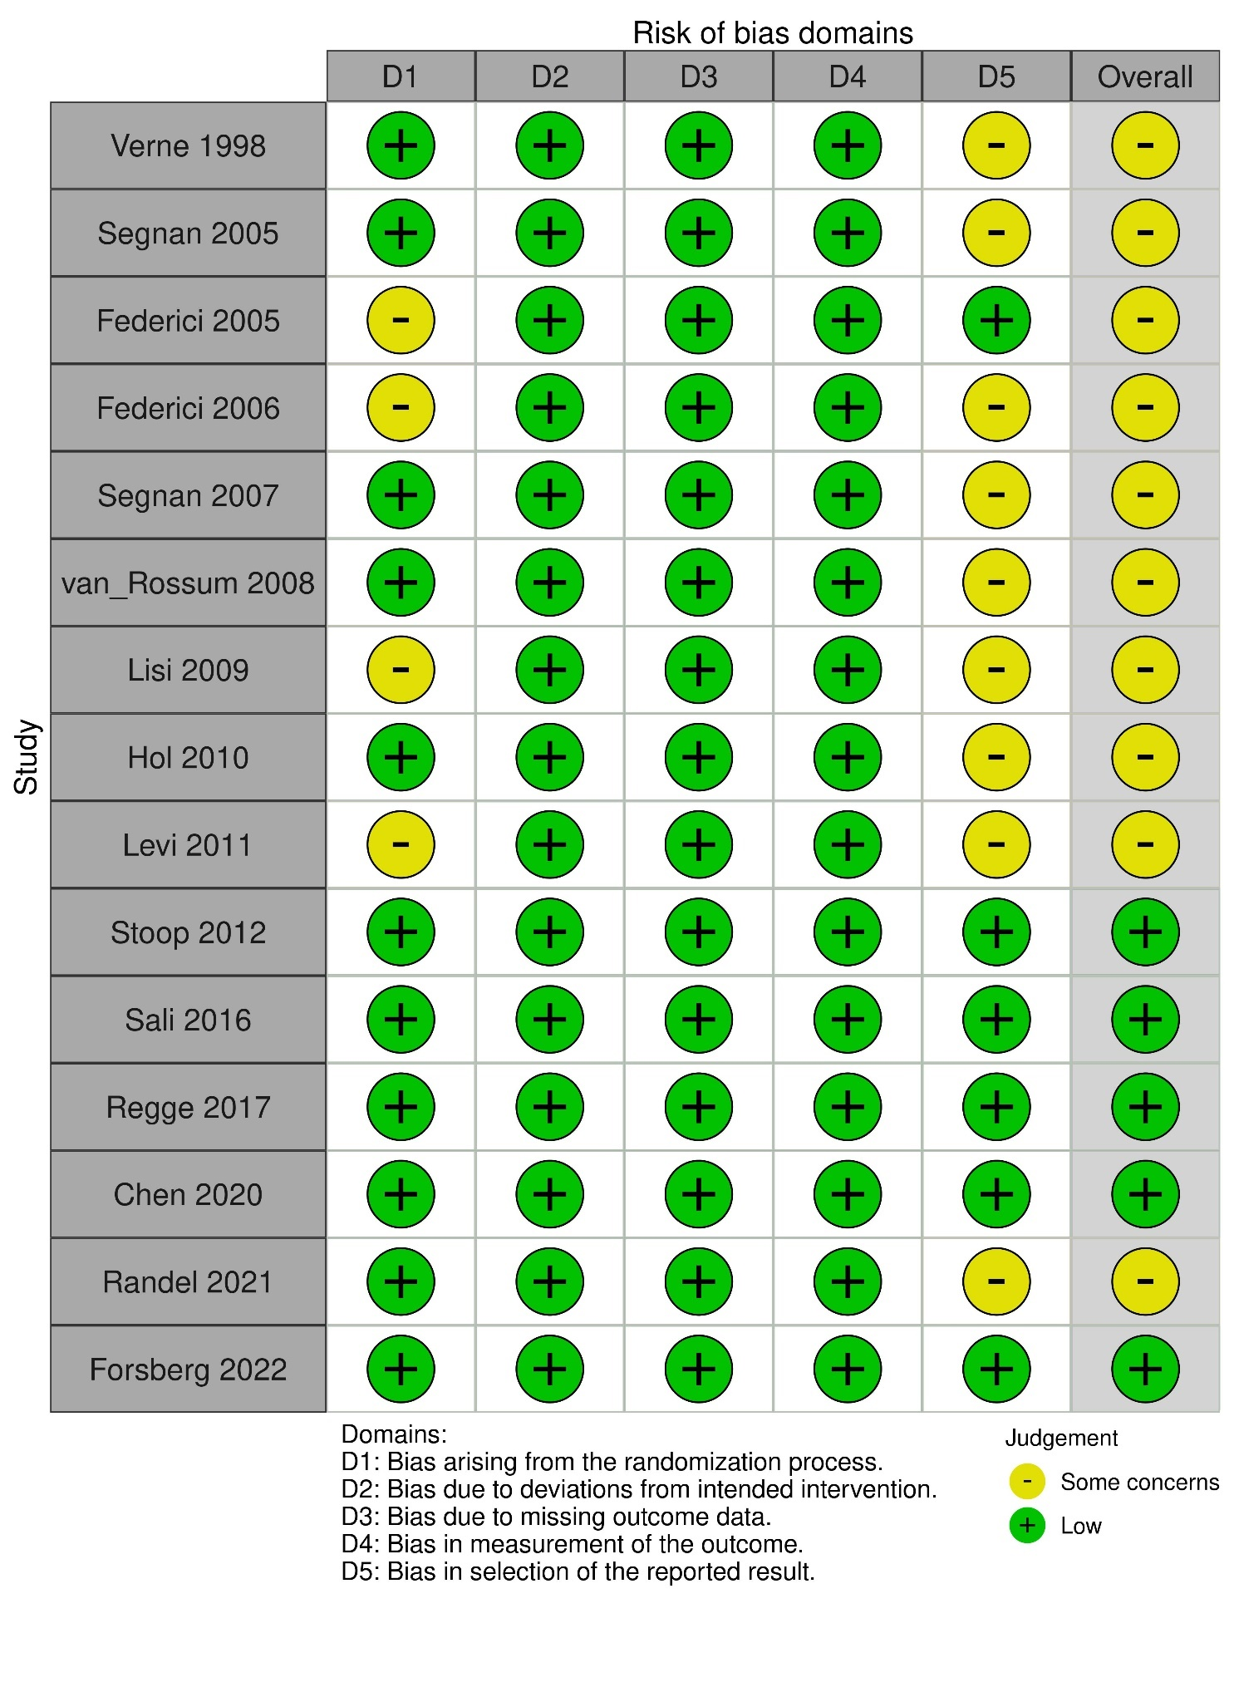

Figure S2. The risk of bias assessment of studies that evaluated screening participation in all screening invitees.

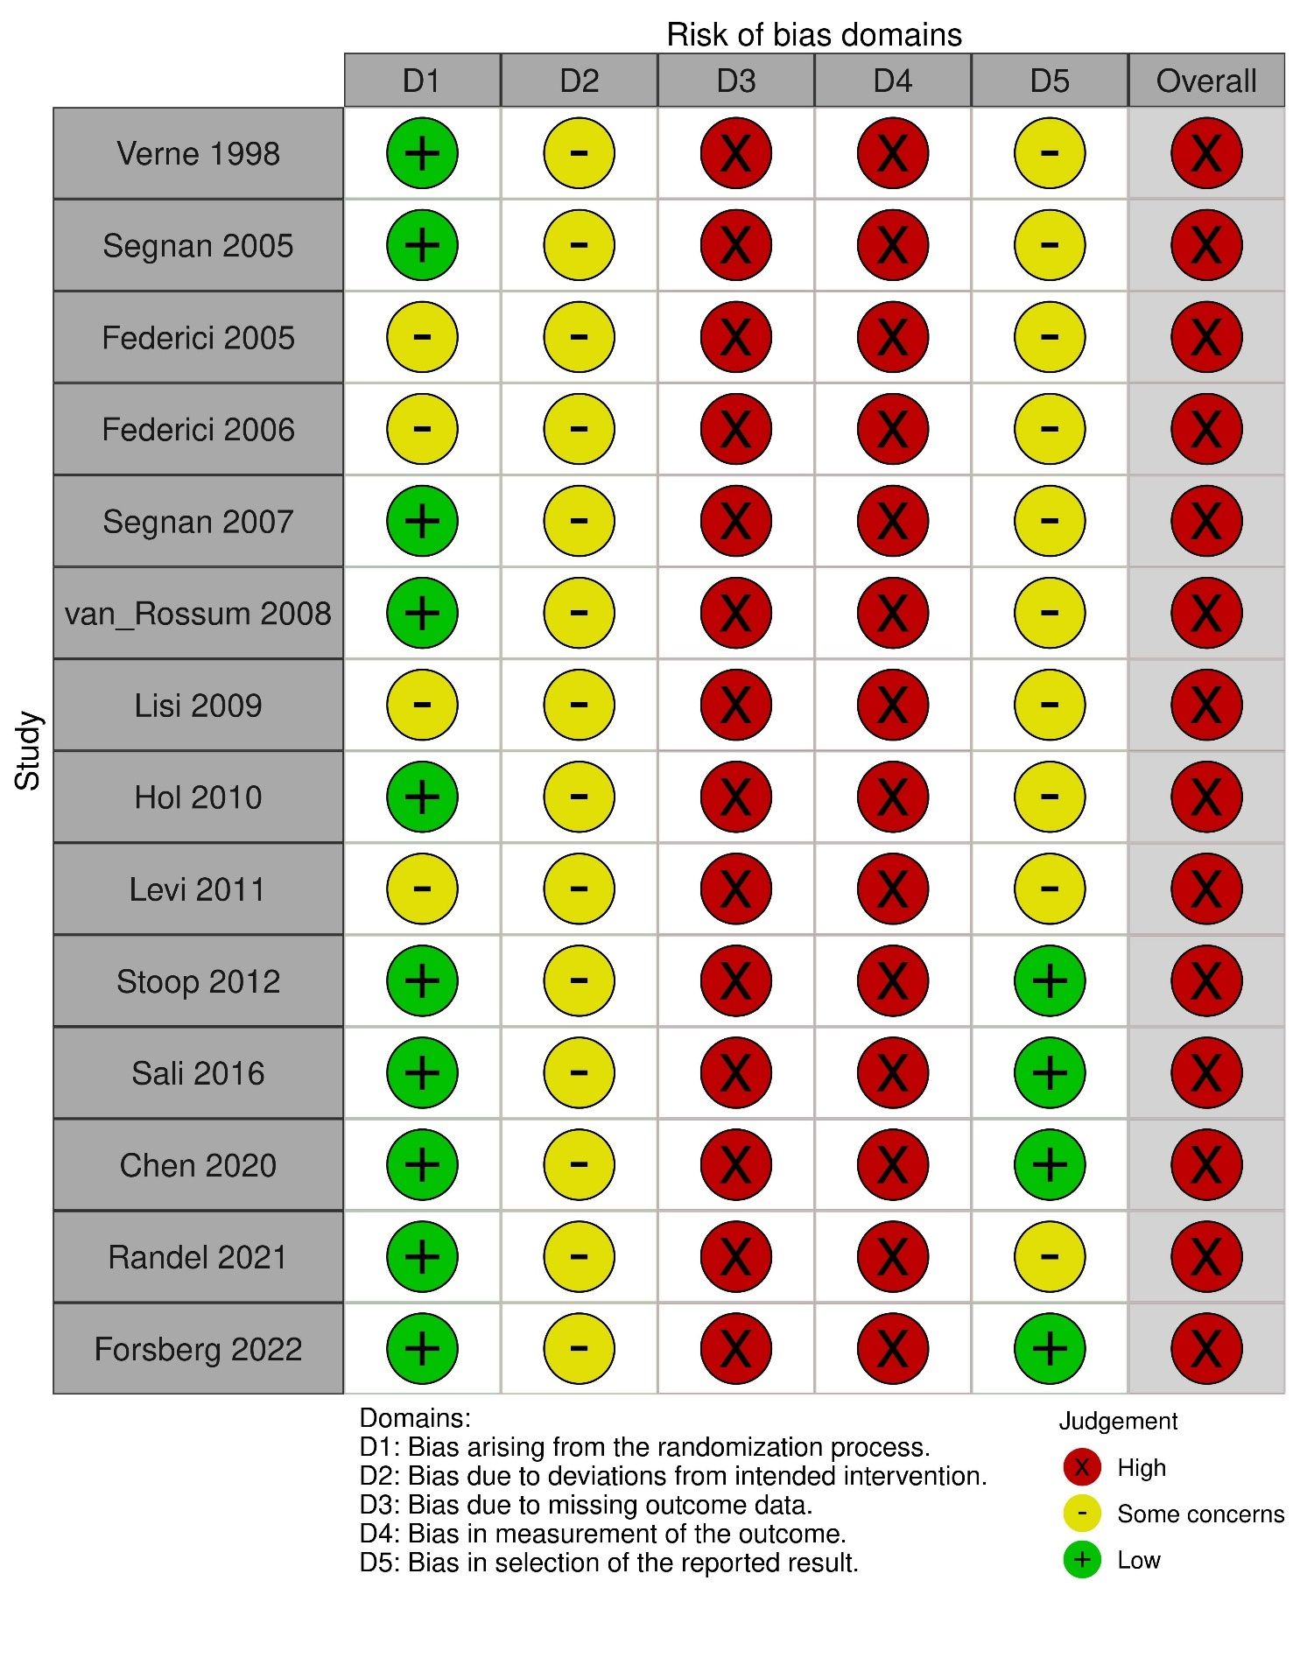

Figure S3. The risk of bias assessment of studies that evaluated the intention-to-screen effect of the detection of advanced neoplasia, colorectal cancer, or both in all screening invitees.

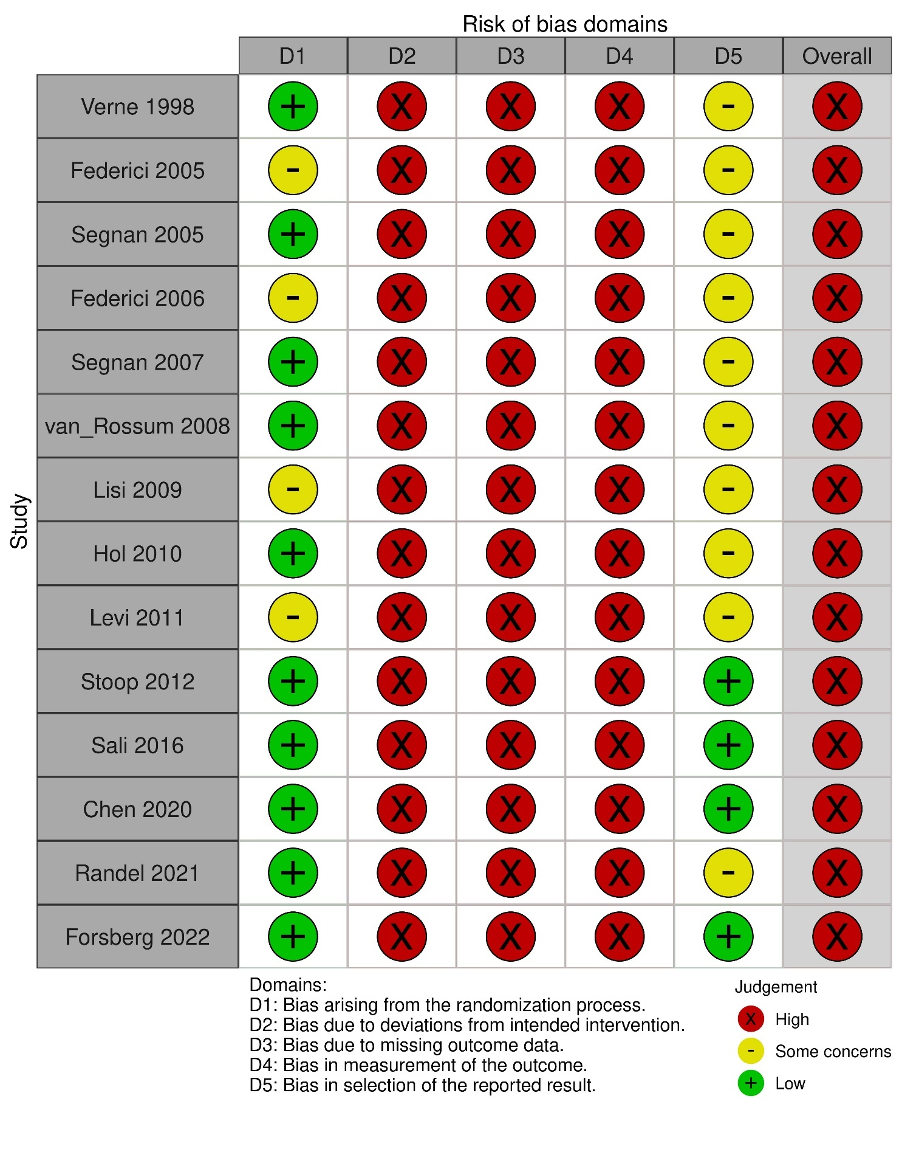

Figure S4. The risk of bias assessment of studies that evaluated the per-protocol effect of the detection of advanced neoplasia, colorectal cancer, or both in screening participants only.

Figure S5. Forest plot of individual study results included in the network meta-analysis of screening participation.
Squares and solid horizontal lines represent the risk ratios (RRs) and their 95% confidence interval (CI), respectively. CTC = computed tomography colonoscopy; FIT = fecal immunochemical test; FS = flexible sigmoidoscopy; gFOBT = guaiac-based fecal occult blood test; TCS = total colonoscopy

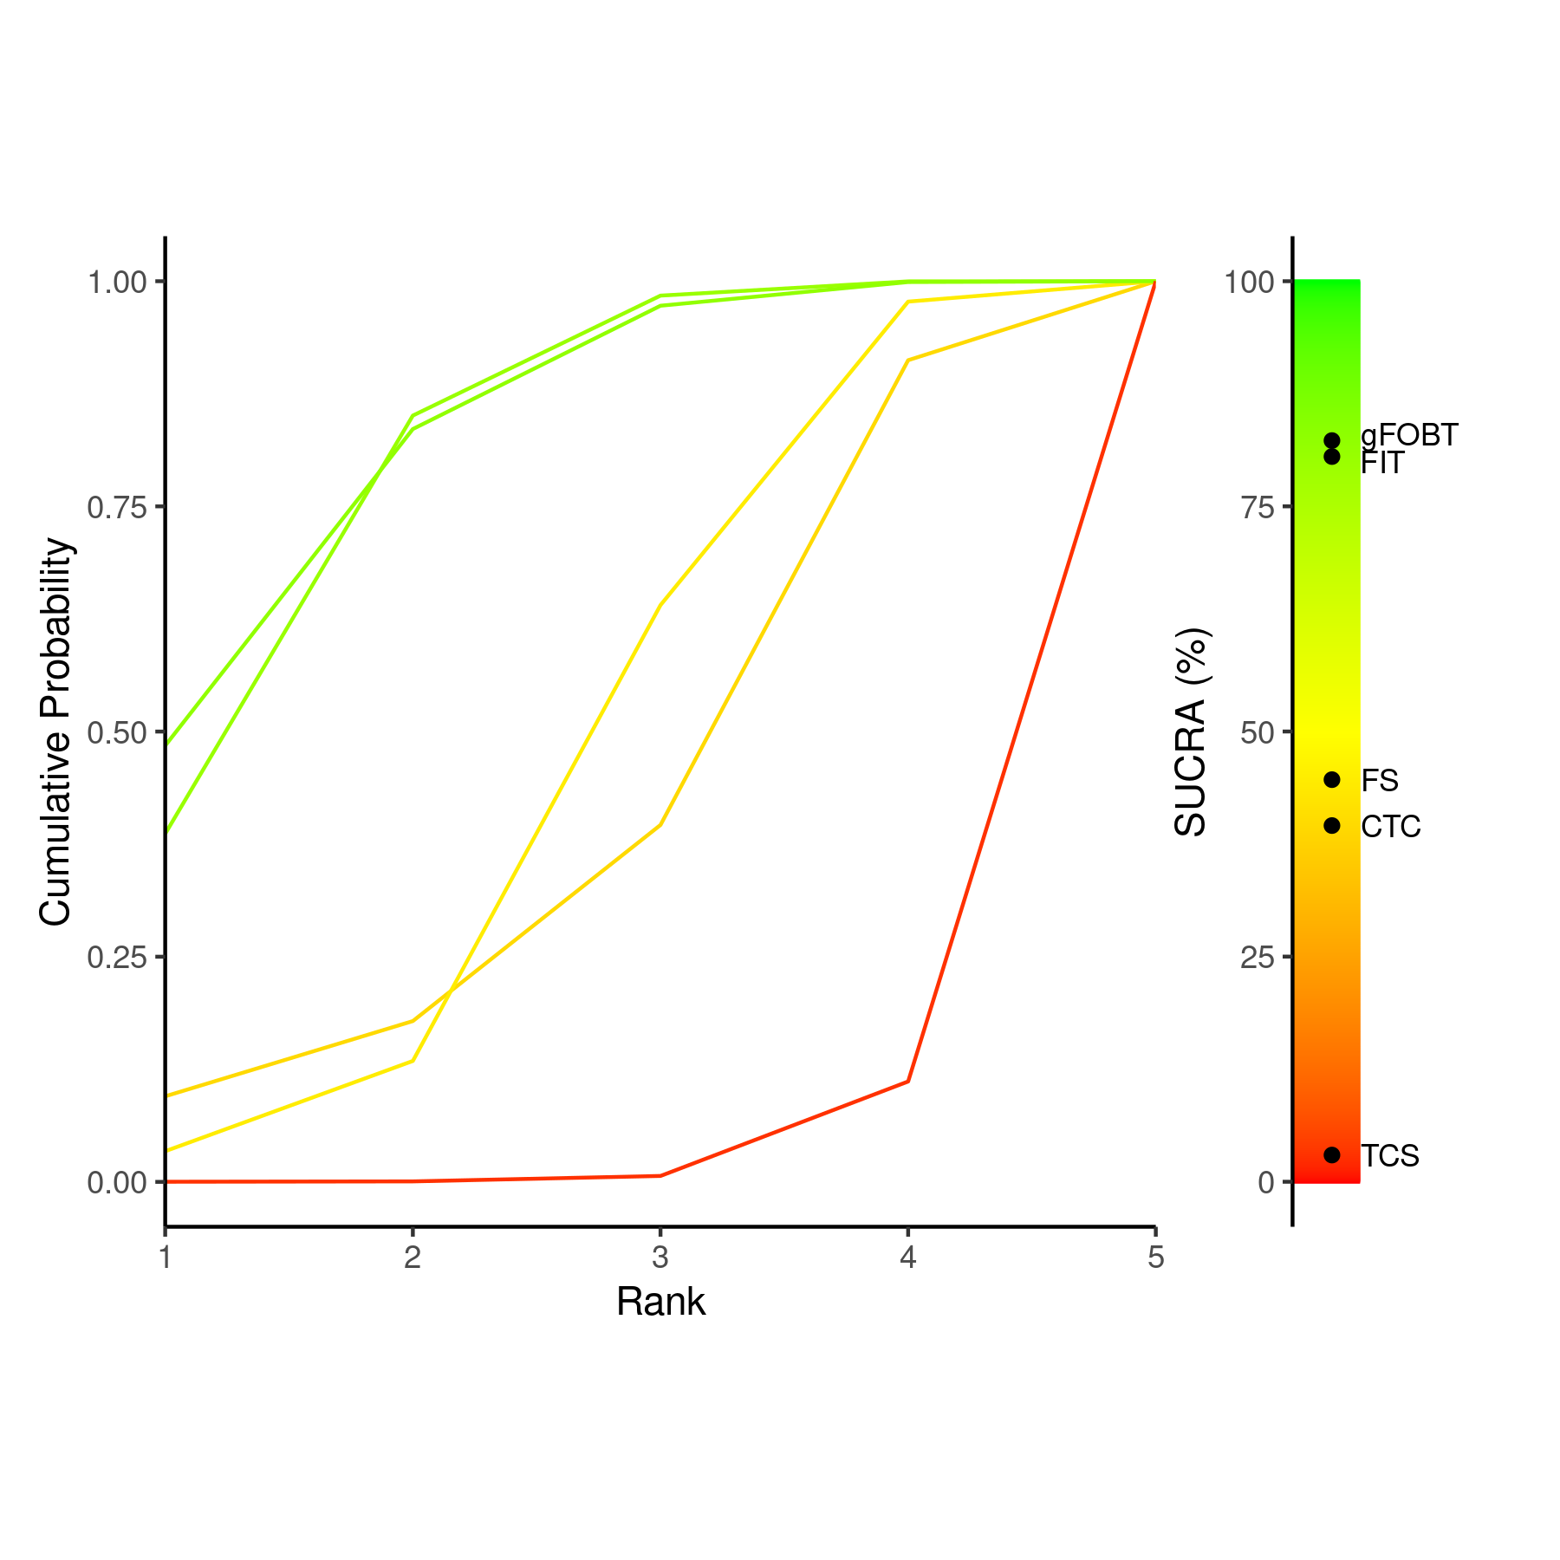

Figure S6. SUCRA plot and Litmus Rank-O-Gram of network meta-analysis of screening participation.
CTC = computed tomography colonoscopy; FIT = fecal immunochemical test; FS = flexible sigmoidoscopy; gFOBT = guaiac-based fecal occult blood test; SUCRA = surface under the cumulative ranking curve; TCS = total colonoscopy

Figure S7. Forest plot of individual study results included in the network meta-analysis of advanced neoplasia detection for evaluating the intention-to-screen effect.
Squares and solid horizontal lines represent the risk ratios (RRs) and their 95% confidence interval (CI), respectively.
CTC = computed tomography colonoscopy; FIT = fecal immunochemical test; FS = flexible sigmoidoscopy; gFOBT = guaiac-based fecal occult blood test; TCS = total colonoscopy
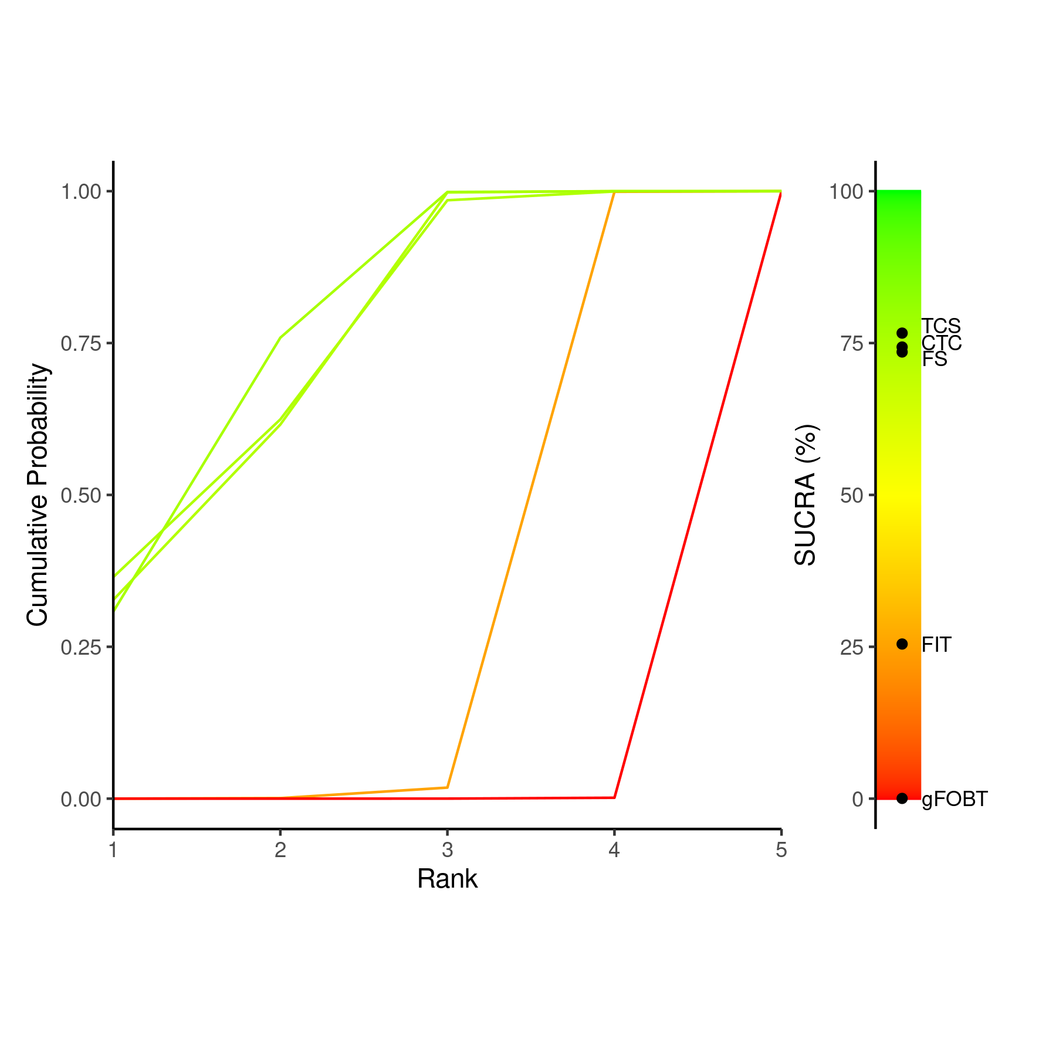

Figure S8. SUCRA plot and Litmus Rank-O-Gram of network meta-analysis of advanced neoplasia detection for evaluating the intention-to-screen effect.
CTC = computed tomography colonoscopy; FIT = fecal immunochemical test; FS = flexible sigmoidoscopy; gFOBT = guaiac-based fecal occult blood test; SUCRA = surface under the cumulative ranking curve; TCS = total colonoscopy

Figure S9. Forest plot of individual study results included in the network meta-analysis of advanced neoplasia detection for evaluating the per-protocol effect.
Squares and solid horizontal lines represent the overall risk ratios (RRs) and their 95% confidence interval (CI), respectively.
CTC = computed tomography colonography; FIT = fecal immunochemical test; FS = flexible sigmoidoscopy; gFOBT = guaiac-based fecal occult blood test; TCS = total colonoscopy

Figure S10. Network meta-analysis of advanced neoplasia detection for evaluating the per-protocol effect.
Squares and solid horizontal lines represent the summary risk ratios (RRs) and their 95% credible interval (CrI), respectively, estimated by network meta-analysis.
CTC = computed tomography colonography; FIT = fecal immunochemical test; FS = flexible sigmoidoscopy; gFOBT = guaiac-based fecal occult blood test; TCS = total colonoscopy
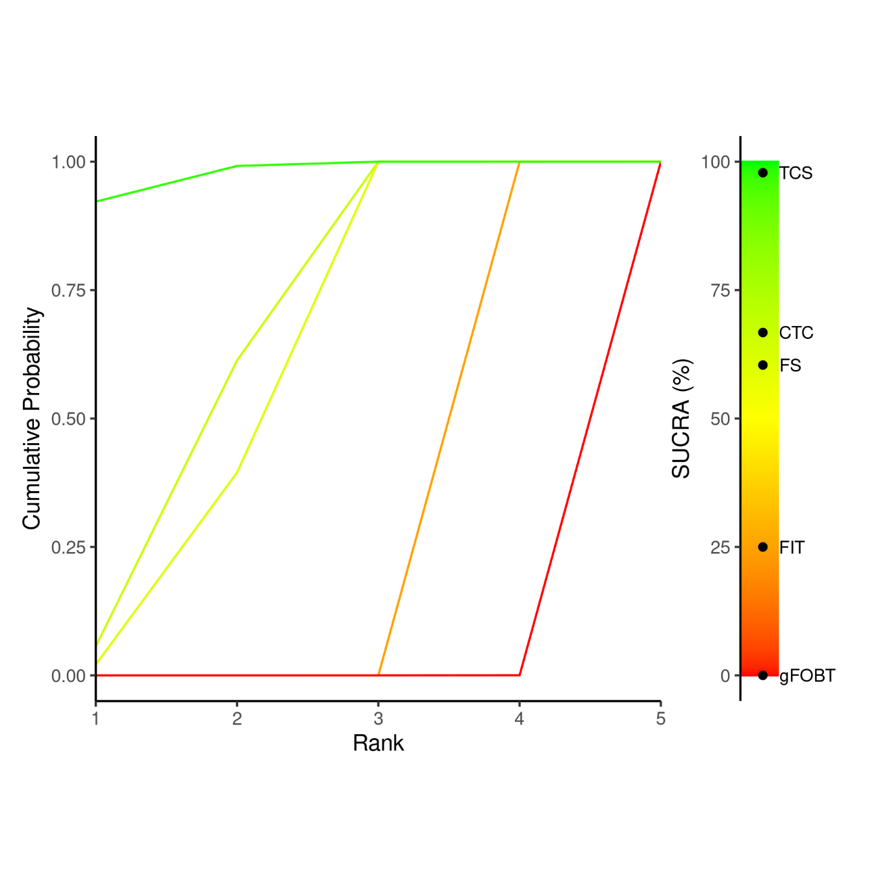

Figure S11. SUCRA plot and Litmus Rank-O-Gram of network meta-analysis of advanced neoplasia detection for evaluating the per-protocol effect.
CTC = computed tomography colonoscopy; FIT = fecal immunochemical test; FS = flexible sigmoidoscopy; gFOBT = guaiac-based fecal occult blood test; SUCRA = surface under the cumulative ranking curve; TCS = total colonoscopy

Figure S12. Forest plot of individual study results included in the network meta-analysis of colorectal cancer detection for evaluating the intention-to-screen analysis.
Squares and solid horizontal lines represent the overall risk ratios (RRs) and their 95% confidence interval (CI), respectively.
CTC = computed tomography colonography; FIT = fecal immunochemical test; FS = flexible sigmoidoscopy; gFOBT = guaiac-based fecal occult blood test; TCS = total colonoscopy
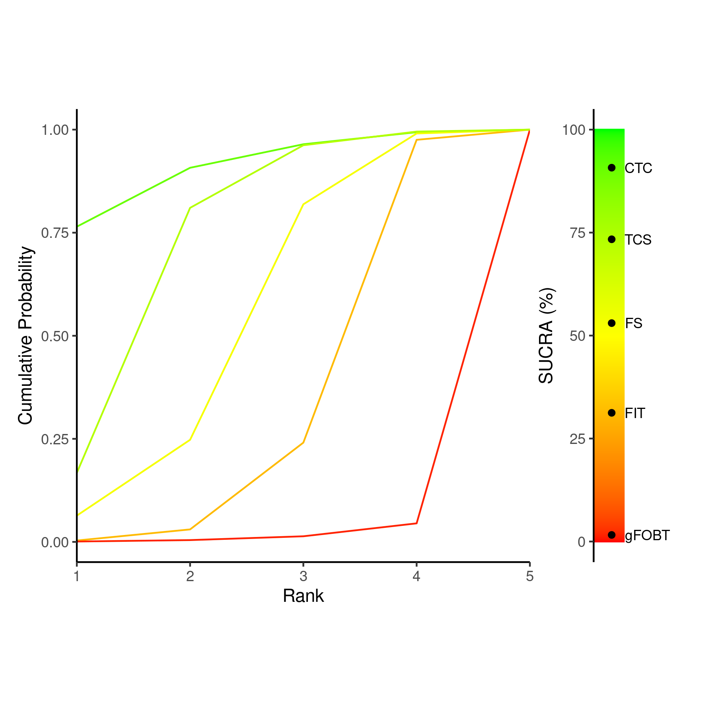

Figure S13. SUCRA plot and Litmus Rank-O-Gram of network meta-analysis of colorectal cancer detection for evaluating the intention-to-screen effect.
CTC = computed tomography colonoscopy; FIT = fecal immunochemical test; FS = flexible sigmoidoscopy; gFOBT = guaiac-based fecal occult blood test; SUCRA = surface under the cumulative ranking curve; TCS = total colonoscopy

Figure S14. Forest plot of individual study results included in the network meta-analysis of colorectal cancer detection for evaluating the per-protocol effect.
Squares and solid horizontal lines represent the overall risk ratios (RRs) and their 95% confidence interval (CI), respectively.
CTC = computed tomography colonography; FIT = fecal immunochemical test; FS = flexible sigmoidoscopy; gFOBT = guaiac-based fecal occult blood test; TCS = total colonoscopy

Figure S15. Network meta-analysis of colorectal cancer detection for evaluating the per-protocol effect.
Squares and solid horizontal lines represent the summary risk ratios (RRs) and their 95% credible interval (CrI), respectively, estimated by network meta-analysis.
CTC = computed tomography colonography; FIT = fecal immunochemical test; FS = flexible sigmoidoscopy; gFOBT = guaiac-based fecal occult blood test; TCS = total colonoscopy
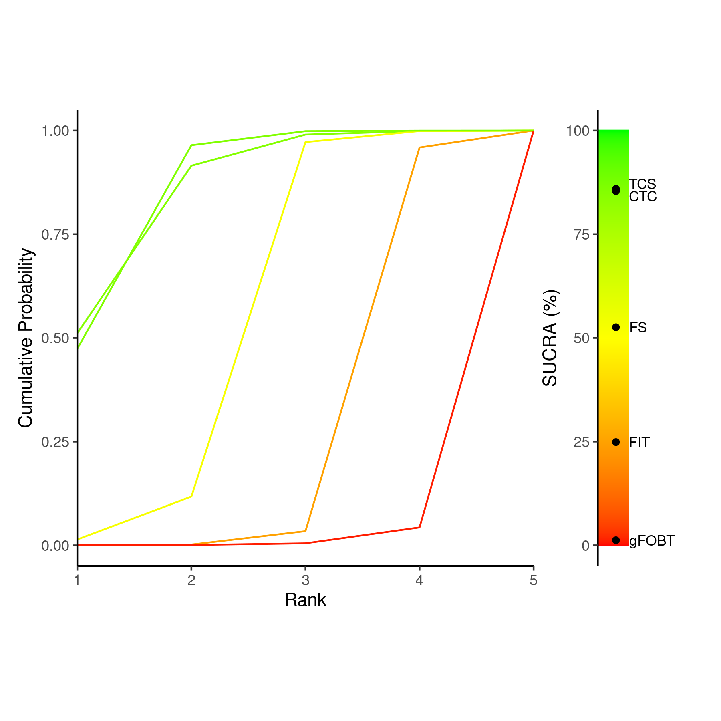

Figure S16. SUCRA plot and Litmus Rank-O-Gram of network meta-analysis of colorectal cancer detection for evaluating the per-protocol effect.
CTC = computed tomography colonoscopy; FIT = fecal immunochemical test; FS = flexible sigmoidoscopy; gFOBT = guaiac-based fecal occult blood test; SUCRA = surface under the cumulative ranking curve; TCS = total colonoscopy

Figure S17. Meta-analysis of screening positivity.
CrI = credible interval; CTC = computed tomography colonography; FIT = fecal immunochemical test; FS = flexible sigmoidoscopy; gFOBT = guaiac-based fecal occult blood test; PI = prediction interval; TCS = total colonoscopy

Figure S18. Meta-analysis of PPV.
CrI = credible interval; CTC = computed tomography colonography; FIT = fecal immunochemical test; FS = flexible sigmoidoscopy; gFOBT = guaiac-based fecal occult blood test; NE = nonestimable; PI = prediction interval; PPV = positive predictive value; TCS = total colonoscopy
(A)
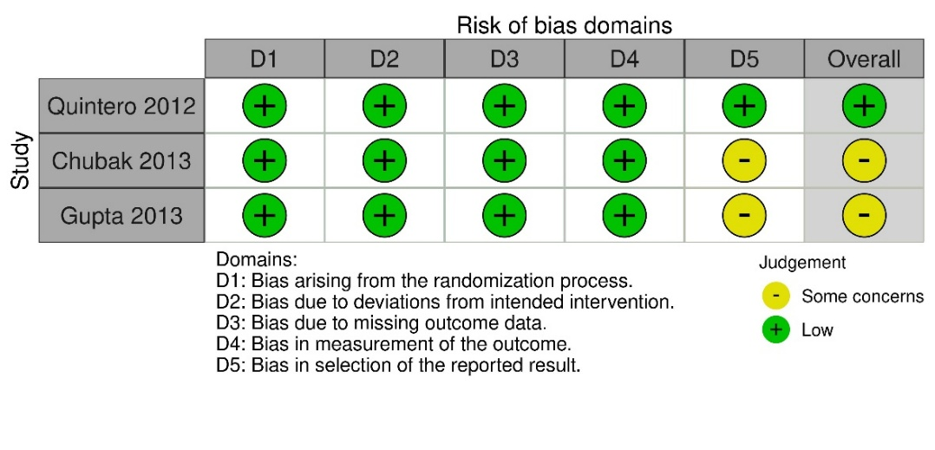
(B)
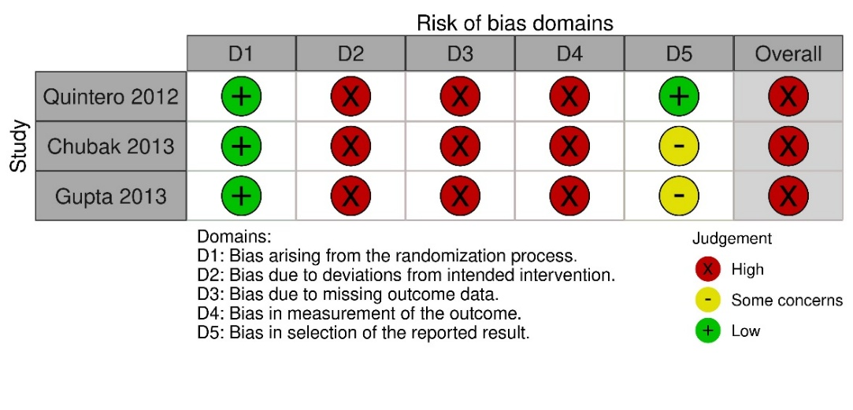
(C)
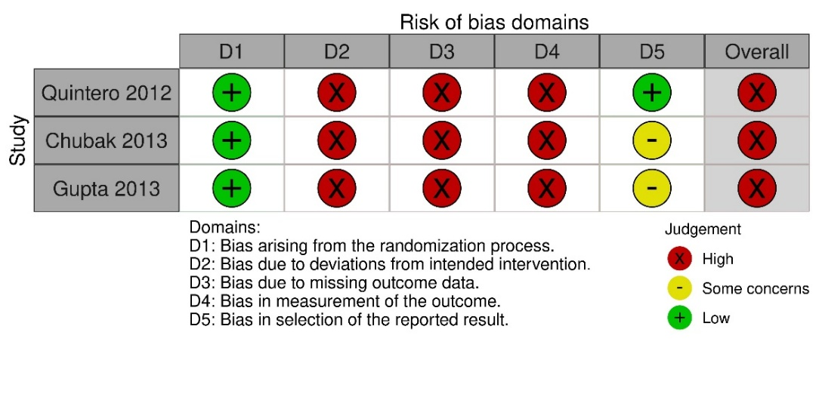

Figure S19. The risk of bias assessment of randomized clinical trials that allowed crossover.
Risk of bias assessment results for (A) screening participation in all screening invitees; (B) intention-to-screen effect of the detection of advanced neoplasia, colorectal cancer, or both in all screening invitees; and (C) per-protocol effect of the detection of advanced neoplasia, colorectal cancer, or both in screening participants only are presented.

List of Excluded Study Reports (n = 33)

RCT reports reporting on screening participation or completion only (n = 8)
Hoffman 2010 [64]
IRENE [65, 66]
Greiner 2014 [67]
Charlton 2014 [68]
Murphy 2019 [69]
Gruner 2020 [70]
CONFIRM [71]

Relevant but duplicate RCT reports (n = 5)
COLONPREV [72, 73]
Part or pooled analysis of selected RCTs from Netherlands [17, 74, 75]

RCT reports reporting on the cumulative number of target regions after multiround screening (n = 5)
TARGET-C [76-78]
SCREENSCO [79]
SAVE [16]

RCTs comparing screening with a guaiac fecal occult blood test (gFOBT) alone with screening with a strategy using combined gFOBT and sigmoidoscopy (n = 3)
Berry 1997 [80]
Rasmussen 1999 [81]
Steele 2020 [82]

RCT reports reporting on the reduction of colorectal cancer incidence or mortality (n = 3)
NordICC [83]
SCORE [84]
Pooled analysis of NORCCAP, PLCO, UKSST, and SCORE[85]

RCT reports from which the data based on both intension-to-screen and per-protocol effects could not be extracted (n = 3)
MACS 2006 [86]
Scott 2004 [87]
You 2015 [88]

RCT reports reporting on irrelevant outcomes (n = 2)
SCREESCO [89]
NCS [11]

Conference abstracts (n = 2)
NordICC [90]
SAVE [91]

RCT not using total colonoscopy as the confirmatory test for the target legions (n = 1)
Brevlinge 1997 [92]

RCT reports reporting on irrelevant comparisons (n = 1)
Álvarez-Delgado 2021 [93]

