Additional File 1
Xie X, Que J, Sun L,Sun T ,Yang, F. Association between urbanization levels and frailty among middle-aged and older adults in China: Evidence from the CHARLS. BMC Medicine.

Supplemental materials
Figure S1. Sensitivity analysis on the association of urbanization level with frailty by excluding the individuals with chronic conditions at the initiation of the follow up.
Figure S2. Sensitivity analysis on the association of urbanization level with frailty by he K-nearest neighbors imputation method to Impute missing values.
Figure S3. Sensitivity analysis on the association of urbanization level with frailty by excluding participants whose frailty event occurred in the first 2 years of follow-up.
Figure S4. Sensitivity analysis of the association between urbanization level and frailty by using the average urbanization level from 2011 to 2018 as the exposure variable.
Figure S5. Sensitivity analysis of the association between urbanization and frailty excluding participants with residential changes during follow-up surveys.
Figure S6. Sensitivity analysis of the association between urbanization and frailty was conducted by adjusting for the covariates PM₁₀ and NO₂.
Figure S7. Sensitivity analysis of urbanization and frailty, accounting for missing data in Household Consumption and BMI.
Table S1. The urbanization evaluation index system and indicator weightings.
Table S2. The 32 items used to construct the frailty index.
Table S3. Covariate description table.
Table S4. The percentages of participants with missing covariates involved in the Analysis of this Study.
Table S5. The urbanization scores of the 101 cities.
Table S6. The association between time-varying urbanization levels and frailty.

Supplemental Figures
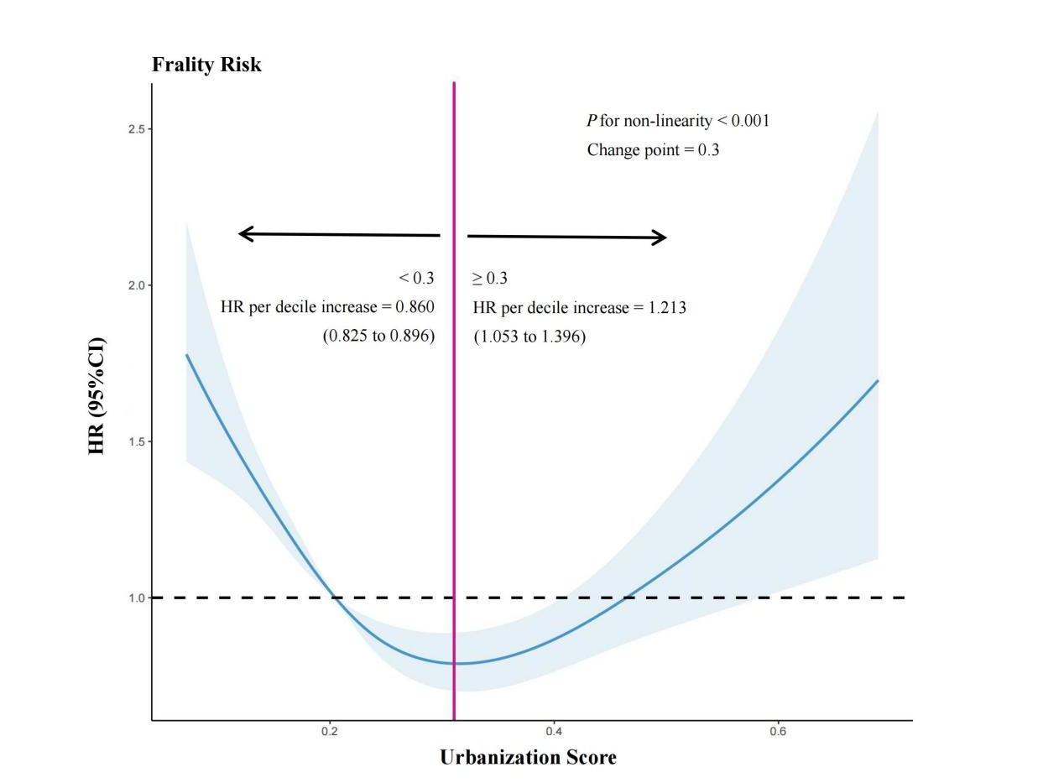
Figure S1. Sensitivity analysis on the association of urbanization level with frailty by excluding the individuals with chronic conditions at the initiation of the follow up (N=7573, Event=1621).
HRs are indicated by solid lines and 95% CIs by shaded areas. Reference point is lowest value for Urbanization Score. Analyses were adjusted for age, sex, marital status, education levels, smoking status, drinking status, youthful health condition, first job, current work status, household consumption, family support, participation in social activities, public health insurance coverage, toilet facilities, BMI, PM_{2.5}. HR, hazard ratio; CI, confidence interval; BMI, body mass index; PM_{2.5}, particulate matter 2.5.

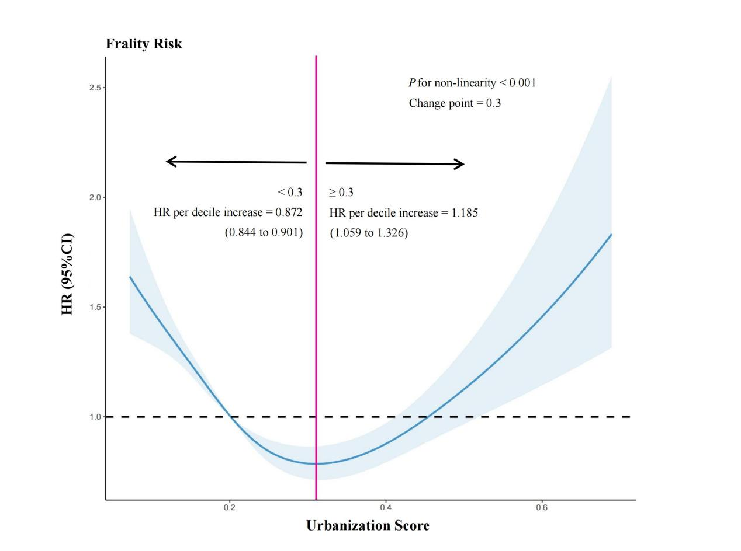
Figure S2. Sensitivity analysis on the association of urbanization level with frailty by he K-nearest neighbors imputation method to Impute missing values (N=10758, Event=2603). HRs are indicated by solid lines and 95% CIs by shaded areas. Reference point is lowest value for Urbanization Score. Analyses were adjusted for age, sex, marital status, education levels, first job, youthful health condition, current work status, household consumption, family support, participation in social activities, smoking status, drinking status, public health insurance coverage, dyslipidemia, liver disease, kidney disease, gastric or digestive disease, BMI, and PM_{2.5}. HR, hazard ratio; CI, confidence interval; BMI, body mass index; PM_{2.5}, particulate matter 2.5.

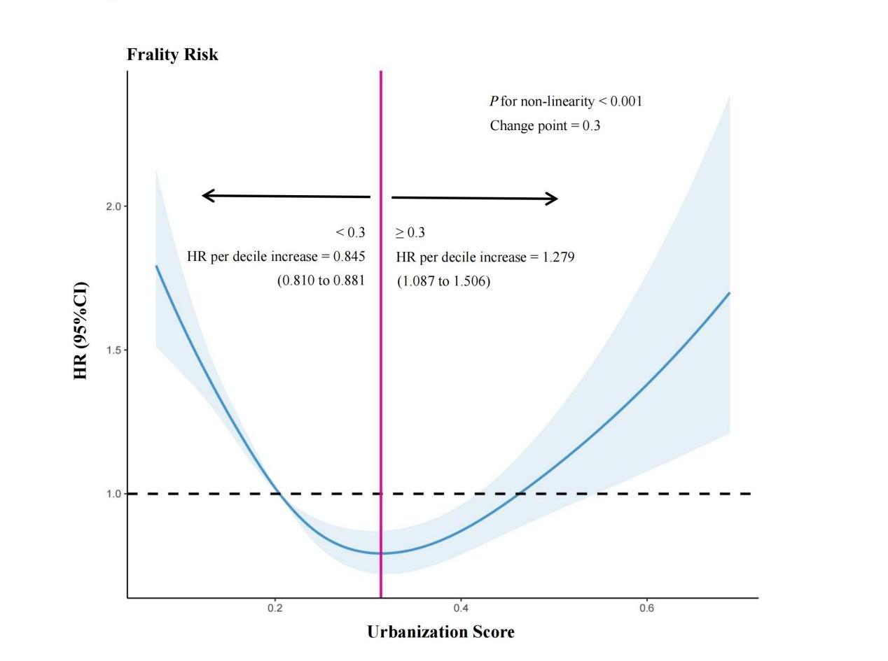
Figure S3. Sensitivity analysis on the association of urbanization level with frailty by excluding participants whose frailty event occurred in the first 2 years of follow-up (N=8668, Event=1534).
HRs are indicated by solid lines and 95% CIs by shaded areas. Reference point is lowest value for Urbanization Score. Analyses were adjusted for age, sex, marital status, education levels, first job, youthful health condition, current work status, household consumption, family support, participation in social activities, smoking status, drinking status, public health insurance coverage, dyslipidemia, liver disease, kidney disease, gastric or digestive disease, BMI, and PM_{2.5}. HR, hazard ratio; CI, confidence interval; BMI, body mass index; PM_{2.5}, particulate matter 2.5.

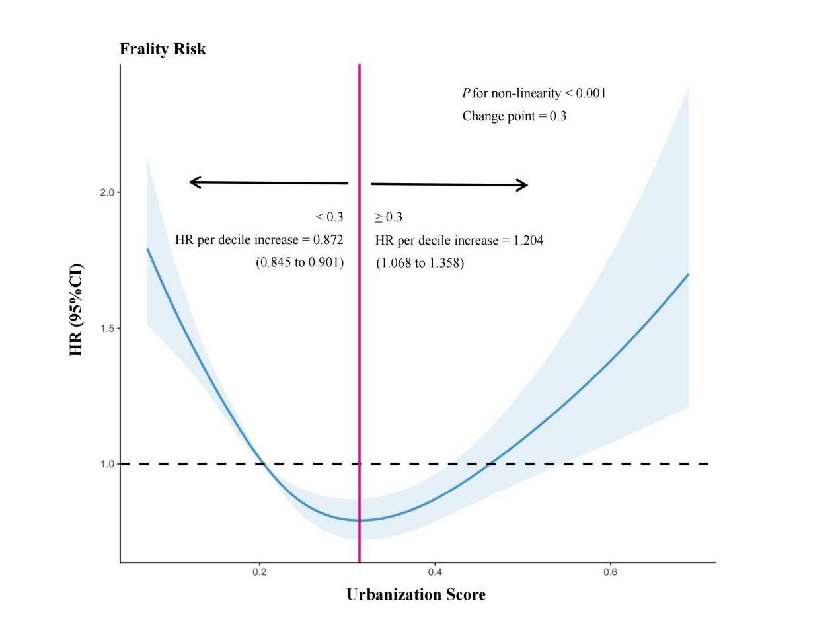
Figure S4. Sensitivity analysis of the association between urbanization level and frailty by using the average urbanization level from 2011 to 2018 as the exposure variable (N = 10758, Event = 2603).
HRs are indicated by solid lines and 95% CIs by shaded areas. Reference point is lowest value for Urbanization Score. Analyses were adjusted for age, sex, marital status, education levels, first job, youthful health condition, current work status, household consumption, family support, participation in social activities, smoking status, drinking status, public health insurance coverage, dyslipidemia, liver disease, kidney disease, gastric or digestive disease, BMI, and PM_{2.5}. HR, hazard ratio; CI, confidence interval; BMI, body mass index; PM_{2.5}, particulate matter 2.5.

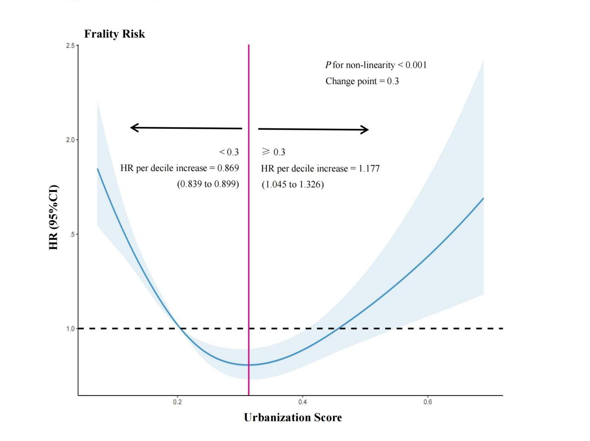
Figure S5. Sensitivity analysis of the association between urbanization and frailty excluding participants with residential changes during follow-up surveys (N = 9415, Event = 2318). HRs are indicated by solid lines and 95% CIs by shaded areas. Reference point is lowest value for Urbanization Score. Analyses were adjusted for age, sex, marital status, education levels, first job, youthful health condition, current work status, household consumption, family support, participation in social activities, smoking status, drinking status, public health insurance coverage, dyslipidemia, liver disease, kidney disease, gastric or digestive disease, BMI, and PM_{2.5}. HR, hazard ratio; CI, confidence interval. BMI, body mass index; PM_{2.5}, particulate matter 2.5.
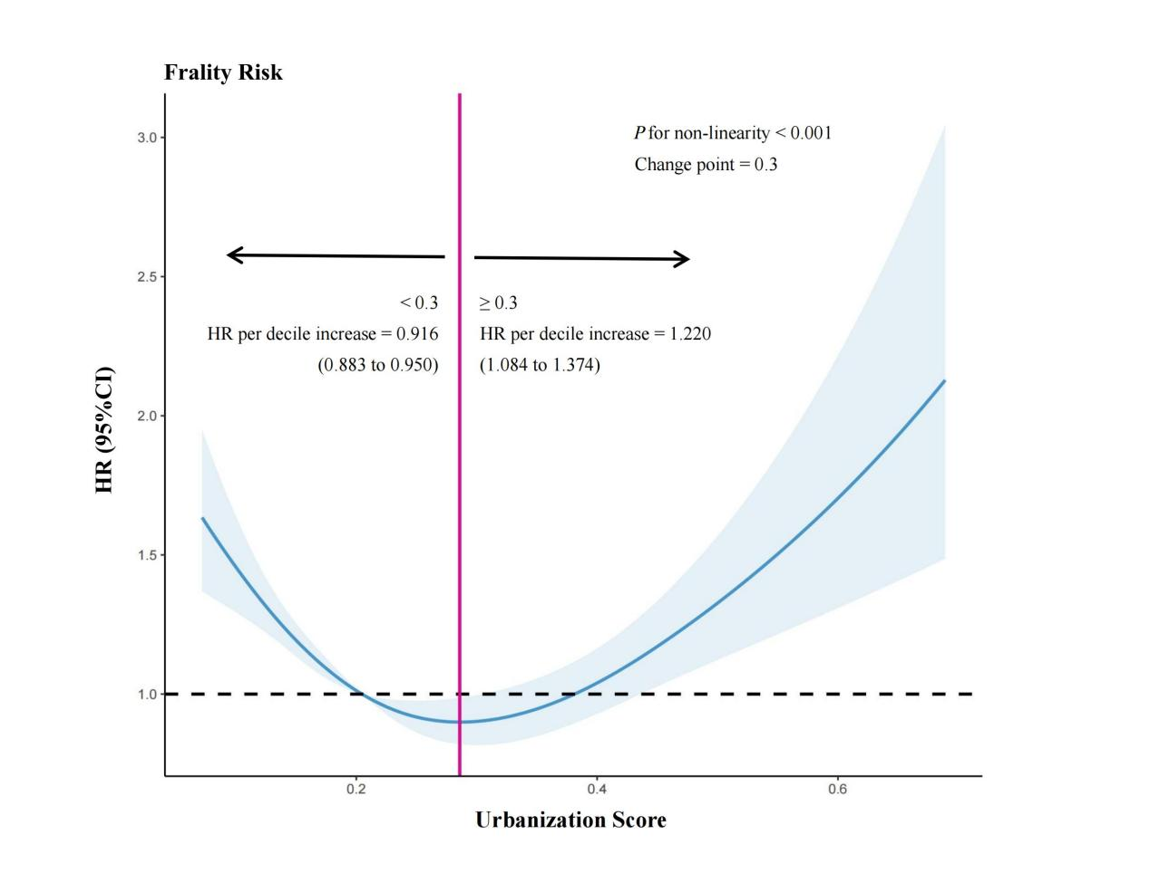
Figure S6. Sensitivity analysis of the association between urbanization and frailty was conducted by adjusting for the covariates PM₁₀ and NO₂ (N = 10758, Event = 2603).
HRs are indicated by solid lines and 95% CIs by shaded areas. Reference point is lowest value for Urbanization Score. Analyses were adjusted for age, sex, marital status, education levels, first job, youthful health condition, current work status, household consumption, family support, participation in social activities, smoking status, drinking status, public health insurance coverage, dyslipidemia, liver disease, kidney disease, gastric or digestive disease, BMI, PM_{2.5}, PM₁₀, and NO₂. HR, hazard ratio; CI, confidence interval; BMI, body mass index; PM_{2.5}, particulate matter 2.5; PM₁₀, particulate matter 10; NO₂, nitrogen dioxide.
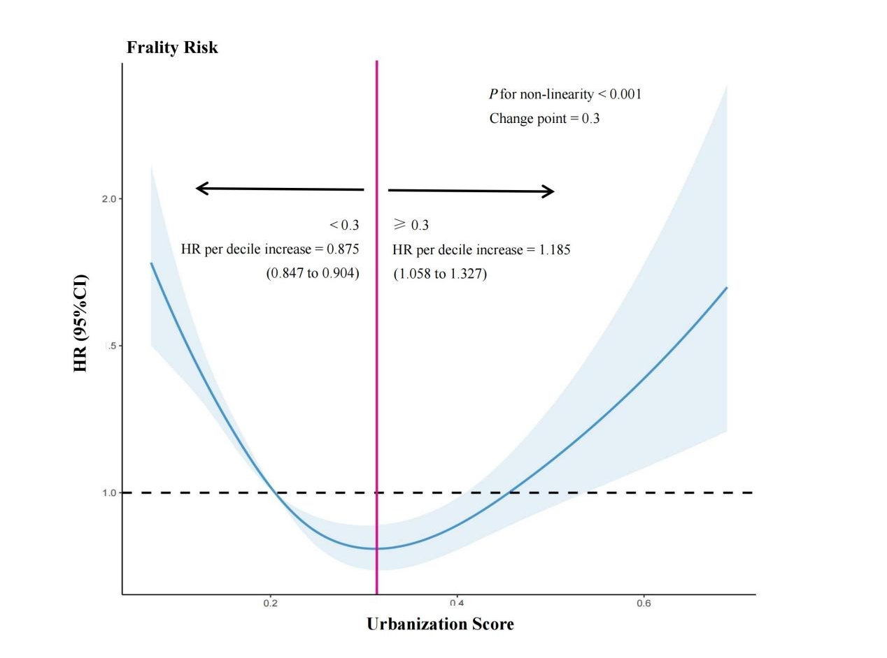
Figure S7. Sensitivity analysis of urbanization and frailty, accounting for missing data in Household Consumption and BMI (N = 10758, Event = 2603).
HRs are indicated by solid lines and 95% CIs by shaded areas. Reference point is lowest value for Urbanization Score. Analyses were adjusted for age, sex, marital status, education levels, first job, youthful health condition, current work status, household consumption, family support, participation in social activities, smoking status, drinking status, public health insurance coverage, dyslipidemia, liver disease, kidney disease, gastric or digestive disease, BMI, and PM_{2.5}. HR, hazard ratio; CI, confidence interval; BMI, body mass index; PM_{2.5}, particulate matter 2.5.

Supplemental Tables
Table S1. The urbanization evaluation index system and indicator weightings.
System | Sub-system | Specific indicators | Unit | Property | Objective weight
Comprehensive Urbanization (CU) | Population Urbanization (PU) | Urbanization rate | % | Positive | 0.038
 |  | Population density | 10,000 people/km² |  | 0.091
 |  | The proportion of population in secondary industry | % |  | 0.024
 |  | The proportion of population in tertiary industry | % |  | 0.028
 | Economic Urbanization (EU) | Per capita GDP | Yuan | Positive | 0.056
 |  | The proportion of secondary industry to GDP | % |  | 0.014
 |  | The proportion of tertiary industry to GDP | % |  | 0.032
 |  | Investment in social fixed assets | 10,000 people |  | 0.109
 |  | GDP growth rate | % |  | 0.007
 | Social Urbanization (SOU) | Total retail sales of consumer goods per capita | Yuan/person | Positive | 0.058
 |  | Per capita disposable income of urban residents | Yuan/person |  | 0.046
 |  | Number of beds per 10,000 people | One/10,000 people |  | 0.043
 |  | Number of doctors per 10,000 people | One/10,000 people |  | 0.035
 |  | Number of public transport vehicles per 10,000 people | Vehicle/10,000 people |  | 0.098
 |  | Number of college students per 10,000 people | One/10,000 people |  | 0.139
 | Spatial Urbanization (SPU) | The proportion of built up land in the urban area | % | Positive | 0.086
 |  | Built-up urban land area per 10,000 people | km²/10,000 people |  | 0.045
 |  | Per capita urban road area | m²/Person |  | 0.044
 |  | Green coverage rate of completed areas | % |  | 0.008
Abbreviation: GDP, gross domestic product.

Table S2. The 32 items used to construct the frailty index.
Individuals components | Description of the items | Criteria
Self-Reported Diseases | Physician diagnosed hypertension | Yes = 1, No = 0
Self-Reported Diseases | Physician diagnosed diabetes | Yes = 1, No = 0
Self-Reported Diseases | Physician diagnosed heart disease | Yes = 1, No = 0
Self-Reported Diseases | Physician diagnosed stroke | Yes = 1, No = 0
Self-Reported Diseases | Physician diagnosed cancer | Yes = 1, No = 0
Self-Reported Diseases | Physician diagnosed arthritis | Yes = 1, No = 0
Self-Reported Diseases | Physician diagnosed chronic lung disease | Yes = 1, No = 0
Self-Reported Diseases | Physician diagnosed asthma | Yes = 1, No = 0
Self-Reported Diseases | Physician diagnosed any emotional, nervous, or psychiatric problems | Yes = 1, No = 0
Self-Reported Diseases | Physician diagnosed memory-related disease | Yes = 1, No = 0
Self-Reported Vision and Hearing Issues | Vision problems | Yes = 1, No = 0
Self-Reported Vision and Hearing Issues | Hearing problems | Yes = 1, No = 0
Self-Reported General and Mental Health Assessment | Self-reported general health status | Poor or fair = 1, excellent, very good, or good = 0
Self-Reported General and Mental Health Assessment | Depression: CESD-10 questionnaire | CESD-10 >10 =1, ≤10 =0
Self-Reported General and Mental Health Assessment | Cognition: (memory test score + orientation test score) / 14 | Continuous, ranging from 0 to 1
Activities of Daily Living (ADLs) | Difficulty with dressing | Yes = 1, No = 0
Activities of Daily Living (ADLs) | Difficulty with bathing or showering | Yes = 1, No = 0
Activities of Daily Living (ADLs) | Difficulty with eating | Yes = 1, No = 0
Activities of Daily Living (ADLs) | Difficulty with getting in and out of bed | Yes = 1, No = 0
Activities of Daily Living (ADLs) | Difficulty with using the toilet | Yes = 1, No = 0
Instrumental Activities of Daily Living (IADLs) | Difficulty with managing money | Yes = 1, No = 0
Instrumental Activities of Daily Living (IADLs) | Difficulty with taking medications | Yes = 1, No = 0
Instrumental Activities of Daily Living (IADLs) | Difficulty with shopping for groceries | Yes = 1, No = 0
Instrumental Activities of Daily Living (IADLs) | Difficulty with preparing meals | Yes = 1, No = 0
Instrumental Activities of Daily Living (IADLs) | Difficulty with doing housework | Yes = 1, No = 0
Mobility Status | Mobility: difficulty with walking 100 yards | Yes = 1, No = 0
Mobility Status | Mobility: difficulty with getting up from a chair after sitting for long periods | Yes = 1, No = 0
Mobility Status | Mobility: difficulty with climbing several flights of stairs without resting | Yes = 1, No = 0
Mobility Status | Mobility: difficulty with lifting or carrying weights over 10 pounds/jins | Yes = 1, No = 0
Mobility Status | Mobility: difficulty with picking up a coin from the table | Yes = 1, No = 0
Mobility Status | Mobility: difficulty with stooping, kneeling, or crouching | Yes = 1, No = 0
Mobility Status | Mobility: difficulty with reaching arms above shoulder level | Yes = 1, No = 0
Heart disease indicates the angina, coronary heart disease, congestive heart failure, or other heart problems.
Memory-related disease indicates Alzheimer’s disease or dementia, organic brain senility, or other serious memory impairment.
Depression is evaluated using Center for Epidemiologic Studies Depression Scale (CESD). In the CHARLS, CESD-10 is used, and the total score ranges from 0 to 30. The higher score indicates more severe depressive symptoms.
The memory score is the average of words that are not recalled in the immediate and delayed word recall tasks. The memory score ranges from 0 to 10. The orientation test comprises four questions about the day of the week, the month, the date of the month, and the year. One point is given for each wrong answer, and the range is from 0 to 4.

Table S3. Covariate description table.
Variable | Indicator Description and Assignment
Population statistics
Age | Continuous variables, ≥ 45 years old
Sex | Male = 1，Female = 2
Marital status | Married = 1, Other = 0
Early life
Education level | Illiterate =1, Primary school education or below =2, Education prior to bachelor's degree = 3, Bachelor's degree or higher = 4
First job | Government departments = 1, Public institutions = 2, Nonprofit organizations = 3, Enterprises = 4, Sole proprietorship = 5, Farm household = 6, Residential household= 7, Others = 8
Youthful health condition | Excellent = 1, Very good = 2, Good = 3, Common = 4, Poor = 5
Social economy
Current work status | Unemployed = 0, Employed = 1
Household consumption | Continuous variables, Total household consumption aggregated from all consumption activities, calculated as annual expenditures
Social psychology
Family support | Living with children = 1, Meeting with children weekly =2, Meeting virtually with children weekly = 3, Having children without support = 4, Having no children and no support = 5
Participation in social activities | If participated in any social activities in the past month, then Participation in social activities = 1; else = 0.
Healthy factors
Drinking status | If had any alcoholic beverages in the past, then Drinking status = 1; else = 0.
Smoking status | If the respondent reports ever smoking (including chewing tobacco, smoking a pipe, self-rolled cigarettes, cigarettes, and cigars), then Smoking status = 1; else = 0.
Public health insurance coverage | If the respondent is covered by any public health insurance program (e.g., urban employee medical insurance, rural cooperative medical insurance, government medical insurance, etc.), then Public health insurance coverage = 1; else = 0.
Dyslipidemia | If informed by a doctor of having dyslipidemia, then Dyslipidemia = 1, else = 0
Liver disease | If informed by a doctor of having liver disease, then Liver disease = 1, else = 0
Kidney disease | If informed by a doctor of having kidney disease, then Kidney Disease = 1, else = 0
Gastric or digestive diseases | If informed by a doctor of having gastric or digestive diseases, then Gastric/Digestive Disease = 1, else = 0
BMI | If BMI < 18.5, then BMI = 1 (Underweight); If 18.5 ≤ BMI < 24, then BMI = 2 (Normal weight); If 24 ≤ BMI < 28, then BMI = 3 (Overweight); If BMI ≥ 28, then BMI = 4 (Obese).
PM_{2.5} | Continuous variables, Fine particulate matter (PM_{2.5}) concentration measured in µg/m³
Abbreviations: BMI, body mass index; PM_{2.5}, particulate matter 2.5.

Table S4. The percentages of participants with missing covariates involved in the analysis of this study.
Characteristics | Count | Missing Rate
Age | 10758 | 0.00%
Sex | 10758 | 0.00%
Marital status | 10758 | 0.00%
Education level | 10758 | 0.00%
First job | 9842 | 8.51%
Youthful health condition | 10582 | 1.63%
Current work status | 10598 | 1.49%
Household consumption | 8979 | 16.54%
Family support | 10758 | 0.17%
Participation in social activities | 10023 | 6.83%
Drinking status | 10749 | 0.08%
Smoking status | 10756 | 0.02%
Public health insurance coverage | 10707 | 0.47%
Dyslipidemia | 10597 | 1.50%
Liver disease | 10713 | 0.42%
Kidney disease | 10716 | 0.39%
Gastric or digestive diseases | 10733 | 0.23%
BMI | 8679 | 19.33%
PM_{2.5} | 10758 | 0.00%
Abbreviations: BMI, body mass index; PM_{2.5}, particulate matter 2.5.

Table S5. The urbanization scores of the 101 cities.
City | Urbanization score | City | Urbanization score | City | Urbanization score
Shenzhen | 0.689 | Yangzhou | 0.245 | Jingmen | 0.159
Guangzhou | 0.602 | Taizhou | 0.242 | Jiamusi | 0.157
Beijing | 0.488 | Jilin | 0.241 | Jixi | 0.156
Shanghai | 0.488 | Anyang | 0.235 | Maoming | 0.155
Changsha | 0.466 | Xuzhou | 0.235 | Qingyuan | 0.153
Jinan | 0.461 | Jingdezhen | 0.225 | Shaoyang | 0.150
Hangzhou | 0.452 | Jiujiang | 0.224 | Lijiang | 0.149
Tianjin | 0.445 | Jiangmen | 0.224 | Ningde | 0.144
Dalian | 0.439 | Chaozhou | 0.223 | Suqian | 0.143
Chengdu | 0.436 | Yangquan | 0.222 | Yulin | 0.136
Nanchang | 0.434 | Lishui | 0.218 | Yibin | 0.134
Suzhou | 0.432 | Lianyungang | 0.213 | Xinzhou | 0.133
Zhengzhou | 0.424 | Huainan | 0.209 | Yiyang | 0.132
Hohhot | 0.420 | Pingdingshan | 0.208 | Nanchong | 0.132
Qingdao | 0.416 | Zhangzhou | 0.206 | Neijiang | 0.131
Ningbo | 0.376 | Linyi | 0.205 | Jian | 0.130
Weihai | 0.375 | Puyang | 0.205 | Qiqihar | 0.128
Lanzhou | 0.375 | Mianyang | 0.201 | Chaoyang | 0.126
Kunming | 0.359 | Yulin | 0.198 | Zhangye | 0.126
Fuzhou | 0.359 | Yancheng | 0.186 | Meishan | 0.123
Foshan | 0.329 | Yuncheng | 0.181 | Xinyang | 0.121
Harbin | 0.306 | Liaocheng | 0.181 | Yichun | 0.121
Jiaxing | 0.305 | Yueyang | 0.179 | Fuyang | 0.112
Luoyang | 0.294 | Zaozhuang | 0.177 | Liuan | 0.111
Chongqing | 0.292 | Loudi | 0.174 | Guang'an | 0.109
Anshan | 0.288 | Xiangyang | 0.173 | Suzhou | 0.102
Nanning | 0.264 | Ganzhou | 0.171 | Pingliang | 0.099
Jiaozuo | 0.262 | Shangrao | 0.169 | Hechi | 0.098
Weifang | 0.262 | Siping | 0.169 | Bozhou | 0.098
Taizhou | 0.255 | Anqing | 0.168 | Baoshan | 0.085
Huzhou | 0.255 | Changde | 0.166 | Dingxi | 0.082
Binzhou | 0.251 | Zhoukou | 0.164 | Lincang | 0.075
Jinzhou | 0.249 | Putian | 0.161 | Zhaotong | 0.072
Benxi | 0.248 | Linfen | 0.161

Table S6. The association between time-varying urbanization levels and frailty.
Model | Urbanization score < 0.3 |  | Urbanization score ≥ 0.3
Model | HR（95%CI） | P_value | HR（95%CI） | P_value
Model 1 | 0.867 (0.839, 0.896) | < 0.05 | 1.110 (1.010,1.210) | < 0.05
Model 2 | 0.854 (0.827, 0.882) | < 0.05 | 1.079 (0.985, 1.182) | 0.101
Model 3 | 0.883 (0.853, 0.914) | < 0.05 | 1.119 (1.009, 1.241) | < 0.05
Notes: Mode1 1: crude model; Model 2: adjusting sex, age and BMI; Model 3, model 2+ additional adjusting marital status, education levels, first job, youthful health condition, current work status, household consumption, family support, participation in social activities, smoking status, drinking status, public health insurance coverage, dyslipidemia, liver disease, kidney disease, gastric or digestive diseases, and time-var PM2.5.
Abbreciations: HR, hazard ratio; CI, confidence interval; BMI, body mass index; PM2.5, particulate matter 2.5.

