– Life After the Lab –
What is the causal effect of mode of oocyte insemination (i.e., ICSI vs standard insemination) on primary school-aged developmental and educational outcomes for children?
DELPHI SURVEY

Number of responses = 20
(incomplete =2)

Area of expertise:

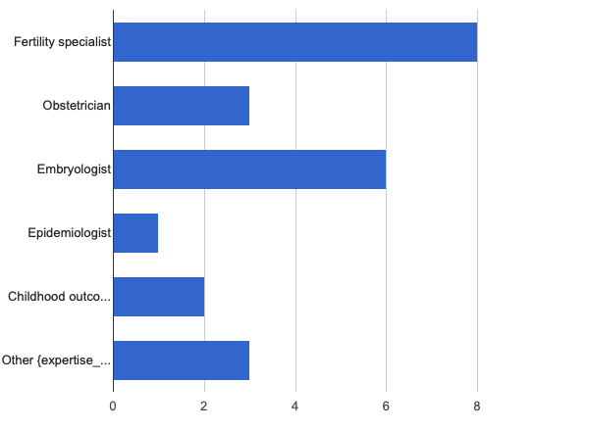
Other Reponses:
- Biostatistician
- Researcher
- O&G Registrar

Round 2
AIM 1:

AIM: To define which indications for intracytoplasmic sperm injection (ICSI) are “absolute” (fertilisation would not occur without ICSI) and which are “moderate” (where ICSI might be preferred but is non-essential).

This is not my area of expertise:
QUESTION 1
Based on a clear demonstration of consensus in responses to round 1, the current list of absolute indications (where standard insemination would not be possible) is:

- Surgically extracted sperm (e.g., PESA, TESA, micro TESA)
- Severe male factor infertility (e.g., OAT oligoasthenoteratozoospermia)
- Oocyte thaw cycle

(Additional variables may be added after this round).

Do you agree?
YES | NO
Not area of expertise (for round 1): n= 4
Result:
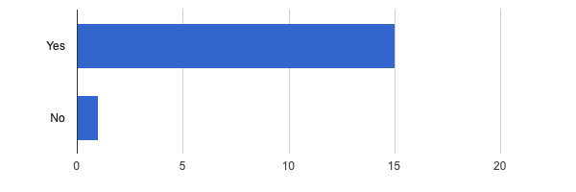
Missing = 0

QUESTION 2
Regarding poor sperm parameters after prep on day of collection:

The majority of respondents agreed that a TMSC <2 mil (after sperm prep on the day of egg collection) would mandate conversion to ICSI.

Some reported that consideration is given to number of eggs collected and some reported slightly higher cut-offs e.g., 3-5 million.

For the purposes of this study, a defined a cut off is required – as these patients will be excluded from analysis 1, and included in the “exposed” arm of analysis 2 (see SAP).

Do you agree a post prep TMSC of < 2 million is a reasonable cut off to indicate ICSI is “absolutely” indicated?
YES | NO
Results:
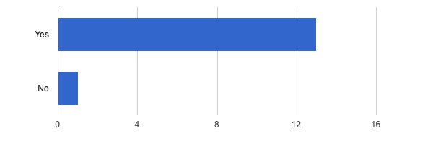
Missing = 2

The following additional variables have been suggested by survey respondents in Round 1:

For each of the following scenarios, please indicate if ICSI for oocyte fertilisation is:
- “Absolutely” indicated (standard insemination not possible)
- “Moderately” indicated (i.e., ICSI is preferred method and standard insemination could achieve fertilisation but may not be desirable,)
- “Not indicated” (ICSI is not required, but may be used empirically)

3: Cycles with PGT-M or PGT-SR
A) Absolutely indicated | B)Moderately indicated | C) ICSI not required
Results:
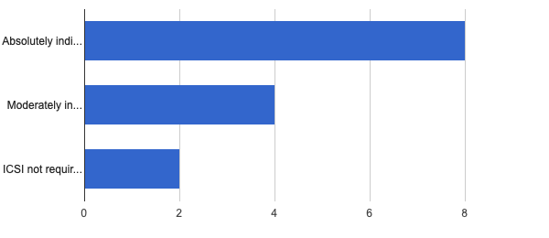
Missing = 2
4: Cycles with PGT - A
A) Absolutely indicated | B)Moderately indicated | C) ICSI Not required
Results:
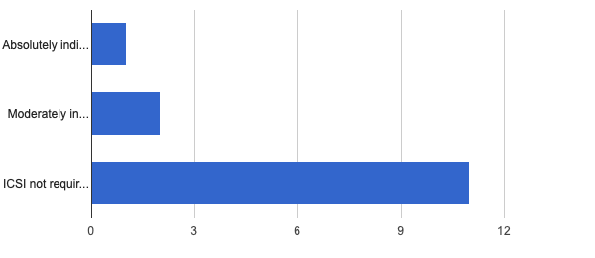
Missing = 2

5: Patients where the female partner is of advanced maternal age
A) Absolutely indicated | B)Moderately indicated | C) ICSI Not required
Results:
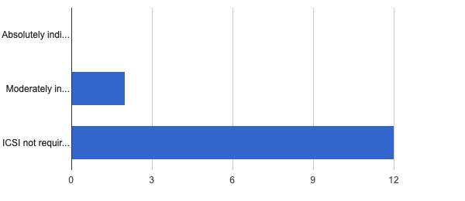
Missing = 2
6: Egg donor cycles
A) Absolutely indicated | B) Moderately indicated | C) ICSI Not required
Results:
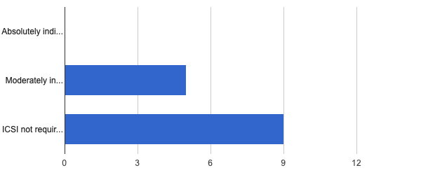
Missing = 2
7: Presence of Anti-Sperm antibodies
A) Absolutely indicated | B) Moderately indicated | C) ICSI Not required
Results:
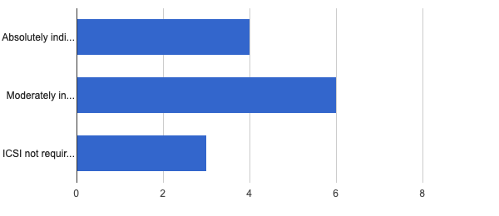
Missing = 3
AIM 2:
AIM: To develop a directed acyclic graph (DAG) describing the relationship between the exposure (ICSI) and the outcome (school-age development and educational outcomes). These variables are to be determined by prior evidence and expert knowledge and not determined by our data.

The following list of variables will be used in the DAG to describe the causal effect of ISCI (exposure) on school-age developmental and educational outcomes (outcome).

Question 1
Factors associated with the outcome by clear consensus:
1: Childs age at assessment
2: Sex at birth
3: Birthweight centile
4: Gestational age at delivery
5: Mode of delivery
6: Level of maternal education
7: Maternal age
8: Family SEIFA quintile (socioeconomic status)
9: Language background other than English (child)
11: Maternal Body Mass Index
12: Parity
13: Parents overseas born
15: Second parent level of education
14: Occupation of both parents

Do you agree with this list?
YES | NO
Results:
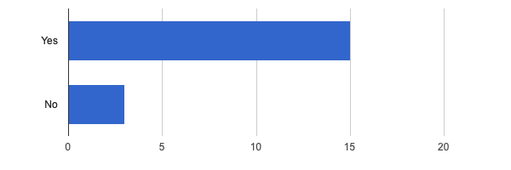
Missing = 2

Question 2
Variables from this list are associated with the outcome and also may be mediators of the exposure (because they occur after the exposure they can not be confounders).

Please consider if you believe these variables either:
A) influence the outcome only and are independent of the exposure
(i.e., are not influenced by mode of fertilisation (ICSI vs standard IVF)
or
B) could be a mediator i.e., influence the outcome and influenced by the fertilisation method.

e.g., some studies suggest adverse perinatal outcomes are actually less likely in cases of ICSI, but this may be due to patient factors not the actual effect of the fertilisation method.

Birthweight centile
A) Outcome | B) Mediator | C) unsure | E) Non expert
Results:
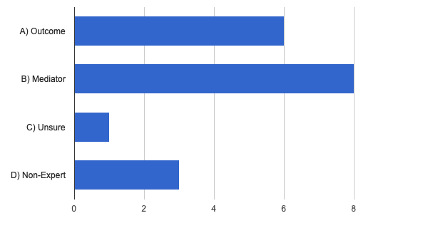
Missing = 2
Gestational age at delivery
A) Outcome | B) Mediator | C) unsure | E) Non expert
Results:
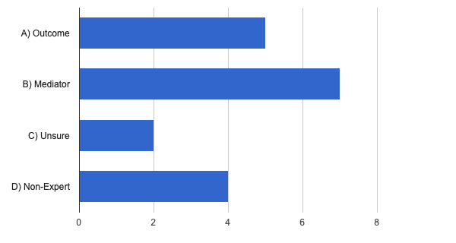
Missing = 2

Mode of delivery
A) Outcome | B) Mediator | C) unsure | E) Non expert
Results:
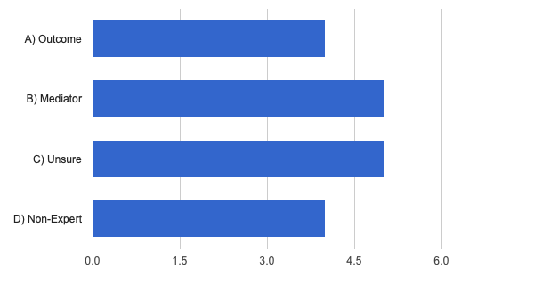
Missing = 2
Question 3
Variables from this list are associated with the outcome and additionally may be associated with the exposure.

Please consider if you believe these variables either:
A) influence the outcome only and are independent of the exposure
(i.e., do not influenced mode of fertilisation (ICSI vs standard IVF)

or

B) could be a confounder i.e., influence the outcome and influenced the exposure (fertilisation method).

Or

if you are unsure if there is an association or not with the exposure -> c) unsure

e.g., maternal age may both increase the use of ICSI and have an effect on school age outcomes in offspring.

Level of maternal education
A) Outcome | B) Both | C) unsure | D) Non expert
Results:
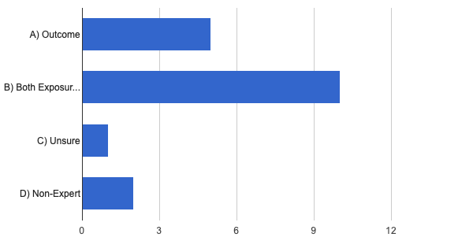
Maternal age
A) Outcome | B) Both | C) unsure | D) Non expert
Results:
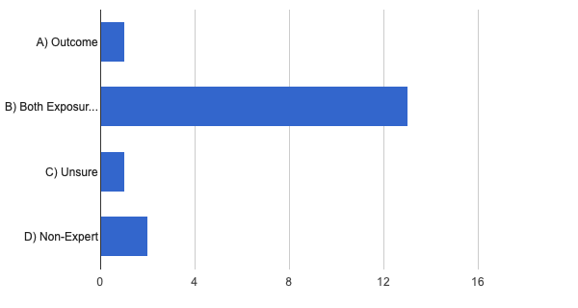
Missing = 3

Family SEIFA quintile (socioeconomic status)
A) Outcome | B) Both | C) unsure | D) Non expert
Results:
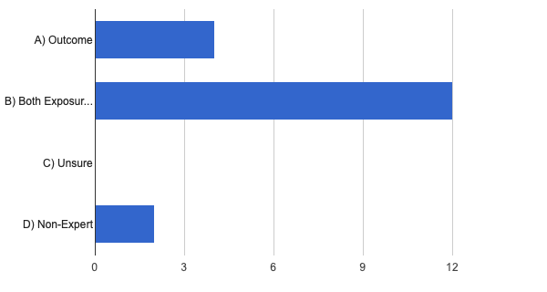
Missing = 2
8: Language background other than English (child)
A) Outcome | B) Both | C) unsure | D) Non expert
Results:
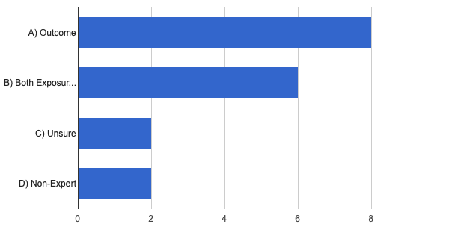
Missing = 2

9: Aboriginal and Torres Strait Islander status (mother & child)
A) Outcome | B) Both | C) unsure | D) Non expert
Results:
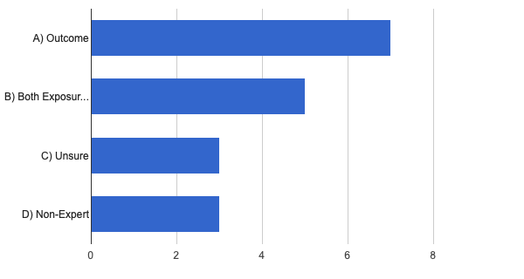
Missing = 2
10: Parents overseas born
A) Outcome | B) Both | C) unsure | D) Non expert
Results:
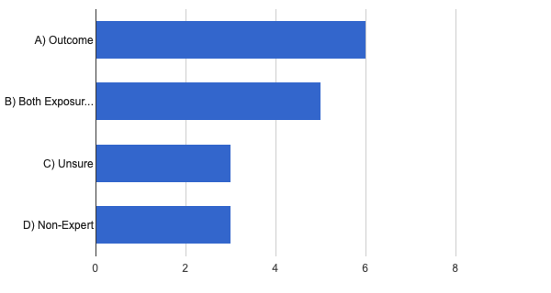
Missing = 3

11: Occupation of both parents
A) Outcome | B) Both |  | C) unsure | D) Non expert
Results:
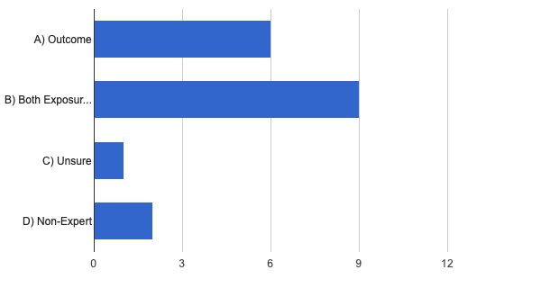
Missing = 2
12: Second parent level of education
A) Outcome | B) Both |  | C) unsure | D) Non expert
Results:
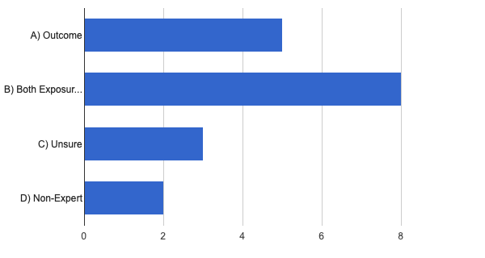
Missing = 2
Question 4
Factors clearly associated with the exposure (increase ICSI use by consensus).
1: Male factor infertility
2: Testicular sperm
3: Severe male factor infertility (e.g., OAT, oligoasthenoteratozoospermia)
4: Low oocyte count at egg collection
5: Previous failed fertilisation
6: Other poor prognosis – female (e.g., poor egg quality)
7: Poor sperm preparation on day of egg collection
8: Oocyte thaw cycle (VOT)
9: Donor sperm
10: Unexplained infertility

The survey has clearly demonstrated that each of these factors would likely increase the use of ICSI – i.e., each factor is a determinant of the exposure.

Do you agree with this list?
YES |  | NO
Results:
Missing = 2
There is some controversy in the literature, and indeed within this Delphi survey, whether or not the variables listed in Q3 are also related to the outcome (school age development and education outcomes).

For most variables majority responded A) exposure (only) and with some responding C) both.

Whilst this is not clearly established in the literature, where adverse outcomes are found in association with ICSI, it has been hypothesised that the indication or the “infertile” male behind the ICSI is the underlying reason for the difference in outcomes.

e.g., Testicular sperm increases the use of ICSI and have may have an effect on school age outcomes in offspring. Sandin et al 2013 https://www.ncbi.nlm.nih.gov/pubmed/23821091

This question/and the effect of these variables on the outcome will be explored in analysis 2.

Round 3
AIM 1:

AIM: To define which indications for intracytoplasmic sperm injection (ICSI) are “absolute” (fertilisation would not occur without ICSI) and which are “moderate” (where ICSI might be preferred but is non-essential).

This is not my area of expertise:
QUESTION 1
Based on a clear demonstration of consensus in responses to round 1, the current list of absolute indications (where standard insemination would not be possible) is:

- Surgically extracted sperm (e.g., PESA, TESA, micro TESA)
- Severe male factor infertility (e.g., OAT oligoasthenoteratozoospermia)
- Oocyte thaw cycle
- PGT-M/SR (though we acknowledge that ICSI not required for fertilisation it is universally used – thus cannot include as violates positivity (probability of not receiving exposure = 0)
- Day of egg collection - post prep TMSC of < 2 million

Do you agree?
YES | NO
Results:
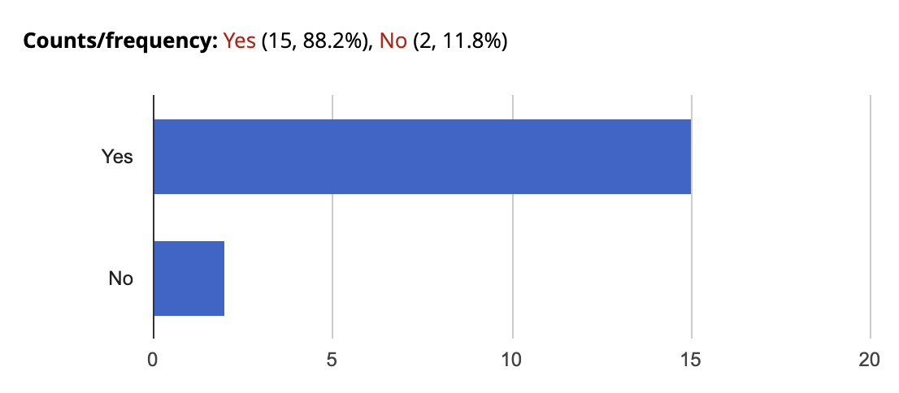

AIM 2:

AIM: To develop a directed acyclic graph (DAG) describing the relationship between the exposure (ICSI) and the outcome (school-age development and educational outcomes). These variables are to be determined by prior evidence and expert knowledge and not determined by our data.

The following DAG has been developed to describe structure of the relationship between the variables to determine the causal effect of ISCI (exposure) on school-age developmental and educational outcomes (outcome).

Question 1
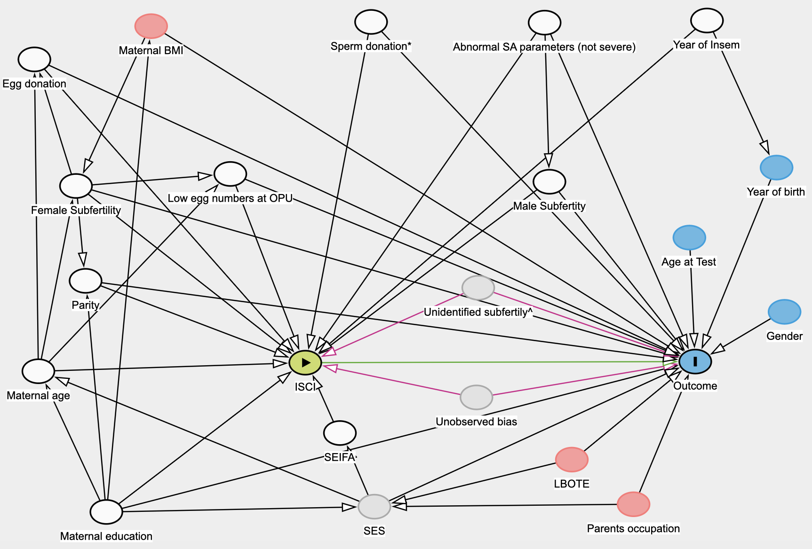
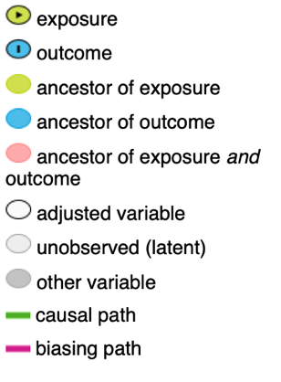
Note:
White nodes indicate adjustment set (the variables required in the model to control back door paths).
Red nodes may be included in adjustment model to improve modelling.
^ cases where incomplete data entry means we cannot determine ICSI indication
* Donor sperm will be excluded if very low frequency of standard insemination (i.e., violates positivity).
Do you agree with this DAG?
YES | NO | Unable to give expert opinion
Results:

