Covariate balance diagnostics across exposure groups

Sample of six randomly selected datasets from the 2000 (BS = 1000 and M =2) used in the analysis. BS1M1 presents both numeric and graphical results the remainder are numeric results only.

Covariate balance summary (BS =1, M=1)
-----------------------------------------------------------------
|Standardized differences Variance ratio
| Raw Weighted Raw Weighted
----------------+------------------------------------------------
L1_sex | -.1150016 -.0916843 1.002917 1.000062
L1_agefeb1 | -.0258976 -.0041776 .8893689 .9527537
L1_lbote | .0836007 .0044349 1.196749 1.009443
L1_seifa5 | -.0601867 -.0043645 1.055003 .9956346
L1_matage2 | -.0544309 -.0870063 .9592454 .927036
L1_parity | .0197837 -.0205887 .992554 .8891604
|
L2_aedc_year |
2015 | -.1571921 -.2402642 .8790681 .8326081
2018 | .1767377 .1243794 1.082038 1.055662
|
L2_P1schooled | -.0820707 .0653285 1.349586 .9489987
L2_P1postschool | -.0771985 .0297522 1.01462 .9188409
L1_malefactor~d | .9004006 -.0175096 4.493754 .9817549
L1_femalefactor | .2031547 .0288287 .9527723 .9337221
-----------------------------------------------------------------

Raw and IPW weighted covariate Kernel density plots by exposure group:
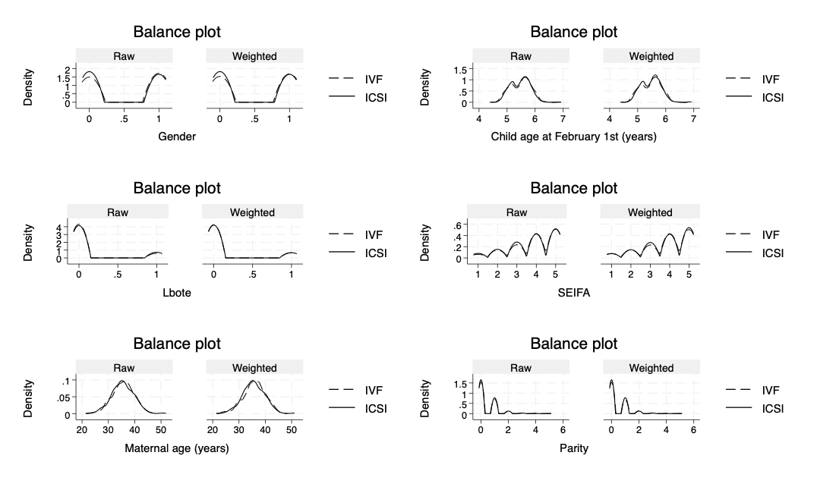

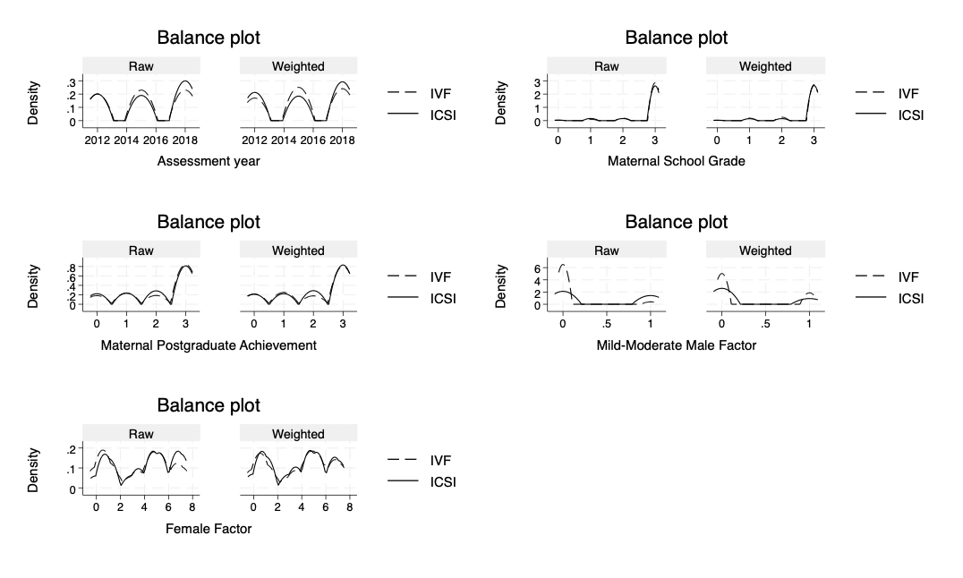
Covariate balance summary (BS =10, M=2)
-----------------------------------------------------------------
|Standardized differences Variance ratio
| Raw Weighted Raw Weighted
----------------+------------------------------------------------
L1_sex | -.1202742 -.1116183 1.007365 1.011899
L1_agefeb1 | .0003917 .0505803 .9868297 1.092066
L1_lbote | .0833506 -.0011339 1.200723 .9975665
L1_seifa5 | -.0447068 .0020431 1.142516 1.067861
L1_matage2 | -.0756888 -.1065165 1.071793 1.08059
L1_parity | .0133402 .0120999 1.02861 1.060449
|
L2_aedc_year |
2015 | -.0967602 -.1529834 .9215066 .888108
2018 | .166109 .0533321 1.071804 1.019709
|
L2_P1schooled | .0113162 .0227208 .9545274 .946284
L2_P1postschool | -.0599852 -.0606944 .9692552 .9747106
L1_malefactor~d | .9827673 -.0222671 5.691872 .9776075
L1_femalefactor | .2496325 .059837 .8997207 .9372725
-----------------------------------------------------------------

Covariate balance summary (BS =37, M=2)
-----------------------------------------------------------------
|Standardized differences Variance ratio
| Raw Weighted Raw Weighted
----------------+------------------------------------------------
L1_sex | -.1250263 -.0794533 1.006339 .9996373
L1_agefeb1 | -.0427581 .0105562 .8679264 .8689607
L1_lbote | .0036275 .0051444 1.007627 1.011147
L1_seifa5 | -.0529038 .0085143 1.053169 1.049944
L1_matage2 | -.0708568 -.0440126 .9628668 .9678
L1_parity | .0384866 -.0098861 1.158039 1.028042
|
L2_aedc_year |
2015 | -.1505941 -.2458318 .8919045 .8448398
2018 | .1610103 .1178088 1.075202 1.053279
|
L2_P1schooled | -.1293063 .0789843 1.597298 .8995974
L2_P1postschool | -.1183087 .0202408 1.127834 1.009175
L1_malefactor~d | .9897235 -.0339604 5.491858 .9668572
L1_femalefactor | .2690105 .0412012 .9349385 .9713819
-----------------------------------------------------------------

Covariate balance summary (BS =289, M=1)
-----------------------------------------------------------------
|Standardized differences Variance ratio
| Raw Weighted Raw Weighted
----------------+------------------------------------------------
L1_sex | -.1506584 -.0812882 1.02461 1.009797
L1_agefeb1 | -.0488092 .0397215 .9723155 .9764155
L1_lbote | .0942456 -.0863075 1.222241 .8472874
L1_seifa5 | -.087567 .0352988 1.101192 1.016492
L1_matage2 | -.0801036 -.0384528 1.038241 .969724
L1_parity | .0196338 .0171181 .9846612 1.018636
|
L2_aedc_year |
2015 | -.0729037 -.1822268 .9488752 .8950794
2018 | .1566287 .0573285 1.083348 1.027928
|
L2_P1schooled | -.0849214 -.0121455 1.27712 1.147582
L2_P1postschool | -.1656731 -.0324167 1.125213 .989556
L1_malefactor~d | .9527202 -.0543638 4.668494 .949851
L1_femalefactor | .2445077 .0406577 .9792582 .9864395
-----------------------------------------------------------------

Covariate balance summary (BS =746, M=2)
-----------------------------------------------------------------
|Standardized differences Variance ratio
| Raw Weighted Raw Weighted
----------------+------------------------------------------------
L1_sex | -.087606 -.0294191 1.003066 .9994325
L1_agefeb1 | -.0646599 .0023357 .9730944 .97911
L1_lbote | -.0210868 -.0382275 .9532561 .9194624
L1_seifa5 | -.0410207 -.0319012 1.092974 1.191783
L1_matage2 | -.0613898 -.0914017 1.079667 1.110011
L1_parity | .0603394 -.0307921 1.130435 1.045227
|
L2_aedc_year |
2015 | -.1178142 -.1805827 .9041174 .8629491
2018 | .2005112 .0822193 1.099468 1.036146
|
L2_P1schooled | -.0010928 -.0027438 1.061541 1.129496
L2_P1postschool | -.0250159 .0039347 1.014697 1.005948
L1_malefactor~d | .9412757 -.0278166 5.940065 .9699829
L1_femalefactor | .2350205 .0486189 .9673579 .9982544
-----------------------------------------------------------------

Covariate balance summary (BS =987, M=1)
-----------------------------------------------------------------
|Standardized differences Variance ratio
| Raw Weighted Raw Weighted
----------------+------------------------------------------------
L1_sex | -.1152042 -.0846903 1.010331 1.007341
L1_agefeb1 | -.0238725 .0303637 1.044715 1.087252
L1_lbote | -.0018505 .0078585 .9959171 1.017099
L1_seifa5 | -.0298582 -.0155679 1.161366 1.097079
L1_matage2 | -.0422635 -.0506688 .9655682 1.012932
L1_parity | .0317501 -.042856 1.050631 .9937615
|
L2_aedc_year |
2015 | -.095053 -.163185 .9254426 .8846348
2018 | .163973 .0718627 1.073059 1.029588
|
L2_P1schooled | -.0674963 .0025557 1.280194 1.084783
L2_P1postschool | -.1218937 -.0255497 1.072451 .9723007
L1_malefactor~d | .9360766 -.0390973 5.664455 .9576056
L1_femalefactor | .2710319 .0645238 .9108355 .9393442
-----------------------------------------------------------------
Bootstrap dataset 987, imputation 1

