Table of contents
Fig. S1 Typical imaging of complete response of metastatic lesions.
Fig. S2 Cochran-Armitage trend test to assess the relationship between the response and, A plasma EBV DNA level at baseline by cut-off of 3000 copies/mL; B decrease of plasma EBV DNA level from baseline to the first post-treatment assessment by cut-off of 50%; C internal duration from latest immunotherapy by cut-off of median time of patients; and D best previous immunotherapy efficacy.
Fig. S3 Kaplan-Meier plots of progression-free survival (PFS) and overall survival (OS). A and B, PFS and OS stratified by the plasma EBV DNA level at baseline (cut-off of 3000 copies/mL); C and D, PFS and OS stratified by the decrease of plasma EBV DNA level from baseline to the first post-treatment assessment (cut-off of 50%).
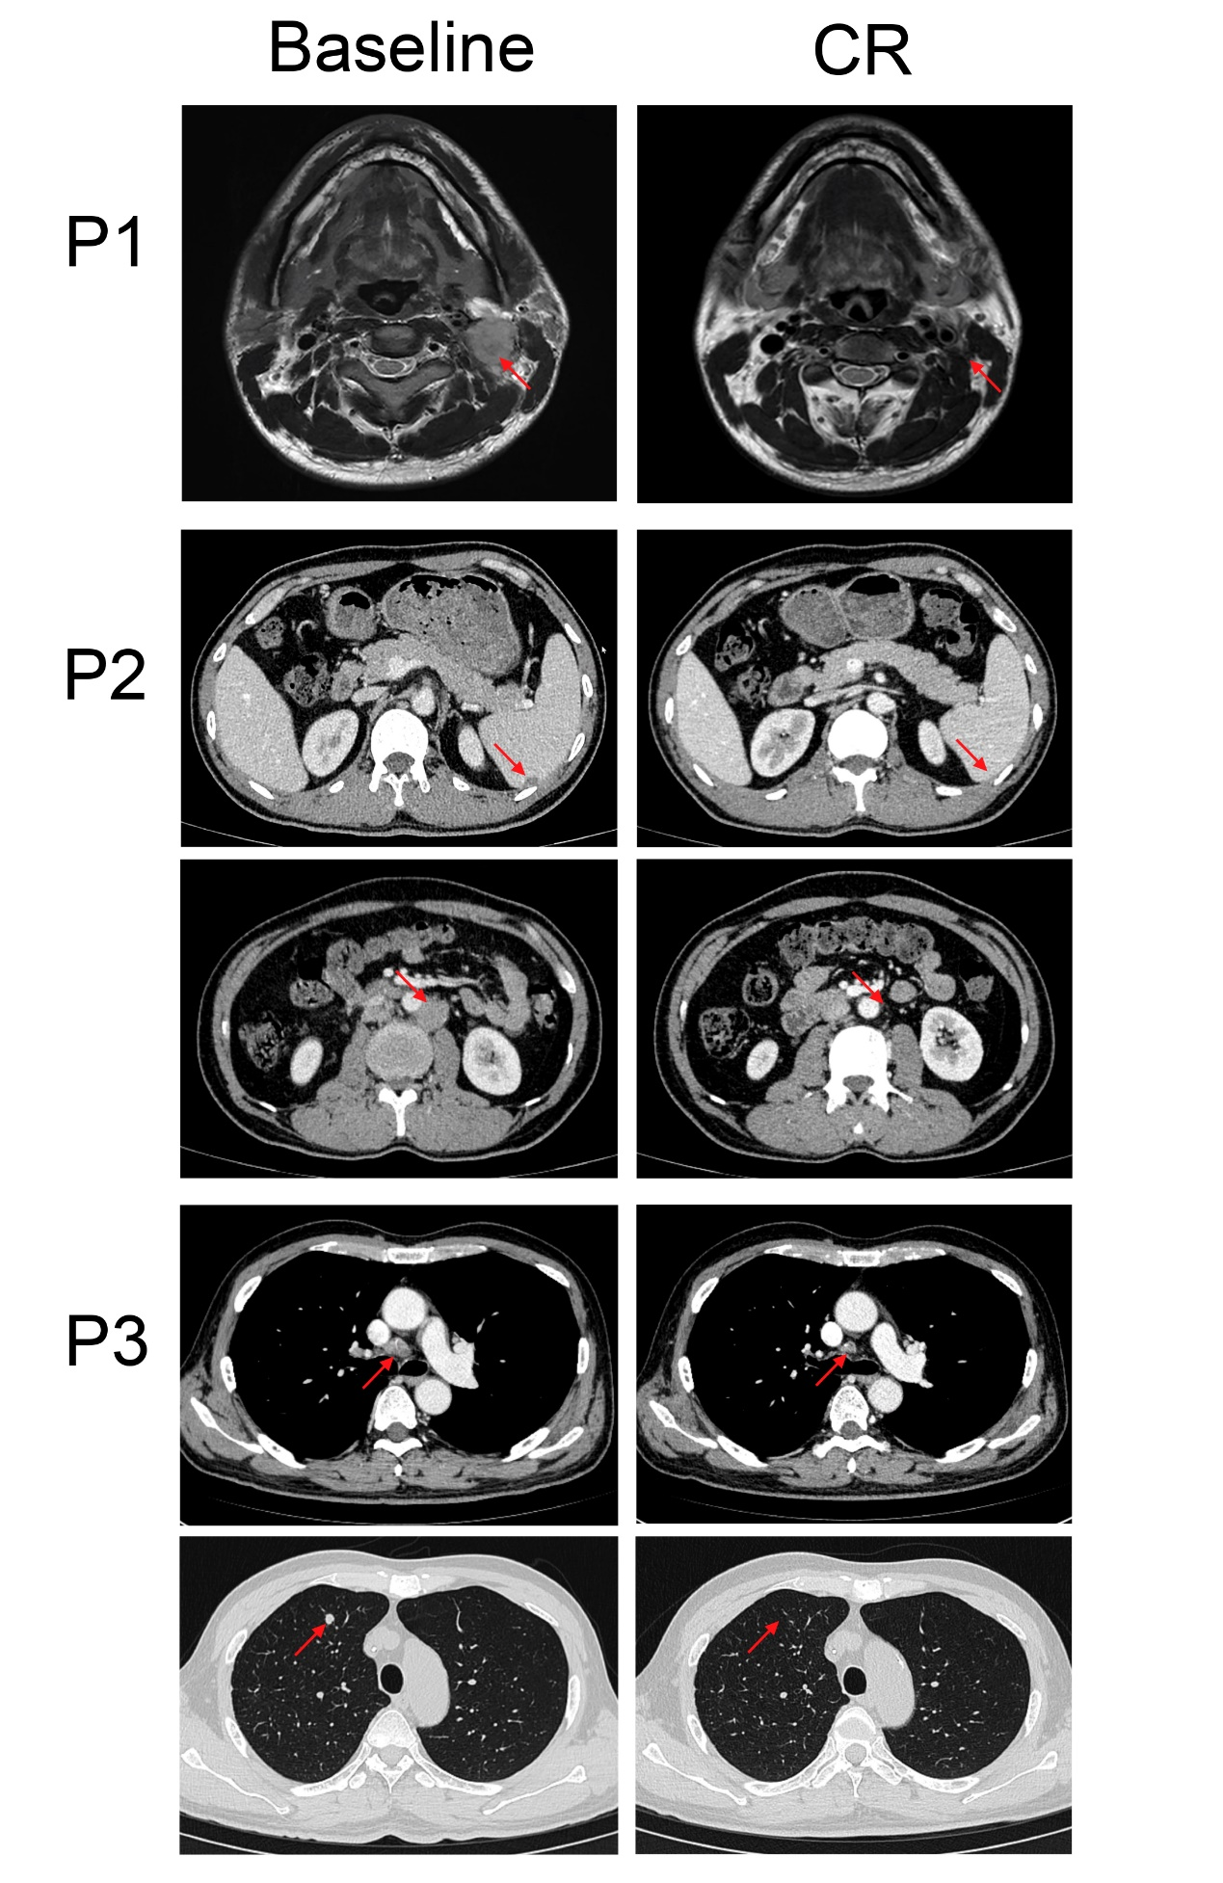
Fig. S1 Typical imaging of complete response of metastatic lesions.

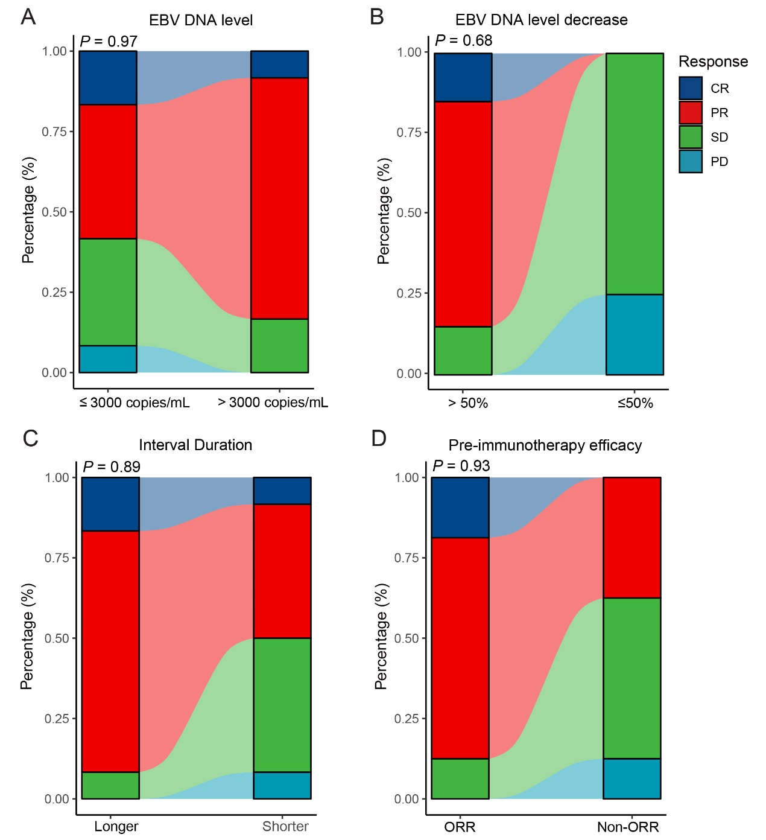
Fig. S2 Cochran-Armitage trend test to assess the relationship between the response and, A plasma EBV DNA level at baseline by cut-off of 3000 copies/mL; B decrease of EBV DNA level from baseline to the first post-treatment assessment by cut-off of 50%; C internal duration from latest immunotherapy by cut-off of median time of patients; and D best previous immunotherapy efficacy.

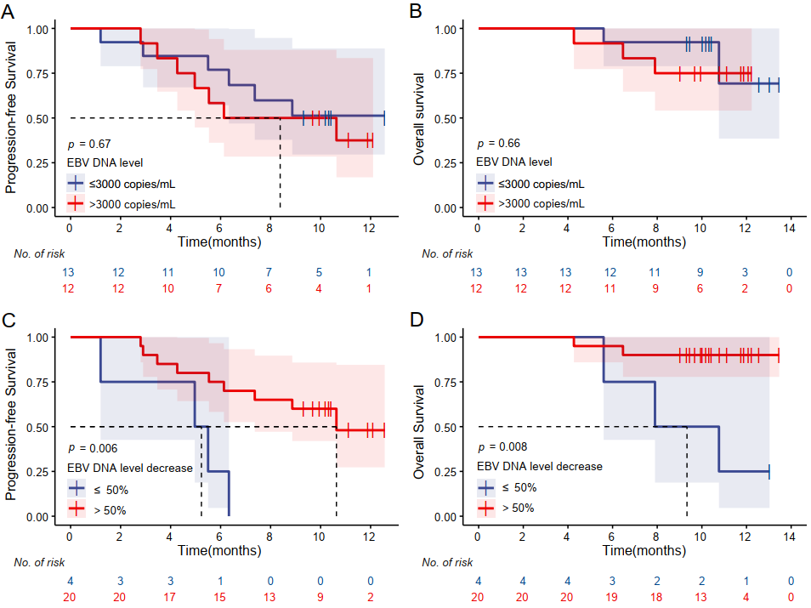
Fig. S3 Kaplan-Meier plots of progression-free survival (PFS) and overall survival (OS). A and B, PFS and OS stratified by the plasma EBV DNA level at baseline (cut-off of 3000 copies/mL); C and D, PFS and OS stratified by the decrease of plasma EBV DNA level from baseline to the first post-treatment assessment (cut-off of 50%).

