Additional file 1

Therapeutic Hypothermia in Patients with Acute Myocardial Infarction Complicated by Out-of-Hospital Cardiac Arrest
Oh-Hyun Lee, MD; Seok-Jae Heo, PhD; Moon-Hyun Kim, MD; Je-Wook Park, MD; SungA Bae, MD; Minkwan Kim, MD; Ji Woong Roh, MD; Yongcheol Kim, MD; Eui Im, MD; In Hyun Jung, MD; Deok-Kyu Cho, MD
CONTENTS
Table S1. Annual trends of ambulance transfers and medical record investigations for patients with out-of-hospital cardiac arrest in Republic of Korea.......................................1
Table S2. Baseline characteristics after inverse probability of treatment weighting.........2
Table S3. Comparison of clinical outcome according to the target temperature……...…5
Table S4. Comparison of clinical outcome according to the duration of therapeutic hypothermia…………………………………………………………………….…………….6
Table S5. Key randomized controlled trials on hypothermia in patients with OHCA…7
Figure S1. Propensity score distribution before (A) and after IPTW (B).........................9
Figure S2. Subgroup analysis for in-hospital mortality and poor neurological outcomes.................................................................................................................................10
Table S1. Annual trends of ambulance transfers and medical record investigations for patients with out-of-hospital cardiac arrest in Republic of Korea
 |  | 2006 | 2007 | 2008 | 2009 | 2010 | 2011 | 2012 | 2013
Ambulance  Transfer | hospitals | 812 | 757 | 708 | 742 | 757 | 739 | 712 | 661
Ambulance  Transfer | patients | 19,480 | 20,353 | 21,905 | 24,442 | 25,909 | 26,382 | 27,823 | 29,356
Medical record  investigation | hospitals | 616 | 619 | 634 | 623 | 644 | 585 | 593 | 575
Medical record  investigation | patients | 16,348 | 18,060 | 20,091 | 22,667 | 24,479 | 24,902 | 26,531 | 28,170

 |  | 2014 | 2015 | 2016 | 2017 | 2018 | 2019 | 2020 | 2021
Ambulance  Transfer | hospitals | 644 | 590 | 556 | 536 | 492 | 476 | 454 | 440
Ambulance  Transfer | patients | 30,309 | 30,771 | 29,832 | 29,262 | 30,539 | 30,782 | 31,652 | 33,235
Medical record  investigation | hospitals | 566 | 547 | 505 | 514 | 477 | 458 | 446 | 433
Medical record  investigation | patients | 29,282 | 29,959 | 28,963 | 28,629 | 30,179 | 30,279 | 31,417 | 33,041

Table S2. Baseline characteristics after inverse probability of treatment weighting
 | Hypothermia  (N=624) | No hypothermia  (N=2,301) | SMD
Demographics
Age, y | 62.2 ± 12.0 | 62.6 ± 12.3 | 0.004
Sex, male | 542 (86.8) | 1,992 (86.6) | 0.006
Comorbidities
Hypertension | 280 (44.8) | 1,038 (45.1) | 0.006
Diabetes mellitus | 178 (28.5) | 667 (29) | 0.010
Cardiovascular disease | 146 (23.4) | 520 (22.6) | 0.017
Ischemic heart disease | 121 (19.4) | 448 (19.4) | 0.001
Valvular heart disease | 4 (0.5) | 7 (0.3) | 0.037
Arrhythmia | 21 (3.2) | 74 (3.2) | 0.003
Heart failure | 14 (2.2) | 64 (2.8) | 0.039
Cerebrovascular disease | 48 (7.7) | 179 (7.8) | 0.004
Chronic kidney disease | 37 (6.0) | 129 (5.6) | 0.017
Chronic lung disease | 19 (3.1) | 71 (3.1) | 0.002
Characteristics of cardiac arrest
Place of cardiac arrest |  |  | 0.006
Public place | 214 (34.2) | 784 (34.1)
Non-public place | 278 (44.5) | 1,031 (44.8)
Unknown | 132 (21.2) | 486 (21.1)
Witness type |  |  | 0.015
Healthcare professional | 106 (16.9) | 377 (16.4)
Bystander | 370 (59.4) | 1,373 (59.7)
Unknown | 148 (23.7) | 552 (24.0)
Layperson witnessed | 490 (78.5) | 1,807 (78.6) | 0.002
Bystander-performed CPR | 322 (51.6) | 1,183 (51.4) | 0.003
Telemetric monitoring before EMS | 427 (68.4) | 1,574 (68.4) | <0.001
Initial EMS rhythm |  |  | 0.011
Shockable rhythm | 459 (73.5) | 1,695 (73.7)
Nonshockable rhythm | 155 (24.8) | 571 (24.8)
Unknown | 10 (1.7) | 35 (1.5)
AED usage | 482 (77.3) | 1,785 (77.6) | 0.008
Arrest to admission timeline
Arrest-to-call time, min | 0 (0-2) | 0 (0-2) | 0.011
Call-to-door time, min | 30 (24-38) | 31 (26-38) | 0.006
Arrest-to-door time, min | 30 (23-39) | 31 (25-40) | 0.071
PCI timeline
Door-to-PPCI time, min | 99 (73-139) | 107 (74-162) | 0.064
Procedure time, min | 23 (14-41) | 23 (13-37) | 0.069
Characteristics on ER admission
Initial ECG rhythm |  |  | 0.027
Post ROSC rhythm | 318 (51.0) | 1143 (49.7)
Shockable rhythm | 71 (11.3) | 263 (11.4)
Non-shockable rhythm | 178 (28.6) | 674 (29.3)
No record | 57 (9.2) | 220 (9.6)
Defibrillation at ER | 208 (33.3) | 762 (33.1) | 0.004
Total CPR time at ER, min | 4 (0-19) | 4 (0-19) | 0.012
ROSC before ER admission | 289 (46.3) | 1,041 (45.2) | 0.021
Therapeutic interventions
ECMO | 133 (21.3) | 482 (20.9) | 0.010
Values are mean ± SD or n (%).
AED, automated external defibrillator; CPR, cardiopulmonary resuscitation; ECG, electrocardiogram; ECMO, extracorporeal membrane oxygenation; EMS, emergency medical service; ER, emergency room; PCI, percutaneous coronary intervention; ROSC, return of spontaneous circulation; SMD, standardized mean difference.
Table S3. Comparison of clinical outcome according to the target temperature
 | Target temperature, 33℃  (N=523) | Target temperature, 36℃  (N=101) | Unadjusted |  | *Multivariable-adjusted |  | IPTW-adjusted
 | Target temperature, 33℃  (N=523) | Target temperature, 36℃  (N=101) | OR (95% CI) | P value | OR (95% CI) | P value | OR (95% CI) | P value
Mortality outcomes
Death within discharge | 183 (35.0) | 36 (35.6) | 0.97 (0.63-1.53) | 0.900 | 1.29 (0.75-2.27) | 0.367 | 1.06 (0.82-1.38) | 0.641
Neurologic outcomes
Poor outcome (CPC 3, 4, 5) | 301 (57.6) | 55 (54.5) | 1.13 (0.74-1.74) | 0.565 | 1.54 (0.88-2.72) | 0.316 | 1.31 (1.04-1.62) | 0.148
*Adjusted variable: age, sex, location at cardiac arrest, bystander-witnessed, bystander-performed CPR, telemetric advice to first aid before EMS, initial EMS rhythm, defibrillation before ER admission, ROSC before ER admission, initial ECG rhythm, defibrillation, total CPR time, defibrillation at ER, ECMO.
Values are n (%, cumulative incidence) unless otherwise indicated. CI, confidence interval- CPC, cerebral performance category- CtD, call-to-door, HR, hazard ratio, OR, odds ratio.
CI, confidence interval; CPC, cerebral performance category; CPR, cardiopulmonary resuscitation; ECG, electrocardiogram; ECMO, extracorporeal membrane oxygenation; EMS, emergency medical service; ER, emergency room; IPTW, Inverse probability of treatment weighting; OR, odds ratio; ROSC, return of spontaneous circulation.
Table S4. Comparison of clinical outcome according to the duration of therapeutic hypothermia
 | 24 hours  (N=374) | 48 hours  (N=125) | Unadjusted |  | *Multivariable-adjusted |  | IPTW-adjusted
 | 24 hours  (N=374) | 48 hours  (N=125) | OR (95% CI) | P value | OR (95% CI) | P value | OR (95% CI) | P value
Mortality outcomes
Death within discharge | 103 (27.5) | 36 (28.8) | 1.06 (0.67-1.66) | 0.786 | 1.11 (0.65-1.88) | 0.708 | 1.05 (0.79-1.41) | 0.731
Neurologic outcomes
Poor outcome (CPC 3, 4, 5) | 197 (52.7) | 63 (50.4) | 0.91 (0.61-1.37) | 0.660 | 0.92 (0.56-1.53) | 0.761 | 0.84 (0.66-1.08) | 0.177
*Adjusted variable: age, sex, location at cardiac arrest, bystander-witnessed, bystander-performed CPR, telemetric advice to first aid before EMS, initial EMS rhythm, defibrillation before ER admission, ROSC before ER admission, initial ECG rhythm, defibrillation, total CPR time, defibrillation at ER, ECMO.
Values are n (%, cumulative incidence) unless otherwise indicated. CI, confidence interval- CPC, cerebral performance category- CtD, call-to-door, HR, hazard ratio, OR, odds ratio.
CI, confidence interval; CPC, cerebral performance category; CPR, cardiopulmonary resuscitation; ECG, electrocardiogram; ECMO, extracorporeal membrane oxygenation; EMS, emergency medical service; ER, emergency room; IPTW, Inverse probability of treatment weighting; OR, odds ratio; ROSC, return of spontaneous circulation.
Table S5. Key randomized controlled trials on hypothermia in patients with OHCA
 | Study population | Sample size  (Study type) | Comparison | Center (Country) | Primary and key secondary endpoint
Bernard et al. 2002²² | OHCA with VF | 43 vs. 34  (Random) | Hypothermia (33℃) vs. Normothermia (37℃) | 4  (Australia) | *Survival to hospital discharge: 49% vs. 26% (adjusted OR, 5.25; 95% CI, 1.47 to 18.76)
HACA trial 2002²³ | OHCA with VF | 137 vs. 138  (Random) | Hypothermia (32-34℃) vs. Normothermia | 8  (Europe) | *Favorable neurologic outcome (CPC 1 or 2) within 6 months: 55% vs. 39% (RR, 1.40; 95% CI, 1.08 to 1.81)  Mortality at 6 months: 41% vs. 55% (RR, 0.74; 95% CI, 0.58 to 0.95)
TTM trial 2013²⁴ | OHCA of presumed cardiac cause | 473 vs. 466  (Random) | Hypothermia (33℃) vs. Normothermia (36℃) | 36 (Europe and Austria) | *Death at end of trial: 50% vs. 48% (HR, 1.06; 95% CI, 0.89 to 1.28)  Poor neurologic function (6-month): 54% vs. 52% (HR, 1.02; 95% CI, 0.88 to 1.16)
TTH48 trial 2017²⁵ | OHCA | 176 vs. 179 (Random) | Hypothermia (33℃) for 48 hrs vs. 24 hrs | 10 (Europe) | *Favorable neurologic outcome (CPC 1 or 2) within 6 months: 69% vs. 64% (RR, 1.08; 95% CI, 0.93 to 1.25)  Mortality at 6 months: 27% vs. 34% (RR, 0.81; 95% CI, 0.59 to 1.11)
HYPERION trial 2019²⁶ | OHCA with nonshockable rhythm | 284 vs. 297  (Random) | Hypothermia (33℃) vs. Normothermia (37℃) | 25  (France) | *Favorable neurologic outcome (CPC 1or 2) at 90 days: 10.2% vs. 5.7% (HR, 4.5; 95% CI 0.1 to 8.9)  Survival to hospital discharge: 19.7% vs. 16.8% (HR, 1.19; 95% CI, 0.81 to 1.74)
TTM2 trial 2021²⁷ | OHCA | 930 vs. 931  (Random) | Hypothermia (33℃) vs. Normothermia (37.5℃) | 65  (Global) | *Death at 6 months: 50% vs. 48% (RR, 1.04; 95% CI, 0.94 to 1.14)  **Poor functional outcome at 6 months: 55% vs. 55% (RR, 1.00; 95% CI 0.92 to 1.09)
* indicates primary endpoint
** Poor functional outcomes was defined as modified Rankin scale score 4 to 6
AMI, acute myocardial infarction; BOX, Blood Pressure and Oxygenation Targets in Post Resuscitation Care; CA, cardiac arrest; CI, condidence interval; CPC, Cerebral Performance Category; CS, cardiogenic shock; GOS, Glasgow Outcome Scale; HACA, Hypothermia After Cardiac Arrest; HR, hazard ratio; HYPERION, Therapeutic Hypothermia After Cardiac Arrest in Non Shockable Rhythm; OHCA, out-of-hospital cardiac arrest; OR, odds ratio; PCI, percutaneous coronary intervention; RR, relative risk; SHOCK-COOL, Mild Hypothermia in Cardiogenic Shock Complicating Myocardial Infarction; TTH48, Time-differentiated Therapeutic Hypothermia; TTM, Target Temperature Management 33°C versus 36°C after Out-of-Hospital Cardiac Arrest; TTM2, Targeted Hypothermia Versus Targeted Normothermia After Out-of-hospital Cardiac Arrest; VF, ventricular fibrillation

Figure S1. Propensity score distribution before (A) and after IPTW (B)

Figure S2. Subgroup analysis for in-hospital mortality and poor neurological outcomes
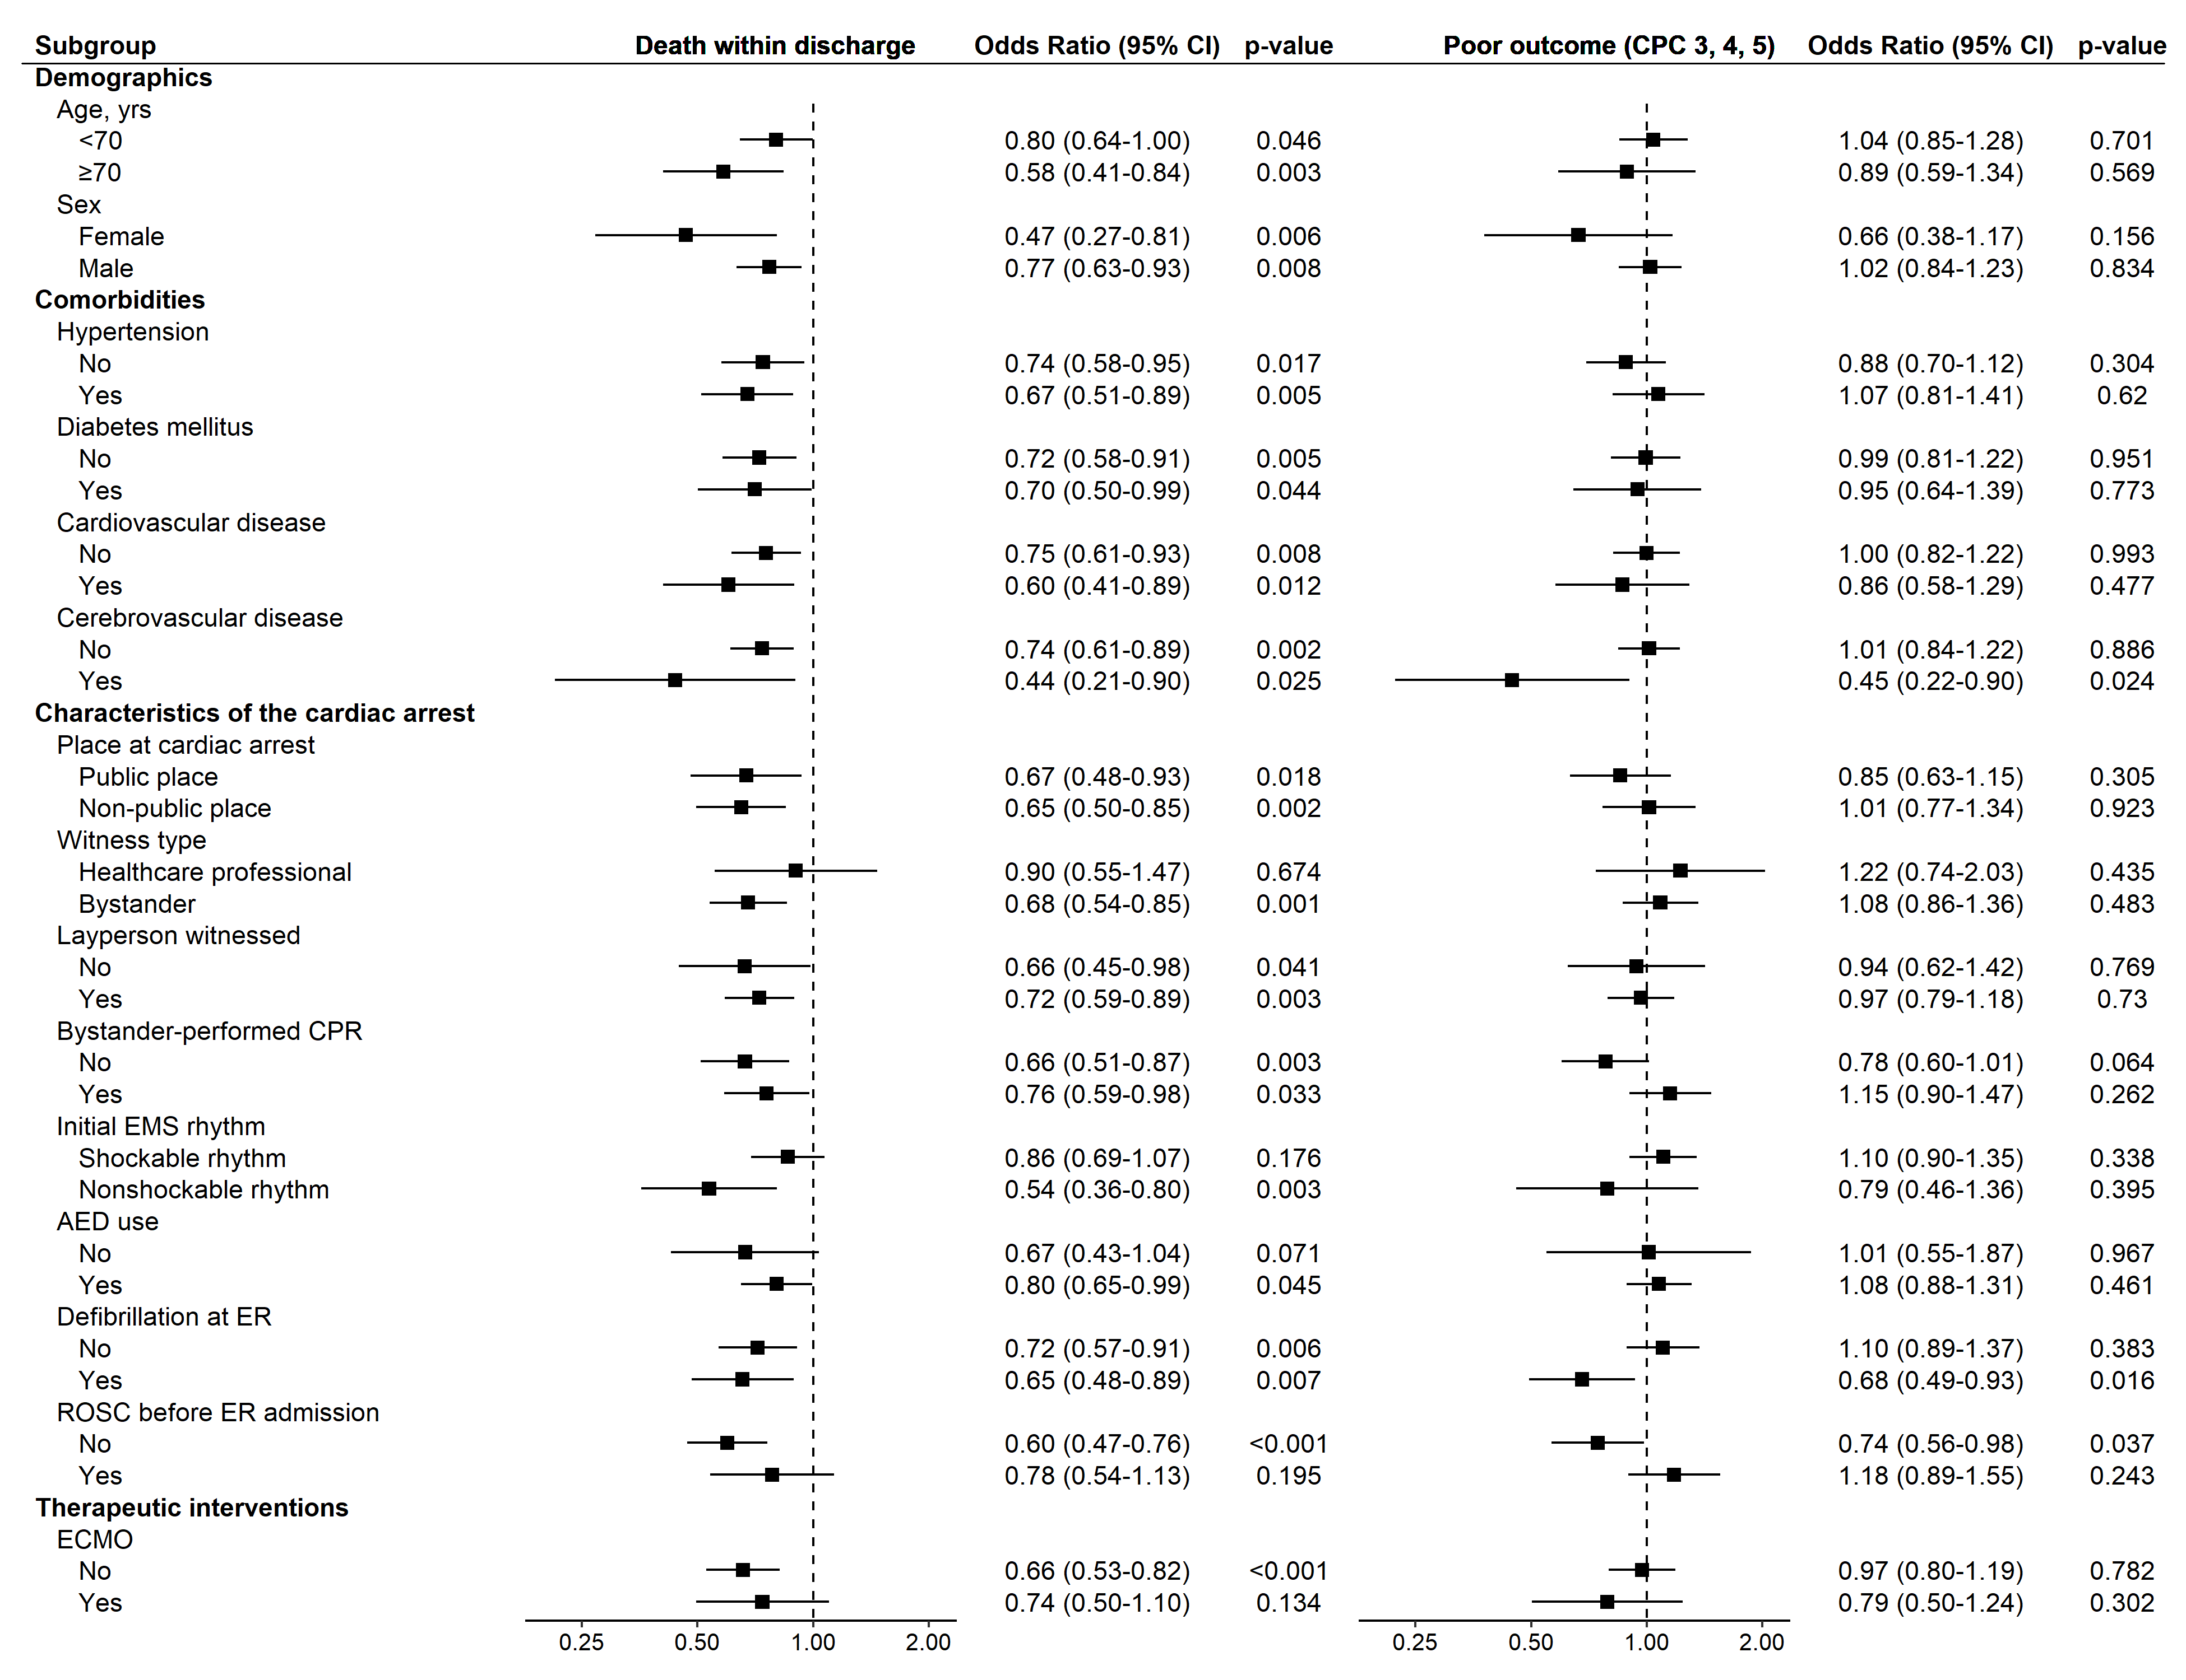
CPC, cerebral performance category; CPR, cardiopulmonary resuscitation; EMS, emergency medical service; AED, automated external defibrillator; ER, emergency room; ROSC, return of spontaneous circulation; ECMO, extracorporeal membrane oxygenation.

