Cancer risk subsequent to cardiovascular disease: A prospective population-based study and meta-analysis

Table S1 to S14
Table S1. International Classification of Diseases (ICD) codes for diagnoses used in this study
Table S2. Summary characteristics of the covariates obtained in UK Biobank
Table S3. Strategy for the literature search
Table S4. Incidence rate (IR) of cancer among CVD patients compared with non-CVD individuals in the UK Biobank
Table S5. Multivariable analysis of factors associated with cancer incidence among all CVD patients in the UK Biobank Cohort
Table S6. Risk of cancer among CVD patients compared with non-CVD individuals in the UK Biobank using competing risk model
Table S7. Risk of cancer among CVD patients compared with non-CVD individuals by different characteristics in the UK Biobank
Table S8. Sensitivity analysis of the UK Biobank on the all CVD-cancer subtypes and different CVD-cancers association
Table S9. Baseline characteristics of the 46 included studies in the meta-analysis
Table S10. A table of 313 unique outcomes information extracted from the 46 included studies and the UK Biobank
Table S11. Newcastle–Ottawa scale (NOS) score of the 46 included studies
Table S12. Summarized effect estimates for associations between specific CVD and cancer subtypes
Table S13. Subgroup analysis of the meta-analysis by sex based on available data
Table S14. Sensitivity analysis of the meta-analysis based on the all CVD-cancer subtypes and different CVD-cancers association
Figure S1 to S10
Figure S1. A. Diagram for participant selection in the UK Biobank; B. Diagram for study selection of the systematic review and meta-analysis
Figure S2. CVD subtypes associated cancer hazard ratios, as determined by Cox modelling
Figure S3. CVD subtypes associated cancer hazard ratios, as determined by competing risk modelling
Figure S4. Forest plots for associations between All CVD and cancer subtypes risk
Figure S5. Forest plots for associations between ischemic heart disease and cancer subtypes risk
Figure S6. Forest plots for associations between cerebrovascular disease and cancer subtypes risk
Figure S7. Forest plots for associations between heart failure and cancer subtypes risk
Figure S8. Forest plots for associations between arrhythmia/conduction disorder and cancer subtypes risk
Figure S9. Forest plots for associations between emboli/thrombosis and cancer subtypes risk
Figure S10. Funnel plots for meta-analyses with over 10 studies

Table S1. International Classification of Diseases (ICD) codes for diagnoses used in this study
 | ICD-9 | ICD-10
All cancer | 140-2089 | C00-C97
Breast cancer | 174 | C50
Prostate cancer | 185 | C61
Colorectal cancer | 153, 154 | C18-C21
Hematologic/lymphatic cancer | 2000-2089 | C81-C96
Melanoma | 172 | C43
Non-melanoma skin cancer | 173 | C44
Bladder cancer | 188 | C67
Lung cancer | 162 | C33, C34
Renal cancer | 189 | C64, C65
Head and neck cancer | 140-149, 160, 161 | C00-C14, C30-C32
Gynaecologic cancer | 180-184 | C51-C58
Gastroesophageal cancer | 150-152 | C15, C16
Pancreatic cancer | 157 | C25
Central nerve system tumour | 191-192 | C70-C72
Cardiovascular disease | 410-414, 4151, 4254, 4259, 426, 427, 428, 430-438, 444, 453 | I20-I26, I420, I428, I429, I44-I50, I60-I69, I75, I82
Ischemic heart disease | 410-414 | I20-I25
Cerebrovascular disease | 430-438 | I60-I69
Emboli/thrombosis | 4151, 444, 453 | I26, I74, I82
Heart failure | 4254, 4259, 428 | I420, I428, I429, I50
Arrhythmia/conduction disorder | 426, 427 | I44-I49
ICD, International Classification of Diseases.

Table S2. Summary characteristics of the covariates obtained in UK Biobank
Category | Covariates | Field ID | Description and category
Basic characteristics | Sex | 31 | Categorized as male, female
Basic characteristics | Age | 21022 | Median: 58 years old. Note that age was used as the time scale.
Basic characteristics | Townsend deprivation index | 22189 | A characteristic of area-based socioeconomic status based on four indicators of deprivation including non-home ownership, non-car ownership, unemployment and overcrowding environment, a positive score suggests higher levels of deprivation than the averages, where a negative means the opposite[15, 16] (Median: -2.14)
Anthropometry | Body mass index | 21001 | Calculated by a person's body weight (in kilograms) divided by the square of their height (in meters), Median: 26.60
Sociodemographic factors | Ethnicity | 21000 | Categorized as British and others
Sociodemographic factors | Geographical location | 54 | Consists of cities of UK, which can be categorized as England, Scotland and Wales
Sociodemographic factors | Income (Average total household income before tax) | 738 | Categorized as less than £18,000, 18,000 to 30,999, 31,000 to 51,999, 52,000 to 100,000, Greater than 100,000
Sociodemographic factors | Employment (Current employment status) | 6142 | Categorized as in paid employment or self-employed, retired, in paid employment or self-employed, unable to work because of sickness or disability, unemployed, doing unpaid or voluntary work, full or part-time student, none of the above
Sociodemographic factors | Education (Qualifications) | 6138 | Categorized as College or university degree, A levels/AS levels or equivalent, O levels/GCSE or equivalent, CSE or equivalent, NVQ or HND or HNC or equivalent, Other professional qualifications
Lifestyle and environment | Physical activity (IPAQ activity group) | 22032 | Categorized as low, moderate, high[17]
Lifestyle and environment | Diet | 1329, 1339, 1349, 1359, 1369, 1379, 1389, 1408, 1418, 6144 | Categorized as vegetarian, which included lacto-ovo-vegetarian (who consumed cheese and/or milk but they never consumed fish, poultry or red meat) and vegan (who reported never consuming milk, cheese, fish, poultry or red meat); pescatarian (who consumed cheese, milk and fish but never consumed poultry or red meat); fish-poultry eaters (who consumed cheese, milk, fish and poultry but never consumed red meat); meat-eaters (who consumed cheese, milk, fish, poultry and red meat)[18]
Lifestyle and environment | Smoking status | 20116 | Categorized as never, previous, current
Lifestyle and environment | Alcohol status | 20117 | Categorized as never, previous, current
Lifestyle and environment | Sun exposure | 1050, 1060 | Time spend outdoors in summer (Median: 4 hours/day), time spend outdoors in winter (Median: 2 hours/day)
Comorbidities | Hypertension | 93, 94, 4079, 4080, 6177 | Defined by the use of blood pressure medication, systolic blood pressure (SBP)/diastolic blood pressure (DBP) ≥ 140/90 mmHg
Comorbidities | Diabetes | 6177, 30750 | Defined by the use of insulin, or glycated haemoglobin (HbA1c) ≥ 6.5%
Comorbidities | Dyslipidaemia | 6177 | Defined by the use of cholesterol lowering medication
Cardiovascular medication | Aspirin intake | 6154 | Defined by the use of Aspirin.
IPAQ, International physical activity questionnaire; A, Advanced; AS, Advanced subsidiary; O, Ordinary; GCSE, General certificate of secondary education; CSE, Certificate of secondary education; NVQ, National vocational qualification; HND, Higher national diploma; HNC, Higher national certificate.

Table S3. Strategy for the literature search
Medline
No. | Search
1. | cardiovascular disease.mp. or exp Cardiovascular Diseases/
2. | Myocardial Ischemia.mp. or exp Myocardial Ischemia/
3. | Myocardial Infarction.mp. or exp Myocardial Infarction/
4. | angina pectoris.mp. or exp Angina Pectoris/
5. | heart block.mp. or exp Heart Block/
6. | Atrial Fibrillation.mp. or exp Atrial Fibrillation/
7. | arrhythmia.mp. or exp Arrhythmias, Cardiac/
8. | heart failure.mp. or exp Heart Failure/
9. | Cerebrovascular Disorders.mp. or exp Cerebrovascular Disorders/
10. | cerebrovascular.ti. or cerebrovascular.ab. or stroke.ti. or stroke.ab. or heart failure.ti. or heart failure.ab. or arrhythmia.ti. or arrhythmia.ab. or angina.ti. or angina.ab. or ischemic heart disease.ti. or ischemic heart disease.ab. or cardiovascular disease.ti. or cardiovascular disease.ab. or CVD.ti. or CVD.ab. or infarction.ti. or infarction.ab.
11. | 1 or 2 or 3 or 4 or 5 or 6 or 7 or 8 or 9 or 10
12. | exp Neoplasms/ or Neoplasms.mp.
13. | exp Carcinoma/ or carcinoma.mp.
14. | malignan*.ti. or malignan*.ab. or tumor.ti. or tumor.ab. or tumour.ti. or tumour.ab. or cancer.ti. or cancer.ab. or carcinoma.ti. or carcinoma.ab. or leukemia.ti. or leukemia.ab. or leukaemia.ti. or leukaemia.ab. or lymphoma.ti. or lymphoma.ab. or melanoma.ti. or melanoma.ab. or sarcoma.ti. or sarcoma.ab.
15. | 12 or 13 or 14
16. | Retrospective Studies.mp. or exp Retrospective Studies/
17. | cohort studies.mp. or exp Cohort Studies/
18. | Longitudinal Studies.mp. or exp Longitudinal Studies/
19. | Follow-Up Studies.mp. or exp Follow-Up Studies/
20. | Prospective Studies.mp. or exp Prospective Studies/
21. | cohort.ti. or cohort.ab. or retrospective.ti. or retrospective.ab. or longitudinal.ti. or longitudinal.ab. or follow up.ti. or follow up.ab. or prospective.ti. or prospective.ab. or database.ti. or database.ab.
22. | 16 or 17 or 18 or 19 or 20 or 21
23. | exp Risk/ or risk.mp.
24. | incidence.mp. or exp Incidence/
25. | exp Prevalence/ or prevalence.mp.
26. | (inciden* or risk or prevalence).ti. or inciden*.ab. or risk.ab. or prevalence.ab.
27. | 23 or 24 or 25 or 26
28. | 11 and 15 and 22 and 27
29. | limit 28 to (english language and humans and "all adult (19 plus years)" and medline)
EMBASE
No. | Search
1. | cardiovascular disease.mp. or exp cardiovascular disease/
2. | ischemic heart disease.mp. or exp ischemic heart disease/
3. | heart infarction.mp. or exp heart infarction/
4. | angina pectoris.mp. or exp angina pectoris/
5. | heart block.mp. or exp heart block/
6. | heart arrhythmia.mp. or exp heart arrhythmia/
7. | heart muscle conduction disturbance.mp. or exp heart muscle conduction disturbance/
8. | heart failure.mp. or exp heart failure/
9. | cerebrovascular disease.mp. or exp cerebrovascular disease/
10. | cerebrovascular accident.mp. or exp cerebrovascular accident/
11. | cerebrovascular.ti. or cerebrovascular.ab. or stroke.ti. or stroke.ab. or heart failure.ti. or heart failure.ab. or conduction.ti. or conduction.ab. or arrhythmia.ti. or arrhythmia.ab. or block.ti. or block.ab. or angina.ti. or angina.ab. or infarction.ti. or infarction.ab. or ischemic heart disease.ti. or ischemic heart disease.ab. or cardiovascular disease.ti. or cardiovascular disease.ab. or CVD.ti. or CVD.ab.
12. | 1 or 2 or 3 or 4 or 5 or 6 or 7 or 8 or 9 or 10 or 11
13. | neoplasm.mp. or exp neoplasm/
14. | malignant neoplasm.mp. or exp malignant neoplasm/
15. | carcinoma.mp. or exp carcinoma/
16. | exp hematopoietic system malignancy/ or malignancy.mp. or exp hematologic malignancy/ or exp lymphatic system malignancy/
17. | malignan*.ti. or malignan*.ab. or tumor.ti. or tumor.ab. or tumour.ti. or tumour.ab. or cancer.ti. or cancer.ab. or carcinoma.ti. or carcinoma.ab. or leukemia.ti. or leukemia.ab. or leukaemia.ti. or leukaemia.ab. or lymphoma.ti. or lymphoma.ab. or melanoma.ti. or melanoma.ab. or sarcoma.ti. or sarcoma.ab.
18. | 13 or 14 or 15 or 16 or 17
19. | retrospective study.mp. or exp retrospective study/
20. | cohort analysis.mp. or exp cohort analysis/
21. | longitudinal study.mp. or exp longitudinal study/
22. | follow up.mp. or exp follow up/
23. | prospective study.mp. or exp prospective study/
24. | database.mp. or exp data base/
25. | cohort.ti. or cohort.ab. or retrospective.ti. or retrospective.ab. or longitudinal.ti. or longitudinal.ab. or follow up.ti. or follow up.ab. or prospective.ti. or prospective.ab. or database.ti. or database.ab.
26. | 19 or 20 or 21 or 22 or 23 or 24 or 25
27. | Prevalence.mp. or exp prevalence/
28. | risk.mp. or exp risk/
29. | incidence.mp. or exp incidence/
30. | (risk or inciden* or prevalence).ti. or risk.ab. or inciden*.ab. or prevalence.ab.
31. | 27 or 28 or 29 or 30
32. | 12 and 18 and 26 and 31
33. | limit 32 to (human and english language and "remove medline records" and (article or article in press))
Cochrane Library
No. | Search
#1 | MeSH descriptor: [Cardiovascular Diseases] explode all trees
#2 | ((myocardial or heart*) and infarc*):ti,ab,kw (Word variations have been searched)
#3 | ((myocardial or heart*) and infarc*):ti,ab,kw (Word variations have been searched)
#4 | ((myocardial or heart*) and infarc*):ti,ab,kw (Word variations have been searched)
#5 | (angina or (transient ischaemic attack*)):ti,ab,kw (Word variations have been searched)
#6 | MeSH descriptor: [Atherosclerosis] explode all trees
#7 | (atherosclerosis or arteriosclerosis):ti,ab,kw (Word variations have been searched)
#8 | (peripheral arterial disease):ti,ab,kw (Word variations have been searched)
#9 | MeSH descriptor: [Thrombosis] explode all trees
#10 | (thrombosis or occulsion* or thromboses or aneurysm* or embolism*):ti,ab,kw (Word variations have been searched)
#11 | (DVT):ti,ab,kw (Word variations have been searched)
#12 | ((atheromatous plaque) or atheromata*):ti,ab,kw (Word variations have been searched)
#13 | #1 or #2 or #3 or #4 or #5 or #6 or #7 or #8 or #9 or #10 or #11 or #12
#14 | MeSH descriptor: [Neoplasms] explode all trees
#15 | (cancer* or oncology* or tumor* or tumour* or neoplas* or malignan* or carcinoma* or adenocarcinoma* or choriocarcinoma* or leukemia* or Leukemia* or metastat* or sarcoma* or teratoma* or lymphoma* or melanoma* or sarcoma*):ti,ab,kw (Word variations have been searched)
#16 | #14 or #15
#17 | MeSH descriptor: [Retrospective Studies] explode all trees
#18 | MeSH descriptor: [Cohort Studies] explode all trees
#19 | MeSH descriptor: [Longitudinal Studies] explode all trees
#20 | MeSH descriptor: [Follow-Up Studies] explode all trees
#21 | MeSH descriptor: [Prospective Studies] explode all trees
#22 | (cohort or longitudinal or followup or prospective* or retrospective* or database* or population* or (follow up)):ti,ab,kw (Word variations have been searched)
#23 | MeSH descriptor: [Registries] explode all trees
#24 | (registry or registries):ti,ab,kw (Word variations have been searched)
#25 | #17 or #18 or #19 or #20 or #21 or #22 or #23 or #24
#26 | #13 and #16 and #25

Table S4. Incidence rate (IR) of cancer among CVD patients compared with non-CVD individuals in the UK Biobank
CVD subtypes | All cancer (IR in case/control group) | Breast cancer | Prostate cancer | Colorectal cancer | Hematologic/lymphatic cancer | Melanoma | Non-melanoma skin cancer | Bladder cancer | Lung cancer | Renal cancer | Head and neck cancer | Gynaecologic cancer | Gastroesophageal cancer | Pancreatic cancer | CNS tumour
All CVD | 25.62/15.41 | 3.35/3.74 | 6.66/4.91 | 1.91/1.23 | 1.73/0.90 | 0.72/0.57 | 7.33/4.65 | 1.05/0.44 | 2.05/0.65 | 0.65/0.27 | 0.33/0.21 | 1.65/1.10 | 0.77/0.32 | 0.52/0.23 | 0.30/0.17
Ischemic heart disease | 25.24/15.41 | 3.21/3.74 | 6.22/4.91 | 1.50/1.23 | 1.65/0.90 | 0.66/0.57 | 7.04/4.65 | 1.03/0.44 | 2.03/0.65 | 0.63/0.27 | 0.32/0.21 | 1.62/1.10 | 0.76/0.32 | 0.51/0.23 | 0.28/0.17
Cerebrovascular disease | 25.82/15.41 | 3.66/3.74 | 6.77/4.91 | 1.99/1.23 | 1.59/0.90 | 0.58/0.57 | 7.52/4.65 | 1.02/0.44 | 2.08/0.65 | 0.60/0.27 | 0.30/0.21 | 1.60/1.10 | 0.76/0.32 | 0.54/0.23 | 0.32/0.17
Heart failure | 25.43/15.41 | 3.33/3.74 | 6.38/4.91 | 1.74/1.23 | 2.16/0.90 | 0.47/0.57 | 7.18/4.65 | 1.06/0.44 | 2.06/0.65 | 0.71/0.27 | 0.29/0.21 | 1.66/1.10 | 0.69/0.32 | 0.50/0.23 | 0.30/0.17
Arrhythmia/conduction disorder | 26.30/15.41 | 3.82/3.74 | 6.91/4.91 | 1.76/1.23 | 1.57/0.90 | 0.71/0.57 | 6.96/4.65 | 0.99/0.44 | 1.95/0.65 | 0.61/0.27 | 0.28/0.21 | 1.62/1.10 | 0.72/0.32 | 0.49/0.23 | 0.34/0.17
Emboli/thrombosis | 24.84/15.41 | 3.11/3.74 | 6.12/4.91 | 1.62/1.23 | 1.57/0.90 | 0.55/0.57 | 6.87/4.65 | 0.97/0.44 | 1.98/0.65 | 0.62/0.27 | 0.28/0.21 | 1.65/1.10 | 0.68/0.32 | 0.56/0.23 | 0.31/0.17
IR, incidence rate, number of cases per 1,000 person-years; CVD, cardiovascular disease.

Table S5. Multivariable analysis of factors associated with cancer incidence among all CVD patients in the UK Biobank Cohort
Covariates | All cancer | Breast | Prostate | Colorectal | Haematologic/lymphatic | Melanoma | Non-melanoma skin | Bladder | Lung | Renal | Head and neck | Gynaecologic | Gastroesophageal | Pancreatic | CNS
Covariates | HR (95%CI) p | HR (95%CI) p | HR (95%CI) p | HR (95%CI) p | HR (95%CI) p | HR (95%CI) p | HR (95%CI) p | HR (95%CI) p | HR (95%CI) p | HR (95%CI) p | HR (95%CI) p | HR (95%CI) p | HR (95%CI) p | HR (95%CI) p | HR (95%CI) p
Sex
Male vs. Female | 1.22 (1.19, 1.24) <0.001 | /* | / | 1.31 (1.22, 1.40) <0.001 | 1.48 (1.37, 1.60) <0.001 | 1.06 (0.96, 1.17) 0.235 | 1.26 (1.22, 1.31) <0.001 | 2.86 (2.52, 3.23) <0.001 | 0.91 (0.84, 0.99) 0.041 | 1.64 (1.41, 1.90) <0.001 | 2.01 (1.70, 2.37) <0.001 | / | 2.38 (2.08, 2.74) <0.001 | 1.15 (0.98, 1.33) 0.065 | 1.50 (1.25, 1.80) <0.001
Ethnicity
British vs. Others | 1.19 (1.15, 1.23) <0.001 | 1.09 (1.00, 1.18) 0.038 | 1.00 (0.93, 1.08) 0.901 | 1.08 (0.97, 1.20) 0.247 | 1.10 (0.98, 1.24) 0.083 | 1.60 (1.32, 1.90) <0.001 | 1.52 (1.43, 1.62) <0.001 | 1.11 (0.92, 1.31) 0.267 | 1.04 (0.91, 1.18) 0.621 | 1.10 (0.77, 1.37) 0.473 | 0.91 (0.73, 1.13) 0.541 | 0.95 (0.82, 1.10) 0.589 | 1.44 (1.15, 1.78) <0.001 | 1.17 (0.92, 1.47) 0.312 | 1.03 (0.78, 1.35) 0.805
Geographical location,
Scotland vs. England | 0.50 (0.48, 0.51) <0.001 | 0.52 (0.47, 0.57) <0.001 | 0.46 (0.42, 0.50) <0.001 | 0.49 (0.44, 0.55) <0.001 | 0.43 (0.37, 1.66) <0.001 | 0.54 (0.45, 0.64) <0.001 | 0.49 (0.46, 0.52) <0.001 | 0.24 (0.19, 0.31) <0.001 | 0.55 (0.48, 0.64) <0.001 | 0.59 (0.47, 0.74) <0.001 | 0.59 (0.45, 0.77) <0.001 | 0.59 (0.50, 0.70) <0.001 | 0.51 (0.41, 0.63) <0.001 | 0.38 (0.30, 0.50) <0.001 | 0.54 (0.40, 0.72) <0.001
Scotland vs. England | 1.34 (1.28, 1.40) <0.001 | 1.30 (1.16, 1.46) <0.001 | 1.31 (1.18, 1.46) <0.001 | 1.56 (1.36, 1.78) <0.001 | 1.41 (1.20, 1.66) <0.001 | 1.77 (1.47, 2.13) <0.001 | 1.20 (1.11, 1.29) <0.001 | 1.38 (1.09, 1.75) <0.001 | 1.53 (1.27, 1.84) <0.001 | 1.13 (0.83, 1.55) <0.001 | 1.88 (1.37, 2.58) <0.001 | 1.68 (1.39, 2.04) <0.001 | 1.42 (1.09, 1.86) <0.001 | 1.63 (1.20, 2.21) <0.001 | 1.53 (1.06, 2.20) <0.001
TDI | 0.99 (0.98, 0.99) <0.001 | 1.00 (0.99, 1.00) 0.458 | 0.98 (0.98, 0.99) <0.001 | 1.00 (0.99, 1.01) 0.693 | 0.99 (0.98, 1.01) 0.378 | 0.97 (0.96, 0.98) <0.001 | 0.97 (0.96, 0.97) <0.001 | 1.00 (0.98, 1.01) 0.548 | 1.04 (1.03, 1.05) <0.001 | 0.99 (0.97, 1.00) 0.056 | 1.05 (1.02, 1.07) 0.001 | 1.01 (0.99, 1.02) 0.689 | 1.02 (0.99, 1.04) 0.427 | 1.03 (0.99, 1.05) 0.316 | 1.02 (0.99, 1.04) 0.714
BMI | 1.00 (0.99, 1.01) 0.429 | 1.01 (1.00, 1.01) <0.001 | 0.98 (0.97, 0.99) <0.001 | 1.02 (1.01, 1.02) <0.001 | 1.00 (0.99, 1.01) 0.689 | 1.01 (0.99, 1.02) 0.315 | 0.98 (0.97, 0.98) <0.001 | 1.00 (0.99, 1.02) 0.475 | 0.97 (0.96, 0.98) <0.001 | 1.05 (1.03, 1.07) <0.001 | 0.99 (0.96, 0.99) 0.005 | 1.06 (1.05, 1.07) <0.001 | 1.03 (1.01, 1.04) <0.001 | 1.02 (1.01, 1.04) 0.001 | 1.01 (0.99, 1.03) 0.432
Diet
Meat eater vs. Fish poultry | 1.05 (0.96, 1.14) 0.256 | 0.95 (0.77, 1.14) 0.529 | 1.05 (0.78, 1.40) 0.781 | 1.13 (0.81, 1.57) 0.587 | 0.90 (1.08, 1.25) 0.637 | 1.31 (0.80, 2.15) 0.346 | 1.08 (0.92, 1.28) 0.472 | 1.03 (0.58, 1.79) 0.830 | 1.74 (1.04, 2.91) 0.033 | 1.06 (0.51, 2.12) 0.791 | 1.56 (0.64, 3.81) 0.442 | 0.89 (0.63, 1.26) 0.638 | 0.69 (0.41, 1.14) 0.364 | 3.52 (1.08, 14.15) 0.043 | 1.01 (0.47, 2.27) 0.889
Pescatarian vs. Fish poultry | 0.94 (0.85, 1.04) 0.259 | 0.88 (0.69, 1.11) 0.415 | 0.82 (0.58, 1.16) 0.337 | 0.91 (0.61, 1.35) 0.702 | 0.85 (0.57, 1.28) 0.524 | 1.11 (0.62, 2.01) 0.725 | 0.97 (0.80, 1.18) 0.739 | 1.18 (0.61, 2.26) 0.638 | 1.36 (0.74, 2.50) 0.413 | 0.84 (0.35, 2.04) 0.812 | 1.94 (0.73, 5.18) 0.224 | 0.86 (0.56, 1.34) 0.642 | 0.60 (0.30, 1.27) 0.228 | 5.01 (1.04, 20.12) 0.031 | 0.90 (0.33, 2.44) 0.778
Vegetarian vs. Fish poultry | 0.79 (0.70, 0.88) <0.001 | 0.76 (0.59, 0.99) 0.038 | 0.62 (0.42, 0.89) 0.010 | 1.03 (0.69, 1.54) 0.889 | 0.89 (0.58, 1.35) 0.574 | 0.60 (0.30, 1.21) 0.154 | 0.74 (0.60, 0.92) 0.005 | 0.96 (0.48, 1.93) 0.919 | 1.21 (0.63, 2.31) 0.573 | 0.84 (0.4, 2.09) 0.706 | 1.10 (0.38, 3.22) 0.864 | 0.90 (0.57, 1.43) 0.668 | 0.61 (0.30, 1.25) 0.175 | 2.59 (0.55, 12.18) 0.230 | 0.68 (0.23, 2.03) 0.492
Smoking
Never vs. Current | 0.79 (0.77, 0.81) <0.001 | 0.86 (0.78, 0.93) <0.001 | 1.22 (1.12, 1.31) <0.001 | 0.77 (0.70, 0.85) <0.001 | 0.87 (0.78, 0.98) 0.021 | 1.38 (1.15, 1.64) <0.001 | 1.22 (1.15, 1.29) <0.001 | 0.39 (0.34, 0.45) <0.001 | 0.08 (0.07, 0.09) <0.001 | 0.67 (0.55, 0.81) <0.001 | 0.40 (0.33, 0.49) <0.001 | 1.26 (1.05, 1.51) 0.015 | 0.46 (0.39, 0.54) <0.001 | 0.58 (0.48, 0.70) <0.001 | 0.96 (0.73, 1.25) 0.753
Previous vs. Current | 0.91 (0.88, 0.93) <0.001 | 0.94 (0.86, 1.03) 0.166 | 1.29 (1.19, 1.39) <0.001 | 0.99 (0.90, 1.10) 0.912 | 0.94 (0.84, 1.06) 0.345 | 1.33 (1.11, 1.59) 0.002 | 1.26 (1.19, 1.34) <0.001 | 0.70 (0.62, 0.80) <0.001 | 0.31 (0.28, 0.34) <0.001 | 0.78 (0.64, 0.94) 0.011 | 0.62 (0.51, 0.76) <0.001 | 1.21 (0.99, 1.46) 0.055 | 0.69 (0.59, 0.81) <0.001 | 0.61 (0.50, 0.75) <0.001 | 0.97 (0.74, 1.28) 0.838
Alcohol
Never vs. Current | 0.91 (0.87, 0.96) <0.001 | 0.86 (0.78, 1.00) 0.054 | 0.82 (0.70, 0.95) 0.012 | 0.90 (0.75, 1.07) 0.226 | 1.17 (0.98, 1.39) 0.088 | 0.90 (0.69, 1.17) 0.432 | 0.84 (0.76, 0.92) <0.001 | 0.98 (0.73, 1.32) 0.897 | 1.03 (0.82, 1.31) 0.786 | 0.67 (0.45, 1.02) 0.061 | 0.76 (0.47, 1.24) 0.277 | 1.13 (0.93, 1.36) 0.209 | 1.42 (1.06, 1.89) 0.016 | 0.96 (0.67, 1.37) 0.809 | 0.96 (0.62, 1.50) 0.866
Previous vs. Current | 1.01 (0.96, 1.06) 0.671 | 0.92 (0.80, 1.06) 0.270 | 0.87 (0.76, 1.00) 0.045 | 1.01 (0.86, 1.19) 0.909 | 0.94 (0.77, 1.13) 0.502 | 0.91 (0.69, 1.20) 0.492 | 0.89 (0.81, 0.98) 0.018 | 1.03 (0.81, 1.32) 0.795 | 1.41 (1.20, 1.65) <0.001 | 1.16 (0.85, 1.57) 0.347 | 1.97 (1.50, 2.59) <0.001 | 0.88 (0.68, 1.14) 0.326 | 1.39 (1.08, 1.79) 0.010 | 1.16 (0.84, 1.60) 0.369 | 0.94 (0.60, 1.48) 0.799
Physical activity
Moderate vs. Low | 0.96 (0.93, 0.98) <0.001 | 0.99 (0.93, 1.06) 0.811 | 0.96 (0.90, 1.02) 0.156 | 0.96 (0.89, 1.04) 0.353 | 0.98 (0.89, 1.08) 0.676 | 1.03 (0.91, 1.16) 0.654 | 0.97 (0.93, 1.02) 0.216 | 1.01 (0.88, 1.15) 0.932 | 0.93 (0.84, 1.04) 0.189 | 0.91 (0.77, 1.06) 0.196 | 0.76 (0.63, 0.92) 0.006 | 0.93 (0.83, 1.06) 0.272 | 0.86 (0.74, 1.00) 0.043 | 0.78 (0.66, 0.94) 0.007 | 1.07 (0.86, 1.34) 0.523
High vs. Low | 0.92 (0.90, 0.95) <0.001 | 0.93 (0.87, 0.99) 0.045 | 0.93 (0.87, 0.99) 0.018 | 0.91 (0.83, 0.99) 0.023 | 0.92 (0.84, 1.02) 0.114 | 1.00 (0.88, 1.14) 0.963 | 0.97 (0.92, 1.01) 0.130 | 0.94 (0.82, 1.08) 0.384 | 0.81 (0.73, 0.91) <0.001 | 0.76 (0.64, 0.90) 0.001 | 0.84 (0.69, 1.02) 0.084 | 0.95 (0.83, 1.08) 0.417 | 0.82 (0.70, 0.96) 0.014 | 0.91 (0.76, 1.09) 0.308 | 0.95 (0.75, 1.20) 0.654
Education
College or university degree vs. NVQ or HND or HNC or equivalent | 0.91 (0.88, 0.93) <0.001 | 1.09 (0.99, 1.19) 0.053 | 0.92 (0.86, 0.99) 0.023 | 1.04 (0.94, 1.15) 0.451 | 0.91 (0.81, 1.02) 0.098 | 0.94 (0.81, 1.10) 0.462 | 0.89 (0.85, 0.94) <0.001 | 0.85 (0.73, 0.99) 0.032 | 0.51 (0.45, 0.58) <0.001 | 0.71 (0.58, 0.86) <0.001 | 0.89 (0.70, 1.14) 0.373 | 1.07 (0.92, 1.25) 0.366 | 0.83 (0.70, 0.99) 0.037 | 1.08 (0.88, 1.33) 0.467 | 0.88 (0.68, 1.15) 0.356
A levels/AS levels or equivalent vs. NVQ or HND or HNC or equivalent | 0.89 (0.86, 0.92) <0.001 | 1.06 (0.96, 1.17) 0.273 | 0.88 (0.80, 0.96) 0.003 | 0.99 (0.88, 1.12) 0.928 | 0.83 (0.72, 0.95) 0.008 | 0.89 (0.74, 1.07) 0.221 | 0.93 (0.87, 0.99) 0.015 | 0.80 (0.66, 0.97) 0.022 | 0.68 (0.59, 0.79) <0.001 | 0.90 (0.71, 1.13) 0.368 | 1.13 (0.85, 1.50) 0.391 | 1.02 (0.85, 1.22) 0.811 | 0.70 (0.55, 0.87) 0.002 | 0.76 (0.58, 1.01) 0.054 | 0.79 (0.57, 1.08) 0.143
O levels/GCSE or equivalent vs. NVQ or HND or HNC or equivalent | 0.89 (0.86, 0.91) <0.001 | 1.03 (0.95, 1.13) 0.474 | 0.89 (0.82, 0.96) 0.002 | 0.98 (0.90, 1.05) 0.769 | 0.81 (0.73, 0.91) <0.001 | 0.97 (0.83, 1.14) 0.741 | 0.91 (0.86, 0.96) <0.001 | 1.01 (0.87, 1.17) 0.911 | 0.71 (0.63, 0.79) <0.001 | 0.92 (0.76, 1.12) 0.393 | 1.08 (0.85, 1.38) 0.518 | 0.94 (0.80, 1.09) 0.409 | 0.78 (0.66, 0.93) 0.007 | 0.89 (0.72, 1.11) 0.302 | 0.71 (0.54, 0.93) 0.014
CSE or equivalent vs. NVQ or HND or HNC or equivalent | 0.73 (0.69, 0.76) <0.001 | 0.83 (0.72, 0.96) 0.009 | 0.57 (0.49, 0.56) <0.001 | 0.98 (0.83, 1.14) 0.767 | 0.65 (0.53, 0.79) <0.001 | 0.93 (0.73, 1.18) 0.549 | 0.73 (0.67, 0.80) <0.001 | 0.68 (0.52, 0.90) 0.007 | 0.62 (0.50, 0.75) <0.001 | 0.88 (0.65, 1.19) 0.409 | 1.16 (0.83, 1.63) 0.387 | 0.93 (0.73, 1.18) 0.556 | 0.67 (0.50, 0.91) 0.010 | 0.68 (0.46, 1.01) 0.054 | 0.90 (0.60, 1.23) 0.609
Income
18,000 to 30,999 vs. Less than £18,000 | 1.04 (1.01, 1.06) 0.002 | 1.01 (0.94, 1.09) 0.697 | 1.03 (0.97, 1.10) 0.358 | 1.04 (0.95, 1.13) 0.382 | 0.99 (0.90, 1.09) 0.806 | 1.19 (1.03, 1.37) 0.018 | 1.11 (1.07, 1.17) <0.001 | 0.96 (0.85, 1.10) 0.582 | 0.89 (0.81, 0.99) 0.031 | 1.02 (0.86, 1.22) 0.814 | 0.87 (0.70, 1.07) 0.185 | 1.11 (0.98, 1.26) 0.102 | 1.00 (0.86, 1.16) 0.975 | 0.97 (0.81, 1.17) 0.756 | 1.19 (0.94, 1.51) 0.145
31,000 to 51,999 vs. Less than £18,000 | 1.02 (0.99, 1.04) 0.215 | 1.04 (0.96, 1.12) 0.315 | 1.03 (0.96, 1.11) 0.435 | 0.98 (0.89, 1.08) 0.716 | 0.97 (0.87, 1.08) 0.607 | 1.35 (1.16, 1.57) <0.001 | 1.14 (1.09, 1.20) <0.001 | 0.93 (0.80, 1.07) 0.310 | 0.71 (0.63, 0.81) <0.001 | 0.98 (0.80, 1.19) 0.812 | 0.83 (0.66, 1.05) 0.115 | 0.93 (0.81, 1.08) 0.335 | 0.80 (0.67, 0.96) 0.015 | 1.01 (0.83, 1.24) 0.892 | 0.99 (0.76, 1.29) 0.948
52,000 to 100,000 vs. Less than £18,000 | 0.98 (0.95, 1.01) 0.142 | 1.04 (0.95, 1.13) 0.384 | 1.01 (0.93, 1.09) 0.875 | 0.84 (0.75, 0.94) 0.002 | 0.84 (0.74, 0.96) 0.008 | 1.44 (1.22, 1.70) <0.001 | 1.15 (1.09, 1.22) <0.001 | 0.80 (0.67, 0.96) 0.015 | 0.63 (0.53, 0.74) <0.001 | 1.02 (0.82, 1.28) 0.860 | 0.92 (0.71, 1.19) 0.520 | 0.91 (0.77, 1.07) 0.253 | 0.61 (0.49, 0.76) <0.001 | 0.67 (0.52, 0.87) 0.003 | 0.98 (0.73, 1.32) 0.882
Greater than 100,000 vs. Less than £18,000 | 0.97 (0.93, 1.02) 0.222 | 0.99 (0.87, 1.12) 0.876 | 1.04 (0.93, 1.16) 0.497 | 0.90 (0.76, 1.05) 0.189 | 0.76 (0.63, 0.92) 0.006 | 1.52 (1.22, 1.90) <0.001 | 1.17 (1.08, 1.27) <0.001 | 0.73 (0.55, 0.96) 0.027 | 0.68 (0.52, 0.89) 0.005 | 0.83 (0.58, 1.19) 0.314 | 0.82 (0.55, 1.19) 0.302 | 0.85 (0.66, 1.10) 0.222 | 0.52 (0.36, 0.76) <0.001 | 0.93 (0.65, 1.32) 0.668 | 0.97 (0.64, 1.48) 0.890
Employment
In paid employment or self-employed vs. Full or part-time student | 0.88 (0.77, 1.01) 0.058 | 1.30 (0.84, 2.01) 0.247 | 0.86 (0.61, 1.22) 0.387 | 0.89 (0.55, 1.44) 0.642 | 0.56 (0.36, 0.87) 0.010 | 3.29 (0.82, 13.19) 0.092 | 0.78 (0.61, 0.99) 0.045 | 1.53 (0.57, 4.10) 0.394 | 0.76 (0.44, 1.32) 0.329 | 0.93 (0.35, 2.50) 0.891 | 0.60 (0.25, 1.45) 0.254 | 1.20 (0.54, 2.68) 0.659 | 0.74 (0.33, 1.66) 0.463 | 0.54 (0.24, 1.22) 0.138 | 0.45 (0.18, 1.09) 0.076
Retired vs. Full or part-time student | 1.33 (1.16, 1.52) <0.001 | 1.47 (0.94, 2.28) 0.089 | 1.40 (0.99, 1.98) 0.060 | 1.34 (0.83, 2.17) 0.226 | 0.91 (0.58, 1.42) 0.680 | 4.36 (1.09, 17.41) 0.038 | 1.32 (1.04, 1.68) 0.025 | 2.27 (0.85, 6.07) 0.103 | 1.20 (0.69, 2.08) 0.510 | 1.27 (0.47, 3.40) 0.638 | 0.75 (0.31, 1.84) 0.536 | 1.59 (0.71, 3.56) 0.259 | 1.20 (0.54, 2.69) 0.657 | 0.78 (0.35, 1.75) 0.543 | 0.66 (0.27, 1.61) 0.362
In paid employment or self-employed vs. Full or part-time student | 0.88 (0.76, 1.02) 0.099 | 1.24 (0.79, 1.95) 0.357 | 0.77 (0.46, 1.28) 0.313 | 0.83 (0.49, 1.41) 0.485 | 0.67 (0.40, 1.11) 0.117 | 3.01 (0.73, 12.47) 0.129 | 0.79 (0.60, 1.03) 0.080 | 1.34 (0.45, 4.03) 0.598 | 0.68 (0.36, 1.27) 0.229 | 0.92 (0.30, 2.77) 0.875 | 0.64 (0.23, 1.78) 0.393 | 1.15 (0.50, 2.65) 0.746 | 0.55 (0.20, 1.50) 0.244 | 0.46 (0.17, 1.23) 0.120 | 0.40 (0.14, 1.19) 0.099
Unable to work because of sickness or disability vs. Full or part-time student | 1.06 (0.92, 1.23) 0.401 | 1.49 (0.93, 2.38) 0.093 | 0.81 (0.56, 1.19) 0.290 | 0.88 (0.52, 1.47) 0.614 | 0.79 (0.49, 1.28) 0.344 | 4.10 (0.99, 16.96) 0.052 | 0.98 (0.75, 1.27) 0.859 | 1.97 (0.72, 5.43) 0.188 | 0.93 (0.53, 1.64) 0.795 | 1.06 (0.38, 2.98) 0.909 | 1.09 (0.43, 2.74) 0.859 | 1.11 (0.47, 2.62) 0.808 | 0.69 (0.29, 1.63) 0.402 | 0.63 (0.26, 1.51) 0.297 | 0.48 (0.18, 1.32) 0.154
Unemployed vs. Full or part-time student | 0.91 (0.78, 1.06) 0.213 | 1.55 (0.95, 2.54) 0.082 | 0.79 (0.53, 1.16) 0.231 | 0.86 (0.50, 1.48) 0.591 | 0.54 (0.32, 0.92) 0.024 | 3.08 (0.72, 13.19) 0.129 | 0.75 (0.57, 1.00) 0.052 | 1.00 (0.34, 2.97) 0.997 | 0.89 (0.49, 1.62) 0.704 | 1.11 (0.38, 3.28) 0.844 | 1.02 (0.39, 2.67) 0.961 | 1.21 (0.48, 3.03) 0.686 | 0.92 (0.38, 2.24) 0.856 | 0.65 (0.25, 1.69) 0.378 | 0.35 (0.11, 1.11) 0.074
Doing unpaid or voluntary work vs. Full or part-time student | 1.02 (0.84, 1.23) 0.832 | 0.94 (0.52, 1.68) 0.825 | 1.37 (0.82, 2.27) 0.229 | 0.94 (0.47, 1.88) 0.857 | 0.82 (0.42, 1.59) 0.549 | 4.22 (0.91, 19.53) 0.066 | 1.10 (0.79, 1.54) 0.560 | 0.97 (0.22, 4.35) 0.972 | 0.36 (0.12, 1.11) 0.075 | 1.24 (0.31, 4.97) 0.758 | 1.79 (0.58, 5.47) 0.308 | 0.90 (0.30, 2.67) 0.845 | 1.47 (0.49, 4.38) 0.489 | / | 0.43 (0.08, 2.24) 0.318
Time spend outdoors in summer | 1.01 (1.00, 1.02) <0.001 | 0.99 (0.97, 1.00) 0.113 | 0.99 (0.98, 1.01) 0.774 | 1.00 (0.98, 1.02) 0.895 | 1.01 (0.99, 1.03) 0.244 | 1.03 (1.01, 1.06) 0.016 | 1.03 (1.02, 1.04) <0.001 | 1.00 (0.97, 1.02) 0.756 | 1.01 (0.99, 1.03) 0.266 | 1.02 (0.98, 1.05) 0.354 | 0.99 (0.95, 1.03) 0.567 | 0.98 (0.96, 1.01) 0.243 | 1.00 (0.97, 1.03) 0.782 | 0.98 (0.95, 1.02) 0.320 | 1.01 (0.96, 1.05) 0.798
Time spend outdoors in winter, | 0.99 (0.98, 1.01) 0.087 | 0.99 (0.97, 1.01) 0.412 | 1.00 (0.98, 1.02) 0.883 | 0.99 (0.97, 1.01) 0.376 | 0.98 (0.96, 1.01) 0.205 | 0.97 (0.94, 1.00) 0.077 | 0.99 (0.98, 1.00) 0.156 | 1.01 (0.98, 1.05) 0.395 | 1.00 (0.97, 1.03) 0.993 | 1.00 (0.95, 1.04) 0.870 | 1.01 (0.96, 1.07) 0.590 | 1.01 (0.97, 1.05) 0.661 | 1.02 (0.98, 1.06) 0.281 | 1.00 (0.95, 1.05) 0.911 | 0.97 (0.91, 1.04) 0.391
Hypertension
Yes vs. No | 1.12 (1.10, 1.14) <0.001 | 1.10 (1.05, 1.16) <0.001 | 1.22 (1.16, 1.28) <0.001 | 1.13 (1.06, 1.20) <0.001 | 1.06 (0.98, 1.14) 0.131 | 1.03 (0.94, 1.13) 0.574 | 1.08 (1.05, 1.12) <0.001 | 1.27 (1.14, 1.41) <0.001 | 1.20 (1.10, 1.31) <0.001 | 1.42 (1.23, 1.63) <0.001 | 1.02 (0.88, 1.19) 0.760 | 1.07 (0.98, 1.17) 0.139 | 1.33 (1.17, 1.51) <0.001 | 1.28 (1.10, 1.48) 0.001 | 0.93 (0.78, 1.10) 0.369
Diabetes
Yes vs. No | 1.05 (1.01, 1.08) 0.014 | 1.01 (0.88, 1.15) 0.935 | 0.84 (0.76, 0.92) <0.001 | 1.25 (1.11, 1.41) <0.001 | 1.01 (0.87, 1.17) 0.860 | 0.94 (0.76, 1.17) 0.587 | 0.96 (0.89, 1.03) 0.219 | 1.26 (1.06, 1.49) 0.008 | 1.17 (1.01, 1.36) 0.040 | 1.19 (0.96, 1.49) 0.119 | 0.91 (0.65, 1.28) 0.584 | 1.02 (0.83, 1.26) 0.850 | 1.35 (1.11, 1.64) 0.003 | 1.53 (1.22, 1.91) <0.001 | 0.89 (0.62, 1.29) 0.548
Dyslipidaemia
Yes vs. No | 1.13 (1.10, 1.16) <0.001 | / | 1.14 (1.08, 1.20) <0.001 | 1.09 (0.99, 1.19) 0.072 | 1.00 (0.90, 1.11) 0.977 | 0.98 (0.84, 1.15) 0.846 | 1.16 (1.10, 1.21) <0.001 | 1.18 (1.04, 1.34) 0.009 | 1.16 (1.03, 1.31) 0.013 | 1.16 (0.98, 1.38) 0.081 | 0.88 (0.70, 1.11) 0.275 | / | 1.04 (0.89, 1.21) 0.612 | 1.19 (0.98, 1.44) 0.079 | 0.99 (0.77, 1.28) 0.956
Aspirin intake
Yes vs. No | 1.01 (0.98, 1.03) 0.495 | 1.01 (0.92, 1.10) 0.896 | 1.00 (0.94, 1.06) 0.909 | 0.88 (0.80, 0.97) 0.006 | 1.11 (1.01, 1.23) 0.035 | 1.07 (0.93, 1.23) 0.320 | 1.04 (1.00, 1.09) 0.065 | 1.07 (0.94, 1.22) 0.300 | 1.17 (1.05, 1.30) 0.004 | 0.99 (0.84, 1.18) 0.932 | 0.88 (0.69, 1.11) 0.268 | 0.91 (0.78, 1.06) 0.228 | 0.89 (0.76, 1.04) 0.136 | 0.93 (0.78, 1.13) 0.478 | 0.81 (0.63, 1.04) 0.102
HR, hazard ratio; CI, confidence interval; CNS, central nervous system; BMI, body mass index; TDI, Townsend deprivation index; *, not enough data for calculation.

Table S6. Risk of cancer among CVD patients compared with non-CVD individuals in the UK Biobank using competing risk model
Cancer sites | All CVD (N=94,845) |  | Ischemic heart disease (N=41,681) |  | Cerebrovascular disease (N=13,561) |  | Heart failure (N=2,636) |  | Arrhythmia/conduction disorder (N=30,097) |  | Emboli/thrombosis (N=6,870)
Cancer sites | HR (95%CI) | p | HR (95%CI) | p | HR (95%CI) | p | HR (95%CI) | p | HR (95%CI) | p | HR (95%CI) | p
All cancer (N=85,362)
CR model | 1.33 (1.30, 1.36) | <0.001 | 1.25 (1.21, 1.30) | <0.001 | 1.28 (1.22, 1.34) | <0.001 | 1.27 (1.13, 1.43) | <0.001 | 1.49 (1.45, 1.54) | <0.001 | 1.36 (1.27, 1.46) | <0.001
Breast cancer (N=10,571)*
CR model | 1.14 (1.05, 1.24) | 0.002 | 1.07 (0.95, 1.20) | 0.280 | 1.07 (0.88, 1.30) | 0.460 | 0.75 (0.43, 1.29) | 0.300 | 1.18 (1.03, 1.34) | 0.016 | 1.29 (1.06, 1.58) | 0.012
Prostate cancer (N=12,072)*
CR model | 1.21 (1.14, 1.28) | <0.001 | 1.11 (1.03, 1.14) | 0.005 | 1.08 (0.95, 1.23) | 0.220 | 0.87 (0.63, 1.21 | 0.410 | 1.30 (1.20, 1.42) | <0.001 | 1.01 (0.84, 1.22) | 0.890
Colorectal cancer (N=6,721)
CR model | 1.34 (1.24, 1.44) | <0.001 | 1.13 (0.99, 1.29) | 0.074 | 1.22 (1.03, 1.46) | 0.022 | 1.32 (0.86, 2.04) | 0.200 | 1.52 (1.36, 1.69) | <0.001 | 1.28 (1.03, 1.59) | 0.026
Haematologic/lymphatic cancer (N=5,134)
CR model | 1.64 (1.50, 1.79) | <0.001 | 1.33 (1.17, 1.52) | <0.001 | 1.49 (1.26, 1.76) | <0.001 | 2.18 (1.48, 3.21) | <0.001 | 1.61 (1.41, 1.84) | <0.001 | 1.71 (1.34, 2.18) | 0.002
Melanoma (N=2,997)
CR model | 1.23 (1.07, 1.22) | 0.003 | 1.14 (0.94, 1.39) | 0.170 | 1.09 (0.80, 1.49) | 0.580 | 0.79 (0.30, 2.07) | 0.630 | 1.46 (1.24, 1.72) | <0.001 | 0.84 (0.55, 1.30) | 0.430
Non-melanoma skin cancer (N=25,481)
CR model | 1.42 (1.37, 1.48) | <0.001 | 1.23 (1.16, 1.31) | <0.001 | 1.25 (1.14, 1.37) | <0.001 | 1.19 (0.95, 1.49) | 0.120 | 1.56 (1.47, 1.65) | <0.001 | 1.34 (1.21, 1.49) | <0.001
Bladder cancer (N=2,655)
CR model | 1.59 (1.41, 1.80) | <0.001 | 1.44 (1.20, 1.74) | <0.001 | 1.49 (1.17, 1.91) | 0.002 | 1.36 (0.74, 2.50) | 0.320 | 1.68 (1.44, 1.97) | <0.001 | 1.10 (0.75, 1.63) | 0.620
Lung cancer (N=4,306)
CR model | 2.22 (2.02, 2.43) | <0.001 | 1.94 (1.72, 2.20) | <0.001 | 1.77 (1.49, 2.10) | <0.001 | 2.15 (1.43, 3.24) | <0.001 | 2.01 (1.77, 2.27) | <0.001 | 2.10 (1.68, 2.62) | <0.001
Renal cancer (N=1,647)
CR model | 1.74 (1.48, 2.05) | <0.001 | 1.32 (1.04, 1.67) | 0.022 | 1.65 (1.24, 2.19) | <0.001 | 1.47 (0.70, 3.09) | 0.310 | 1.86 (1.50, 2.30) | <0.001 | 1.62 (1.04, 2.53) | 0.033
Head and neck cancer (N=1,147)
CR model | 1.33 (1.10, 1.60) | <0.001 | 1.32 (1.02, 1.72) | 0.038 | 1.09 (0.70, 1.70) | 0.700 | 0.96 (0.02, 54.09) | 0.990 | 1.47 (1.09, 1.98) | 0.013 | 0.84 (0.43, 1.66) | 0.620
Gynaecologic cancer (N=3,197)*
CR model | 1.32 (1.17, 1.49) | <0.001 | 1.22 (0.98, 1.51) | 0.077 | 1.47 (1.15, 1.89) | 0.003 | 1.14 (0.53, 2.45) | 0.740 | 1.29 (1.05, 1.60) | 0.018 | 1.31 (0.92, 1.88) | 0.140
Gastroesophageal cancer (N=1,956)
CR model | 1.59 (1.39, 1.80) | <0.001 | 1.46 (1.20, 1.76) | <0.001 | 1.35 (0.96, 1.89) | 0.083 | 1.05 (0.43, 2.54) | 0.920 | 1.67 (1.39, 2.01) | <0.001 | 1.18 (0.78, 1.78) | 0.440
Pancreatic cancer (N=1,388)
CR model | 1.90 (1.62, 2.22) | <0.001 | 1.40 (1.11, 1.76) | 0.004 | 1.48 (1.06, 2.08) | 0.021 | 2.26 (1.17, 4.35) | 0.015 | 2.11 (1.72, 2.60) | <0.001 | 2.08 (1.39, 3.11) | <0.001
CNS tumour (N=951)
CR model | 1.61 (1.33, 1.96) | <0.001 | 1.18 (0.88, 1.59) | 0.270 | 2.72 (1.88, 3.94) | <0.001 | 0.38 (0.01, 35.48) | 0.860 | 1.27 (0.89, 1.80) | 0.190 | 1.89 (1.12, 3.20) | 0.018
CR model: age, sex, ethnicity, geographical location, body mass index, Townsend deprivation index, diet, smoking, alcohol, physical activity, education, income, employment, sun exposure, hypertension, diabetes, dyslipidaemia; CR, competing risk, and non-Cancer death was defined as the competing event; HR, hazard ratio; CI, confidence interval; CNS, central nerve system; * For sex-specific (Breast, prostate and gynaecologic) cancers, sex is not adjusted in the CR models

Table S7. Risk of cancer among CVD patients compared with non-CVD individuals by different characteristics in the UK Biobank
Characteristics | HR (95%CI) | p value
Age, years
<65 | 1.19 (1.15, 1.22) | <0.001
≥65 | 1.08 (1.04, 1.13) | <0.001
P_{interaction*} | <0.001
Sex
Female | 1.16 (1.11, 1.20) | <0.001
Male | 1.13 (1.10, 1.17) | <0.001
P_{interaction} | 0.302
Ethnicity
British | 1.14 (1.11, 1.17) | <0.001
Non-British | 1.21 (1.12, 1.32) | <0.001
P_{interaction} | 0.176
Hypertension
Yes | 1.12 (1.09, 1.15) | <0.001
No | 1.19 (1.14, 1.24) | <0.001
P_{interaction} | 0.017
Diabetes
Yes | 1.09 (1.01, 1.18) | 0.030
No | 1.15 (1.12, 1.18) | <0.001
P_{interaction} | 0.200
Dyslipidaemia
Yes | 1.04 (0.99, 1.09) | 0.100
No | 1.19 (1.16, 1.22) | <0.001
P_{interaction} | <0.001
Aspirin intake
Yes | 1.05 (1.00, 1.09) | 0.040
No | 1.20 (1.17, 1.23) | <0.001
P_{interaction} | <0.001
Follow-up time
≤ 3 years | 1.57 (1.51, 1.64) | <0.001
> 3 years | 1.11 (1.09, 1.13) | <0.001
P_{interaction} | <0.001
CVD, cardiovascular disease; IR, incidence rate, number of cases per 1,000 person-years;
HR, hazard ratio; CI, confidence interval; *The interaction of hazard ratios for CVD between different characteristics by Wald test.

Table S8. Sensitivity analysis of the UK Biobank on the all CVD-cancer subtypes and different CVD-cancers association
CVD types | Cancer types | CVD based on the primary diagnosis (95%CI) p | Only including CVD patients after enrolment HR (95%CI) p | Lag-time* 1-year (95%CI) p | 2 years (95%CI) p | 3 years (95%CI) p | Excluding sex-specific cancers (95%CI) p
All CVD | All cancer | 1.17 (1.14, 1.20) <0.001 | 1.25 (1.21, 1.29) <0.001 | 1.14 (1.11, 1.17) <0.001 | 1.15 (1.12, 1.17) <0.001 | 1.14 (1.12, 1.17) <0.001 | 1.21 (1.18, 1.24) <0.001
All CVD | Breast cancer | 1.01 (0.93, 1.10) 0.547 | 1.06 (0.95, 1.19) 0.072 | 0.97 (0.89, 1.05) 0.738 | 0.99 (0.91, 1.07) 0.367 | 0.98 (0.90, 1.07) 0.415 | /
All CVD | Prostate cancer | 0.94 (0.88, 1.01) 0.326 | 0.99 (0.92, 1.07) 0.548 | 0.94 (0.89, 1.11) 0.213 | 0.95 (0.89, 1.12) 0.278 | 0.94 (0.88, 1.11) 0.198 | /
All CVD | Colorectal cancer | 1.06 (0.97, 1.15) 0.112 | 1.09 (0.98, 1.22) 0.059 | 0.95 (0.91, 1.03) 0.288 | 0.98 (0.91, 1.07) 0.356 | 0.98 (0.90, 1.07) 0.395 | /
All CVD | Haematologic/lymphatic cancer | 1.48 (1.35, 1.62) <0.001 | 1.50 (1.34, 1.68) <0.001 | 1.38 (1.26, 1.50) <0.001 | 1.38 (1.26, 1.51) <0.001 | 1.35 (1.23, 1.48) <0.001 | /
All CVD | Melanoma | 1.03 (0.90, 1.18) 0.491 | 1.00 (0.83, 1.20) 0.315 | 1.01 (0.89, 1.15) 0.452 | 1.03 (0.90, 1.17) 0.442 | 1.01 (0.88, 1.16) 0.478 | /
All CVD | Non-melanoma skin cancer | 1.08 (1.04, 1.13) 0.003 | 1.18 (1.11, 1.24) <0.001 | 1.10 (1.06, 1.15) 0.002 | 1.10 (1.06, 1.15) 0.002 | 1.11 (1.06, 1.16) 0.001 | /
All CVD | Bladder cancer | 1.33 (1.12, 1.57) <0.001 | 1.33 (1.14, 1.55) <0.001 | 1.25 (1.11, 1.41) <0.001 | 1.38 (1.13, 1.44) <0.001 | 1.29 (1.14, 1.46) <0.001 | /
All CVD | Lung cancer | 1.90 (1.74, 2.07) <0.001 | 1.86 (1.66, 2.09) <0.001 | 1.73 (1.59, 1.89) <0.001 | 1.75 (1.30, 1.92) <0.001 | 1.79 (1.61, 1.93) <0.001 | /
All CVD | Renal cancer | 1.67 (1.43, 1.93) <0.001 | 1.59 (1.31, 1.92) <0.001 | 1.44 (1.24, 1.67) <0.001 | 1.44 (1.24, 1.67) <0.001 | 1.40 (1.20, 1.64) <0.001 | /
All CVD | Head and neck cancer | 1.11 (0.90, 1.36) 0.527 | 1.18 (0.92, 1.50) 0.081 | 1.05 (0.85, 1.28) 0.233 | 1.02 (0.83, 1.26) 0.238 | 1.04 (0.83, 1.28) 0.209 | /
All CVD | Gynaecologic cancer | 1.10 (0.96, 1.26) 0.101 | 1.23 (1.02, 1.47) 0.002 | 1.09 (0.95, 1.24) 0.195 | 1.07 (0.94, 1.53) 0.212 | 1.06 (0.92, 1.22) 0.257 | /
All CVD | Gastroesophageal cancer | 1.26 (1.10, 1.45) <0.001 | 1.47 (1.24, 1.75) <0.001 | 1.18 (1.02, 1.36) 0.005 | 1.19 (1.02, 1.48) 0.006 | 1.30 (1.12, 1.50) <0.001 | /
All CVD | Pancreatic cancer | 1.62 (1.39, 1.88) <0.001 | 1.73 (1.42, 2.10) <0.001 | 1.42 (1.21, 1.66) <0.001 | 1.39 (1.19, 1.63) <0.001 | 1.42 (1.21, 1.67) <0.001 | /
All CVD | CNS tumour | 1.78 (1.46, 2.17) <0.001 | 2.01 (1.58, 2.55) <0.001 | 1.48 (1.21, 1.80) <0.001 | 1.49 (1.21, 1.82) <0.001 | 1.53 (1.23, 1.88) <0.001 | /
Ischemic heart disease | All cancer | 1.02 (1.00, 1.06) 0.031 | 1.14 (1.09, 1.19) 0.001 | 1.03 (1.00, 1.06) 0.036 | 1.03 (1.00, 1.07) 0.039 | 1.03 (1.00, 1.07) 0.041 | 1.07 (1.03, 1.10) 0.021
Cerebrovascular disease | All cancer | 1.14 (1.08, 1.20) 0.002 | 1.26 (1.17, 1.36) <0.001 | 1.13 (1.07, 1.19) 0.001 | 1.13 (1.08, 1.19) 0.001 | 1.13 (1.07, 1.19) 0.001 | 1.19 (1.12, 1.25) <0.001
Heart failure | All cancer | 1.26 (1.13, 1.41) <0.001 | 1.38 (1.19, 1.60) <0.001 | 1.19 (1.06, 1.34) 0.001 | 1.19 (1.06, 1.34) 0.001 | 1.20 (1.06, 1.35) 0.001 | 1.36 (1.19, 1.54) <0.001
Arrhythmia/conduction disorder | All cancer | 1.17 (1.13, 1.21) <0.001 | 1.23 (1.17, 1.28) <0.001 | 1.15 (1.11, 1.19) <0.001 | 1.15 (1.11, 1.19) <0.001 | 1.14 (1.10, 1.19) <0.001 | 1.22 (1.17, 1.26) <0.001
Emboli/thrombosis | All cancer | 1.35 (1.26, 1.44) <0.001 | 1.38 (1.24, 1.54) <0.001 | 1.19 (1.11, 1.27) <0.001 | 1.19 (1.11, 1.27) <0.001 | 1.17 (1.09, 1.25) 0.001 | 1.28 (1.19, 1.38) <0.001
HR, hazard ratio; CI, confidence interval; *, different lag-times of cancer diagnosis (only including cancer cases with at least 1, 2 and 3 years of follow-up)

Table S9. Baseline characteristics of the 46 included studies in the meta-analysis
Author | Year | Region | Database | Observation period | Follow-up time | Population | No. case | No. control | No. cancer occurrence | Metric
Banke[31] | 2016 | Denmark | Danish Heart Failure Clinics Network (DHFCN)/Danish national registries | 2002-2009 | Mean: 4.5 years | 9307 outpatients with verified HF without a prior diagnosis of cancer | 9,307 | NA | 975 | HR
Bell[24] | 2023 | USA | IBM MarketScan Research Databases | 2009-2019 | Median: 33 months | 5,681,601 patients with CVD and 21,513,487 controls | 5,681,601 | 21,513,487 | 511,734 | HR
Bertero[32] | 2022 | Italy | Anonymized administrative health care records of Puglia | 2002-2018 | Median: 5 years | 103,421 subjects with HF at baseline and 104,012 control subjects | 103,421 | 104,012 | 19,081 | HR
Chen[12] | 2017 | China, Taiwan | The Longitudinal Health Insurance Database 2000 (LHID2000) of the National Health Insurance Research Database (NHIRD) of Taiwan, created by the National Health Insurance (NHI) program in 1996 | 1996-2013 | 14 years | 17,161 patients in the stroke group and 68,644 controls | 17,161 | 68,644 | 8,171 | HR
Christensen[33] | 2018 | Denmark | The Danish National Patient Registry (DNPR) and Danish Cancer Registry | 1978–2013 | 36 years | 3,269 patients diagnosed with VTE | 3,269 | NA | 403 | SIR
Conen[34] | 2016 | USA | Women’s Health Study | 1993-2014 | 19.1 years | 34,691 women aged ≥ 45 years and free of atrial fibrillation, cardiovascular disease and cancer at baseline | 1,467 | NA | 147 | HR
Dreyer[35] | 1998 | Denmark | The Danish Hospital Discharge Register/the Danish Cancer Registry | 1977-1989 | Mean: 5.9 years | 96,891 patients with acute myocardial infarct | 96,891 | NA | 10,514 | SIR
Erichsen[36] | 2013 | Denmark | Nationwide Danish registries | 1978–2010 | AMI median: 3.1 years; Stroke median: 2.9 years | 297,523 patients with AMI and 246,998 patients with stroke | 544,521 | NA | 7,422 | SIR
Hasin[10] | 2013 | USA | The Rochester Epidemiology Project medical records linkage system | 1979-2002 | Mean: 7.7 years | 596 patients with HF matched to 596 HF-free individuals | 596 | 596 | 244 | HR
Hasin[37] | 2016 | USA | The Rochester Epidemiology Project | 2002-2010 | Mean: 4.9 years | 228 patients with HF after MI and 853 patients without HF after MI | 228 | 853 | 98 | HR
Hatlen[38] | 2014 | Norway | The Nord-Trondelag Health Study linked to the Norwegian Cancer and Death Cause Registry | 1984–2008 | Mean: 15 years | 5,981 patients with self-reported CVD and 80,483 without self-reported CVD | 5,981 | 80,483 | 1,439 | HR
Hu[39] | 2018 | China, Taiwan | National Health Research Institutes in Taiwan | 2000-2010 | Mean: case 5.76 years, control 4.02 years | 42,675 critical illness and 42,675 controls | 42,675 | 42,675 | 5,676 | HR
Hung[40] | 2019 | China, Taiwan | The “National Health Insurance Research Database (NHIRD)” released by the Taiwan National Health Research Institutes (NHRI) | 1996-2011 | Median: 3.1 years | 332,555 AF patients aged ≥ 20 years without past history of cancer | 332,555 | NA | 22,911 | SIR
Jacob[41] | 2019 | Germany | The Disease Analyzer database (IQVIA) | 2006-2015 | 10 years | 18,668 patients with stroke and 18668 matched individuals without stroke | 18,668 | 18,668 | 9,222 | HR
Kaneta[42] | 2023 | Japan | The Japanese Registry of All Cardiac and Vascular Diseases–Diagnosis Procedure Combination (JROAD-DPC) | 2012-2020 | 8 years | 617,305 patients with HF | 617,305 | NA | 13,383 | OR
Kwak[43] | 2020 | Korea | The Korean National Health Insurance Service (NHIS) claims database | 2010-2015 | Median: 4.56 years | 125,613 patients who underwent the first PCI without a prior history of cancer and 628,065 age- and sex-matched controls without any history of cancer or PCI | 125,613 | 628,065 | 48,694 | HR
Kwak[44] | 2021 | Korean | Korean NHIS claims database | 2010-2015 | Median: 4.06 years | 128,441 HF patients without a history of cancer and 642,205 age- and sex-matched individuals with no history of cancer and HF | 128,441 | 1,220,471 | 52,613 | HR
Lai[45] | 2013 | China, Taiwan | Taiwan National Health Insurance program (NHRI) | 2000-2009 | Mean: 5.48 years | 89,034 patients with newly diagnosed cardiovascular disease (CVD) and 89,034 control subjects without CVD | 89,034 | 89,034 | 988 | HR
Lambe[46] | 2005 | Sweden | A nationwide PTCA database/the Swedish Cancer Register/a Cause of Death Register/a Migration Register | 1989-1998 | Mean: 4.8 years; Median: 4.5 years | 23,097 PTCA patients | 23,097 | NA | 1,244 | SIR
Leader[47] | 2022 | Israel | Clalit Health Services (CHS) database/the Israeli national cancer registry | 2008-2015 | Mean (ATE): 317 days; Mean (control): 356 days | The full cohort included 86,216 subjects, with 43,108 in each of the ATE and matched control cohorts | 43,108 | 43,108 | 1,398 | HR
Leedy[48] | 2021 | USA | The Women’s Health Initiative | 1993-1998 | Median: 8.4 years | 3,272 patients with HF and 143,545 controls | 3,272 | 143,545 | 17,475 | HR
Leening[49] | 2023 | Netherland | The STEMI cohort/the Rotterdam Study/the Netherlands Cancer Registry of the Netherlands Comprehensive Cancer Organization | 2010-2017 | 5 years | 1,809 patients with ST-segment-elevation myocardial infarction and 10,052 controls | 1,809 | 10,052 | 792 | HR
Malmborg[50] | 2018 | Denmark | The Danish Civil Registration System registry, the Danish National Patient Registry (NPR), the National Causes of Death Registry and the Danish National Prescription Registry | 1996-2012 | 17 years | 2,871,168 individuals without prior MI or cancer, and 122,275 individuals subsequently developed an MI | 122,275 | 2,748,893 | 383,772 | IRR
Montomoli[51] | 2015 | Denmark | The Danish National Patient Register (DNPR)/the Danish Cancer Registry | 1980-2010 | Non-cirrhotic liver disease median: 4.2 years; Cirrhotic liver disease median: 1.3 years | 2,755 patients with liver disease with a first time VTE diagnosis | 2,755 | NA | 2,054 | SIR
Munch[52] | 2015 | Denmark | The National Patient Discharge Register/the Danish Cancer Registry | 1978-2011 | Median: 28 years | A total of 404,812 individuals were diagnosed with one or more structural brain injuries, consisting of 48,194 traumatic brain injuries, 309,528 cerebral ischemic infarctions, and 44,123 intracerebral haemorrhages; 2,967 persons had more than one structural brain injury diagnosis. | 404,812 | 6,485,035 | 6,489 | RR
Murchison[53] | 2004 | Scotland | The Information and Statistics Division (ISD) of the National Health Service (NHS) | 1982-2000 | Median: 32 months | 59,534 patients with VTE | 59,534 | NA | 4,441 | SIR
Nardi-Agmon[54] | 2023 | Israel | The Israeli National Health and Nutrition Surveys/ the Population Registry/ the Population Registry | 1992-2018 | Median: 10 years | 2,040 acute coronary syndrome (ACS) patients and 2,040 matched (CVD)-free patients | 2,040 | 2,040 | 535 | HR
Ostenfeld[55] | 2014 | Denmark | The Danish National Registry of Patients/the Danish Cancer Registry | 1980–2011 | Median: 3.4 years | 269,742 patients with a new diagnosis of atrial fibrillation | 269,742 | NA | 37,869 | SIR
Pedersen[56] | 2015 | Denmark | The Danish National Registry of Patients/the Danish Cancer Registry | 2000-2011 | 12 years (median 2.8 years) | A total of 6,723 ICD recipients | 6,723 | NA | 410 | SIR
Pehrsson[57] | 2005 | Sweden | National Board of Health and Welfare/ a Coronary Artery Bypass Graft (CABG) register at the Department of Thoracic Surgery, Karolinska University Hospital/the Swedish National Cancer Register | 1972-2000 | Mean: 9.3 years | The study population consisted of 63,921 patients, 41,675 men and 22,246 women | NA | NA | 5,514 | SIR
Prandoni[58] | 2010 | Italy | Two Italian centres | NA | 30 months | 1,495 patients who remained cancer free during the initial 6 months after the thrombotic episode, and in 1,495 age- and sex-matched control subjects | 1,495 | 1,495 | 91 | HR
Qureshi[59] | 2015 | USA | Vitamin Intervention for Stroke Prevention (VISP) study | 1996-2003 | 2 years | A total of 3,247 adults with non-disabling ischemic stroke | 3,247 | NA | 133 | SIR
Reicher-Reiss[60] | 2001 | Israel | The Bezafibrate Infarction Prevention (BIP) study/the National Cancer Registry and National Death Registry | 1990-1992 | Mean: 5.6 years | 10,923 men with coronary heart disease | 10,923 | NA | 761 | RR
Rinde[61] | 2017 | Norway | The Tromsø Study/the Cancer Registry of Norway | 1994-2008 | Median: 15.7 years | 1,747 subjects experienced a first-time MI and 27,016 subjects without a first-time MI | 1,747 | 27,016 | 2,616 | HR
Rioux[62] | 2022 | Canada | The Canadian Longitudinal Study on Aging (CLSA) | 2011–2015 | Median(stroke): 10 years: Median(non-stroke): 11 years | 920 patients with ischemic stroke and 3,680 matched non-stroke controls | 920 | 3,680 | 523 | HR
Roderburg[63] | 2021 | Germany | The Disease Analyser database (IQVIA) | 2001-2018 | 10 years | 100,124 patients with heart failure and 100,124 patients without heart failure | 100,124 | 100,124 | 41,952 | HR
Schmidt[64] | 2015 | Denmark | National health care databases/The Danish National Registry of Patients/ the Danish Cancer Registry | 1978-2011 | Acute myocardial infarction group: median 0.16 years; Stroke group: median 0.41 years | 2,878 acute myocardial infarction patients and 1,971 stroke patients with a first-time diagnosis of venous thromboembolism | 4,849 | NA | 394 | SIR
Schwartz[65] | 2020 | Denmark | The Danish Nationwide administrative databases | 1997-2017 | Median (HF): 3 years; Median(control): 6.8 years | 167,633 patients with heart failure and 837,126 patients without heart failure | 167,633 | 837,126 | 125,699 | HR
Sealy-Jefferson[66] | 2018 | USA | The Women’s Health Initiative | 1993–2014 | Median: 14.88 years for stroke; 16.16 years for stroke-free | 6,201 postmenopausal women with stroke and 138,874 postmenopausal women without stroke, aged 50 to 79 years | 6,201 | 138,874 | 25,272 | HR
Selvaraj[67] | 2018 | USA | The Physicians’ Health Studies I and II | 1982-2011 | Median: 19.9 years | Heart Failure and Cancer Free at Initial PHS Enrollment (N = 28,341) | 1,420 | 26,921 | 7,363 | HR
Sorensen[68] | 2022 | Denmark | Danish health system | 1995-2017 | Median: 4.1 years | 604 VTE patients | 604 | NA | NA | SIR
Sun[69] | 2016 | China, Taiwan | The National Health Insurance Research Database (NHIRD) | 1998-2008 | Median (VTE): 4.18 years; Median(non-VTE): 5.87 years | 27,751 VTE patients and compared them with 110,409 frequency-matched people without VTE | 27,751 | 110,409 | 9,820 | HR
Vinter[70] | 2018 | Denmark | The Danish Diet, Cancer, and Health study/the Danish National Patient Registry /the Danish Cancer Registry | 1993-1997 | Men median: 16.7 years; Women median:16.9 years | 55,101 patients with AF | 4,487 | 50,614 | 11,297 | HR
Wang[71] | 2022 | Denmark | The Danish National Patient Registry (DNPR)/the Danish Cancer Registry (DCR) | 1967-2006 | Median: 10.2 years | 306,285 patients with CVD and 1,222,140 individuals without CVD | 306,285 | 1,222,140 | 780 | HR
Wassertheil-Smoller[72] | 2017 | USA | The Women’s Health Initiative (WHI) Observational Study | 1994-1998 | Breast Cancer group median: 15.3 years; Colorectal Cancer group median: 15.9 years | 65,352 Breast cancer-free and 76,252 Colorectal cancer-free women with AF | 4,376 | 81,670 | 5,870 | HR
Watanabe[73] | 2005 | Japan | The Japan Collaborative Cohort Study (JACC Study) | 1988-1990 | 10 years | 110,792 Japanese inhabitants aged 40-79 years | NA | 110,792 | 799 | HR
HR, hazard ratio; RR, risk ratio; OR, odds ratio; SIR, standardized incidence ratio; IRR, incidence rate ratio

Table S10. A table of 313 unique outcomes information extracted from the 46 included studies and the UK Biobank
Author | Year | Region | CVD types | Cancer types | No. cancer | Metric | RR | LCI | UCI
Banke | 2016 | Danmark | HF | Cancer | 730 | IRR | 1.14 | 1.05 | 1.24
Banke | 2016 | Denmark | HF | Colon/rectal cancer | 120 | HR | 1.24 | 1.04 | 1.49
Banke | 2016 | Denmark | HF | Lung cancer | 153 | HR | 1.81 | 1.54 | 2.12
Banke | 2016 | Denmark | HF | Melanoma/skin cancer | 159 | HR | 1.84 | 1.57 | 2.15
Banke | 2016 | Denmark | HF | Breast cancer | 47 | HR | 1.36 | 1.02 | 1.81
Banke | 2016 | Denmark | HF | Prostate cancer | 127 | HR | 1.04 | 0.88 | 1.24
Banke | 2016 | Denmark | HF | Kidney/urinary system cancer | 80 | HR | 1.75 | 1.41 | 2.18
Banke | 2016 | Denmark | HF | Hematologic/lymphatic cancer | 66 | HR | 1.45 | 1.14 | 1.85
Bell | 2023 | USA | CVD | Cancer | / | HR | 1.13 | 1.12 | 1.13
Bell | 2023 | USA | CVD | Lung cancer | 31,531 | HR | 2.76 | 2.70 | 2.83
Bell | 2023 | USA | CVD | Brain cancer | 8,291 | HR | 2.07 | 1.95 | 2.19
Bell | 2023 | USA | CVD | Other haematological cancers | 16,232 | HR | 1.66 | 1.61 | 1.72
Bell | 2023 | USA | CVD | Neuroendocrine tumour | 8,157 | HR | 1.60 | 1.51 | 1.69
Bell | 2023 | USA | CVD | Renal cancer | 17,575 | HR | 1.53 | 1.48 | 1.58
Bell | 2023 | USA | CVD | Pancreas cancer | 9,153 | HR | 1.42 | 1.36 | 1.49
Bell | 2023 | USA | CVD | Lymphoma | 34,285 | HR | 1.40 | 1.37 | 1.43
Bell | 2023 | USA | CVD | Bladder cancer | 20,603 | HR | 1.38 | 1.34 | 1.41
Bell | 2023 | USA | CVD | Colon cancer | 20,060 | HR | 1.34 | 1.31 | 1.38
Bell | 2023 | USA | CVD | Head and neck cancer | 10,640 | HR | 1.31 | 1.25 | 1.37
Bell | 2023 | USA | CVD | Leukaemia | 16,405 | HR | 1.24 | 1.20 | 1.28
Bell | 2023 | USA | CVD | Rectal and anal cancer | 13,634 | HR | 1.23 | 1.18 | 1.28
Bell | 2023 | USA | CVD | Prostate cancer | 89,087 | HR | 1.01 | 0.99 | 1.02
Bell | 2023 | USA | CVD | Melanoma | 34,886 | HR | 0.96 | 0.93 | 0.98
Bell | 2023 | USA | CVD | Ovary cancer | 8,546 | HR | 0.85 | 0.80 | 0.90
Bell | 2023 | USA | CVD | Breast cancer | 116,460 | HR | 0.72 | 0.71 | 0.73
Bell | 2023 | USA | CVD | Uterus cancer | 16,748 | HR | 0.64 | 0.61 | 0.67
Bertero | 2022 | Italy | HF | Cancer | 7,045 | HR | 1.76 | 1.71 | 1.81
Bertero | 2022 | Italy | HF | Colorectal cancer | / | HR | 1.46 | 1.35 | 1.57
Bertero | 2022 | Italy | HF | Lung cancer | / | HR | 4.49 | 4.06 | 4.98
Bertero | 2022 | Italy | HF | Female breast cancer | / | HR | 1.05 | 0.96 | 1.06
Bertero | 2022 | Italy | HF | Lymphoma | / | HR | 1.84 | 1.54 | 1.22
Bertero | 2022 | Italy | HF | Multiple myeloma | / | HR | 2.33 | 1.94 | 2.80
Bertero | 2022 | Italy | HF | Upper digestive system cancer | / | HR | 2.37 | 2.04 | 2.75
Bertero | 2022 | Italy | HF | Pancreas cancer | / | HR | 4.64 | 3.71 | 5.81
Bertero | 2022 | Italy | HF | Melanoma | / | HR | 1.30 | 1.00 | 1.68
Bertero | 2022 | Italy | HF | Others of skin, soft tissues, or bones cancer | / | HR | 1.86 | 1.39 | 2.47
Bertero | 2022 | Italy | HF | Male breast cancer | / | HR | 1.16 | 0.63 | 2.13
Bertero | 2022 | Italy | HF | Gynaecologic cancers | / | HR | 2.09 | 1.79 | 2.45
Bertero | 2022 | Italy | HF | Head and neck cancer | / | HR | 1.35 | 1.15 | 1.59
Bertero | 2022 | Italy | HF | Nervous system cancer | / | HR | 3.85 | 2.91 | 5.08
Bertero | 2022 | Italy | HF | Leukaemia | / | HR | 2.17 | 1.85 | 2.54
Chen | 2017 | China, Taiwan | Stroke | Cancer | 8,171 | HR | 0.79 | 0.74 | 0.84
Chen | 2017 | China, Taiwan | Stroke | Head and neck cancer | 410 | HR | 0.89 | 0.67 | 1.18
Chen | 2017 | China, Taiwan | Stroke | Respiratory system tumours | 1,402 | HR | 0.85 | 0.73 | 0.99
Chen | 2017 | China, Taiwan | Stroke | Bone and skin cancer | 276 | HR | 0.69 | 0.48 | 0.98
Chen | 2017 | China, Taiwan | Stroke | Brain cancer | 74 | HR | 3.09 | 1.80 | 5.30
Christensen | 2018 | Denmark | VTE | Cancer | 292 | SIR | 1.22 | 1.08 | 1.37
Christensen | 2018 | Denmark | VTE | Colorectal cancer | 33 | SIR | 1.33 | 0.92 | 1.93
Christensen | 2018 | Denmark | VTE | Lung,bronchi,and trachea cancer | 36 | SIR | 1.55 | 1.1 | 2.2
Christensen | 2018 | Denmark | VTE | Other skin cancer (excluding  basal cell carcinoma) | 15 | SIR | 1.38 | 0.79 | 2.41
Christensen | 2018 | Denmark | VTE | Breast cancer | 44 | SIR | 1.32 | 0.97 | 1.8
Christensen | 2018 | Denmark | VTE | Ovary cancer | 5 | SIR | 1.01 | 0.36 | 2.86
Christensen | 2018 | Denmark | VTE | Bladder cancer | 13 | SIR | 1.44 | 0.31 | 6.64
Christensen | 2018 | Denmark | VTE | Non-Hodgkin malignant lymphoma | 12 | SIR | 1.62 | 0.86 | 3.05
Christensen | 2018 | Denmark | VTE | Basal cell carcinoma | 58 | SIR | 1.2 | 0.91 | 1.57
Christensen | 2018 | Denmark | VTE | Pancreas cancer | 6 | SIR | 1.7 | 0.63 | 3.72
Christensen | 2018 | Denmark | VTE | Cervix cancer | 5 | SIR | 3.99 | 1.29 | 9.29
Christensen | 2018 | Denmark | VTE | Uterus cancer | 2 | SIR | 0.52 | 0.06 | 1.88
Christensen | 2018 | Denmark | VTE | Prostate cancer | 9 | SIR | 1.46 | 0.67 | 2.78
Christensen | 2018 | Denmark | VTE | Rectum cancer | 8 | SIR | 1.68 | 0.73 | 3.32
Christensen | 2018 | Denmark | VTE | Malignant melanoma | 5 | SIR | 1.67 | 0.54 | 3.89
Conen | 2016 | USA | AF | Cancer | 5,130 | HR | 1.42 | 1.18 | 1.71
Conen | 2016 | USA | AF | Breast cancer | 2,106 | HR | 1.32 | 0.99 | 1.77
Conen | 2016 | USA | AF | Colon cancer | 451 | HR | 2.11 | 1.33 | 3.36
Conen | 2016 | USA | AF | Lung cancer | 440 | HR | 1.51 | 0.90 | 2.54
Dreyer | 1998 | Denmark | AMI | Cancer | 10,514 | SIR | 1.05 | 1.03 | 1.07
Dreyer | 1998 | Denmark | AMI | Lung cancer | 1,838 | SIR | 1.37 | 0.89 | 2.09
Dreyer | 1998 | Denmark | AMI | Laryngeal cancer | 126 | SIR | 1.20 | 0.73 | 1.97
Dreyer | 1998 | Denmark | AMI | Oesophagus cancer | 129 | SIR | 1.28 | 0.89 | 1.84
Dreyer | 1998 | Denmark | AMI | Oral and tongue cancer | 70 | SIR | 1.04 | 0.60 | 1.79
Dreyer | 1998 | Denmark | AMI | Pharyngeal cancer | 35 | SIR | 0.87 | 0.38 | 1.97
Dreyer | 1998 | Denmark | AMI | Bladder cancer | 893 | SIR | 1.22 | 0.96 | 1.54
Dreyer | 1998 | Denmark | AMI | Pancreas cancer | 310 | SIR | 1.03 | 0.78 | 1.37
Dreyer | 1998 | Denmark | AMI | Kidney cancer | 362 | SIR | 1.36 | 0.89 | 2.09
Dreyer | 1998 | Denmark | AMI | Stomach cancer | 397 | SIR | 1.10 | 1.01 | 1.19
Dreyer | 1998 | Denmark | AMI | Leukaemia | 223 | SIR | 0.88 | 0.76 | 1.01
Dreyer | 1998 | Denmark | AMI | Cervix cancer | 63 | SIR | 1.00 | 0.80 | 1.30
Dreyer | 1998 | Denmark | AMI | Colon cancer | 845 | SIR | 1.00 | 0.95 | 1.05
Dreyer | 1998 | Denmark | AMI | Rectum cancer | 495 | SIR | 0.98 | 0.89 | 1.06
Dreyer | 1998 | Denmark | AMI | Non-Hodgkin lymphoma | 200 | SIR | 1.00 | 0.86 | 1.17
Dreyer | 1998 | Denmark | AMI | Hodgkin lymphoma | 30 | SIR | 1.60 | 0.71 | 3.57
Dreyer | 1998 | Denmark | AMI | Breast cancer | 470 | SIR | 1.01 | 0.91 | 1.11
Dreyer | 1998 | Denmark | AMI | Prostate cancer | 981 | SIR | 1.00 | 1.00 | 1.10
Dreyer | 1998 | Denmark | AMI | CNS tumour | 177 | SIR | 1.01 | 0.77 | 1.34
Dreyer | 1998 | Denmark | AMI | Uterus cancer | 111 | SIR | 0.90 | 0.80 | 1.10
Dreyer | 1998 | Denmark | AMI | Ovary cancer | 99 | SIR | 1.00 | 0.80 | 1.20
Erichsen | 2013 | Denmark | AMI | Colorectal cancer | 3,547 | SIR | 0.98 | 0.95 | 1.02
Erichsen | 2013 | Denmark | Stroke | Colorectal cancer | 2,372 | SIR | 0.96 | 0.93 | 1.00
Hasin | 2013 | USA | HF | Cancer | 244 | HR | 1.64 | 1.07 | 2.51
Hasin | 2016 | USA | HF | Cancer | 28 | HR | 1.71 | 1.07 | 2.73
Hatlen | 2014 | Norway | CVD | Lung cancer | 1,080 | HR | 1.43 | 1.13 | 1.80
Hu | 2018 | China, Taiwan | AMI | Hematologic malignancy | / | SHR | 1.79 | 0.76 | 4.24
Hu | 2018 | China, Taiwan | AMI | Uterus cancer | / | SHR | 0.47 | 0.07 | 0.38
Hu | 2018 | China, Taiwan | AMI | Head and neck cancer | / | SHR | 1.69 | 0.85 | 3.34
Hu | 2018 | China, Taiwan | AMI | Oesophagus cancer | / | SHR | 0.83 | 0.24 | 2.92
Hu | 2018 | China, Taiwan | Cerebrovascular disease | Hematologic malignancy | / | SHR | 1.21 | 0.84 | 1.75
Hu | 2018 | China, Taiwan | Cerebrovascular disease | Uterus cancer | / | SHR | 1.29 | 0.88 | 1.88
Hu | 2018 | China, Taiwan | Cerebrovascular disease | Head and neck cancer | / | SHR | 1.51 | 1.15 | 1.99
Hu | 2018 | China, Taiwan | Cerebrovascular disease | Oesophagus cancer | / | SHR | 0.88 | 0.50 | 1.54
Hung | 2019 | China, Taiwan | AF | Cancer | 22,911 | SIR | 1.37 | 1.36 | 1.39
Hung | 2019 | China, Taiwan | AF | Head and neck cancer | 1,100 | SIR | 1.17 | 1.10 | 1.24
Hung | 2019 | China, Taiwan | AF | Oesophagus cancer | 487 | SIR | 1.58 | 1.44 | 1.73
Hung | 2019 | China, Taiwan | AF | Stomach cancer | 1,579 | SIR | 1.38 | 1.32 | 1.45
Hung | 2019 | China, Taiwan | AF | Colorectal cancer | 4,116 | SIR | 1.43 | 1.38 | 1.47
Hung | 2019 | China, Taiwan | AF | Pancreas cancer | 468 | SIR | 1.27 | 1.15 | 1.39
Hung | 2019 | China, Taiwan | AF | Thoracic cancers | 4,010 | SIR | 1.51 | 1.47 | 1.56
Hung | 2019 | China, Taiwan | AF | Skin cancer | 557 | SIR | 1.23 | 1.13 | 1.24
Hung | 2019 | China, Taiwan | AF | Breast cancer | 808 | SIR | 1.22 | 1.14 | 1.31
Hung | 2019 | China, Taiwan | AF | Cervix cancer | 380 | SIR | 1.11 | 1.00 | 1.23
Hung | 2019 | China, Taiwan | AF | Uterus cancer | 119 | SIR | 1.32 | 1.09 | 1.58
Hung | 2019 | China, Taiwan | AF | Ovary cancer | 106 | SIR | 1.16 | 0.95 | 1.40
Hung | 2019 | China, Taiwan | AF | Prostate cancer | 1,775 | SIR | 1.26 | 1.20 | 1.32
Hung | 2019 | China, Taiwan | AF | Bladder cancer | 917 | SIR | 1.23 | 1.15 | 1.31
Hung | 2019 | China, Taiwan | AF | Kidney cancers | 642 | SIR | 1.35 | 1.24 | 1.45
Hung | 2019 | China, Taiwan | AF | Hematologic/lymphatic cancer | 1,125 | SIR | 1.53 | 1.44 | 1.62
Jacob | 2019 | Germany | Stroke | Cancer | 9,222 | HR | 1.20 | 1.13 | 1.27
Jacob | 2019 | Germany | Stroke | Lip, oral cavity, and pharynx cancer | 137 | HR | 1.61 | 0.99 | 2.63
Jacob | 2019 | Germany | Stroke | Thoracic cancer | 689 | HR | 1.94 | 0.91 | 4.13
Jacob | 2019 | Germany | Stroke | Skin cancer | 1,714 | HR | 1.14 | 0.99 | 1.33
Jacob | 2019 | Germany | Stroke | CNS tumour | 82 | HR | 2.49 | 1.24 | 5.00
Jacob | 2019 | Germany | Stroke | Hematologic/lymphatic cancer | 854 | HR | 1.17 | 0.95 | 1.43
Jacob | 2019 | Germany | Stroke | Breast cancer | 618 | HR | 1.06 | 0.84 | 1.34
Jacob | 2019 | Germany | Stroke | Gynaecologic cancer | 827 | HR | 1.08 | 0.88 | 1.33
Kaneta | 2023 | Japan | HF | Prostate cancer | 13,383 | OR | 0.94 | 0.92 | 0.96
Kwak | 2021 | Korea | HF | Cancer | 25,984 | HR | 1.09 | 1.05 | 1.13
Kwak | 2021 | Korea | HF | Liver/Biliary/Pancreas cancer | 5,419 | HR | 1.16 | 1.08 | 1.25
Kwak | 2021 | Korea | HF | Lung cancer | 4,541 | HR | 1.35 | 1.25 | 1.46
Kwak | 2021 | Korea | HF | Prostate cancer | 3,258 | HR | 1.01 | 0.91 | 1.12
Kwak | 2021 | Korea | HF | Hematologic/lymphatic cancer | 1,321 | HR | 1.20 | 1.03 | 1.39
Kwak | 2021 | Korea | HF | Breast cancer | 868 | HR | 1.09 | 0.91 | 1.31
Kwak | 2021 | Korea | HF | Gynaecologic cancer | 597 | HR | 1.14 | 0.92 | 1.42
Kwak | 2021 | Korea | HF | Head and neck cancer | 563 | HR | 1.09 | 0.94 | 1.50
Kwak | 2021 | Korea | HF | Skin cancer | 132 | HR | 1.14 | 0.60 | 1.65
Kwak | 2020 | Korea | IHD | Cancer | 36,171 | HR | 1.02 | 0.99 | 1.05
Kwak | 2020 | Korea | IHD | Lung cancer | 6,675 | HR | 1.22 | 1.15 | 1.30
Kwak | 2020 | Korea | IHD | Prostate cancer | 5,250 | HR | 1.05 | 0.98 | 1.13
Kwak | 2020 | Korea | IHD | Hematologic/lymphatic cancer | 1,801 | HR | 1.14 | 1.01 | 1.29
Kwak | 2020 | Korea | IHD | Head and neck cancer | 952 | HR | 1.09 | 0.92 | 1.30
Kwak | 2020 | Korea | IHD | Breast cancer | 776 | HR | 0.76 | 0.62 | 0.94
Kwak | 2020 | Korea | IHD | Skin cancer | 172 | HR | 0.95 | 0.63 | 1.45
Kwak | 2020 | Korea | IHD | Gynaecologic cancer | 578 | HR | 0.83 | 0.65 | 1.05
Kwak | 2020 | Korea | IHD | Liver/Biliary/Pancreas cancer | 7,487 | HR | 0.92 | 0.86 | 0.98
Lai | 2013 | China, Taiwan | CVD | Colorectal cancer | 988 | HR | 0.99 | 0.87 | 1.13
Lai | 2013 | China, Taiwan | Coronary artery disease | Colorectal cancer | 517 | HR | 0.98 | 0.80 | 1.20
Lai | 2013 | China, Taiwan | Heart failure | Colorectal cancer | 410 | HR | 1.14 | 0.77 | 1.68
Lai | 2013 | China, Taiwan | Cerebrovascular disease | Colorectal cancer | 462 | HR | 0.97 | 0.76 | 1.25
Lambe | 2005 | Sweden | IHD | Cancer | 1,244 | SIR | 0.94 | 0.88 | 0.99
Leader | 2022 | Israel | ATE | Cancer | 1,398 | HR | 1.67 | 1.49 | 1.86
Leedy | 2021 | USA | HF | Cancer | 13,966 | HR | 1.28 | 1.11 | 1.48
Leedy | 2021 | USA | HF | Breast cancer | 4,604 | HR | 1.17 | 0.87 | 1.56
Leedy | 2021 | USA | HF | Lung cancer | 1,243 | HR | 1.58 | 1.09 | 2.30
Leedy | 2021 | USA | HF | Colorectal cancer | 1,337 | HR | 1.52 | 1.02 | 2.27
Leening | 2023 | Netherland | MI | Cancer | 792 | HR | 0.96 | 0.78 | 1.19
Malmborg | 2018 | Denmark | MI | Cancer | 382,166 | IRR | 0.97 | 0.92 | 1.01
Malmborg | 2018 | Denmark | MI | Lung cancer | 65,288 | IRR | 0.97 | 0.86 | 1.10
Malmborg | 2018 | Denmark | MI | Colorectal cancer | 60,162 | IRR | 0.90 | 0.78 | 1.04
Malmborg | 2018 | Denmark | MI | Lower urinary tract cancer | 16,629 | IRR | 1.13 | 0.99 | 1.30
Malmborg | 2018 | Denmark | MI | Prostate cancer | 38,213 | IRR | 0.84 | 0.76 | 0.93
Malmborg | 2018 | Denmark | MI | Breast cancer | 60,970 | IRR | 0.82 | 0.70 | 0.92
Montomoli | 2015 | Denmark | VTE | Cancer | 246 | SIR | 1.67 | 1.30 | 2.16
Munch | 2015 | Denmark | Stroke | Brain cancer | 50 | RR | 1.05 | 0.78 | 1.37
Murchison | 2004 | Scotland | VTE | Oesophagus cancer | 78 | SIR | 1.43 | 0.92 | 2.23
Murchison | 2004 | Scotland | VTE | Stomach cancer | 147 | SIR | 1.48 | 0.61 | 3.57
Murchison | 2004 | Scotland | VTE | Colon cancer | 280 | SIR | 1.62 | 0.86 | 3.04
Murchison | 2004 | Scotland | VTE | Rectal and anal cancer | 88 | SIR | 1.01 | 0.8 | 1.28
Murchison | 2004 | Scotland | VTE | Pancreas cancer | 94 | SIR | 1.64 | 0.55 | 4.9
Murchison | 2004 | Scotland | VTE | Lung cancer | 613 | SIR | 1.56 | 0.72 | 3.38
Murchison | 2004 | Scotland | VTE | Breast cancer | 222 | SIR | 1.31 | 1.04 | 1.64
Murchison | 2004 | Scotland | VTE | Uterus cancer | 28 | SIR | 1.28 | 0.51 | 3.23
Murchison | 2004 | Scotland | VTE | Cervix cancer | 32 | SIR | 2.04 | 1.04 | 4.01
Murchison | 2004 | Scotland | VTE | Ovary cancer | 97 | SIR | 2.27 | 0.59 | 8.67
Murchison | 2004 | Scotland | VTE | Prostate cancer | 264 | SIR | 1.64 | 0.87 | 3.09
Murchison | 2004 | Scotland | VTE | Bladder cancer | 125 | SIR | 1.24 | 0.74 | 2.07
Murchison | 2004 | Scotland | VTE | Renal and urothelial cancer | 68 | SIR | 1.83 | 0.69 | 4.86
Murchison | 2004 | Scotland | VTE | CNS tumour | 26 | SIR | 1.41 | 0.71 | 2.83
Murchison | 2004 | Scotland | VTE | Non-Hodgkin lymphoma | 107 | SIR | 1.97 | 0.63 | 6.13
Murchison | 2004 | Scotland | VTE | Hodgkin lymphoma | 11 | SIR | 2.76 | 0.83 | 9.13
Murchison | 2004 | Scotland | VTE | Multiple myeloma | 49 | SIR | 2.02 | 0.95 | 4.28
Murchison | 2004 | Scotland | VTE | Leukaemia | 50 | SIR | 1.22 | 0.74 | 2.01
Murchison | 2004 | Scotland | VTE | Cancer | 4,441 | SIR | 1.28 | 1.25 | 1.33
Nardi-Agmon | 2023 | Israel | ACS | Cancer | 535 | HR | 0.75 | 0.61 | 0.91
Ostenfeld | 2014 | Denmark | AF | Cancer | 31,213 | SIR | 1.13 | 1.12 | 1.15
Ostenfeld | 2014 | Denmark | AF | Oesophagus cancer | 394 | SIR | 1.21 | 1.10 | 1.34
Ostenfeld | 2014 | Denmark | AF | Stomach cancer | 589 | SIR | 1.10 | 1.01 | 1.19
Ostenfeld | 2014 | Denmark | AF | Colon cancer | 2,699 | SIR | 1.13 | 1.09 | 1.17
Ostenfeld | 2014 | Denmark | AF | Rectum cancer | 1,160 | SIR | 1.01 | 0.95 | 1.07
Ostenfeld | 2014 | Denmark | AF | Pancreas cancer | 838 | SIR | 1.16 | 1.08 | 1.24
Ostenfeld | 2014 | Denmark | AF | Lung,bronchial,and tracheal neoplasms | 3,542 | SIR | 1.16 | 1.12 | 1.20
Ostenfeld | 2014 | Denmark | AF | Breast cancer | 2,239 | SIR | 1.16 | 1.11 | 1.21
Ostenfeld | 2014 | Denmark | AF | Uterus cancer | 502 | SIR | 1.26 | 1.15 | 1.38
Ostenfeld | 2014 | Denmark | AF | Ovary cancer | 317 | SIR | 1.06 | 0.94 | 1.18
Ostenfeld | 2014 | Denmark | AF | Cervix cancer | 123 | SIR | 0.92 | 0.77 | 1.10
Ostenfeld | 2014 | Denmark | AF | Prostate cancer | 3,186 | SIR | 1.04 | 1.01 | 1.07
Ostenfeld | 2014 | Denmark | AF | Kidney cancer | 623 | SIR | 1.49 | 1.37 | 1.61
Ostenfeld | 2014 | Denmark | AF | Bladder cancer | 1,822 | SIR | 1.12 | 1.07 | 1.18
Ostenfeld | 2014 | Denmark | AF | Brain cancer | 448 | SIR | 1.10 | 1.00 | 1.21
Ostenfeld | 2014 | Denmark | AF | Non-Hodgkin lymphoma | 1,049 | SIR | 1.21 | 1.13 | 1.28
Ostenfeld | 2014 | Denmark | AF | Malignant melanoma | 624 | SIR | 1.14 | 1.05 | 1.23
Ostenfeld | 2014 | Denmark | AF | Basal cell carcinoma | 5,370 | SIR | 1.14 | 1.11 | 1.17
Pedersen | 2015 | Denmark | IHD | Cancer | 410 | SIR | 1.10 | 1.00 | 1.20
Pehrsson | 2005 | Sweden | AMI | Cancer | 5,514 | SIR | 1.11 | 1.04 | 1.18
Pehrsson | 2005 | Sweden | AMI | Lip cancer | 23 | SIR | 1.34 | 0.79 | 1.88
Pehrsson | 2005 | Sweden | AMI | Pharyngeal cancer | 29 | SIR | 0.83 | 0.53 | 1.13
Pehrsson | 2005 | Sweden | AMI | Oesophagus cancer | 51 | SIR | 0.83 | 0.60 | 1.06
Pehrsson | 2005 | Sweden | AMI | Stomach cancer | 248 | SIR | 1.24 | 0.93 | 1.65
Pehrsson | 2005 | Sweden | AMI | Colon cancer | 442 | SIR | 1.12 | 1.02 | 1.23
Pehrsson | 2005 | Sweden | AMI | Rectum cancer | 225 | SIR | 0.97 | 0.85 | 1.10
Pehrsson | 2005 | Sweden | AMI | Pancreas cancer | 186 | SIR | 1.10 | 0.95 | 1.27
Pehrsson | 2005 | Sweden | AMI | Laryngeal cancer | 38 | SIR | 0.96 | 0.66 | 1.27
Pehrsson | 2005 | Sweden | AMI | Lung cancer | 639 | SIR | 1.46 | 0.97 | 2.20
Pehrsson | 2005 | Sweden | AMI | Prostate cancer | 1,073 | SIR | 1.05 | 0.99 | 1.11
Pehrsson | 2005 | Sweden | AMI | Kidney cancer | 240 | SIR | 1.66 | 1.22 | 2.25
Pehrsson | 2005 | Sweden | AMI | Bladder cancer | 423 | SIR | 1.35 | 1.08 | 1.68
Pehrsson | 2005 | Sweden | AMI | Melanoma | 112 | SIR | 0.92 | 0.57 | 1.49
Pehrsson | 2005 | Sweden | AMI | Non-melanoma | 226 | SIR | 0.90 | 0.79 | 1.03
Pehrsson | 2005 | Sweden | AMI | CNS tumour | 105 | SIR | 1.11 | 0.92 | 1.36
Pehrsson | 2005 | Sweden | AMI | Non-Hodgkin lymphoma | 158 | SIR | 1.10 | 0.94 | 1.29
Pehrsson | 2005 | Sweden | AMI | Multiple myeloma | 56 | SIR | 1.08 | 0.80 | 1.36
Pehrsson | 2005 | Sweden | AMI | Leukaemia | 104 | SIR | 0.90 | 0.74 | 1.10
Pehrsson | 2005 | Sweden | AMI | Breast cancer | 277 | SIR | 0.95 | 0.84 | 1.07
Pehrsson | 2005 | Sweden | AMI | Cervix cancer | 21 | SIR | 0.83 | 0.48 | 1.19
Pehrsson | 2005 | Sweden | AMI | Uterus cancer | 53 | SIR | 0.82 | 0.6 | 1.04
Pehrsson | 2005 | Sweden | AMI | Ovary cancer | 54 | SIR | 0.99 | 0.73 | 1.26
Prandoni | 2010 | Italy | VTE | Cancer | 91 | HR | 1.09 | 0.59 | 1.34
Qureshi | 2015 | USA | Stroke | Cancer | 133 | SIR | 1.20 | 1.16 | 1.24
Qureshi | 2015 | USA | HF | Cancer | / | SIR | 1.20 | 1.10 | 1.21
Reicher-Reiss | 2001 | Israel | Coronary heart disease | Cancer | 603 | RR | 1.18 | 1.08 | 1.29
Reicher-Reiss | 2001 | Israel | Coronary heart disease | Colon cancer | 83 | RR | 1.41 | 1.11 | 1.80
Reicher-Reiss | 2001 | Israel | Coronary heart disease | Lung cancer | 78 | RR | 1.26 | 0.99 | 1.61
Reicher-Reiss | 2001 | Israel | Coronary heart disease | Bladder cancer | 74 | RR | 1.46 | 1.31 | 1.88
Reicher-Reiss | 2001 | Israel | Coronary heart disease | Prostate cancer | 93 | RR | 1.10 | 0.88 | 1.38
Reicher-Reiss | 2001 | Israel | Coronary heart disease | Kidney cancer | 34 | RR | 1.09 | 0.75 | 1.59
Reicher-Reiss | 2001 | Israel | Coronary heart disease | Hematologic/lymphatic cancer | 49 | RR | 1.29 | 0.95 | 1.76
Rinde | 2017 | Norway | MI | Cancer | 2,616 | HR | 1.46 | 1.21 | 1.77
Rioux | 2021 | Canada | Ischemic stroke | Cancer | 523 | HR | 1.20 | 0.97 | 1.49
Roderburg | 2021 | Germany | HF | Cancer | 41,952 | HR | 1.76 | 1.71 | 1.81
Roderburg | 2021 | Germany | HF | Lip, oral, cavity and pharyngeal cancer | / | HR | 2.10 | 1.66 | 2.67
Roderburg | 2021 | Germany | HF | Respiratory system cancer | / | HR | 1.91 | 1.74 | 1.20
Roderburg | 2021 | Germany | HF | Female genital cancer | / | HR | 1.86 | 1.56 | 2.17
Roderburg | 2021 | Germany | HF | Skin cancer | / | HR | 1.83 | 1.72 | 1.94
Roderburg | 2021 | Germany | HF | Hematologic/lymphatic cancer | / | HR | 1.77 | 1.63 | 1.91
Roderburg | 2021 | Germany | HF | Urinary tract cancer | / | HR | 1.64 | 1.48 | 1.81
Schmidt | 2015 | Denmark | CVD | Cancer | 246 | SIR | 1.00 | 0.88 | 1.14
Schmidt | 2015 | Denmark | AMI/VTE | Cancer | 146 | SIR | 1.00 | 0.84 | 1.17
Schmidt | 2015 | Denmark | AMI/VTE | Large intestine cancer | 7 | SIR | 0.54 | 0.22 | 1.11
Schmidt | 2015 | Denmark | AMI/VTE | Rectum cancer | 4 | SIR | 0.60 | 0.16 | 1.53
Schmidt | 2015 | Denmark | AMI/VTE | Pancreas cancer | 3 | SIR | 0.73 | 0.15 | 2.15
Schmidt | 2015 | Denmark | AMI/VTE | Lung, bronchi and trachea cancer | 20 | SIR | 1.15 | 0.70 | 1.77
Schmidt | 2015 | Denmark | AMI/VTE | Basal cell carcinoma | 16 | SIR | 0.72 | 0.41 | 1.17
Schmidt | 2015 | Denmark | AMI/VTE | Breast cancer | 12 | SIR | 1.20 | 0.62 | 2.10
Schmidt | 2015 | Denmark | AMI/VTE | Prostate cancer | 10 | SIR | 0.66 | 0.32 | 1.21
Schmidt | 2015 | Denmark | AMI/VTE | Bladder cancer | 12 | SIR | 1.25 | 0.65 | 2.19
Schmidt | 2015 | Denmark | Stroke/VTE | Cancer | 100 | SIR | 1.00 | 0.81 | 1.21
Schmidt | 2015 | Denmark | Stroke/VTE | Large intestine cancer | 14 | SIR | 1.59 | 0.87 | 2.67
Schmidt | 2015 | Denmark | Strok /VTE | Rectum cancer | 3 | SIR | 0.71 | 0.15 | 2.08
Schmidt | 2015 | Denmark | Stroke/VTE | Pancreas cancer | 1 | SIR | 0.37 | 0.01 | 2.04
Schmidt | 2015 | Denmark | Stroke/VTE | Lung, bronchi and trachea cancer | 13 | SIR | 1.17 | 0.62 | 2.00
Schmidt | 2015 | Denmark | Stroke/VTE | Basal cell carcinoma | 12 | SIR | 0.72 | 0.37 | 1.26
Schmidt | 2015 | Denmark | Stroke/VTE | Breast cancer | 6 | SIR | 0.65 | 0.24 | 1.42
Schmidt | 2015 | Denmark | Stroke/VTE | Prostate cancer | 12 | SIR | 1.34 | 0.69 | 2.34
Schmidt | 2015 | Denmark | Stroke/VTE | Bladder cancer | 6 | SIR | 1.09 | 0.40 | 2.37
Schwartz | 2020 | Denmark | HF | Cancer | 115,690 | HR | 0.93 | 0.91 | 0.96
Schwartz | 2020 | Denmark | HF | Lung cancer | 6,121 | HR | 1.11 | 1.06 | 1.17
Schwartz | 2020 | Denmark | HF | Gastric cancer | 1,931 | HR | 1.04 | 0.94 | 1.15
Schwartz | 2020 | Denmark | HF | Colon cancer | 12,273 | HR | 0.95 | 0.84 | 1.01
Schwartz | 2020 | Denmark | HF | Rectal cancer | 7,243 | HR | 0.96 | 0.88 | 1.03
Schwartz | 2020 | Denmark | HF | Prostate cancer | 13,488 | HR | 0.76 | 0.72 | 0.8
Schwartz | 2020 | Denmark | HF | Bladder/Ureteral cancer | 5,799 | HR | 0.99 | 0.9 | 1.08
Schwartz | 2020 | Denmark | HF | Renal cancer | 2,651 | HR | 0.89 | 0.79 | 1.01
Schwartz | 2020 | Denmark | HF | Ovary cancer | 2,380 | HR | 1.06 | 0.89 | 1.26
Schwartz | 2020 | Denmark | HF | Breast cancer | 21,219 | HR | 0.96 | 0.90 | 1.03
Schwartz | 2020 | Denmark | HF | Hematologic cancer | 9,681 | HR | 1.08 | 1.01 | 1.16
Schwartz | 2020 | Denmark | HF | Melanoma | 6,386 | HR | 0.86 | 0.77 | 0.96
Schwartz | 2020 | Denmark | HF | Non-melanoma | 17,548 | HR | 0.84 | 0.79 | 0.88
Schwartz | 2020 | Denmark | HF | Myeloma | 1,343 | HR | 1.15 | 0.98 | 1.35
Sealy-Jefferson | 2018 | USA | Stroke | Cancer | 25,272 | HR | 0.81 | 0.75 | 0.88
Selvaraj | 2018 | USA | HF | Cancer | 7,363 | HR | 1.05 | 0.86 | 1.29
Selvaraj | 2018 | USA | HF | Total hematologic cancer | / | HR | 1.22 | 0.83 | 1.81
Selvaraj | 2018 | USA | HF | Lung cancer | / | HR | 1.14 | 0.70 | 1.85
Selvaraj | 2018 | USA | HF | Colorectal cancer | / | HR | 0.84 | 0.52 | 1.36
Selvaraj | 2018 | USA | HF | Prostate cancer | / | HR | 0.65 | 0.50 | 0.84
Selvaraj | 2018 | USA | HF | Melanoma | / | HR | 0.52 | 0.23 | 1.18
Sørensen | 2022 | Denmark | VTE | Cancer | / | SIR | 1.41 | 0.82 | 2.25
Sun | 2016 | China, Taiwan | VTE | Cancer | 9,820 | HR | 2.26 | 2.16 | 2.37
Sun | 2016 | China, Taiwan | VTE | Head and neck cancer | 453 | HR | 1.34 | 1.05 | 1.70
Sun | 2016 | China, Taiwan | VTE | Oesophagus cancer | 177 | HR | 1.76 | 1.22 | 2.54
Sun | 2016 | China, Taiwan | VTE | Stomach cancer | 603 | HR | 2.08 | 1.71 | 2.52
Sun | 2016 | China, Taiwan | VTE | Colorectal cancer | 1,460 | HR | 1.73 | 1.52 | 1.97
Sun | 2016 | China, Taiwan | VTE | Pancreas cancer | 219 | HR | 2.88 | 2.13 | 3.89
Sun | 2016 | China, Taiwan | VTE | Lung cancer | 1,518 | HR | 2.82 | 2.51 | 3.16
Sun | 2016 | China, Taiwan | VTE | Breast cancer | 522 | HR | 1.37 | 1.10 | 1.71
Sun | 2016 | China, Taiwan | VTE | Uterus and ovary cancer | 126 | HR | 5.94 | 4.10 | 8.61
Sun | 2016 | China, Taiwan | VTE | Cervix cancer | 408 | HR | 2.95 | 2.37 | 3.67
Sun | 2016 | China, Taiwan | VTE | Prostate cancer | 639 | HR | 1.83 | 1.51 | 2.22
Sun | 2016 | China, Taiwan | VTE | Bladder cancer | 365 | HR | 1.63 | 1.26 | 2.11
Sun | 2016 | China, Taiwan | VTE | Kidney cancer | 300 | HR | 2.70 | 2.08 | 3.49
Sun | 2016 | China, Taiwan | VTE | Brain cancer | 89 | HR | 5.72 | 3.67 | 8.93
Sun | 2016 | China, Taiwan | VTE | Hematologic cancer | 525 | HR | 3.61 | 2.99 | 4.36
Vinter | 2018 | Denmark | AF | Cancer | 11,297 | HR | 1.28 | 1.04 | 1.56
Vinter | 2018 | Denmark | AF | Colorectal cancer | 1,442 | HR | 1.34 | 1.05 | 1.70
Vinter | 2018 | Denmark | AF | Lung cancer | 1,382 | HR | 1.32 | 0.84 | 2.07
Vinter | 2018 | Denmark | AF | Prostate cancer | 2,014 | HR | 1.08 | 0.91 | 1.28
Vinter | 2018 | Denmark | AF | Breast cancer | 1,990 | HR | 1.09 | 0.88 | 1.35
Wang | 2022 | Denmark | CVD | Lung cancer | 780 | HR | 1.67 | 1.42 | 1.96
Wang | 2022 | Denmark | IHD | Lung cancer | 26 | HR | 1.67 | 0.65 | 4.30
Wang | 2022 | Denmark | Cerebrovascular disease | Lung cancer | 37 | HR | 3.30 | 1.47 | 7.41
Wang | 2022 | Denmark | VTE | Lung cancer | 23 | HR | 2.83 | 1.09 | 7.32
Wassertheil-Smoller | 2017 | USA | AF | Breast cancer | 4,497 | HR | 1.19 | 1.03 | 1.38
Wassertheil-Smoller | 2017 | USA | AF | Colorectal cancer | 1,373 | HR | 0.91 | 0.71 | 1.18
Watanabe | 2005 | Japan | Stroke | Colon cancer | 246 | HR | 1.43 | 0.70 | 2.91
Watanabe | 2005 | Japan | Stroke | Rectal cancer | 151 | HR | 1.10 | 0.13 | 9.42
Watanabe | 2005 | Japan | MI | Colon cancer | 248 | HR | 1.16 | 0.68 | 2.00
Watanabe | 2005 | Japan | MI | Rectal cancer | 154 | HR | 1.21 | 0.17 | 8.60
HR, hazard ratio; RR, risk ratio; OR, odds ratio; SIR, standardized incidence ratio; IRR, incidence rate ratio; CVD, cardiovascular disease; CHD, coronary heart disease; MI, myocardial infarction; IHD, ischemic heart disease; VTE, venous thromboembolism.
Table S11. Newcastle–Ottawa scale (NOS) score of the 46 included studies
Author | Year | Study design | Selection |  |  |  | Comparability | Exposure/Outcome |  |  | Total Score | Risk of Bias
 |  |  | Representativeness of cohort* | Selection of control cohort * | Ascertainment of exposure * | Outcome not present at start * | Comparability of cohorts ** | Assessment of outcome * | Length of follow-up * | Adequacy of follow-up * | Total score 9* | Risk of Bias
Banke | 2016 | Retrospective | * | * | * | * | ** | * | * | * | 9 | Low
Bell | 2023 | Retrospective | * | * | * | * | ** | * | * | - | 8 | Low
Bertero | 2022 | Retrospective | * | * | * | * | ** | * | * | - | 8 | Low
Chen | 2017 | Retrospective | * | * | * | * | ** | * | * | - | 8 | Low
Christensen | 2018 | Retrospective | * | * | * | * | ** | * | * | - | 8 | Low
Conen | 2016 | Retrospective | * | * | * | * | ** | * | * | - | 8 | Low
Dreyer | 1998 | Retrospective | * | * | * | * | * | * | * | - | 7 | Moderate
Erichsen | 2013 | Prospective | * | * | * | * | ** | * | * | - | 8 | Low
Hasin | 2013 | Prospective | * | * | * | * | ** | * | * | - | 8 | Low
Hasin | 2016 | Prospective | * | * | * | * | ** | * | * | - | 8 | Low
Hatlen | 2014 | Prospective | * | * | * | * | ** | * | * | - | 8 | Low
Hu | 2018 | Retrospective | - | * | * | * | ** | * | * | - | 7 | Moderate
Hung | 2019 | Prospective | * | * | * | * | ** | * | * | - | 8 | Low
Jacob | 2019 | Retrospective | * | * | * | * | * | * | * | - | 7 | Moderate
Kaneta | 2023 | Retrospective | * | - | * | - | ** | * | * | - | 6 | Moderate
Kwak | 2021 | Retrospective | * | * | * | * | ** | * | * | - | 8 | Low
Kwak | 2020 | Retrospective | * | * | * | * | ** | * | * | - | 8 | Low
Lai | 2013 | Prospective | * | * | * | * | ** | * | - | - | 7 | Moderate
Lambe | 2005 | Prospective | * | * | * | * | ** | * | * | - | 8 | Low
Leader | 2022 | Retrospective | * | * | * | * | ** | * | * | - | 8 | Low
Leedy | 2021 | Prospective | - | * | * | * | ** | * | * | - | 7 | Moderate
Leening | 2023 | Prospective | * | - | * | * | ** | * | * | - | 7 | Moderate
Malmborg | 2018 | Retrospective | * | * | * | * | ** | * | * | - | 8 | Low
Montomoli | 2015 | Prospective | - | - | * | * | ** | * | * | - | 6 | Moderate
Munch | 2015 | Prospective | - | * | * | * | * | * | * | - | 6 | Moderate
Murchison | 2004 | Retrospective | * | * | * | * | ** | * | * | - | 8 | Low
Nardi-Agmon | 2023 | Prospective | * | * | - | * | ** | * | * | - | 7 | Moderate
Ostenfeld | 2014 | Prospective | * | * | * | * | ** | * | * | - | 8 | Low
Pedersen | 2015 | Prospective | * | * | * | * | ** | * | * | - | 8 | Low
Pehrsson | 2005 | Prospective | * | * | * | - | * | * | * | - | 6 | Moderate
Prandoni | 2010 | Prospective | * | * | * | * | * | - | * | * | 7 | Moderate
Qureshi | 2015 | Retrospective | * | - | * | * | * | * | * | - | 6 | Moderate
Reicher-Reiss | 2001 | Retrospective | * | * | * | * | * | * | * | * | 8 | Low
Rinde | 2017 | Prospective | * | * | * | * | ** | * | * | - | 8 | Low
Rioux | 2022 | Retrospective | * | * | * | * | ** | - | * | - | 7 | Moderate
Roderburg | 2021 | Retrospective | * | * | * | * | * | * | * | - | 7 | Moderate
Schmidt | 2015 | Prospective | * | * | * | * | ** | * | * | - | 8 | Low
Schwartz | 2020 | Retrospective | * | * | * | * | ** | * | * | - | 8 | Low
Sealy-Jefferson | 2018 | Prospective | - | * | * | * | ** | - | * | - | 6 | Moderate
Selvaraj | 2018 | Prospective | - | * | * | * | ** | * | * | * | 8 | Low
Sørensen | 2022 | Prospective | * | * | * | * | * | * | * | - | 7 | Moderate
Sun | 2016 | Retrospective | * | * | * | * | ** | * | * | - | 8 | Low
Vinter | 2018 | Prospective | * | * | * | * | ** | * | * | - | 8 | Low
Wang | 2022 | Prospective | * | * | * | * | ** | * | * | - | 8 | Low
Wassertheil-Smoller | 2017 | Prospective | * | * | * | * | ** | * | * | - | 8 | Low
Watanabe | 2005 | Prospective | * | * | * | * | ** | * | * | - | 8 | Low

Table S12. Summarized effect estimates for associations between specific CVD and cancer subtypes
CVD types | Cancer types | No. studies | RR (95%CI) | p | I²(%)
All CVD | All cancer | 3 | 1.13 (1.11,1.15) | <0.001 | 52.5
All CVD | Breast cancer | 3 | 0.92 (0.75,1.14) | 0.443 | 75.0
All CVD | Prostate cancer | 3 | 1.03 (0.98,1.09) | 0.437 | 9.2
All CVD | Colorectal cancer | 4 | 1.08 (0.98,1.18) | 0.136 | 57.9
All CVD | Bladder cancer | 3 | 1.23 (1.12,1.36) | <0.001 | 0.0
All CVD | Lung cancer | 5 | 1.62 (1.50,1.74) | <0.001 | 37.0
All CVD | Pancreatic cancer | 3 | 1.34 (1.22,1.47) | <0.001 | 0.0
Ischemic heart disease | All cancer | 11 | 1.04 (1.00,1.08) | 0.050 | 83.1
Ischemic heart disease | Breast cancer | 5 | 0.91 (0.83,1.00) | 0.040 | 58.3
Ischemic heart disease | Prostate cancer | 6 | 0.99 (0.94,1.05) | 0.830 | 70.9
Ischemic heart disease | Colorectal cancer | 8 | 0.99 (0.96,1.01) | 0.303 | 46.3
Ischemic heart disease | Hematologic/lymphatic cancer | 6 | 1.09 (1.02,1.17) | 0.016 | 33.9
Ischemic heart disease | Bladder cancer | 5 | 1.21 (1.11,1.31) | <0.001 | 8.1
Ischemic heart disease | Lung cancer | 7 | 1.25 (1.09,1.43) | 0.002 | 73.9
Ischemic heart disease | Renal cancer | 4 | 1.28 (1.11,1.48) | <0.001 | 28.2
Ischemic heart disease | Head and neck cancer | 5 | 1.07 (0.96,1.20) | 0.234 | 0.0
Ischemic heart disease | Gynaecological cancer | 5 | 0.92 (0.85,1.00) | 0.041 | 0.0
Cerebrovascular disease | All cancer | 6 | 1.03 (0.88,1.21) | 0.683 | 97.5
Cerebrovascular disease | Colorectal cancer | 4 | 0.97 (0.93,1.00) | 0.051 | 18.7
Cerebrovascular disease | Hematologic/lymphatic cancer | 3 | 1.22 (1.07,1.39) | 0.003 | 0.0
Cerebrovascular disease | Lung cancer | 4 | 1.48 (0.92,2.37) | 0.104 | 89.8
Cerebrovascular disease | Head and neck cancer | 4 | 1.16 (0.84,1.60) | 0.368 | 72.9
Cerebrovascular disease | Gynaecological cancer | 3 | 1.14 (0.97,1.33) | 0.103 | 0.0
Cerebrovascular disease | CNS tumour | 4 | 2.12 (1.15,3.89) | 0.016 | 87.5
Heart failure | All cancer | 11 | 1.29 (1.06,1.56) | 0.010 | 99.4
Heart failure | Breast cancer | 7 | 1.15 (0.93,1.41) | 0.191 | 93.5
Heart failure | Prostate cancer | 6 | 0.88 (0.78,1.00) | 0.053 | 92.4
Heart failure | Colorectal cancer | 7 | 1.16 (0.93,1.45) | 0.186 | 92.4
Heart failure | Hematologic/lymphatic cancer | 7 | 1.47 (1.15,1.89) | 0.002 | 96.3
Heart failure | Melanoma | 5 | 1.04 (0.67,1.63) | 0.854 | 93.9
Heart failure | Non-melanoma skin cancer | 3 | 1.17 (0.76,1.80) | 0.480 | 93.7
Heart failure | Bladder cancer | 3 | 1.28 (0.84,1.94) | 0.259 | 96.2
Heart failure | Lung cancer | 8 | 1.73 (1.18,2.51) | 0.005 | 98.9
Heart failure | Renal cancer | 3 | 1.25 (0.72,2.17) | 0.426 | 92.9
Heart failure | Head and neck cancer | 4 | 1.46 (1.09,1.94) | 0.011 | 77.6
Heart failure | Gynaecological cancer | 5 | 1.43 (1.04,1.95) | 0.027 | 91.3
Heart failure | Gastroesophageal cancer | 3 | 1.23 (0.64,2.39) | 0.537 | 97.7
Heart failure | Pancreatic cancer | 3 | 2.17 (0.75,6.34) | 0.155 | 98.5
Arrhythmia/conduction disorder | All cancer | 5 | 1.26 (1.12,1.42) | <0.001 | 99.2
Arrhythmia/conduction disorder | Breast cancer | 6 | 1.13 (1.04,1.23) | 0.003 | 69.4
Arrhythmia/conduction disorder | Prostate cancer | 4 | 1.13 (1.01,1.28) | 0.041 | 93.6
Arrhythmia/conduction disorder | Colorectal cancer | 6 | 1.24 (1.06,1.45) | 0.008 | 89.5
Arrhythmia/conduction disorder | Hematologic/lymphatic cancer | 3 | 1.32 (1.11,1.58) | 0.002 | 93.5
Arrhythmia/conduction disorder | Bladder cancer | 3 | 1.18 (1.09,1.27) | <0.001 | 64.3
Arrhythmia/conduction disorder | Lung cancer | 5 | 1.39 (1.16,1.68) | <0.001 | 97.0
Arrhythmia/conduction disorder | Renal cancer | 3 | 1.41 (1.34,1.49) | <0.001 | 35.7
Arrhythmia/conduction disorder | Gynaecological cancer | 3 | 1.06 (0.92,1.23) | 0.426 | 63.0
Arrhythmia/conduction disorder | Gastroesophageal cancer | 3 | 1.27 (1.07,1.50) | 0.006 | 77.5
Arrhythmia/conduction disorder | Pancreatic cancer | 3 | 1.23 (1.12,1.35) | <0.001 | 51.4
Emboli/thrombosis | All cancer | 8 | 1.45 (1.15,1.83) | 0.002 | 98.5
Emboli/thrombosis | Breast cancer | 4 | 1.34 (1.19,1.50) | <0.001 | 0.0
Emboli/thrombosis | Prostate cancer | 4 | 1.21 (0.92,1.60) | 0.175 | 72.5
Emboli/thrombosis | Colorectal cancer | 4 | 1.34 (1.01,1.76) | 0.039 | 76.7
Emboli/thrombosis | Hematologic/lymphatic cancer | 4 | 1.98 (1.16,3.38) | 0.012 | 91.9
Emboli/thrombosis | Bladder cancer | 4 | 1.25 (0.88,1.77) | 0.209 | 61.6
Emboli/thrombosis | Lung cancer | 4 | 1.66 (1.42,1.93) | <0.001 | 0.0
Emboli/thrombosis | Renal cancer | 3 | 1.99 (1.21,3.26) | 0.007 | 69.5
Emboli/thrombosis | Gynaecological cancer | 4 | 1.93 (1.19,3.13) | 0.008 | 62.5
Emboli/thrombosis | Gastroesophageal cancer | 3 | 1.44 (0.92,2.26) | 0.111 | 81.3
Emboli/thrombosis | Pancreatic cancer | 4 | 2.10 (1.49,2.98) | <0.001 | 51.0
Emboli/thrombosis | CNS tumour | 3 | 2.44 (0.96,6.20) | 0.062 | 88.2
CVD, cardiovascular disease; RR, risk ratio; CI, confidence interval.

Table S13. Subgroup analysis of the meta-analysis by sex based on available data
CVD | Cancer | No. studies | Subgroup | Relative risk (95%CI) | P_{interaction*}
Heart failure | All cancer | 7 | Female | 1.44 (1.17, 1.79) | 0.696
 |  | 7 | Male | 1.36 (1.13, 1.66)
Arrhythmia/conduction disorder | All cancer | 5 | Female | 1.29 (1.24, 1.35) | 0.598
 |  | 4 | Male | 1.31 (1.26, 1.36)
Ischemic heart disease | All cancer | 9 | Female | 1.04 (0.96, 1.12) | 0.990
 |  | 10 | Male | 1.04 (1.00, 1.08)
Emboli/thrombosis | All cancer | 4 | Female | 1.54 (1.08, 2.28) | 0.992
 |  | 4 | Male | 1.54 (1.07, 2.20)
Cerebrovascular disease | All cancer | 4 | Female | 0.97 (0.74, 1.27) | 0.708
 |  | 3 | Male | 1.04 (0.81, 1.32)
All CVD | Colorectal cancer | 3 | Age, sex, comorbidity adjusted | 1.11 (1.02, 1.20) | 0.995
 |  | 3 | Not adjusted | 1.11 (1.04, 1.20)
All CVD | Lung cancer | 4 | Age, sex, comorbidity adjusted | 1.84 (1.42, 2.40) | NA
 |  | NA | Not adjusted | NA
Ischemic heart disease | All cancer | 6 | Age, sex, comorbidity adjusted | 1.05 (0.97, 1.15) | 0.681
 |  | 6 | Not adjusted | 1.03 (1.00, 1.07)
Cerebrovascular disease | All cancer | 3 | Age, sex, comorbidity adjusted | 1.04 (0.73, 1.50) | 0.964
 |  | 3 | Not adjusted | 1.03 (0.84, 1.27)
Heart failure | All cancer | 5 | Age, sex, comorbidity adjusted | 1.16 (1.09, 1.24) | 0.108
 |  | 6 | Not adjusted | 1.40 (1.12, 1.74)
Arrhythmia/conduction disorder | All cancer | NA | Age, sex, comorbidity adjusted | NA | NA
 |  | 3 | Not adjusted | 1.24 (1.06, 1.45)
Emboli/thrombosis | All cancer | 3 | Age, sex, comorbidity adjusted | 1.71 (1.18, 2.47) | 0.497
 |  | 8 | Not adjusted | 1.47 (1.17, 1.86)
CVD, cardiovascular disease; *The interaction of relative risk for CVD between different characteristics by Wald test.

Table S14. Sensitivity analysis of the meta-analysis based on the all CVD-cancer subtypes and different CVD-cancers association
CVD types | Cancer types | Prospective cohorts | NOS ≥ 8 | Metric HR only | Age adjusted | Age, sex adjusted | Age, sex, comorbidity adjusted
All CVD | All cancer | / | 1.12 (1.11, 1.12) | / | / | / | /
All CVD | Breast cancer | / | 0.83 (0.73, 0.96) | / | / | / | /
All CVD | Prostate cancer | / | 1.00 (0.95, 1.05) | / | / | / | /
All CVD | Colorectal cancer | 1.05 (0.98, 1.13) | 1.13 (1.06, 1.20) | 1.09 (1.00, 1.19) | / | / | 1.11 (1.01, 1.20)
All CVD | Bladder cancer | / | 1.31 (1.21, 1.42) | / | / | / | /
All CVD | Lung cancer | 1.56 (1.41, 1.72) | 1.58 (1.44, 1.74) | 1.62 (1.47, 1.79) | / | / | 1.84 (1.41, 2.40)
All CVD | Pancreatic cancer | / | 1.36 (1.27, 1.46) | / | / | / | /
Ischemic heart disease | All cancer | 1.03 (0.94, 1.12) | 1.04 (0.98, 1.11) | 1.02 (0.92, 1.12) | 1.10 (0.96, 1.23) | 1.08 (0.95, 1.21) | 1.05 (0.96, 1.15)
Cerebrovascular disease | All cancer | / | / | 0.98 (0.79, 1.21) | 1.03 (0.82, 1.27) | / | 1.03 (0.72, 1.50)
Heart failure | All cancer | 1.25 (1.14, 1.38) | 1.26 (0.98, 1.61) | 1.33 (1.05, 1.68) | 1.26 (1.12, 1.40) | 1.24 (1.10, 1.40) | 1.16 (1.09, 1.23)
Arrhythmia/conduction disorder | All cancer | 1.25 (1.08, 1.44) | 1.27 (1.12, 1.45) | 1.29 (1.18, 1.42) | 1.36 (1.22, 1.51) | / | /
Emboli/thrombosis | All cancer | 1.46 (1.26, 1.70) | 1.53 (1.12, 2.08) | 1.63 (1.25, 2.13) | / | / | 1.70 (1.18, 2.46)

Figure S1. A. Diagram of inclusions/exclusions in the UK Biobank; B. Diagram for study selection of the systematic review and meta-analysis
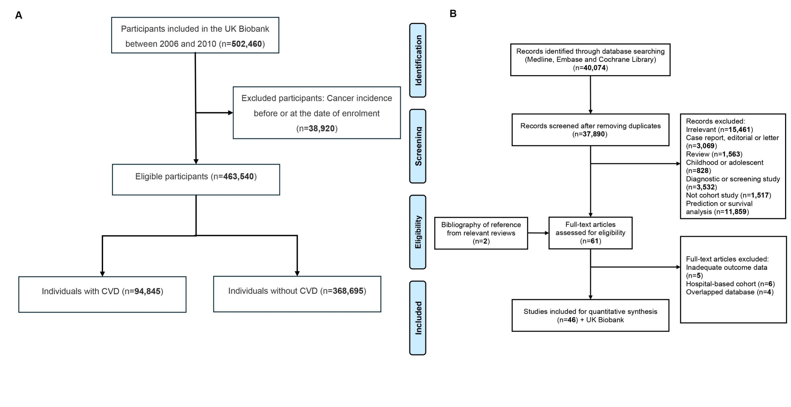

Figure S2. CVD subtypes associated cancer hazard ratios, as determined by Cox modelling
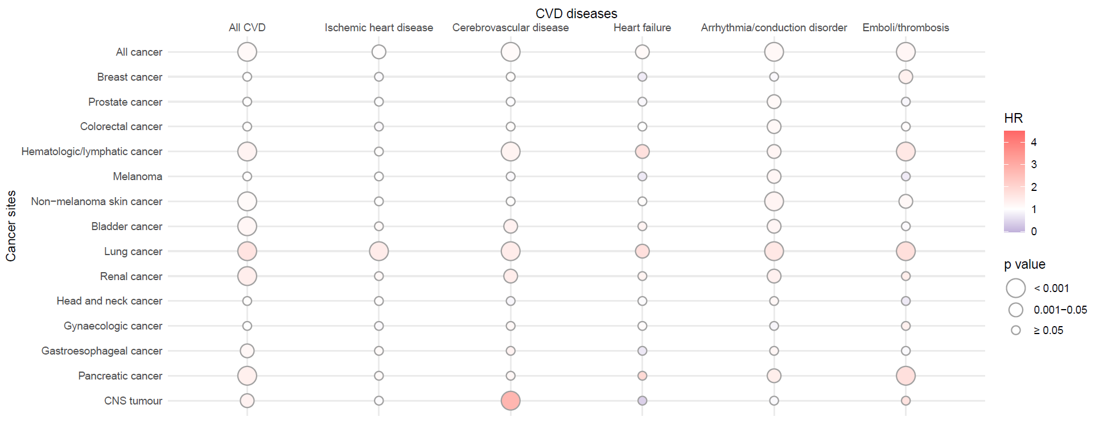

Figure S3. CVD subtypes associated cancer hazard ratios, as determined by competing risk modelling
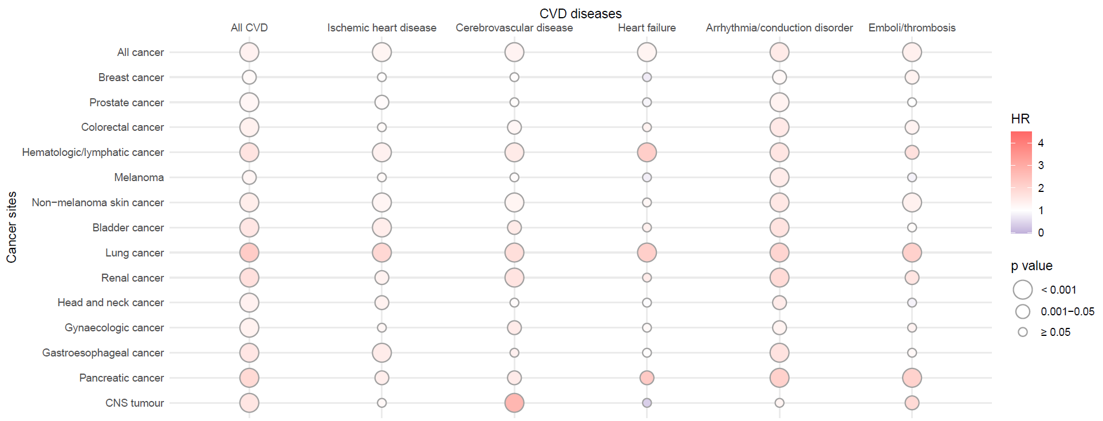

Figure S4. Forest plots for associations between All CVD and cancer subtypes risk
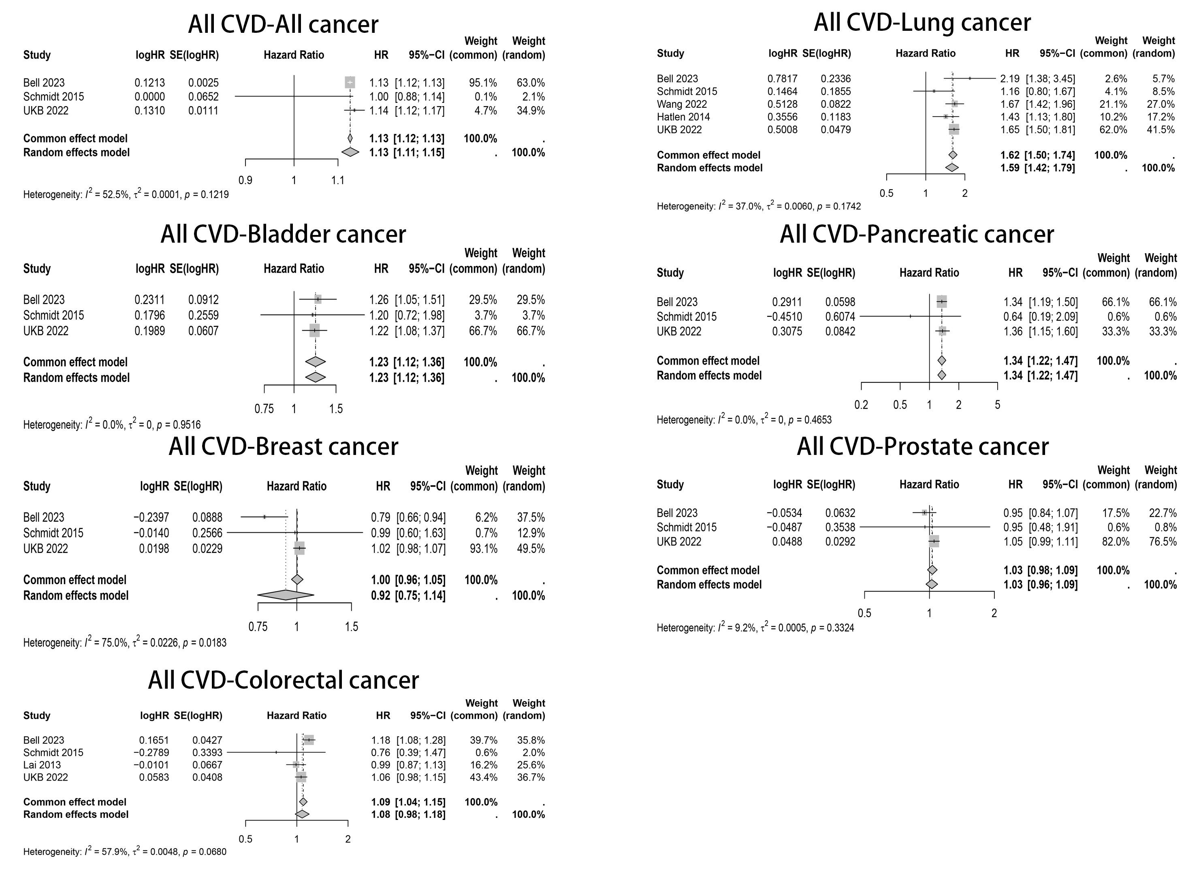

Figure S5. Forest plots for associations between ischemic heart disease and cancer subtypes risk
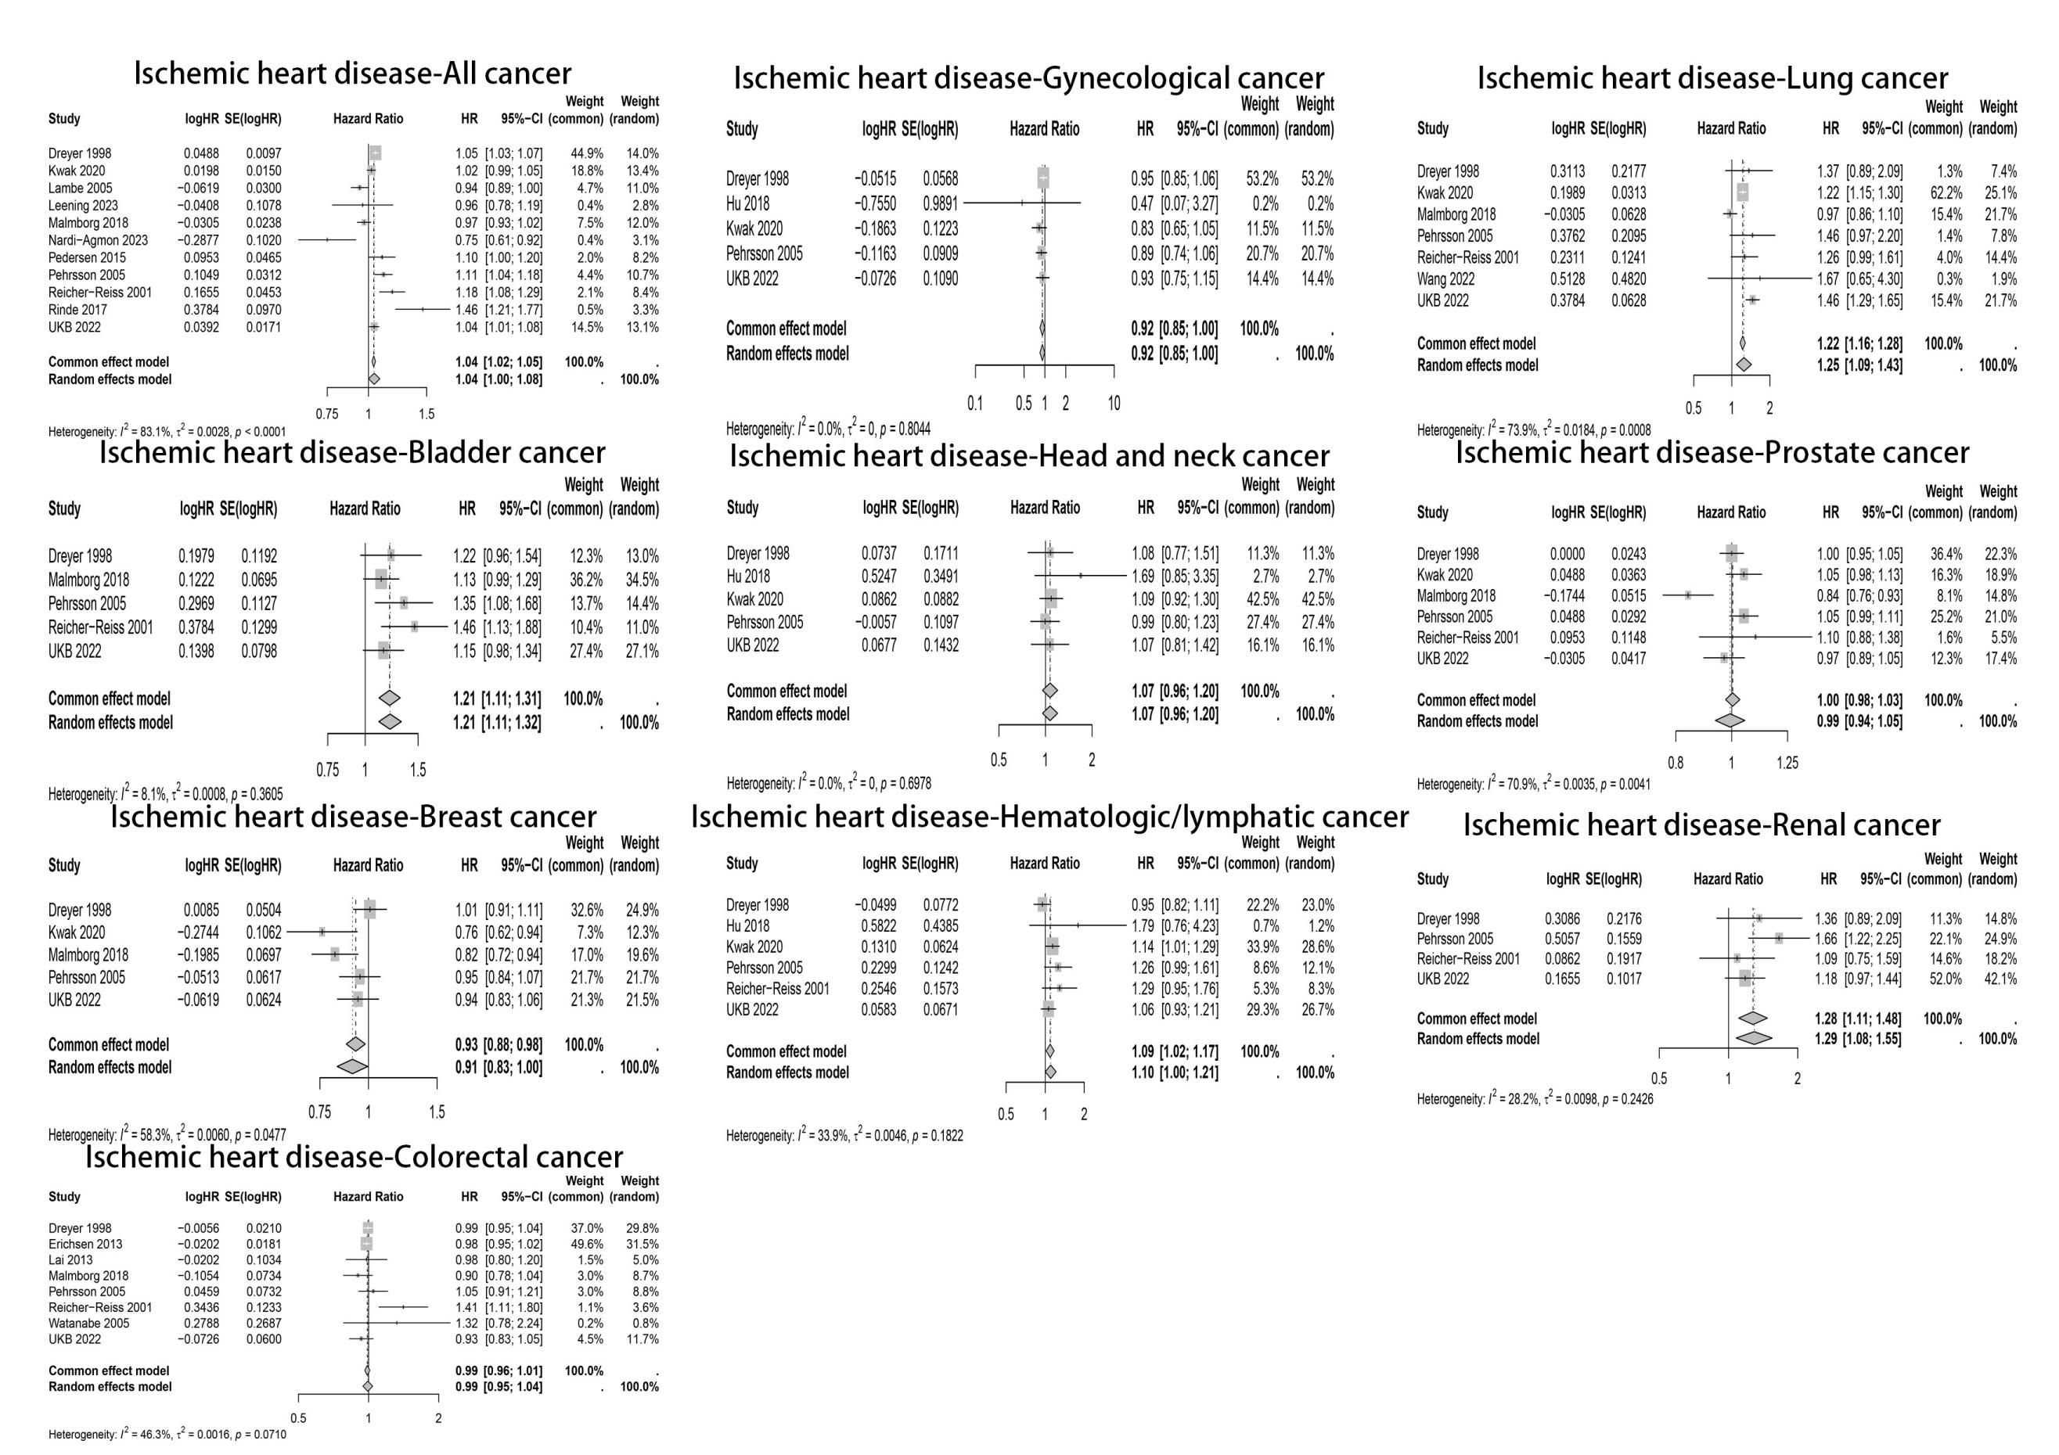
Figure S6. Forest plots for associations between cerebrovascular disease and cancer subtypes risk
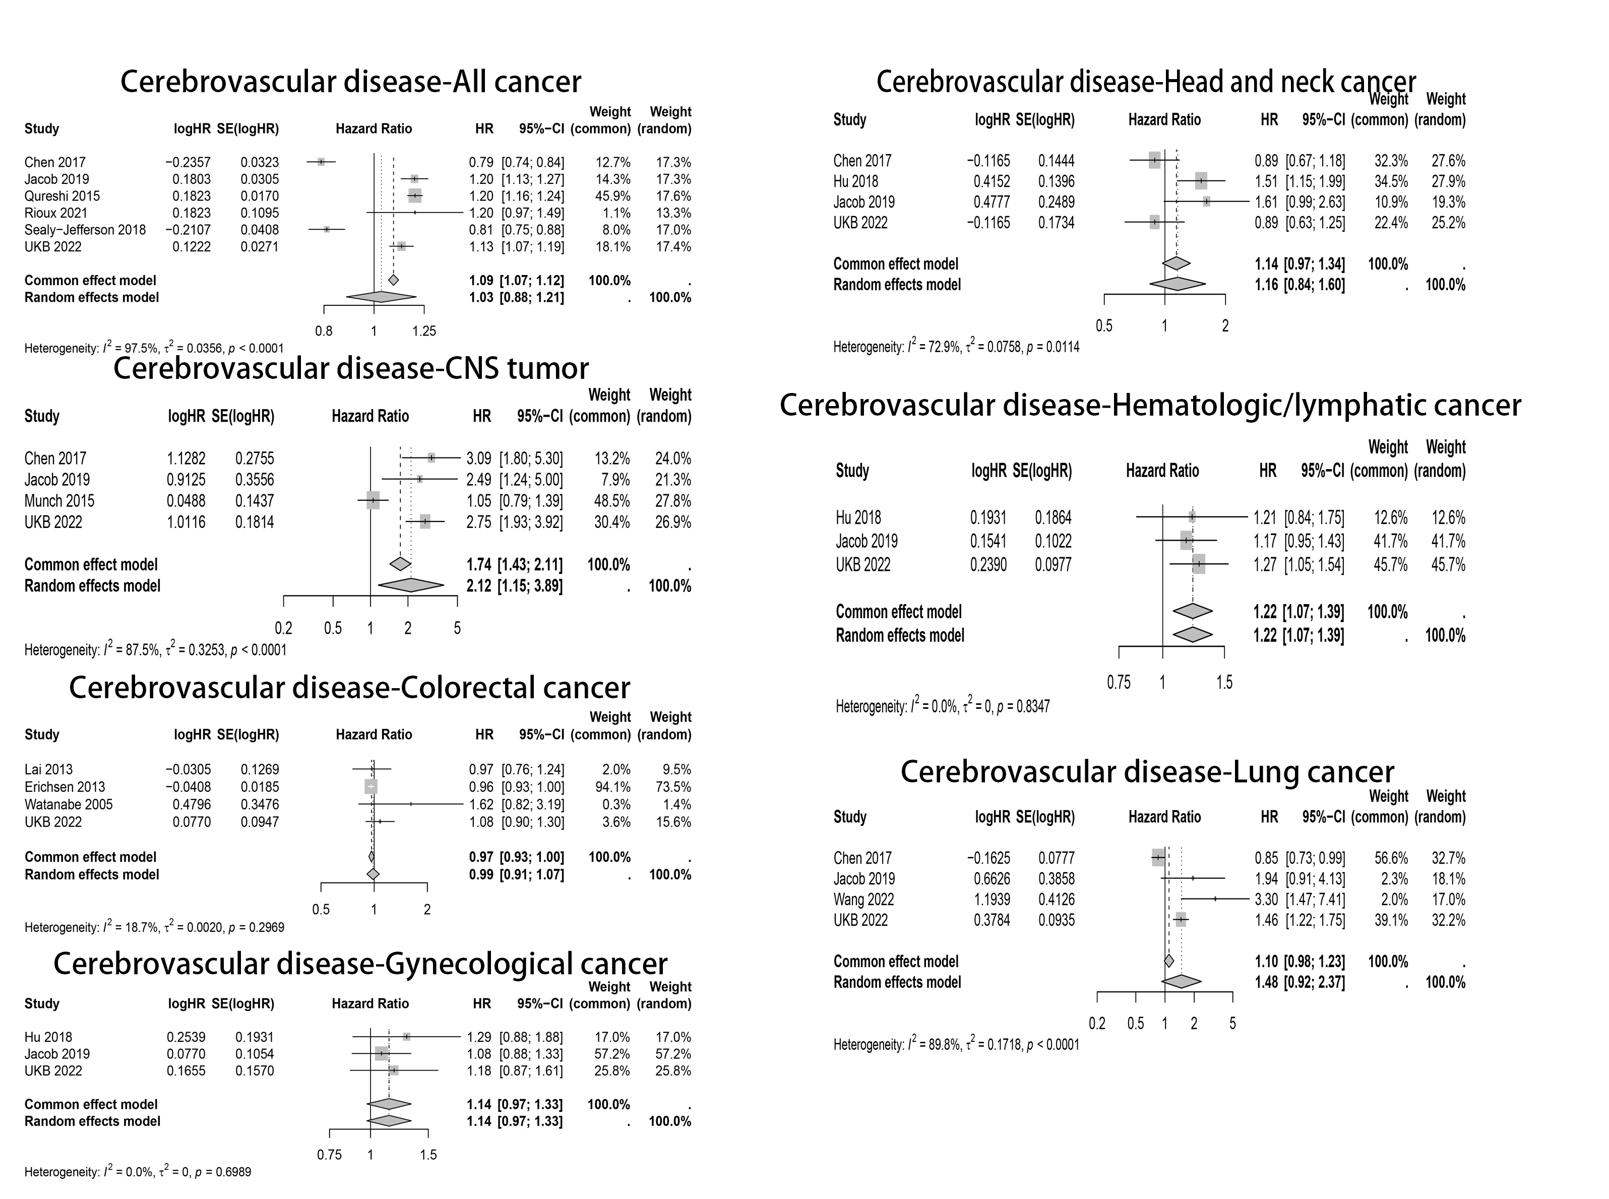
Figure S7. Forest plots for associations between heart failure and cancer subtypes risk

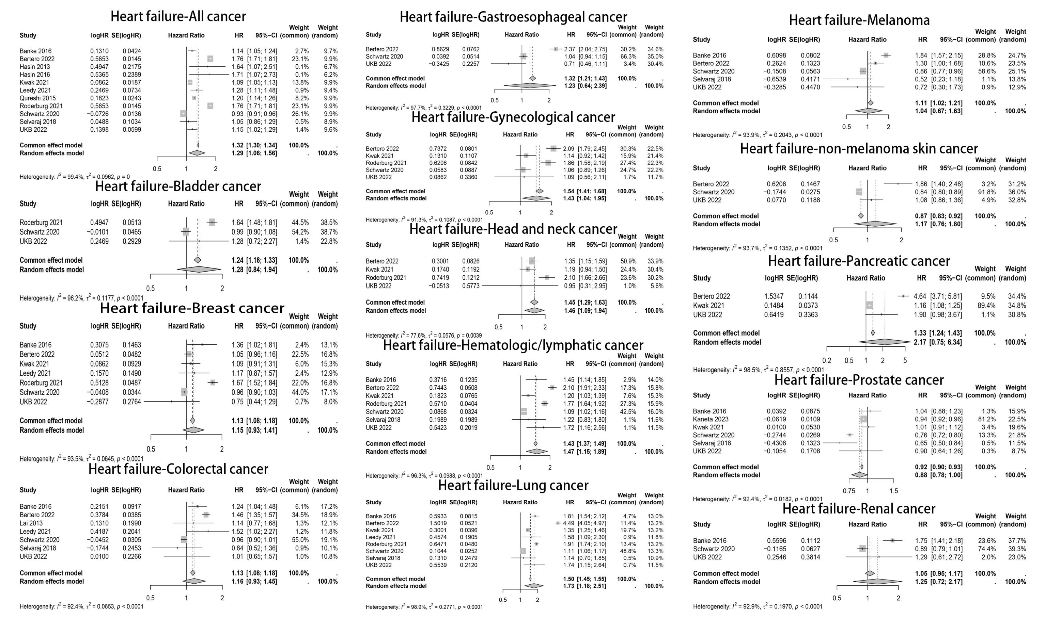

Figure S8. Forest plots for associations between arrhythmia/conduction disorder and cancer subtypes risk

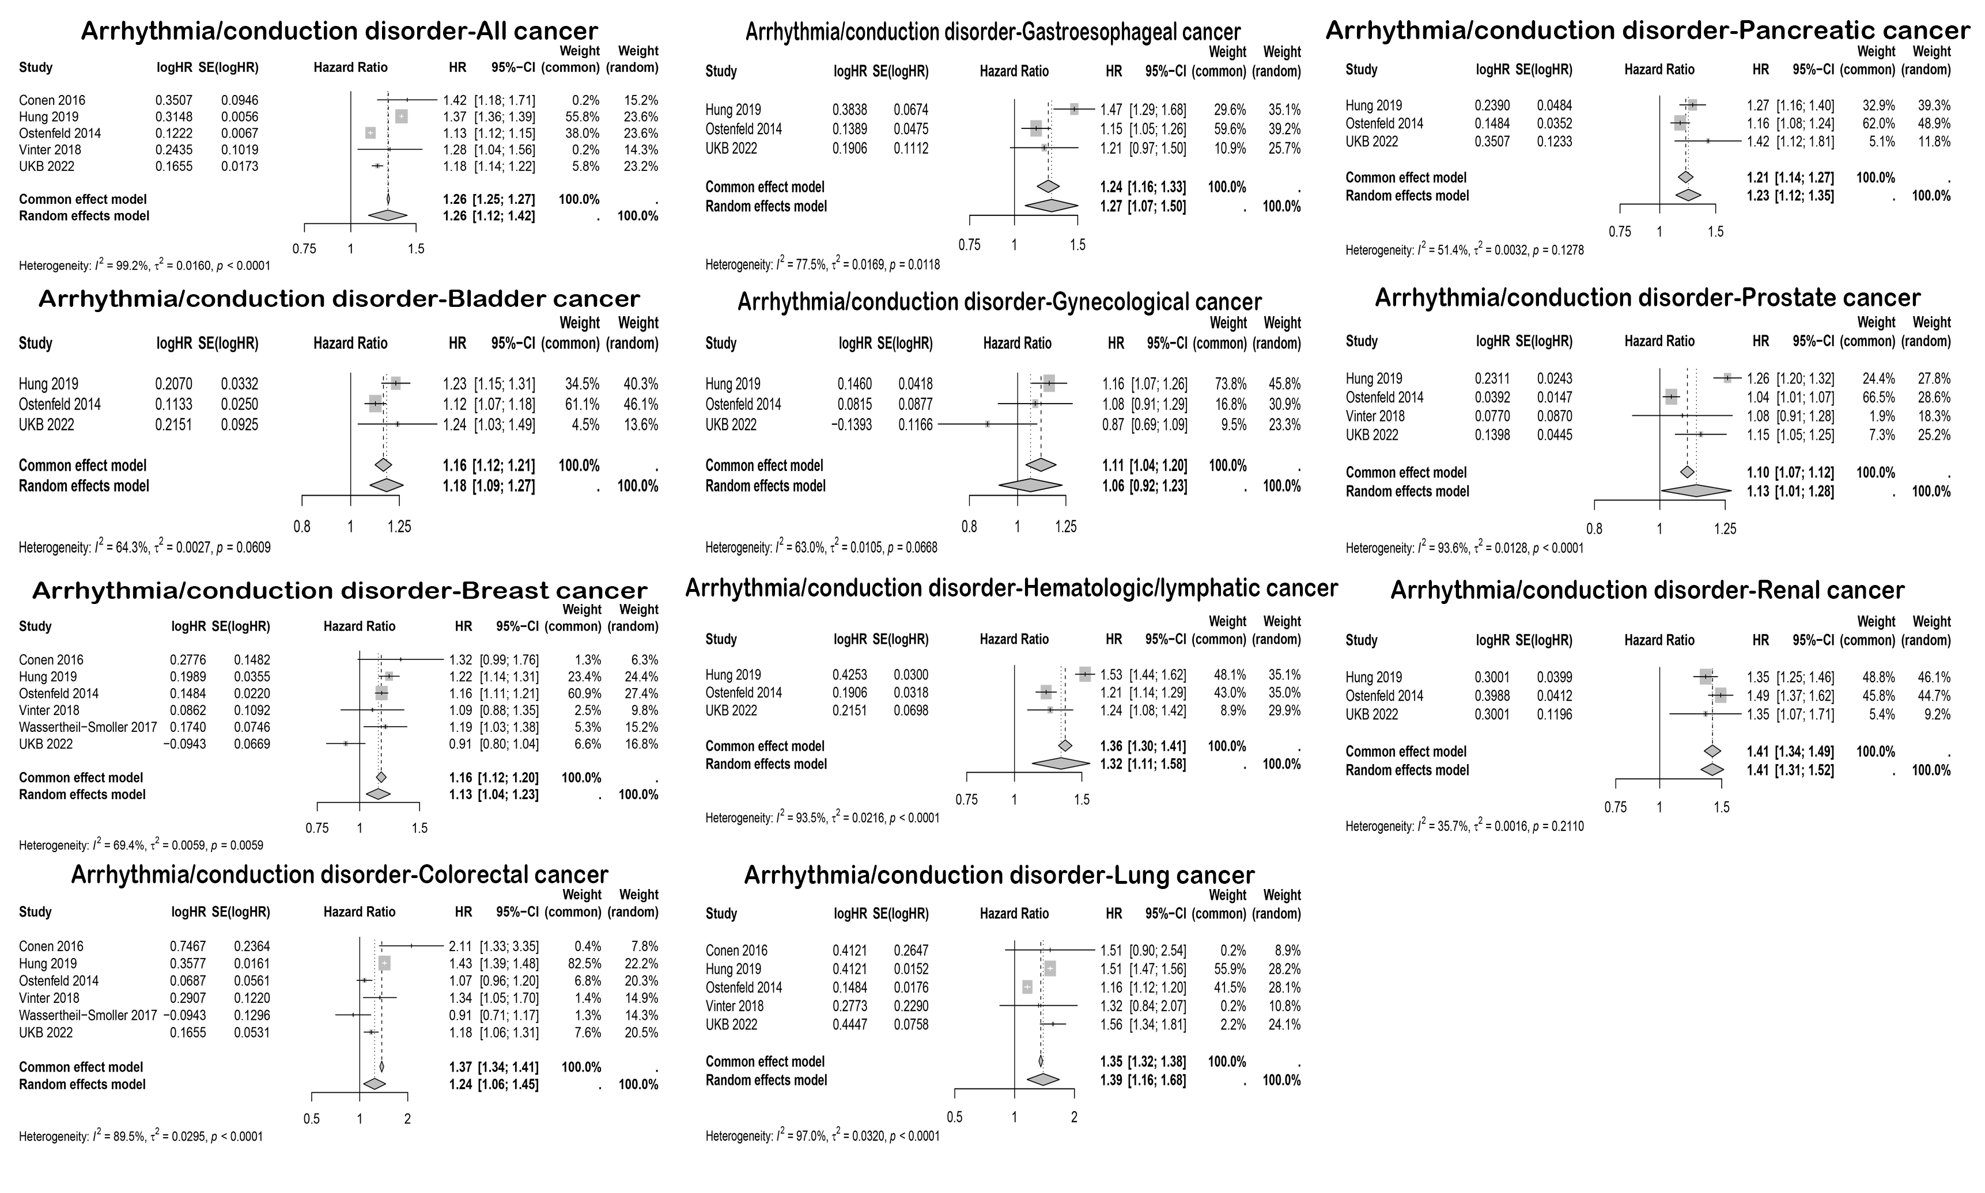

Figure S9. Forest plots for associations between emboli/thrombosis and cancer subtypes risk
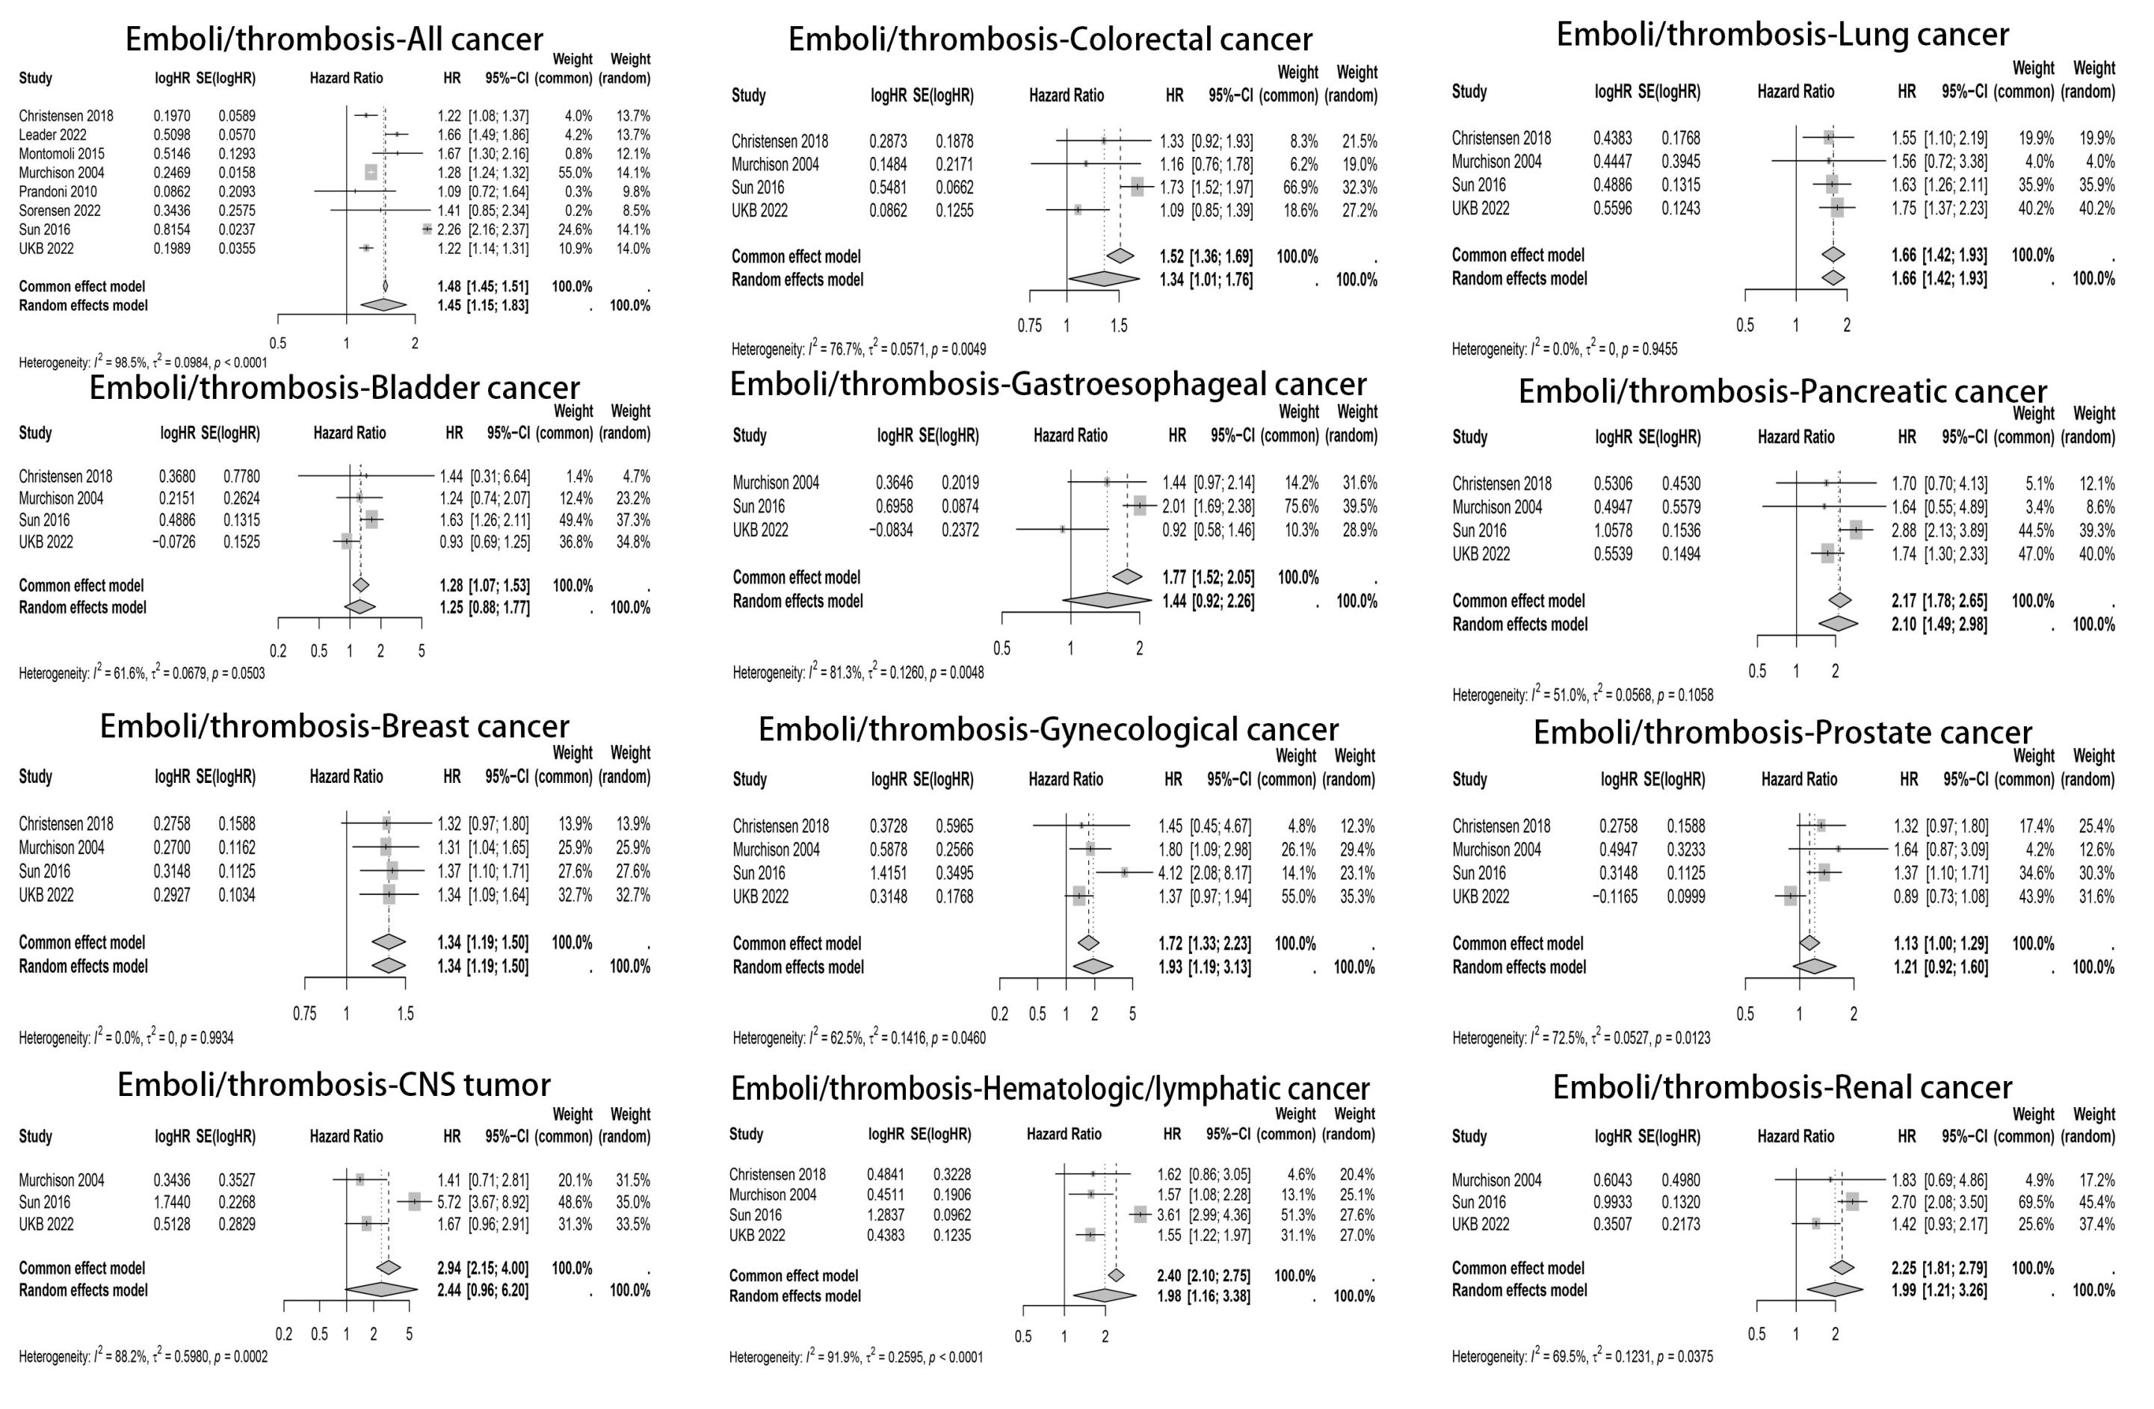

Figure S10. Funnel plots for meta-analyses with over 10 studies

