Additional file 2
Figure S1. Flow chart.
Figure S2. Association of early-life risk score with T2D risk in adulthood, stratified by PRS for T2D.
Figure S3. Association of early-life risk score with T2D, stratified by modifiable healthy lifestyle in adulthood.
Figure S4. Combined association of early-life risk score and PRS with T2D risk in adulthood, stratified by sex.
Figure S5. Combined association of early-life risk score and modifiable healthy lifestyle with T2D risk in adulthood, stratified by sex.
Figure S1. Flow chart.
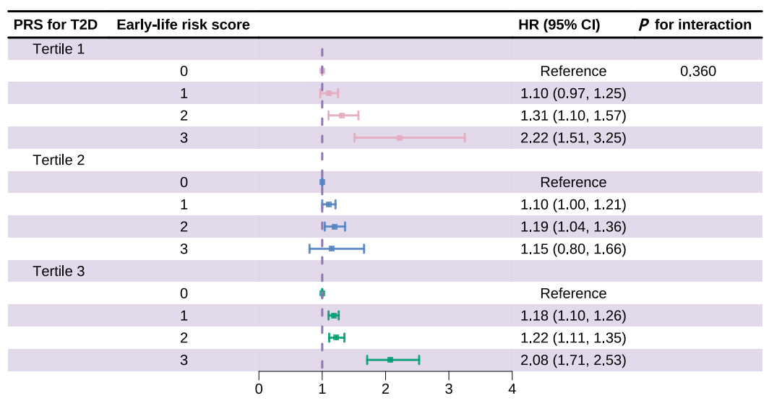
Figure S2. Association of early-life risk score with T2D risk in adulthood, stratified by PRS for T2D.
Abbreviation: T2D, Type 2 diabetes mellitus; PRS, Polygenic risk score; HR, Hazard ratio; CI, Confidence interval.
Models were adjusted for sex, age, Townsend Deprivation Index, birth year, ethnicity, household income, education, region, and family history of diabetes.
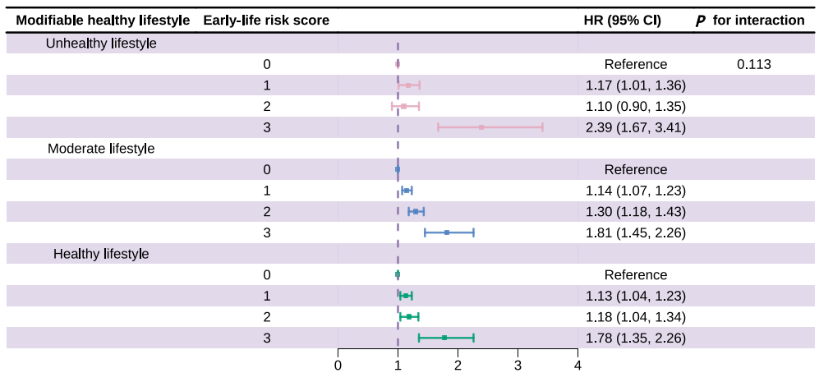 Figure S3. Association of early-life risk score with T2D, stratified by modifiable healthy lifestyle in adulthood.
Abbreviation: T2D, Type 2 diabetes mellitus; HR, Hazard ratio; CI, Confidence interval.
Models were adjusted for sex, age, Townsend Deprivation Index, birth year, ethnicity, household income, education, region, and family history of diabetes.

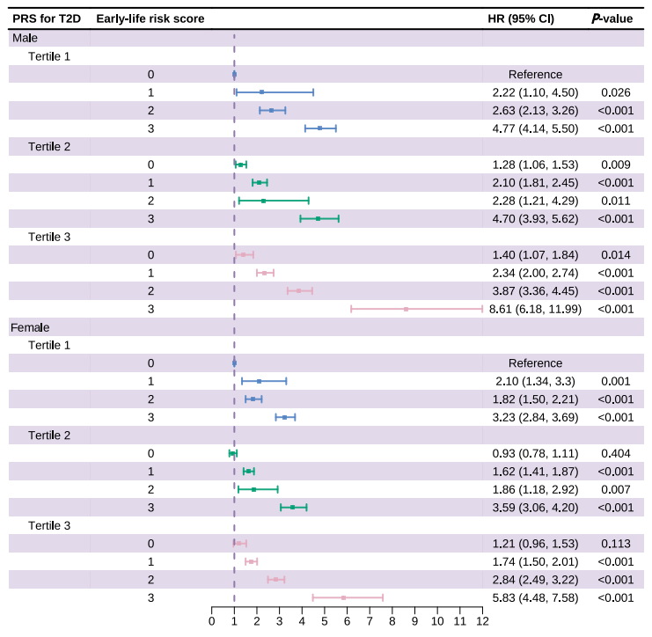 Figure S4. Combined association of early-life risk score and PRS with T2D risk in adulthood, stratified by sex.
Abbreviation: T2D, Type 2 diabetes mellitus; PRS, Polygenic risk score; HR, Hazard ratio; CI, Confidence interval.
Models were adjusted for sex, age, Townsend Deprivation Index, birth year, ethnicity, household income, education, region, and family history of diabetes.
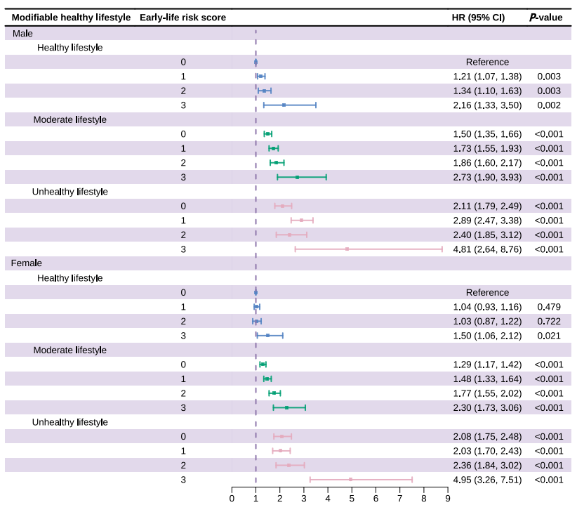 Figure S5. Combined association of early-life risk score and modifiable healthy lifestyle with T2D risk in adulthood, stratified by sex.
Abbreviation: T2D, Type 2 diabetes mellitus; HR, Hazard ratio; CI, Confidence interval.
Models were adjusted for sex, age, Townsend Deprivation Index, birth year, ethnicity, household income, education, region, and family history of diabetes.

