Additional Files
Additional Table 1. PRISMA Checklist 2
Additional Table 2. Literature Search Strategy 6
Additional Table 3. Definition of the Clinical Outcome 7
Additional Table 4. Confounding Variables of Included Studies 10
Additional Table 5. List of Excluded Studies After Full-Text Review and Reasons for Exclusion. 12
Additional Table 6. Basic characteristics of Studies Included in the Analysis of Overall eGDR Levels 15
Additional Table 7. NIH Quality Assessment of Included Studies on the Risk of CVD, DMC and Mortality 20
Additional Table 8. NIH Quality Assessment of Studies Included in the Analysis of Overall eGDR Levels 22
Additional Table 9. Subgroup Analysis of Overall eGDR Levels in patients with DM 25
Additional Table 10. GRADE evidence profile 26
Fig. S1. Forest Plot of the Overall eGDR Levels in Patients with T1DM 29
Fig. S2. Forest Plot of the Overall eGDR Levels in Patients with T2DM 30
Fig. S3. Sensitivity Analysis of the Risk of CVD in Patients with T1DM Based on Different Degrees of Adjustment 31
Fig. S4. Sensitivity Analysis of the Risk of DMC in Patients with T1DM Based on Different Degrees of Adjustment 32
Fig. S5. Sensitivity Analysis of the Risk of Mortality in Patients with T1DM Based on Different Degrees of Adjustment 33
Fig. S6. Sensitivity Analysis of the Risk of CVD in Patients with T1DM Based on Leave-one-out Method 34
Fig. S7. Sensitivity Analysis of the Risk of DMC in Patients with T1DM Based on Leave-one-out Method 35
Fig. S8. Sensitivity analysis of the Risk of Mortality in Patients with T1DM Based on Leave-one-out Method 36
Fig. S9. Sensitivity Analysis of the Risk of Mortality in Patients with T2DM Based on Leave-one-out Method 37
Fig. S10. Sensitivity Analysis of the Risk of Mortality in General Population Based on Leave-one-out Method 38
Fig. S11. Funnel Plot of the Overall eGDR Levels in Patients with T1DM 39

Additional Table 1. PRISMA Checklist
Section and Topic | Item # | Checklist item | Location where item is reported
TITLE
Title | 1 | Identify the report as a systematic review. | Page 1
ABSTRACT
Abstract | 2 | See the PRISMA 2020 for Abstracts checklist. | Page 2
INTRODUCTION
Rationale | 3 | Describe the rationale for the review in the context of existing knowledge. | Page 3
Objectives | 4 | Provide an explicit statement of the objective(s) or question(s) the review addresses. | Page 4
METHODS
Eligibility criteria | 5 | Specify the inclusion and exclusion criteria for the review and how studies were grouped for the syntheses. | Page 4–5
Information sources | 6 | Specify all databases, registers, websites, organisations, reference lists and other sources searched or consulted to identify studies. Specify the date when each source was last searched or consulted. | Page 4
Search strategy | 7 | Present the full search strategies for all databases, registers and websites, including any filters and limits used. | Page 4
Selection process | 8 | Specify the methods used to decide whether a study met the inclusion criteria of the review, including how many reviewers screened each record and each report retrieved, whether they worked independently, and if applicable, details of automation tools used in the process. | Page 6
Data collection process | 9 | Specify the methods used to collect data from reports, including how many reviewers collected data from each report, whether they worked independently, any processes for obtaining or confirming data from study investigators, and if applicable, details of automation tools used in the process. | Page 6
Data items | 10a | List and define all outcomes for which data were sought. Specify whether all results that were compatible with each outcome domain in each study were sought (e.g. for all measures, time points, analyses), and if not, the methods used to decide which results to collect. | Page 5
Data items | 10b | List and define all other variables for which data were sought (e.g. participant and intervention characteristics, funding sources). Describe any assumptions made about any missing or unclear information. | Page 5
Study risk of bias assessment | 11 | Specify the methods used to assess risk of bias in the included studies, including details of the tool(s) used, how many reviewers assessed each study and whether they worked independently, and if applicable, details of automation tools used in the process. | Page 8
Effect measures | 12 | Specify for each outcome the effect measure(s) (e.g. risk ratio, mean difference) used in the synthesis or presentation of results. | Page 6–7
Synthesis methods | 13a | Describe the processes used to decide which studies were eligible for each synthesis (e.g. tabulating the study intervention characteristics and comparing against the planned groups for each synthesis (item #5)). | Page 6–7
Synthesis methods | 13b | Describe any methods required to prepare the data for presentation or synthesis, such as handling of missing summary statistics, or data conversions. | Page 6–7
Synthesis methods | 13c | Describe any methods used to tabulate or visually display results of individual studies and syntheses. | Page 7
Synthesis methods | 13d | Describe any methods used to synthesize results and provide a rationale for the choice(s). If meta-analysis was performed, describe the model(s), method(s) to identify the presence and extent of statistical heterogeneity, and software package(s) used. | Page 7
Synthesis methods | 13e | Describe any methods used to explore possible causes of heterogeneity among study results (e.g. subgroup analysis, meta-regression). | Page 7
Synthesis methods | 13f | Describe any sensitivity analyses conducted to assess robustness of the synthesized results. | Page 7–8
Reporting bias assessment | 14 | Describe any methods used to assess risk of bias due to missing results in a synthesis (arising from reporting biases). | Page 8
Certainty assessment | 15 | Describe any methods used to assess certainty (or confidence) in the body of evidence for an outcome. | Page 8
RESULTS
Study selection | 16a | Describe the results of the search and selection process, from the number of records identified in the search to the number of studies included in the review, ideally using a flow diagram. | Page 8
Study selection | 16b | Cite studies that might appear to meet the inclusion criteria, but which were excluded, and explain why they were excluded. | Page 8
Study characteristics | 17 | Cite each included study and present its characteristics. | Page 8
Risk of bias in studies | 18 | Present assessments of risk of bias for each included study. | Page 9
Results of individual studies | 19 | For all outcomes, present, for each study: (a) summary statistics for each group (where appropriate) and (b) an effect estimate and its precision (e.g. confidence/credible interval), ideally using structured tables or plots. | Page 9–11
Results of syntheses | 20a | For each synthesis, briefly summarise the characteristics and risk of bias among contributing studies. | Page 9–11
Results of syntheses | 20b | Present results of all statistical syntheses conducted. If meta-analysis was done, present for each the summary estimate and its precision (e.g. confidence/credible interval) and measures of statistical heterogeneity. If comparing groups, describe the direction of the effect. | Page 9–11
Results of syntheses | 20c | Present results of all investigations of possible causes of heterogeneity among study results. | Page 9–11
Results of syntheses | 20d | Present results of all sensitivity analyses conducted to assess the robustness of the synthesized results. | Page 9–11
Reporting biases | 21 | Present assessments of risk of bias due to missing results (arising from reporting biases) for each synthesis assessed. | Page 11
Certainty of evidence | 22 | Present assessments of certainty (or confidence) in the body of evidence for each outcome assessed. | Page 11
DISCUSSION
Discussion | 23a | Provide a general interpretation of the results in the context of other evidence. | Page 11–12
Discussion | 23b | Discuss any limitations of the evidence included in the review. | Page 13–14
Discussion | 23c | Discuss any limitations of the review processes used. | Page 13–14
Discussion | 23d | Discuss implications of the results for practice, policy, and future research. | Page 12–14
OTHER INFORMATION
Registration and protocol | 24a | Provide registration information for the review, including register name and registration number, or state that the review was not registered. | PROSPERO: CRD42024527263
Registration and protocol | 24b | Indicate where the review protocol can be accessed, or state that a protocol was not prepared. | Page 4
Registration and protocol | 24c | Describe and explain any amendments to information provided at registration or in the protocol. | Page 4
Support | 25 | Describe sources of financial or non-financial support for the review, and the role of the funders or sponsors in the review. | Page 16
Competing interests | 26 | Declare any competing interests of review authors. | Page 16
Availability of data, code and other materials | 27 | Report which of the following are publicly available and where they can be found: template data collection forms; data extracted from included studies; data used for all analyses; analytic code; any other materials used in the review. | Page 15–16
From: Page MJ, McKenzie JE, Bossuyt PM, Boutron I, Hoffmann TC, Mulrow CD, et al. The PRISMA 2020 statement: an updated guideline for reporting systematic reviews. BMJ 2021;372:n71. doi: 10.1136/bmj.n71 For more information, visit: http://www.prisma-statement.org/

Additional Table 2. Literature Search Strategy
Database | Search strategies | Results
MEDLINE | (eGDR) OR (Estimated glucose disposal rate) AND ((((((((((((cardiovascular disease) OR (coronary artery disease)) OR (stroke)) OR (peripheral arterial disease)) OR (major adverse cardiac events)) OR (diabetes microangiopathy)) OR (diabetic nephropathy)) OR (diabetic peripheral neuropathy )) OR (diabetic neuropathy)) OR (diabetic retinopathy)) OR (mortality)) OR ( all-cause mortality)) OR (death rate) | 380
Embase | ('eGDR' OR 'estimated glucose disposal rate') AND ('cardiovascular disease' OR 'coronary artery disease' OR 'stroke' OR 'peripheral arterial disease' OR 'major adverse cardiac events' OR 'diabetes microangiopathy' OR 'diabetic nephropathy' OR 'diabetic peripheral neuropathy' OR 'diabetic neuropathy' OR 'diabetic retinopathy' OR 'mortality' OR 'all-cause mortality' OR 'death rate' ) | 173
Web of Science | #1 (TS=("eGDR") OR TS=("estimated glucose disposal rate")  #2 TS=("cardiovascular disease") OR TS=("coronary artery disease") OR TS=("stroke") OR TS=(peripheral arterial disease) OR TS=(major adverse cardiac events) OR TS=("diabetes microangiopathy") OR TS=("diabetic nephropathy") OR TS=("diabetic peripheral neuropathy") OR TS=('diabetic neuropathy) OR TS=(diabetic retinopathy) OR TS=("mortality") OR TS=("all-cause mortality") OR TS=("death rate")  #3 #1 AND #2 | 657
Cochrane Library | #1 (cardiovascular disease):ti,ab,kw OR (coronary artery disease):ti,ab,kw OR (stroke):ti,ab,kw OR (peripheral arterial disease):ti,ab,kw OR (major adverse cardiac events):ti,ab,kw OR (diabetes microangiopathy):ti,ab,kw OR (diabetic nephropathy):ti,ab,kw OR (diabetic peripheral neuropathy):ti,ab,kw OR (diabetic neuropathy):ti,ab,kw OR (diabetic retinopathy):ti,ab,kw OR (mortality):ti,ab,kw OR (all-cause mortality):ti,ab,kw OR (death rate):ti,ab,kw  #2 (eGDR):ti,ab,kw OR (estimated glucose disposal rate):ti,ab,kw  #3 #1 AND #2 | 32

Additional Table 3. Definition of the Clinical Outcome
Study | Outcome identify
Linn 2023 | Retinopathy was classified as any retinopathy, PPDR, or PDR. PDR was defined as evidence of current proliferations or any earlier laser photocoagulation.  Kidney disease was classified as any microalbuminuria defined as two positive test results from three samples taken within one year with an albumin/creatinine ratio of 3–30 mg mmol−1, or urinary albumin of 20–200 µg min−1 (20–300 mg/L), or macroalbuminuria defined as an albumin/creatinine ratio >30 mg mmol−1, or urinary albumin >200 µg min−1 (>300 mg L−1).
Mao 2022 | The primary CVD outcome was time to the first occurrence of any of the following types of cardiovascular events: cardiovascular death, nonfatal MI, nonfatal stroke, subclinical MI on ECG, angina confirmed by ischemic changes with exercise tolerance testing or by clinically significant obstruction on coronary angiography, revascularization, or congestive heart failure.  DR was defined by the presence of PDR and/or a history of pan-retinal scatter photocoagulation (laser) therapy.  DPN was confirmed from nerve conduction testing in EDIC year 13 or 14.
Helmink, 2021 | The outcome of interest was three-fold: (1) cardiovascular events (comprising of myocardial infarction, stroke (infarction or hemorrhagic), subarachnoid hemorrhage or vascular mortality), (2) cardiovascular events or vascular interventions (combined endpoint) and (3) all-cause mortality.
Harjutsalo 2021 | CVD was defined as having either CAD, any stroke, or PAD. CAD was diagnosed in individuals having had either MI or coronary revascularization (percutaneous coronary intervention or coronary artery bypass graft). Stroke was defined as either ischemic or hemorrhagic. PAD was defined as a nontraumatic LEAD at any level or revascularization of lower-extremity arteries.
Garofolo 2020 | CVD outcomes were based on the national and regional health care registers using ICD-9 Clinical Modification codes.
Miller 2019 | Incidence of total CVD, defined as the first instance of CVD death, nonfatal MI (including clinical events and subclinical MI on electrocardiogram, i.e., Minnesota code 1.1 or 1.2), nonfatal stroke, coronary revascularization procedure, blockage≥50%, ischemic electrocardiogram at EDC study visit (Minnesota codes 1.3, 4.1–4.3, 5.1–5.3, 7.1), or EDC physician-diagnosed angina.
Nyström 2018 | The main outcome measure was time to death from any cause relative to the index date. The Cause of Death Register was used to obtain dates and causes of death. A major CVD event was defined as hospitalization for acute myocardial infarction, stroke or ischemic heart disease. This information was obtained from the National Patient Register.
Kilpatrick 2007 | Severity of DR was determined by the 25-point Early Diabetic Retinopathy Treatment Study interim score. DN was defined as an increase in albumin excretion rate 40 mg/24 h on any annual evaluation providing that the baseline albumin excretion rate was 40 mg/dl. CVD events during the trial were those as defined as by the DCCT group and included angina, fatal and nonfatal myocardial infarction, coronary revascularization, and major electrocardiogram events.
Olson 2002 (1) | The definition of LEAD event is any of claudication, “ischemic” or “type uncertain” ulceration, gangrene, amputation, infection, or necrobiosis diabeticorum.
Olson 2002 (2) | Death certificates were obtained for all reported deaths. Cause of death was classified as i) cardiovascular disease; ii) renal disease; iii) infection; iv) other diabetic; or v) other nondiabetic, according to the principles of classification of the Diabetes Epidemiology Research International.
Zhang Y 2024 | The DPN-Check test was considered abnormal when sural sensory nerve conduction amplitude was<4 uV and/or velocity was <40 m/s.
Xu 2024 | Assessment of DR was performed by a trained grader and adjudicated by a retinal specialist based on the clinical status of the patient. Two-field (optic disc and macular centered) pupil-dilated fundus photographs were obtained from all participants.
Meng 2023 | DR was graded according to the 2002 International Academy of Ophthalmology grading criteria. It is a practical way to screen for DR to take at least two 45° fundus color images in each eye, one with the optic disc centered and the other with the macula centered, by trained professionals employing non-mydriatic fundus cameras.
Ciardullo, 2023 | Mortality data from death certificates from the National Death Index were linked to NHANES based on the particif pant sequence number available on both datasets.
Zabala 2021 | The main outcome was time to stroke and mortality. Patients were studied from the index date until stroke, death, or end of the study. International Classification of Diseases codes (ICD codes) I63 and I64 were used for ischaemic stroke, and I61 to I62 for intracerebral hemorrhage, to identify all strokes. Subarachnoid hemorrhage (ICD code I60) was not included in the study.
Nyström, 2017 | The primary outcome was all-cause mortality, and the Cause of Death Register was used to ascertain dates of death. The risk of a MACE or death as a combined secondary outcome measure was also investigated. We defined MACE as rehospitalization for myocardial infarction (ICD-10 I21–I21.9), heart failure (ICD-10 I50–I50.9), stroke (ICD-10 I60–I64.9), or repeat PCI or CABG (ICD-10 FNG, FNA, and FNC).
Zhang Z 2024 | The primary outcome of interest was CVD, including heart disease and stroke. Consistent with established precedents, incident CVD was determined based on self-reports where participants confirmed having received a definite diagnosis of CVD from physicians. Participants were followed from baseline (2011) until the occurrence of stroke or cardiac events or the most recent survey (2018), whichever occurred first.
He 2024 | The endpoints of the present study were all-cause mortality and cardiovascular mortality. To determine the death status of each individual during follow-up, the NHANES public-use mortality file through December 31, 2019, which was linked to the National Death Index with a  probabilistic matching algorithm, was used. The causes of death were determined according to the International Statistical Classification of Diseases and Related Health Problems, Tenth Revision (ICD-10) codes.
Sun 2023 | The endpoint is the vital status of the participants which was verified by the telephone interviews with the participants or their family members.
CAD, coronary artery disease; CABG, coronary artery bypass grafting; CTA, computational tomography angiography; CVD, cardiovascular disease; DR, diabetic retinopathy; DN, diabetic nephropathy; DPN, diabetic peripheral neuropathy; ECG, electrocardiogram; EDIC, Epidemiology of Diabetes Interventions and Complications study; ESRD, Early Treatment of Diabetic Retinopathy Scale; LEAD, lower extremity clinical events; MACE, major adverse cardiovascular event; MI, myocardial ischemia; NPDR, non-proliferative; ICDR, International Classification of DR; IHD, Ischemic heart disease; PCI, percutaneous coronary intervention; PPDR, preproliferative diabetic retinopathy; SPECT, single-photon emission computed tomography

Additional Table 4. Confounding Variables of Included Studies
Study | Confounding variables | Degree of adjustment
Linn 2023 | Age, sex, physical activity, smoke, LDL-C, HDL-C, TC, Triglyceride, BMI, antihypertensive, lipid lowering drug, eGFR | I/II/III
Mao 2022 | Gender, age, diabetes duration. | II
Harjutsalo 2021 | Age, sex, disease duration, mean HbA1, smoking history, ratio of triglycerides to HDL cholesterol, hypertension, lipid-lowering medication. | III
Helmink 2021 | Age, sex, current smoking, non-HDL-C, eGFR. | II/III
Garofolo 2020 | Age, sex, diabetes duration, active smoking, LDL cholesterol, eGFR, lipid-lowering drugs, metformin use, total daily dose of insulin, peripheral neuropathy, retinopathy, and prior CV events, HDL cholesterol, triacylglycerol, and uACR. | I/II/III
Miller 2019 | Age, sex, diabetes duration. | I/III
Nystrom 2018 | Age, sex, diabetes duration, BMI, LDL-C, HDL-C, triglycerides, TC, lipid-lowering medication, BP, physically inactive, eGFR, macroalbuminuria, microalbuminuria, retinopathy, MI, CHD, AF, HF, stroke, PVD, cancer. | I/II/III
Kilpatrick 2007 | Age, sex, disease duration, randomization treatment (conventional/intensive), and prevention cohort (primary/secondary). | III
Olson 2002 (1) | Age, sex, disease duration, HbA1, hypertension, heart rate. | III
Olson 2002 (2) | Age, sex, disease duration, HbA1, hypertension, heart rate. | III
Zhang Y 2024 | Age, gender, HDL-C, TG, use of metformin, ACEI at baseline. | I/II/III
Xu 2024 | Age, sex, diabetes duration, combination therapy for diabetes, smoke, DN, history of DPN, FPG | I/II/III
Meng 2023 | Age, BMI, gender, hypertension, WC, FPG, GGT, ALT, AST, Alb, TC, TG, HDL-C, LDL-C, Cr, BUN, UA, course. | I/II/III
Ciardullo 2023 | Age, sex, educational status, race-ethnicity, smoke, CKD, CVD, alcohol consumption, TC, BP category. | III
Zabala 2021 | Age, sex, diabetes duration, LDL-C, HDL-C, triglycerides, lipid lowering medication, microalbuminuria, macroalbuminuria, creatinine, eGFR, retinopathy, smoke, physical activity, income, marital status, education, CVD, renal disorder, hyperglycaemia, amputation, dementia, psychiatric disorder, gastric bypass surgery. | I/II/III
Nystrom 2017 | Age, sex, hyperlipidemia, PVD, prior PCI, CPD, prior MI, stroke, AF, cancer, HF, left ventricular ejection fraction, alcohol dependency, smoke, physically inactive, diabetes duration, treatment, TC, triglycerides, LDL-C, HDL-C. | I/II/III
Zhang Z 2024 | Age, sex, rural residence, marital status, education, smoking, and alcohol consumption status, total cholesterol, high density lipoprotein, triglyceride , low density lipoprotein, BUN, uric acid, hsCRP, hemoglobin, chronic kidney disease, and obesity. | I/II/III
He 2024 | Age, gender, race, and body mass index, smoking status, alcohol consumption, educational level, family poverty-to-income ratio, cardiovascular diseases, antidiabetic agents, anti-hypertensive agents, antihyperlipidemic agents, eGFR, HDL-C, and LDL-C. | II/III
Sun 2023 | Age, sex, BMI, SBP, DBP, TC, HDL-C, LDL-C, smoke, drinking status, CHD, DM, antiplatelet agents, antihypertensive agents, hypoglycaemic therapy, lipid-lowering therapy. | I/II/III
ACEI, angiotensin-converting enzyme inhibitor; AF, atrial fibrillation; Alb, Albumin; ALT, alanineaminotransferase; AST, aspartate aminotransferase; BMI, body mass index; BUN, urea nitrogen; CAD, coronary artery disease; CHD, coronary heart disease; CKD, chronic kidney disease; CPD, chronic pulmonary disease; CVD, cardiovascular disease; Cr, creatinine; DM, diabetes mellitus; DR, diabetic retinopathy; DN, diabetic nephropathy; DPN, diabetic peripheral neuropathy; DBP, diastolic blood pressure; eGDR, estimated glucose disposal rate; eGFR, estimated glomerular fltration rate; FPG, fasting plasma glucose; GGT, γ-glutamyl transpeptadase; HDL-C, high-density lipoprotein cholesterol; HF, heart failure; LDL-C, low-density lipoprotein cholesterol;MI, Myocardial ischemia; NR, not reported; PCI, percutaneous coronary intervention; PVD, peripheral vascular disease; SBP, systolic blood pressure; TC, total cholesterol; UA, uric acid; WC, white blood cells.

Additional Table 5. List of Excluded Studies After Full-Text Review and Reasons for Exclusion.
Exclusion Reasons of Outcome One | Reference number
The outcome is diabetes-related mortality, which does not align with all-cause mortality. | [1]
The outcome is eGFR decline, which does not meet the criteria for DN diagnosis. | [2]
No endpoint events or effect sizes were reported. | [3]
The outcome is hypertension, which is not relevant. | [4]
The outcome for CVD lacks effect size. | [5]
The effect size for diabetic microvascular complications in T1DM does not have a 95% CI. | [6]
Data source duplication with Zhang Z 2024 and outcome duplication. | [7-8]
The mortality outcome duplicates with He 2024. | [9]
Data source duplication with Kong 2024. | [10]
Data source duplication with He 2024, and the outcome is heart failure, which is not relevant. | [11]
The outcome is left ventricular hypertrophy, which is not relevant. | [12]
Exclusion Reasons of Outcome Two
Data source duplicates with Kietsiriroje 2022. | [13-15]
Data source duplicates with Valente 2022. | [16-17]
Data source for Karguppikar 202 is the same as that for Indian children and the same time period. | [18-19]
Data source duplicates with Miller 2019. | [20-23]
Data source is the same as Leroux 2015. | [24]
There is partial data overlap with Chillarón JJ 2011. | [25]
- Pambianco G, Costacou T, Orchard TJ. The prediction of major outcomes of type 1 diabetes: a 12-year prospective evaluation of three separate definitions of the metabolic syndrome and their components and estimated glucose disposal rate: the Pittsburgh Epidemiology of Diabetes Complications Study experience. Diabetes Care. 2007;30(5):1248-1254.
- Peng J, Li A, Yin L, Yang Q, Pan J, Yi B. Estimated Glucose Disposal Rate Predicts Renal Progression in Type 2 Diabetes Mellitus: A Retrospective Cohort Study. J Endocr Soc. 2023;7(7):bvad069.
- Valente F, Valente T, Crispim F, et al. Parents' cardiovascular risk factors are related to overweight and obesity in young Brazilians with type 1 diabetes. J Diabetes Complications. 2022;36(1):108082.
- Ebert T, Anker SD, Ruilope LM, et al. Outcomes With Finerenone in Patients With Chronic Kidney Disease and Type 2 Diabetes by Baseline Insulin Resistance. Diabetes Care. 2024;47(3):362-370.
- Gudenkauf B, Shaya G, Mukherjee M, et al. Insulin resistance is associated with subclinical myocardial dysfunction and reduced functional capacity in heart failure with preserved ejection fraction. J Cardiol. 2024;83(2):100-104.
- Bhagadurshah RR, Eagappan S, Kasthuri Santharam R, Subbiah S. The Impact of Body Mass Index, Residual Beta Cell Function and Estimated Glucose Disposal Rate on the Development of Double Diabetes and Microvascular Complications in Patients With Type 1 Diabetes Mellitus. Cureus. 2023;15(11):e48979.
- Ren X, Jiang M, Han L, Zheng X. Estimated glucose disposal rate and risk of cardiovascular disease: evidence from the China Health and Retirement Longitudinal Study. BMC Geriatr. 2022;22(1):968.
- Yao J, Zhou F, Ruan L, et al. Association between estimated glucose disposal rate control level and stroke incidence in middle-aged and elderly adults. J Diabetes. 2024;16(8):e13595.
- Kong X, Wang W. Estimated glucose disposal rate and risk of cardiovascular disease and mortality in U.S. adults with prediabetes: a nationwide cross-sectional and prospective cohort study. Acta Diabetol. Published online May 28, 2024.
- Song J, Ma R, Yin L. Associations between estimated glucose disposal rate and arterial stiffness and mortality among US adults with non-alcoholic fatty liver disease. Front Endocrinol (Lausanne). 2024;15:1398265.
- Zhang D, Shi W, An T, Li C, Ding Z, Zhang J. Usefulness of estimated glucose disposal rate in detecting heart failure: results from national health and nutrition examination survey 1999-2018. Diabetol Metab Syndr. 2024;16(1):189.
- Shi W, Qin M, Wu S, Xu K, Zheng Q, Liu X. Value of estimated glucose disposal rate to detect prevalent left ventricular hypertrophy: implications from a general population. Postgrad Med. 2023;135(1):58-66.
- Kietsiriroje N, Scott GE, Ajjan RA, Brôz J, Schroeder V, Campbell MD. Plasma levels of mannan-binding lectin-associated serine proteases are increased in type 1 diabetes patients with insulin resistance. Clin Exp Immunol. 2024;215(1):58-64.
- Coales EM, Ajjan RA, Pearson SM, et al. Application of Machine Learning to Assess Interindividual Variability in Rapid-Acting Insulin Responses After Subcutaneous Injection in People With Type 1 Diabetes. Can J Diabetes. 2022;46(3):225-232.e2.
- O'Mahoney LL, Churm R, Stavropoulos-Kalinoglou A, et al. Associations Between Erythrocyte Membrane Fatty Acid Compositions and Biomarkers of Vascular Health in Adults With Type 1 Diabetes With and Without Insulin Resistance: A Cross-Sectional Analysis. Can J Diabetes. 2022;46(2):111-117.
- Pinto C, Sá JR, Lana J, Dualib P, Gabbay M, Dib S. Association of parental cardiovascular risk factors with offspring type 1 diabetes mellitus insulin sensitivity. J Diabetes Complications. 2023;37(2):108393.
- Ramaldes LAL, Dos Santos SS, Dualib PM, de Sa JR, Dib SA. Heterogeneous response of estimated insulin sensitivity indices to metformin in young individuals with type 1 diabetes and different phenotypes. Diabetol Metab Syndr. 2024;16(1):214.
- Oza C, Khadilkar V, Karguppikar M, et al. Prevalence of metabolic syndrome and predictors of metabolic risk in Indian children, adolescents and youth with type 1 diabetes mellitus. Endocrine. 2022;75(3):794-803.
- Antani M, Pargaonkar Y, Oza C, et al. Triple burden of malnutrition and role of anaemia in the development of complications associated with type 1 diabetes in Indian children and youth. J Pediatr Endocrinol Metab. 2022;35(12):1464-1473.
- Orchard TJ, Olson JC, Erbey JR, et al. Insulin resistance-related factors, but not glycemia, predict coronary artery disease in type 1 diabetes: 10-year follow-up data from the Pittsburgh Epidemiology of Diabetes Complications Study. Diabetes Care. 2003;26(5):1374-1379.
- Olson JC, Erbey JR, Forrest KY, Williams K, Becker DJ, Orchard TJ. Glycemia (or, in women, estimated glucose disposal rate) predict lower extremity arterial disease events in type 1 diabetes. Metabolism. 2002;51(2):248-254.
- Pambianco G, Costacou T, Orchard TJ. The prediction of major outcomes of type 1 diabetes: a 12-year prospective evaluation of three separate definitions of the metabolic syndrome and their components and estimated glucose disposal rate: the Pittsburgh Epidemiology of Diabetes Complications Study experience. Diabetes Care. 2007;30(5):1248-1254.
- Yishak AA, Costacou T, Virella G, et al. Novel predictors of overt nephropathy in subjects with type 1 diabetes. A nested case control study from the Pittsburgh Epidemiology of Diabetes Complications cohort. Nephrol Dial Transplant. 2006;21(1):93-100.
- Gingras V, Leroux C, Desjardins K, et al. Association between Cardiometabolic Profile and Dietary Characteristics among Adults with Type 1 Diabetes Mellitus. J Acad Nutr Diet. 2015;115(12):1965-1974. doi:10.1016/j.jand.2015.04.012
- Chillarón JJ, Goday A, Flores-Le-Roux JA, et al. Estimated glucose disposal rate in assessment of the metabolic syndrome and microvascular complications in patients with type 1 diabetes. J Clin Endocrinol Metab. 2009;94(9):3530-3534.

Additional Table 6. Basic characteristics of Studies Included in the Analysis of Overall eGDR Levels
Study | Design | Country | Participates | Data Source | Data collection | Duration of DM, y | Sample size | Men, % | Age, y | Single-center study | eGDR  formula
Zeng 2024 | CS | China | Patients with T1DM | First Affiliated Hospital of Shantou University Medical College | July 2021 to June 2023 | 11.35 ± 8.66 | 101 | 44.55% | 30.97±15.43 | yes | A
Promsod 2024 | CS | Thailand | Adolescents and young adults with T1DM | King Chulalongkorn Memorial Hospital | August to December 2022 | Median 7.5 | 30 | 53.3% | 18.7±3.4 | yes | B
Mondkar 2024 | PC | India | Adolescents with T1DM, aged 10-19 years | Tertiary care center, Western Maharashtra | November 2019 to August 2020 | 5.2 ±2.3 | 82 | 51% | 14.7 ±2.9 | yes | A
Özkaya 2024 | CS | Turkey | Children and adolescents with T1DM, aged 6-18 years | Bursa Uludağ University Health Research Center | December 2019 to June 2020 | 5.3±3.3 | 150 | 47% | 12.2±3.1 | yes | A
Cielonko 2023 | CS | USA | Youth with T1DM, aged 6-18 years | Phoenix Children's Hospital | NR | 7.7 ± 2.6 | 38 | 36.84% | 13.3 ± 3.0 | yes | C
Canat 2023 | CS | Turkey | Adults with T1DM who were on multiple insulin injections or continuous insulin infusion | Sisli Hamidiye Etfal Training and Research Hospital | January to December, 2022 | 11.67±8.89 | 184 | 48.30% | 33.18±10.86 | yes | A
Malinowska-Polubiec 2023 | RC | Poland | Pregnant women with T1DM | Three public perinatal tertiary referral centers | 2015 to 2022 | 12.0±7.9 | 495 | 0 | 30.0±5.1 | no | B
Jirawatwarakul 2023 | RC | Thailand | Individuals with T1DM, aged 18-50 years | Prince of Songkla University Hospital Health Information System | January 2001 to November 2022 | Median 2.9 | 69 | 26.09% | 24.91±7.05 | yes | B
Oza 2023 | PC | India | Children and adolescents with T1DM, aged 3-18 years | Tertiary care hospital in Pune | December 2015 to March 2016 | 4.15±3.18 | 112 | 44.60% | 11.0 ± 3.9 | yes | A
Popa 2023 | CS | Romania | Patients with T1DM | Emergency Clinical Hospital Craiova | NR | 14.9±10.6 | 181 | 40.20% | 40.2±13.1 | yes | A
Karguppikar 2022 | CS | India | Children and youth with T1DM, aged 2.6-21 years | Tertiary care hospital in Pune | October 2020 to March 2021 | 6.7 ±3.6 | 319 | 47.30% | 13.8 ± 4.3 | yes | A
Kietsiriroje 2022 | CS | UK | Patients with T1DM | Baseline data from three RCTs : ISRCTN40811115, ISRCTN13641847, NCT05231642 | 2021 to 2022,  2020 to 2022,  2017 to 2019 | 16.5±7.0 | 107 | 50.50% | 29±6 | no | B
Lecumberr 2022 | CS | Spain | Patients with T1DM | Diabetes Unit of an Academic Hospital in Madrid | 2016 to 2018 | 20 ± 11 | 280 | 57% | 36 ± 12 | yes | A
Valente 2022 | CS | Brazil | Individuals with T1DM aged 15-35 years | Diabetes Centre of the Federal University of São Paulo | February of 2012 to July of 2014 | 12.1 ± 7.2 | 181 | 51.93% | 23.6 ± 5.5 | yes | A
Calcaterra 2021 | CS | Italy | Pediatric patients with T1DM | Children’s Hospital Vittore Buzzi | September 2020 to May 2021 | 5.64 ± 4.84 | 138 | 52.90% | 12.5 ± 4.5 | yes | C
Helliwell 2021 | CS | UK | Individuals with T1DM | Leeds Teaching Hospital Trust | November 2016 to February 2018 | Median 20 | 2,151 | 51.10% | 41 (29, 55) | yes | B
Miller 2021 | PC | USA | European-ancestry individuals diagnosed with childhood-onset T1DM before 17 years | Pittsburgh Epidemiology of Diabetes Complications study | 1950-1980 | 18.8±7.5 | 422 | 53% | 27.2±7.9 | yes | A
Ibrahim 2020 | CS | Egypt | Adolescents with T1DM | Diabetes Endocrine and Metabolism Pediatric Unit at Cairo University | December 2016 to December 2018 | NR | 50 | 42% | 14.44±1.76 | yes | C
Simoniene 2020 | CS | Lithuania | Adults with T1DM | Lithuanian University of Health Sciences | February 2015 to April 2016 | 16.4±10.8 | 200 | 58.00% | 39.9±12.1 | yes | A
Nishtala 2020 | CS | UK | Young adults with T1DM | A large teaching hospital | NR | NR | 175 | 61.70% | 22.0±1.6 | yes | B
Garofolo 2020 | PC | Italy | Individuals with T1DM | University of Pisa and Azienda Ospedaliero-Universitaria Pisana | December 2017 to October 2018 | 19.4±12.2 | 774 | 52.60% | 40.2±11.7 | yes | C
Köken 2020 | CS | Turkey | Children and adolescents with T1DM, aged 10-18 years | Faculty of Medicine, Samsun Ondokuz  Mayıs University | NR | At least 6 months | 200 | 52% | 13.8±2.8 | yes | C
Rusu A, 2019 | CS | Romania | Adults with T1DM | Emergency County Clinical Hospital Cluj-Napoca | May 2017 to January 2018 | 17.5±11.5 | 109 | 55.00% | 37.4±14.6 | yes | C
Rogowicz-Frontczak 2018 | CS | Poland | Patients with T1DM | Poznan University of Medical Sciences | NR | 13±6 | 100 | 53% | 29±6 | yes | A
Sheriba 2018 | PC | Egypt | Male patients with T1DM | Diabetes Outpatient Clinic of Ain Shams University Hospital | October 2013 to June 2014 | NR | 40 | 100% | 24.55±2.46 | yes | A
Fernandez-Miro 2017 | CS | Spain | Male patients with T1DM | Three hospitals in the urban area of Barcelona | July 2013 to February 2014 | NR | 181 | 100% | 44.2±13.2 | yes | A
Calcaterra 2018 | CS | Italy | Youths with T1DM | Fondazione IRCCS Policlinico San Matteo | September to December, 2017 | NR | 104 | 52% | 16.4±8.6 | yes | C
Gon 2017 | CS | Mexico | Adults with T1DM | National Medical Center 21st Century | NR | At least 10 years | 48 | 27% | 31.4 + 9.9 | yes | A
Kupfer 2017 | CS | Brasil | Young adult women with T1DM | IEDE | NR | 18.1±9.5 | 45 | 0 | 36.2 ± 9.5 | yes | A
Uday 2017 | CS | UK | Children and adolescents with T1DM, aged 5-18 years | Bradford, West Yorkshire | November 2013 to April 2014 | 5.4±3.5 | 69 | 50.72% | 12.7±3.1 | yes | C
Vladu 2017 | CS | Romania | Adults with T1DM | Clinical Centre of Diabetes of Dolj county | 2010 to 2013 | 21.49±8.49 | 200 | 42% | 37.57±12.45 | yes | C
Duvnjak 2016 | PC | Croatia | T1DM patients aged 25 to 61 years | Vuk Vrhovac University Hospital | 2010 to 2015 | 17.09±9.67 | 832 | NR | 39.24±9.37 | yes | A
Pop 2016 | CS | Romania | Patients with T1DM | Romanian diabetic nephropathy study | 2010 to 2011 | 22.7±8.0 | 272 | 61.40% | 44.3±11.9 | no | A
Duta 2015 | CS | Romania | Patients with T1DM | "N.C. Paulescu" Institute | January to December 2012 | 24.59±8.18 | 167 | 64.67% | 46.37±13.38 | yes | A
Leroux 2015 | CS | Canada | Adults with T1DM, using insulin therapy | Montreal University Hospital Centre | September 2011 to August 2013 | 23.1±12.8 | 124 | 49% | 44.0±12.5 | yes | A
Epstein 2013 | CS | USA | Adults with a prior clinical diagnosis of T1DM | Montefiore Medical Center | NR | Median 21 | 207 | 80% | 43 (34–54) | yes | C
Bulum 2012 | CS | Croatia | Euthyroid patients with T1DM, aged 18-65 years. | Vuk Vrhovac Clinic | NR | 16±10 | 353 | 53% | 38±11 | yes | A
Girgis 2012 | CS | Australia | Young adults with T1DM | Nepean Hospital | January to September 2010 | 7.8±4.8 | 61 | 48% | 19.9±2.7 | yes | A
Duvnjak 2012 | CS | Croatia | Patients with T1DM | Vuk Vrhovac University Hospital | January 2008 to September 2010 | 18.00±10.04 | 298 | 48.99% | 42.66±11.94 | yes | A
Chillaron 2011 | CS | Spain | Patients with T1DM | Hospital del Mar and Hospital General de Granollers | January and December 2008 | 15.31±11.3 | 291 | 57.04% | 38.0±11.8 | yes | A
Januszewski 2011 | CS | Australia | Patients with T1DM | St. Vincent’s Hospital | NR | 20.13±14.11 | 69 | 55.07% | 36.48±14.06 | yes | A
Momesso 2011 | CS | Brasil | Adult women with T1DM | Instituto Estadual de Diabetes Endocrinologia | NR | 18.16±3.29 | 45 | 0 | 36 ± 9 | yes | A
Yazıcı 2011 | CS | Turkey | Patients with T1DM | NR | NR | 9.8 ± 7.6 | 36 | 38.89% | 31±8 | yes | A
Danielson 2010 | CS | USA | Racially/ethnically diverse individuals diagnosed with T1DM before age 18 | University of Chicago General Clinical Research Center | NR | 5.7 ± 4.5 | 79 | 46.80% | 13.5± 5.7 | yes | C
Uruska 2010 | PC | Poland | Patients with T1DM | Poznan University of Medical Sciences | NR | 10.0±1.6 | 81 | 62.69% | 34.5±6.4 | yes | A
Hadjadj 2007 | CS | France | Patients with T1DM | Poitiers Diabetes Centre | January 2002 to January 2003 | 22.46±12.77 | 160 | 49% | 42±13 | yes | A
Saraheimo 2003 | CS | Finland | Patients with T1DM | FinnDiane | NR | Range,  10 to 30 | 194 | 55.15% | 36.4±7.6 | no | A
Zhang Y 2024 | PC | China | T2DM subjects without DPN | Six communities in Shanghai | 2011 to 2014 | NR | 366 | 45.63% | 62.66±8.21 | no | A
Zabala 2021 | RC | Sweden | Adult individuals with T2DM | Swedish national diabetes register | 2004 to 2016 | 4.1±5.7 | 104697 | 56% | 62.9±11.5 | no | C
Komosinska-Vassev 2020 | CS | Poland | Newly diagnosed with T2DM, aged 47-72 years | Faculty of Pharmaceutical Sciences in Sosnowiec | NR | Within 3 months | 40 | 40% | 59.28±7.29 | no | A
Cardoso-Sanchez 2015 | CS | Mexico | Patients with T2DM | UMAE Hospital de Especialidades, CMN “Siglo XXI,” IMSS | August 2013 to July 2014 | 13.23± 5.9 | 107 | 29% | 55.38±11.8 | no | A
BMI, body mass index; CS, cross-sectional study; DR, diabetic retinopathy; DN, diabetic nephropathy; DM, diabetes mellitus ; DPN, diabetic peripheral neuropathy; eGDR, estimated glucose disposal rate; FinnDiane, Finnish diabetic nephropathy study; IEDE, Instituto Estadual de Diabetes e Endocrinologia Luiz Capriglione ; NR, not reported; PC, prospective cohort study; RC, retrospective cohort study; y, years.
The formula for calculating eGDR: A. eGDR_{WHR}=24.31–12.22*(WHR)–3.29*(HTN)–0.57*(HbA1c); B. eGDR_{BMI}=19.02–0.22*(BMI)–3.26*(HTN)– 0.61*(HbA1c); C. eGDR_{WC}=21.158−0.09*(WC)−3.407*(HTN)−0.551* (HbA1c)

Additional Table 7. NIH Quality Assessment of Included Studies on the Risk of CVD, DMC and Mortality
Study | Design | Item 1 | Item 2 | Item 3 | Item 4 | Item 5 | Item 6 | Item 7 | Item 8 | Item 9 | Item 10 | Item 11 | Item 12 | Item 13 | Item 14 | Score | OverallQuality
Linn 2023 | RC | Y | Y | Y | Y | N | Y | Y | Y | Y | N | Y | Y | Y | Y | 12 | High
Mao 2022 | PC | Y | Y | Y | Y | N | Y | Y | Y | Y | Y | Y | Y | Y | Y | 13 | High
Harjutsalo 2021 | PC | Y | Y | Y | Y | N | Y | Y | Y | Y | Y | Y | Y | NR | Y | 12 | High
Helmink 2021 | PC | Y | Y | Y | Y | N | Y | Y | Y | Y | N | Y | Y | Y | Y | 12 | High
Garofolo 2020 | PC | Y | Y | Y | Y | N | Y | Y | Y | Y | N | Y | NR | NR | Y | 10 | High
Miller 2019 | PC | Y | Y | Y | Y | N | Y | Y | Y | Y | Y | Y | Y | Y | Y | 13 | High
Nystrom 2018 | PC | Y | Y | Y | Y | N | Y | Y | Y | Y | N | Y | Y | Y | Y | 12 | High
Kilpatrick 2007 | PC | Y | Y | Y | Y | N | Y | Y | Y | Y | N | Y | NR | NR | Y | 10 | High
Olson 2002 (1) | PC | Y | Y | Y | Y | N | Y | Y | N | Y | N | Y | Y | Y | N | 10 | High
Olson 2002 (2) | PC | Y | Y | Y | Y | N | Y | Y | N | Y | N | Y | Y | Y | N | 10 | High
Zhang Y 2024 | PC | Y | Y | NR | Y | N | Y | Y | Y | Y | Y | Y | NA | NR | Y | 10 | High
Xu 2024 | CS | Y | Y | Y | Y | N | Y | Y | Y | Y | N | Y | NA | NA | Y | 10 | High
Meng 2023 | CS | Y | Y | N | Y | N | N | N | Y | Y | N | Y | Y | NA | Y | 8 | High
Ciardullo 2023 | PC | Y | Y | Y | Y | N | Y | Y | Y | Y | N | Y | Y | Y | Y | 12 | High
Zabala 2021 | RC | Y | Y | Y | Y | N | Y | Y | Y | Y | N | Y | Y | Y | Y | 12 | High
Nystrom 2017 | PC | Y | Y | Y | Y | N | Y | Y | Y | Y | N | Y | Y | NR | Y | 11 | High
Zhang Z 2024 | PC | Y | Y | Y | Y | N | Y | Y | Y | Y | N | Y | N | NR | Y | 10 | High
He 2024 | PC | Y | Y | Y | Y | N | Y | Y | Y | Y | Y | Y | Y | Y | Y | 13 | High
Sun 2023 | PC | Y | Y | Y | Y | N | Y | Y | Y | Y | N | Y | Y | Y | Y | 12 | High
PC, prospective cohort study; RC, retrospective cohort study; NIH = National Institutes of Health; Y = yes; N = no; NR = not reported; NA = not applicable; Longitudinal studies: high quality (>9 points), medium quality (4–9 points), low quality (<4 points); Cross-sectional studies: high quality (>7 points), medium quality (3–7 points), low quality (<3 points)
1. Was the research question or objective in this paper clearly stated?
2. Was the study population clearly specified and defined?
3. Was the participation rate of eligible persons at least 50%?
4. Were all the subjects selected or recruited from the same or similar populations (including the same time period)? Were inclusion and exclusion criteria for being in the study prespecified and applied uniformly to all participants?
5. Was a sample size justification, power description, or variance and effect estimates provided?
6. For the analyses in this paper, were the exposure(s) of interest measured prior to the outcome(s) being measured?
7. Was the timeframe sufficient so that one could reasonably expect to see an association between exposure and outcome if it existed?
8. For exposures that can vary in amount or level, did the study examine different levels of the exposure as related to the outcome (e.g., categories of exposure, or exposure measured as continuous variable)?
9. Were the exposure measures (independent variables) clearly defined, valid, reliable, and implemented consistently across all study participants?
10. Was the exposure(s) assessed more than once over time?
11. Were the outcome measures (dependent variables) clearly defined, valid, reliable, and implemented consistently across all study participants?
12. Were the outcome assessors blinded to the exposure status of participants?
13. Was loss to follow-up after baseline 20% or less?
14. Were key potential confounding variables measured and adjusted statistically for their impact on the relationship between exposure(s) and outcome(s)?

Additional Table 8. NIH Quality Assessment of Studies Included in the Analysis of Overall eGDR Levels
Study | Design | Item 1 |  | Item 2 |  |  | Item 3 | Item 4 |  | Item 5 |  | Item 6 |  |  | Item 7 |  |  |  | Item 8 |  | Item 9 | Item 10 |  |  | Item 11 | Item 12 |  |  | Item 13 |  |  | Item 14 | Score | OverallQuality
Zeng 2024 | CS | Y |  | Y |  |  | Y | Y |  | N |  | N |  |  | N |  |  |  | Y |  | Y | N |  |  | Y | Y |  |  | NA |  |  | Y | 9 | High
Promsod 2024 | CS | Y |  | Y |  |  | Y | Y |  | N |  | N |  |  | N |  |  |  | N |  | Y | N |  |  | Y | Y |  |  | NA |  |  | Y | 8 | High
Mondkar 2024 | PC | Y |  | Y |  |  | Y | Y |  | N |  | Y |  |  | Y |  |  |  | Y |  | Y | N |  |  | Y | Y |  |  | Y |  |  | Y | 12 | High
Özkaya 2024 | CS | Y |  | Y |  |  | N | Y |  | N |  | N |  |  | N |  |  |  | Y |  | Y | N |  |  | Y | Y |  |  | NA |  |  | Y | 8 | High
Cielonko 2023 | CS | Y |  | Y |  |  | N | Y |  | N |  | N |  |  | N |  |  |  | Y |  | Y | N |  |  | Y | Y |  |  | NA |  |  | Y | 8 | High
Canat 2023 | CS | Y |  | Y |  |  | Y | Y |  | N |  | N |  |  | N |  |  |  | N |  | Y | N |  |  | Y | Y |  |  | NA |  |  | Y | 8 | High
Malinowska-Polubiec 2023 | RC | Y |  | Y |  |  | Y | Y |  | N |  | Y |  |  | Y |  |  |  | Y |  | Y | N |  |  | Y | Y |  |  | Y |  |  | Y | 12 | High
Jirawatwarakul 2023 | RC | Y |  | Y |  |  | Y | Y |  | N |  | Y |  |  | Y |  |  |  | Y |  | Y | N |  |  | Y | Y |  |  | NR |  |  | Y | 11 | High
Oza 2023 | PC | Y |  | Y |  |  | Y | Y |  | N |  | Y |  |  | Y |  |  |  | Y |  | Y | N |  |  | Y | Y |  |  | Y |  |  | Y | 12 | High
Popa 2023 | CS | Y |  | Y |  |  | NR | N |  | N |  | N |  |  | N |  |  |  | Y |  | Y | N |  |  | Y | Y |  |  | NA |  |  | Y | 7 | Medium
Karguppikar 2022 | CS | Y |  | Y |  |  | Y | Y |  | N |  | N |  |  | N |  |  |  | N |  | Y | N |  |  | Y | Y |  |  | NA |  |  | Y | 8 | High
Kietsiriroje 2022 | CS | Y |  | Y |  |  | NR | N |  | N |  | N |  |  | N |  |  |  | Y |  | Y | N |  |  | Y | Y |  |  | NA |  |  | Y | 7 | Medium
Lecumberr 2022 | CS | Y |  | Y |  |  | Y | Y |  | N |  | N |  |  | N |  |  |  | Y |  | Y | N |  |  | Y | Y |  |  | NA |  |  | Y | 9 | High
Valente 2022 | CS | Y |  | Y |  |  | NR | N |  | N |  | N |  |  | N |  |  |  | Y |  | Y | N |  |  | Y | Y |  |  | NA |  |  | Y | 7 | Medium
Calcaterra 2021 | CS | Y |  | Y |  |  | Y | Y |  | N |  | N |  |  | N |  |  |  | Y |  | Y | N |  |  | Y | Y |  |  | NA |  |  | Y | 9 | High
Helliwell 2021 | CS | Y |  | Y |  |  | NR | Y |  | N |  | N |  |  | N |  |  |  | N |  | Y | N |  |  | Y | Y |  |  | NA |  |  | N | 6 | Medium
Miller 2019 | PC | Y |  | Y |  |  | Y | Y |  | N |  | Y |  |  | Y |  |  |  | Y |  | Y | N |  |  | Y | Y |  |  | Y |  |  | Y | 12 | High
Ibrahim 2020 | CS | Y |  | Y |  |  | NR | N |  | N |  | N |  |  | N |  |  |  | Y |  | Y | N |  |  | Y | Y |  |  | NA |  |  | Y | 7 | Medium
Simoniene 2020 | CS | Y |  | Y |  |  | Y | Y |  | N |  | N |  |  | N |  |  |  | Y |  | Y | N |  |  | Y | Y |  |  | NA |  |  | Y | 9 | High
Nishtala 2020 | CS | Y |  | Y |  |  | NR | Y |  | N |  | N |  |  | N |  |  |  | N |  | Y | N |  |  | Y | Y |  |  | NA |  |  | N | 6 | Medium
Garofolo 2020 | PC | Y |  | Y |  |  | Y | Y |  | N |  | Y |  |  | Y |  |  |  | Y |  | Y | Y |  |  | Y | Y |  |  | Y |  |  | Y | 13 | High
Köken 2020 | CS | Y |  | Y |  |  | NR | N |  | N |  | N |  |  | N |  |  |  | Y |  | Y | N |  |  | Y | Y |  |  | NA |  |  | Y | 7 | Medium
Rusu A, 2019 | CS | Y |  | Y |  |  | Y | Y |  | N |  | N |  |  | N |  |  |  | Y |  | Y | N |  |  | Y | Y |  |  | NA |  |  | Y | 9 | High
Rogowicz-Frontczak 2018 | CS | Y |  | Y |  |  | NR | Y |  | N |  | N |  |  | N |  |  |  | N |  | Y | N |  |  | Y | Y |  |  | NA |  |  | N | 6 | Medium
Sheriba 2018 | PC | Y |  | Y |  |  | Y | Y |  | N |  | Y |  |  | Y |  |  |  | Y |  | Y | N |  |  | Y | Y |  |  | Y |  |  | Y | 12 | High
Fernandez-Miro 2017 | CS | Y |  | Y |  |  | Y | Y |  | N |  | N |  |  | N |  |  |  | N |  | Y | N |  |  | Y | Y |  |  | NA |  |  | Y | 8 | High
Calcaterra 2018 | CS | Y |  | Y |  |  | NR | N |  | N |  | N |  |  | N |  |  |  | N |  | Y | N |  |  | Y | Y |  |  | NA |  |  | Y | 6 | Medium
Gon 2017 | CS | Y |  | Y |  |  | NR | N |  | N |  | N |  |  | N |  |  |  | N |  | Y | N |  |  | Y | Y |  |  | NA |  |  | Y | 6 | Medium
Kupfer 2017 | CS | Y |  | Y |  |  | NR | Y |  | N |  | N |  |  | N |  |  |  | N |  | Y | N |  |  | Y | Y |  |  | NA |  |  | Y | 7 | Medium
Uday 2017 | CS | Y |  | Y |  |  | Y | Y |  | N |  | N |  |  | N |  |  |  | Y |  | Y | N |  |  | Y | Y |  |  | NA |  |  | Y | 9 | High
Vladu 2017 | CS | Y | Y |  |  |  | NR |  | N | N |  |  | N | N |  |  | N |  |  | Y |  | N |  | Y |  |  |  | Y |  | NA |  | Y | 6 | Medium
Duvnjak 2016 | PC | Y |  |  | Y | Y |  |  | Y |  | N | Y |  |  |  | Y |  | Y |  | Y |  |  | N |  | Y |  | Y |  |  |  | Y | Y | 12 | High
Pop 2016 | CS | Y |  |  | Y | NR |  |  | N |  | N | N |  |  |  | N |  | N |  | Y |  |  | N |  | Y |  | Y |  |  |  | NA | Y | 6 | Medium
Duta 2015 | CS | Y |  | Y |  |  | NR | Y |  | N |  | N |  |  | N |  |  |  | N |  | Y | N |  |  | Y | Y |  |  | NA |  |  | Y | 7 | Medium
Leroux 2015 | CS | Y |  | Y |  |  | NR | Y |  | N |  | N |  |  | N |  |  |  | N |  | Y | N |  |  | Y | Y |  |  | NA |  |  | N | 6 | Medium
Epstein 2013 | CS | Y |  | Y |  |  | NR | N |  | N |  | N |  |  | N |  |  |  | Y |  | Y | N |  |  | Y | Y |  |  | NA |  |  | Y | 7 | Medium
Bulum 2012 | CS | Y |  | Y |  |  | Y | Y |  | N |  | N |  |  | N |  |  |  | Y |  | Y | N |  |  | Y | Y |  |  | NA |  |  | Y | 9 | High
Girgis 2012 | CS | Y |  | Y |  |  | NR | Y |  | N |  | N |  |  | N |  |  |  | N |  | Y | N |  |  | Y | Y |  |  | NA |  |  | N | 6 | Medium
Duvnjak 2012 | CS | Y |  | Y |  |  | NR | N |  | N |  | N |  |  | N |  |  |  | Y |  | Y | N |  |  | Y | Y |  |  | NA |  |  | Y | 7 | Medium
Chillaron 2011 | CS | Y |  | Y |  |  | Y | Y |  | N |  | N |  |  | N |  |  |  | Y |  | Y | N |  |  | Y | Y |  |  | NA |  |  | Y | 9 | High
Januszewski 2011 | CS | Y |  | Y |  |  | NR | N |  | N |  | N |  |  | N |  |  |  | Y |  | Y | N |  |  | Y | Y |  |  | NA |  |  | Y | 7 | Medium
Momesso 2011 | CS | Y |  | Y |  |  | NR | N |  | N |  | N |  |  | N |  |  |  | Y |  | Y | N |  |  | Y | Y |  |  | NA |  |  | Y | 7 | Medium
Yazıcı 2011 | CS | Y |  | Y |  |  | Y | Y |  | N |  | N |  |  | N |  |  |  | Y |  | Y | N |  |  | Y | Y |  |  | NA |  |  | Y | 9 | High
Danielson 2010 | CS | Y |  | Y |  |  | Y | Y |  | N |  | N |  |  | N |  |  |  | Y |  | Y | N |  |  | Y | Y |  |  | NA |  |  | Y | 9 | High
Uruska 2010 | PC | Y |  | Y |  |  | NR | N |  | N |  | Y |  |  | Y |  |  |  | N |  | Y | N |  |  | Y | Y |  |  | NR |  |  | Y | 8 | Medium
Hadjadj 2007 | CS | Y |  | Y |  |  | Y | Y |  | N |  | N |  |  | N |  |  |  | Y |  | Y | N |  |  | Y | Y |  |  | NA |  |  | Y | 9 | High
Saraheimo 2003 | CS | Y |  | Y |  |  | NR | Y |  | N |  | N |  |  | N |  |  |  | N |  | Y | N |  |  | Y | Y |  |  | NA |  |  | Y | 7 | Medium
Zhang Y 2024 | PC | Y |  | Y |  |  | NR | Y |  | N |  | Y |  |  | Y |  |  |  | Y |  | Y | Y |  |  | Y | NA |  |  | NR |  |  | Y | 10 | High
Zabala 2021 | RC | Y |  | Y |  |  | Y | Y |  | N |  | Y |  |  | Y |  |  |  | Y |  | Y | N |  |  | Y | NA |  |  | NA |  |  | Y | 10 | High
Komosinska-Vassev 2020 | CS | Y |  | Y |  |  | N | Y |  | N |  | N |  |  | N |  |  |  | Y |  | Y | N |  |  | Y | Y |  |  | NA |  |  | Y | 8 | High
Cardoso-Sanchez 2015 | CS | Y |  | Y |  |  | Y | Y |  | N |  | N |  |  | N |  |  |  | N |  | Y | N |  |  | Y | Y |  |  | NA |  |  | Y | 8 | High
CS, cross-sectional study; PC, prospective cohort study; RC, retrospective cohort study; NIH = National Institutes of Health; Y = yes; N = no; NR = not reported; NA = not applicable; Longitudinal studies: high quality (>9 points), medium quality (4–9 points), low quality (<4 points); Cross-sectional studies: high quality (>7 points), medium quality (3–7 points), low quality (<3 points)
1. Was the research question or objective in this paper clearly stated?
2. Was the study population clearly specified and defined?
3. Was the participation rate of eligible persons at least 50%?
4. Were all the subjects selected or recruited from the same or similar populations (including the same time period)? Were inclusion and exclusion criteria for being in the study prespecified and applied uniformly to all participants?
5. Was a sample size justification, power description, or variance and effect estimates provided?
6. For the analyses in this paper, were the exposure(s) of interest measured prior to the outcome(s) being measured?
7. Was the timeframe sufficient so that one could reasonably expect to see an association between exposure and outcome if it existed?
8. For exposures that can vary in amount or level, did the study examine different levels of the exposure as related to the outcome (e.g., categories of exposure, or exposure measured as continuous variable)?
9. Were the exposure measures (independent variables) clearly defined, valid, reliable, and implemented consistently across all study participants?
10. Was the exposure(s) assessed more than once over time?
11. Were the outcome measures (dependent variables) clearly defined, valid, reliable, and implemented consistently across all study participants?
12. Were the outcome assessors blinded to the exposure status of participants?
13. Was loss to follow-up after baseline 20% or less?
14. Were key potential confounding variables measured and adjusted statistically for their impact on the relationship between exposure(s) and outcome(s)?

Additional Table 9. Subgroup Analysis of Overall eGDR Levels in patients with DM
Subgroup | No. of studies | HR (95% CI) | Tests for heterogeneity |  |  | Subgroup differences
Subgroup | No. of studies | HR (95% CI) | I² | τ² | P | P
Patients with TIDM | 46 | 8.19 (7.80–8.59) | 99% | 1.813 | < 0.01
eGDR formula
A | 29 | 7.97 (7.40– 8.55) | 99% | 2.493 | < 0.01 | 0.37
B | 6 | 8.28 (7.44–9.12) | 99% | 1.070 | < 0.01 | 0.37
C | 11 | 8.73 (7.84–9.61) | 99% | 2.183 | < 0.01 | 0.37
Patients with T2DM | 4 | 7.03 (4.89–9.17) | 100% | 4.735 | < 0.01
eGDR formula
A | 3 | 7.52 (5.62–9.42) | 99% | 2.771 | < 0.01 | 0.05
C | 1 | 5.60 (5.59–5.61) | NA | NA | NA | 0.05
The formula for calculating eGDR: A. eGDRWHR=24.31–12.22*(WHR)–3.29*(HTN)–0.57*(HbA1c); C. eGDRWC=21.158−0.09*(WC)−3.407*(HTN)−0.551* (HbA1c)

Additional Table 10. GRADE evidence profile
Certainty assessment |  |  |  |  |  |  |  |  | Total no. | Effect |  | Certainty
Outcome | No. of studies | Study design | Risk of biasª | Inconsistency | Indirectness | Imprecision | Publication bias | Other considerations | Total no. | Relative | Absolute | Certainty
 |  |  |  |  |  |  |  |  |  | (95% CI) | (95% CI) | Certainty
CVD in T1DM | 6 | observational studiesb | not serious | serious^{c} | not serious | not serious | undetected | none | 20,546 | HR 0.78  (0.69 to 0.87) | 1fewer per 1,000  (from 1 fewer to 1 fewer) | ⨁◯◯◯  Very low
DMC in T1DM | 3 | observational studies^{d} | not serious | not serious | not serious | not serious | undetected | none | 24,440 | HR 0.86  (0.72 to 1.03) | 1 fewer per 1,000  (from 1 fewer to 1 fewer) | ⨁⨁◯◯  Low
All-cause mortality in T1DM | 5 | observational studies^{e} | not serious | not serious | not serious | not serious | undetected | none | 19,403 | HR 0.83  (0.79 to 0.88) | 1 fewer per 1,000  (from 1 fewer to 1 fewer) | ⨁⨁◯◯  Low
All-cause mortality in T2DM | 2 | observational studies^{f} | not serious | not serious | not serious | not serious | undetected | none | 108,250 | HR 0.90  (0.84 to 0.97) | 1 fewer per 1,000  (from 1 fewer to 1 fewer) | ⨁⨁◯◯  Low
All-cause mortality in general population | 2 | observational studiesh | not serious | not serious | not serious | not serious | undetected | none | 16,454 | HR 0.88  (0.82 to 0.94) | 1 fewer per 1,000  (from 1 fewer to 1 fewer) | ⨁⨁◯◯  Low
Mean eGDR in T1DM | 46 | observational studies^{h} | not serious | serious^{i} | not serious | not serious | undetected | none | 10,604 | NA | NA | ⨁◯◯◯  Very low
Mean eGDR in T2DM | 4 | observational studies^{j} | not serious | serious^{k} | not serious | not serious | undetected | none | 105,210 | NA | NA | ⨁◯◯◯  Very low
CI, confidence interval; HR, hazard ratio.
All of the studies we included were observational, hence the Cochrane suggestion is that the grading start at low quality. On GRADE Working Group grades of evidence, High certainty: we are very confident that the true effect lies close to that of the estimate of the effect. Moderate certainty: we are moderately confident in the effect estimate: the true effect is likely to be close to the estimate of the effect, but there is a possibility that it is substantially different. Low certainty: our confidence in the effect estimate is limited: the true effect may be substantially different from the estimate of the effect. Very low certainty: we have very little confidence in the effect estimate: the true effect is likely to be substantially different from the estimate of effect.
- Based on National Heath Lung, and Blood Institute's (NHLBI) quality rating tool for included studies, a "high quality" study has the low risk of bias and results are considered to be valid; a "medium quality" study is susceptible to some risk of bias deemed not sufficient to invalidate its results; a " low quality" rating indicates high risk of bias.
- Six cohort studies are among the observational studies.
- Downgraded one level due to evidence of unexplained inconsistency indicated by the presence of substantial heterogeneity (I² = 68%) and statistically significant Chi² test (p for heterogeneity < 0.001).
- Three cohort studies are among the observational studies.
- Five cohort studies are among the observational studies.
- Two cohort studies are among the observational studies.
- Two cohort studies are among the observational studies.
- Forty-six cohort studies and eight cohort studies are among the observational studies.
- Downgraded one level due to evidence of unexplained inconsistency indicated by the presence of substantial heterogeneity (I² = 99%) and statistically significant Chi² test (p for heterogeneity < 0.001).
- Two cohort studies and two cross-sectional studies are among the observational studies.
- Downgraded one level due to evidence of unexplained inconsistency indicated by the presence of substantial heterogeneity (I² = 100%) and statistically significant Chi² test (p for heterogeneity < 0.001).

Fig. S1. Forest Plot of the Overall eGDR Levels in Patients with T1DM
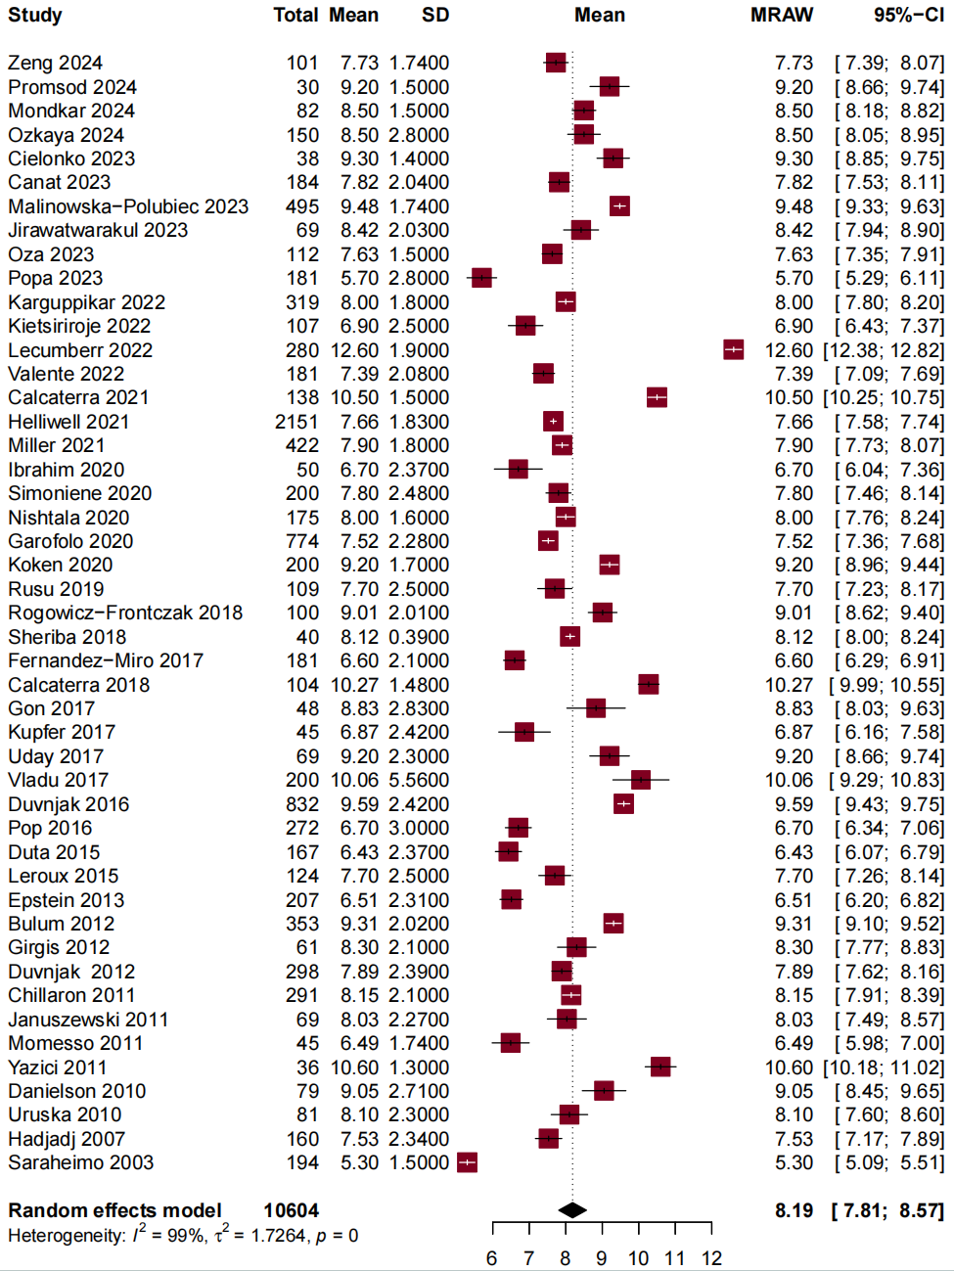

Fig. S2. Forest Plot of the Overall eGDR Levels in Patients with T2DM
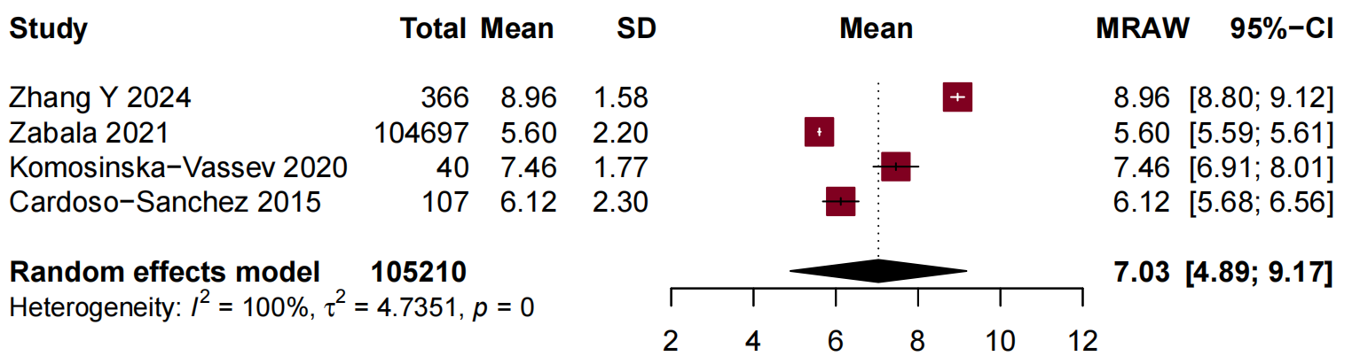

Fig. S3. Sensitivity Analysis of the Risk of CVD in Patients with T1DM Based on Different Degrees of Adjustment
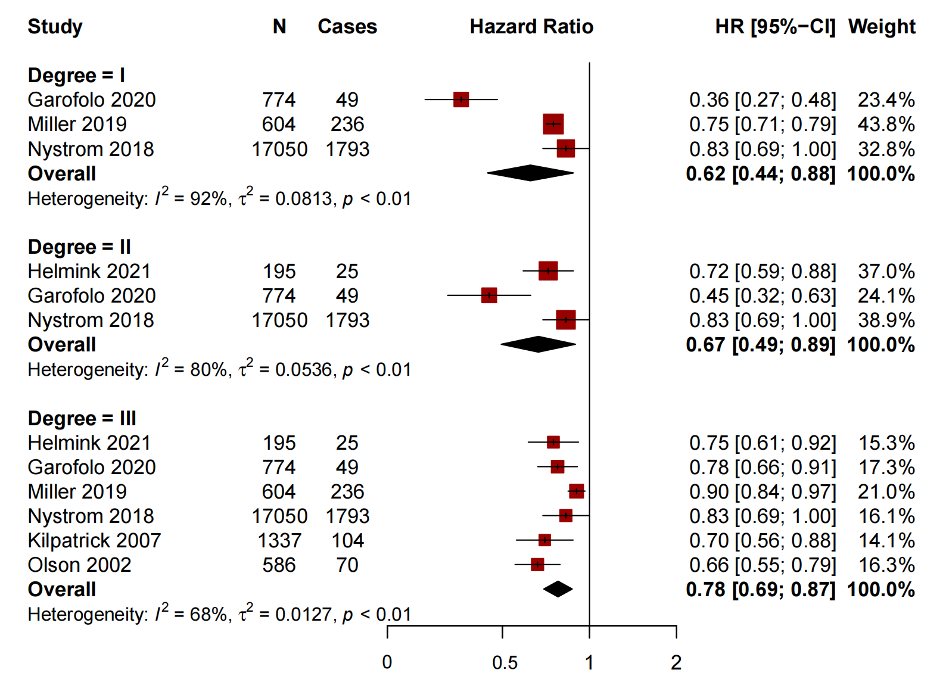

Fig. S4. Sensitivity Analysis of the Risk of DMC in Patients with T1DM Based on Different Degrees of Adjustment
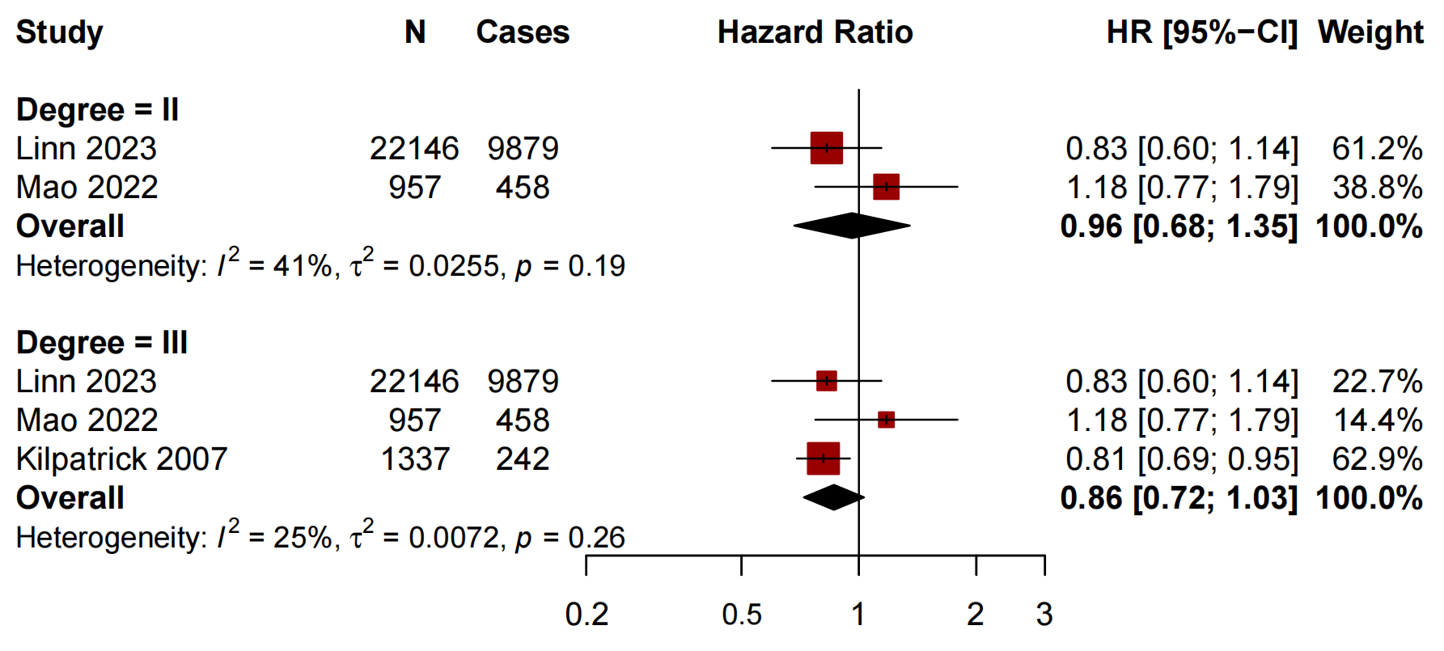

Fig. S5. Sensitivity Analysis of the Risk of Mortality in Patients with T1DM Based on Different Degrees of Adjustment
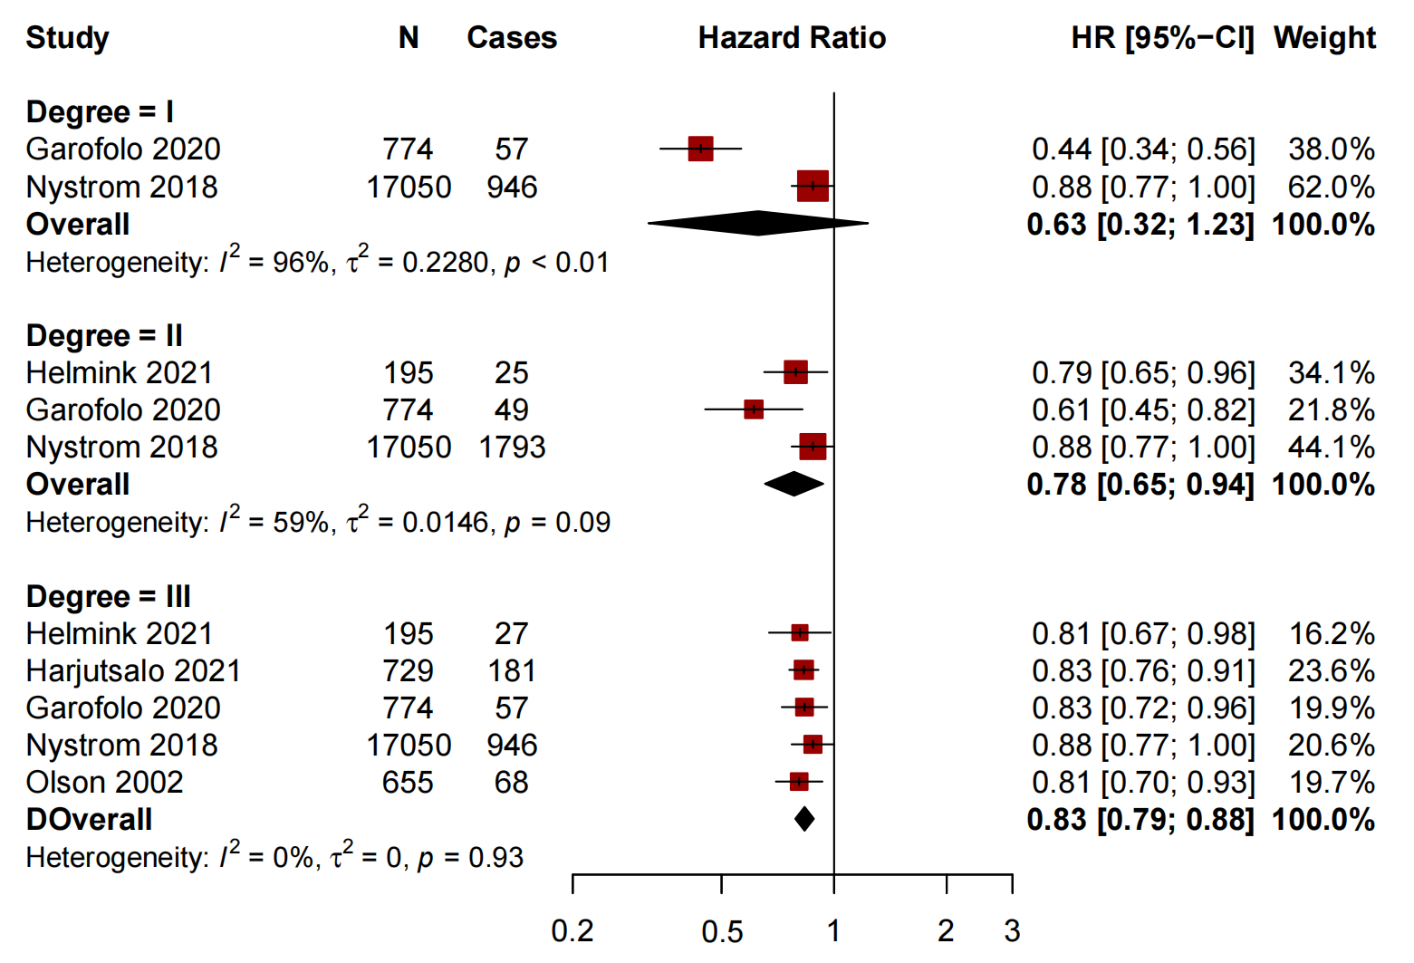

Fig. S6. Sensitivity Analysis of the Risk of CVD in Patients with T1DM Based on Leave-one-out Method
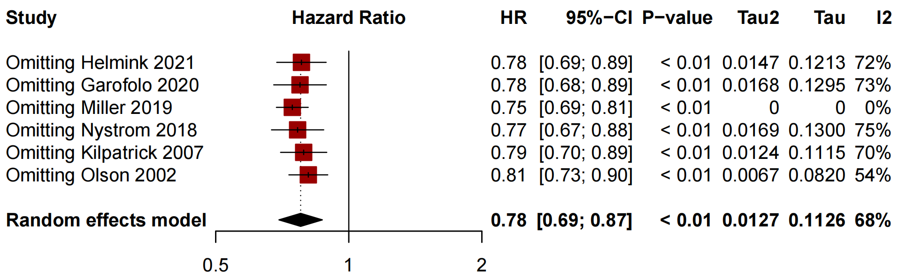

Fig. S7. Sensitivity Analysis of the Risk of DMC in Patients with T1DM Based on Leave-one-out Method
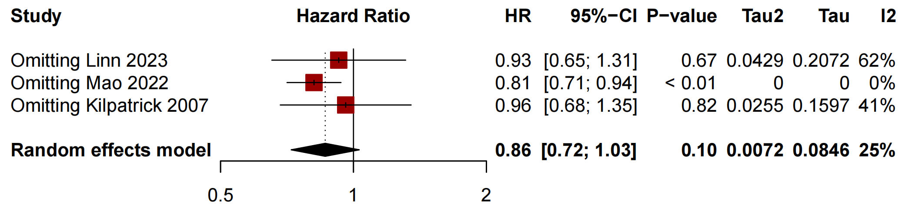

Fig. S8. Sensitivity analysis of the Risk of Mortality in Patients with T1DM Based on Leave-one-out Method
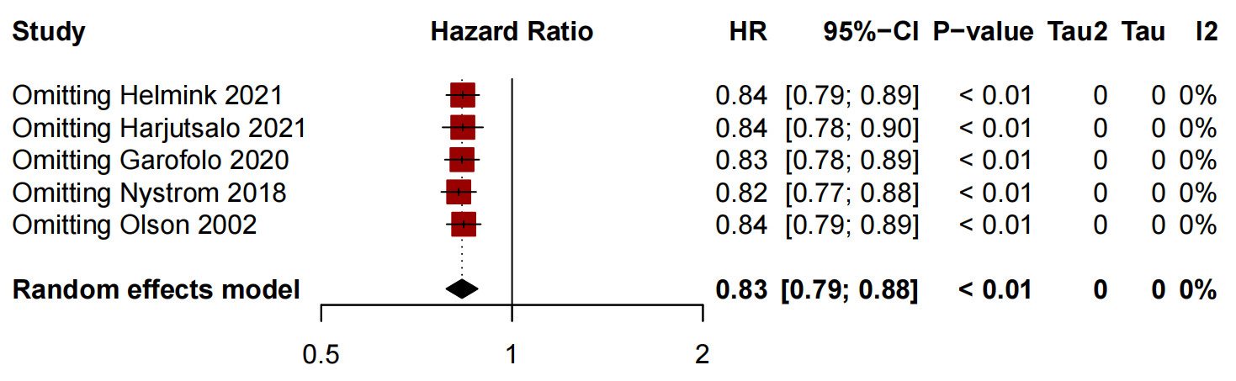

Fig. S9. Sensitivity Analysis of the Risk of Mortality in Patients with T2DM Based on Leave-one-out Method
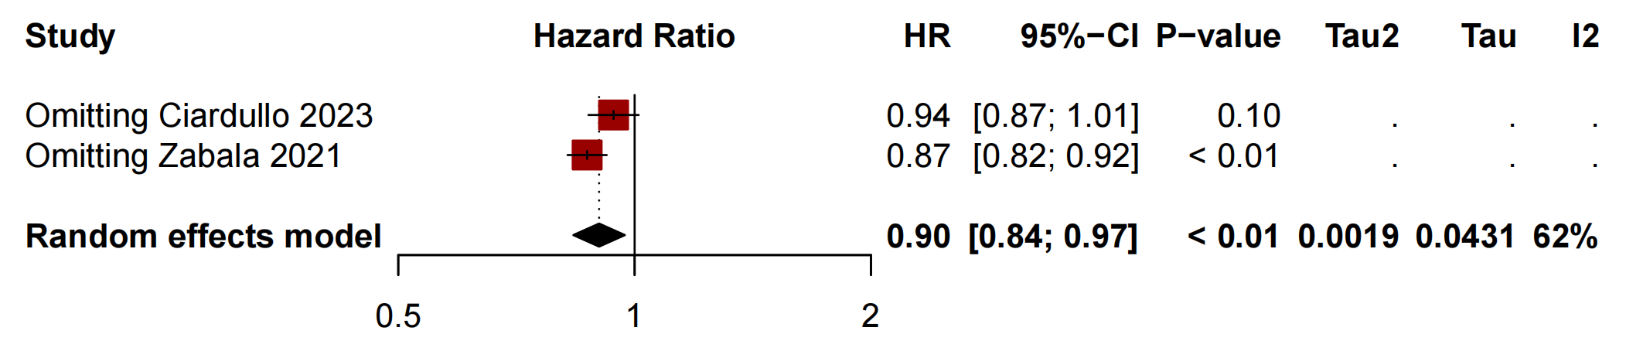

Fig. S10. Sensitivity Analysis of the Risk of Mortality in General Population Based on Leave-one-out Method
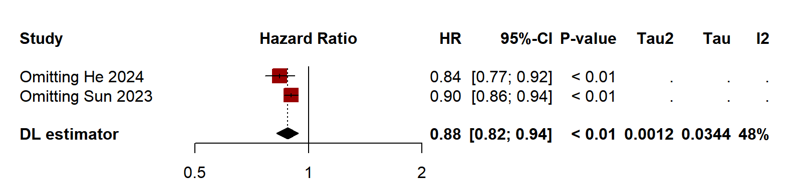

Fig. S11. Funnel Plot of the Overall eGDR Levels in Patients with T1DM
